MODULE

Professional Career Development (BMSW4005_BIRM)

Task 3 / Parts 1 &2 / – Reflective portfolio

Student: Hristina Birova-Kokkini

Student ID:2120089

Lecturer: Olubukola Adegbite

C O N T E N T S

Task 3 / Part 1/ Pages 3 - 5

Task 3 / Part 2 / Pages 6 - 10

Sources Pages 10 - 11

Task 3 / Part 1 /

PDP - Personal Development Planning
Cottrell, Stella in her book ‘’Skills for success : personal development and employability says’’
-'' PDP is a creative process, requiring time, curiosity, inquiry, toying with ideas, looking for inspiration, taking risks, learning new skills, building strength, trial and errors, discussion, false starts, rethinking and even soul searching.'' Page 5

The individual plan is prepared specifically for a certain person.
Depending on his knowledge, professional skills, opportunities and desires, the plan itself is made.
A person may make a 360-degree turn in his life and choose at that stage to start a new business or start learning, say, a new profession.
In order to prepare an individual plan, we must be honest with ourselves to know what we are capable of at the given moment, to set real achievable goals.
The individual plan must be flexible, personal, planned sensibly, updated regularly and progress and gaps monitored.
Knowing ourselves well, we can choose several professions and see which one we fit into and which corresponds to our capabilities and desires.
For example, professions that I am targeting are - teacher, parcel delivery driver, operator in a medical equipment factory, care assistant.
What follows after reflection and consideration of positives and negatives.
1. Teacher - I really like this profession, but after research it turns out that I have to go back to university and study for a long time. I definitely won't be consistent and I won't be able to do it because I have to devote a lot of time to my little child. No .
2. Parcel delivery driver - the pay is good, I will allocate my own time, but the job requires working a lot of hours and it's still not for me. No.
3. Operator in a factory for medical equipment - the work is good, the shifts suit me, but unfortunately after a month of working there, a decision is made to close the factory due to Brexit. No.
4.Care Assistant - in the past I have volunteered to help people in need and I was happy with that. After researching, I understand that I can learn and develop in this field. That's why yes.
Healthcare organizations are committed to offering training to part-time employees / that's right for me /.
Now I have to look for a suitable company offering work in my area.
I will look on indeed.co.uk, totaljob.co.uk, sv-library .co .uk and the local classifieds.
I'm looking, but I'm finding full-time ads, but that's not for me, if I have to leave the child with a babysitter, I won't succeed, because the money I'll earn will have to be given to the babysitter.
My child attends classes at the Methodist Church and there, while waiting for them to finish, I met some of the parents and we talk.
After a long search, appearing for interviews, one day when I went to pick up my son, apparently the expression on my face provoked the curiosity of one of the mothers and she asked me if I was okay...
It turned out that she was the manager of a nursing home.
And right now they needed people part-time...
Miracles also happen!
We exchanged phone numbers and Ms. Nancy said she would talk to the owner and let me know.
The other day Ms. Nancy looked for my email address and I sent it to her.
After a few hours I received an official email inviting me to a meeting in two days and telling me which documents to bring with me.
After two days I had my CV, cover letter and some other documents with me and I went to the interview.
I dressed elegantly and wore sparing almost no make-up.
When I entered the hall where the meeting was scheduled, I smiled and greeted.
They asked for the necessary documents, they were impressed that I was a volunteer and they asked me if I wanted to study and develop in this field. I answered that I wanted to develop and this is what made me apply for this job.
They told me that I was welcome to the company and to apply for a DBS to be issued, and once I got it to take it to them and sign a contract and start work.
After a week, the DBS arrived at my home address, I called and told them that I already have a DBS and told me the next day at 9:30 in the morning to go to the company. and told me
The next day I was at the company at the appointed time, we signed and they told me that I would start work next Monday part time.
The goal has been achieved, I am assigned to a job that I like.
On Monday I went and started work, the first week is an induction week.
The induction week has passed.
I am satisfied with the work and colleagues.
The colleagues are young but trained and work with self-confidence and respect.
I think I found my place!
I think I found my place!
Individual plan of HBK - Care Assistant
- To start my E-Learning studies / I have to do it in 3 months /.
-When I complete 6 months of work in the company, I have the right to start NVQ1 / after completing my E-Learning training, I will start looking for NVQ1 training providers
-After completing NVQ1 I will have already done one year of work in the company and will start NVQ 2
-Upon completing 2 years of work I will apply to study NVQ3
-After 3 years in the job will be able to apply to study at the University of Health & Social Care
Regarding S.M.A.R.T., the goals are clearly stated:
- the manager is informed and has under her supervision my individual plan.
-she monitors my work contribution almost every day.

S - I will study an NVQ in healthcare to be competitive and work with knowledge and confidence.
M- I will measure my progress on each certification against the next NVQ each year
A - I will aim to achieve my targets within the planned time frame - one consecutive NVQ every 12 months
R - I will minimize the chances of failure by increasing the learning time
T - I will follow the schedule and achieve my goals in the allotted time

Task 3 / Part 2 /

During the learning process of the lectures at the university, we did Activities where the teacher, based on the material from the module, introduced us step by step and was next to us and helped with advice.

Personal Development Plan (PDP)
Personal Development Planning or PDP is a structured framework that you can use to:

-realize the skills you have
-identify and develop the skills you need
-think about what you want to achieve and how to achieve it
-focus on potential study, career and personal development options and goals
-develop a source of information for CV, job applications, interviews and workplace assessments
-demonstrate your readiness for promotion and advancement of knowledge.

Personal Development Plan (PDP)
The PDP is planned for each individual.
Covers:
- skills we have and what others we want to acquire and develop
- consider what we want to achieve and how to achieve it, focusing on opportunities and goals for education, career and personal development
- acquiring professional SV writing skills, interview skills and good presentation skills
-demonstrate your readiness for promotion and advancement of knowledge.
In principle, PDP is learned and developed throughout life and everywhere.

S.M.A.R.T.
It allows us to decide on a plan, to put the important things in the first place and realize them in the planned time and thus achieve the set goals.

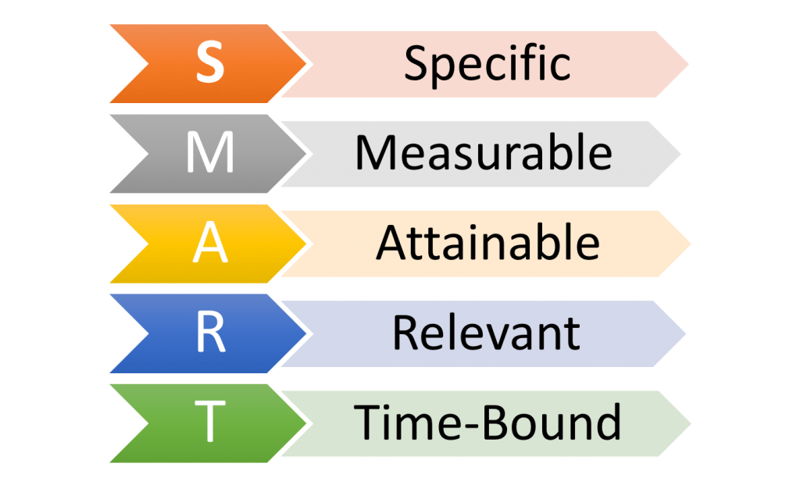

CV

This is a document that is required when applying for a job.
With this document, we want to convince the employer to accept us for work.
Every self-respecting person should learn to write a professional CV, because it is our business card.
In the resume, it is written what education we have, what qualifications and skills we have, work experience.

Cover letter

When applying for a job, we need to get to know the company as much as possible.
To emphasize our qualities and skills that fit into the company's policy and the subject of activity
In a word, we have to present ourselves in such a way that they prefer us and hire us.

When selecting people for work, there are requirements that must be met.
Before announcing the jobs, every company has long considered how many and what kind of people they need.
With the Yeld pyramid, it is clear that out of 1200 applicants, only 50 were hired that they thought were suitable (this means that out of 24 applicants, 1 was hired).

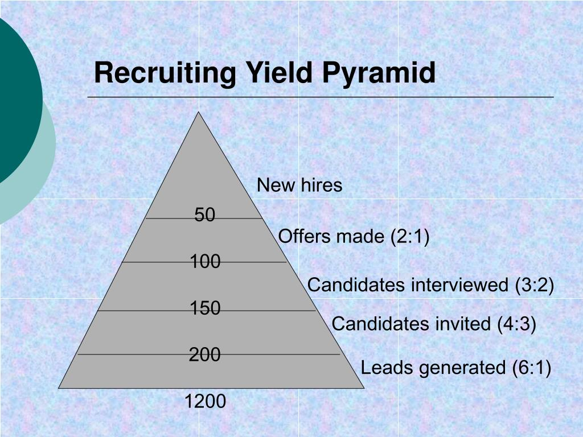

Job interview

Before appearing for a job interview, we should prepare properly.
- to be at the designated place on time
- to be dressed elegantly with clean and ironed clothes
- to know all the characteristics of the workplace
- to know the history of the company
- to be polite and to say hello
- to answer clearly and precisely the questions asked to us
- to have good manners
- to ask meaningful questions

In time, what is good for both parties and leads to progress is retained, and what is unsatisfactory is discarded.
The book Employability: Making the Most of Your Career Development by John Neugebauer and Jane Evans-Brain addresses vital issues affecting most people around the world, namely:
1. Preparation for work
2.Finding a job
3. Training and development in the workplace
4. Progress and Navigation
5. Managing yourself
and other.
Given my experience so far and the jobs I have changed, the most important thing is whether they will accept you to work there is decided at the interview.
An experienced recruiter or recruiter knows what to look for and knows how to find the right candidate for the job opening.
I made sure that face to face is the most important thing!
quote:
''Interviews
While you may be able to afford to be good (rather than excellent) in many of the selection methods used so far, you need to excel in face-to-face interviews. In part, they should test your ability, experience and commitment. But they're also about making an assessment: Is this the type of person we want working here? Is this someone I would like to work with? Do this candidate's values align with the organization's values? You can expect two types of interview, structured and unstructured. You have to be ready for both.” - Employment Opportunities: Making the Most of Career Development - by John Neugebauer and Jane Evans-Brain (Chapter 4, page 75)

The employer-employee relationship is variable and involves many aspects.
For example, in 2016 Mr Stephen Timms made an inquiry to the Department for Business, Innovation and Skills
Apprentices: Degrees, I quote:
Stephen Timms: [40634] To ask the Secretary of State for Business, Innovation and Skills what
the maximum duration should be for an apprenticeship with a degree.
Nick Bowles: There is no maximum length of internships. The delivery model of
degree will be a key component of the apprenticeship duration for both employers and graduates
Education providers will want to ensure that the apprenticeship standard is fully achieved.
Stephen Timms: [40637] To ask the Secretary of State for Business, Innovation and Skills what his policy is
on whether the cost of a degree apprenticeship is supported by the earnings of the apprenticeship
fee.
Nick Bowles: The Apprenticeship Levy will fund growth in apprenticeships at all levels, including degree
Apprenticeship. Apprenticeships with diplomas widen access to occupations and provide a higher level
technical skills needed by employers'. - Workplace Training and Skills Bulletin, 2.7.2016, Issue 187, pp. 6-11, 6 p.

We also got acquainted with some legal documents that regulate the relations between employers and workers in England.
-The Equality Act 2010
-The Employment Relations Act 1999

Sources

indeed.co.uk

totaljob.co.uk

cvlibrary.co.uk

Skills for success: personal development and employability
Title: Skills for success: personal development and employability
Author: Cottrell, Stella
Edition: 4th edition.
Pages: 1 online resource (428)
Publication Date: 2021
Publisher: Red Globe Press
Place of Publication : London

Answers in Parliament
Source: Workplace Learning & Skills Bulletin
Date: July 2, 2016

Workplace Learning & Skills Bulletin, 7/2/2016, Issue 187, p6-11, 6p
Subjects: Apprenticeship programs; Great Britain. Parliament. House of Commons; Great Britain. Civil Aviation Authority; Apprenticeship Training; All other schools and instruction; performing arts; Air pilots; Weather radar networks

Employability: Making the Most of Your Career Development
by John Neugebauer, and Jane Evans-Brain
PUBLISHER
SAGE Publications, Limited
Date: 27 September, 2016

