AutoPark Management System Database Report

Student name: Saidas Stankevicius
Student ID: 2533410
Module: Database Report – Term 2
Date: 20 July 2026

Contents
Introduction 3
2.Scenario Analysis 4
3.Entity Relationship Diagram 5
4. Data Structure Development 6
5. Normalisation 7
6. Sample Data Population 8
7.Query Development 11
8. Validation and Testing 13
9.Conclusion 14
10. References 15

Introduction
This report presents the design and development of an Auto Park Management System database using Microsoft Access. The system is intended to store and manage information about customers, vehicles parking slots, bookings and payments. The purpose of the database is to reduce manual errors, improve data accuracy and make parking operations easier to manage.
The database was developed to demonstrate the principles of relational database design, including tables, primary keys, foreign keys, relationships, normalisation, queries and validation. Microsoft access was selected because it allows data to be stored, linked and searched efficiently within one system.

2.Scenario Analysis
The Auto Park Management system needs a relational database to manage customers, vehicles, parking slots, bookings and payments, each table stores a different type of information, primary keys uniquely identify each record. While foreign keys connect related tables. This structure helps reduce duplicated data and improves accuracy.
- Customer
- Vehicle
- Parking Slot
- Booking
- Payment
The main purpose of the system is to keep all parking information in one organised database. The customer table stores personal details such as the customer’s name, phone number, email address and home address. The vehicle table stores the registration number, make, model and colour of each vehicle. It also included customer ID so that every vehicle can be linked to its owner.
The parking slot table stores details about each parking space, including the slot number, parking level and status. The booking table records which customer and vehicle have reserved a parking slot, together with the booking date, entry time and exit time. The payment table stores the amount paid, payment date and payment method for each booking.
These entities are connected because the information is related. A customer can own more than one vehicle and can make several bookings. A vehicle can be used in different bookings over time, and a parking slot can also be booked many times on different dates. Each booking can hen be linked to a payment record. Using separate tables makes the database easier to manage and avoids repeating the same information unnecessarily.

3.Entity Relationship Diagram
The entity relationship diagram shows how the five tables are connected. A customer can own more than one vehicle and can make more than one booking. Each booking is linked to one vehicle and one parking slot. Payment information is linked to the booking through the booking field. These relationships are created using primary and foreign keys.
The relationship between customer and vehicle is one-to-many because one customer may own several vehicles, while each vehicle belongs to one customer. Customer ID is the primary key in the customer table and is used as a foreign key in the vehicle table. [2]
The customer table is also linked to the booking table through customer ID. This means one customer may make several bookings. The vehicle table is linked to booking through vehicle ID, allowing the system to record which vehicle is used for each booking.
Parking slot is linked to booking through slot ID. One parking slot may be used in many bookings over time, but each booking is linked to one selected slot. Booking is linked to payment through booking ID so the payment details can be matched to the correct booking.
Referential integrity was used to prevent invalid records. For example, a booking should not be created using customer ID, vehicle ID or slot ID that does not already existing the related table.
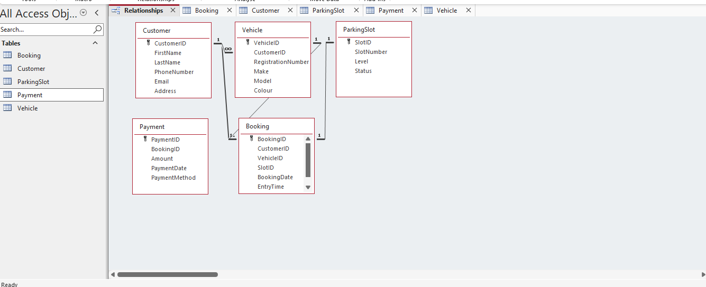
Figure 1: Entity relationship diagram for the Auto Park Management System

4. Data Structure Development
The database was developed using five tables: customer, vehicle, parking slot, booking and payment. Each table contains fields that match the information required by the Auto Park System. Auto Number fields were used as primary keys, while number fields were used as foreign keys to connect related records. [1]
The customer table stores personal details, vehicle table stores vehicle information and links each vehicle to a customer. The parking slot table store slot numbers, levels and availability status. The booking table records parking reservations, and the payment table store payment details linked to bookings.
The customer table uses customer ID as an Auto number primary key. This ensures that every customer record has a unique identification number. The remaining fields use short text because they store names, telephone numbers, email addresses and home addresses.
The vehicle table uses vehicle ID as its primary key. Customer ID is included as a foreign key so that each vehicle can be connected to the correct customer. Registration number, make, model and colour use short text because they contain letter and numbers.
The parking slot table uses slot ID as its primary key. Slot number, level and status use short text. This allows the database to record the location of each parking space and whether it is available or occupied.
The booking table uses booking ID and its primary key. Customer ID, vehicle ID and slot ID are number fields because they link to the primary keys in other tables. Booking date, entry time and exit time use the date/time data type.
The payment table uses payment ID as its primary key. Booking ID is included as a foreign key. Amount uses the currency data type; payment date uses date/time and payment method uses short text.

5. Normalisation
The database was organised to the third normal form (3NF) #. [4] Each table contents information about one main subject, and every table has a primary key. Repeated data was separated into different tables, for example: customer details are stored only in customer table, while vehicle details are to connect in tables without unnecessarily repeating information.
This structure reduces duplication improves consistency and makes database easier to update and maintain [5].
In the first stage of normalisation, the data was organised so that each field contained only one value. For example, first name and last name were stored in separate fields, and vehicle details were divided into registration number, make, model and colour. This follows first normal form because there are no repeating groups or multiple values stored in ne field.
The database also follows second normal form because each table has a primary key and the other fields depend on that key. For example, in the vehicle table, the registration number, make, model and colour all describe the vehicle identified by vehicle ID.
Third normal form was achieved by removing information that did not directly belong in a table. Customer details were not repeated in the vehicle or booking tables. Instead, customer ID was used to create the relationship. This reduces duplication and makes updates more accurate because customer information only needs to be changed in one place.

6. Sample Data Population
The database was populated with at least five sample records in each table. The samples data included customer details, vehicle registration, parking slot records, booking details and payment information. Realistic data was used to demonstrate how the database would operate in practical environment.
The records were entered in the correct order to related information already existed before foreign key values were added. Customers, vehicles and parking slots were entered before bookings, and bookings were entered before payments.
Five sample records were prepared for each table to demonstrate that the database could store realistic information. The customer table included different names, telephone numbers, email addresses and locations. The vehicle makes, models and colours linked to the correct customers.
The parking slot table included different slot numbers, parking levels and availability statuses. The booking table was designed to link customers, vehicles and parking slots using their identification numbers. The payment table was designed to store the amount, payment date and payment method for each completed booking.
Entering the data in the correct order was important because of referential integrity. Parent records such as customers, vehicles and parking records such as customers, vehicles and parking slots had to exist before related booking records could be added. Payment records could then be entered after the relevant bookings had been created.

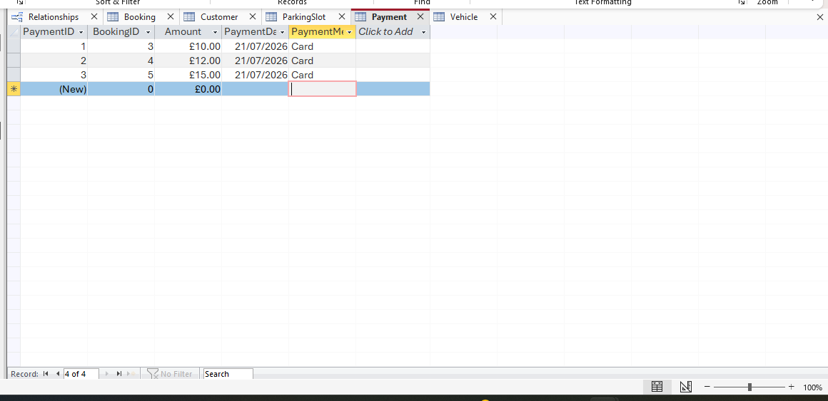
Figure 5: Payment table showing sample payment records.
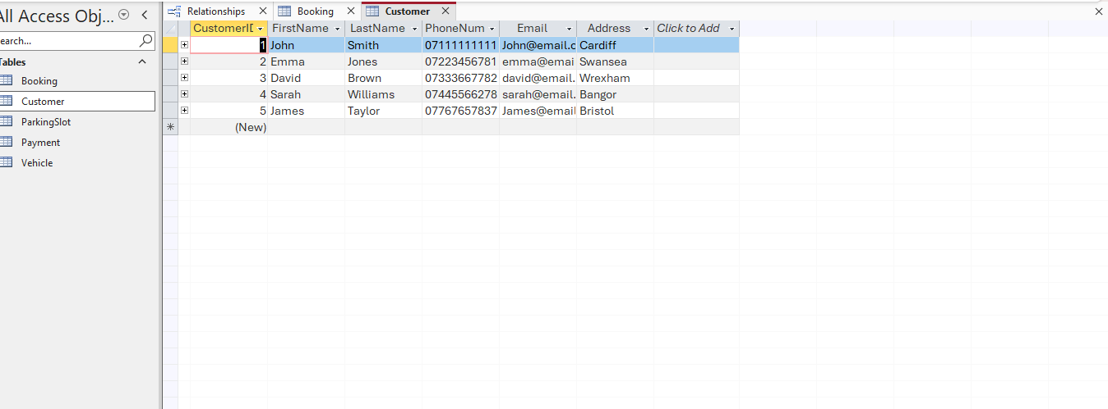
Figure 6: customer table showing 5 sample records

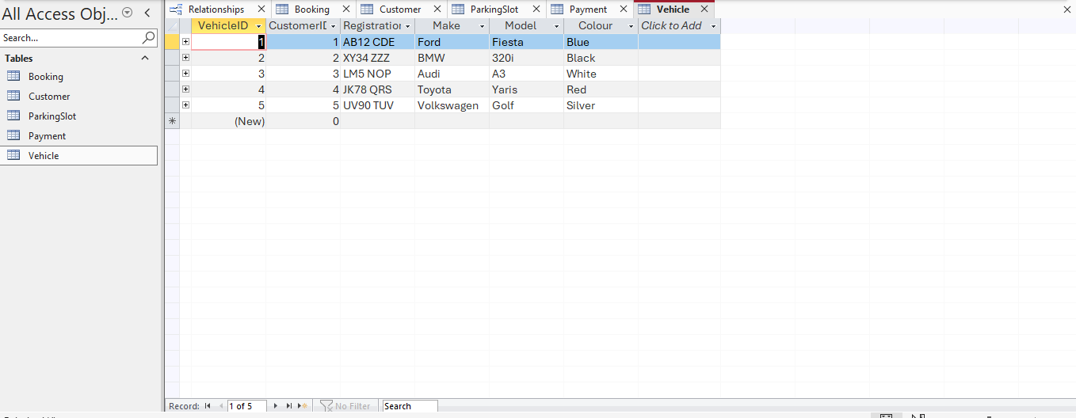
Figure 7: vehicle table showing five sample records

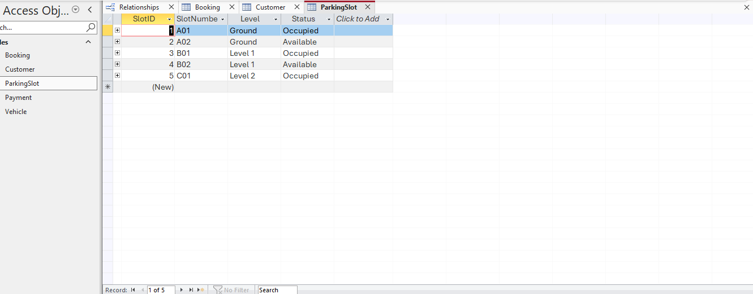
Figure 8: Parking slot table showing five sample records

7.Query Development
Queries were created to retrieve useful information from the database. These queries help user find specific customers, vehicles, parking slots, bookings and payments without searching through every table manually.
The queries were designed to support practical tasks such as viewing available parking slots checking customer bookings and reviewing payments.
Several queries were planned to retrieve useful information from the database. One query will display all available parking slots by filtering the status field for “available”. Another query will show booking details together with the customer’s name, vehicle registration number and paring slot number. [3]
A payment query will display the booking number, payment amount, payment date and payment method. These queries make the database easier to use because the required information can be viewed quickly without opening each table separately.
Query criteria can also be used to search for a particular customer, vehicle registration number or booking date. The completed queries will be tested to make sure they return accurate results.
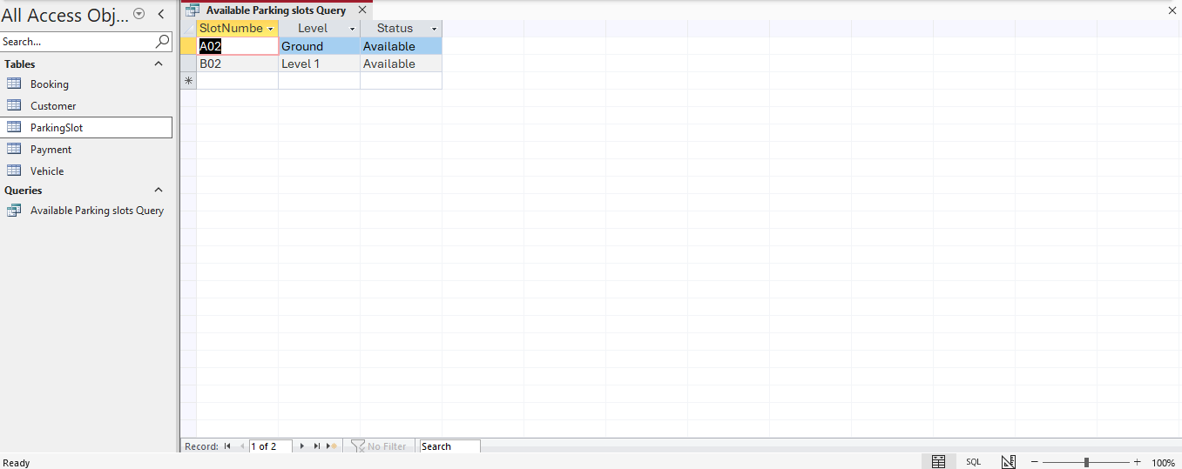
Figure 10: Query showing available parking slots.
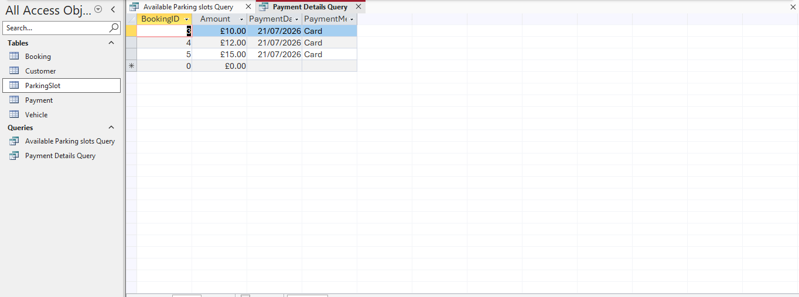
Figure 11: Query showing payment details.

8. Validation and Testing
The database was tested to check that tables relationships and queries worked correctly. Test records were entered to confirm that primary keys created unique values and foreign keys only accepted matching records from related tables.
The database was also checked for missing information, incorrect data types and invalid relationships. Any errors found during testing were corrected to improve readability and data accuracy.
By entering sample records data was tested by checking if the relationships worked correctly. Primary keys were tested to confirm that each record received unique identification number. Foreign keys were tested by entering customer ID, vehicle ID and slot ID value into the booking table.
Referential integrity was also tested. Access displayed an error when booking was entered using a value that did not match an existing record in a related table. This showed that the database was preventing invalid information from being saved. The relationships and field setting were then reviewed and corrected where necessary.
The queried will be tested by comparing the results with the original table data. For example, the available parking slot query should only display records where the status field is set “available” successful and unsuccessful testes will be documented using screenshots as evidence.

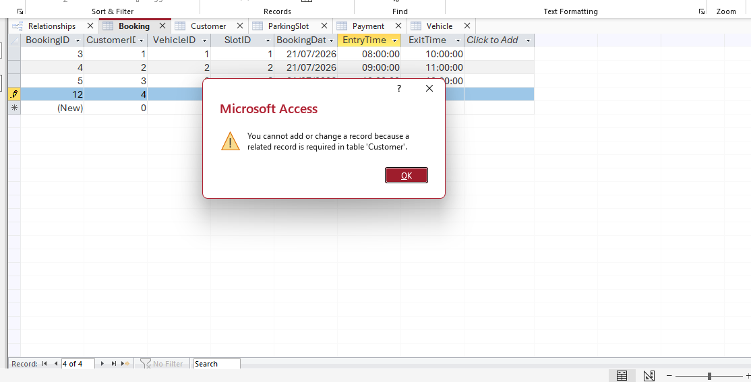
Figure 9: booking table showing three successfully saved records and a referential integrity error during testing.

9.Conclusion
The auto park management system database was designed to manage customers, vehicles, parking slots, bookings and payments in an organised way. The use of separate tables, primary keys and foreign keys improves accuracy and reduces repeated data.
Overall, the database provides a practical structure for storing and retrieving parking information. The system could be developed further by adding forms, reports, automatic calculations and more advanced queries.
The completed design demonstrated how a relational database can improve the management of parking information. Separating the data into linked tabled makes the system more accurate and easier to maintain it also allows users to search for information quickly through queries rather than checking each Table manually.
Although the system currently focuses on the main parking operations, it could be improved further. Future development could include user-friendly forms for entering data, reports for daily bookings and payments, automatic calculation of parking charges and alerts when parking slots are unavailable.

10. References
[1] Microsoft, “Introduction to tables,” Microsoft support, 2026.

[2] Microsoft, “Guide to table relationships,” Microsoft support, 2026.

[3] Microsoft, “create a simple select query,” Microsoft support, 2026

[4] R. Elmasri and S.B. Navathe, fundamentals of database systems, 7th ed. Pearson, 2016.

[5] T. Connolly and C. Begg, Database Systems: A practical Approach to design, implantation, and Management, 6th ed. Pearson, 2014.

