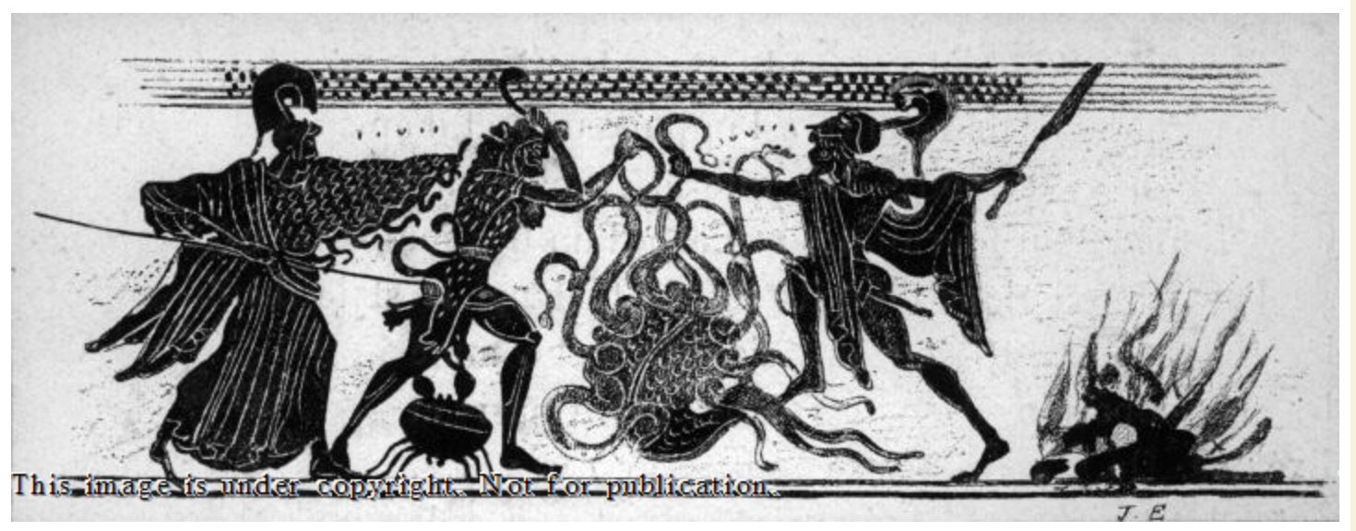

Text - Nonsense: imitation letters, from left to right: ιιυιι and ιυυι(.)(.). Black-figure Lekythos, Eritrea. Early 5th C. BC (BCE). Current collection: Paris, Musee du Louvre: CA598

Analysis
This piece of art is in the style of black figure, it can be found on a vase and is thought to have been made in the fifth century. However, the artist is not known but is attributed to the Diosphos Painter. It depicts a battle scene of Hercules or Herakles depending whether we use the Greek or Roman name, as it does not specify on the art. The only text that is there makes no sense, as the caption states, this would make it difficult for someone with no previous knowledge of ancient myths and art, or any other sources to compare the figures to. For example, another vase showing Hercules/Herakles completing the labour of collecting Cerberus from the gates of hell. Hercules or Heracles is seen to be battling the mythical beast known as Lernaean Hydra, with the assistance of his nephew Iolaos. We know this by first recognising the figure wearing the lion skin cloak to be Hercules/Herakles. Then the monster in the middle to be the Lernaean Hydra. Hercules/Herakles got the cloak after his first labour, when he defeated the Nemean Lion (Apollod. 2.5.1). This links to one of Hercules/Herakles Labours he had to perform, defeating the Lernaean Hydra is the second labour according to Apollodorus (2.5.2). Apollodorus wrote a book which included sections on what we now would call myth, this includes Hercules/Herakles and his labours. In the myth Hercules/Heracles chops one of the mortal heads off with his sword then two grow back in its place. So he begins to struggle with the beast as it coiled round his feet and a giant crab (friend of the Lernaean Hydra, seen in painting in between Hercules/Herakles legs) started nipping at him. So he uses his club to batter the crab away and asks his nephew Iolaos for assistance. After a head is chopped off, Iolaos cauterises the neck to stop new heads from growing (Apollod. 2.5.2). This helps Hercules/Herakles to defeat all the mortal heads. Then the immortal head was removed and buried with a rock on top for good measure. However, because Hercules/Herakles had some help, this particular labour was not counted in his original set ten labours. As this caused the setting of the twelve labours most people know. On the art piece, the figures from left to right are as follows; the first figure, said to be Athena wearing a cloak with snakes at the hem. The second, Hercules/Herakles, then the Lernaean Hydra, and then Iolaos, Hercules/Herakles nephew, who was an armoured squire. The first figure is thought to be Athena as she appears in other pieces of artwork of Hercules/Herakles other labours in order to show victory of battle strategy. However, she is not always added to other pieces of art showing Hercules/Herakles defeating the Lernaean Hydra this may show that she either did not play a big part in it or that she might not have even been there. Much like Athena the giant crab that is seen to be helping the hydra isn’t always depicted either. But unlike Athena, the crab was seen as important in the battle as the Goddess Hera gave it a constellation (cancer) for its efforts. Due to this the crab is often refereed to as Heras crab.

Bibliography
E701, L., n.d. Hercules and Kerberos. [Art] (Musee du Louvre).
Apollodorus, The Library, with an English Translation by Sir James George Frazer, F.B.A., F.R.S. in 2 Volumes. Cambridge, MA, Harvard University Press; London, William Heinemann Ltd. 1921. Includes Frazer's notes. From Perseus http://www.perseus.tufts.edu/hopper/text?doc=Perseus%3Atext%3A1999.01.0022%3Atext%3DLibrary%3Abook%3D2%3Achapter%3D5#note6.
LIMC 5, S.V. Herakles 2004, pl. 54; Boardman 1974, fig. 270. Taken from perseus http://www.perseus.tufts.edu/hopper/artifact?name=Louvre+CA+598&object=Vase.

http://www.perseus.tufts.edu/Herakles/cerberus.html (E701, n.d.)
http://www.perseus.tufts.edu/hopper/artifact?name=Louvre+CA+598&object=Vase

