MENTAL DISORDERS AND PSYCHOPATHOLOGY
BMHP6006
Musammat Khaleda Begum
1714938
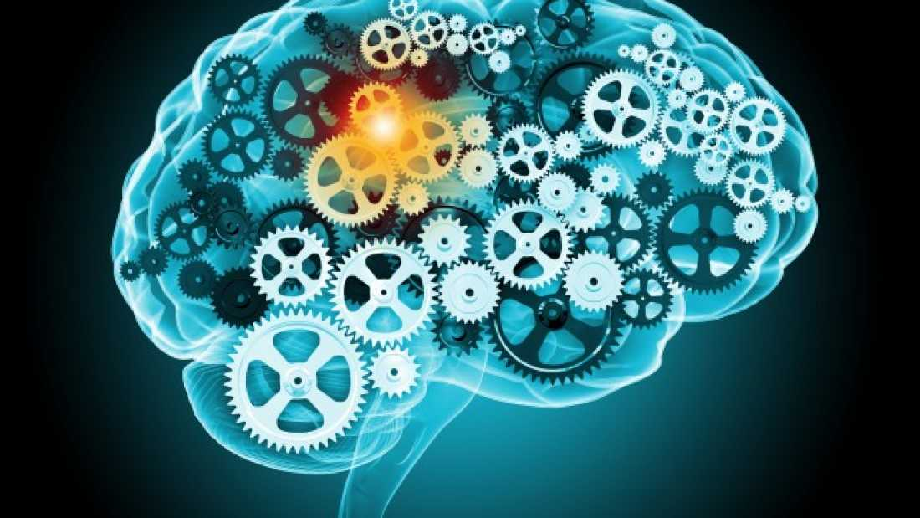

Executive Summary
This report has been developed on the care system of mentally ill patients in terms of the historical concept of the healthcare system. The context of mental health has been considered in the duration of this course by exploring historical concepts as well as legislations in detail. Exclusion and inclusion criteria for UK law and regulations are projected with journey of mental health set up in detail. Recommendations are given for doctors to reduce current mental health problem for UK health care centres. It has been concluded from this report that several laws have been implemented in the country that supports healthcare management for mentally ill people.

Table of Contents
1. Introduction 4
2. Definition of mental disorder 4
3. Historical context of mental disorder in the UK 5
4 Changes in the UK by mental health legislation 7
5 Examples of inclusion and exclusion 8
6 Recommendation 8
7 Conclusion 9
References 10

Supporting Paper

1. Introduction
The aim of the task is to analyse whether UK government has supported individual people regarding their mental health disorder or not. Historical context of mental health provision in the UK is evaluated within this study. Constant change in UK laws and legislations for mental health recovery is represented by elaborating inclusion and exclusion criteria. 1 out of 4 people in the UK are suffering from mental disorders in the UK each year. Moreover, few recommendations are suggested for minimizing mental health issues as well as related consequences for this country.

2. Definition of mental disorder
Mental disorder is a kind of illness that reduces its ability to think, behave, feel or respond. It affects the daily life of the patient as they are unable to cope up with social life. However, the mental disorder can be occasional or chronic and it can be cured with proper treatment and medication in the early stages. Mental disorder creates mood swings, abnormal behaviour with others as well as imbalance in behaviour. As examples depression, dementia, schizophrenia, bipolar disorder, autism and other developmental disorders can be considered (Maben and Bridges, 2020).
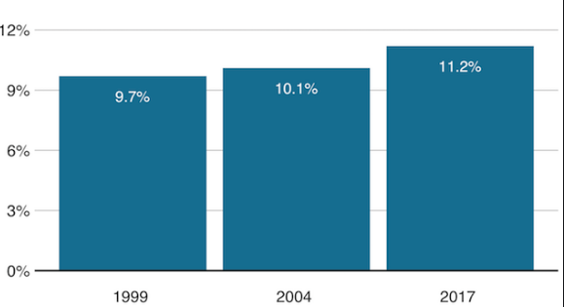
Figure 1: Mental health disorder prevalence in UK
(Source: Nhs.com, 2020)
It has been revealed in the study that most of the people around the globe are suffering from either depression or anxiety. In UK 1 out of 6 people are suffering from depression that is the main reason for worldwide mental disorders (Walker et al. 2017). However, patients that are suffering from mild to moderate depression can be treated with talking therapy by the psychiatrists. Bipolar disorder is another severe mental disorder in which patients can have irritable mood, rapid speech, and over-activity. In the UK 1.3 million people are suffering from bipolar disorder manic.
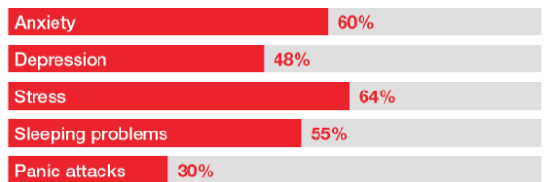
Figure 2: Different types of mental health disorders in UK
(Source: Hjelmeland and Knizek, 2017)
Schizophrenia is another severe mental disorder in which the patients face the problem of hallucination and imagining about unreal things. As per the view of Hjelmeland and Knizek (2017), in the UK 1.45% of people are suffering from Schizophrenia. Most importantly people suffering from schizophrenia can commit criminal activities that violate human rights. This mental disorder can be treated with medications, counselling, and other social supports. Stress, nutrition, genetics, prenatal infections, and exposure to environmental hazards are also contributing factors to mental disorders.

3. Historical context of mental disorder in the UK
It has been revealed from The 2014 Adult Psychiatric Morbidity Survey that one out of 6 people have been suffering from mental health issues in the UK. However, this survey revealed that 25% of people in England have been diagnosed with mental disorders (Davis et al. 2020). Previously, people with mental disorders used to face social decline and were bullied by the people in the society. However, as the time passed people started understanding that mental illness is a serious matter that they must take seriously. Therefore, people started visiting doctors for their mental health issues and started their treatment.
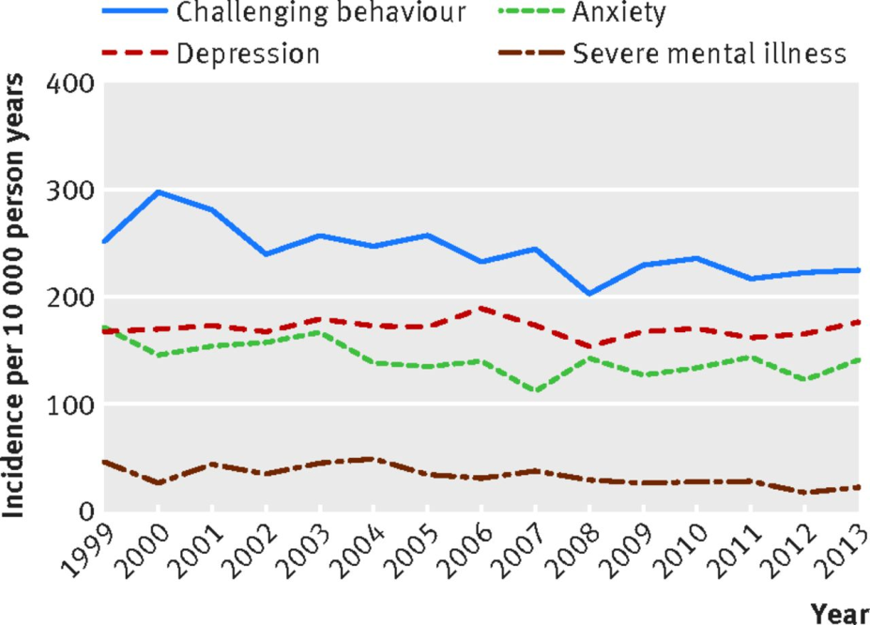
Figure 3: Historical context
(Source: Davis et al. 2020)
Mental health issues in the UK are seen in almost every sector and age group of the country. The United Kingdom is one of the first countries that developed the concept of asylum to take care of the patients with mental illness. This concept was aborted by this country as asylum uses isolation of the patients in order to treat them. The period of 1960s experienced a shift of the UK towards a new practice of care system for the mentally ill people (Davis et al. 2018). New practice in the system followed Care in the Community which is a policy of deinstitutionalization. Patients had to be treated in their home under this system rather than using isolation as a part of the treatment process.
Madhouse Act 1774 was the first legal provision in the UK to control the asylums in the country that used to abuse the patients. The term Madhouse used to refer to the private houses that were utilized for keeping the mentally ill patients with little or no medical treatment (Davis et al. 2020). Abusive behaviour to the patients was of two types and the first type was to keep the patients within atrocious conditions. The second type was to detain the falsely insane people in these houses in terms of private imprisonment.
The Mental Health Act of 1959 was passed after almost a decade after the establishment of the National Health Services (NHS). Under this act, hospitalization of a patient with mental illness used to be decided by the medical personnel who are treating an individual. Some attempts of the UK government are evident that the government wanted to integrate mental health services to the NHS (Pitchforth et al. 2019). In 1961, the government again announced that the Victorian asylums have to be closed and the patients under their care will be treated in conventional hospitals or within the community.

4 Changes in the UK by mental health legislation
The United Kingdom has progressed in their care system for the mentally ill people of the country. The Mental Health Act of 1959 and Hospital Plan of 1962 enabled the UK government to rule out asylums from the care system and integrate the system into hospitals (Murphy et al. 2019). The treatment methods for the insane people developed against the local government and the organizational restructuring of the NHS. The 1970s showed up with a scarcity of resources in the handicap and mental hospitals and it was acknowledged by the Labour and Conservative governments. In 1984, Conservative government reorganized the system of administration by the NHS via imposition of the general management in the health authorities (Arango et al. 2018). The National Health and Community Care Act of 1990 enabled a complete reorganization of the healthcare services and put the responsibility on the local authorities. Till 1997, the UK focused on the improvements of the services for the mentally ill people.
Throughout the time, people in the UK did not invest much in the mental health sector in comparison with physical health. Labour governments in the UK increased the investment for mental wellness between 1997 and 2010 and it was performed without increasing the expenditure of the NHS (Williamson et al. 2018). This policy was implemented in society as part of the reformation of NHS provision and via Modernising Mental Health Services in 1998. National Service Framework (NSF) for Mental Health, a policy of 1999, specified some objectives for the national care system however; these were only for adults within working age. The NHS Plan of 2000 declared mental health as one of the three main priorities of the national healthcare system besides heart diseases and cancer (Allan et al. 2020). The Department of Health promised to invest sufficient funds for the care of insane citizens of the country and guide the professionals with more detailed training.
A programme of 2006, the Improving Access to Psychological Therapies (IAPT) was put into action for the UK. It showed the necessity of fund reduction in the countries with mild or moderate mental illness. Labours demanded for a clear and extended definition of the compulsion powers on the mentally ill people after the codification of this matter in the 1959 Act (Freeman et al. 2017). However, mitigation of the issues consumed a long time and ultimately happened after the 1983 Mental Health Act. This act passed later in 2007 and a programme of the Labour Government ruled out the contemporary workplace culture. February of 2011 came up with a policy paper from the coalition government that was named No Health without Mental Health.
The mental health services in 1950 used to focus on the detention of mental patients in the asylums under the care of nurses and the doctors. This system changed after sixty years and patients could spend their life outside hospitals and without legal conflicts (Foskett and Longstaff, 2018). They used to be under care of professional healthcare personnel that can be termed as care in the community.

5 Examples of inclusion and exclusion
Inclusion criteria for this study
Both adults and children have been considered in this study in terms of determining the cases of mental illness in UK people. The patients in consideration have to fulfil the criteria of Movement Disability Society Clinical Diagnostic criteria for Parkinson’s disease (Allan et al. 2020). People who have experienced visual hallucinations on a weekly basis are included in this study and their achievement of 3 or more in the SAPS-H test is important. A score of 4 or more in the CGI-S test indicates moderate severity of the symptoms related to their mental health issues. Capacity of a person to give consent for the study is important however; in case of lack of the same, a legal representative must be present (Williamson et al. 2018). Administration of the antipsychotic drug has to be stopped one day before the start of the research.
Exclusion criteria for this study
Data from any countries other than the UK regarding mental health disorders have not been considered in this study as it is focused on this particular nation. People unable to give consent for the research and absence of legal representation are a sufficient factor for a candidate to be excluded (Murphy et al. 2019). Laws and regulations of other countries have not been introduced in any case of this research. As a result, focuses become short and only a particular section has been studied with relevant information as well as its analysis.

6 Recommendation
The yearly data of the UK shows that one among four people in the country has experienced at least one type of mental issue. Besides this fact, 1 among every 6 people in this country suffers from common mental issues such as anxiety and depression (Rona et al. 2017). The second data regarding mental health is a statistics for weekly analysis of the country. Prevalent mental disorders in this country can be mentioned as phobia, obsessive-compulsive disorders, post-traumatic disorders, mixed anxiety and depression and panic disorders. Therefore, some recommendations can be given as follows in order to reduce these cases in the UK.
- It can be recommended to the UK government that the country has to be taken care of in terms of mental wellness (Taylor et al. 2017). This will prevent the development of mental health diseases among the citizens of the nation.
- It can be suggested to the country government that the people with mental health issues have to be supported with resources (Foskett and Longstaff, 2018). This will enable these people to live a life with good quality and make them feel important for the country.
- It can be advised for all doctors working in mental asylum of UK to follow correct strategy for patient communication purpose. It can be helpful for them to understand patient population and their ineffective knowledge related with proper treatment provision for all.

7 Conclusion
It can be interpreted from this study that mental health disorder is one of the most prioritized issues in the UK. This study has been conducted with the psychopathology systems in this country besides the definition of the situation. The historical concept of the situation has been taken into account and several laws have been listed. It is reported that the UK is one of the first countries to launch the concept of asylum in order to treat insane people. In later years, this concept was aborted as patients were being abused in these organizations. The concept of madhouse was prevalent at that time and these were private houses dedicated to patients with mental illnesses. The act of 1774 ruled out this ideology of madhouse from the healthcare system and instead mental patients had to be treated within the community. Some of the significant changes in the UK mental health care system are mentioned in this study that occurred by legislation besides some recommendations for improving the care system.

References
Allan, S.M., Bealey, R., Birch, J., Cushing, T., Parke, S., Sergi, G., Bloomfield, M. and Meiser-Stedman, R., 2020. The prevalence of common and stress-related mental health disorders in healthcare workers based in pandemic-affected hospitals: a rapid systematic review and meta-analysis. European journal of psychotraumatology, 11(1), p.1810903.
Arango, C., Díaz-Caneja, C.M., McGorry, P.D., Rapoport, J., Sommer, I.E., Vorstman, J.A., McDaid, D., Marín, O., Serrano-Drozdowskyj, E., Freedman, R. and Carpenter, W., 2018. Preventive strategies for mental health. The Lancet Psychiatry, 5(7), pp.591-604.
Davis, K.A., Coleman, J.R., Adams, M., Allen, N., Breen, G., Cullen, B., Dickens, C., Fox, E., Graham, N., Holliday, J. and Howard, L.M., 2020. Mental health in UK Biobank–development, implementation and results from an online questionnaire completed by 157 366 participants: a reanalysis. BJPsych Open, 6(2).
Davis, K.A., Coleman, J.R., Adams, M., Allen, N., Breen, G., Cullen, B., Dickens, C., Fox, E., Graham, N., Holliday, J. and Howard, L.M., 2018. RETRACTED–Mental health in UK Biobank: development, implementation and results from an online questionnaire completed by 157 366 participants. BJPsych open, 4(3), pp.83-90.
Davis, K.A., Coleman, J.R., Adams, M., Allen, N., Breen, G., Cullen, B., Dickens, C., Fox, E., Graham, N., Holliday, J. and Howard, L.M., 2020. Mental health in UK Biobank–development, implementation and results from an online questionnaire completed by 157 366 participants: a reanalysis. BJPsych Open, 6(2).
Foskett, R.L. and Longstaff, F., 2018. The mental health of elite athletes in the United Kingdom. Journal of science and medicine in sport, 21(8), pp.765-770.
Freeman, D., Reeve, S., Robinson, A., Ehlers, A., Clark, D., Spanlang, B. and Slater, M., 2017. Virtual reality in the assessment, understanding, and treatment of mental health disorders. Psychological medicine, 47(14), pp.2393-2400.
Hjelmeland, H. and Knizek, B.L., 2017. Suicide and mental disorders: A discourse of politics, power, and vested interests. Death Studies, 41(8), pp.481-492.
Maben 1, 2, 3,✉, J. and Bridges, J., 2020. Covid‐19: Supporting nurses' psychological and mental health.
Murphy, D., Ashwick, R., Palmer, E. and Busuttil, W., 2019. Describing the profile of a population of UK veterans seeking support for mental health difficulties. Journal of Mental Health, 28(6), pp.654-661.
Pitchforth, J., Fahy, K., Ford, T., Wolpert, M., Viner, R.M. and Hargreaves, D.S., 2019. Mental health and well-being trends among children and young people in the UK, 1995–2014: analysis of repeated cross-sectional national health surveys. Psychological medicine, 49(8), pp.1275-1285.
Rona, R.J., Burdett, H., Khondoker, M., Chesnokov, M., Green, K., Pernet, D., Jones, N., Greenberg, N., Wessely, S. and Fear, N.T., 2017. Post-deployment screening for mental disorders and tailored advice about help-seeking in the UK military: a cluster randomised controlled trial. The Lancet, 389(10077), pp.1410-1423.
Taylor, C.D., Bee, P. and Haddock, G., 2017. Does schema therapy change schemas and symptoms? A systematic review across mental health disorders. Psychology and Psychotherapy: Theory, Research and Practice, 90(3), pp.456-479.
Walker, I.F., Baral, S.C., Wei, X., Huque, R., Khan, A., Walley, J. and Newell, J.N., 2017. Multidrug-resistant tuberculosis treatment programmes insufficiently consider comorbid mental disorders. The International Journal of Tuberculosis and Lung Disease, 21(6), pp.603-609.
Williamson, V., Stevelink, S.A., Greenberg, K. and Greenberg, N., 2018. Prevalence of mental health disorders in elderly US military veterans: A meta-analysis and systematic review. The American Journal of Geriatric Psychiatry, 26(5), pp.534-545.

