Title: Social Challenges Faced by Society: Navigating the Complexities

Introduction:
In today's interconnected world, society faces numerous social challenges that demand our attention and collective effort. Whether it is inequality, discrimination, poverty, or environmental degradation, these challenges have far-reaching impacts on individuals, communities, and the planet as a whole. In this blog, we will explore five significant social challenges faced by society and discuss potential solutions to address them.

- Income Inequality:

Income inequality remains a pervasive issue across the globe, with a disproportionate distribution of wealth and resources. It breeds a range of social problems, including limited access to education, healthcare, and basic necessities. A comprehensive approach that includes fair taxation policies, investments in education, and social welfare programs can help bridge this gap and promote a more equitable society. (Reference: The World Bank, "Inequality.")

- Gender Inequality:

Gender inequality persists worldwide, impacting women's access to education, economic opportunities, healthcare, and representation in leadership roles. Empowering women through education, dismantling gender stereotypes, and implementing policies promoting equal pay and equal opportunities are crucial steps in achieving gender equality. (Reference: United Nations Development Programme, "Gender Equality and Women's Empowerment.")

- Racial and Ethnic Discrimination:

Discrimination based on race and ethnicity continues to be a significant barrier to social cohesion and equality. It affects individuals' opportunities, mental well-being, and social integration. To combat racial and ethnic discrimination, society needs to foster inclusivity, promote cultural diversity, enact anti-discrimination laws, and encourage dialogue and understanding among diverse communities. (Reference: United Nations, "Racial Discrimination.")

- Climate Change and Environmental Degradation:
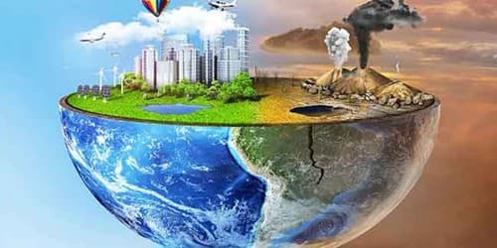
The increasing impacts of climate change and environmental degradation pose significant challenges to society. Rising temperatures, natural disasters, and resource depletion threaten ecosystems and human livelihoods. Society must prioritize sustainable practices, invest in renewable energy sources, and advocate for policy changes that reduce carbon emissions and protect natural resources for future generations. (Reference: Intergovernmental Panel on Climate Change, "Climate Change and Land.")

- Mental Health and Wellness:

Mental health challenges, including anxiety, depression, and stress, are prevalent in our society. The stigma surrounding mental health often obstructs proper treatment and support. To address this, society needs to increase awareness, improve access to affordable mental healthcare, and create supportive environments that promote well-being. Implementing mental health education programs in schools and workplaces can also play a significant role in DE stigmatization and early intervention. (Reference: World Health Organization, "Mental Health.")

Conclusion:
The social challenges faced by society are both complex and interconnected. Addressing these challenges necessitates collective action, policy changes, and a shift in societal attitudes. By implementing evidence-based strategies, fostering inclusivity, and promoting equal opportunities, we can strive towards a more equitable and sustainable future. It is up to all of us to recognize these challenges, educate ourselves, and work towards positive change that will benefit individuals and society as a whole.

References:
1. The World Bank. "Inequality." Retrieved from: https://www.worldbank.org/topic/poverty/inequality.
2. United Nations Development Programme. "Gender Equality and Women's Empowerment." Retrieved from: http://www.undp.org/content/undp/en/home/sustainable-development-goals/goal-5-gender-equality-and-womens-empowerment.html.
3. United Nations. "Racial Discrimination." Retrieved from: https://www.un.org/en/sections/issues-depth/racial-discrimination/.
4. Intergovernmental Panel on Climate Change. "Climate Change and Land." Retrieved from: https://www.ipcc.ch/srccl/.
5. World Health Organization. "Mental Health." Retrieved from: https://www.who.int/mental_health/en/.

