

LOCATION: Swansea | LLEOLIAD: abertawe
LEVEL 6 | LEFEL 6
EXAMINATION PERIOD | CYFNOD ARHOLIADAU
may 2017 | mai 2017

MODULE CODE: M6X01110
USABILITY ENGINEERING
TIME: 2 HOURS

answer THREE quESTIONS out of FOUR

INSTRUCTIONS TO CANDIDATES:

Answer any THREE of the four questions contained in this paper. All questions carry equal marks.

The questions relate to the Student Application case study issued previously. A clean copy of the case study is provided.

This is an OPEN-BOOK examination; you may bring into the examination room notes prepared on SIX sides of A4 paper only.

answer THREE quESTIONS out of FOUR

QUESTION ONE

a) Present a rough sketch of an example Web/Mobile application aimed at university students. Give a usability evaluation of the proposed student application applying usability theory in your evaluation. Analyse the effectiveness of interface metaphor examples form the interfaces and assess its affordance.
(12 marks)

b) Outline the process of developing the prototype and where each usability technique was applied in the process. Provide a timeline showing where these usability techniques can usefully be applied over the project lifecycle.
(8 marks)

c) Mike Dacey questions the time spent applying these usability techniques as he thinks you should have spent all the time on coding. Give an explanation for Mike of the benefits of the usability techniques you have applied.
(5 marks)

QUESTION TWO

a) Give your analysis of the options for evaluation studies throughout the project development for the Web/Mobile application aimed at university students, including future stages where the system is implemented and maintained. Give a clear recommendation for the interface evaluation strategy to be used for stages in the development of the application and its implementation with reference to alternative methods and to examples of evaluation studies from your research.

(20 marks)

b) Gordon Dickers asks you to justify the amount of time devoted to student evaluation of the application as he believes students should spend more time on maths examples. Give an explanation to Gordon of the benefits of user involvement in interface evaluation referring to examples from your evaluation plan in 2 a).
(5marks)

QUESTION THREE

a) Provide an analysis of the application of general usability guidelines (such as Dix’s guidelines) to the design of the Web/Mobile application aimed at university students which may be from your own example application s or from other similar applications you have researched. You should provide specific examples of applications of guidelines to aspects of the spaces and technologies considered. Use rough sketches to explain the application of guidelines where helpful. Give your analysis of the usefulness of usability guidelines in this context.

(12 marks)

b) Software such as the student Web/Mobile application needs to be as accessible as possible to all students, including those with a disability. Give your recommendations for making the system accessible, with reference to relevant legislation and guidelines. You should include an analysis of the extent to which general guidelines on IT accessibility are applicable to interactive mobile application.

(13 marks)
`
QUESTION FOUR

a) “Maps presented within mobile sites are often difficult to manipulate by touch and fail to adequately differentiate between location options to help users make their choice” Aurora Harley

Evaluation the above statement with reference to your analysis of research literature and industry practice. Describe your own observations of map users from class sessions and your own research with specific examples used to illustrate your arguments.

(12 marks)

b) Provide a sketch of a suitable map based interface for your example Student Application and justify the design choices used with reference to the usability issues in 4. a). To what extent were you able to overcome the design challenges for mobile map interfaces?

(13 marks)

Diwedd/End

Usability Engineering Case Study 2017 / 2018

Clean Copy Provided for your reference

FACULTY OF: APPLIED DESIGN AND ENGINEERING

NAME OF COURSE/PROGRAMME: | BSc Computing Portfolio
YEAR OR LEVEL: | 6
NAME OF MODULE/UNIT/EXAM PAPER: | Usability Engineering
CASE STUDY FOR EXAMINATION

INSTRUCTIONS TO CANDIDATES:

This Case Study will form the basis of the Usability Engineering Examination
Students should make no more than six A4 sides of notes to take ‘to the examination
Select 3 out of the 4 topics to prepare. Include the recommended resources for each topic in your preparation.

Case Study for Usability Engineering Examination: May 2018

Background: Student Information Application

ExamTime Skout University of Dundee Map
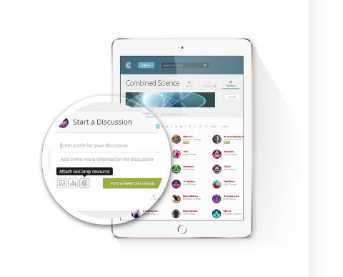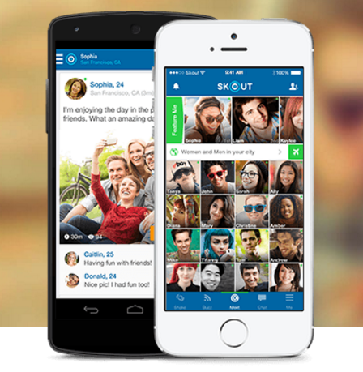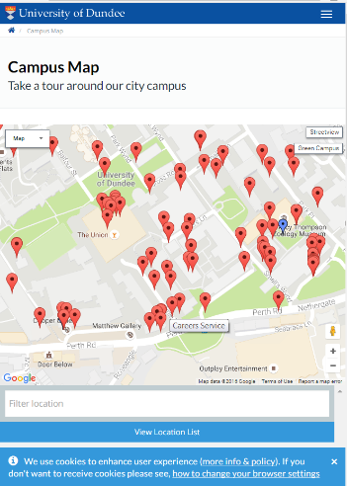

The examples above show applications aimed at university students. In preparation for the Usability Engineering examination you are asked to consider an application for new UWTSD students to help with common student activities such as exam preparation, networking or navigating around the campus. You are asked to select a design for a new UWTSD students and to analyse its use. Working together is encouraged and there may be opportunities to collaborate with other student groups. While you are encouraged to share application design work, the analysis, preparation and write up must be your own individual work. Any queries on this see Sue.

Design of example UWTSD

You should apply a range of techniques of Usability Engineering, such as application of Human Factors theory to your critical evaluation of a design for a proposed UWTSD student application which can be mobile, desktop or embedded. Clearly state the application function selected and the role of your proposed application in student life. Outline the Usability theory applied in your analysis (please concentrate on application rather than just stating the theory) and your conclusions about the usability of the application. Metaphor and affordance are key design topics to be included.

Produce an outline design for your application for new UWTSD students. You should include outline sketches of your learning space which may be the result of collaboration. Give a brief written explanation of the process of developing the application design, including any collaboration with others. Explain how the usability design work you have done might fit in an appropriate project lifecycle.

Usability Guidelines and Accessibility Applied to UWTSD Student Application

You are now asked to apply a set of usability guidelines to your selected UWTSD Student Application. You should apply a set of usability guidelines such as Dix's or Shneiderman’s to a proposed student application and evaluate the guidelines and their usefulness in this context. You may wish to present examples of guidelines which do and do not provide good advice in the student application context. Specific examples of student application features should be included in your analysis.
The accessibility of the UWTSD Student Application is important; both to comply with legislation and to give every student a fair chance in University life. You should consider the applicability of accessibility guidelines to a proposed UWTSD Student Application. Do IT accessibility guidelines give good advice in the design of such applications?

An Evaluation Strategy for UWTSD Student Application

You should be familiar with a range of usability evaluation techniques. Consider how these could be applied to the development a strategy to evaluate a proposed UWTSD Student Application. Justify your choices of interface evaluation techniques for the stages of development in comparison to alternatives. Give feedback for any attempted evaluation activities. You should specify the project stages (eg, initial paper design concept, software prototype) for your planned evaluation strategy.

Map based Interfaces in UWTSD Student Application

Outline the potential usability challenges in developing map based interfaces based on your analysis of research literature and industry practice. Describe your own observations of map users from class sessions and your own research.
Provide a sketch of a suitable map based interface for the UWTSD Student Application and justify the design choices used.

