

Do extra-curricular school sports clubs or physical activities cater for the needs of young people with autism?

Matthew Noyes
ECAD6003

BA (Hons) Primary Education with QTS

University of Wales Trinity Saint David

May 2019

Word Count: 6,582

Frontispiece
This is to certify that except where specific reference is made, the work described in this research project is the result of the investigation carried out by the author, and that neither this research project nor any part of it has been presented, or is currently being submitted in candidature of any award other that in part for the degree of BA (Hons) in Primary Education with QTS of Trinity Saint David University of Wales. I understand that any work I use without reference constitutes as plagiarism, which will lead to the failure of this model.

Acknowledgements
The author would like to take the opportunity to thank the staff, pupils and parents of the schools involved in this research as well as those who kindly responded to the electronic questionnaire; their responses have made a large contribution to this research project.
I would also like to take this opportunity to express a sincere thank you to the school, staff and pupils from my final teaching placement that supported me and participated in this research project. In addition to this, I would like to thank Dr. Sioned Hughes and Heddwen Davis for providing me with the relevant literature, guidance and continuous encouragement throughout my final placement.

Contents

Chapter 1: Introduction Page 5

Chapter 2: Literature Review Page 7

Chapter 3: Methodology and Research Design Page 13
Questionnaires Page
Secondary Research Page
Analysis of data Page

Chapter 4: Research and Discussion Page
Questionnaires- Practitioners Page
Questionnaires- Parents Page
Interviews/ Questionnaires- Young people with ASD Page
Main findings Page
Limitations Page

Conclusion Page

Reference Page

Appendix Page

Chapter 1: Introduction

The aim of this research project is to gain an insight into how extra-curricular sports clubs and physical activities cater for the needs of young people aged between 3-16 with Autistic Spectrum Disorder, also known as ASD. Prior to addressing this question, research will be carried out with the purpose of obtaining a clear understanding of how extra-curricular sports clubs and physical activities are delivered within mainstream and special educational needs schools.
The overall aim of this project is to conduct research which will support in identifying the amount of extra-curricular sports clubs and physical activities available, which cater for the needs of children with ASD and to improve knowledge and understanding of any barriers that may prevent the delivery or participation in these activities.
‘One of the most underrated activities is physical fitness. However, a growing body of literature suggests the far-ranging benefits of physical fitness in terms of emotional and sensory regulation, as well as motor control and even social interaction with others’ (Geslak, 2015:11). Geslak (2015) also stresses the importance of physical activity for people with ASD, stating ‘through my personal experience of having autism, from my conversations with others on the autism spectrum, and in the course of my research into approaches for educating children with autism, I have seen many examples of where physical activity and fitness have led to great improvement in peoples’ lives’ (2015 :11). These views highlight the importance of physical activity for young adults with ASD and thus, the need for opportunities for young people to participate in such activities.
To formulate a hypothesis for this research project it could be suggested that transport is a barrier to young people accessing physical activities and extracurricular sports clubs as many children are taxied to and from school. It could also be suggested that a lack of sports specific training for staff/volunteers/coaching regarding ASD pupils, has in turn led to a lack of opportunities for young people with ASD.
To gain a deeper understanding of the key components surrounding young people with ASD and their participation into extra-curricular sports clubs and physical activities, the author chose to implement different research strategies. The main strategies used were questionnaires and interviews to gain relevant data. The author also used multiple observational techniques and field notes while observing ASD and mainstream pupils to obtain data.
Extra-curricular sports clubs are deemed as being a ‘great way to meet new people’ (Mason, 2017). The term extra-curricular can be ‘broken down into its roots for a literal explanation: “extra” means “outside” and “curricular” refers to all of the work you do in the classroom. So extracurricular activities are just activities that you do outside of class’ (Barge, 2018)
ASD is regarded as being ‘characterized by deficits in social communication and social interaction across multiple contexts and restrictive and repetitive behaviour patterns, interests, or activities’ (Luciano, 2016:14). Similarly, Blenner (2011:894) defines ASD as a ‘commonly used umbrella term for a class of neurodevelopmental disorders characterised by a triad of deficits in social reciprocity, impaired communication, and repetitive restricted patterns of behaviour or interests’. It is thought that ASD ‘occurs in approximately 1% of children and young people’ (Kendall, 2013:34), which is accumulates to approximately ‘700,000’ (National Autistic Society, 2018) young people in United Kingdom. According to the National Autistic Society (2018), if the families of the young people with ASD are included, then ‘autism is a part of daily life for 2.8 million people’.
The author has a strong interest in the area of physical and mental wellbeing, especially within young people with additional learning needs. Through experience, the author has observed first-hand the benefits of physical activity on young people’s mental well-being. However, ‘many people on the autism spectrum miss out on these benefits because sport and physical activity leaders aren’t always aware of the impact of the condition’s hidden’ (Webster, 2016:2).

Chapter 2: Literature Review

Autism spectrum disorder (ASD) is regarded as the ‘fastest growing developmental disability’ (Ketcheson et al, 2018). The theory that it has a ‘lifelong detrimental impact on physical, mental, social and academic development’ (Ikeda, 2014:1069) poses the question; are there enough supporting strategies being implemented as a preventative measure against this?
One strategy of provision that has been suggested to support in lessening the impact of ASD on young peoples physical, social, and academic development, is extra-curricular sports clubs and physical activities. Bandini (2014) believes that ‘physical activity is important for promoting health and well-being; however, physical activity behaviours in children with autism spectrum disorders (ASD) have received little attention’ (2014:1). Similarly, Nichols (2018) states that physical activity ‘is important for all people, but especially for young adults on the autism spectrum’ (2018:7) and that ‘there has been very limited research’ (2018:7) in this area.
In considering autistic pupils being supported within other aspects of the curriculum, it is similarly stated that ‘autism is one of the most common types of special educational need, it affects children in every school in the country and so every teacher will, or should expect to, have autistic pupils in their classes’ (Ambitious about Autism, 2018). In addition, research by the National Autistic Society (2018) found that over 70% of all autistic pupils attend ‘mainstream schools’ and as a result ‘every teacher will have autistic students in their classes at some point in their careers. It’s vital that they understand autism and know how to support all the children in their class’.
In considering autism within education, the Welsh Government have launched a ‘consultation on a Code of Practice on the Delivery of Autism Services’ (National Autistic Society, 2018). It is thought that this ‘makes clear what is required of Local Authorities, Health Boards and other public bodies in relation to services and support for autistic people and their families in Wales’ (National Autistic Society, 2018). However, throughout this code no recommendation of training or personal development for practitioners is made.
Although, there are multiple forms of training available to practitioners working with children with autism in the education system, for example, the training produced by ASD Info Wales. ASD Info Wales (2019) state that they provide training for practitioners in Wales supporting children with autism in early years settings, primary schools and in secondary school settings. A similar training method available to teachers in Wales is the TEACCH training or as it is also known ‘Treatment and Education of Autistic and related Communication handicapped Children’ (Moor, 2008:44). This training course aims to develop a participant’s ‘understanding of how to support autistic people’ (National Autistic Society, 2018) by providing its participants with an insight into the ‘best available approaches and methods known so far, for educating and teaching’ (National Autistic Society, 2018) individuals with autism.
Although there are multiple training schemes available for teachers, it is thought that they are very scarce and difficult to obtain. Tirraoro (2016) states that ‘the lack of autism training is letting down children and young people on the autism spectrum’. Similarly, though there are some forms of training available, it is argued that autism specific training for teachers ‘remains patchy, with significant gaps. Some teachers will have received no special educational needs training at all’ (Ambitious about Autism, 2018).
As a result of this many teachers have stated that they ‘do not feel that they have the necessary training to support their autistic students’ (Brede, 2017:3). Similar research by Finch (2013) found that teachers had an ‘eagerness to increase training for educating children with ASD’ (2013:1). However, Jung (2007) states that ‘training is lacking’ (2007:1) in being provided for teachers. Furthermore Finch (2013) states that ‘educators need increased training on inclusion to be prepared for the flood of students with ASD’ (2013:2).
Due to this lack of training, research has found that ‘teacher knowledge about autism is limited, with many believing that they lack the training to provide appropriate support to autistic pupils’ (Brede, 2017:15) This has led to teachers ‘demanding training to cope with growing numbers of children on the autistic spectrum’ (Doyle, 2017). Finch (2013) agrees that more staff training is needed and states that ‘proper training for inclusion can increase educator confidence and knowledge base to better aid special needs students’ (Finch, 2013:2) and therefore improve the education of pupils with ASD.
It is suggested that due to many teachers’ inability to better support pupils with autism, research has found that ‘over half of parents of children with autism have kept their child off school because of a lack of appropriate support in the classroom’ (Ambitious about Autism, 2018). Many believe a similar scenario commonly occurs within physical activities or PE sessions. For example, research by Bandini (2014) states that parents felt that ‘children with ASD participated in significantly fewer types of physical activities than typically developing children’ (2014:1). The same research also stated that ‘children with ASD engaged in fewer physical activities and for less time’ (2014:1).
‘Parents and clinicians frequently report that the social, physical, cognitive, and behavioral limitations that children with autism spectrum disorder (ASD) experience often prevent them from participating in team sports and other physical activities’ (Bandini, 2014:2). Due to this low level of participation, it is suggested that children and youths with autism spectrum disorder, ‘tend to be physically inactive and have low health-related fitness’ (Haegele, 2018:372)
To counteract this lower level of participation, ‘some school teams offer children with special needs the opportunity to participate by helping to manage the team or by taking part in the game when their participation won't have an impact on the outcome of the game’ (Rudy, 2018). For some schools, this can be considered a positive strategy, as this supports the partial participation of ASD pupils in team sports or physical activities. However, it does not enable pupils with ASD to physically participate in the activity, and thus consequently pupils will be missing out on the physical and mental benefits. John-Henderson (2010) states that, ‘team sports boost mental health’, similarly, research by Eime (2013) has acknowledged that social or team based physical activities pose ‘health benefits’ that are ‘not limited to physical health but also incorporate mental components’ (2013:2).
However, though research into team sports has shown some positive effects on pupils with ASD, it has also been argued that pupils with ASD are better suited to participating in ‘non-team sports’ (Rudy, 2018). This is largely because ‘social conventions of games can keep a child with autism from participating’ (Sarris, 2018). This is due to ‘many children on the spectrum finding certain sports to be emotionally and socially taxing because they involve following complex rules, waiting your turn to play or get the ball, and interacting with many children all at once’ (Sarris, 2018). It is also believed that young people with ASD within physical activities have ‘social difficulties and anxiety related to lack of routine and excessive noise’ (Healy, 2013:223). ‘Often noisy, crowded classes may make children with sensory and social problems miserable’ (Sarris, 2018).
This belief is shared not only within sports but in multiple forms of everyday life. The National Autistic Society (2018) believe ‘many autistic people can experience social isolation’ and ‘find social situations difficult’. It is suggested that sports such as swimming or athletics, which can ‘have an element of being on a team to help with social skills but also enable ASD pupils to concentrate predominantly on personal effort’ (Admin-nurse, 2014) should be encouraged for young people with ASD who are unable to participate in team sports due to communication and difficult rule sets, but also desire social interaction. Rudy (2018) states that ‘not every team sport requires high-level communication and cooperation, and many can include an individual athlete as a valued team member’.
According to Cardiff and Vale Autism (2019) ‘there are an increasing number of sports clubs that cater for people with autism’. Disability Sport Wales have implemented an initiative addressing the issue of young people with autism being able to access sports, by introducing the ‘Autism Initiatives Trampoline Club’ (Disability Sport Wales, 2019). However, research by the Sport and Recreation Alliance (2013) found that ‘only three in ten (32%) of the UK’s sports clubs have access to appropriate equipment for disabled people to participate fully in their activity’. This highlights the deficit between sports clubs and physical activities that can and can not provide adequate support for children with specific learning needs. In addition to this, ‘only 8% of volunteers and staff at UK sports clubs have received training to amend and adapt their sport to make it more inclusive’ (Sport and Recreation Alliance, 2013).
‘As Physical Education is a compulsory part of the curriculum at all Key Stages, every pupil should have the same access to PE, and disability should not be a barrier to inclusion. Yet an EFDS survey carried out just after the Paralympic Games showed that 51 per cent of respondents said they do not enjoy their experiences of sport at school while 69 per cent said they prefer taking part in sport with friends outside the school gates’ (Shields, 2019). This along with the previous statement that teachers are ‘demanding training to cope with growing numbers of children on the autistic spectrum’ (Doyle, 2017) and that they have an ‘eagerness to increase training for educating children with ASD’ (Doyle, 2017), highlights the need for practitioners to receive further professional development in this area.
‘Teachers themselves are clear that they want this training, especially in autism, with a survey conducted by the NASUWT in 2013 found that 60 per cent of teachers believe that they haven’t had the training they need to teach pupils who are on the autism spectrum’ (Ambitious about Autism, 2018). Given that teachers’ prior knowledge of autism is related to more positive attitudes towards inclusion (L. Crane, A. Remington, L. Kenny, & E. Pellicano, in preparation; Robertson et al., 2003), efforts should be directed towards improving education professionals’ knowledge and awareness of autism, and effective ways of responding to these students’ needs. This situation is set to improve, at least in England, with autism becoming a mandatory training subject for trainee teachers in 2018’ (Brede, 2017).
‘Despite the lack of specialist PE-trained staff in primary schools, catering for children with special needs is more about creativity than technical knowledge. “Teachers need to feel more confident and competent when dealing with disabled children,” said EFDS chief executive Barry Horne, and not feel like they are fragile and going to break but that they are actually robust individuals who could join in the activity’ (Shields, 2019).
Elaine Burgess, a former PE teacher who now manages school sport projects in London suggests that,
“It’s really not difficult for a teacher to work out how to use different equipment, facilities or even change the rules.” For example: Children in wheelchairs can play team sports like football, hockey and cricket by adjusting the size of the pitch or court, or marking out zones where only wheelchairs are allowed, Nets that are height-adjustable can enable children in wheelchairs to play volleyball or tennis’ (Shields, 2019).
However, these suggestions are heavily based on adaptations for those with physical disabilities; there are very little suggestions or research based on the ‘creative’ adjustments of physical activities for pupils with ASD.
Though this is the case, "it is very common for children with ASD to have some motor delays that are recognised by the parents before the delays in social and communication skills are apparent," said IAN Director Paul H. Lipkin M.D’ (Sarris, 2018). Many people with autism spectrum disorder (ASD) also face problems with motor (muscle) skills, including balance and coordination.’ (Sarris, 2018). Thus, adapting the physical barriers to such activities would be a beneficial initial stepping stone into physical activity for pupils with ASD, however further research into additional strategies to overcome physical activity barriers for pupils with ASD are needed. The author aims to rectify this gap in research through providing findings that focus closely on the activities of young people with ASD.
To summarise, practitioners ‘need to design pedagogical approaches to match the specific learning needs of their individual children and young people’ (Donaldson, 2015:91). In regard to supporting the learning of pupils with autism accessing physical activities it is also suggested that ‘additional training and resources designed to provide an understanding of the unique needs of these youths are essential for such students to participate in physical activities and to enhance health-related physical fitness’ (Haegele, 2018:372-373). However, to do this, practitioners need an understanding of autism and how to better support individuals with autism during sport and physical activities.
‘Childhood obesity in Wales are the highest in the UK, with about 35 per cent of children (under 16 years old) being overweight or obese’ (National Assembly for Wales, 2013). With the national rise of obesity and mental health issues among both young people with SEN and those without SEN, the need for access to physical activities and extra-curricular clubs has never been more significant. The introduction of UNICEF’s rights of the child, has highlighted this issue. Article 24 states that ‘every child has the right to the best possible health’ (UNICEF, 2013) and that Governments must provide ‘education on health and well-being so that children can stay healthy’ (UNICEF, 2013). In considering this, it would be suggested that not ‘every child’ in the United Kingdom does currently receive the best possible health. According to data collected from Sports England, Disabled people are twice as likely to be physically inactive (43 per cent) than non-disabled people (21 per cent) (Activity Alliance, 2019). Thus, demonstrating a need for more research into this area which the research project will aim to achieve.

Chapter 3: Methodology and Research Design

Throughout the research project, it is vital to ensure the research followed the prior set components of the related ethics form. Including the ethical practices and techniques. Adhering to this, all participants in the research were made aware that any data collected would remain totally confidential and abide by the Data Protection Act 1998. ‘The British Educational Research Association believes that education research should operate within an ethic of respect for any persons-including themselves-involved in or touched by the research they are undertaking’ (BERA, 6).
To minimise the risk of harm towards research participants, a consent form was signed by the Head Teacher (Appendix D1 and Appendix D2) of all participating schools, which was then shared to their participating staff. Participant confidentiality was also ensured by an accompanying letter to the surveys/questionnaires (Appendix D3), which assured participants that the information provided would remain anonymous and only used for research purposes, this would then later be destroyed. No names were also recorded on surveys. To overt deceptive practice, all participants were made aware of what was being observed during observational research prior to this being conducted. Finally, participants were also made aware of their right to withdraw from the research by stopping during interviews or by retracting their questionnaires.
Contrary to these ethical principles, Homan (1992) argues ethical obligations are no longer central to the research once a letter of consent has been provided. However, CIRT state that ‘researchers must also adhere to ethical standards in order for the public to support and believe in the research’ (Centre for Innovation in Research and Teaching, 2019).
To gain a deeper understanding of the key components surrounding young people with ASD and their participation into extra-curricular sports clubs and physical activities, the author chose to implement both primary and secondary research strategies. The primary research strategies implemented were questionnaires, interviews and observations. The author chose to use primary research as this enabled ‘complete control’ (Sparrow, 2019) of the research process, enabling the research to become ‘streamlined as far as its objectives and scope is concerned’ (Sparrow, 2019). Shetty (2017) concurs with this, as he states that the data produced by primary research is beneficial as it can be catered to relate ‘directly to the researcher’s study’. It is stated by Sparrow (2019) that primary research provides data that can be ‘examined and interpreted’ by the researcher ‘depending on their needs rather than relying on the interpretation made by collectors of secondary data’. However, conducting primary research proved to be time consuming with regards to the creation of resources, such as questionnaires or interview questions.

Questionnaires
Sparrow (2019) similarly suggests that ‘the time required to do research accurately is very long as compared to secondary data, which can be collected in much lesser time duration’. This proved to be true for the author when creating different questionnaires for different participants. The author chose not only to research the opinions of young people with ASD but also their parents and educational practitioners, who had worked with young people with ASD. Gathering data from a variety of participants imposed the largest time constraints.
These questionnaires were designed to fit different perspectives of participation. For example, questionnaires were tailored to teaching staff of both primary schools and secondary schools, as well as special educational schools and mainstream schools. Questionnaires were also tailored to parents for them to share their personal opinions and experiences. Additionally, these were also designed for the use of pupils of all ages with ASD. To better support this research, observations and interviews were used to aid the younger pupils and pupils with lower ability levels in writing whom were unable to complete questionnaires, this allowed them to verbally communicate their thoughts or answers. By using the research strategy of observing and gathering notes, it enables the observer to use a naturalistic approach as ‘participants are in their normal environment so are more likely to react in a realistic/ genuine way’ (Sharna, 2017). Interviews with younger pupils were also carried out during lunch when pupils were relaxed and thus more responsive, this provided a calmer environment where younger pupils were more confident to answer research questions.
To make the questionnaire more convenient for practitioners to complete the author chose to make a QR code available in a communal area available to practitioners only. QR code’s ‘provide a convenient one-step process for directing users to a website, phone number, directions, promotions or other information’ (Human Service Solutions, 2019). In this case they provided practitioners with a direct link to an online version of the chosen questionnaire. Accompanying the QR codes (Appendix D4) were print outs of the questionnaires, this was to fit the demands of the participants, as it is suggested that some ‘people now prefer to use technological things such as tablets and computers as opposed to writing’ (Patel, 2019). In contrast, many people ‘prefer pen and paper because the process allows you to think’ (Patel, 2019). According to Weinschenk (2013) ‘we like having choices because it makes us feel in control. We won’t always choose the fastest way to get something done. If you want people to do stuff, give them options.’ Thus, the combination of both questionnaire options provided participant with the ‘power’.
As well of multiple choice encouraging people to participate, ‘shorter surveys generally have higher response rates and lower abandonment among survey respondents. It’s human nature to want things to be quick and easy’ (Johnson, 2019). To support this, parent surveys were made intentionally short and quick to complete, thus encouraging participation.
However, the research would have benefited from questionnaires being made available to practitioners throughout Wales or nationally to gather a better understanding of the current situation surrounding the participation of young people with ASD in extra-curricular sports clubs and physical activities. According to Activity Alliance (2019) disabilities and impairments vary considerably based on location, for example ‘disability is most prevalent in the north of England. 25 per cent of people in the North East and North West stated they are disabled. London has the lowest prevalence with only 14 per cent of people stating they are disabled’ (2019). Therefore, the attitudes and opportunities of participants may vary depending on a geographical basis, which could in turn effect the replicability of this research project.

Secondary Research
In addition to questionnaires and interviews, the author also chose to carry out secondary research as this can help clarify any primary research questions. KnowThis (2019) states ‘secondary research is often used prior to larger scale primary research to help clarify what is to be learned’. However, it is recognised that ‘the quality of secondary research should be scrutinized closely since the origins of the information may be questionable’ (KnowThis, 2019)
The author utilised secondary research to both support and argue findings derived from the primary research. Researchers are often attracted to secondary data because getting this information is much less expensive than if the researchers had to carry out the research themselves (KnowThis, 2019). However, a combination of both secondary and primary research was crucial in order to ensure findings within this research project remained consistent and reliable.

Analysis of data
The quantitative data collected was used to produce bar charts (Appendix C5) and pie charts (Appendix C4) to highlight research findings. This data was collected using google forms and Microsoft form which each proved beneficial for the author as these were easily navigable and allowed participant anonymity and direct responses. However, the author chose to republish these graphs using meta-chart to improve audience readability.

Chapter 4: Research and Discussion

In this chapter, the authors aim is to interpret and discuss the findings collected which was analysed after collating all primary data. To increase the reliability of the results, the author chose to utilise a combination of both qualitative and quantitative data. The main ‘purpose of research is to inform action, to prove a theory, and contribute to developing knowledge in a field or study’ (Zarah, 2018). In this project, research was used to develop better understanding of the participation levels of young people with ASD in physical activities and extra-curricular sports clubs and looked closely at how these activities catered for the needs of young people with autism.
To gain a greater understanding of how extra-curricular clubs cater to young people with ASD, the author chose to gather the opinions of different practitioners through a questionnaire, by firstly asking them to identify their professional role (Appendix A1). Understanding the participants professional role would support the analysis of the information as participants opinions would alter depending on their profession. This also enabled the author to gain ‘different perspectives’ (Burbidge,2017) from a range of ‘different contexts’ (Burbidge,2017). In doing so, the author was also able to gage if training or opinions of practitioners on supporting young people with ASD had changed over time, as the individuals participating had been working in the chosen area for different time frames (Appendix A2).

Questionnaires- Practitioners
When linking this to the findings of another question which asked practitioners if they have ‘received any additional training regarding supporting the learning of pupils with autism that are accessing sport?’ (Appendix A3). Data highlighted how, of all the practitioners questioned, 91.7% had not received any additional training (Appendix A3) to support young people with ASD in sport or physical activities. Furthermore, 94.6% of practitioners questioned stated that they were unaware of any additional training available to them to aid them in better supporting young people with ASD when participating in physical activity (Appendix A4). This reflects the statement made by Tirraoro (2016) who says that there is a ‘lack of autism training’ available for practitioners. This has led to many professionals believing they ‘do not feel that they have the necessary training to support their autistic students’ (Brede, 2017:3).
It would then be suggested that this lack of training and insecurity when supporting young people with ASD, may have led to the lack of available extra-curricular sports clubs or physical activities for young people with ASD. Evidence of this can be found within the primary research data (Appendix A5), which found that 76.5% of all practitioners questioned, stated that the school they currently work in, does not host any extra-curricular sports clubs, that cater to the needs of young people with autism.

Questionnaires- Parents
Similarly, the parents of young people with ASD were also questioned about the extra-curricular sports clubs or physical activities available to their child, being organised by the school. A staggering 92% of parents questioned (Appendix B1) stated that they were unaware of any sports related clubs or physical activities available, that catered for the needs of young people with autism. Of the parents questioned, 69% stated that the largest barriers to their child participating in extra-curricular sports or physical activities was the lack of opportunity, provided by the school (Appendix B2). It is suggested that parents and guardians have a ‘significant role in the physical activity level’ (Nichols, 2018:8) of their child with ASD. However, these findings would suggest the lack of extra-curricular opportunities for children with ASD would largely outweigh parental impact. Further findings from primary research (Appendix C1) support this interpretation, as 75% of young people asked, stated that the greatest barrier preventing them from participating in extra-curricular sports clubs, which are organised by the school, was ‘there are no sports clubs available’, as opposed to 0% of young people choosing ‘parental consent’ as a barrier. These findings were also reflected when asking young people, the same question but in regard to extra-curricular activities that were not organised by the school (Appendix C2)

Interviews/ Questionnaires- Young people with ASD
Cohen (2007) recognise the significance of questioning a wide range of participants, in ‘order to ensure strength and richness to the data’ (2007:115). Therefore, in addition to data gathered based on the opinions of parents and practitioners, young people with ASD (within the foundation phase, key stage two and three) were also interviewed. They were asked ‘on average how often do you participate in an extra-curricular sports club organised by the school?’ (Appendix C3). Of the young people questioned, 100% answered ‘never’.
Upon reflection during this research project, many young people with ASD were not familiar with the term ‘extra-curricular’. Therefore, this term was then adapted by the author, by referring to this as ‘after school clubs’ instead. The young people who had previously been interviewed with this terminology were then re-interviewed to ensure reliability of findings.
When asked if they enjoy participating in sports or physical activity, 44% of the young people with ASD stated they enjoyed participating and a further 28% stated that they loved participating in sports or physical activities (Appendix C4). Furthermore, findings showed that 8% of these participants did not mind participating in sports. As a result, only 16% of all young people with ASD disliked participating in sport and physical activity, with only 4% of participants hating participating in sports or physical activity.
As previously mentioned in the literature review, ‘an EFDS survey carried out showed that 51 per cent of respondents said they do not enjoy their experiences of sport at school while 69 per cent said they prefer taking part in sport with friends outside the school gates’ (Shields, 2019). This demonstrates the importance of providing young people with ASD with the opportunities to participate in sports clubs outside of school hours.

Main Findings
Upon reflection, analysis of a combination of all the findings combined, prompted an alternative question to the initial question asked in this research project. It became apparent that instead of asking ‘do extra-curricular school sports clubs or physical activities cater for the needs of young people with autism?’, the most important question seemed to be ‘are their opportunities for young people with ASD to participate in extra-curricular sports clubs and physical activities’. Findings have shown that the greatest barrier to young people participating in these clubs is the lack of availability of these clubs.
Findings have determined that this is due to a combination of reasons prohibiting extra-curricular sports clubs from catering for young people with ASD. Lack of training (Appendix A3), lack of facilities (Appendix A6) /resources (Appendix A7) and transport arrangements (Appendix A8) all proved to be consistent causes for the scarcity of extra-curricular sports clubs and physical activities throughout staff questionnaires. As a result of such causes, when carrying out secondary research it became apparent that there are a very few physical activity clubs available within Cardiff that cater for the needs of young people with ASD alone. This was also reflected in the opinions of parents, as only 13.5% stated that they were aware of extra-curricular sports clubs being run for young people with ASD in the local community (Appendix B3). These being; Pedal Power, Local Motion Dance and Trampolining: Rebounders. Though according to Disability Sports Wales, there are regular opportunities for young people with disabilities to partake in physical activity, there are only a select few clubs that specify that they cater to young people on the autism spectrum. However, most mention adaptions for physical disabilities.
Of these clubs, there are very few that enable young people with ASD to participate in team sports. According to findings from the practitioner questionnaires (Appendix A9), 68.6% of practitioners believed that young people with ASD benefit more from participating in team sports. As the literature review states, ‘research into team sports have shown some positive effects on pupils with ASD’. Contradicting this, interviews and questionnaires with young people with ASD (Appendix C5) showed that most of them would like to participate in sports such as swimming, dance, horse riding and ‘other’, which referred to sports like judo, MMA, fishing and running. The lowest results shown in the data were for netball and tennis, closely followed by football and rugby. This highlighted the desire for young people with ASD to participate in individual sports, as opposed to more team-based sports.
These findings demonstrate how current physical activity clubs which have not been organised by schools, reflect the interests of young people with ASD. These findings also suggest, a lack of understanding on practitioners behalves on how to best cater for and support the needs and desires of young people with ASD in school settings. Thus, demonstrating the importance of young people accessing provision outside of school in sporting activities that may not be regularly available to them i.e. swimming and horse riding.
Finally, these findings also reflect the opinion of practitioners regarding facilities and resources as being a barrier to the creation of extra-curricular activities, as sports such as swimming and horse riding would require much more selective venues and resources, which would thus require additional funding and transport to offsite facilities.

Limitations
Upon reflection, observing extra-curricular sports clubs and physical activities that are available to young people with ASD, would have been beneficial in order to gather further qualitative data to analyse for this research project. However, due to the lack of available extra-curricular sports clubs and physical activities for young people with ASD in the area, conducting these observations proved to be unachievable.
If this research project were to be extended, similar questionnaires for the same demographic would be distributed in additional locations and settings to compare data on a wider scale. As the Activity Alliance (2019) suggests, prevalence of disabilities fluctuate largely based upon geographical location. For instance, of the population of Wales, 26% are registered as having a disability. In comparison to this, 21% of people in Northern Ireland are registered as having a disability (Appendix D5).
This contrast highlights the likelihood of a variable demand for extra-curricular sports clubs or physical activities based on location and how opportunities may vary based on geographic variables. Thus, distributing questionnaires to different areas would increase the reliability of findings, as the data collected would be reflective of more than one locality.

Conclusion
To conclude, this research project has highlighted that there are multiple barriers preventing young people with ASD from participating in extra-curricular sports clubs and physical activities. One barrier of participation is the continuous battle with transportation for participants with ASD. According to the research findings carried out with practitioners who facilitate young people with ASD, transportation to and from school, is the third largest barrier preventing these young people from participating in extra-curricular sports clubs and physical activities (Appendix A8). Transport to and from school is a national requirement, as the National Autistic Society (2018) state ‘there is a legal duty for the local authority to provide pupils of compulsory school age (5 to 16 years) with free transport to their nearest suitable school’. Regarding this requirement the Welsh Government has ‘published statutory Learner Travel Operational Guidance (June 2014) which outlines statutory provisions, specific duties and responsibilities for relevant bodies’ (Hughes, 2016:1). However, transport to and from extra-curricular activities does not fall within this legislation.
Therefore, it can be argued that these regulations are lessening opportunities for young people with ASD to participate in extra-curricular activities organised by schools. The main barrier for young people participating in extra-curricular activities was answered that there is ‘not enough opportunities’ (appendix C1). However, it can be argued that if young people are unable to stay behind after school hours, then there is no demand for these clubs to be run. Therefore, it could be suggested that the next step to support in raising physical activity levels of young people with autism is to look in more detail at the flexibility and availability of transport arrangements to and from schools/clubs.
Conversely, Smith (2012) states that ‘for people with autism, any change is too much change, and this can have a massive impact on their lives and on the lives of people who care about them’ (2012:19). As a result of this, changing the daily routine of young people with ASD could have a significant impact on their well-being. Thus, encouraging young people with ASD to attend sports clubs after school, which would entail changes to their pickup times and daily schedule, could in fact have a negative impact.
To conclude, this research project has highlighted the lack of participation from young people with ASD in extra-curricular sports clubs or physical activities and has supported in identifying the causes for this. However, these causes have proven to be often complex barriers which could be challenging to overcome.
As opposed to increasing the number of sports clubs available catering for young people with ASD, a further suggestion would be to ensure young people with ASD were accessing additional extra-curricular opportunities within school hours. Certain SEN schools already offer such opportunities, for example Ysgol Y Deri (2019) in the Vale of Glamorgan, state that they offer their pupils, rebound trampolining therapy sessions and swim sessions in their hydrotherapy pool. However, such opportunities need to be ensured for young people with Autism attending mainstream schools also.
An additional suggestion to combat the lack of sports clubs or physical activities that are being catered to young people with ASD, would be to ensure all sports clubs both extra-curricular and outside of schools are fully inclusive. As Donaldson (2015) states that education needs to be ‘inclusive, with all children and young people making progress along the same continuum, regardless of any additional learning needs they may have’ (2015:54).
According to the Activity Alliance (2019), ‘two thirds (64 per cent) of disabled people would prefer to take part in sport with both disabled and non-disabled people, currently only half (51 per cent) are doing so’ and ‘ only 14 per cent of non-disabled people are aware of having previously taken part in sport with disabled people. However, almost three quarters (73 per cent) of non-disabled people say they are open to taking part in sport with disabled people.’ These statistics show a possible solution to the issues identified throughout this research project, however with questionnaire results (appendix A3) showing 91.7% of practitioners having received no training in supporting young people with autism when accessing sports, it is clear to see that training and practitioner confidence is crucial to ensure that these opportunities are being provided.

References

Activity Alliance. (2019). Facts and statistics. Available: http://www.activityalliance.org.uk/how-we-help/fact-and-statistics/page:2. Last accessed 24th April 2019.
Admin-nurse. (2014). Should Autistic children play Team or Individual Sports? Available: https://www.hirenurses.com/autism_team_sports_individual/. Last accessed 8th Apr 2019.
Ambitious about Autism. (2018). Training for teachers and school staff. Available: https://www.ambitiousaboutautism.org.uk/understanding-autism/training-for-teachers-and-school-staff. Last accessed 9th Mar 2019.
ASD Info Wales. (2019). Professionals. Available: https://www.asdinfowales.co.uk/professionals. Last accessed 10th Mar 2019.
Barge, M. (2018). What Are Extracurricular Activities and Why Do You Need Them? Available: https://blog.prepscholar.com/what-are-extracurricular-activities-and-why-do-you-need-them. Last accessed 11th Apr 2019.
BERA (2018). Ethical guidelines for ethical research. 4th ed. London: BERA. 6.
Blenner, S. (2011). Diagnosis and management of autism in childhood. British Medical Journal. 343 (7829), pp894.
Brede, J. (2017). Excluded from school: Autistic students’ experiences of school exclusion and subsequent re-integration into school. Autism & Developmental Language Impairments. 2 (1), pp14.
Burbidge, I. (2017). Why diverse opinions lead to better outcomes. Available: https://www.thersa.org/discover/publications-and-articles/rsa-blogs/2017/01/Why-diverse-opinions-lead-to-better-outcomes. Last accessed 18th Apr 2019.
Cardiff and Vale Autism. (2019). Sport, Music and Arts clubs/groups. Available: http://www.cardiffandvaleautism.org.uk/info-help/sports-clubs. Last accessed 8th Apr 2019.
Centre for Innovation in Research and Teaching. (2019). Ethical Considerations. Available: https://cirt.gcu.edu/research/developmentresources/tutorials/ethics. Last accessed 15th Apr 2019.
Cohen,L (2007). Research Methods in Education. 6th ed. Oxon: Routledge. pp115.
Disability Sport Wales. (2019). Clubs. Available: https://www.disabilitysportwales.com/clubs/autism-initiatives/. Last accessed 8th Apr 2019.
Donaldson, G (2015). Successful Futures. Cardiff: Crown. pp54.
Donaldson, G (2015). Successful Futures. Cardiff: Crown. pp91.
Doyle, S. (2017). Teachers demand training to cope with growing number of autistic pupils. Available: https://www.irishnews.com/news/2017/10/23/news/teachers-call-for-funded-autism-training-1168562/. Last accessed 10th Mar 2019.
Eime et al. (2013). A systematic review of the psychological and social benefits of participation in sport for children and adolescents: informing development of a conceptual model of health through sport. International journal of behavioural nutrition and physical activity. 10 (98), pp2.
Finch, K. (2013). Teacher Needs for Educating Children with Autism Spectrum Disorders in the General Education Classroom. The Journal of Special Education Apprenticeship. 2 (2), pp1-2.
Geslak, D (2015). The Autism Fitness Handbook: An Exercise Program to Boost Body Image, Motor Skills, Posture and Confidence in Children and Teens with Autism Spectrum Disorder. London: Jessica Kingsley Publishers. pp11.
Haegele, J. (2018). Weekday Physical Activity and Health-Related Fitness of Youths with Visual Impairments and Those with Autism Spectrum Disorder and Visual Impairments. Journal of Visual Impairment & Blindness. 112 (4), pp372-373.
Hughes, S (2016). Research Briefing Home to school transport - a guide for constituents. Cardiff: National Assembly for Wales. pp1.
Human Service Solutions. (2019). QR Codes for Marketing: A Unique Way to Bridge Offline and Online Media. Available: https://www.hswsolutions.com/services/mobile-web-development/qr-code-marketing/. Last accessed 12th Apr 2019.
Ikeda, E. (2014). Assessment of quality of life in children and youth with autism spectrum disorder: a critical review. Quality of life research. 23 (4), pp1069.
John-Henderson, N. (2010). Team sports boost mental health. Available: https://greatergood.berkeley.edu/article/research_digest/team_sports_boost_mental_health. Last accessed 8th Apr 2019.
Johnson, H. (2019). 10 tips to improve your online surveys. Available: https://www.surveymonkey.com/curiosity/10-online-survey-tips/. Last accessed 14th Apr 2019.
Kendall, T. (2013). Management of autism in children and young people: summary of NICE and SCIE guidance. British Medical Journal. 347 (7923), pp34.
Ketcheson, L. et al (2018). The Levels of Physical Activity and Motor Skills in Young Children with and without Autism Spectrum Disorder, Aged 2-5 Years. Autism: The International Journal of Research and Practice. 22 (4), pp414.
KnowThis. (2019). Secondary Research – Advantages. Available: https://www.knowthis.com/data-collection-low-cost-secondary-research/secondary-research-advantages/. Last accessed 18th Apr 2019.
KnowThis. (2019). Secondary Research – Disadvantages. Available: https://www.knowthis.com/data-collection-low-cost-secondary-research/secondary-research-disadvantages/. Last accessed 18th Apr 2019.
Luciano, K. (2016). Autism spectrum disorder. Journal of the American Academy of Physician Assistants. 29 (10), pp14.
Lund Research. (2012). Principles of research ethics. Available: http://dissertation.laerd.com/principles-of-research-ethics.php. Last accessed 15th Apr 2019.
Mason, D. (2017). The importance of extra-curricular activities. Available: https://www.prospects.ac.uk/careers-advice/applying-for-jobs/the-importance-of-extra-curricular-activities. Last accessed 10th Apr 2019.
Moor, J (2008). Playing, laughing and learning with children on the autism spectrum. 2nd ed. London: Jessica Kingsley Publishers. pp44.
National Autistic Society. (2018). Autism facts and history. Available: https://www.autism.org.uk/about/what-is/myths-facts-stats.aspx. Last accessed 11th Apr 2019.
National Autistic Society. (2018). Back to school: What teachers need to know about autism (30 August 2018). Available: https://www.autism.org.uk/get-involved/media-centre/news/2018-08-29-teacher-training.aspx. Last accessed 9th Mar 2019.
National Autistic Society. (2018). Introduction to TEACCH. Available: https://www.autism.org.uk/professionals/training-consultancy/courses/teacch.aspx. Last accessed 13th Mar 2019.
National Autistic Society. (2018). School transport in Wales. Available: https://www.autism.org.uk/about/in-education/transport/wales.aspx. Last accessed 23rd Apr 2019.
National Autistic Society. (2018). Social isolation and social interaction. Available: https://www.autism.org.uk/about/communication/social-isolation.aspx. Last accessed 7th Apr 2019.
National Autistic Society. (2018). TEACCH. Available: https://www.autism.org.uk/about/strategies/teacch.aspx. Last accessed 13th Mar 2019.
National Autistic Society. (2018). Welsh Government seeking views on new Autism Code of Practice (30 November 2018). Available: https://www.autism.org.uk/get-involved/media-centre/news/2018-11-30-welsh-government-seeks-views.aspx. Last accessed 9th Mar 2019.
National Assembly for Wales. (2013). Discover Debate Decide Childhood Obesity. Available: http://www.assembly.wales/NAfW%20Documents/child_obesity_booklet.pdf%20-%2026022014/child_obesity_booklet-English.pdf. Last accessed 24th April 2019.
Nichols et al. (2018). Physical activity in young adults with autism spectrum disorder: Parental perceptions of barriers and facilitators. autism. 1-10 (1), pp7.
Ohrberg, J. (2013). Autism Spectrum Disorder and Youth Sports: The Role of the Sports Manager and Coach. Journal of Physical Education, Recreation & Dance. 84 (9), pp52.
Patel, I. (2019). Pen and Paper vs. Computer – Which Do You Use? Available: http://www.writerstreasure.com/pen-and-paper-vs-computer/. Last accessed 17th Apr 2019.
Rudy, L. (2018). What Are the Best Sports for Kids with Autism? Available: https://www.verywellhealth.com/best-sports-for-kids-with-autism-260157. Last accessed 7th Apr 2019.
Sarris, M. (2018). The challenge of physical fitness for people with autism. Available: https://iancommunity.org/ssc/autism-physical-fitness. Last accessed 10th Mar 2019.
Sarris, M. (2018). The challenge of physical fitness for people with autism. Available: https://iancommunity.org/ssc/autism-physical-fitness. Last accessed 7th Apr 2019.
Sharna, A. (2017). Advantages and Disadvantages of Observational Methods. Available: https://getrevising.co.uk/grids/advantages-and-disadvantages-of-observational. Last accessed 12th Apr 2019.
Shetty, C. (2017). What are the advantages and disadvantages of primary research? Available: https://www.quora.com/What-are-the-advantages-and-disadvantages-of-primary-research. Last accessed 15th Apr 2019.
Shields, A. (2019). Active and inclusive: PE provision for children with disabilities. Available: https://www.theschoolrun.com/active-and-inclusive-pe-provision-for-children-with-disabilities. Last accessed 14th Apr 2019.
Smith, J (2012). Helping Children with Autism Spectrum Conditions Through Everyday Transitions. London: Jessica Kingsley Publishers. pp19.
Sparrow, P. (2019). Primary Research Advantages and Disadvantages. Available: https://www.ianswer4u.com/2012/02/primary-research-advantages-and.html. Last accessed 15th Apr 2019.
Sport and Recreation Alliance. (2013). Make disability sport a priority. Available: https://www.sportandrecreation.org.uk/news/industry/make-disability-sport-a-priority-says-allianc. Last accessed 9th Apr 2019.
Tirraoro, T. (2016). Urgent action needed to train all teachers in Autism. Available: https://specialneedsjungle.com/urgent-action-needed-to-train-all-teachers-in-autism/. Last accessed 10th Mar 2019.
UNICEF. (2013). The rights of every child. Available: https://www.unicef.org.uk/child-rights-partners/wp-content/uploads/sites/3/2016/08/CRC_summary_leaflet_Child_Rights_Partners_web_final.pdf. Last accessed 10th Apr 2019.
Webster, A (2016). Autism, sport & physical activity. London: The National Autistic Society. pp2.
Weinschenk, S. (2013). Why Having Choices Makes Us Feel Powerful. Available: https://www.psychologytoday.com/us/blog/brain-wise/201301/why-having-choices-makes-us-feel-powerful. Last accessed 18th Apr 2019.
Welsh Government (2006). Inclusion and Pupil Support. Cardiff: Crown. pp2-3.
Ysgol Y Deri. (2019). Physical Education. Available: http://www.yyd.org.uk/Physical-Education-. Last accessed 24th April 2019.
Zarah, L. (2018). 7 Reasons Why Research Is Important. Available: https://owlcation.com/academia/Why-Research-is-Important-Within-and-Beyond-the-Academe. Last accessed 12th Apr 2019.

Appendix

A1
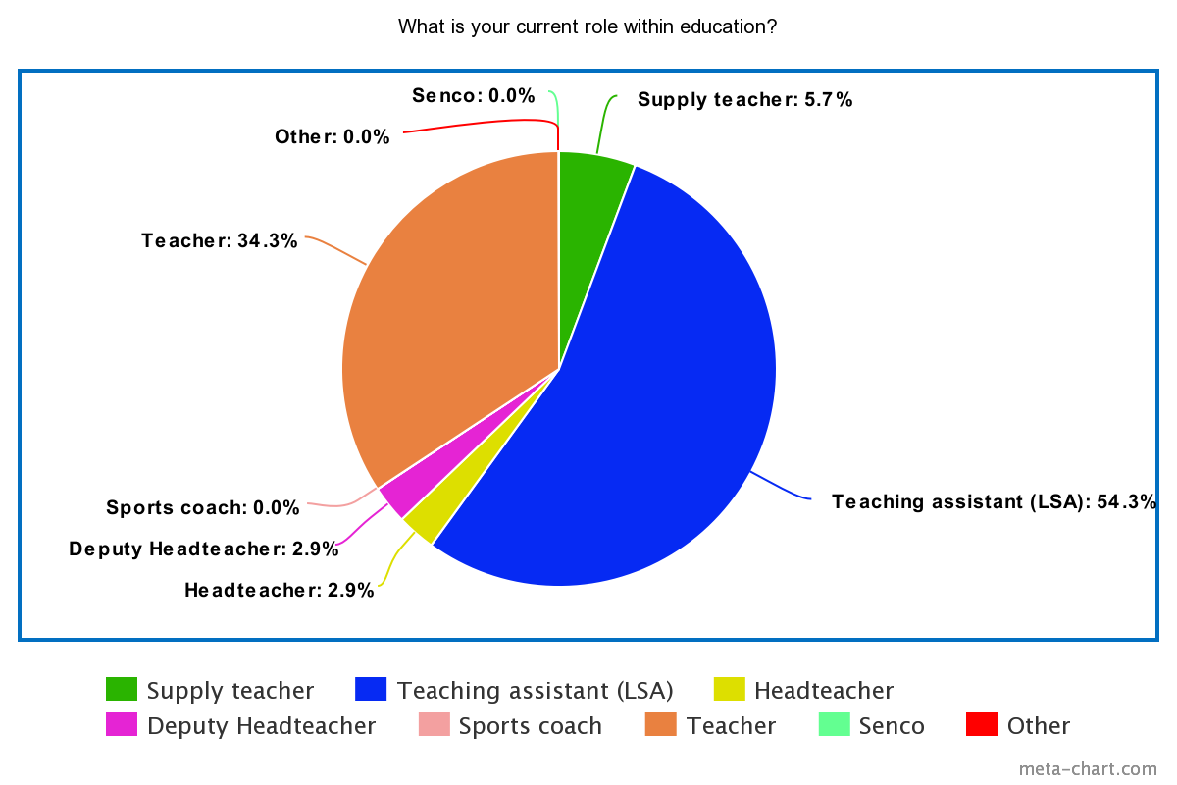

A2
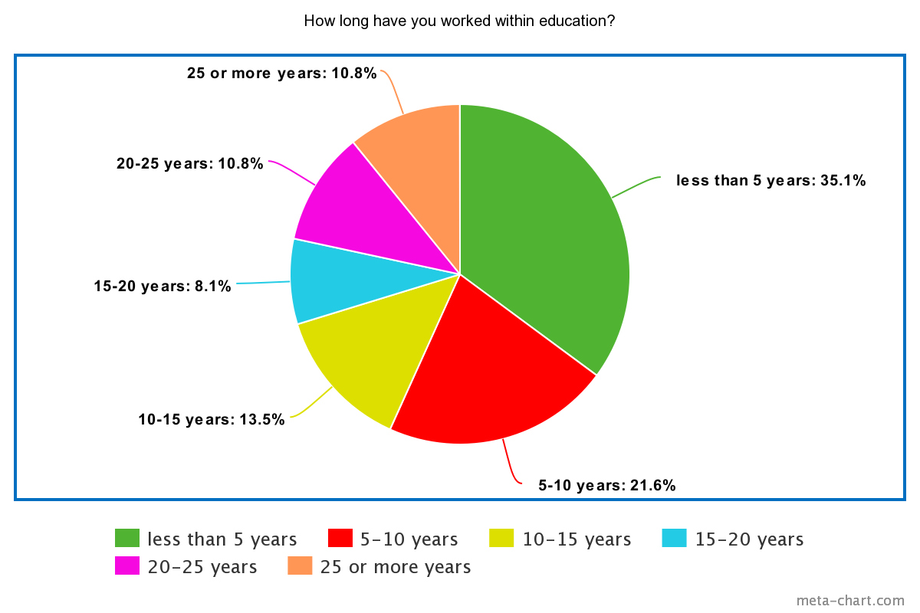

A3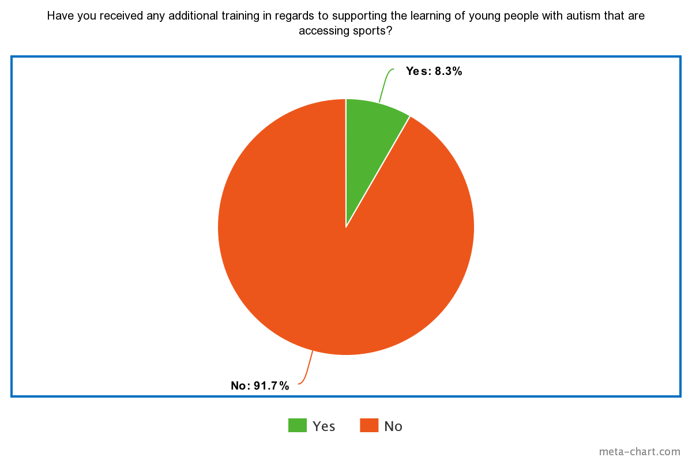

A4
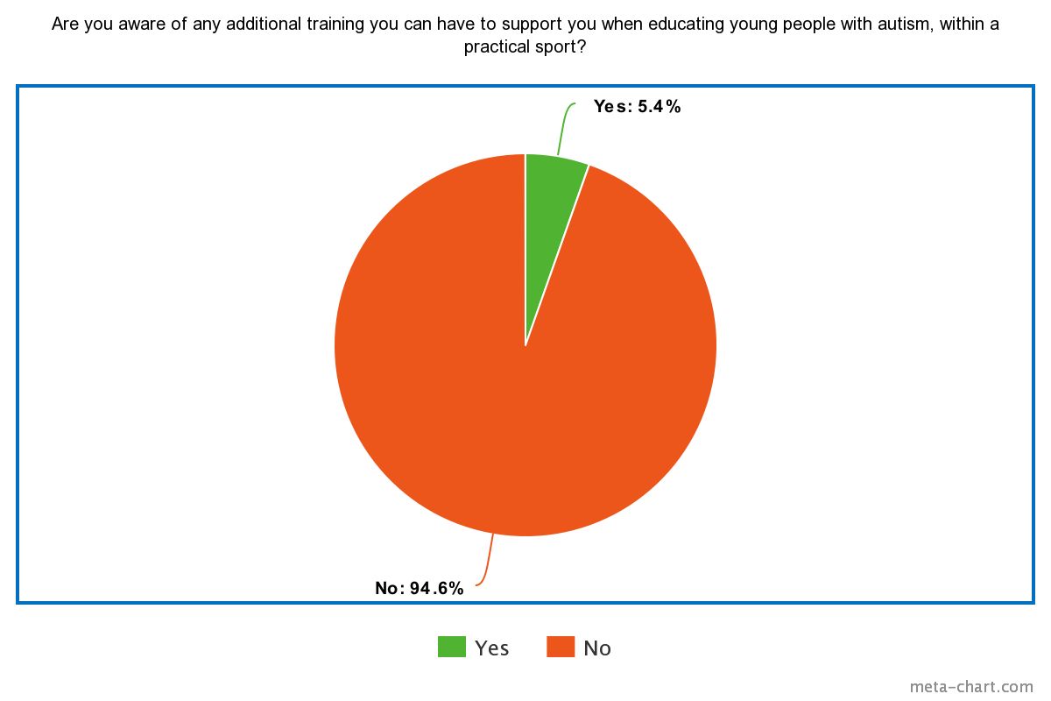
A5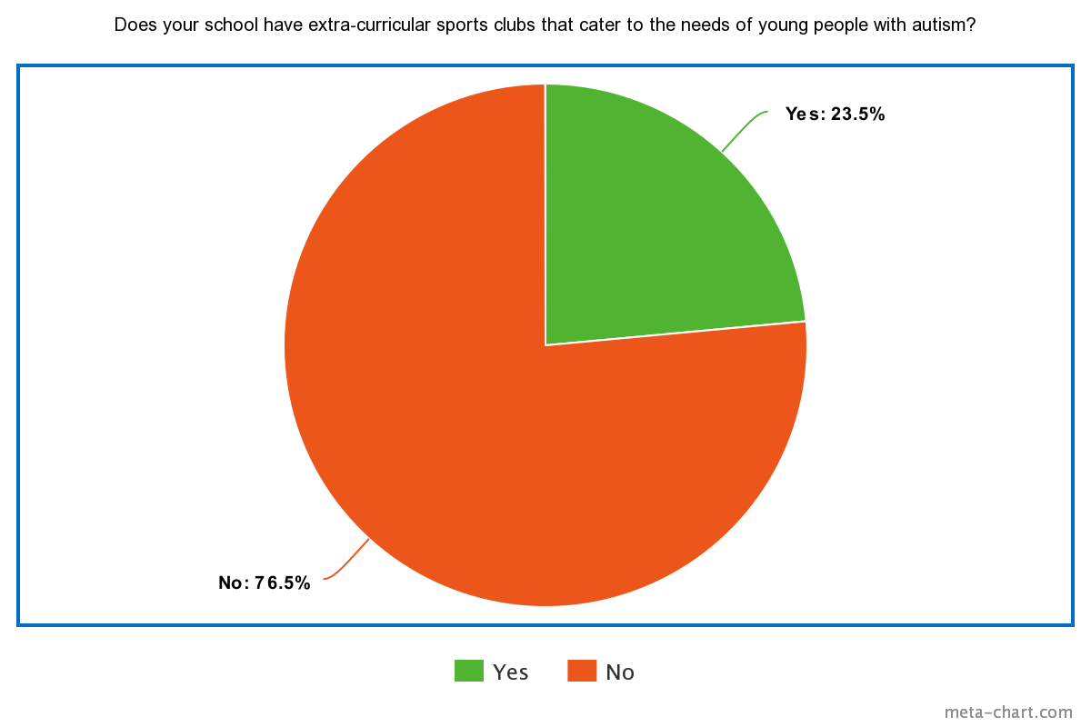
A6
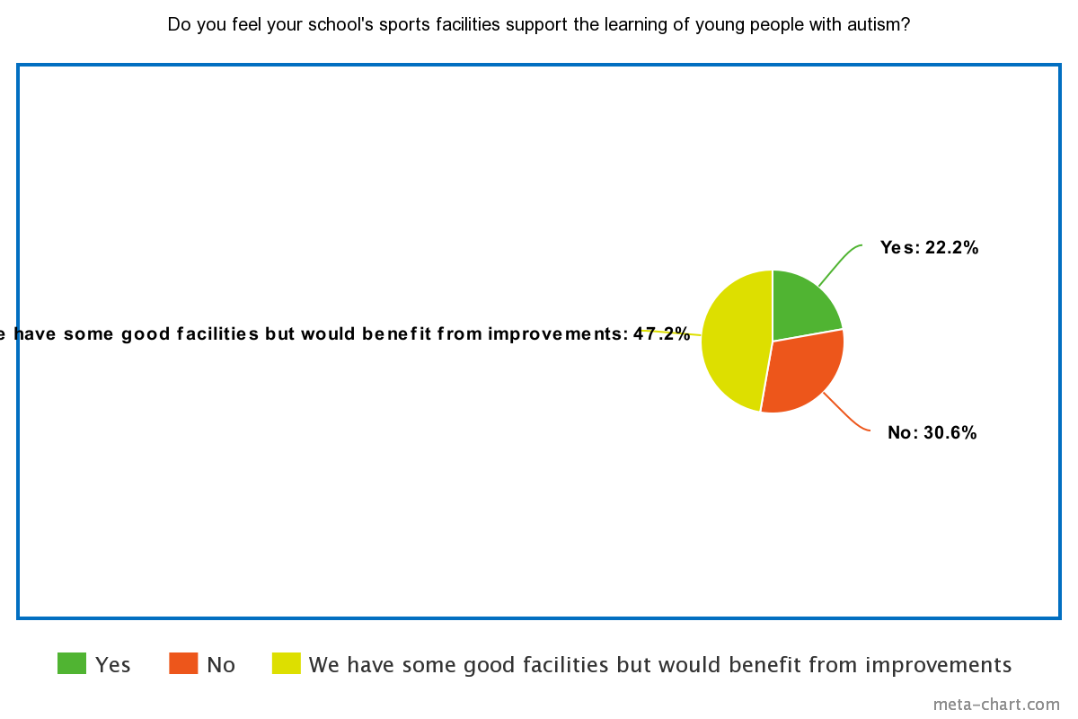

A7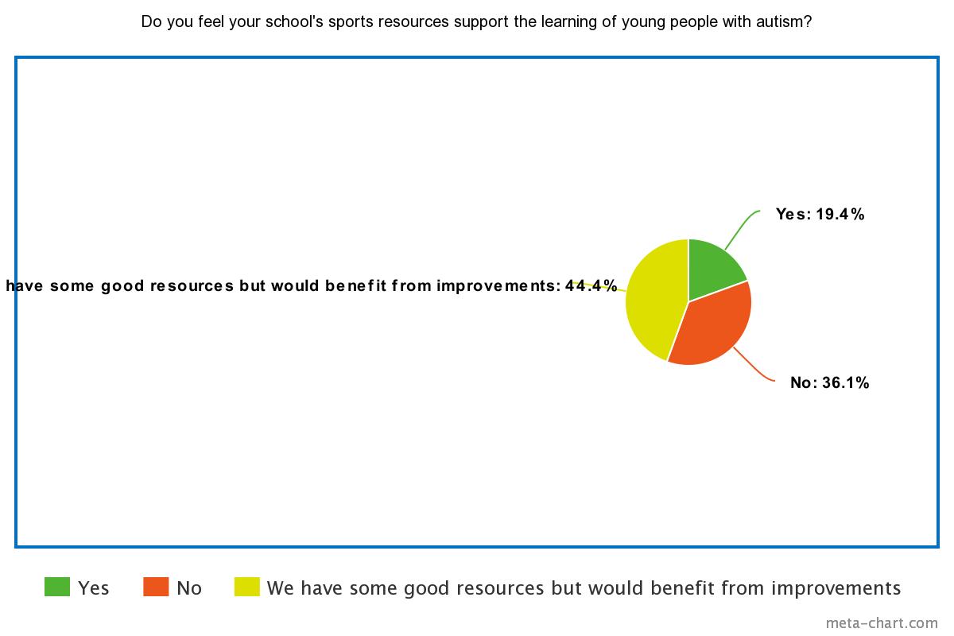
A8
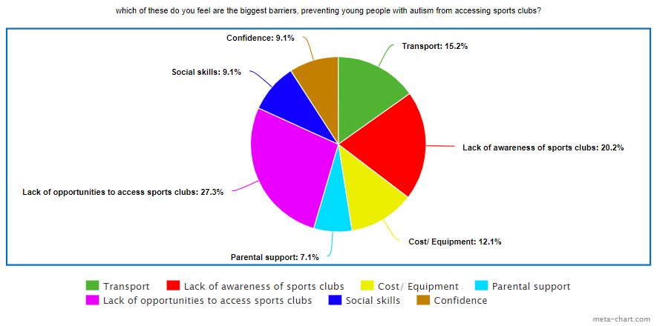

A9
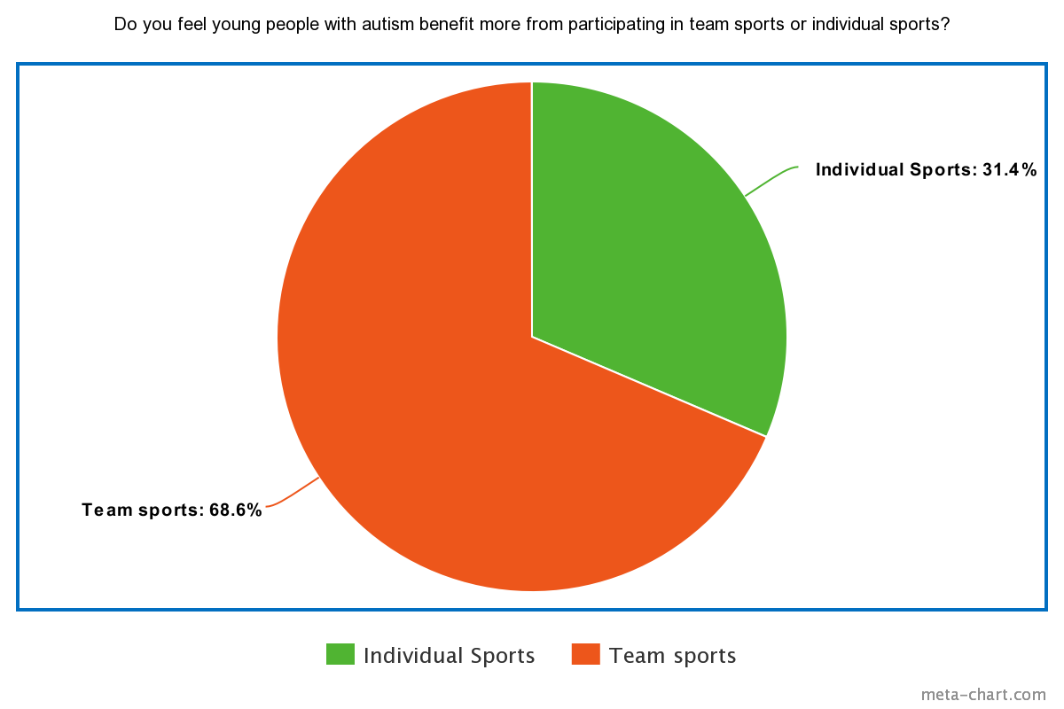

B1
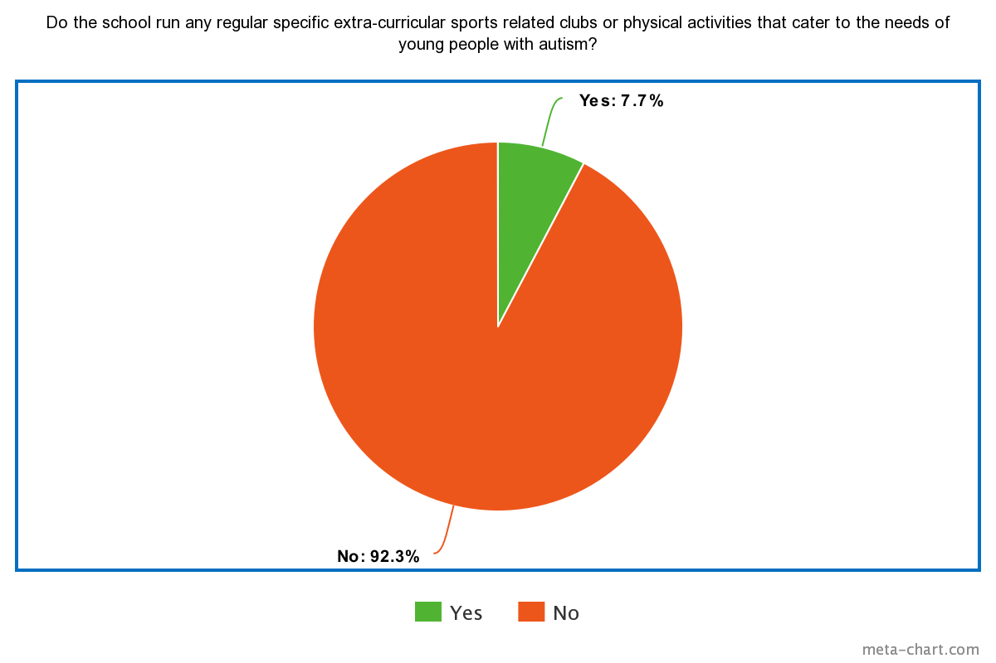

B2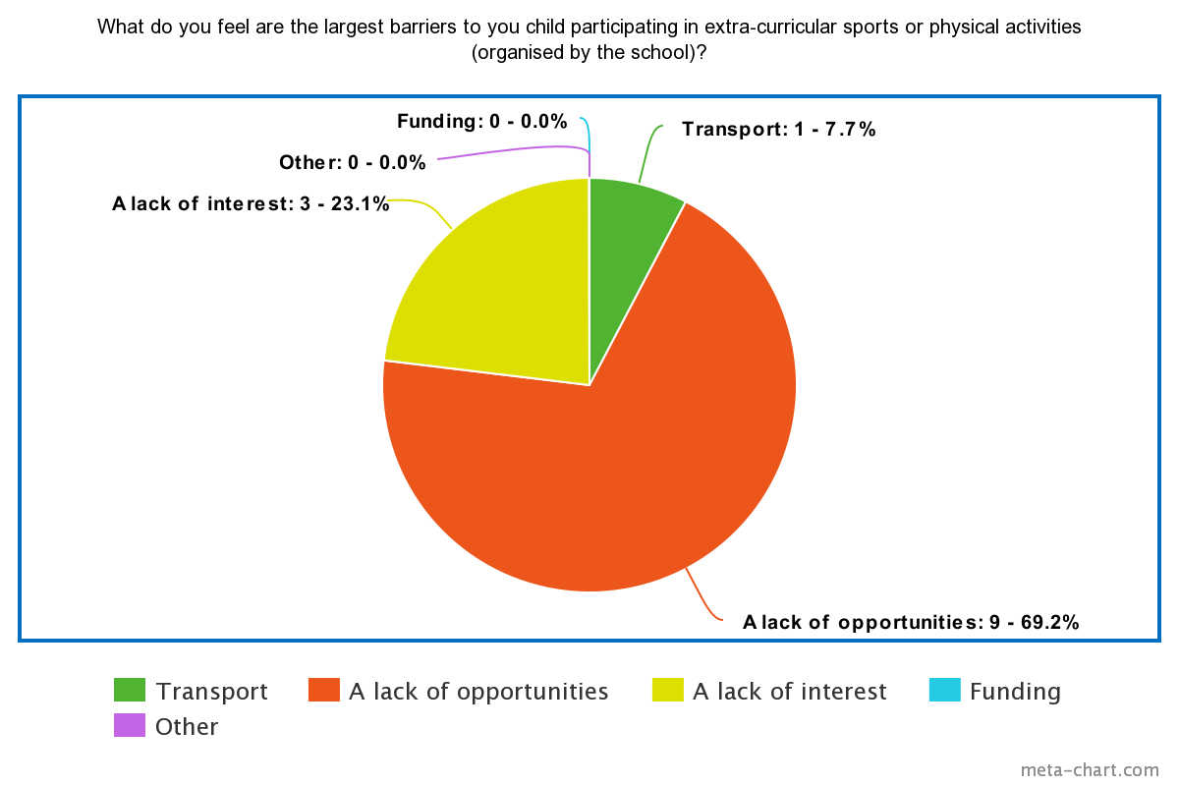

B3
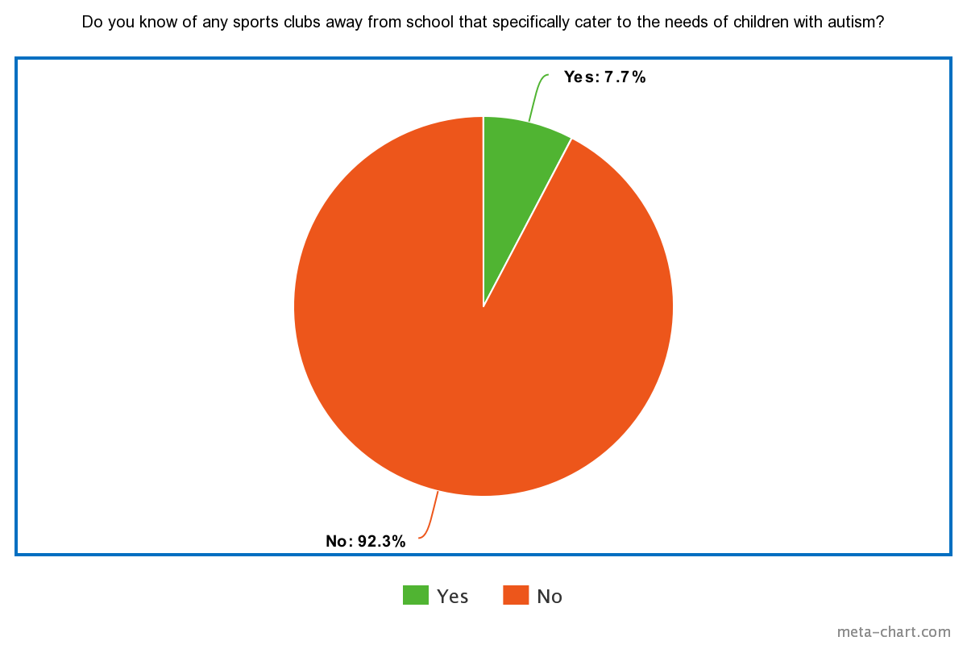

C1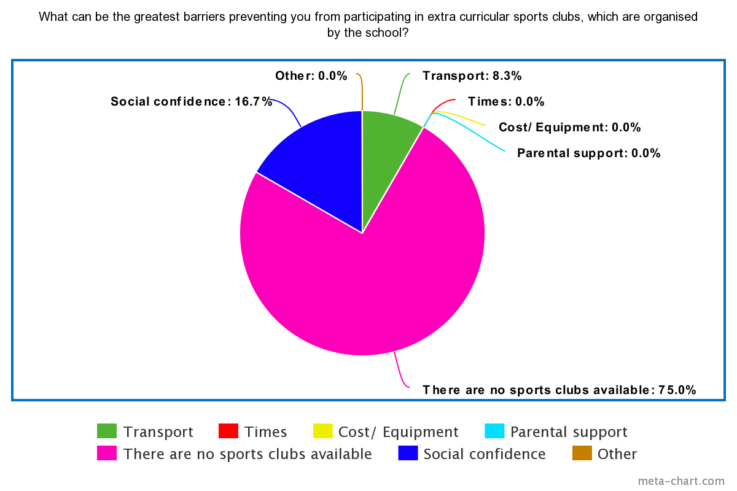

C2
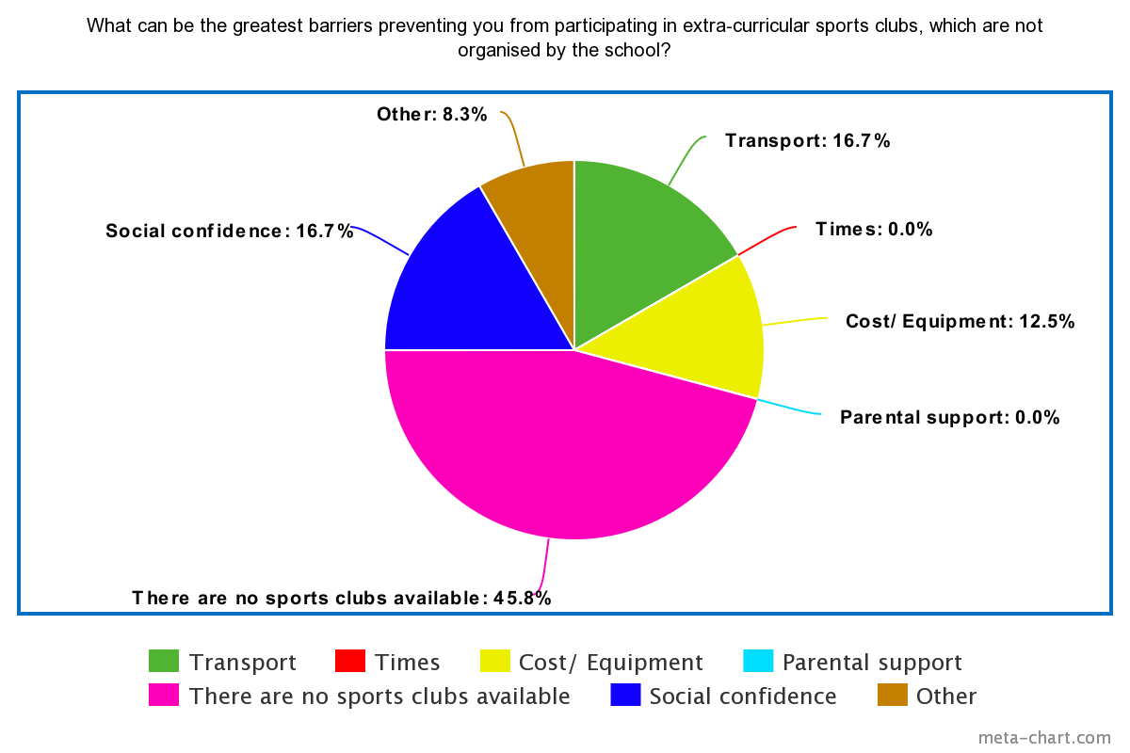

C3
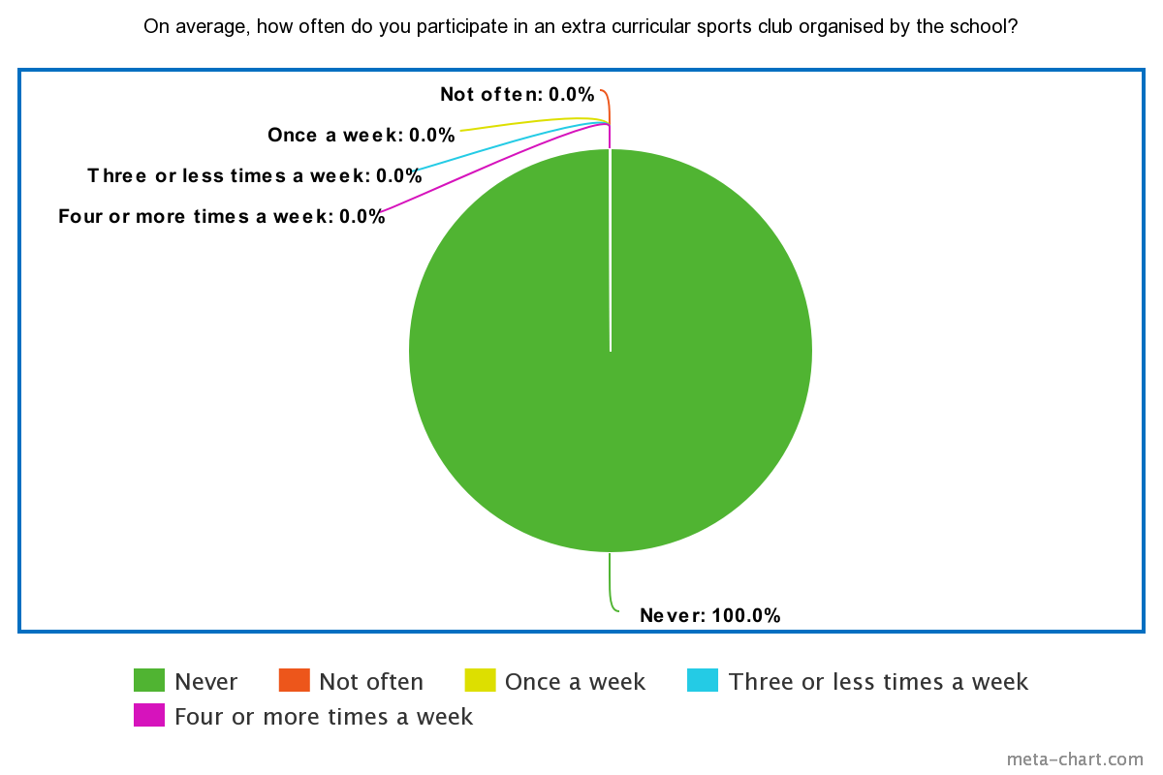

C4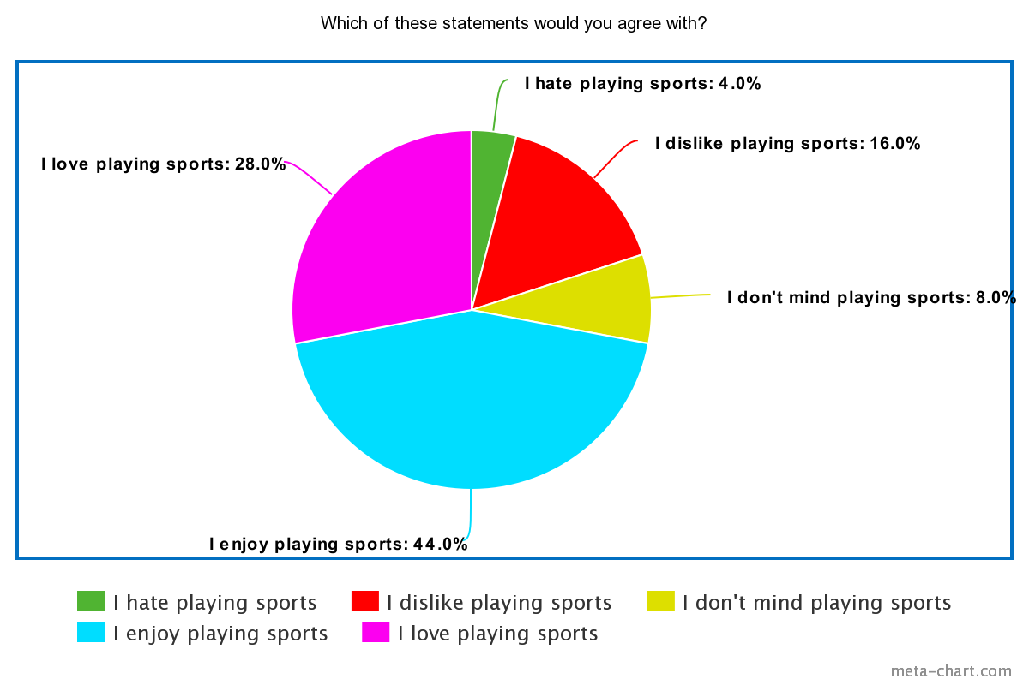

C5
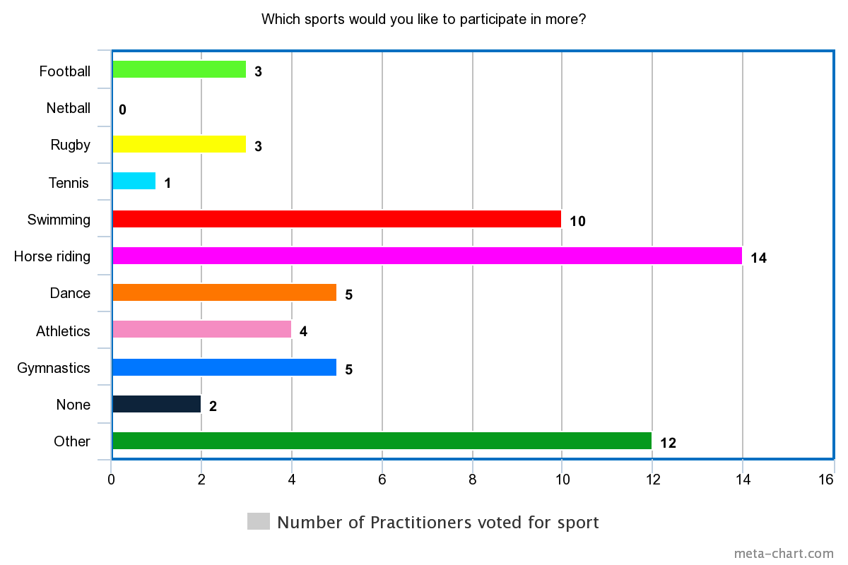
D1
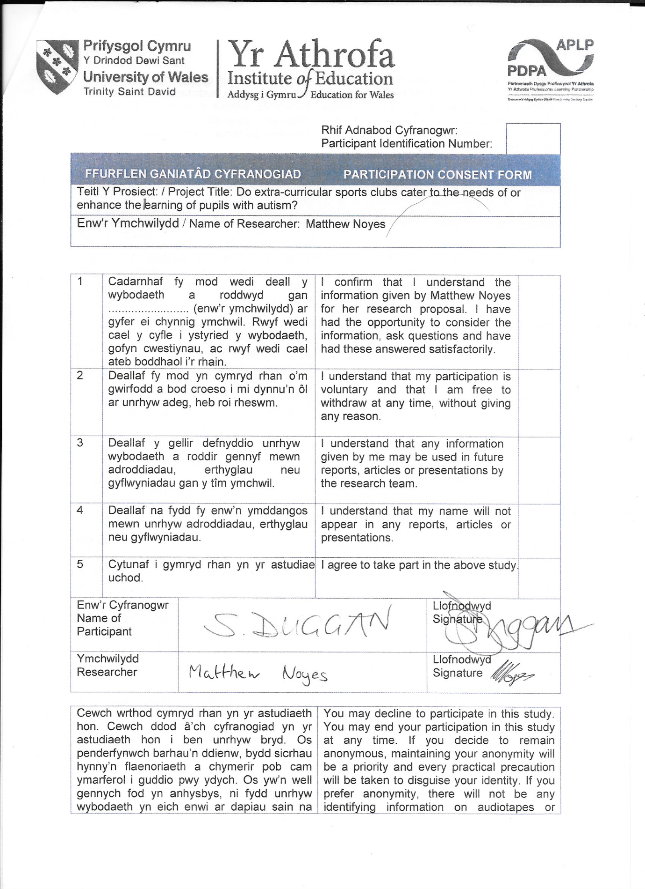

D2
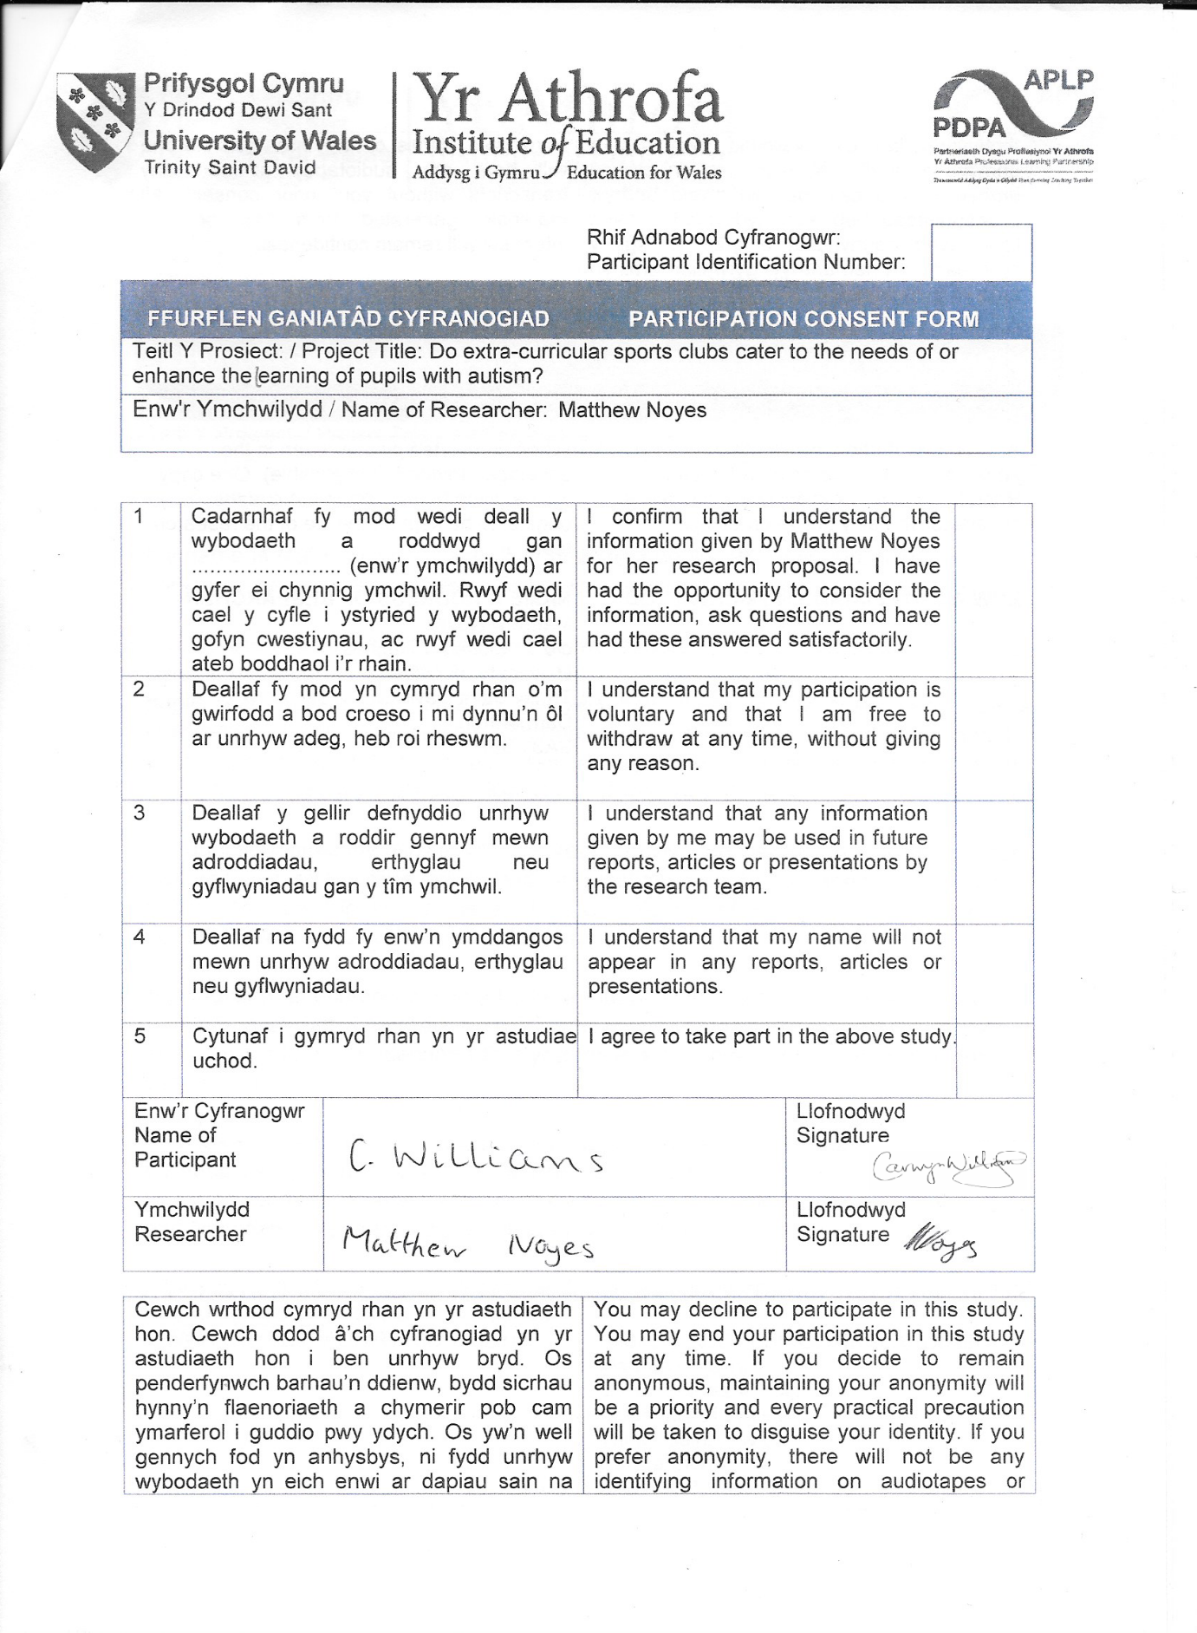

D3
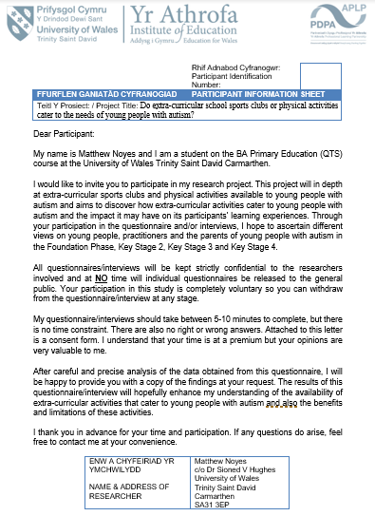
D4

D5
Disability prevalence by region/country, 2015/16, United Kingdom


