University of Wales Trinity Saint David
School of Engineering



Engineering Design Assessment
Joe Shankland
231772
BEng Mechanical Engineering
20/01/2025

ACMA4008(PT) – Design

Contents
Introduction and Design Interpretation 2
Legislative Considerations 3
Specification 4
Designs 6
Conclusion 11
References 14

Introduction and Design Interpretation

The aim of this coursework is to work through the entire process of designing and manufacturing a solution to a problem affecting an automotive original equipment manufacturer (OEM). This included interpreting the brief from the given problem status, creating and designing possible solutions based on the design interpretation, assessing and justifying these designs for plausibility and deciding on a final design, as well as choosing a material and manufacturing method to create the solution.
The design brief that was given in this circumstance, was to design a solution that would avoid the manual handling of a heavy cover to an acid tank. The acid tank is used by the OEM to submerge and anodise aluminium body parts, the issue with the current design shown in Figure 1, is that it is difficult to place and requires two people. The design brief needs a mechanical solution and the initial factors that must be considered for this design brief are:
- Material choice must be able to withstand the environment (30% Sulphuric Acid, cycled to 25°C).
- Must be operational by one person (previously two).
- Must include clearance from above, to allow access for parts to be submerge into the tank.
- Must not alter the dimensions of the existing tank.
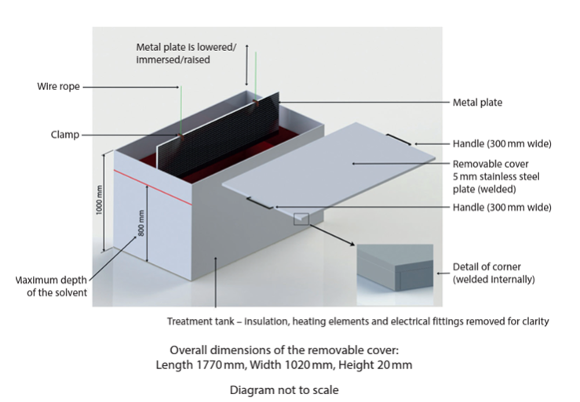
- Must be safe for human operation.
Figure 1 – Original Tank and Cover Design

Research

When considering the design brief, we must also consider the legislative considerations around sulphuric acid, mainly around the safety of workers. While Sulphuric Acid is mainly covered by REACH legislations in the UK, there are many other legislations that have to be considered, for example:
- Poisons Act 1972
- Health and Safety at Work Act 1974 (Health and Safety Executive, 2020).
- COSHH standards
- Manual Handling at work
These standards cover information such as First Aid and Firefighting Measures, Accidental Release Measures, Handling and Storage, as well as Protection for Workers. According to REACH Regulations, any purchase of Sulphuric Acid in large quantities has to come with a Safety Data Sheet, which outlines this information and gives us information which we must consider when design a solution which may impact storage of the chemical. In these guidelines, it is recommended that containers should be ‘tightly closed’ and stored away from ‘incompatible materials’ which includes metal powders, such as aluminium (Anderson Chemical Company, 2020). Introducing Aluminium parts to the storage tank could lead to chemical reactions taking place that were not risk assessed for, and in this circumstance, could lead to increased levels of Hydrogen being created and may need an improved fume extraction system.
We can also find that standards such as the Health and Safety at Work Act 1974, dictate that a workplace must maintain ‘a safe working environment that is properly maintained’. This means we must risk assess any design ideas to ensure that no new hazards are introduced into the workplace (British Safety Council, 2023).
When researching solutions for this design, I was mainly basing my research around mechanical solutions to the brief, especially ones that could offer mechanical advantage to ensure the cover could be removed by one person. Some examples of current mechanical solutions to this issue include, hinges, sliding mechanisms, pulley systems, hydraulic systems, and more. To ensure I was able to keep the cost down, my research supported the introduction of these simple mechanical solutions, instead of changing the cover or surrounding infrastructure that is in place in the factory. For example, an elongated Piano Hinge, similar to a Plastic Elongated Hinge (Plumley, 2002) as seen in Figure 2, which can be manufactured and installed very inexpensively out of hot rolled steel or other similar materials. Another mechanical system that I researched was the pulley system (Beck, 1905) as seen in Figure 3, which can also be manufactured and installed using simple stock hardware while also keeping the cost low.
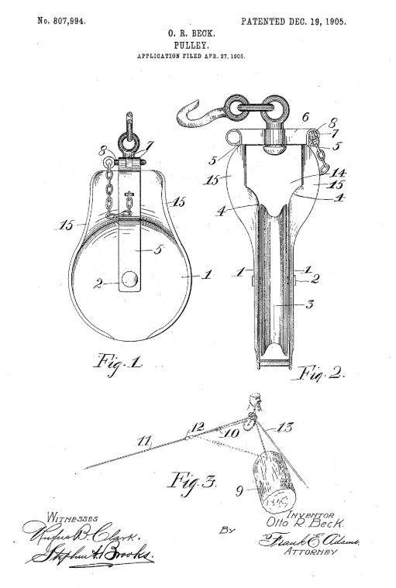
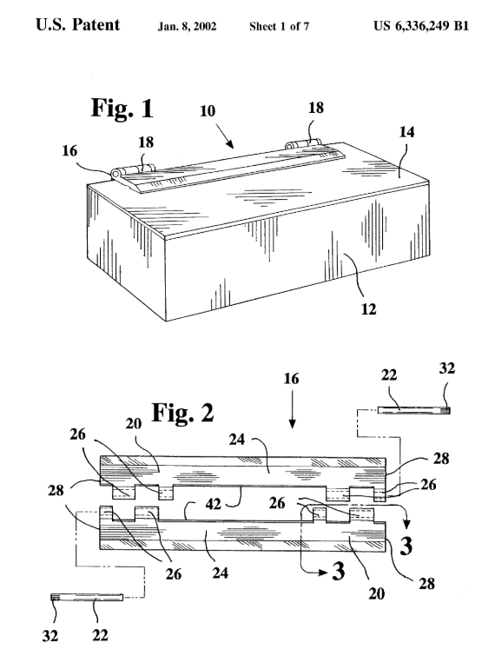

Figure 3 – Pulley Hinge, US807994A
Figure 2 – Plastic Elongated Hinge Patent, US6336249B1

Specification

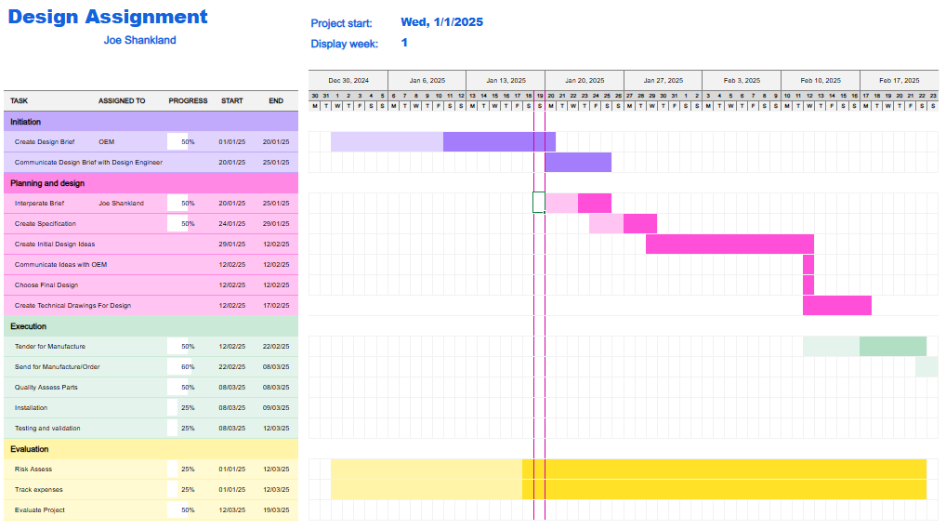
The designed solution must follow certain requirements, as previously mentioned when interpreting the design brief, another consideration which must be considered is the time taken to create the solution as the longer this is, the more chance there is that someone could get injured or an incident could occur due to the current cover not being appropriate for the job. If the design process is to follow the Gantt Chart proposed in Figure 4, then the solution must use ‘off the shelf’ parts, that are widely available and easy to acquire, as opposed to requiring hours of custom fabrication. Ensuring that the parts used are ‘off the shelf’ also keeps down the cost, another major consideration, especially since this solution needs to be implemented dozens of times.
Figure 4 – Gannt Chart of Design Project

Another consideration is to ensure that the solution still maintains the current functionality of the tank, this includes maintaining clearance from above after removing the cover and allowing the cover to be replaced. For this to be achieved, the solution must ensure that the cover can also be lifted off to the side, as opposed to just vertically off the tank, and must ensure that the process can be easily reversed. This must also be done without altering the dimensions of the tank, this is stated in the design brief and is presumably to maintain function and to keep cost low, as changing the tank size would require the acid to be drained and replaced into a new tank, which would also have to be paid for. While there are no size restraints mentioned in the brief, this must be considered, as by keeping the size small, it ensures that this solution is applicable for all tanks throughout the company. Material choice must also be considered for this design as it may come into contact with the 30% Sulphuric Acid, and must be able to withstand this being heated to 25°C. To ensure that the material is correct, the material must show high chemical resistance to corrosion, as well as showing high fatigue resistance, as it will be in use constantly during the process as well as maintaining a relatively low density. The material should also be weldable, and easily machined to ensure that the solution is cheap and easy to produce. Finally, the solution must be able to improve the safety of the
operation, this will be done by maintaining the containment of the chemicals in use, and by not introducing any other potential hazards to the operator.
Table 1 – Table of Material Properties
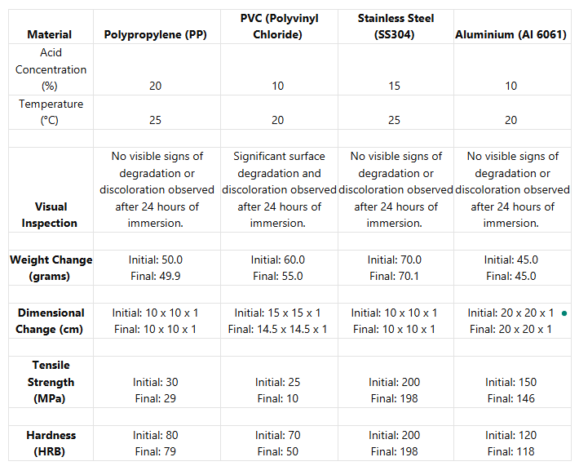

Table X above shows a comparison of suitable materials for the design brief. The table shows how each material, Polypropylene (PP), Polyvinyl Chloride (PVC), Stainless Steel, and Aluminium react to Sulphuric Acid, the table also shows some other properties such as Tensile Strength and Hardness. The first thing that can be seen from the table is that PVC is the only material to show visible signs of degradation after 24 hours of submersion, it also shows that PVC has a percentage weight change of -8.3%, the largest among the materials. This information tells us that PVC is not suitable for this application and would show significant deterioration in the circumstances, meaning it would require frequent maintenance. The other materials however, PVC, Stainless Steel, and Aluminium all show no visible signs of degradation after 24 hours of immersion, and their percentage weight changes are only -0.2%, +0.14% and 0% respectively and that none of their dimensions change after the immersion. We can also see however that Stainless Steel has a much higher Hardness (HRB) and Tensile Strength, of 200 and 200 MPa respectively, this could allow the design to take larger forces and more damage, this could be important at avoiding unplanned downtime.

Designs

The first design, as shown below in Figure 6 & 7, uses a pulley system to lift the cover off the tank. The use of a mechanical system like the pulley would lower the force needed to lift the cover, so depending on the number of pulleys, the force required could be lowered by a factor of two, three, or even more, therefore making it operational by one person. Pulleys and Pulley Hangars as shown in the design are widely available in lots of sizes and materials meaning no custom fabrication is required, and the parts can be quickly ordered and installed. This also means we can order the pulleys to be made of Stainless Steel, to increase the overall strength of the system and lengthen the life. The design also still incorporates the handles on the side of the cover, to insure it is properly replaced.
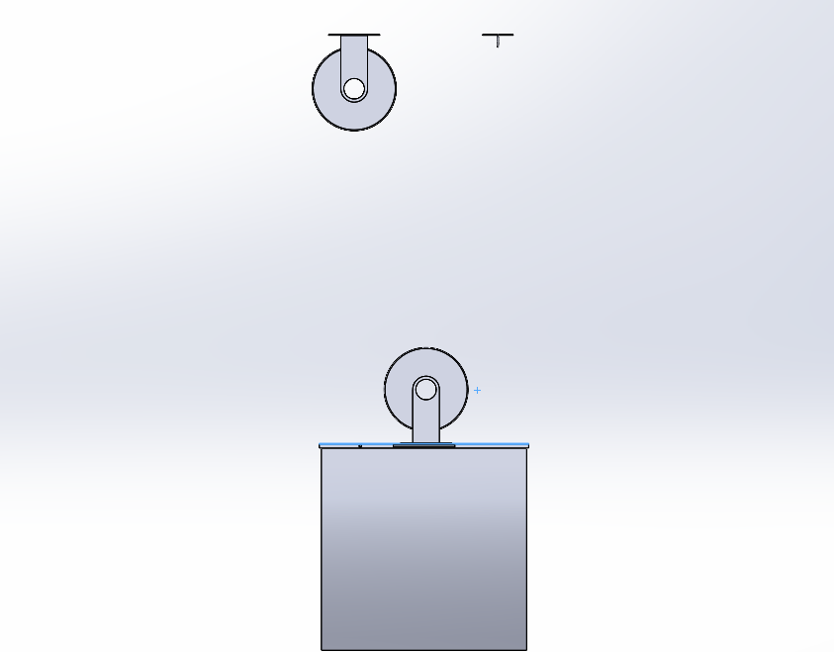

Figure 5 – Side View of Simple Pulley Assembly

This design however does not meet the requirement to leave access space above the tank, to achieve this, the pulley system would have to be attached to a removable gantry, which could be manoeuvred out of the way when open. This design also however introduces a new hazard, as depending on the space in the factory, the user may be required to work underneath a suspended load, which is not safe.
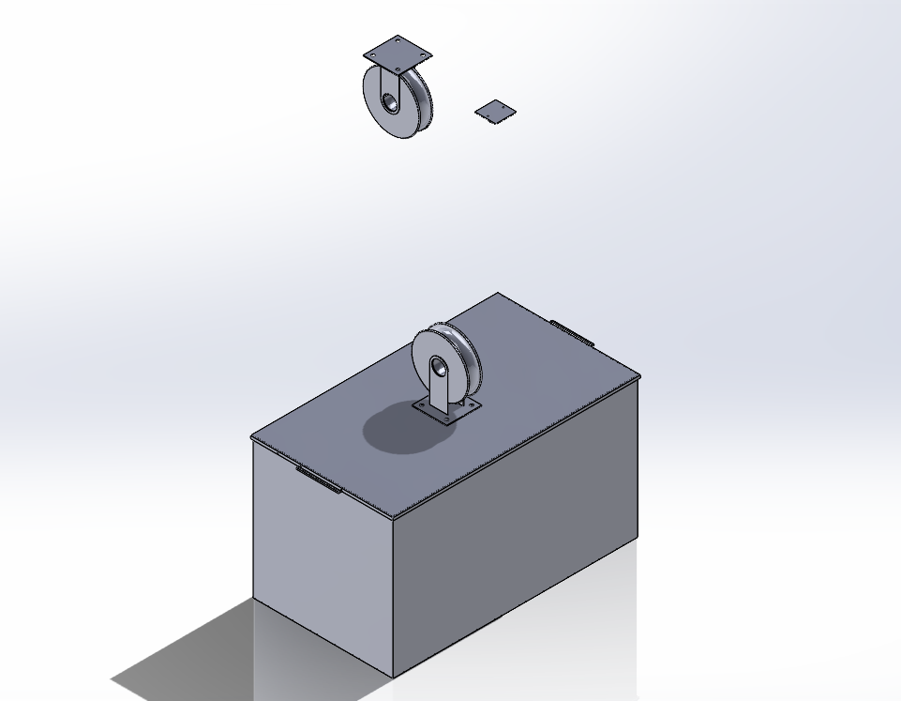
Figure 6 – Isometric View of Simple Pulley Assembly

The second design idea, shown below in Figure 7 & 8, was to incorporate a hinge mechanism into the pulley system, so that the lid could be pulled out of the way. Integrating this with the pulley system means that we can still make use of the mechanical advantage gained, as well as ensuring that there is access from above so that the tank remains functional. As previously mentioned, the pulley system can be manipulated to change the mechanical advantage and is also very easy to order/manufacture which keeps the cost low, this is also the case for hinges as they are widely manufactured in different materials.

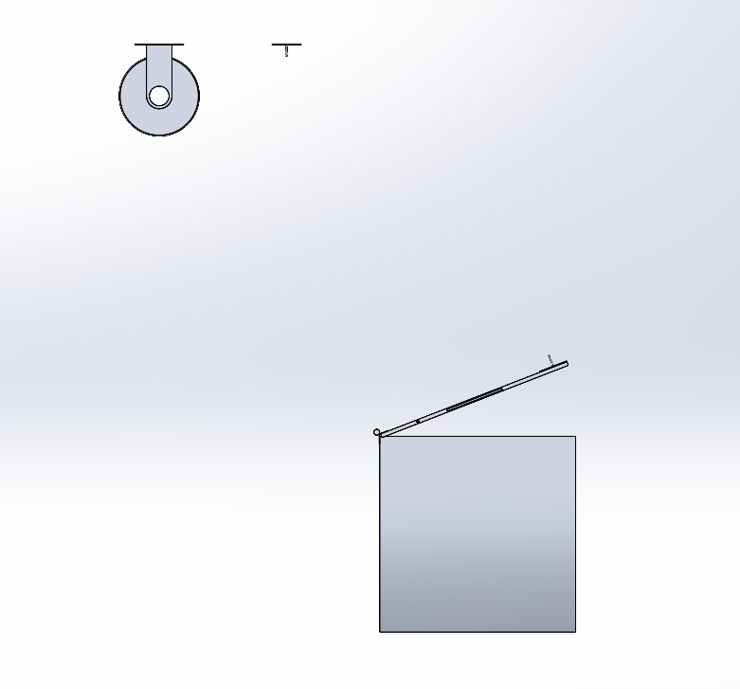

Figure 7 – Side View of Pulley System & Hinge Assembly
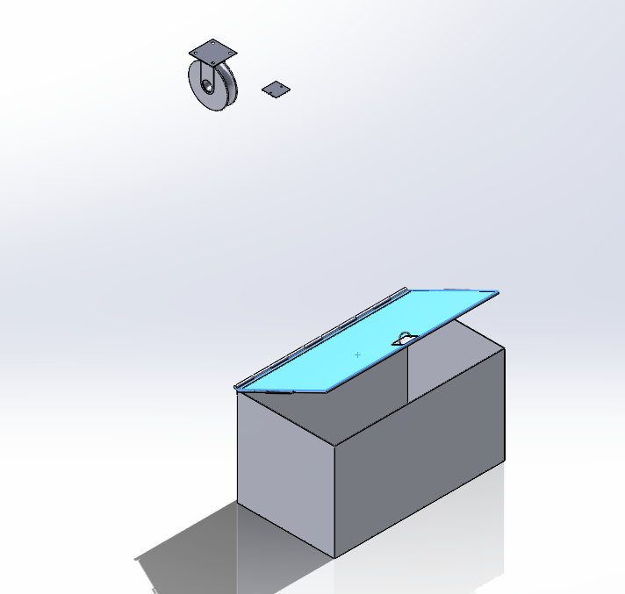
As well as now accommodating for above clearance, this method also eliminates the risk of working underneath a suspended load as the cover will be supported by the hinge as well as the pulley system, therefore creating a safer solution. However, there is still chance of mechanical failure that should be risk assessed when working in the area, this is either through failure of a component in the pulley system, such as the rope, rope lock, pulley hardware, or material.

Figure 8 - Isometric View of Pulley System & Hinge Assembly
For my final design idea, shown below in Figure 9 & 10, I chose to incorporate the hinge system developed previously, with a pair of gas struts. The hinge system would still maintain the clearance above, and make sure the tank remained functional, and the gas struts would give a mechanical advantage to the system based on the strength selected. Gas struts are also a widely manufactured part, meaning that they are available in all sizes and different materials, this means we would be able to calculate the force required to assist the opening and the stroke, to ensure the cover is able to hinge far enough open, but not too far as to make replacing the cover difficult.
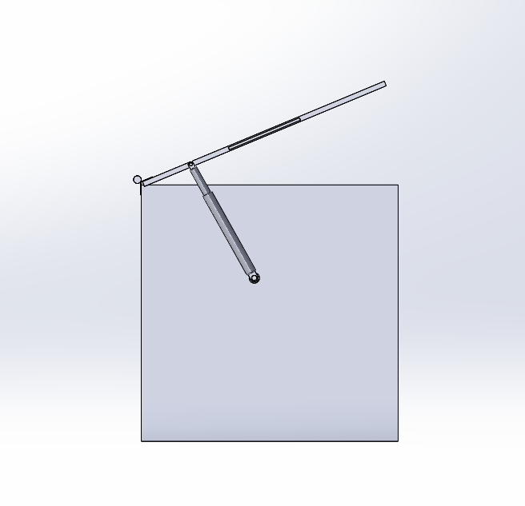

Figure 9 – Side View of Hinge & Gas Strut Assembly

This system would also attach directly to the tank, meaning it would be suitable for all the tanks in the factory, as it wouldn’t rely on having an overhead gantry nearby, such as the previous designs. While there is still chance that the struts fail, the redundancy of having a second strut means that the cover would not collapse and create a hazard. As previously mentioned, these parts are also widely available and easy to replace, as replacement would just mean sliding off the old strut and replacing it with a new compressed one.

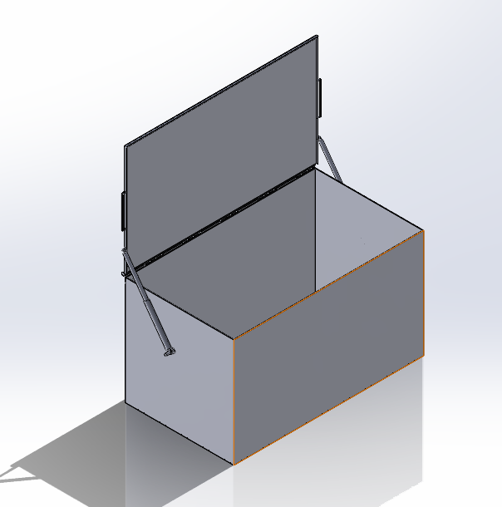

Figure 10 – Isometric View of Hinge & Gas Strut Assembly

Conclusion

After considering all of the above designs, I decided that the one best suited for the brief is the combination of hinges and gas struts. I believe that this is the most suitable design as it fills all of the requirements in the brief, while also keeping the cost of install, maintenance and repair low, it is also available in Stainless Steel, which we have previously seen is a great material for this application due to its high acid resistance and high tensile strength. This solution also ensures that the tank cover can be removed by one person while maintaining a safe working area, the design also allows for us to decide the mechanical advantage by changing the strength of the struts used. Where this design also improves on the previous designs is by removing the need for extra infrastructure, such as an overhead gantry as used in the other designs. This design allows us to keep the footprint small and ensures that it will be compatible with all of the tanks within the factory.
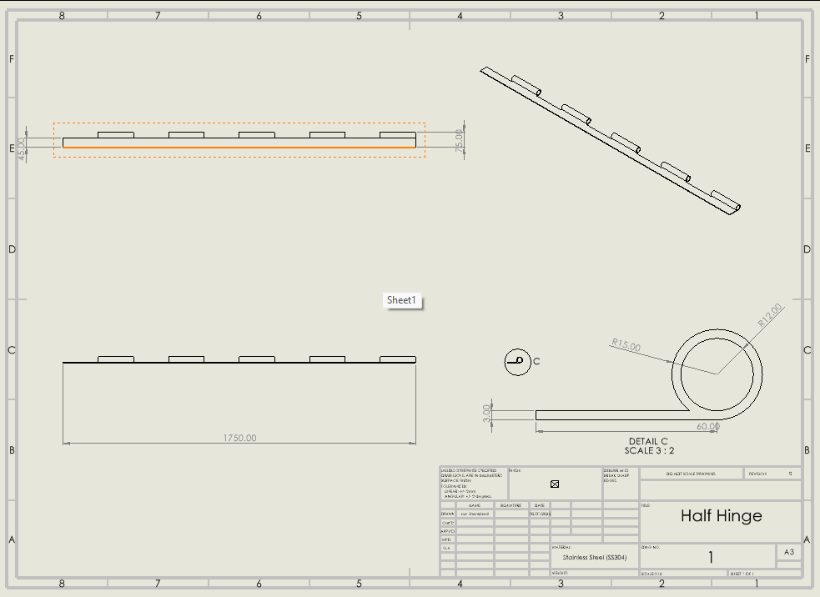
The following designs would be manufactured using the following Technical Drawings, with the hinge shown in Figure 11, and both parts of the gas strut in Figure 12 & 13. The manufacturing process for the hinges would be very simple, it would first require plate steel that had been hot rolled to a thickness of 3mm. This plate material would then need to be machined, possibly using CNC machinery, to get exact dimensions, and finally the side of the segment would have to be rolled into shape.

Figure 11 – Technical Drawing of Hinge Half

The gas struts would however require a different manufacturing process, it would first require cutting round stock stainless steel to the correct length, before machining fully to the correct dimensions. After both halves of the strut are correctly dimensioned, they would then be attached to the bolt eyes either side, these would have to be machined out of plate steel and then welded to the end of the strut halves. Finally, the strut would have to be fully assembled with the seals and reservoirs filled.
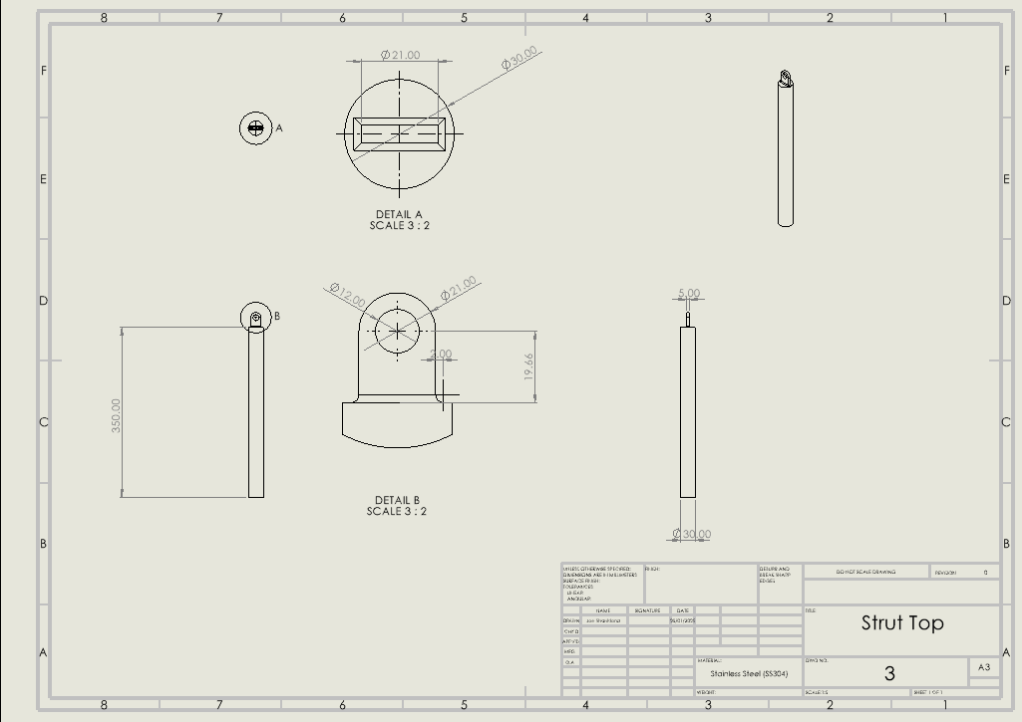
Figure 12 – Technical Drawing of Top Strut Half

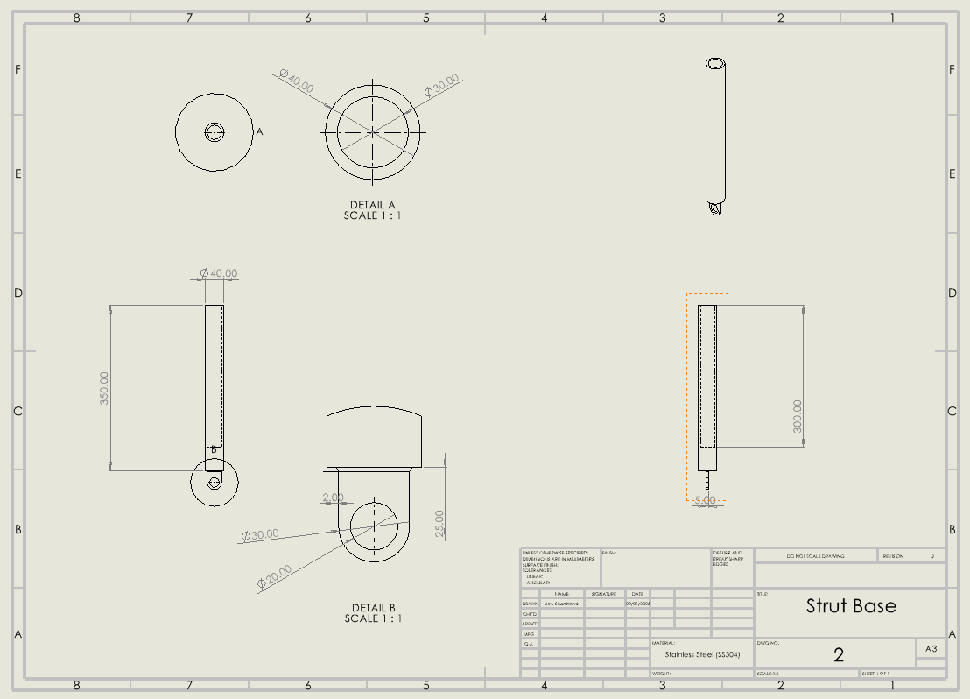
Figure 13 – Technical Drawing of Strut Base

References

Health and Safety Executive (2020). Health and Safety at Work Act 1974. [online] Hse.gov.uk. Available at: https://www.hse.gov.uk/legislation/hswa.htm.
‌British Safety Council (2023). The Health and Safety at Work Act Explained. [online] British Safety Council. Available at: https://www.britsafe.org/training-and-learning/informational-resources/the-health-and-safety-at-work-act-explained.
‌Anderson Chemical Company (2020). Sulphuric Acid – Safety Data Sheet. [online] Anderson Chemical Company
Plumley, R. (2002). Plastic Elongated Hinge. [online] Available at: https://patents.google.com/patent/US6336249B1/en.
‌Beck, O.R. (1905). Pulley. [online] Available at: https://patents.google.com/patent/US807994A/en.
‌

