Revision 3 (combinational and VHDL)
Q1
- For the function $f(A,B,C,D)$ , Implement a 4:2 Encoder and represent the following
- Combinational Diagram
- Truth Table
- Logic Diagram
Solution
Combinational Diagram
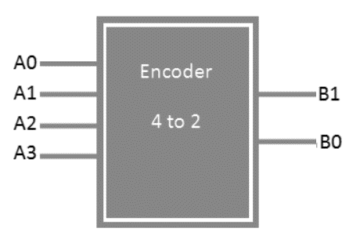
Truth Table
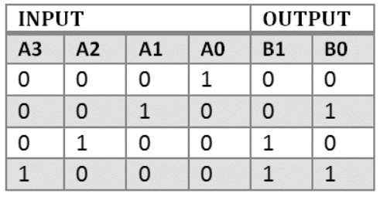
Logic Diagram
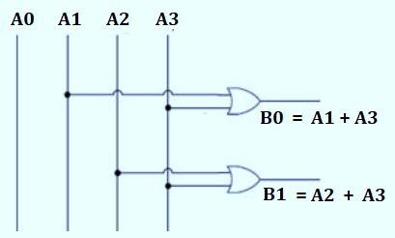

Q2
- For the function $f(A,B,C,D)$ , Implement a 1:4 De-mux and represent the following
- Combinational Diagram
- Truth Table
- Logic Diagram
Solution
Combinational Diagram
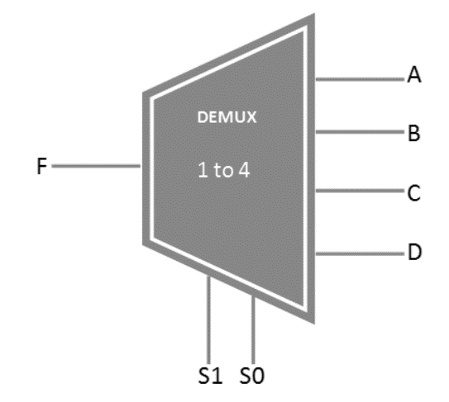

Truth Table
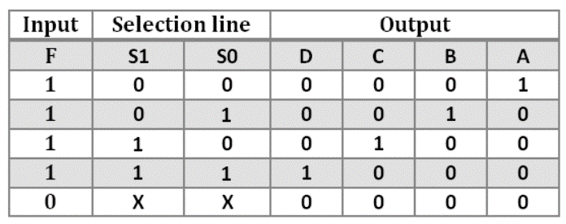
Logic Diagram
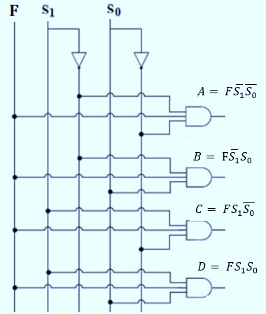

Q3
- For the function f , Implement a half adder and represent the following
- Combinational Diagram
- Truth Table
- Logic Diagram
Solution
Combinational Diagram
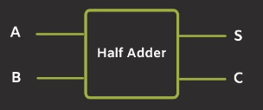
Truth Table
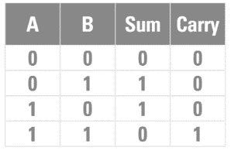
Logic Diagram
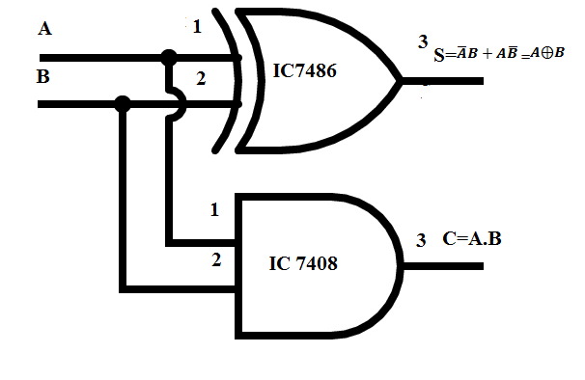

Q4
Write a VHDL code for a Full adder.
Solution: Refer Lecture 12

Q5
Write a VHDL code for a 2X2 Binary Multiplier
Solution: Refer Lecture 12
Q6
Write a VHDL code for a 4 :1 Mux.
Solution: Refer Lecture 12
Q7
(i) Consider two signed numbers -6 (Multiplicand) and 4 (Multiplier).

(b) Draw the Booths Algorithm flow chart for a 4 bit Multiplier.
(c) Use the Booths Multiplier operation table to verify the resultant of the product from part (a).
Solution
Multiply the above given numbers using 2’s Compliment method
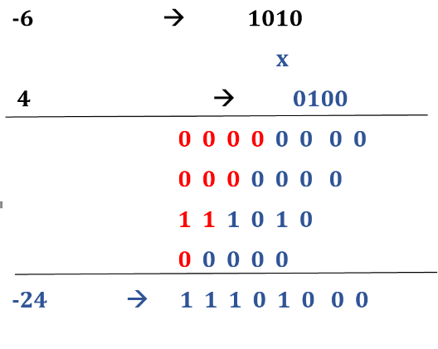
Draw the Booths Algorithm flow chart for a 4 bit Multiplier.
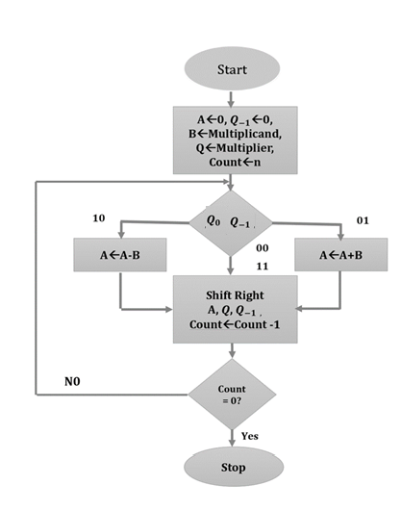
Draw the Booths Algorithm flow chart for a 4 bit Multiplier.
Steps | A |  |  |  | Q3 Q2 Q1 Q0 |  |  |  | $$Q_{-1 }$$ | Count  n | Operation
 | 0 | 0 | 0 | 0 | 0 | 1 | 0 | 0 | 0 | n= 4 | If 00 or 11 , then Right Shift
1 | 0 | 0 | 0 | 0 | 0 | 0 | 1 | 0 | 0 | n=4-1=3 | If 00 or 11 , then Right Shift
2 | 0 | 0 | 0 | 0 | 0 | 0 | 0 | 1 | 0 | n=3-1=2 | If 10, then AA-B and Right Shift
 | 0 | 1 | 1 | 0 | 0 | 0 | 0 | 1 | 0 |  | AA-B = 0000-1010=0110
 | 0 | 0 | 1 | 1 | 0 | 0 | 0 | 0 | 1 | n= 2-1=1 | Right Shift
 | 0 | 0 | 1 | 1 | 0 | 0 | 0 | 0 | 1 |  | If 01, then AA+B and Right Shift
3 | 1 | 1 | 0 | 1 | 0 | 0 | 0 | 0 | 1 |  | AA+B = 0011+1010=1101
4 | 1 | 1 | 1 | 0 | 1 | 0 | 0 | 0 | 0 | n= 1-1=0 | Right Shift

