

Module Title: | Dissertation
Module Code: | LCMB7020
Course: | Master of Business Administration in General Management
Dissertation Topic: | Charging Ahead: Assessing and Validating Tesla's Competitive Advantage in the UK Auto Industry
Lecturer: | Dr Hoang Dang Nguyen

Acknowledgements
I am writing to extend my sincere appreciation to my supervisor, Dr Hoang Dang Nguyen, for his indispensable mentorship, steadfast encouragement, and perceptive evaluation during the entirety of this dissertation. His erudition and dedication to excellence were crucial in influencing the direction of the research and improving its calibre. I consider myself extraordinarily privileged to have been mentored by an individual of your calibre and expertise.
Sincere gratitude is also extended to the professors whose erudition and expertise have been conveyed to me throughout my academic career. Their instruction has served as a wellspring of motivation and scholarly development. Additionally, I am appreciative of the intellectually stimulating discussions, camaraderie, and shared learning experiences of my peers that have enhanced my academic career.
I would also like to extend my sincere gratitude to my companions for their support, tolerance, and inspiration throughout the arduous stages of this research endeavour. Their unwavering support has served as an invaluable reservoir of fortitude.
Finally, I would like to extend my utmost appreciation to my family for their inexhaustible support, motivation, and steadfast faith in my capabilities. Their support and encouragement have served as the bedrock for my scholarly pursuits.

Declaration

Master’s Degrees by Examination and Dissertation
Declaration Form.
1. This work has not previously been accepted in substance for any degree and is not being concurrently submitted in candidature for any degree.
Signed: Mohammed Midlaj Ponnadan Karimbanakkal
Date: 08/02/2024

2. This dissertation is being submitted in partial fulfilment of the requirements for the degree of Master in Business Administration.
Signed: Mohammed Midlaj Ponnadan Karimbanakkal
Date: 08/02/2024

3. This dissertation is the result of my own independent work/investigation, except where otherwise stated.
Other sources are acknowledged by footnotes giving explicit references.
A bibliography is appended.
Signed candidate: Mohammed Midlaj Ponnadan Karimbanakkal
Date: 08/02/2024

4. I hereby give consent for my dissertation, if accepted, to be available for photocopying, inter- library loan, and for deposit in the University’s digital repository
Signed (candidate): Mohammed Midlaj Ponnadan Karimbanakkal
Date: 08/02/2024
Supervisor’s Declaration.
I am satisfied that this work is the result of the student’s own efforts.
Signed: Hoang Dang Nguyen
Date: 13/02/2024

Abstract
This dissertation examines the factors that impact consumer purchasing decisions in the electric vehicle market of the United Kingdom, focusing particularly on Tesla electric vehicles. The study provides evidence in support of four hypotheses pertaining to charging infrastructure, brand image, technology, and sustainability, by means of an exhaustive survey and literature review. The research specifically underscores the substantial positive influence that Tesla's brand image has on consumer preferences, thereby underscoring its critical function in moulding buying choices amidst the fiercely competitive electric vehicle industry. The substantial favourable public opinion surrounding Tesla's brand, specifically with regard to technological advancements and environmental consciousness, highlights the brand's impact on consumer decision-making.
Moreover, the research demonstrates the pivotal significance of technological advancement, as customers exhibit a pronounced inclination towards state-of-the-art functionalities. This is consistent with the overarching objective of the industry to promote environmental awareness and sustainability. The study offers a thorough examination of the complex decision-making process, which has significant ramifications for marketers, policymakers, and industry participants who are attempting to navigate the complex terrain of the electric vehicle market in the United Kingdom. In light of the automotive industry's paradigmatic transition towards sustainable practices, it is critical to comprehend the relation between charging infrastructure, brand image, technology, sustainability, and sustainability in order to develop efficacious strategies. This dissertation makes a valuable contribution to the ongoing dialogue regarding the adoption of electric vehicles by providing a nuanced analysis of the dynamic elements that impact consumer decisions in the electric vehicle market of the United Kingdom.

Table of Contents
Acknowledgements 1
Declaration 2
Abstract 3
1. Introduction 6
1.1 Background 6
1.2 Research Aims 7
1.3 Research Questions 7
1.4 Research Objectives 8
1.5 Hypotheses 8
1.6 Significance of the Study 8
1.7 Structure of the Dissertation 9
2. Literature Review 11
2.1 Definitions 11
2.2 Impact of Brand Image on Purchasing Decisions 17
2.3 Impact of Technology on Purchasing Decisions 19
2.4 Impact of Sustainability on Purchasing Decisions 22
2.5 Impact of Charging Infrastructure on Purchasing Decisions 25
2.5.1 Proximity and Convenience of Charging Stations 25
2.5.2 Alleviating Range Anxiety 26
2.5.3 Social Norms and Charging Infrastructure 27
2.6 Literature Gap 28
2.7 Conclusion 29
3. Methodology 30
3.1 Research Design 30
3.1.1 Quantitative Approach 30
3.1.2 Structured Questions 31
3.2 Data Collection Methods 32
3.2.1 Microsoft Forms 33
3.3 Data Analysis Techniques 34
3.3.1 Quantitative Analysis 34
3.3.2 Visual Representation 34
3.4 Sampling Strategy 35
3.5 Ethical Considerations 36
3.5.1 Ethical Form 36
4. Data Analysis and Findings 37
4.1 Demographic Analysis 37
4.2 Hypothesis Testing 38
4.2.1 Hypothesis 1 39
4.2.2 Hypothesis 2 43
4.2.3 Hypothesis 3 48
4.2.4 Hypothesis 4 53
5. Discussion of Findings 59
5.1 Hypothesis 1 59
5.2 Hypothesis 2 60
5.3 Hypothesis 3 62
5.4 Hypothesis 4 64
6. Conclusion 67
6.1 Summary of Findings 67
6.2 Recommendations 68
6.3 Research Limitations 69
6.3 Final Conclusion 70
References 72
Appendices 84
Ethics Forms 84
Survey Questions 84

1. Introduction

1.1 Background
A paradigm transition has occurred in the automotive industry, characterised by a growing emphasis on environmentally friendly and sustainable transportation. As awareness of environmental issues increases and the imperative to reduce carbon emissions grows, this evolution ensues. EVs have become a crucial component in this paradigm shift, providing an environmentally friendly and energy-efficient substitute for conventional vehicles powered by internal combustion engines. As countries across the globe join forces to combat climate change, the United Kingdom has experienced a significant increase in the adoption of electric vehicles (Delmonte et al., 2020; Longo et al., 2015). One of the leading companies in this shift is Tesla, an organisation that has gained a reputation for pioneering advancements in electric mobility.
Tesla has a significant influence on the automotive market in the United Kingdom. The organization's notable methodology in designing electric vehicles, in conjunction with its dedication to state-of-the-art technology, has established it as a dominant force in the electric mobility industry (Gavsi, 2023). This dissertation, entitled "Charging Ahead: Evaluating and Verifying Tesla's Competitive Advantage in the United Kingdom Automobile Sector via Comprehensive Surveys," undertakes a thorough investigation of Tesla's competitive position in the ever-changing automotive market of the United Kingdom. The objective of this study is to offer a thorough comprehension of the complex elements that contribute to Tesla's competitive edge, concentrating on charging infrastructure, branding and marketing tactics, consumer perceptions, and adherence to government policies.
Considering the increasing demand for EVs, it is crucial to comprehend the intricacies that affect consumer preferences and purchasing choices. This context establishes the foundation for an in-depth examination of the complex elements that comprise Tesla's competitive edge. Through the utilisation of surveys as the principal research instrument, this study aims to thoroughly analyse the complex dynamics that impact consumer decision-making in the electric vehicle industry. The aforementioned dynamics comprise a range of factors, such as consumer perceptions, the influence of charging infrastructure on decision-making processes, the effectiveness of Tesla's marketing and branding strategies, and the conformity of the company's methodologies with governmental policies and regulations.
The spread of electric vehicle adoption signifies not only a passing market trend, but also a more extensive societal transformation towards transportation that is environmentally conscious and sustainable (Sperling, 2013). Tesla, being at the forefront of this paradigm shift, holds a distinctive stance in influencing the trajectory of the automotive sector. Gaining insight into the elements that contribute to Tesla's competitive edge carries not only strategic significance for the organisation but also wider ramifications for the future of sustainable transportation. The preceding information establishes the groundwork for an exhaustive analysis of Tesla's position within the United Kingdom's automotive sector, thereby making a contribution to the ongoing dialogue surrounding the adoption of electric vehicles and the sector's transition towards a more environmentally sustainable trajectory.

1.2 Research Aims
The aim of this study is to examine the determinants that impact the purchasing choices of consumers in the United Kingdom regarding electric vehicles (EVs). Specifically, it will investigate how brand image, technological advancements, and environmental factors are prioritised. The purpose of this research is to determine how these elements contribute to Tesla's competitive advantage in the United Kingdom automobile industry. Furthermore, this study aims to investigate the correlation between the level of convenience and contentment consumers experience with electric vehicle charging infrastructure and their propensity to select Tesla as opposed to alternative electric or conventional vehicles.

1.3 Research Questions
- How do UK consumers prioritize factors such as brand image, technology, and environmental considerations when making purchasing decisions in the electric vehicle (EV) market, and how does this impact Tesla's competitive advantage?
- To what extent does the accessibility and satisfaction with electric vehicle charging infrastructure influence consumers' likelihood to choose Tesla over other electric or traditional vehicles, and how does this impact Tesla's competitive position in the UK auto industry?

1.4 Research Objectives
- To evaluate the relative importance of factors such as brand image, technology, and environmental considerations in the decision-making process of UK consumers when choosing electric vehicles, employing surveys to quantify and rank these factors for understanding their impact on Tesla's competitive advantage.
- To examine the influence of the accessibility and satisfaction with electric vehicle charging infrastructure on consumer preferences in the UK auto industry, utilizing surveys to measure and analyze these factors' impact on the likelihood of consumers choosing Tesla over other electric or traditional vehicles, thereby contributing to Tesla's competitive positioning.

1.5 Hypotheses
- H1: Brand Image positively influence purchasing decisions in the UK electric vehicle (EV) market
- H2: Technology positively influences purchasing decisions in the UK electric vehicle (EV) market
- H3: Sustainability positively influences purchasing decisions in the UK electric vehicle (EV) market
- H4: Availability of charging infrastructure positively influence purchasing Tesla vehicles over its competitors.
For the purpose of the hypothesises, we will consider technology as the technical developments related to electric vehicles, like range, power, and other such related factors. Similarly purchasing decision in this context refers to the factors that influence a person to purchase an electric vehicle. Lastly, sustainability refers to the environmental concerns like global warming and other similar calamities that could be reduced by employing sustainable aspects, like switching from an internal combustion engine vehicle to an EV.

1.6 Significance of the Study
Primarily, this research possesses pragmatic implications for Tesla as it furnishes the organisation with a comprehensive comprehension of its position within the United Kingdom market. Through a comprehensive analysis of the determinants that impact consumer preferences, Tesla could optimise its approaches, thereby bolstering its market standing and potentially fixing deficiencies. By applying the knowledge acquired from this research, Tesla can modify its technological, marketing, and branding approaches to better correspond with the inclinations and anticipations of consumers in the United Kingdom. This, in turn, will enhance the company's competitive advantage.
The strategic implications of the study's findings are particularly significant for companies entering or considering expanding their operations in the electric vehicle sector, as well as for the automotive industry as a whole. Gaining insight into the factors that contribute to Tesla's achievements establishes a standard against which to evaluate efficacious approaches within the dynamic domain of sustainable transportation. Competitors can be informed of critical areas to concentrate their efforts on, thereby promoting healthy competition and innovation in the industry.
The study makes a scholarly contribution to the extant body of literature concerning the adoption of electric vehicles, consumer behaviour, and competitive dynamics within the automotive industry. This study offers a thorough analysis of the intricate dynamics among charging infrastructure, branding, consumer preferences, and government policies, thereby contributing to the existing body of knowledge on these topics. Academics and researchers within the discipline may utilise this study as a fundamental basis for subsequent investigations, delving into unexplored facets or validating results across various contexts.
The study's findings regarding the congruence between Tesla's strategies and government policies make a valuable contribution to policy-oriented dialogues pertaining to the regulatory structure governing electric vehicles. This data can be utilised by policymakers to assess the efficacy of current regulations and pinpoint potential areas that require modifications to encourage additional adoption of sustainable transportation.

1.7 Structure of the Dissertation
- Literature Review: Subdivided into major themes, this chapter provides a critical analysis of the extant literature on electric vehicle adoption and competitive dynamics. It investigates the influence of social norms, economic factors, and individual attitudes on the decision-making process. Moreover, it delves into the importance of branding, marketing, and brand loyalty, with an emphasis on the influence of charging infrastructure and governmental policies concerning the widespread acceptance of electric vehicles.
- Methodology: The chapter provides a comprehensive account of the study's data collection methods, research design, and analysis procedures. The article highlights the utilisation of a quantitative methodology, the structured survey instrument consisting of Likert scales and multiple-choice questions (MCQs), and the justification for employing Microsoft Forms. The sampling strategy section provides an explanation of the reasoning behind the implementation of stratified random sampling, which guarantees demographic diversity. A section is devoted to ethical considerations, with an emphasis on data confidentiality and participant anonymity.
- Data Analysis and Findings: This chapter provides a comprehensive examination of the data that was gathered via the survey. The study examines demographic trends, investigates the determinants of consumer prioritisation, and assesses the influence of charging infrastructure on Tesla's competitive standing. The utilisation of visual representation tools, including bar charts and graphs, serves to enhance comprehension of patterns and trends present in the dataset.
- Discussion: The findings of the data analysis are interpreted and debated in this chapter with respect to the literature that was examined in Chapter 2. Insights into the extent to which the findings corroborate or diverge from established theories and research are the objective of this chapter. Furthermore, it delves into the potential ramifications of the findings on Tesla's competitive edge within the automotive sector in the United Kingdom. This enhancements comprehension of the intricate relationship that exists among branding, government policies, consumer preferences, and charging infrastructure.
- Conclusion: In accordance with the research objectives, the concluding chapter provides a synthesis of the principal discoveries, deduces conclusions, and presents suggestions for Tesla and the automotive industry at large.

2. Literature Review
Within the ever-changing realm of electric vehicle (EV) adoption, this literature review examines pivotal factors that influence consumer decisions and the dynamics of the industry. Section 2.1 commences our investigation by providing fundamental "Definitions,". Following this, Section 2.2 provides an in-depth analysis of "Consumer Decision-Making in Electric Vehicle Adoption," elucidating the complex dynamics at play between societal norms, economic factors, and individual perspectives. In the subsequent analysis, Section 2.3 examines "The Role of Branding and Marketing in the Automotive Industry," delving into the consequences of brand loyalty, advertising tactics, and brand equity in the rapidly expanding electric vehicle sector.
In the subsequent section, Section 2.4, "Charging Infrastructure and Its Impact on Electric Vehicle Adoption," an analysis is presented of the pivotal factors influencing charging behaviours: proximity, convenience, and social conventions. In conclusion, the extensive impact of "Government Policies and Regulatory Frameworks" on the adoption of electric vehicles (EVs) is investigated in Section 2.5. This section explores the significance of infrastructure regulations, financial incentives, and coordinated approaches. The objective of this review is to consolidate these various elements, offering a unified viewpoint on the complex factors that impact the rate of electric vehicle adoption.

2.1 Definitions
The literature review explores the role of EV through the lens of the following terms:
Consumer Decision Making
When discussing the adoption of electric vehicles (EVs), Consumer Decision-Making (CDM) pertains to the complex procedure by which individuals assess, choose, and make a commitment to purchasing an EV. The process of making this complex decision entails both cognitive and emotive deliberations that are impacted by various elements, such as personal sentiments, economic circumstances, and societal interactions (Stankevich, 2017).
This research employs a comprehensive methodology to evaluate Consumer Decision Making (CDM). It includes demographic data and specifically formulated survey questions that aim to explore the viewpoints, inclinations, and priorities of respondents with respect to electric vehicles (EVs) in the United Kingdom market. Demographic information, encompassing gender and age, serves as a fundamental basis for comprehending possible discrepancies in the decision-making processes of various demographic cohorts.
The study also seeks to obtain a qualitative assessment of the general sentiment towards the Tesla brand by classifying responses as either very positive, positive, neutral, negative, or very negative. Additionally, the degree to which the brand image of Tesla impacts electric vehicle (EV) purchasing decisions in the United Kingdom is measured and categorised, with values spanning from highly influential to non-existent. This metric offers a quantitative assessment of the influence that brand perception has on the decision-making processes of consumers.
Brand Image
Brand image refers to the combined perception and impression that people have of a brand, encompassing its visual identity, messaging, affiliations, and general reputation (Malik, Naeem and Munawar, 2012). Within the realm of electric vehicle (EV) research, the brand image of firms like as Tesla extends beyond the physical characteristics of the vehicles. It includes the intangible attributes that influence consumer attitudes and preferences. The brand's emotional and psychological connection with consumers is determined by various aspects, including innovation, environmental conscience, reliability, and overall brand positioning. An influential brand image cultivates confidence, allegiance, and favourable consumer emotions, thereby enhancing the company's unique identity in a competitive market. The amalgamation refers to the combination of consumers' experiences, perceptions, and the overall story that the brand transmits. This combination influences how individuals perceive and interact with the brand in the ever-changing electric vehicle business.
The measurement of brand image in this research is conducted through a survey using a blend of qualitative and quantitative evaluations. The participants are initially requested to express their personal viewpoint regarding the brand image of Tesla in the electric vehicle (EV) market of the United Kingdom. Their responses will span a spectrum from extremely positive to extremely negative. The utilisation of qualitative data enables an investigation into the general sentiment and affective connections that individuals form in relation to the Tesla brand.
Following this, the survey utilises a quantitative methodology to assess the degree to which the brand image of Tesla impacts the purchasing choices of respondents regarding electric vehicles in the United Kingdom. The scale provided, which spans from highly influential to completely insignificant, enables the quantification of the extent to which brand perception influences the decision-making processes of consumers. The utilisation of this dual-method approach guarantees a thorough comprehension of the intricate aspects of brand image by merging subjective opinions with measurable observations.
Purchasing Decision
The purchasing decision is a complex process in which consumers evaluate, contemplate, and ultimately decide to obtain a product or service (Alavi et al., 2015). The process entails an intricate interaction between cognitive and emotional elements, which are shaped by individual preferences, economic factors, social influences, and the perceived worth of the product or service. Within the realm of electric vehicle (EV) research, the act of purchasing involves taking into account factors such as vehicle characteristics, cost, brand standing, ecological considerations, and the presence of charging infrastructure. The decision-making process is characterised by its dynamic nature, always evolving as consumers acquire information, compare different options, and navigate through the numerous aspects that influence their final selection. Gaining a comprehensive understanding of the complexities involved in the purchasing decision is crucial for players in the electric vehicle (EV) business. This understanding allows them to customise marketing efforts, address consumer apprehensions, and take advantage of the variables that influence customers to go for electric vehicles instead of conventional options.
The assessment of purchasing decisions in this research includes 2 steps. First, the participants are requested to rate the extent to which the brand image of Tesla impacts their buying choices regarding electric vehicles in the United Kingdom. The rating scale spans from highly influential to non-existent. The numerical aspect of this analysis presents the influence of brand perception on the process of decision-making.
Additionally, we explore which facets of Tesla's brand identity are most attractive to respondents in the context of contemplating electric vehicle alternatives. Through the identification of pivotal elements including design, brand reputation, innovation, and environmental sustainability, the survey amasses qualitative insights pertaining to the subtle components that influence consumers' preferences. By integrating these qualitative and quantitative metrics, a holistic evaluation can be produced regarding the extent to which the brand image of Tesla impacts and directs consumers in the United Kingdom when it comes to acquiring electric vehicles.
Technology
Technology involves the use of scientific information, tools, and methodologies to develop solutions, products, or systems that meet human requirements or address issues. Technology, in a broader context, refers to the methodical utilisation of information to create practical solutions that improve efficiency, convenience, and capacities in several sectors. Technology is crucial in the domain of electric vehicles (EVs) since it drives the progress of propulsion systems, battery technologies, connectivity, and autonomous features (Abro et al., 2023). It serves as the foundation of innovation, propelling the advancement of the automotive sector towards sustainable and intelligent mobility solutions. Technological progress in the electric vehicle (EV) industry encompasses enhancements in battery energy density, charging infrastructure, and the incorporation of intelligent technologies that reinvent the driving experience.
To measure technological factors, our survey participants are requested to rate the significance of technological innovation in electric vehicles (EVs) on a continuum that spans from extremely significant to not at all significant. The inclusion of this quantitative aspect enables the categorization and juxtaposition of the degrees of importance ascribed to technological progressions in the process of making decisions. Following this, the survey delves into particular technological attributes by evaluating the impact of cutting-edge technology on electric vehicle (EV) preferences. The participants are requested to provide ratings on the degree to which various aspects such as autonomous driving capabilities, connectivity features, charging speed, energy efficiency, infotainment systems, navigation systems, smartphone integration, and advanced safety features influence their driving preferences. This qualitative investigation provides intricate and nuanced perspectives on the various technological elements that influence consumers' decision-making in the electric vehicle market of the United Kingdom.
Sustainability
Sustainability is a holistic approach that seeks to meet the present needs of society without compromising the ability of future generations to meet their own needs. In the context of industries, including electric vehicles (EVs), sustainability involves integrating environmentally friendly practices, social responsibility, and economic viability (Dao, Langella and Carbo, 2011). Sustainable practices in the EV sector encompass reducing carbon emissions, minimizing resource depletion, and promoting ethical and equitable business practices (Niri et al., 2024). From manufacturing processes to end-of-life disposal, sustainability initiatives in the electric vehicle industry aim to create a harmonious balance between ecological preservation, social responsibility, and economic prosperity, contributing to a more resilient and enduring future.
The initial step in measuring sustainability involves gauging our survey participants' perceptions of the overall significance of environmental sustainability on a continuum ranging from extremely significant to not at all significant. This assesses the overall importance attributed to environmentally sustainable factors in the process of making decisions. Subsequently, the survey examines the influence that a brand's sustainability commitment has on the choice of electric vehicle. By having participants assess the impact of sustainability commitments on their decision-making processes, we will obtain a quantitative measure of the extent to which environmental practices influence their choices. The ratings range from "very influential" to "not influential at all." In order to further examine particular sustainability aspects, participants are requested to rank electric vehicle alternatives according to their importance to the following criteria: minimal carbon emissions, energy efficiency, utilisation of recycled materials, and ethical manufacturing practices.
Charging Infrastructure and Availability
Charging infrastructure encompasses the interconnected system of charging stations and related amenities that facilitate the recharging of electric vehicle (EV) batteries (Das et al., 2020). It plays a crucial role in facilitating the mass adoption of electric vehicles by offering easy and easily accessible venues for consumers to charge their vehicles. The charging infrastructure encompasses different types of chargers, including Level 1 (conventional household outlets), Level 2 (specific charging stations), and Level 3 or DC fast chargers (high-capacity stations) (Rajendran et al., 2021). Availability, in the context of charging infrastructure, refers to the degree of ease with which electric vehicle (EV) users can locate functional and easily accessible charging stations (LaMonaca and Ryan, 2022). This ensures that charging facilities are evenly distributed across different geographical areas and that users can conveniently charge their vehicles whenever necessary. The presence of charging infrastructure is essential for alleviating range anxiety, a prevalent worry among prospective EV users, and for enhancing the overall viability and comfort of electric transportation.
Measuring this factor commences by soliciting responses from our survey participants regarding the significance of charging infrastructure availability, ranging from extremely significant to not significant at all. This quantitative metric offers valuable insights into the extent to which consumer decisions are influenced by the availability and frequency of charging stations. Subsequently, the survey investigates the impact of charging station accessibility and convenience on respondents' preferences, requesting them to quantify the degree to which these elements influence their choice between Tesla electric vehicles and those of competitors. This qualitative component explores the pragmatic elements of charging infrastructure and enhances comprehension of its effects through the introduction of nuanced qualitative elements.
Furthermore, the survey delineates particular facets of charging infrastructure that are deemed essential by the respondents. The qualitative dimension of charging station reliability, charging station density, charging speed, and geographic coverage are all presented as options for participants to indicate their preferences and priorities. Lastly, participants are also asked regarding the extent to which they would prefer a Tesla electric vehicle over rival models if the former provided easier access to a dependable and well-established charging network.

2.2 Impact of Brand Image on Purchasing Decisions
According to Keller (1993), brand equity signifies the perceived worth and power of a brand among consumers. Priority number one in the context of EVs is the establishment of positive brand equity. Aaker (1996) highlights the importance of consumer attitudes being notably influenced by a robust and favourable brand perception. This influence can encourage consumers to contemplate and select products that are affiliated with reputable and esteemed brands. Establishing brand equity for electric vehicle manufacturers entails developing a distinct and favourable brand image that effectively connects with the intended demographic. This is especially critical in the electric vehicle market, which is undergoing rapid change and consumer perceptions are still developing. The brand image is a perceptual representation of a brand that encompasses visual features and consumer associations. The efficacy of this portrayal has a direct effect on the equity of the brand, shaping consumer perceptions, confidence, and allegiance. An appealing and optimistic brand image improves the perceived equity of the brand (Biel, 1992), which plays a crucial role in influencing consumer preferences and choices in the ever-changing electric car industry.
Bairrada, Coelho and Lizanets (2019) conducted a study that examined the psychological and emotional aspects of brand equity, emphasising the significance of brand personality in influencing consumer perceptions. A brand's personality comprises the collection of human qualities that are ascribed to it and have an impact on the way in which consumers perceive and interact with it. Consumer perceptions can be positively impacted in the realm of electric vehicles through the cultivation of a brand personality that is congruent with values including innovation, environmental consciousness, and technological sophistication. EV manufacturers frequently spotlight qualities such as environmentally benign, state-of-the-art technology, and a steadfast dedication to sustainability in their branding endeavours, with the intention of establishing a unique and attractive brand persona. Furthermore, the research conducted by Schuitema et al. (2013) indicates that brand personality can play a significant role in distinguishing emerging electric vehicle markets. When consumers are confronted with a multitude of electric vehicle alternatives, the distinct identity linked to a brand can differentiate it from rivals. This uniqueness subsequently impacts the brand's perceived value, which in turn affects consumer preferences and decision-making within the EV sector.
Moreover, within the electric vehicle (EV) industry, brand image is a complex concept that surpasses conventional automotive qualities. Bennet & Vijaygopal (2018) conducted a study that highlights the distinctive characteristics of brand image within the electric vehicle (EV) industry. In this market, consumers form associations with EV brands that represent values such as sustainability, technological advancement, and innovation. This correlation signifies a deviation from traditional understandings, giving greater significance to the influence of brand values and ethos on consumer inclinations. A favourable brand perception within the electric vehicle (EV) industry signifies not only dependability and excellence but also a dedication to environmental consciousness and progress in EV technology.
In the electric vehicle (EV) industry, the perception of range, along with the accessibility and availability of charging infrastructure, also are pivotal factors that shape brand image. The study conducted by Carley, Siddiki and Nicholson‐Crotty (2019) examines the significance of perceived range in shaping the perceptions and preferences of consumers regarding electric vehicles. Consumers frequently associate an extended electric driving range with a favourable brand perception, thereby assuaging apprehensions associated with range anxiety, according to the research. The commitment of a brand to the development of electric vehicles (EVs) with extended range capabilities positively influences consumer confidence and the probability of their selection of an EV.
In addition to the concrete qualities of range, the symbolic worth attributed to an electric vehicle (EV) brand exerts a substantial impact on consumer purchasing choices. Heffner, Kurani and Turrentine (2007) examine the symbolic significance that consumers ascribe to electric vehicles, with a particular focus on the influence of brand image on the formation of these meanings. Positive brand image, exemplified by characteristics such as technological innovation and environmental friendliness, contributes to the symbolic appeal of electric vehicles, according to the study. Consumers who desire to associate themselves with environmentally conscious decisions are inclined to select electric vehicles (EVs) from brands that exemplify these symbolic principles.
The manner in which consumers perceive a brand's dedication to sustainability and environmental consciousness also significantly influences the brand's image with regard to electric vehicles. Vongurai (2020) investigate the relationship between EV brand preference and perceived eco-friendliness. Consumers are more inclined to select electric vehicles from brands that are perceived as environmentally responsible, according to the findings. In this instance, a brand's commitment to sustainable practices is reflected in its image, which influences environmentally conscious consumers to make purchases that are consistent with their values. Furthermore, it is crucial to recognise the significant impact that influencer marketing and celebrity endorsements have on brand image within the electric vehicle industry. The impact of celebrity endorsements on consumer perceptions of electric vehicles is examined by Zang, Qian and Jiang (2022). Celebrities endorsing electric vehicles (EVs), according to the study, positively impact the overall brand image by associating these automobiles with sophistication and social standing. Brands that successfully utilise influencer marketing in the electric vehicle (EV) industry have the ability to exploit these associations and impact consumer decisions by associating their brand image with favourable lifestyle qualities.
In summary, the influence of brand image on the purchasing decisions of electric vehicles is a complex interaction of both material and symbolic elements. Research indicates that electric vehicle (EV) consumers establish associations between brands and principles including sustainability, technological advancement, and environmental accountability. The symbolic connotations, charging infrastructure, and perceived range of electric vehicles all significantly impact brand image.

2.3 Impact of Technology on Purchasing Decisions
Prominently influenced by technological advancements, the automotive sector is presently experiencing a monumental shift towards electric vehicles (EVs). Innovations in battery technology form the fundamental basis of the electric vehicle revolution. Andwari et al. (2017) underscore the critical significance of battery technology in influencing the market for electric vehicles. The ongoing enhancement of energy density and the protracted longevity of batteries significantly influence the overall performance of electric vehicles (EVs). These developments not only augment the range of electric vehicles but also make a substantial contribution to their perceived value. With the growing recognition of these technological advancements among consumers, electric vehicles are expected to experience a significant surge in appeal and desirability.
Similarly, Intelligent connectivity constitutes an additional pivotal aspect that impacts the user experience within the realm of electric vehicles. The increasing significance of smart technologies in consumer decision-making is emphasised by Featherman et al. (2021). The incorporation of functionalities including remote monitoring, over-the-air updates, and uninterrupted connectivity with smartphones enhances the level of convenience and ingenuity linked to electric vehicles. In the contemporary automotive industry, the integration of these attributes amplifies the allure of electric vehicles for technologically proficient consumers, thereby establishing them as appealing alternatives. Also, the autonomous driving capabilities represent an uncharted territory that has the capacity to profoundly influence consumer preferences. Whittle et al. (2019) underscores the growing significance attributed to autonomous characteristics in the context of decision-making. The positive perception of electric vehicles (EVs) is influenced by the prospective time-saving benefits, enhanced convenience, and safety that autonomous driving offers. The ongoing progression of technology in this domain implies that the incorporation of autonomous functionalities will presumably have a significant impact on consumer preferences, favouring electric vehicle models that offer state-of-the-art attributes.
The revolutionary effects of technology transcend the performance characteristics of electric vehicles and permeate the domain of manufacturing procedures. Electric vehicle design, production, and efficacy are all directly impacted by the proliferation of cutting-edge manufacturing technologies, including 3D printing and lightweight materials (Selema, Ibrahim and Sergeant, 2023). These technologies not only enhance the overall sustainability of electric vehicles (EVs), but also have a substantial impact on cost reduction, thereby increasing the affordability of EVs for a wider range of consumers. Moreover, the impact of technology on the adoption of electric vehicles is also evident in the domain of vehicle-to-grid (V2G) technology. By utilising V2G technology, electric vehicles are capable of both drawing power from the grid and returning surplus energy, thereby establishing a bidirectional and dynamic energy flow. The study conducted by Harighi et al. (2018) highlights the potential of V2G technology in mitigating issues pertaining to energy storage and the stability of power grids. With the progression of this technology, it has the potential to significantly impact consumer choices, particularly among environmentally aware individuals who desire to engage in more sustainable energy initiatives.
Additionally, the incorporation of machine learning and artificial intelligence (AI) into electric vehicles represents an additional significant technological development. By implementing AI-powered mechanisms, electric vehicle efficacy is improved through the optimisation of energy usage, anticipation of maintenance requirements, and customisation of the driving encounter. The study conducted by Khayyam et al. (2019) emphasises the significance of artificial intelligence (AI) in establishing an electric vehicle ecosystem that is more intelligent and adaptable. The increasing prevalence of AI technologies is anticipated to influence consumer preferences through the provision of a streamlined and customised driving experience in electric vehicles. Furthermore, the impact of technology on the adoption of electric vehicles transcends the vehicle itself and permeates the adjacent infrastructure. The proliferation of smart charging stations, which incorporate sophisticated functionalities including instantaneous charge, streamlined payment processes, and up-to-the-second surveillance, serves as evidence of the dynamic nature of technology (Moghaddam et al., 2018).
Although technological advancements significantly influence consumer preferences, it is crucial to also recognise the critical importance of consumer education and awareness. A study conducted by Egbue and Long (2012) indicates that consumers who possess greater knowledge are more inclined to perceive electric vehicles as a feasible alternative. As a result, in order to influence consumer perceptions, it is vital to convey technological features, benefits, and developments in an effective manner. In order to empower consumers and narrow the knowledge divide regarding the adoption of electric vehicles, it is imperative that manufacturers and policymakers organise educational initiatives.
In summary, it is indisputable that technology is the primary catalyst for the revolutionary developments occurring within the electric vehicle industry. The electric vehicle ecosystem is profoundly impacted by technological advancements, encompassing innovations in manufacturing processes, vehicle-to-grid technology, artificial intelligence, and smart connectivity and autonomous driving capabilities. Additional research is crucial in order to investigate emergent trends and guarantee the continued positive influence of technology on the electric vehicle industry, given the ongoing evolution of technology. The effective incorporation of these technological developments not only amplifies the desirability of electric vehicles but also makes a valuable contribution towards the overarching objective of establishing an automotive sector that is sustainable and environmentally aware in the coming years.

2.4 Impact of Sustainability on Purchasing Decisions
The degree to which individuals are environmentally conscientious influences the adoption of EVs, reflecting a worldwide trend towards environmentally conscious transportation. Adnan et al. (2016) suggests that there is a growing consumer inclination towards sustainable alternatives, which in turn shapes their perceptions of electric vehicles as environmentally benign substitutes. This is consistent with the wider pattern in which environmental factors significantly influence consumer preferences within the automotive industry. This trend is highlighted in the study by Jansson, Nordlund and Westin (2017), which emphasises the growing significance of environmentally beneficial modes of transportation. The increasing environmental awareness of consumers contributes to a greater propensity for the adoption of EVs, underscoring the importance of personal attitudes in influencing consumer choices.
In addition, research by Hua and Dong (2022) indicates that consumers are inclined to investigate electricity-powered vehicles due to the perceived environmental harm associated with conventional internal combustion engine vehicles. This change in perspective is emphasised by an increasing consciousness regarding climate change and a motivation to mitigate individual carbon footprints. As consumers become more cognizant of the potential environmental benefits associated with the adoption of EVs, their attitudes progressively converge with the tenets of sustainability, cultivating a favourable inclination towards EVs.
The research conducted by Berkeley et al. (2017) examines the complex sides of consumer attitudes towards electric vehicles, with a particular focus on the substantial influence that the perceived environmental advantages of such vehicles have on their level of adoption. The correlation between pro-environmental attitudes and the intention to adopt electric vehicles serves to underscore the significance of personal values and beliefs in influencing automotive industry consumer behaviour. Fundamentally, individual stances concerning environmental sustainability exert a substantial influence on the process of determining whether to employ electric vehicles. As consumer consciousness regarding the environmental ramifications of their decisions grows and they place greater emphasis on environmentally sustainable alternatives, the favourable perception of electric vehicles emerges as a catalyst for their widespread acceptance.
Government incentives and sustainable mobility policies represent an additional factor that affects the way in which sustainability influences the adoption of electric vehicles. Zhang et al. (2014) provide insight into the impact of government incentives on the adoption of electric vehicles. The research highlights that areas that implement favourable policies, such as providing financial incentives, tax credits, or other advantages to encourage the adoption of electric vehicles, observe an increased probability that consumers will base their purchasing decisions on sustainability considerations. The alignment of government initiatives with sustainable mobility objectives enhances the general attractiveness of electric vehicles, thereby demonstrating the reciprocal association between policy measures and consumer preferences that are motivated by sustainability.
In addition to the impact of governments, corporate sustainability initiatives significantly influence consumer preferences and perceptions. In their study, Zhang et al. (2024) examine the influence of corporate environmental responsibility on the perceptions of consumers with regard to electric vehicles. The findings of the research indicate that consumers have a more favourable perception of brands that implement sustainable practices, which in turn influences their favourable attitudes towards the electric vehicles associated with those brands. When conveyed effectively, corporate sustainability initiatives contribute to the enhancement of the electric vehicle industry's overall sustainability image. This phenomenon underscores the far-reaching impact that sustainability initiatives have on consumer decisions, spanning from production to branding along the supply chain.
Additionally, social factors and the changing standards of sustainable mobility influence the effect of sustainability on the decision to purchase an electric vehicle. Barth, Jugert and Fritsche (2016) emphasise the significance of social influence in the formation of consumer choices. A favourable public perception is bolstered by positive word-of-mouth, testimonials, and endorsements that pertain to the sustainability attributes of electric vehicles. With the growing integration of sustainable mobility standards into society, there is a heightened propensity among consumers to select environmentally favourable alternatives, such as electric vehicles. The social aspect discussed here is indicative of the wider societal transition towards sustainability, which in turn influences the decisions of individual consumers.
The environmental consequences of electric vehicles extend well beyond their operational lifespan, encompassing their complete life cycle. Reimer et al. (2020) found that in order to assess the environmental repercussions of electric vehicles. The research underscores the significance of incorporating sustainable materials and manufacturing processes to decrease the environmental impact of electric vehicles as a whole. The environmentally conscious consumer base is not solely impacted by the environmentally friendly operation of electric vehicles, but is also influenced by the sustainable methods used in their manufacturing. The necessity for the automotive industry to adopt a comprehensive approach in order to tackle sustainability issues is emphasised by this life cycle perspective.
The dissemination of information and consumer education play pivotal roles in determining the extent to which sustainability influences the purchasing decisions of electric vehicles. Degirmenci and Breitner (2017) emphasise the significance of well-informed consumers when it comes to evaluating the viability of electric vehicles. Educational endeavours that emphasise the ecological advantages and sustainable characteristics of electric vehicles enhance their reputation, thereby motivating consumers to select alternatives that are in line with sustainable transportation principles. The growing consciousness of consumers regarding the environmental benefits associated with electric vehicles contributes to an elevated inclination towards selecting sustainable alternatives, underscoring the critical significance of education in influencing decisions regarding sustainable mobility.
In summary, the impact of sustainability factors on the decision to purchase electric vehicles is vast and varied. Consumer preferences in the EV market are influenced by a variety of factors, including environmental consciousness, evaluations of eco-friendliness, educational endeavours, government incentives, corporate sustainability programmes, social influences, and life cycle assessments. In light of the automotive industry's growing emphasis on sustainable mobility solutions, it is crucial for manufacturers and policymakers to comprehend and proactively tackle these sustainability factors in order to promote the extensive integration of electric vehicles.

2.5 Impact of Charging Infrastructure on Purchasing Decisions

2.5.1 Proximity and Convenience of Charging Stations
Primarily, the strategic positioning of charging stations mitigates range anxiety, a prominent apprehension linked to the widespread adoption of electric vehicles. The apprehension of depleting the battery without access to charging infrastructure has constituted an enduring psychological obstacle for prospective electric vehicle (EV) owners (Karl, 2021). The integration of charging stations into residential areas, workplaces, and retail centres, where they are strategically placed, allows for the seamless integration of this convenience into the daily routines of individuals. Consumer confidence in the usefulness and dependability of electric vehicles for their daily commuting requirements is enhanced by the prompt availability of charging infrastructure in these frequently visited areas, which alleviates concerns regarding the accessibility of charging facilities.
Furthermore, charging stations provide a level of convenience that surpasses simple accessibility, thereby enhancing the overall viability of integrating electric vehicles into routine activities. The significance of the perceived convenience of charging infrastructure in shaping consumer attitudes towards electric vehicle ownership is underscored by Carley, Siddiki and Nicholson‐Crotty (2019). With the increasing strategic placement of charging stations, there is a greater likelihood that consumers will perceive electric vehicles as pragmatic and well-suited to their way of life. A fundamental change in perspective is required to surmount scepticism and encourage the adoption of EVs, as more and more people acknowledge the effortless incorporation of EVs into their everyday lives.
In addition, the establishment of charging infrastructure in a strategic location facilitates the development of a positive feedback mechanism (Kumar, Chakraborty and Mandal, 2021). EVs become more appealing as a result of the convenience provided by charging stations, which in turn increases their adoption. The increasing prevalence of electric vehicles on the road reinforces the need for charging stations, thereby contributing to the normalisation of electric mobility through a reciprocal cycle of benefits. The process of normalisation, as proposed by Berkeley et al. (2017), is crucial in promoting the adoption of electric vehicles within society. Hence, the ease of charge not only caters to pragmatic considerations but also serves as a catalyst for more extensive societal transformations in perspectives regarding environmentally friendly modes of transportation.

2.5.2 Alleviating Range Anxiety
The mitigation of range anxiety is an essential goal in the advancement of electric vehicle (EV) charging infrastructure. Range anxiety, which refers to the apprehension of depleting the battery without access to charging stations, has been recognised as a substantial psychological obstacle to the extensive adoption of electric vehicles (Xu, Yang and Wang, 2020). Existing research suggests that the presence and ease of access to charging stations significantly impact the reduction of this apprehension, consequently affecting the way consumers perceive and make decisions.
Additionally, charging station convenience is a significant factor in reducing range anxiety. EV owners could seamlessly integrate charging into their daily routines by strategically positioning charging infrastructure in areas frequented by individuals, such as workplaces or retail centres (Apata, Bokoro and Sharma, 2023). This level of accessibility promotes a feeling of security, as users are assured that they can conveniently recharge their vehicles while engaging in routine tasks, thereby reducing apprehensions regarding unanticipated battery depletion.
In addition, advancements in charging infrastructure technology serve to mitigate concerns related to limited driving range. Fast-charging stations improve the overall efficacy of electric vehicle (EV) charging by delivering a significant charge within a comparatively brief period of time (Collin et al., 2019; Shafiei and Ghasemi-Marzbali, 2022). As a consequence, electric vehicles attain a level of convenience that is more comparable to conventional internal combustion engine vehicles, as the time needed for refuelling is diminished. The ongoing development of charging infrastructure, which integrates more rapid and efficient charging technologies, effectively mitigates apprehensions regarding electric vehicle range anxiety and augments the overall desirability of electric vehicles.

2.5.3 Social Norms and Charging Infrastructure
Charging infrastructure serves the dual purpose of addressing pragmatic issues associated with the adoption of EVs and exerting a substantial impact on the formation of societal conventions and the way in which individuals perceive electric mobility. The study conducted by Haidar and Rojas (2022) underscores the interrelationship of societal attitudes and charging infrastructure, placing particular emphasis on the significance of an all-encompassing charging network in promoting the acceptance and integration of electric vehicles.
An essential element of this correlation pertains to the influence that charging infrastructure has on the societal acceptance of electric vehicles. The proliferation and inclusivity of charging stations facilitate the development of an EV infrastructure that is conspicuous and cohesive. The research indicates that the mere presence of charging stations in public areas plays a role in normalising electric mobility by shaping individuals' perceptions of EVs as mainstream and acceptable options.
Charging infrastructure exerts a social normative impact that transcends mere visibility, encompassing a wider acceptability of electric vehicles among communities. Wang et al. (2022) suggest that the expansion of charging networks facilitates a positive feedback cycle in which the growing prevalence of EVs on the road bolsters societal acceptance. The process of normalisation not only mitigates apprehensions associated with the novelty of electric vehicle technology but also augments the general appeal and reception of electric vehicles among communities.
Additionally, the research by Ajanović and Haas (2016) indicates that the visibility and expansion of charging infrastructure play a role in the propagation of favourable attitudes and perceptions concerning electric vehicles. The growing prevalence of EVs and the charging infrastructure that supports them influences the beliefs and attitudes of individuals, creating a favourable atmosphere for the adoption of electric mobility. The dissemination of favourable perceptions plays a role in the formation of a societal convention that electric vehicles are regarded favourably, thereby motivating others to contemplate the adoption of EVs as a socially sanctioned and permissible option.

2.6 Literature Gap
A significant knowledge deficit concerns the comprehensive understanding of the ways in which consumers in the United Kingdom rank different aspects when selecting electric vehicles. While there are studies that examine consumer preferences in the EV market (Ko and Hahn, 2013; Liao, Molin and Van Wee, 2016; Liao et al., 2019), there is a dearth of comprehensive research that specifically examines the UK market. To narrow this divide, this study conducts a thorough analysis of the relative significance of technological attributes, environmental factors, brand image, and other elements in the purchasing decisions of British consumers. Through this action, it endeavours to provide contributions that are customised to the distinct inclinations and viewpoints of the United Kingdom market.
An additional area of research that has been identified as lacking is an analysis of how charging infrastructure influences consumer preferences, with a particular focus on the competitive standing of Tesla (Funke et al., 2019). Although research recognises the significance of charging infrastructure, there is a scarcity of studies that investigate the relationship between the level of satisfaction and accessibility of charging facilities and the probability that consumers in the United Kingdom will select Tesla over alternative electric or conventional vehicles. The objective of this research is to address this knowledge deficit through an in-depth examination of the relationship between charging infrastructure and consumer decisions; thus, a more comprehensive comprehension of Tesla's competitive edge can be achieved.
The alignment of Tesla's strategies with governmental policies and regulations in the United Kingdom constitutes the third research divide (Akakpo et al., 2018). Although research acknowledges the impact of regulatory frameworks on the electric vehicle industry, little is known about the strategic alignment that Tesla maintains with these policies. The objective of this research is to address this disparity by examining the extent to which Tesla's methodologies align with the complex fabric of governmental policies and regulations. By doing so, it will provide insight into the company's strategic positioning within the wider regulatory environment.

2.7 Conclusion
In conclusion, the literature study thoroughly examines the several complex factors that influence consumer decision-making in the electric vehicle (EV) market, including brand image, technology, sustainability, and charging infrastructure. An analysis of brand image highlights its crucial influence on moulding consumer views and preferences, especially in the realm of electric vehicles (EVs) where ideals like sustainability and technological innovation are of utmost importance.
The studies emphasised the importance of brand personality, dedication to sustainability, and the symbolic attractiveness of electric vehicles (EVs) in shaping consumer decisions. Significantly, the impact of influencers and celebrities in supporting electric vehicles (EVs) introduces an additional dimension to the dynamics of brand image, linking these automobiles with elegance and social status. The dynamic nature of the electric vehicle (EV) market requires a brand image that not only conveys reliability and superiority, but also corresponds to environmental awareness and progress in EV technology.

3. Methodology

3.1 Research Design
The research design functions as the fundamental structure for the inquiry, delineating the methodical strategy utilised to address the research inquiries and accomplish the intended goals. A quantitative research design (Balnaves and Caputi, 2001) has been selected for this dissertation in order to offer a thorough and nuanced understanding of the various elements that impact consumer perceptions and the competitive environment in the electric vehicle (EV) market of the United Kingdom.

3.1.1 Quantitative Approach
The rationale for selecting a quantitative research methodology for this study is to conduct a methodical and empirical examination of the variables that impact consumer attitudes and the competitive environment in the electric vehicle (EV) sector of the United Kingdom. A quantitative approach is distinguished by its prioritisation of the accumulation and statistical analysis of numerical data, which establishes a systematic and quantifiable framework for investigating the research inquiries and goals (Fryer, Larson‐Hall and Stewart, 2018).
By employing a quantitative methodology, the research endeavours to amass voluminous data, thereby enabling a more comprehensive comprehension of interrelationships, patterns, and trends among the variables. This strategy is especially pertinent in light of the complex array of elements that impact the adoption of electric vehicles and Tesla's competitive edge. The research design endeavours to obtain a comprehensive understanding of consumer preferences and decision-making processes by utilising structured questions, such as multiple-choice (MCQ) and Likert scales, to elicit a diverse array of responses.
The selection of the quantitative approach is based on its capacity to yield insights that can be applied universally, allowing researchers to derive conclusions that transcend the particular sample under investigation. In order to obtain a comprehensive comprehension of Tesla's competitive position in the UK automotive industry, this generalizability is vital. Ensuring consistency in data collection, the structured format of the questions facilitates a rigorous analysis of the quantitative data, thereby facilitating the identification of significant trends and correlations.
Furthermore, the utilisation of a quantitative methodology is consistent with the research's aim of evaluating and substantiating Tesla's competitive edge. The research design intends to quantify the influence of a variety of variables—including brand image, technology, and environmental factors—on consumer preferences through the application of statistical methods. By employing this methodology, the research gains greater objectivity and reproducibility, thereby bolstering the validity of the results and their relevance to the wider automotive industry in the United Kingdom.

3.1.2 Structured Questions
The research design utilises a series of questions in the shape of Likert scales and multiple-choice questions (MCQs). These instruments were deliberately selected to collect precise and intricate data that is crucial for analysing consumer preferences, decision-making processes, and Tesla's competitive edge in the electric vehicle (EV) market of the United Kingdom.
MCQs provide participants with a range of predetermined answer options, enabling a standardised and transparent approach to gathering data. The purpose of these inquiries is to elicit categorical answers and support the process of quantitative analysis. For example, participants might be requested to select from a range of alternatives pertaining to elements that impact their preference for electric vehicles, including but not limited to brand reputation, technological attributes, and ecological implications. MCQs guarantee consistency in data collection through their structured format, which facilitates efficient comparison and statistical interpretation.
Conversely, Likert scales offer a formatted system of graded responses that enable respondents to indicate the extent to which they concur or disagree with particular statements. By documenting the intensity of attitudes or perceptions, the survey instrument gains an additional dimension of depth through the incorporation of Likert scales. Participants may be requested to indicate their level of agreement with statements pertaining to Tesla's brand image, the efficacy of its marketing strategies, or charging infrastructure satisfaction using a numeric scale. Likert scales enable a more comprehensive examination of the sentiments expressed by participants, thereby facilitating a more nuanced comprehension of their viewpoints.
By utilising a combination of multiple-choice questions and Likert scales, the research questions can be comprehensively addressed. MCQs provide a methodical and organised framework for collecting categorical data, whereas Likert scales offer a versatile and intricate method for assessing the intensity of viewpoints or attitudes. By employing this dual methodology, the dataset is more comprehensively enriched, enabling a thorough analysis of the intricate elements that impact consumers' decision-making regarding EVs and their evaluations of Tesla's competitive standing. The structured inquiries, which are customised to extract particular data, enhance the methodical and empirical character of the quantitative research framework.

3.2 Data Collection Methods
The data collection methodology employed in this study entails the distribution of a questionnaire to respondents (Roopa and Rani, 2012). The purpose of the survey is to collect data on the primary determinants that impact consumer choices concerning electric vehicles, with a specific emphasis on Tesla's standing within the United Kingdom market. The participants are requested to offer their viewpoints on significant factors including the rate at which autonomous features are adopted, battery range, and recharge speed, by responding to a predetermined series of inquiries. By employing this methodology, data can be obtained in a focused and precise manner from individuals who are presently involved or have a vested interest in the electric vehicle industry.
Although the questionnaire functions as the principal instrument for gathering firsthand perspectives and inclinations, the survey recognises the necessity of augmenting this qualitative data with insights accessible through the organization's official website. This task may entail the retrieval and examination of pertinent reports and publications published by Tesla. These sources may provide supplementary perspectives on technological progressions and organization-specific information that the participants are unable to disclose.
However, the sources utilised to evaluate purchasing decisions are not explicitly specified in the survey. Researchers may consult a variety of external sources, including official company reports, government websites, and market research reports, in order to gain a comprehensive understanding of this aspect. These sources may offer a more comprehensive examination of the determinants that impact purchasing decisions, encompassing market trends, regulatory environments, and corporate performance. Conducting a comprehensive analysis of purchasing decisions enriches the results of the survey, thereby providing a more holistic understanding of consumer behaviour in the electric vehicle industry.

3.2.1 Microsoft Forms
The principal approach utilised for gathering data in this study is through the implementation of a Microsoft Forms survey, which was selected due to its adaptability and intuitive interface that harmonises effortlessly with the research's goals. By providing a flexible and dynamic platform that can be tailored to the unique circumstances of the automotive market in the United Kingdom, Microsoft Forms guarantees participants a survey-taking experience that is both satisfactory and effective. The structured format of the survey, which includes Likert scale inquiries and multiple-choice questions (MCQs), enables methodical data collection. This provides a consistent and standardised approach to comprehending consumer preferences, decision-making patterns, and the determinants of Tesla's competitive advantage.
An important benefit of utilising the Microsoft Forms survey is its accessibility, which effectively eliminates geographical limitations and encourages responses from a wide range of locations. This characteristic increases the study's inclusiveness by ensuring that a wide-ranging and representative sample of participants is contacted, thereby bolstering the research's external validity. The survey's digital format guarantees streamlined data collection processes, enabling the timely acquisition of a substantial number of responses. Ensuring efficiency is of utmost importance in order to adhere to the research timeline and create a reliable dataset for subsequent analysis.
The survey's structured segment, which consists of multiple-choice questions and Likert scales, serves to augment the methodical nature of the data gathering process. The inquiries have been meticulously designed with the intention of encompassing a wide range of consumer perspectives, inclinations, and deliberations concerning electric vehicles. By employing both query types, systematic data collection is enabled, which establishes the foundation for comprehensive quantitative analysis. In brief, the Microsoft Forms survey functions as a critical and efficacious instrument in the research framework, enhancing the study's quantitative methodology's overall rigour, dependability, and efficiency.

3.3 Data Analysis Techniques
After the data collection process via the Microsoft Forms survey concludes, the research utilises a series of rigorous data analysis methods to extract significant insights from the quantitative data that was gathered. The techniques that have been selected are intended to enable a thorough and methodical analysis of the correlations, patterns, and trends present in the dataset.

3.3.1 Quantitative Analysis
Quantitative analysis is an essential element of the research methodology as it processes and interprets the numerical data obtained from the structured survey instrument in a systematic manner. By employing an assortment of statistical techniques, this approach aims to reveal relationships, patterns, and trends within the dataset. As a result, it furnishes a comprehensive comprehension of the determinants that impact consumer preferences and Tesla's competitive edge in the electric vehicle (EV) market of the United Kingdom.
In addition, the research utilises inferential analysis, such as hypothesis testing, to strengthen the comprehensiveness and credibility of the quantitative findings. Inferential analysis facilitates the extrapolation of findings beyond the particular sample examined, empowering researchers to make more extensive claims about the community being studied. This rigorous statistical methodology not only uncovers numerical patterns but also enables a deeper investigation into the wider consequences and importance of elements that contribute to Tesla's achievements or difficulties in the changing environment of the UK's electric vehicle market.

3.3.2 Visual Representation
To augment the comprehensibility of the gathered data, the research incorporates visual representation via bar charts and graphs, in conjunction with quantitative analysis. Bar charts, which are widely recognised for their ability to visually represent categorical data, will be utilised to present the answers to multiple-choice questions (MCQs) and underscore discrepancies in preferences regarding the various factors that impact the adoption of EVs. As an illustration, the distribution of participants' preferences concerning the importance of brand image in their selection process for electric vehicles could be graphically represented using a bar chart.
Graphs, such as scatter plots and line graphs, are indispensable for depicting the relationships between variables. Line graphs are highly effective in illustrating temporal trends, whereas scatter plots offer a graphical depiction of the correlation that exists between two variables. The utilisation of these visual components is crucial for clarifying the relationships that have been identified via regression analysis. As an illustration, the correlation between consumer contentment with charging infrastructure and the probability of choosing Tesla over alternative electric or conventional vehicles could be graphically represented through the use of a scatter plot.
The strategic incorporation of visual components into data presentation serves to improve the legibility of intricate information and facilitate comprehension among a wide range of individuals. The utilisation of bar charts and graphs is justified by their capacity to simplify complex statistical discoveries into visually comprehensible formats, thereby facilitating a more persuasive and unambiguous dissemination of the research findings. By employing both quantitative analysis and visual representation, this study endeavours to offer an all-encompassing, intricate, and aesthetically captivating examination of Tesla's competitive edge within the ever-changing domain of the United Kingdom automotive sector.

3.4 Sampling Strategy
The sampling methodology utilised in this investigation is a stratified random sampling approach, which was meticulously planned to guarantee that the sample of the study is both representative and diverse. Stratified random sampling is an approach that entails partitioning the population into discrete strata or groups according to pertinent demographic factors, including but not limited to age, gender, geographic location, and previous encounters with electric vehicles (Ajay, 2014). By employing this methodology, the accuracy and dependability of the research outcomes are improved, as it guarantees that every stratum is sufficiently reflected in the sample.
Our data collection strategy incorporates a random sampling technique in order to obtain a diverse and representative sample of respondents. Our intention is to administer the survey to an approximate sample size of 50 individuals, with participants intentionally chosen to represent a range of demographic characteristics including age, socioeconomic status, and gender. Intentionally diversifying our sample is done so as to ensure that our selection remains random and to ensure that our data encompasses a wide range of perspectives. By incorporating participants who possess a variety of demographic attributes, our objective is to amass a comprehensive dataset that will enable us to validate every one of our hypotheses.
In order to minimise biases and guarantee that every member of the target population has an equal opportunity of being included in the survey, random sampling is an indispensable technique. By adopting this methodology, the applicability of our results to the wider populace with an interest in electric vehicles in the United Kingdom is improved. Furthermore, through the deliberate inclusion of participants from various demographic backgrounds, our objective is to encompass a wide spectrum of perspectives and inclinations concerning electric vehicles. This approach enhances the reliability and validity of our study.

3.5 Ethical Considerations
Ethical considerations hold utmost importance throughout the entirety of the research process, emphasising the dedication to maintaining stringent ethical principles in each aspect of the study. Ensuring the adherence to ethical principles is of paramount importance in protecting the welfare, rights, and confidentiality of research subjects.

3.5.1 Ethical Form
The ethical form provides a comprehensive delineation of the procedures through which participants will be furnished with thorough information pertaining to the study's characteristics, aims, and methods. This practice guarantees that individuals engage in the study with a comprehensive comprehension, underscoring the voluntary aspect of their involvement. The consent form emphasises the independence of the participants, confirming their voluntary agreement to participate in the research.
The importance of confidentiality is emphasised in the ethical form, which details the rigorous safeguards implemented to protect participant data. By offering transparency regarding data storage protocols, it ensures that participants' responses will be aggregated and kept anonymous. The adherence to confidentiality fosters an atmosphere of confidence, encouraging candid and transparent responses from participants who are not apprehensive about the traceability of their specific contributions.

4. Data Analysis and Findings
As mentioned in the data analysis section of the methodology. Our data analysis comprises of 2 parts. Firstly, we will analyse the mean, median and standard deviation of our responses regarding to age and gender. Then we will analyse each of the responses with the help of pie and bar charts. Then with the help of the two, we will reach a conclusion.

4.1 Demographic Analysis
First let us analyse the age and gender of our survey respondents.
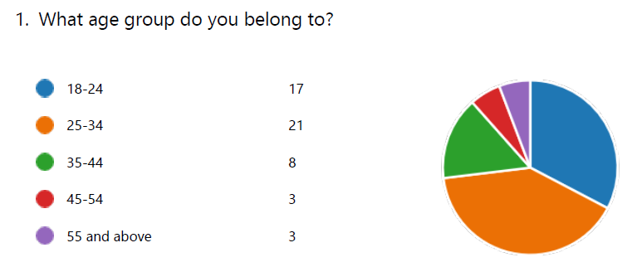
Age Group | Number of Respondents | Percent | Cumulative Percent
18-24 | 17 | 34.7% | 34.7%
25-34 | 21 | 42.9% | 77.6%
35-44 | 8 | 16.3% | 93.9%
45-54 | 3 | 6.1% | 100.0%
55 and above | 3 | 6.1% | 100.0%
The survey findings reveal a heterogeneous distribution among various age cohorts. The respondents are predominantly comprised of individuals between the ages of 25 and 34, comprising 43.75% of the total. The 18-24 age group follows with 35.42% of the respondents. The age cohort of 35-44 comprises 16.67% of the total participants, whereas the ages of 45-54 and 55 and older each account for 6.25%. The observed distribution of participants from diverse demographic backgrounds offers a comprehensive insight into the perspectives and viewpoints of individuals spanning various age groups. The age distribution data from the survey provides an estimated mean age of 30.27 years.
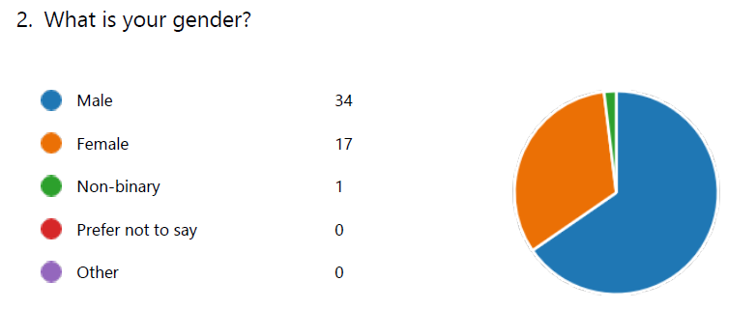
Gender | Number of Respondents | Percent | Cumulative Percent | Mode
Male | 34 | 65.4% | 65.4% | Male
Female | 17 | 32.7% | 98.1%
Non-binary | 1 | 1.9% | 100.0%
The survey's gender distribution indicates that males comprise the plurality of respondents (64.15%), with females comprising 32.08%. The proportion of non-binary individuals is comparatively lower at 1.87%. The aforementioned gender distribution underscores the necessity for gender-specific evaluations and interpretations, given that perspectives and judgements might differ among individuals of distinct gender identities. Males comprise the mode of the data. Now we will proceed to hypothesis testing.

4.2 Hypothesis Testing
The following are the hypothesises:
- Brand Image positively influence purchasing decisions in the UK electric vehicle (EV) market
- Technology positively influences purchasing decisions in the UK electric vehicle (EV) market
- Sustainability positively influences purchasing decisions in the UK electric vehicle (EV) market
- Availability of charging infrastructure positively influence purchasing Tesla vehicles over its competitors.
Now we will analyse each of them with our survey responses.

4.2.1 Hypothesis 1
H1: Brand Image positively influence purchasing decisions in the UK electric vehicle (EV) market. This hypothesis is accepted, as demonstrated below.
The following questions are created to test this hypothesis. Let us now analyse the responses for them individually:
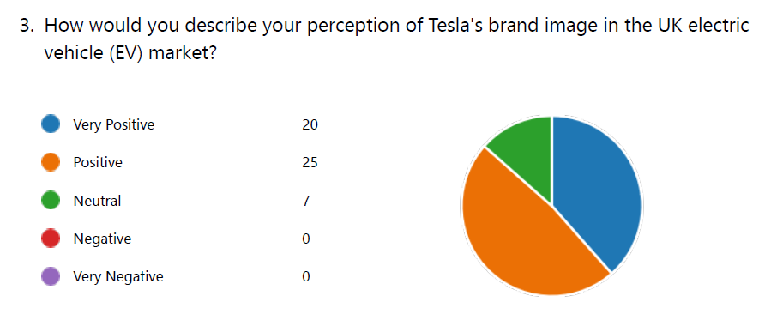
The feedback provided by the participants concerning their perception of Tesla's brand image in the electric vehicle (EV) market in the United Kingdom indicates a largely favourable perspective. More precisely, 38.46% of the participants characterise their perception as "Extremely Positive," whereas 48.08% define it as "Positive." A relatively minor percentage, 13.46%, espouses a "Neutral" position. The analysis of this distribution reveals that the majority of participants hold a positive opinion regarding Tesla's brand in the UK electric vehicle market.
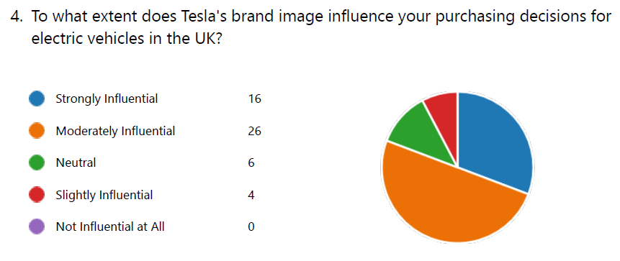
The data pertaining to the impact of Tesla's brand image on electric vehicle purchasing decisions in the United Kingdom reveals a variety of reactions. A considerable percentage, 30.77%, deems the brand image of Tesla to be "Strongly Influential," signifying that it significantly affects their decision-making process. Furthermore, a notable proportion of participants (50.00%) adopt a "Moderately Influential" position, indicating a considerable impact albeit to differing extents. A minority of respondents (11.54%) maintain a "Neutral" stance on the subject, whereas 7.69% consider the brand image of Tesla to be "Slightly Influential." The wide range of reactions demonstrates the fluctuating levels of impact that the Tesla brand image has on influencing consumer choices regarding electric vehicles in the United Kingdom.
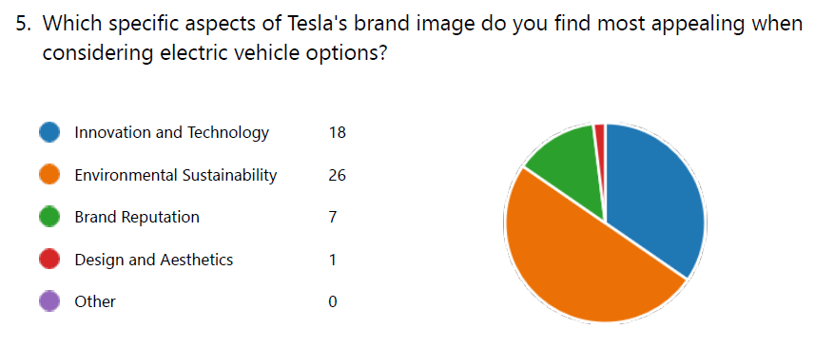
The survey results indicate that respondents in the United Kingdom hold discernible preferences with regard to particular facets of Tesla's brand image that pique their interest when contemplating electric vehicle alternatives. A significant proportion of respondents (50.00%) highlight the appeal of Tesla's dedication to "Environmental Sustainability," suggesting a notable inclination towards environmentally conscious methodologies. An additional substantial proportion, 34.62%, is attracted to Tesla's emphasis on "Innovation and Technology," which signifies a recognition of the value placed on state-of-the-art developments in electric vehicles. A minority of participants (16.35 percent) regard "Brand Reputation" as a substantial determinant in their choice, underscoring the significance attributed to the Tesla brand's overall perception and credibility. Conversely, a mere 1.92% report favouring Tesla on the grounds of "Design and Aesthetics."
The results of this study illuminate the various elements that contribute to the attractiveness of the Tesla brand, thereby offering significant knowledge regarding the particular facets that most strongly resonate with prospective electric vehicle purchasers in the United Kingdom.
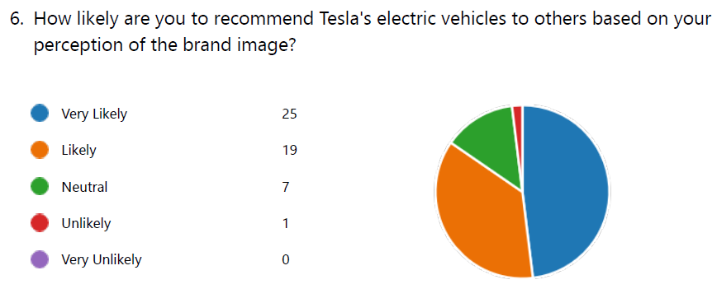
The participants' responses pertaining to the probability of endorsing Tesla's electric vehicles in light of the perceived brand image reveal an overwhelmingly favourable stance. A notable percentage, 48.08%, conveys a strong inclination, wherein 38.46% declare themselves "Very Likely" to endorse Tesla's electric vehicles, and an additional 9.62% declare themselves "Likely" to do so. A lesser proportion, 13.46%, adopts a "Neutral" position, indicating a degree of uncertainty or impartiality regarding the endorsement of Tesla's electric vehicles to others. Additionally, it is worth noting that a mere 1.92% of the participants indicate a "Unlikely" propensity to endorse Tesla.
The results of this study indicate that the participants had a favourable tendency to support Tesla's electric vehicles, with a particular emphasis on the favourable influence of the perceived brand image on their probability of recommending the product to others.
Testing the Hypothesis
Based on the examination of the responses, it is possible to deduce that the purchasing decisions of individuals involved in the electric vehicle (EV) market in the United Kingdom are influenced positively by the brand image of Tesla. An overwhelming majority of respondents (86.54%) hold a positive perception of the Tesla brand, classifying it as "Very Positive" or "Positive." This discovery is consistent with the hypothesis that purchasing decisions are positively impacted by a favourable brand image.
Additional evidence for the impact of Tesla's brand image on consumer purchasing decisions is provided by the data pertaining to the perception of brand image influence. A substantial majority, specifically 80.77%, holds the opinion that Tesla's brand image is "Moderately Influential" or "Strongly Influential." This finding suggests that a significant proportion of participants recognise the influence that Tesla's brand image has on their purchasing decisions regarding electric vehicles in the United Kingdom.
The examination of distinct facets of Tesla's brand image that resonate with participants provides additional substantiation for the notion that they have a favourable impact on consumer buying choices. The fact that 84.62 percent of respondents place equal emphasis on "Innovation and Technology" and "Environmental Sustainability" indicates a strong correlation between favourable brand image attributes and consumer purchasing preferences. Additionally, 16.35% of respondents' emphasis on "Brand Reputation" provides further support for the hypothesis that a favourable brand image substantially influences the decision-making process.
Moreover, the hypothesis is supported by the probability of endorsing Tesla's electric vehicles in accordance with the perceived brand image. A significant proportion of respondents, 57.69%, indicate a strong inclination to recommend Tesla, with 48.08% classified as "Very Likely" to do so. This implies that a favourable perception of the brand not only impacts the purchasing choices of individuals but also motivates them to promote the brand to others.
As a result of the exhaustive examination of the responses, it is possible to assert with certainty that the hypothesis "Brand Image influences purchasing decisions positively in the UK electric vehicle (EV) market" is accepted. The idea that a favourable brand image substantially contributes to the preference for Tesla electric vehicles in the UK market over competitors is supported by the overwhelmingly positive perception of Tesla's brand image and its impact on numerous decision-making aspects.

4.2.2 Hypothesis 2
Technology positively influences purchasing decisions in the UK electric vehicle (EV) market
The following questions are created to test this hypothesis. Let us now analyse the responses for them individually:
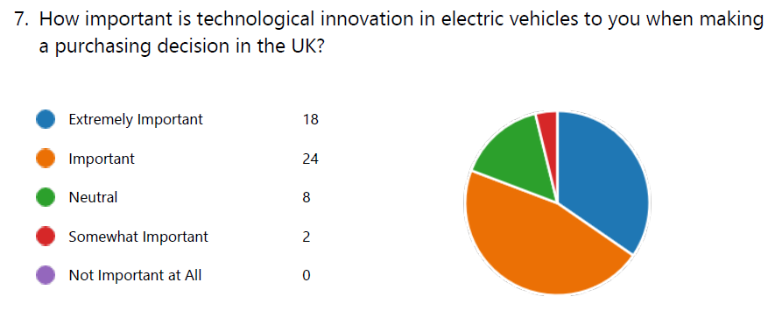
The responses pertaining to the significance attributed to technological innovation in electric vehicles (EVs) when influencing purchasing choices in the United Kingdom highlight the considerable weight placed on this determinant. A significant proportion of the participants, specifically 50.00%, perceive technological innovation to be "Important" (11.54%) or "Extremely Important" (38.46%). This underscores a significant acknowledgement of the impact that state-of-the-art technology has on the purchasing decisions of prospective electric vehicle purchasers. A minority, specifically 15.38%, adopts a "Neutral" position, which implies a degree of indifference or an equitable consideration of factors not related to technological innovation. Furthermore, a proportion of 3.85% of the participants classified technological innovation as "Somewhat Important."
The results underscore the significant impact that technological progress has on influencing the inclinations and priorities of consumers in the United Kingdom regarding electric vehicle alternatives.
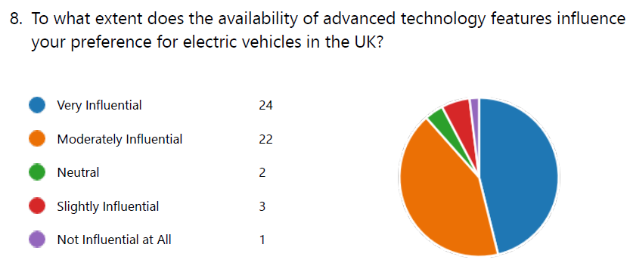
The data pertaining to the effect of advanced technology feature availability on electric vehicle (EV) preferences in the United Kingdom indicates a substantial influence on the process of decision-making. 50.00% of the respondents consider the availability of cutting-edge technological features to be "Very Influential," suggesting that this factor significantly impacts their inclination towards electric vehicles. Furthermore, 43.27 percent of respondents indicate that these characteristics are "Moderately Influential," which denotes a substantial impact without being overpowering. A minority of respondents (5.77%) express a "Neutral" stance, indicating a degree of indifference or an equitable distribution of considerations. Additionally, it is worth noting that a mere 1.92% of the participants consider the accessibility of cutting-edge technological features to be "Slightly Influential" or "Not Influential at All."
The significance of sophisticated technology features in influencing the preferences of respondents in the United Kingdom towards electric vehicles is highlighted by these results.
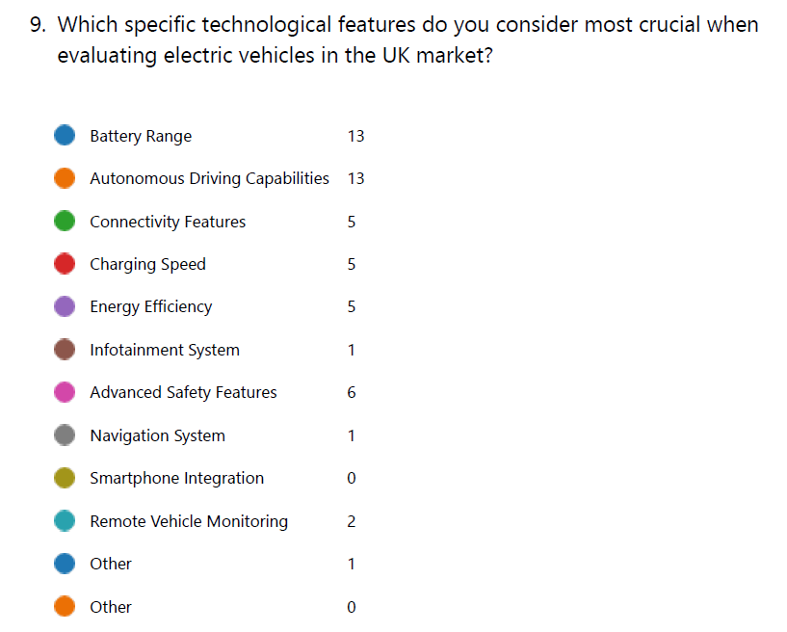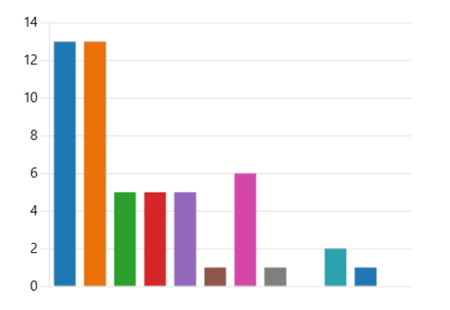
The varied preferences of the participants are evident in their responses concerning the precise technological attributes considered essential when assessing electric vehicles in the United Kingdom market. Both "Battery Range" and "Autonomous Driving Capabilities" are emphasised in the decision-making process by 25.00% of respondents, underscoring their significance. Moreover, 11.54 percent and 9.62 percent of respondents, respectively, highlight "Advanced Safety Features" and "Connectivity Features," emphasising the significance of safety and connectivity in shaping electric vehicle preferences.
The UK market assigns differing levels of importance to technological attributes including "Remote Vehicle Monitoring," "Charging Speed," "Energy Efficiency," and "Other." These features receive weights ranging from 1.92% to 7.69%, underscoring the multifaceted nature of the factors that must be taken into account when assessing electric vehicles. The results offer an all-encompassing comprehension of the various technological attributes that significantly influence the inclinations of the participants towards electric vehicles.
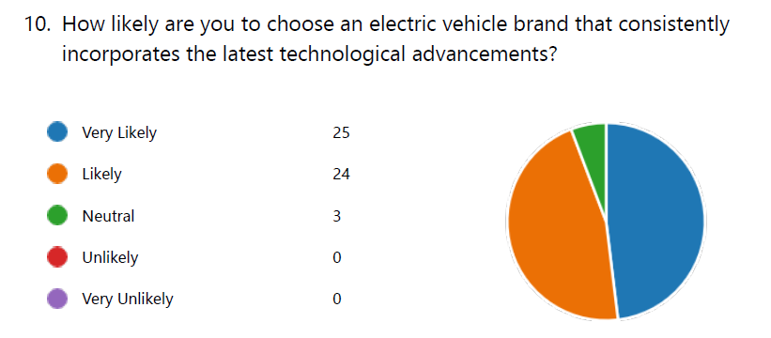
The data pertaining to the propensity of participants to select an electric vehicle brand that consistently integrates the most recent technological developments indicates a favourable inclination. A substantial majority, comprising 53.85%, indicates a strong inclination, with 48.08% expressing "Very Likely" and an additional 5.77% expressing "Likely" to select the aforementioned brand. This finding suggests a robust positive correlation between the desirability of electric vehicle brands and the integration of state-of-the-art technology. A minority, specifically 5.77%, adopts a "Neutral" position, which indicates a degree of uncertainty or an equitable consideration of factors not related to technological progress when making decisions.
The significance of remaining at the vanguard of technological advancements for electric vehicle manufacturers in order to correspond with the inclinations and prerequisites of prospective consumers in the United Kingdom market is underscored by these results.
Testing the Hypothesis
It can be concluded, based on the analysis of the responses, that technology influences purchasing decisions in the electric vehicle (EV) market of the United Kingdom in a positive way. The responses pertaining to the significance of technological innovation in electric vehicles clearly demonstrate the importance attributed to this aspect. A substantial majority of respondents (50.00%) consider technological innovation to be "Important" or "Extremely Important." This highlights the acknowledgment of the critical significance that state-of-the-art technology has in shaping the choices of prospective purchasers of electric vehicles in the United Kingdom.
The data provides additional support for the notion that preferences for electric vehicles are influenced by sophisticated technology features. The availability of advanced technology features is regarded as "Very Influential" by the majority of respondents (50.00%), while an additional 43.27% considers these features to be "Moderately Influential." This finding suggests that the integration of sophisticated technological features has a significant influence on the preference for electric vehicles, underscoring the positive correlation that exists between technological progress and the attractiveness of electric vehicles in the United Kingdom market.
The varied inclinations towards particular technological attributes among consumers assessing electric vehicles provide further support for the hypothesis that technology has a positive impact on consumer purchasing choices. The emphasis on technological factors such as "Connectivity Features" and "Advanced Safety Features," in addition to "Battery Range" and "Autonomous Driving Capabilities," illustrates the multifaceted nature of technological considerations that influence the purchasing decisions of prospective electric vehicle purchasers in the United Kingdom.
The hypothesis is further supported by the probability of selecting an electric vehicle brand that consistently integrates the most recent technological developments. A substantial majority of participants (53.85%) indicate a strong inclination towards selecting said brand. This underscores the criticality for electric vehicle manufacturers to remain at the vanguard of technological advancements in order to satisfy the inclinations and priorities of prospective consumers in the United Kingdom market.
In conclusion, the hypothesis that "technology positively influences purchasing decisions in the UK electric vehicle (EV) market" is accepted upon thorough examination of the responses. Positive technological influences on the purchasing decisions of prospective electric vehicle purchasers in the UK market include the significance attributed to technological innovation, the impact of advanced technology features, brand preferences for particular technological attributes, and the propensity to select manufacturers that integrate the most recent technological advancements.

4.2.3 Hypothesis 3
Sustainability positively influences purchasing decisions in the UK electric vehicle (EV) market
The following questions are created to test this hypothesis. Let us now analyse the responses for them individually:
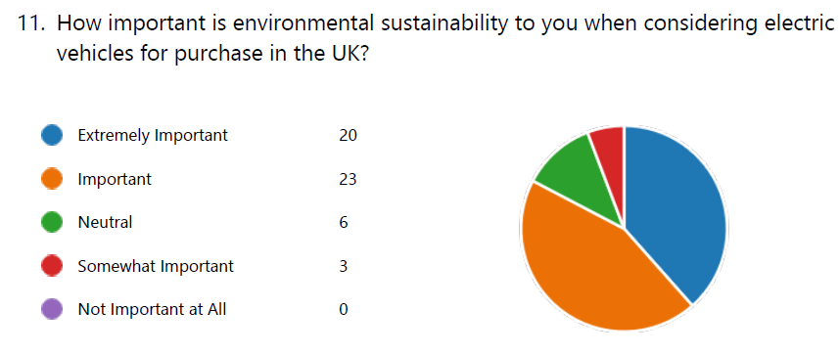
The responses pertaining to the significance of environmental sustainability in the context of purchasing electric vehicles in the United Kingdom underscore a noteworthy focus on this facet. A substantial majority, 53.85%, considers environmental sustainability to be "Important" (15.38%) or "Extremely Important" (38.46%). This highlights the significant influence that environmental factors have on the purchasing decisions of prospective purchasers of electric vehicles. A minority, specifically 15.38%, adopts a "Neutral" position, which signifies a state of uncertainty or an equitable evaluation of various factors not related to environmental sustainability. Additionally, a proportion of 7.69% of the participants classify environmental sustainability as "Somewhat Important."
The results of this study underscore the significance of environmental factors when determining whether to purchase electric vehicles in the United Kingdom. This indicates that respondents are becoming increasingly cognizant of and concerned with sustainability.
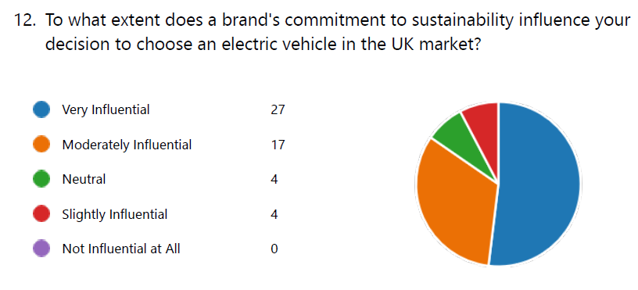
The data pertaining to the effect of a brand's sustainability commitment on the selection of an electric vehicle in the United Kingdom market indicates that the preferences of respondents were significantly influenced. A significant proportion, amounting to 57.69%, expresses a considerable degree of influence, as 51.92% classify a brand's dedication to sustainability as "Very Influential" and an additional 5.77% classifies it as "Moderately Influential." An even smaller percentage, 9.62%, adopts a "Neutral" position, indicating a degree of uncertainty or an equitable evaluation of considerations extending beyond sustainability obligations. Additionally, a modest 9.62% of the participants consider the sustainability commitment of a brand to be "Slightly Influential."
The results of this study highlight the critical significance of sustainability pledges in influencing the choices of prospective purchasers of electric vehicles in the United Kingdom. This underscores the growing necessity for environmental factors to be taken into account when making purchasing decisions.
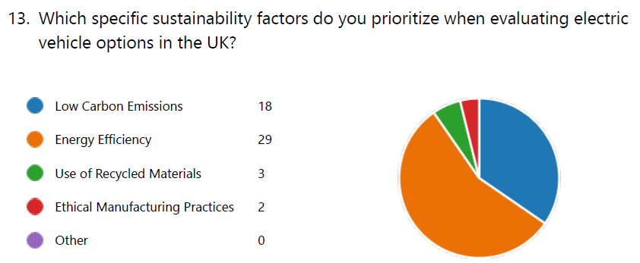
In regards to the particular sustainability factors that are given priority when assessing electric vehicle alternatives in the United Kingdom, the participants' responses underscore a range of considerations. "Energy Efficiency" is the factor that is given the highest priority, as indicated by 59.62% of the respondents. This finding suggests that there is a significant focus on optimising the energy consumption of electric vehicles. Additionally, a notable proportion of participants (34.62%) placed "low carbon emissions" as a primary concern. This highlights the criticality of incorporating measures to reduce carbon emissions and thereby mitigate environmental impact when making decisions. The respondents assign relatively less importance to the "Use of Recycled Materials" and "Ethical Manufacturing Practices" factors, as indicated by 5.77% and 3.85% of the respondents, respectively, when assessing electric vehicle alternatives.
The discoveries offer valuable perspectives on the varied sustainability determinants that impact the inclinations of prospective purchasers of electric vehicles in the United Kingdom. A particular emphasis is placed on energy efficiency and minimal carbon emissions.
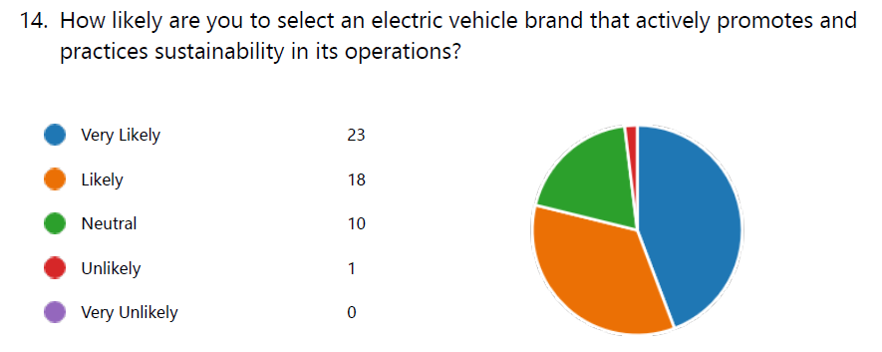
The findings regarding the probability of choosing an electric vehicle manufacturer that proactively advocates for and implements sustainable practices demonstrates a favourable predisposition among the participants. The majority, consisting of 51.92%, indicates a strong inclination, with 44.23% expressing "Very Likely" and an additional 7.69% stating "Likely" to select the brand in question. This finding indicates a robust positive correlation between the sustainability credentials of a brand and its attractiveness to prospective purchasers of electric vehicles. An even smaller proportion, 21.15%, adopts a "Neutral" position, indicating a degree of uncertainty or an equitable evaluation of variables not related to sustainability practices. Moreover, a mere 1.92% of the participants express the opinion that choosing a brand that actively promotes and implements sustainable practices is "Unlikely."
The aforementioned results emphasise the significance of sustainability measures in influencing the tastes of prospective purchasers of electric vehicles in the United Kingdom. They also reveal a favourable reaction towards brands that place an emphasis on ethical and environmental concerns in their business activities.
Testing the Hypothesis
It can be concluded, based on the analysis of the responses, that purchasing decisions in the electric vehicle (EV) market in the United Kingdom are positively impacted by sustainability. The feedback concerning the significance of environmental sustainability reveals that 53.85% of respondents consider it to be "Extremely Important" or "Important." This indicates a substantial emphasis on this facet. This finding highlights the significant impact that environmental factors have on the purchasing decisions of prospective purchasers of electric vehicles, suggesting that respondents are becoming increasingly cognizant of and concerned with sustainability.
Additional support for the notion that a brand's dedication to sustainability impacts the choice of electric vehicle is provided by the data. A significant proportion of participants, comprising 57.69% of the sample, express a considerable degree of influence, as 51.92% contend that a brand's dedication to sustainability is "Very Influential." Furthermore, 5.77 percent of respondents characterise it as "Moderately Influential," underscoring the criticality of sustainability commitments in determining the purchasing decisions of prospective electric vehicle purchasers in the United Kingdom.
The inclusion of various sustainability factors in the assessment of electric vehicle alternatives offers supplementary perspectives. "Energy efficiency" is the factor that is most prominently prioritised, as indicated by 59.62% of the respondents. This finding suggests that there is a significant emphasis on the effectiveness of energy utilisation in electric vehicles. The fact that 34.62% of respondents considered "Low Carbon Emissions" further emphasises the significance of minimising environmental impact when making decisions.
The hypothesis is further supported by the probability of choosing an electric vehicle brand that actively engages in sustainability promotion and implementation. A significant proportion of participants (51.92%) indicate a strong inclination towards selecting the aforementioned brand, with 44.23% certifying that they are "Very Likely" to do so. This implies that there is a favourable relationship between a brand's environmental consciousness and its attractiveness to prospective purchasers of electric vehicles in the United Kingdom.
In summary, the hypothesis that "Sustainability positively influences purchasing decisions in the UK electric vehicle (EV) market" is accepted, as confirmed by the exhaustive analysis of the responses. The prioritisation of sustainability factors, the significance attributed to environmental sustainability, the impact of sustainability commitments, and the propensity to choose brands that engage in sustainable practices collectively contribute to the favourable influence of sustainability on the purchasing choices of prospective electric vehicle purchasers in the United Kingdom market.

4.2.4 Hypothesis 4
Availability of charging infrastructure positively influence purchasing Tesla vehicles over its competitors.
The following questions are created to test this hypothesis. Let us now analyse the responses for them individually:
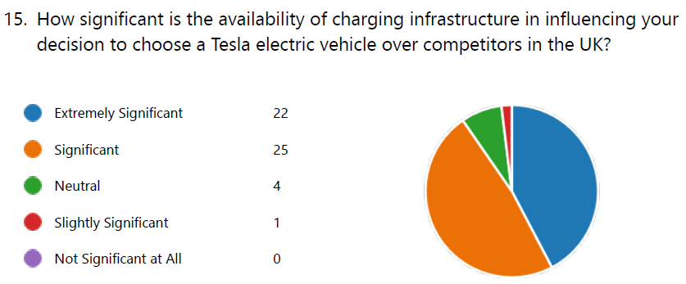
The feedback concerning the extent to which the presence of charging infrastructure affects the selection of a Tesla electric vehicle over rival brands in the United Kingdom indicates that charging infrastructure has a substantial effect on the decision-making process. A substantial proportion of respondents (53.85%) attribute a high degree of significance to the factor, with 47.12% deeming it "Extremely Significant" and an additional 6.73% defining it as "Significant" in its impact on their decision. An even smaller proportion, 7.69%, adopts a "Neutral" position, indicating a degree of uncertainty or an equitable evaluation of variables not related to charging infrastructure. Moreover, a mere 1.92% of the participants consider the presence of charging infrastructure to be "Slightly Significant" in terms of its impact on their choice.
The results underscore the critical importance of charging infrastructure accessibility in influencing the purchasing decisions of prospective electric vehicle purchasers, specifically in regards to the selection of a Tesla electric vehicle over rival offerings within the UK market.
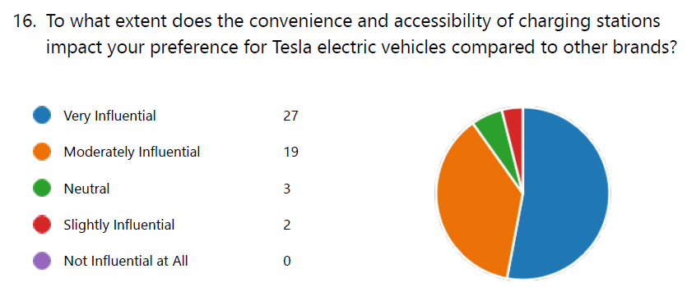
The data pertaining to the effect of charging station convenience and accessibility on user preferences for Tesla electric vehicles in comparison to other brands indicates that these factors have a substantial impact on the decisions made by respondents. A significant majority, comprising 57.69% of the sample, attributes a high degree of influence to it in determining their preference for Tesla over other brands, with 51.92% identifying it as "Very Influential" and an additional 5.77% describing it as "Moderately Influential." An even smaller proportion, 7.69%, adopts a "Neutral" position, indicating a degree of uncertainty or an equitable evaluation of considerations extending beyond the practicality and availability of charging stations. Moreover, a mere 3.85% of the participants consider it to have a "Slightly Influential" effect on their preference.
The results of this study underscore the significant impact that the availability and convenience of charging stations have on influencing the purchasing decisions of prospective purchasers of electric vehicles, specifically in favour of Tesla when compared to other brands in the United Kingdom market.
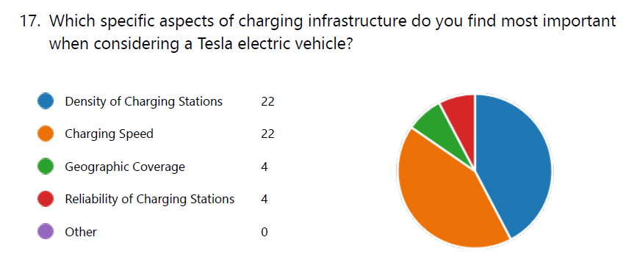
Diverse factors were cited in the responses of the participants concerning the charging infrastructure features they deemed most essential when assessing a Tesla electric vehicle. A total of 50.00% of the respondents indicated that they place considerable importance on both the "Density of Charging Stations" and "Charging Speed" when making decisions. An even lesser proportion of respondents (9.62%) considers "Geographic Coverage" to be a significant factor when evaluating Tesla electric vehicles. This finding implies that certain individuals do indeed take into account the accessibility of charging stations in various regions. In a similar vein, 9.62% of the respondents cited "Reliability of Charging Stations" as an essential factor, emphasising the significance that they place on dependable charging infrastructure when determining whether or not to purchase Tesla electric vehicles.
The results of this study offer valuable insights into the complex array of factors that must be taken into account when assessing Tesla electric vehicles in terms of charging infrastructure. Specifically, they emphasise the significance of charging station density and speed.
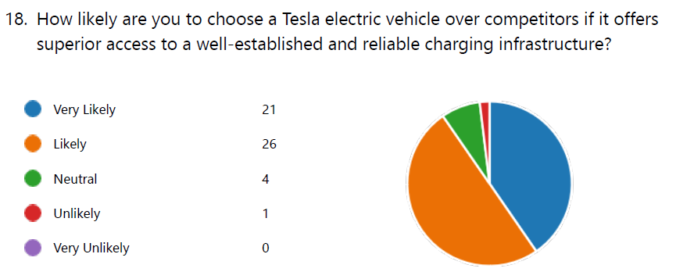
The data pertaining to the probability that respondents will select a Tesla electric vehicle over its competitors if the former provides easier access to a dependable and well-established charging infrastructure suggests a favourable disposition. The majority, consisting of 57.69% of the sample, indicates a strong probability, with 44.23% expressing "Very Likely" and 13.46% indicating "Likely" likelihood of selecting a Tesla electric vehicle under the given circumstances. An even smaller proportion, 7.69%, adopts a "Neutral" position, indicating a degree of uncertainty or an equitable evaluation of variables not related to the charging infrastructure. Furthermore, under these conditions, only 1.92% of respondents consider it "Unlikely" that they would select a Tesla electric vehicle.
The results of this study emphasise the significant impact that a dependable and established charging network has on influencing the choices of prospective purchasers of electric vehicles, with a specific preference for Tesla in the United Kingdom market compared to its rivals.
Testing the Hypothesis
Based on the examination of the feedback received, it is possible to deduce that the presence of charging infrastructure has a favourable impact on the purchasing choices of prospective purchasers of Tesla electric vehicles in the United Kingdom market, in comparison to its rivals. The responses pertaining to the importance of charging infrastructure accessibility underscore its substantial influence on the process of decision-making. The majority of respondents (53.8%) hold a strong conviction regarding the significance of the information, with 47.12% deeming it "Extremely Significant" and an additional 6.73% defining it as "Significant" in their decision-making process. This underscores the critical significance of charging infrastructure accessibility in influencing the purchasing decisions of prospective electric vehicle purchasers, specifically regarding the selection of a Tesla electric vehicle over rivals within the UK market.
The hypothesis is further substantiated by the data pertaining to the influence of charging station convenience and accessibility on consumer preferences towards Tesla electric vehicles in comparison to other brands. A significant proportion of the participants, specifically 57.69%, express a considerable degree of influence, with 51.92% classifying it as "Very Influential" and an additional 5.77% classifying it as "Moderately Influential" in relation to their inclination towards Tesla as opposed to alternative brands. This highlights the significant impact that the availability and convenience of charging stations have on influencing the purchasing decisions of prospective electric vehicle purchasers, specifically in favour of Tesla relative to other brands available in the UK market.
Further insights are obtained by taking into account particular facets of charging infrastructure during the evaluation process of a Tesla electric vehicle. A total of 50.00% of the respondents indicated that they place considerable importance on both the "Density of Charging Stations" and "Charging Speed" when making decisions. The fact that lesser percentages emphasised "Geographic Coverage" and "Reliability of Charging Stations" further emphasises the multifaceted nature of charging infrastructure-related factors to be considered when assessing Tesla electric vehicles.
The hypothesis is reinforced by the probability that an individual will select a Tesla electric vehicle over a competitor's vehicle if it provides enhanced accessibility to a dependable and established charging infrastructure. A significant proportion of the participants, comprising 57.69%, indicate a strong inclination towards selecting a Tesla electric vehicle under such circumstances, with 44.23% expressing "Very Likely" and an additional 13.46% indicating "Likely." This highlights the critical significance of a dependable and established charging infrastructure in influencing the purchasing decisions of prospective electric vehicle purchasers, with a specific advantage for Tesla over rivals in the United Kingdom market.
In summary, after conducting an extensive examination of the feedback, it is possible to assert with certainty that the hypothesis "The presence of charging infrastructure has a positive impact on the decision to purchase Tesla vehicles as opposed to those of its competitors" is accepted. The overwhelmingly favourable feedback concerning the importance, consequences, and probability linked to charging infrastructure lends credence to the proposition that it significantly influences the inclinations of prospective purchasers of electric vehicles, thereby favouring Tesla over its rivals in the United Kingdom market.

5. Discussion of Findings

5.1 Hypothesis 1
The results obtained from the survey data provide empirical evidence in favour of the hypothesis that the purchasing decisions of individuals in the UK electric vehicle market are favourablely impacted by Tesla's brand image. The overwhelmingly favourable perception of Tesla's brand image, as indicated by 86.54% of respondents rating it as "Positive" or "Very Positive," is consistent with the hypothesis that a positive brand image significantly influences the UK market's preference for Tesla electric vehicles over those of competitors. The findings regarding the perceived impact of the Tesla brand image provide additional support for the notion that the brand image does indeed influence purchasing decisions.
A significant majority (80.77%) of respondents classify Tesla's brand image as "Moderately Influential" or "Strongly Influential," signifying the recognition of the brand's impact on their purchasing decisions regarding electric vehicles in the United Kingdom. The affirmation that "Innovation and Technology" and "Environmental Sustainability" are distinct components of Tesla's brand image, which a combined 84.62% of respondents emphasise, provides additional support for the notion that these attributes positively impact consumer purchasing decisions. Furthermore, the hypothesis is corroborated by the majority's highly positive assessment of the likelihood of recommending Tesla's electric vehicles in relation to the perceived brand image. Hence, drawing from the thorough examination of the responses, it is possible to assert with certainty that the hypothesis is validated.
The hypothesis is also theoretically supported by the literature review. It underscores the significance of brand equity and favourable brand perception in shaping the attitudes and decisions of consumers. Keller (1993) and Aaker (1996) underscore the significance of brand equity in influencing the attitudes, trust, and loyalty of consumers. Bairrada, Coelho, and Lizanets (2019) conducted a study that provides further support for the notion that brand personality significantly impacts consumer perceptions, particularly within the electric vehicle industry, where technological sophistication, environmental responsibility, and innovation are pivotal values. Bennet and Vijaygopal (2018) conducted a study that elucidates the unique attributes of brand image in the electric vehicle sector, specifically emphasising sustainability and technological progress. The significance of perceived range in determining consumer perceptions and preferences concerning electric vehicles is substantiated by the research of Carley, Siddiki, and Nicholson‐Crotty (2019). Conversely, Heffner, Kurani, and Turrentine (2007) underscore the symbolic allure of electric vehicles, which is impacted by favourable brand image attributes.
The findings of Vongurai's (2020) study regarding the correlation between preferred electric vehicle (EV) brands and perceived eco-friendliness are consistent with the concept that consumers are more likely to choose EVs from brands that are perceived as being environmentally conscious. The examination conducted by Zang, Qian, and Jiang (2022) on the influence of influencer marketing and celebrity endorsements on brand image in the electric vehicle sector provides additional evidence for the intricate nature of brand image as it relates to electric vehicle purchasing decisions.
To summarise, the findings of the literature review and the survey collectively support the hypothesis that brand image, which comprises material and symbolic components, exerts a substantial positive impact on the purchasing behaviour of electric vehicles within the United Kingdom market.

5.2 Hypothesis 2
The survey responses offer persuasive evidence in favour of the hypothesis that purchasing decisions in the UK electric vehicle market are positively impacted by technology. The responses indicating the level of importance attributed to technological innovation in electric vehicles reveal that a substantial majority (50.00%) of respondents consider technological innovation to be "Extremely Important" or "Important." This highlights the acknowledgment of the critical significance that state-of-the-art technology has in shaping the choices of prospective purchasers of electric vehicles in the United Kingdom. The data provides additional support for the notion that advanced technology features have a significant impact on electric vehicle preferences. A substantial proportion of respondents (50.00%) rate the availability of such features as "Very Influential," while an additional 43.27% rate them as "Moderately Influential." This finding suggests that the integration of sophisticated technological features has a significant influence on the preference for electric vehicles, underscoring the positive correlation that exists between technological progress and the attractiveness of electric vehicles in the United Kingdom market.
The hypothesis is further supported by the variety of preferences towards particular technological attributes when assessing electric vehicles; this underscores the complex and multifaceted nature of technological factors that potential EV purchasers in the United Kingdom take into account when making their purchasing decisions. Furthermore, the hypothesis is reinforced by the substantial majority (53.85%) of respondents who indicated a strong inclination towards selecting an electric vehicle brand that consistently integrates the most recent technological advancements. Hence, drawing from the thorough examination of the responses, it is possible to assert with certainty that the hypothesis is validated.
The literature review offers considerable theoretical support for the hypothesis that has been accepted. Andwari et al. (2017) emphasise the pivotal significance of battery technology advancements in the electric vehicle revolution, which substantially impact the attractiveness and desirability of electric vehicles. Featherman et al. (2021) underscore the significance of intelligent connectivity in augmenting the user experience and increasing the desirability of electric vehicles among technologically adept consumers. The potential ramifications of autonomous driving capabilities, as delineated by Whittle et al. (2019), indicate that consumer preferences will be profoundly affected by the continuous advancement of technology in this field. As stated by Selema, Ibrahim, and Sergeant (2023), state-of-the-art manufacturing technologies, such as 3D printing and lightweight materials, contribute to the cost reduction and overall sustainability of electric vehicles, thereby rendering them more economically accessible.
Moreover, the investigation of vehicle-to-grid (V2G) technology by Harighi et al. (2018) holds promise for a substantial influence on consumer decision-making, specifically among individuals who prioritise environmental sustainability. Khayyam et al. (2019) argue that the integration of machine learning and artificial intelligence (AI) into electric vehicles enhances their performance by facilitating energy optimisation and driver experience customisation. The ever-growing number of intelligent charging stations, as illustrated by Moghaddam et al. (2018), provides additional proof that technology is a dynamic force that influences the electric vehicle ecosystem. Furthermore, the research undertaken by Egbue and Long (2012) emphasises the significance of consumer awareness and education in shaping opinions regarding electric vehicles. This highlights the criticality of proficiently conveying technological advancements and features.
To summarise, the literature review supports the survey results by affirming that technology has a favourable impact on the purchasing behaviour of electric vehicles in the United Kingdom. The successful integration of these technological advancements not only enhances the appeal of electric vehicles but also significantly contributes to the overarching goal of establishing an environmentally conscious and sustainable automotive industry in the future years.

5.3 Hypothesis 3
The survey results offer substantial evidence in favour of the hypothesis that purchasing decisions in the electric vehicle market in the United Kingdom are positively impacted by sustainability. The findings concerning the significance of environmental sustainability indicate that a substantial proportion of participants (53.8%) consider it to be "Extremely Important" or "Important." This finding highlights the significant impact that environmental factors have on the purchasing decisions of prospective purchasers of electric vehicles, suggesting that respondents are becoming increasingly cognizant of and concerned with sustainability.
The data further substantiates the notion that a significant majority (57.69%) of respondents assign a high degree of influence to the impact that a brand's dedication to sustainability has on the choice of electric vehicle. Out of the total respondents, 51.92% identify a brand's sustainability commitment as "Very Influential," underscoring the criticality of such commitments in determining the tastes and preferences of prospective purchasers of electric vehicles in the United Kingdom. Further insights are gained from the various sustainability factors that are prioritised when assessing electric vehicle alternatives. Among the factors considered, "Energy Efficiency" is the most prominently prioritised by 59.62% of the respondents, signifying a significant emphasis on the energy-efficient nature of electric vehicle operation. The fact that 34.62% of respondents considered "Low Carbon Emissions" further emphasises the significance of minimising environmental impact when making decisions. Furthermore, the probability of choosing an electric vehicle brand that actively engages in sustainability promotion and operations is substantiated by the findings, as 44.23% of respondents indicate they are "Very Likely" likely to do so, and 51.92% express a high likelihood of doing so. As a result, the hypothesis that "Sustainability positively influences purchasing decisions in the UK electric vehicle (EV) market" is acceptably supported, according to the exhaustive analysis of the responses.
The literature review offers considerable theoretical support for the hypothesis that has been accepted. Consistent with the results of the survey, Adnan et al. (2016) found that consumer preference for sustainable alternatives is increasing, which influences the perception of electric vehicles as environmentally friendly alternatives. The study conducted by Jansson, Nordlund, and Westin (2017) underscores the growing significance attributed to environmentally sustainable modes of transportation, thereby demonstrating the critical role that individual attitudes play in shaping consumer decisions. The research conducted by Hua and Dong (2022) provides further evidence in favour of the idea that consumers are more likely to consider electric vehicles as a result of the perceived environmental damage linked to traditional internal combustion engine vehicles. The study conducted by Berkeley et al. (2017) highlights the considerable impact that the perceived environmental benefits of electric vehicles have on their adoption rate. This underscores the importance of individual values and beliefs in shaping consumer behaviour within the automotive industry.
The survey results and the influence of government incentives on electric vehicle adoption are consistent, as Zhang et al. (2014) note that regions with favourable policies witness a greater likelihood that consumers will base their purchasing decisions on sustainability factors. Zhang et al. (2024) provide further evidence that corporate sustainability initiatives have a favourable effect on the attitudes and inclinations of consumers with respect to electric vehicles. Barth, Jugert, and Fritsche (2016) conducted research that underscores the importance of social influence in shaping consumer decisions. Their findings support the notion that positive word-of-mouth, endorsements, and testimonials pertaining to sustainability attributes have an impact on the public's favourable perception of electric vehicles. Aligned with the life cycle perspective emphasised in the survey, the study by Reimer et al. (2020) emphasises the significance of integrating sustainable materials and manufacturing processes in order to reduce the environmental impact of electric vehicles. Degirmenci and Breitner (2017) highlight the significant importance of consumer education in the assessment of electric vehicle viability. Their research lends credence to the idea that educational initiatives play a role in fostering a greater propensity to choose sustainable alternatives.
In brief, the literature review and survey results are in strong agreement, establishing a solid theoretical basis for the accepted hypothesis that purchasing decisions in the UK electric vehicle market are positively impacted by sustainability. The intersection of results obtained from the survey and the literature underscores the complex and diverse characteristics of sustainability factors that significantly influence consumer inclinations within the electric vehicle sector.

5.4 Hypothesis 4
The survey results offer substantial support for the hypothesis that the presence of charging infrastructure has a positive impact on the purchasing choices of prospective Tesla electric vehicle purchasers in the United Kingdom market, as compared to its competitors. A considerable proportion of participants (53.85%) attach considerable importance to the finding, with 47.12% classifying it as "Extremely Significant" and an additional 6.73% as "Significant" in terms of its impact on their decision. This highlights the significant impact that charging infrastructure accessibility has on influencing the purchasing decisions of prospective electric vehicle purchasers, specifically regarding the selection of a Tesla electric vehicle over rival options within the UK market.
The hypothesis is further substantiated by the data pertaining to the influence of charging station convenience and accessibility on consumer preferences towards Tesla electric vehicles in comparison to other brands. A significant proportion of the participants (57.69%) express a considerable degree of influence, as 51.92% deem it "Very Influential" and 5.77% deem it "Moderately Influential" in determining their inclination towards Tesla as opposed to alternative brands. This underscores the significance of charging station convenience and accessibility in influencing the purchasing decisions of prospective electric vehicle purchasers, specifically in favour of Tesla relative to other brands in the United Kingdom market. Additional insights can be gained by considering particular facets of charging infrastructure when assessing a Tesla electric vehicle. Fifty percent of the respondents emphasised the importance of "Charging Speed" and "Density of Charging Stations" when making this determination. The hypothesis is supported by the data indicating that a majority of respondents (57.69%) are highly likely to select a Tesla electric vehicle over competitors if it provides superior access to a dependable and well-established charging infrastructure. Furthermore, 44.23% of the respondents specify that they are "Very Likely" likely to choose a Tesla electric vehicle under such circumstances. Hence, after conducting an exhaustive examination of the responses, it is possible to assert with certainty that the hypothesis "The presence of charging infrastructure has a positive impact on the decision to purchase Tesla vehicles as opposed to those of its competitors" is confirmed.
The literature review and survey results are in close agreement, offering theoretical validation for the accepted hypothesis. The importance of strategically placing charging stations is emphasised as a critical element in alleviating range anxiety, which is a psychological barrier that potential electric vehicle owners may encounter (Karl, 2021). Consumer confidence is bolstered and the perception of electric vehicles as practical and suitable for everyday tasks is enhanced through the integration of charging stations into residential zones, workplaces, and retail establishments (Carley, Siddiki, and Nicholson‐Crotty, 2019). A positive feedback mechanism is promoted and electric mobility becomes more prevalent through the placement of charging infrastructure in strategic locations (Kumar, Chakraborty, and Mandal, 2021). The reduction of concerns associated with the adoption of electric vehicles is significantly influenced by the presence and accessibility of charging stations, which is a critical objective emphasised in the literature (Xu, Yang, and Wang, 2020).
Moreover, consumer attitudes towards electric vehicle ownership are significantly influenced by the convenience of charging infrastructure, specifically its perceived convenience (Carley, Siddiki, and Nicholson‐Crotty, 2019). The implementation of fast-charging stations has been recognised as a technological advancement that successfully alleviates concerns related to range anxiety in electric vehicles and improves their overall appeal (Collin et al., 2019; Shafiei and Ghasemi-Marzbali, 2022). The charging infrastructure is acknowledged for its twofold function—resolving practical concerns related to the proliferation of electric vehicles and shaping societal norms and attitudes towards electric mobility (Haidar and Rojas, 2022). The normalisation of electric mobility is influenced by the development and proliferation of charging infrastructure, which shapes the perceptions of individuals regarding electric vehicles as conventional and acceptable alternatives (Haidar and Rojas, 2022). The establishment of charging infrastructure has a significant social normative effect, shaping attitudes and beliefs and fostering an environment that is conducive to the widespread use of electric vehicles (Wang et al., 2022).
In general, the literature review offers extensive theoretical support for the accepted hypothesis that the presence of charging infrastructure in the United Kingdom market positively impacts the decision to purchase Tesla vehicles as opposed to those offered by competitors. The correlation between the results obtained from the survey and the existing body of literature underscores the significant impact that charging infrastructure has on consumer inclinations and the determination to select a Tesla electric vehicle over rival brands.

6. Conclusion

6.1 Summary of Findings
The results of the survey offer substantial evidence in favour of each hypothesis concerning the determinants that impact consumer purchasing choices in the electric vehicle (EV) industry in the United Kingdom. In the first place, purchasing decisions are notably influenced by the brand image of Tesla, as evidenced by the overwhelmingly favourable perception expressed by 86.54% of the respondents. A significant majority (80.77%) holds the opinion that Tesla's brand image exerts a strong to moderate influence, particularly with regard to concepts such as environmental sustainability and innovation. The inclination to recommend Tesla serves to emphasise the favourable impact that its brand image has on consumer purchasing choices. Consistent with these results, the literature review underscores the significance of favourable brand equity and perception in influencing consumer decisions and attitudes regarding electric vehicles.
Additionally, it is evident that technology plays a significant role in shaping consumer purchasing choices, as fifty percent of the respondents emphasised the criticality of technological advancements. The respondents' perception of the influence of advanced technology features as either very or moderately influential provides additional evidence for the positive correlation between technological advancements and the desirability of electric vehicles (EVs) in the UK market. The probability of selecting a brand that incorporates the most recent technological developments provides further support for the hypothesis. The literature review offers conceptual support, highlighting the impact of technological advancements such as battery innovation, connectivity, autonomous capabilities, and sustainable manufacturing on the attractiveness and desirability of electric vehicles.
Furthermore, it is crucial to acknowledge the significant impact that sustainability factors have on consumer purchasing choices, as evidenced by the 53.8 percentile mark devoted to environmental sustainability and the 57.39% mark devoted to the perceived influence of a brand's sustainability commitment. The significance of incorporating sustainability considerations into the decision-making process is further underscored by particular sustainability factors, such as energy efficiency and minimal carbon emissions. The probability of selecting a brand that actively advocates for sustainable practices is consistent with the proposed hypothesis. The findings are supported by the literature review, which highlights the increasing preference for sustainable alternatives among consumers and the influence that corporate sustainability initiatives have on consumer perceptions and preferences.
Finally, the impact of charging infrastructure accessibility on consumer purchasing behaviour is substantial, with a particular preference for Tesla products. The importance and consequences of charging infrastructure, in addition to inclinations towards particular attributes such as density and charging velocity, emphasise its pivotal function in influencing EV preference. The hypothesis is further supported by the increased probability of selecting a Tesla vehicle when a dependable charging infrastructure is readily available. The theoretical foundation of the literature review is established through its emphasis on the significance of strategic charging station placement in alleviating range anxiety, fostering societal acceptability, and facilitating the normalisation of electric mobility.
In summary, the acceptance of all hypotheses is confirmed by the exhaustive analysis of survey responses and the theoretical perspectives derived from the literature review. The sustainability credentials, brand reputation, technology, and charging infrastructure accessibility of Tesla all play a role in influencing the choices and inclinations of prospective electric vehicle purchasers in the ever-changing and dynamic UK market. The complex interaction of these elements underscores the multifaceted character of consumer factors in the swiftly progressing electric vehicle sector.

6.2 Recommendations
Drawing from our comprehensive examination of the literature review and survey data, we are able to offer Tesla the subsequent suggestions:
- Enhance Environmental Brand Messaging: One potential strategy for Tesla to strengthen its environmental brand messaging is to place greater emphasis on sustainability and innovation. By enhancing communication via marketing and strategic alliances, Tesla can bolster its favourable brand reputation, thereby exerting a positive influence on prospective purchasers.
- Emphasise State-of-the-Art Technologies: Manufacturers of electric vehicles ought to consistently exhibit technological progress, including innovations in battery technology, connectivity functionalities, and sustainable manufacturing practises. Fostering consciousness regarding the advantages of this technology is vital in shaping consumer inclinations within the electric vehicle market in the United Kingdom.
- Advance Sustainability Initiatives: It is imperative for electric vehicle manufacturers to proactively disseminate information regarding their sustainability endeavours, which encompass environmentally conscious manufacturing methods and material selection. Supporting energy efficiency initiatives and participating in environmental partnerships will appeal to consumers whose purchasing decisions are influenced by a concern for sustainability.
- Expand Charging Infrastructure Networks: It is recommended that stakeholders, encompassing both public and private entities, allocate resources towards the expansion and enhancement of charge infrastructure networks throughout the United Kingdom. The implementation of charging stations in strategic locations, in conjunction with cooperative endeavours, will mitigate concerns regarding electric vehicle range and have a favourable impact on prospective purchasers.

6.3 Research Limitations
Although our research offers significant contributions to the understanding of the determinants of electric vehicle purchase decisions in the United Kingdom, it is critical to recognise specific constraints that could affect the applicability and interpretation of the results. The potential constraints on the results' applicability may stem from the study's sample size and demographic composition. The sample size of the respondents may not adequately reflect the wide range of demographics and preferences that comprise the potential electric vehicle purchasers in the United Kingdom as a whole. This constraint prompts inquiries regarding the wider implications of our results for a more varied and extensive demographic.
Additionally, the utilisation of self-reported survey data raises the possibility of response bias. Socially desirable responses from participants may compromise the precision and dependability of the data. Furthermore, it is possible that the survey's Likert scale format oversimplifies the intricate decision-making processes associated with the purchase of electric vehicles, thereby neglecting subtle factors that influence consumers' selections. Furthermore, it should be noted that our research primarily concentrates on factors at the individual level, including but not limited to brand image, technology, sustainability, and charging infrastructure. We do not extensively investigate external factors such as economic conditions, government policies, or global events. The excluded external factors have the potential to exert a substantial impact on the electric vehicle market and consumer preferences; thus, their omission restricts the overall comprehensiveness of our analysis.
Finally, the survey design's cross-sectional nature ensures that a momentary depiction of consumer preferences is obtained. The electric vehicle market is characterised by changes in consumer perceptions and technologies that advance at a rapid rate. Conducting a longitudinal study that documents the progression of trends and alterations would provide a more comprehensive comprehension of the intricacies inherent in the electric vehicle market of the United Kingdom. Put simply, although our study illuminates significant facets of the purchasing decisions for electric vehicles in the United Kingdom, these constraints underscore the necessity for prudence when extrapolating the results and highlight the potential for further investigation into the complex elements that impact this ever-changing and dynamic market.

6.3 Final Conclusion
To summarise, this dissertation has conducted an extensive examination of the primary determinants that impact consumer purchasing behaviour in the electric vehicle sector of the United Kingdom, with a specific emphasis on Tesla electric vehicles. The survey results provide strong support for the four hypotheses that were formulated, offering valuable insights that are consistent with the theoretical perspectives presented in the literature review. It is clear that the purchasing decisions of the majority are influenced positively by Tesla's brand image, as the majority perceives the company favourably and recognises the substantial impact it has on their choices. The significance of brand equity and favourable brand perception in influencing consumer attitudes, specifically in the ever-changing electric vehicle sector, is further underscored by the literature review. Furthermore, respondents highlight the significance of technological innovation in electric vehicles, indicating that technology is a critical factor in determining purchasing decisions. Consistent with these results, the literature review emphasises the significance of advancements in battery technology, connectivity, and autonomous functionalities as primary determinants of consumer inclinations.
Nevertheless, it is imperative to recognise the constraints of the research, which comprise the cross-sectional design of the survey, potential response bias in self-reported survey data, an overemphasis on individual-level factors without thorough examination of external influences, and limitations related to sample size and demographic representation. This dissertation presents a comprehensive analysis of the dynamic and intricate electric vehicle market in the United Kingdom, with a particular focus on the diverse and intricate characteristics of consumer inclinations. The results establish a fundamental basis for subsequent investigations and offer strategic implications for participants in the electric vehicle sector, with the ultimate goal of accelerating the shift towards environmentally friendly and technologically sophisticated modes of transportation.

References
Aaker, D.A. (1996) 'Measuring brand equity across products and markets,' California Management Review, 38(3), pp. 102–120. https://doi.org/10.2307/41165845.
Abro, G.E.M. et al. (2023) 'Comprehensive review of recent advancements in battery technology, propulsion, power interfaces, and vehicle network systems for intelligent autonomous and connected electric vehicles,' Energies, 16(6), p. 2925. https://doi.org/10.3390/en16062925.
Adnan, N. et al. (2016) 'A comprehensive review on theoretical framework-based electric vehicle consumer adoption research,' International Journal of Energy Research, 41(3), pp. 317–335. https://doi.org/10.1002/er.3640.
Ajanović, A. and Haas, R. (2016) 'Dissemination of electric vehicles in urban areas: Major factors for success,' Energy, 115, pp. 1451–1458. https://doi.org/10.1016/j.energy.2016.05.040.
Ajay, S.S. (2014) 'SAMPLING TECHNIQUES & DETERMINATION OF SAMPLE SIZE IN APPLIED STATISTICS RESEARCH: AN OVERVIEW,' International Journal of Economics, Commerce and Management [Preprint]. http://ijecm.co.uk/wp-content/uploads/2014/11/21131.pdf.
Akakpo, A. et al. (2018) 'Foresight, organization policies and management strategies in electric vehicle technology advances at Tesla,' in Springer eBooks, pp. 57–69. https://doi.org/10.1007/978-3-319-94923-9_3.
Alavi, S.A. et al. (2015) 'Examining shopping mall consumer decision-making styles, satisfaction and purchase intention,' The International Review of Retail, Distribution and Consumer Research, 26(3), pp. 272–303. https://doi.org/10.1080/09593969.2015.1096808.
Andwari, A.M. et al. (2017) 'A review of Battery Electric Vehicle technology and readiness levels,' Renewable & Sustainable Energy Reviews, 78, pp. 414–430. https://doi.org/10.1016/j.rser.2017.03.138.
Apata, O., Bokoro, P.N. and Sharma, G. (2023) 'The Risks and Challenges of Electric Vehicle Integration into Smart Cities,' Energies, 16(14), p. 5274. https://doi.org/10.3390/en16145274.
Axsen, J. et al. (2018) 'What drives the Pioneers? Applying lifestyle theory to early electric vehicle buyers in Canada,' Energy Research & Social Science, 44, pp. 17–30. https://doi.org/10.1016/j.erss.2018.04.015.
Bairrada, C.M., Coelho, A. and Lizanets, V. (2019) 'The impact of brand personality on consumer behavior: the role of brand love,' Journal of Fashion Marketing and Management, 23(1), pp. 30–47. https://doi.org/10.1108/jfmm-07-2018-0091.
Balnaves, M. and Caputi, P. (2001) Introduction to quantitative research methods: An Investigative Approach. SAGE.
Barth, M., Jugert, P. and Fritsche, I. (2016) 'Still underdetected – Social norms and collective efficacy predict the acceptance of electric vehicles in Germany,' Transportation Research Part F: Traffic Psychology and Behaviour, 37, pp. 64–77. https://doi.org/10.1016/j.trf.2015.11.011.
Batawi, H.H. (2016) Factors leading to decision making to buy electric car : an empirical study in kingdom of Saudi Arabia. https://repositum.tuwien.at/bitstream/20.500.12708/2408/2/Batawi%20Hani%20Hassan%20-%202016%20-%20Factors%20leading%20to%20decision%20making%20to%20buy%20electric...pdf.
Bennett, R. and Vijaygopal, R. (2018) 'Consumer attitudes towards electric vehicles,' European Journal of Marketing, 52(3/4), pp. 499–527. https://doi.org/10.1108/ejm-09-2016-0538.
Berkeley, N. et al. (2017) 'Assessing the transition towards Battery Electric Vehicles: A Multi-Level Perspective on drivers of, and barriers to, take up,' Transportation Research Part A: Policy and Practice, 106, pp. 320–332. https://doi.org/10.1016/j.tra.2017.10.004.
Berkeley, N., Jarvis, D. and Jones, A. (2018) 'Analysing the take up of battery electric vehicles: An investigation of barriers amongst drivers in the UK,' Transportation Research Part D: Transport and Environment, 63, pp. 466–481. https://doi.org/10.1016/j.trd.2018.06.016.
Bhatti, G., Mohan, H. and Singh, R. (2021) 'Towards the future of smart electric vehicles: Digital twin technology,' Renewable & Sustainable Energy Reviews, 141, p. 110801. https://doi.org/10.1016/j.rser.2021.110801.
Bhuyan, B. and Sultana, P. (2023) A Review on Influence of Branding in Selection of Auto vehiclesby Customers.
Biel, A.L. (1992) ‘How brand image drives brand equity’. Journal of advertising research, 32(6), pp.6-12.
Bjerkan, K.Y., Nørbech, T.E. and Nordtømme, M.E. (2016) 'Incentives for promoting Battery Electric Vehicle (BEV) adoption in Norway,' Transportation Research Part D: Transport and Environment, 43, pp. 169–180. https://doi.org/10.1016/j.trd.2015.12.002.
Björck, L. and Lu, M. (2019) Consumer Perception of Brand Image: Country of Origin and Country of Ownership in Electric Vehicle Brands.
Bogner, W.C., Thomas, H. and McGee, J. (1999) 'Competence and competitive advantage: towards a dynamic model,' British Journal of Management, 10(4), pp. 275–290. https://doi.org/10.1111/1467-8551.00139.
Carley, S., Siddiki, S. and Nicholson‐Crotty, S. (2019) 'Evolution of plug-in electric vehicle demand: Assessing consumer perceptions and intent to purchase over time,' Transportation Research Part D: Transport and Environment, 70, pp. 94–111. https://doi.org/10.1016/j.trd.2019.04.002.
Carley, S., Siddiki, S. and Nicholson‐Crotty, S. (2019) 'Evolution of plug-in electric vehicle demand: Assessing consumer perceptions and intent to purchase over time,' Transportation Research Part D: Transport and Environment, 70, pp. 94–111. https://doi.org/10.1016/j.trd.2019.04.002.
Carlson, J. and O’Cass, A. (2010) 'Exploring the relationships between e‐service quality, satisfaction, attitudes and behaviours in content‐driven e‐service web sites,' Journal of Services Marketing, 24(2), pp. 112–127. https://doi.org/10.1108/08876041011031091.
Chen, Y., Frei, A. and Mahmassani, H.S. (2014) 'From personal attitudes to public opinion,' Transportation Research Record, 2430(1), pp. 28–37. https://doi.org/10.3141/2430-04.
Clinton, B. and Steinberg, D. (2019) 'Providing the Spark: Impact of financial incentives on battery electric vehicle adoption,' Journal of Environmental Economics and Management, 98, p. 102255. https://doi.org/10.1016/j.jeem.2019.102255.
Collin, R. et al. (2019) 'Advanced electric vehicle Fast-Charging technologies,' Energies, 12(10), p. 1839. https://doi.org/10.3390/en12101839.
Conti, M., Kötter, R. and Putrus, G. (2014) 'Energy efficiency in electric and plug-in hybrid electric vehicles and its impact on total cost of ownership,' in Lecture notes in mobility, pp. 147–165. https://doi.org/10.1007/978-3-319-12244-1_9.
Dao, V.T., Langella, I.M. and Carbo, J.A. (2011) 'From green to sustainability: Information Technology and an integrated sustainability framework,' The Journal of Strategic Information Systems, 20(1), pp. 63–79. https://doi.org/10.1016/j.jsis.2011.01.002.
Das, H.S. et al. (2020) 'Electric vehicles standards, charging infrastructure, and impact on grid integration: A technological review,' Renewable & Sustainable Energy Reviews, 120, p. 109618. https://doi.org/10.1016/j.rser.2019.109618.
Daziano, R.A. and Chiew, E. (2012) 'Electric vehicles rising from the dead: Data needs for forecasting consumer response toward sustainable energy sources in personal transportation,' Energy Policy, 51, pp. 876–894. https://doi.org/10.1016/j.enpol.2012.09.040.
Debnath, R. et al. (2021) 'Political, economic, social, technological, legal and environmental dimensions of electric vehicle adoption in the United States: A social-media interaction analysis,' Renewable & Sustainable Energy Reviews, 152, p. 111707. https://doi.org/10.1016/j.rser.2021.111707.
Degirmenci, K. and Breitner, M.H. (2017) 'Consumer purchase intentions for electric vehicles: Is green more important than price and range?,' Transportation Research Part D: Transport and Environment, 51, pp. 250–260. https://doi.org/10.1016/j.trd.2017.01.001.
Delmonte, E. et al. (2020) 'What do consumers think of smart charging? Perceptions among actual and potential plug-in electric vehicle adopters in the United Kingdom,' Energy Research & Social Science, 60, p. 101318. https://doi.org/10.1016/j.erss.2019.101318.
Egbue, O. and Long, S. (2012) 'Barriers to widespread adoption of electric vehicles: An analysis of consumer attitudes and perceptions,' Energy Policy, 48, pp. 717–729. https://doi.org/10.1016/j.enpol.2012.06.009.
Featherman, M. et al. (2021) 'The impact of new technologies on consumers beliefs: Reducing the perceived risks of electric vehicle adoption,' Technological Forecasting and Social Change, 169, p. 120847. https://doi.org/10.1016/j.techfore.2021.120847.
Fryer, L.K., Larson‐Hall, J. and Stewart, J. (2018) 'Quantitative methodology,' in Palgrave Macmillan UK eBooks, pp. 55–77. https://doi.org/10.1057/978-1-137-59900-1_3.
Funke, S. et al. (2019) 'How much charging infrastructure do electric vehicles need? A review of the evidence and international comparison,' Transportation Research Part D: Transport and Environment, 77, pp. 224–242. https://doi.org/10.1016/j.trd.2019.10.024.
Gavsi, A.S. (2023) The impact of less carbon emission on the brand image of Tesla and Hyundai in the UK (Master's thesis, İstanbul Gelişim Üniversitesi Lisansüstü Eğitim Enstitüsü).
Ghasri, M., Ardeshiri, A. and Rashidi, T.H. (2019) 'Perception towards electric vehicles and the impact on consumers’ preference,' Transportation Research Part D: Transport and Environment, 77, pp. 271–291. https://doi.org/10.1016/j.trd.2019.11.003.
Guo-Li, X. et al. (2020) 'Moving towards sustainable purchase behavior: examining the determinants of consumers’ intentions to adopt electric vehicles,' Environmental Science and Pollution Research, 27(18), pp. 22535–22546. https://doi.org/10.1007/s11356-020-08835-9.
Haidar, B. and Rojas, M.T.A. (2022) 'The relationship between public charging infrastructure deployment and other socio-economic factors and electric vehicle adoption in France,' Research in Transportation Economics, 95, p. 101208. https://doi.org/10.1016/j.retrec.2022.101208.
Hall, D. and Lutsey, N. (2017) 'Emerging best practices for electric vehicle charging infrastructure,' The International Council on Clean Transportation (ICCT) [Preprint]. https://apo.org.au/node/180416.
Harighi, T. et al. (2018) 'An overview of energy scenarios, storage systems and the infrastructure for Vehicle-to-Grid technology,' Energies, 11(8), p. 2174. https://doi.org/10.3390/en11082174.
Heffner, R.R., Kurani, K.S. and Turrentine, T. (2007) 'Symbolism in California’s early market for hybrid electric vehicles,' Transportation Research Part D: Transport and Environment, 12(6), pp. 396–413. https://doi.org/10.1016/j.trd.2007.04.003.
Heffner, R.R., Kurani, K.S. and Turrentine, T. (2007) 'Symbolism in California’s early market for hybrid electric vehicles,' Transportation Research Part D: Transport and Environment, 12(6), pp. 396–413. https://doi.org/10.1016/j.trd.2007.04.003.
Hua, Y. and Dong, F. (2022) 'How can new energy vehicles become qualified relays from the perspective of carbon neutralization? Literature review and research prospect based on the CiteSpace knowledge map,' Environmental Science and Pollution Research, 29(37), pp. 55473–55491. https://doi.org/10.1007/s11356-022-21096-y.
Jansson, J., Nordlund, A. and Westin, K. (2017) 'Examining drivers of sustainable consumption: The influence of norms and opinion leadership on electric vehicle adoption in Sweden,' Journal of Cleaner Production, 154, pp. 176–187. https://doi.org/10.1016/j.jclepro.2017.03.186.
Jenn, A., Azevedo, I.L. and Ferreira, P. (2013) 'The impact of federal incentives on the adoption of hybrid electric vehicles in the United States,' Energy Economics, 40, pp. 936–942. https://doi.org/10.1016/j.eneco.2013.07.025.
Karl, J. (2021) Public charging infrastructure as the key enabler for electric mobility in Germany: The future electric vehicle charging point and the provision of parameters for a sustainable business model concept (Doctoral dissertation).
Kato, T. (2021) 'Factors of loyalty across corporate brand images, products, dealers, sales staff, and after-sales services in the automotive industry,' Procedia Computer Science, 192, pp. 1411–1421. https://doi.org/10.1016/j.procs.2021.08.144.
Keller, K.L. (1993) 'Conceptualizing, measuring, and managing Customer-Based Brand Equity,' Journal of Marketing, 57(1), p. 1. https://doi.org/10.2307/1252054.
Khayyam, H. et al. (2019) 'Artificial intelligence and internet of things for autonomous vehicles,' in Springer eBooks, pp. 39–68. https://doi.org/10.1007/978-3-030-18963-1_2.
Khurana, A., Kumar, V. and Sidhpuria, M. (2019) 'A study on the adoption of electric vehicles in India: The Mediating role of attitude,' Vision, 24(1), pp. 23–34. https://doi.org/10.1177/0972262919875548.
Ko, W. and Hahn, T.-K. (2013) 'Analysis of consumer preferences for electric vehicles,' IEEE Transactions on Smart Grid, 4(1), pp. 437–442. https://doi.org/10.1109/tsg.2012.2234770.
Kumar, R.R., Chakraborty, A. and Mandal, P. (2021) 'Promoting electric vehicle adoption: Who should invest in charging infrastructure?,' Transportation Research Part E: Logistics and Transportation Review, 149, p. 102295. https://doi.org/10.1016/j.tre.2021.102295.
LaMonaca, S. and Ryan, L. (2022) 'The state of play in electric vehicle charging services – A review of infrastructure provision, players, and policies,' Renewable & Sustainable Energy Reviews, 154, p. 111733. https://doi.org/10.1016/j.rser.2021.111733.
Li, W. et al. (2017) 'A review of factors influencing consumer intentions to adopt battery electric vehicles,' Renewable & Sustainable Energy Reviews, 78, pp. 318–328. https://doi.org/10.1016/j.rser.2017.04.076.
Liao, F. et al. (2019) 'Consumer preferences for business models in electric vehicle adoption,' Transport Policy, 73, pp. 12–24. https://doi.org/10.1016/j.tranpol.2018.10.006.
Liao, F., Molin, E. and Van Wee, B. (2016) 'Consumer preferences for electric vehicles: a literature review,' Transport Reviews, 37(3), pp. 252–275. https://doi.org/10.1080/01441647.2016.1230794.
Ling, Z., Cherry, C. and Yu, W. (2021) 'Determining the factors that influence electric vehicle adoption: a Stated Preference Survey study in Beijing, China,' Sustainability, 13(21), p. 11719. https://doi.org/10.3390/su132111719.
Longo, M. et al. (2015) 'How is the spread of the Electric Vehicles?,' 2015 IEEE 1st International Forum on Research and Technologies for Society and Industry Leveraging a Better Tomorrow (RTSI) [Preprint]. https://doi.org/10.1109/rtsi.2015.7325137.
Malik, M.E., Naeem, B. and Munawar, M. (2012) 'Brand Image: Past, Present and Future,' Journal of Basic and Applied Scientific Research [Preprint]. https://textroad.com/pdf/JBASR/J.%20Basic.%20Appl.%20Sci.%20Res.,%202(12)13069-13075,%202012.pdf.
Mehdizadeh, M. and Mohaymany, A.S. (2021) 'Who are less likely to vote for a low emission charging zone? Attitudes and adoption of hybrid and electric vehicles,' Transportation Research Part A: Policy and Practice, 146, pp. 29–43. https://doi.org/10.1016/j.tra.2021.02.001.
Moghaddam, Z. et al. (2018) 'Smart charging strategy for electric vehicle charging stations,' IEEE Transactions on Transportation Electrification, 4(1), pp. 76–88. https://doi.org/10.1109/tte.2017.2753403.
Morrissey, P., Weldon, P. and O’Mahony, M. (2016) 'Future standard and fast charging infrastructure planning: An analysis of electric vehicle charging behaviour,' Energy Policy, 89, pp. 257–270. https://doi.org/10.1016/j.enpol.2015.12.001.
Niri, A.J. et al. (2024) 'Sustainability challenges throughout the electric vehicle battery value chain,' Renewable & Sustainable Energy Reviews, 191, p. 114176. https://doi.org/10.1016/j.rser.2023.114176.
Nogueira, M., Dias, F.E.F. and De Gouveia Santos, V.L.C. (2023) 'Sustainable mobility choices: Exploring the impact of consumers’ values, attitudes, perceived behavioural control and subjective norms on the likelihood to choose sustainable mobility options,' Journal of Consumer Behaviour, 22(2), pp. 511–528. https://doi.org/10.1002/cb.2144.
Rajendran, G. et al. (2021) 'A comprehensive review on system architecture and international standards for electric vehicle charging stations,' Journal of Energy Storage, 42, p. 103099. https://doi.org/10.1016/j.est.2021.103099.
Reimer, L. et al. (2020) 'Design of Eco-Efficient Body parts for electric vehicles considering life cycle environmental information,' Sustainability, 12(14), p. 5838. https://doi.org/10.3390/su12145838.
Ren, X., Sun, S. and Yuan, R. (2021) 'A study on selection strategies for battery electric vehicles based on sentiments, analysis, and the MCDM model,' Mathematical Problems in Engineering, 2021, pp. 1–23. https://doi.org/10.1155/2021/9984343.
Rong, K. et al. (2017) 'Organizing business ecosystems in emerging electric vehicle industry: Structure, mechanism, and integrated configuration,' Energy Policy, 107, pp. 234–247. https://doi.org/10.1016/j.enpol.2017.04.042.
Roopa, S. and Rani, M.S. (2012) 'Questionnaire designing for a survey,' Journal of Indian Orthodontic Society, 46(4_suppl1), pp. 273–277. https://doi.org/10.1177/0974909820120509s.
Sæther, S.R. (2022) 'Mobility at the crossroads – Electric mobility policy and charging infrastructure lessons from across Europe,' Transportation Research Part A: Policy and Practice, 157, pp. 144–159. https://doi.org/10.1016/j.tra.2022.01.010.
Schuitema, G. et al. (2013) 'The role of instrumental, hedonic and symbolic attributes in the intention to adopt electric vehicles,' Transportation Research Part A: Policy and Practice, 48, pp. 39–49. https://doi.org/10.1016/j.tra.2012.10.004.
Selema, A., Ibrahim, M.N. and Sergeant, P. (2023) 'Advanced Manufacturability of Electrical Machine Architecture through 3D Printing Technology,' Machines, 11(9), p. 900. https://doi.org/10.3390/machines11090900.
Shafiei, M. and Ghasemi-Marzbali, A. (2022) 'Fast-charging station for electric vehicles, challenges and issues: A comprehensive review,' Journal of Energy Storage, 49, p. 104136. https://doi.org/10.1016/j.est.2022.104136.
Sierzchula, W. et al. (2014) 'The influence of financial incentives and other socio-economic factors on electric vehicle adoption,' Energy Policy, 68, pp. 183–194. https://doi.org/10.1016/j.enpol.2014.01.043.
Sperling, D. (2013) Future drive: Electric Vehicles And Sustainable Transportation. Island Press.
Stankevich, A. (2017) 'Explaining the Consumer Decision-Making Process: Critical Literature Review,' Journal of International Business Research and Marketing, 2(6), pp. 7–14. https://doi.org/10.18775/jibrm.1849-8558.2015.26.3001.
Veleva, V.R. and Ellenbecker, M.J. (2001) 'Indicators of sustainable production: framework and methodology,' Journal of Cleaner Production, 9(6), pp. 519–549. https://doi.org/10.1016/s0959-6526(01)00010-5.
Vongurai, R. (2020) 'Factors Affecting Customer Brand Preference toward Electric Vehicle in Bangkok, Thailand,' The Journal of Asian Finance, Economics and Business, 7(8), pp. 383–393. https://doi.org/10.13106/jafeb.2020.vol7.no8.383.
Wang, N. et al. (2022) 'Analysis of public acceptance of electric vehicle charging scheduling based on the technology acceptance model,' Energy, 258, p. 124804. https://doi.org/10.1016/j.energy.2022.124804.
Wang, X., Cao, Y. and Zhang, N. (2021) 'The influences of incentive policy perceptions and consumer social attributes on battery electric vehicle purchase intentions,' Energy Policy, 151, p. 112163. https://doi.org/10.1016/j.enpol.2021.112163.
Whittle, C. et al. (2019) 'User decision-making in transitions to electrified, autonomous, shared or reduced mobility,' Transportation Research Part D: Transport and Environment, 71, pp. 302–319. https://doi.org/10.1016/j.trd.2018.12.014.
Wood, E. et al. (2017) National Plug-In Electric Vehicle Infrastructure Analysis. https://doi.org/10.2172/1393792.
Xu, M., Yang, H. and Wang, S. (2020) 'Mitigate the range anxiety: Siting battery charging stations for electric vehicle drivers,' Transportation Research Part C: Emerging Technologies, 114, pp. 164–188. https://doi.org/10.1016/j.trc.2020.02.001.
Yue, Z. et al. (2019) 'GIS-Based Multi-Objective Particle Swarm Optimization of charging stations for electric vehicles,' Energy, 169, pp. 844–853. https://doi.org/10.1016/j.energy.2018.12.062.
Zang, Y., Qian, J. and Jiang, Q. (2022) 'Research on the influence mechanism of consumers’ purchase intention of electric vehicles based on perceived endorsement: A case study of Chinese Electric Vehicle Start-Ups,' World Electric Vehicle Journal, 13(1), p. 19. https://doi.org/10.3390/wevj13010019.
Zhang, J. et al. (2024) 'Leveraging environmental corporate social responsibility to promote green purchases: The case of new energy vehicles in the era of sustainable development,' Journal of Cleaner Production, 434, p. 139988. https://doi.org/10.1016/j.jclepro.2023.139988.
Zhang, X. et al. (2014) 'Policy Incentives for the Adoption of Electric Vehicles across Countries,' Sustainability, 6(11), pp. 8056–8078. https://doi.org/10.3390/su6118056.

Appendices

Ethics Forms

Survey Questions


