Accounting fundamental
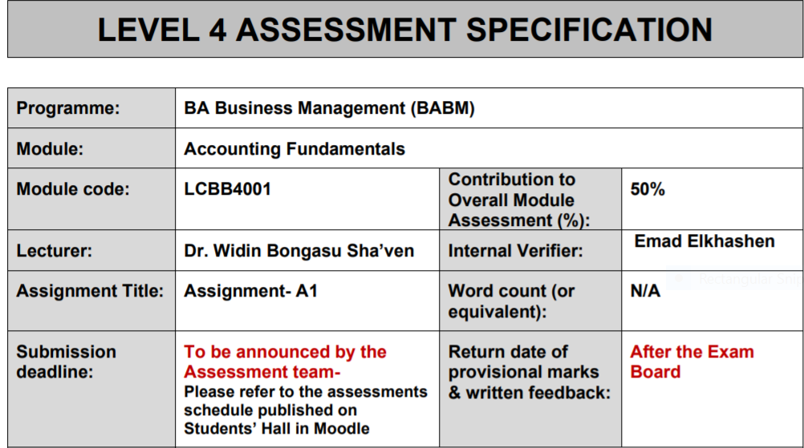

Introduction:
The report will be going to cover the calculation and the preparation of the various important types of financial statements such as balance sheet and the income statement in the task 1 and why the balance is required in the balance sheet or importance of equal of assets with the liabilities. In the task 2, the report will be going to cover the calculation and the working of the key financials’ ratios of the company and the financial analysis of the Choco company on the basis of the calculated ratios. They are affected by the window dressing and the data manipulation techniques.

Question 1
Part A: Prepare a Profit and Loss statement for the year ended 31st December 2020 for Kedison PLC and a statement of financial position as at that date.

Income statement and Balance sheet
Financial statements are very essential tools and technique for managing, recording and reporting the financial and the economical transactions of the company. It is important to understand the advantages and the disadvantages of the same. It has been seen that there are three main categories of financial statements, and they are cash flow, pay statement and the balance sheet of the company. Income statement represents the profits and the revenue from operations of the company. Cash flow statements represents the cash inflows and cash outflows for the company which is a good sign if the cash inflows are more as compares to the cash outflows. At the end, balance sheet represents the total assets vs the total liabilities of the company. Its preparations have the standard format and with the help of which the management of the company can easily increase the efficiency and also increase the liquidity of the company. Below shows the working of the profit and loss and the balance sheet of the corporation for the year ended 31st December 2020 (Mousawi 2019):
Profit and loss statement
Particular | Amount
Revenue from operations | 826650
Cost of goods sold | 578650
Gross profit | 248000
Margin % | 30.00%
Total expenses | 68000
Administrative expenses | 30000
Direct commission | 5000
Distribution cost | 28000
Commission | 3000
Interest | 2000
Profit before tax | 180000
Less: - Corporate Tax | 68000
Profit after tax | 112000

Balance sheet
Total assets | 815755
Current assets | 183025
Debtor | 170125
Cash and bank | 12900
Non-current assets | 632730
Plant and equipment | 632730
Total liability and equity | 815755
Current liability | 171355
Creditors | 171355
Non-current liability | 0
Equity | 644400

It has been seen that the profits of the company at the end of the year 2020 were 112000. The revenue of the same company at the same accounting period is at the level of 826650 and the total expenses were at 68,000. It is the good sign that the profits of the company are in positive zone which means that the level of same should then be compared with the peers or the competitors that are operating in the same industry or the average. One of the area of improvement for the company can be in the form of high administration cost for the company. The company can take up the disciplinary steps to mitigate the influence of the same on the corporate operations and at a same time lower the expenses which increases the direct and indirect cost for the company (Mousawi 2019).
Balance sheet is the financial performance which is at the period of time. It has been noticed and investigated that the total liability of the company is 815775 and the equity of the same is 644400. It is important to understand the disadvantages of the same. For example the balance sheet figures can be impacted by the window dressing or the changes in the data manipulation technique. It does not incorporate the figures such as goodwill or the tenure of the employee that are working within the organizations (Widiyanti 2019).
Part B: Why does the statement of financial position balance?

Importance of balance in the financial statements
It is important to balance the last amount of the balance sheet and if does not balance with each other then there must be some issues with the financial transactions or transactions are not recorded accurately. Balancing the figures means that the total assets of the company should be equal to the sum of the liabilities and the equity. It is the important to know the cost which are associated with the same process. In order to balance the same the management of the company need to hire the professional experts so that they can improve the financial health of the company and at a same time increase the market share of the company. It is directly related with the changes in the stock price or the changes in the commodities of the goods and services (Widiyanti 2019).
Question 2

A: Calculations of financial ratios
Financial ratios are very crucial for the business to grow and also increase the sources of finance of the company. There are various sources of the same and some of them are debt and equity and the profits of the company which is also know as the retained earnings of the company. As per the order perking theory it has been seen that the company should first use their debt as the source of finance, then profits and lastly uses the equity to finance there sources. The report have covered the calculations of various types of ratios such as efficiency, liquidity, solvency and the profits ratios for the Choco company. Below shows the working of the same:

Ratio’s calculations
Return on capital employed
Formula: | EBIT / Total assets - current liability |  |  | Formula: | EBIT / Total assets - current liability
2019 |  |  |  | 2020
EBIT | 699 |  |  | EBIT | 805
Total assets | 10087 |  |  | Total assets | 9736
Current liability | 3046 |  |  | Current liability | 2511
Return on capital employed | 9.93% |  |  | Return on capital employed | 11.14%
Return on equity
Formula: | Net income / Average shareholder equity |  |  | Formula: | Net income / Average shareholder equity
2019 |  |  |  | 2020
Net income | 366 |  |  | Net income | 431
Shareholder equity | 2912 |  |  | Shareholder equity | 3088
Return on equity | 12.57% |  |  | Return on equity | 13.96%
Earnings per share
Formula: | Net income / Number of share outstanding |  |  | Formula: | Net income / Number of share outstanding
2019 |  |  |  | 2020
Net income | 366 |  |  | Net income | 431
Share outstanding | 75 |  |  | Share outstanding | 58.59
Earnings per share | 4.88 |  |  | Earnings per share | 7.356204
Net profit margin
Formula | Net income / revenue |  |  | Formula | Net income / revenue
2019 |  |  |  | 2020
Revenue | 6441 |  |  | Revenue | 6738
Net income | 366 |  |  | Net income | 431
Net profit margin | 5.68% |  |  | Net profit margin | 6.40%
Assets turnover ratio
Formula | Revenue / total assets |  |  | Formula | Revenue / total assets
2019 |  |  |  | 2020
Revenue | 6441 |  |  | Revenue | 6738
Total assets | 10087 |  |  | Total assets | 9736
Assets turnover ratio | 0.638545 |  |  | Assets turnover ratio | 0.692071
Stock holding days
Formula | 365/ Inventory turnover ratio |  |  | Formula | 365/ Inventory turnover ratio
2019 |  |  |  | 2020
Average inventory | 659 |  |  | Average inventory | 708
Cost of goods sold | 3096 |  |  | Cost of goods sold | 3235
Inventory turnover ratio | 4.698027 |  |  | Inventory turnover ratio | 4.569209
Stock holding days | 77.69218 |  |  | Stock holding days | 79.88253
Debtor collection period
Formula | 365/Receivable turnover ratio |  |  | Formula | 365/Receivable turnover ratio
2019 |  |  |  | 2020
Average receivable | 1287 |  |  | Average receivable | 1249
Revenue | 6441 |  |  | Revenue | 6738
Receivable turnover ratio | 5.004662 |  |  | Receivable turnover ratio | 5.394716
Debtor collection period | 72.932 |  |  | Debtor collection period | 67.6588
Current ratio
Formula | Current assets/ Current liability |  |  | Formula | Current assets/ Current liability
2019 |  |  |  | 2020
Current assets | 2355 |  |  | Current assets | 2303
Current liability | 3046 |  |  | Current liability | 2511
Current ratio | 0.773145 |  |  | Current ratio | 0.917164
Gearing ratio
Formula | Total debt / total equity |  |  | Formula | Total debt / total equity
2019 |  |  |  | 2020
Total debt | 4129 |  |  | Total debt | 4137
Total equity | 2912 |  |  | Total equity | 3088
gearing ratio | 1.417926 |  |  | Gearing ratio | 1.339702
Investor cover
Formula | Dividend / operating profit |  |  | Formula | Dividend / operating profit
2019 |  |  |  | 2020
Dividend | 242 |  |  | Dividend | 255
Operating profit | 699 |  |  | Operating profit | 805
Inventor cover | 34.62% |  |  | Inventor cover | 31.68%

Part B: Financial analysis on the basis of ratios:
1): ROCE - Return on capital employed: This is the profit measuring ratios of the company. This includes the operating profits, total assets and the current liabilities of the company. It has been seen that this ratios have increased from 2019 financial year 2020 financial year which is the good sign as it means that the directly the profits of the company are in the increasing trend (Bragg 2021).
2): ROE - Return on equity: It measures how much the company have generated the profits from the money which belongs to there owners or the promotors of the company. This ratio also shows the positive sign as this is in increasing trend which is the good sign. It means that the net income has increased more as compares to the shareholders equity. It then should be compared the same with the competitors analysis (Bragg 2021).
3): Earnings per share: It means that how much investors are gaining as compared to there investors. Its formula is net income divided by the number of shares outstanding. It has also increased from 2019 to 2020 financial year. It means that the investors are getting more attracts towards the stock price of the Choco company share. It means that the market share of the company increases as the time increases.
4): Net profit margins: This is some of the most significant financial ratio of the company because net income is the bottom line of the company. Every business weather it is big or small, private or public conduct their operations because they need to generate the profits. It has been seen that this ratio also have increased in value. In financial year 2019 the ratio was 5.68% and the 2020 was at the level of 6.40%.
5): Assets turnover ratio: Efficiency ratio is the key role of the business. It measures the efficiency of the assets and now much revenue from operations of the company is generated with the help of the assets. Efficiency of the assets has also increased which is the good sign.
6): Stock holding days: It means that how much the company is taking to sell of their inventory in hand. With the help of this ratio the management have came to know that this ratio is not in there strong area because it has increased and the it constitute of 5 days which is not a hype results.
7): Debtors collections days: It means that how much time the company is taking to collect the due money form there debtors. The efficiency has increased because this ratio has decreased from 72 days to 68 days. It means that the company was taking 72 days to collect the liquidity and now it is taking to 68 days to collect the money which is due from their inventory (Melo 2018).
8): Current ratio: This is the cash flow ratio of the company. Its formula is present assets divided by the current liabilities. The ratio of the company have increased from 0.77 to 0.91. It is the good sign; however, it is a negative sign because the ratio is low as compares to the industry average which is 2 times (Melo 2018).
9): Gearing ratio: It has decreased because the total liability of the company have decreased as comparisons to the total equity of the company (Maswadeh et al. 2018).
10): Inventors cover ratio: Its formula is the dividend divided by the operating profits of the company. The ratio has decreased which means that there are various investors. In 2009 its value was 34% and now its level is 31% which is not a good because operating profits has increased with the lowers rate as compares to the dividend (Maswadeh et al. 2018).

Conclusion:
From this report, it has been concluded that the Choco financial health is very good when it measures by their own financial ratios of the company. Financial ratios which have covered in the report are return on capital employed, current ratio, net profit margin etc. However, it has several disadvantages as well and some of them are changes in the key corporate governance parameters and part 1 it has covered the importance of financial statements such as balance sheet and its preparations about the same.

References:
- Bragg, S. (2021). Financial ratios. [Online] Accounting tools. Available at: https://www.accountingtools.com/articles/financial-ratios.html. Accessed on: 11-01-2021
- El-Mousawi, H.Y. and Kanso, H.H, (2019). Impact of Accounting Measurement and Disclosure of Human Resources on Financial Statements: An Empirical Study. International Journal of Economics and Finance, 11(6), pp.1-33.
- Maswadeh, S, Abutaber, T.A. and Alathamneh, M.S, (2018). The effect of dividends and earnings per share on the stock market value by moderating bank size. Journal of Modern Accounting and Auditing, 14(8), pp.408-415.
- Melo, W, Delarica, D, Guedes, A, Lavezzo, L, Donha, R, de Araújo, A, de Melo, G. and Macedo, F, (2018). Ten years of application of sewage sludge on tropical soil. A balance sheet on agricultural crops and environmental quality. Science of the total environment, 643, pp.1493-1501.
- Widiyanti, M, (2019). Pengaruh Net Profit Margin, Return On Assets Dan Debt To Equity Ratio Terhadap Pertumbuhan Laba Pada Perusahaan LQ-45. Jurnal Riset Akuntansi dan Keuangan Vol, 7(3).

