Business Report-Comparison of Two Hospitality Organisations

Module title: Financial Management for the Hotel Industry BMIH5007
Student name: Oana Simona Ungureanu
Student ID:2209544
Lecturer name: Tristan Hawkins

Executive Summary
The below report has reflected on analysing and understanding the comparison between two hotel groups such as Ibis Hotels as well as Corinthia Hotel Groups. These hotel chains basically operate their activities by offering both reasonable and luxurious services. However, the following report has evaluated various key aspects associated with the overall amount of revenue along with their market share and growth potential. The evaluation of CSR practices for both hotel chains has also been explained in this context. Additionally, based on the above analysis, has also described recommendations for both Ibis Hotels and Corinthia Hotel Group.

Table of Contents
Introduction 4
Highlighting the differentiation of Ibis Hotels and Corinthia Hotel Groups 5
Determining the overall revenue of Ibis Hotels and Corinthia Hotel Groups 5
Illustrating the market position of Ibis Hotels and Corinthia Hotels 6
Analysing and differentiating the growth potential of Ibis Hotels as well as Corinthia Hotel Groups 9
Explaining CSR activities of Ibis Hotel and Corinthia Hotel Groups 10
Recommendation for Ibis Hotels and Corinthia Hotels based on the above analysis 14
Conclusion 15
References 16

Introduction
Financial management plays a crucial role in operating various finance-related operations to achieve business objectives and goals as well as become successful in the market. However, the main aim of this report is to develop and analyse a differentiation of two hotel chains such as Ibis Hotels and Corinthia Hotel chains regarding various crucial components. The following report will evaluate the revenue trends, revenue sources as well as several factors that drive the revenue of both hotel chains. Brand perception, consumer demographics as well as the market share of the two hotel chains will also be reflected in this context. Moreover, the below report will describe the market opportunities, expansion approaches and possible barriers to growth for the Ibis Hotel and Corinthia Hotel Chains. CSR activities such as community engagement, ethical business practices and sustainability practices of both hotel chains will be elucidated here.

Highlighting the differentiation of Ibis Hotels and Corinthia Hotel Groups

Determining the overall revenue of Ibis Hotels and Corinthia Hotel Groups

Corinthia Hotel Groups

Overall revenue: The overall revenue of the respective hotel group has varied significantly over the time period. It can be seen from their annual report that Corinthia Hotel Group earned nearly $5,119 million in the year 2019 which hugely enhanced to $75,649 million in 2020. This huge enhancement may be experienced due to implementing acquisitions as well as strategic approaches. However, the hotel chain faced a huge decline in its earnings in 2021 due to the outbreak of the pandemic which was $30,328 million (Corinthia, 2024).
Sources of revenue: The overall revenue of the respective hotel chains generally comes from food and beverage services, accommodation, events and conferences. Along with this, the respective hotel chains also have spas, bike rental and other services as well which also assist them to generate revenue.
Factors that drive revenue: There are a wide range of external factors such as travel restrictions, the global pandemic and changes in customer behaviour which play a key role in the variations of the hotel chain's revenue. Additionally, the capability of the business to adjust to transforming situations, innovate and promote services and execute efficient marketing approaches will also be crucial for their further revenue growth.
Ibis Hotels
Revenue trends: It can be seen from the annual report of Ibis Hotels that the respective business has gained near about $6,491 million in 2019 which has increased to $84,322 million in 2020 (de Bastos, 2023). It has occurred as a result of the increased demand for hotel rooms along with the effective execution of marketing strategies. In addition to that, the business has also faced a huge decline in its revenue due to the outbreak of coronavirus which was $43,983 million.
Sources of Revenue: The procedure of generating revenue for Ibis Hotels is also similar to Corinthia Hotel Groups. However, the revenue of the business generally comes from hotel bookings, services of beverages and food, corporate events and conferences (de Bastos, 2023). The respective business has executed efficient marketing strategies to capture a large amount of market share in the hotel industry.
Factors that drive revenue: The revenue of Ibis Group in the financial period of 2021 has been negatively influenced as a result of restrictions associated with travel and transportation. The business is also capable of adapting marketing strategies, resilience as well as possible transformations in customer behaviours.

Illustrating the market position of Ibis Hotels and Corinthia Hotels
Corinthia Hotel Group
Market share: The market share of Corinthia Hotel Groups is divided by its existence in both luxury and premium segments. This is considered vital evidence for their higher portfolio. The annual report of the respective company states that the overall capital of the hotel group is approximately €615 million whereas their asset valuation is €1.544 billion (John et al., 2024).
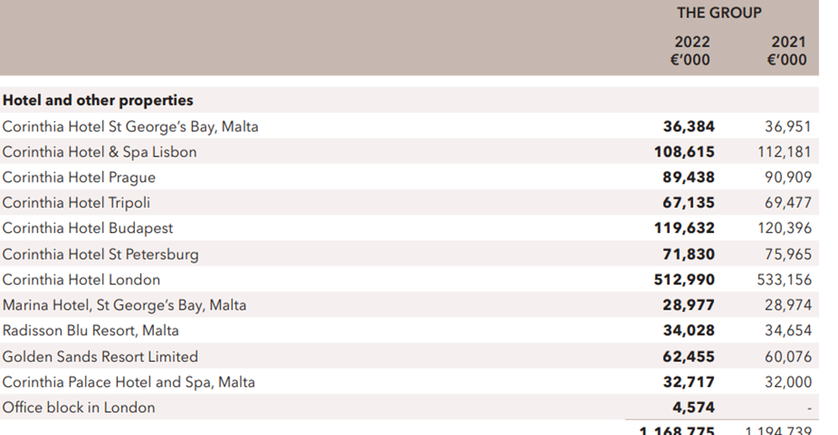

Figure: Market Share of Corinthia Hotel Groups
Source: (Corinthiagroup, 2022)
The above-mentioned picture highlights the market share of the business in various nations. According to the above image, it can be seen that the highest market share of the hotel group Corinthia Hotel London with €512,990 in the accounting period of 2022.
Customer demographics: This specific hotel group basically prioritises luxurious customers who are willing to enjoy luxurious experiences (John et al., 2024). The commitment of the respective firm towards luxury is aligned with its customer base which generally values opulence, exclusive amenities and personalised services.
Brand perception: The brand perception of the Corinthia Hotel group is identical with luxury and sophistication along with the responsibility of offering effective hospitality services. Along with this, the respective hotel is also associated with iconic eminent such as Corinthia Hotel Budapest and Corinthia Hotel London which enhances their overall global reputation.
Ibis Hotels
Market Share: Ibis Hotels is naturally a part of Accor which basically holds an extensive share in the marketplace within the sector of economy hotels. However, the respective hotel is regarded as one of the recognised budget-friendly hotels with existence in 70 nations and around 1218 hotels as per the report of 2018.
Customer demographics: Ibis Hotels basically cater to a diverse as well as wide range of consumer demographics such as targeting budget-conscious customers for affordable as well as comfortable accommodation (Achmad and Yulianah, 2022). However, the global presence of the business enables them to appeal to a large customer base which includes tourists and business travellers.
Brand perception: The respective firm is known as a cost-effective and reliable option for visitors seeking quality and reasonable accommodations. However, the effort towards digitalisation, digital marketing, as well as market expansion approaches, contribute positively to the segment of economy hotels.
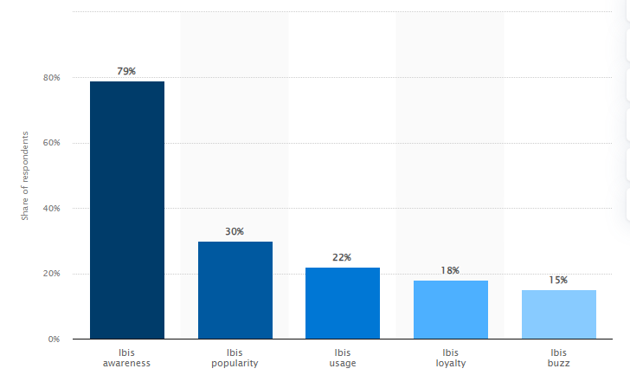
Figure: Ibis brand awareness in Germany in 2022
Source: (Statista, 2022)
Moreover, the responsibility of the hotel towards sustainable practices is aligned with the transforming preferences of customers which helps the business to enhance its brand image.

Analysing and differentiating the growth potential of Ibis Hotels as well as Corinthia Hotel Groups
Corinthia Hotels
Expansion strategies: The overall growth of the respective firm relies on placing itself as one of the recognised, reputed and luxurious hotel brands. In addition to that, the respective hotel chain has implemented a multi-faceted strategy to enlarge its business. The hotel group plans to enlarge its portfolio in a steady and sensible way, preferring the right site in an accurate location, especially in important resorts and cities (Lee and Kim, 2020). Additionally, the group is also searching for future opportunities in crucial gateway locations across the world.
Market opportunities: The opportunities in the market of Corinthia Hotel Groups rely on the luxurious segment, offering high-end travellers seeking exclusive and special experiences. The demand for premium and luxurious rooms acts as paths for enlargement in key marketplaces. Corinthia's diverse properties portfolio includes various iconic locations like Corinthia Hotel London. It may help the business to attract more customers which leads to an increase in its revenue and profitability margin.
Potential barriers to growth: The respective business has experienced different barriers which may hinder their overall growth. It can be seen from a report that the occurrence of recessions and global pandemics influence consumer spending which may disrupt the growth of the business (Lee and Kim, 2020). Additionally, the accomplishment of expansion strategies depends on several components which include compliance with rules and regulations, geopolitical stability as well as the ability to maintain a high level of standards (Achmad and Yulianah, 2022).
Ibis Hotels
Expansion strategies: Ibis Hotels has also made an effort to enlarge its activities globally, especially in the segment of economic hotels. The approach deployed by the business depends on differentiating its hotel portfolio, with a concentration on developing regions and nations which are facing an increase in the demand for travel. Moreover, the commitment of the respective firm to atmospheric projects matches with the preferences of modern consumers which may help them by increasing its market position.
Market opportunities: The growth potential of the respective hotel group depends on continuous demand for affordable and trustworthy hotel choices. Ibis Hotels is well-positioned to generate profit from new trends in travel due to its international presence. In addition to that, the economic segment hotels generally attract budget-conscious visitors which represents a consistent market with huge improvement opportunities (Achmad and Yulianah, 2022). Additionally, they can address various needs of their customers within the budgetary range by utilising their different portfolios.
Potential barriers to growth: Ibis Hotels has experienced different types of barriers and one of them includes competition from other hotels. However, the hospitality industry can also be influenced by both economic disruptions and ambiguity in travel due to the outbreak of the pandemic. Adapting to transforming customer demands and addressing legislative obstacles need to be considered for guaranteeing future development.

Explaining CSR activities of Ibis Hotel and Corinthia Hotel Groups
Corinthia Hotel Groups
Corinthia Hotel Group implements sustainable and eco-friendly practices in its business operations to support the environment. The respective business is generating effective outcomes by actively engaging in the community as well as a wide range of social programs. It also prioritises an ethical code of conduct by placing more value on accountability and openness in its business operations. Along with this, the financial commitment of Corinthia Hotel is evaluated by its continuous effort to promote sustainable practices, charitable movements and ongoing dedication to ethical principles (Camilleri, 2022).
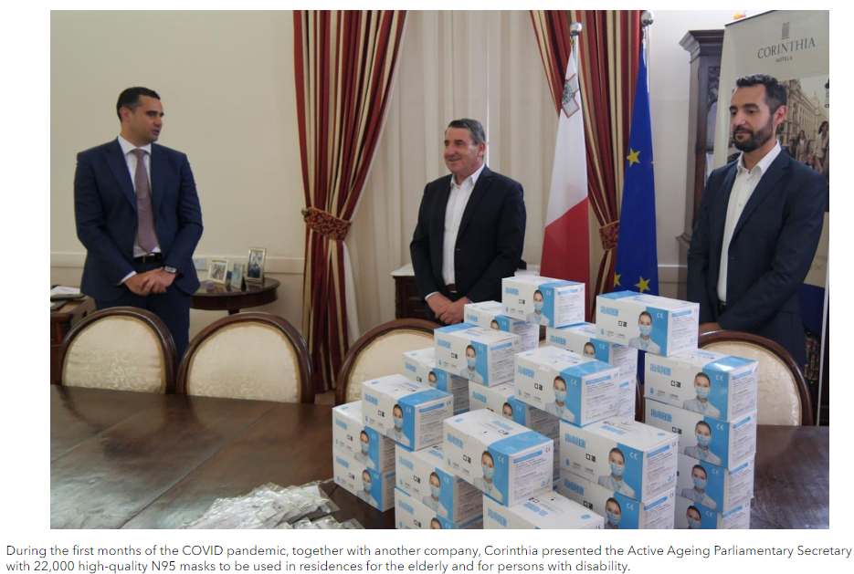
Figure: CSR activities of Corinthia Hotels
Source: (Corinthiagroup, 2024)
The team of Corinthia also introduced two charitable initiatives in London such as NHS Nurse Heros and Everyday Heros. These heroes are generally selected through email with details of the reason for their deservedness. They provided them tea vouchers for the heroes as well as their visitors of choice.
Ibis Hotels
The respective hotel exhibits a robust financial consciousness and they prioritise resource competence and protect the environment by executing eco-friendly practices within its hotels. However, one of the key preferences is engaging or involving with the community. Ibis Hotels also supports regional improvement programs as well. Ethical practices such as similar pay for staff, transparency activities within the supply chain and the amount of money assigned to social responsibility (Oriade et al., 2021).

Figure: Sustainable hotel operations of Ibis Hotels
Source: (Accor, 2024)
The implementation of ethical practices into the operational model, community associations and constant conservation programs are considered some key instances of the inclusive policy of Ibis Hotels.

Recommendation for Ibis Hotels and Corinthia Hotels based on the above analysis
Ibis Hotels
It can be recommended that Ibis Hotels focus more on developing its online presence as the usage of social media platforms has increased significantly. They need to make investments in cutting-edge technology to introduce online reservation platforms which will assist them to increase their customer base (Makanyeza et al., 2021). Moreover, it will also open up many new markets and reinforce the position of the brand in the economic hotel sector.
Corinthia Hotel Groups
It can also be recommended to the respective hotel groups to collaborate with various partners to enlarge their business globally. This partnership and collaboration with other business entities can assist the business in promoting its services in a new marketplace. It can lead to appeal to more customers that drive their sales and profitability margin.

Conclusion
The above report has reflected on various crucial components related to the financial management of two hotel businesses, Ibis Hotels and Corinthia Hotel Groups. It can be concluded from the report that both hotels generate revenue from their accommodation, food and beverage services. Corinthia Hotels prioritises luxurious customers whereas Ibis Hotels prefers budget-friendly customers. Along with this, the above report has evaluated the growth potential for two hotel businesses as well. Market expansion strategies, market opportunities and possible barriers to growth for both firms have been explained in the above context. Furthermore, CST activities such as sustainable and ethical practices of Ibis Hotels and Corinthia Hotel Groups have also been explained in this report.

References
Accor, (2024). Sustainability Strategy. [Online] Available at: https://group.accor.com/en/commitment/approach/sustainability-strategy [Accessed 27 January 2024].
Achmad, W. and Yulianah, Y., (2022). Corporate social responsibility of the hospitality industry in realizing sustainable tourism development. Enrichment: Journal of Management, 12(2), pp.1610-1616.
Camilleri, M.A., (2022). Strategic attributions of corporate social responsibility and environmental management: The business case for doing well by doing well!. Sustainable Development, 30(3), pp.409-422.
Corinthia, (2024). CORINTHIA DISCOVERY. [Online] Available at: https://www.corinthia.com/en-gb/discovery/ [Accessed 27 January 2024].
Corinthiagroup, (2022). ANNUAL REPORT. [Online] Available at: https://www.corinthiagroup.com/wp-content/uploads/2023/06/37547-CORINTHIA-ANNUAL-REPORT-2022_WEB-min.pdf [Accessed 27 January 2024].
Corinthiagroup, (2024). OVERVIEW OF OUR RECENT CSR ACTIVITIES. [Online] Available at: https://www.corinthiagroup.com/insider/overview-of-our-recent-csr-activities/ [Accessed 27 January 2024].
de Bastos, B.P., (2023). Contribution of hotels’ revenue management for supply chain sustainability. Journal of revenue and pricing management, 22(4), pp.294-305.
John, A., Vincent, M. and Rosemarie, K., (2024). Driving Revenue Growth: The Role of Strategic Human Resource Practices in 3-5 Star Hotels in Selected Regions of Ghana. European Journal of Hospitality and Tourism Research, 12(1), pp.24-41.
Lee, S. and Kim, D.Y., (2020). The BRAND tourism effect on loyal customer experiences in luxury hotel: The moderating role of psychological ownership. Tourism Management Perspectives, 35, p.100725.
Makanyeza, C., Svotwa, T.D. and Jaiyeoba, O., (2021). The effect of consumer rights awareness on attitude and purchase intention in the hotel industry: Moderating role of demographic characteristics. Cogent Business & Management, 8(1), p.1898301.
Oriade, A., Osinaike, A., Aduhene, K. and Wang, Y., (2021). Sustainability awareness, management practices and organisational culture in hotels: Evidence from developing countries. International Journal of Hospitality Management, 92, p.102699.
Statista, (2022). Ibis brand awareness, usage, popularity, loyalty, and buzz among hotel customers in Germany in 2022. [Online] Available at: https://www.statista.com/forecasts/1335648/ibis-hotels-brand-profile-in-germany [Accessed 27 January 2024].

