

Component 1: Design and implementation of a relational Database System

Module: Introduction to Web and Database Concepts
Module Code: ACCA 4023
Student Name: Sara Baiai
Student ID: 2437772
Lecturer Name: Sadhana Jha

Contents
Scenario Analysis 2
Entity Relationship Diagram (ERD) 2
1. List of attributes and their descriptions 2
2. List of relationships and their meaning. 5
3. ER diagram: 7
Normalization 9
Sample Data Population 10
Query Development 12
Testing and Validation 14
Design Decisions and Future Work 15
1. Design Decisions: 15
2. Future Work: 15
References: 16

Scenario Analysis
A fast-growing Pharmacy called Medilink, has been facing many challenges within its system due to manual record keeping. The company currently stores records of Medicines, Suppliers, prescriptions, customers and sales manually. This manual system often causes errors, mistakes, consumes time and makes it more difficult to manage information properly. As the pharmacy progresses, these errors effect stock control, tracking of sales and customer service. In order to solve these problems, the CEO wants a Database system created using Microsoft Access. Within this new Database, there will be information stored about medicines, suppliers, customer prescriptions, customer information and sale transactions. This new system will improve accuracy and prevent errors, making it easier to generate information for stock management, better monitor sales and keep track of customers details.

Entity Relationship Diagram (ERD)

List of attributes and their descriptions
Below I have provided a list of all the entities and attributes for the ER diagram created for MediLink Pharmacy. I will also be identifying the foreign and primary keys in each entity. Identifying the primary key is important as it ensures that all records are identifiable [1]. Foreign key on the other hand will help me to link two tables together when generating the table [2].
Medicine
This entity holds information about all the medicines that are available in MediLink Pharmacy.
Attributes:
MedicineID (Primary Key): This is a unique identifier that ensures each medicine can be distinctly tracked and retrieved.
MedicineName: This represents the Name of each medicine.
MedicineType: This holds the type of medicine such as tablets, capsules, syrup, or any other form.
UnitPrice: The cost for a single unit of medicine.
StockQuantity: This holds information on available and unavailable medicine.
ExpiryDate: This provides the Date on which the medicine is no longer safe or effective.
SupplierID (Foreign Key): This attribute identifies the supplier of the medicine.
Primary key: MedicineID
Foreign Key: SupplierID
Supplier
This entity holds information about the providers who supply medicine to MediLink Pharmacy.
Attributes:
SupplierID (Primary Key): This is a unique identifier for each supplier.
SupplierName: This stores the name of the supplier.
ContactNumber: This attribute holds the suppliers contact number.
SupplierAddress: This contains information about the supplier address
Primary key: SupplierID
Foreign Key: N/A

Customer
This entity contains information about the MediLink Pharmacy customers.
Attributes:
CustomerID (Primary Key): This attribute uniquely identifies each customer.
CustomerName: This holds the Customers full name.
DateOfBirth: unique identifier of each customer’s date of birth.
ContactNumber: This stores all customers contact numbers.
CustomerAddress: This contains customer’s address.
Primary key: CustomerID
Foreign Key: N/A

Prescription
The prescription entity holds and records customer prescription information including the medicine prescribed.
Attributes:
PrescriptionID (Primary Key): This records a unique identifier for each prescription.
PrescriptionQuantity: This attribute hold information on the quantity of medicine prescribed to be taken.
PrescriptionDate: The date in which the prescription was issued.
CustomerID (Foreign Key): This attribute identifies and links each customer uniquely to the correct prescription.
MedicineID (Foreign key): This links the prescription to the medicine being prescribed.
Primary key: CustomerID
Foreign Key: CustomerID and MedicineID

Sales
This entity stores information of medicine sale transactions made in MediLink Pharmacy.
Attributes:
SaleID (Primary Key): This attribute is used to uniquely identify each sale.
SaleDate: This contains information of the date each sale was made.
QuantitySold: The number of units sold is stored in this attribute.
TotalAmount: This records the total cost of sale.
MedicineID (Forign Key): This attribute identifies the medicine that has been sold.
CustomerID (Foreign Key): This attribute identifies the customer in which purchased medicine.
Primary Key : SaleID
Foreign Key: MedicineID and CustomerID

List of relationships and their meaning.
Below is a list of relationships between entities in the new MediLink system along with their meaning and cardinalities. Relationships between entities are important in creating this database design because it will show different data and how it will connect, it will also give me an idea as to how many entities relate to one another which is known as cardinality [3].
Supplier to Medicine
Relationship: Supplier supplies medicine.
This means that the supplier delivers medicine to MediLink Pharmacy for its use.
Cardinality:
A single supplier can supply many medicines, while each medicine is supplied by one supplier. This makes it a One-to-many relationship.
Participation:
Each medicine must have a supplier, on the other hand, a supplier may supply zero or many medicines.

Customer to Prescription
Relationship: Customer is issued a prescription.
This means that a customer can have a prescription issued to them to fulfill their medical needs.
Cardinality:
One customer can have zero to many prescriptions, but each prescription can be given to one customer. This makes it a one-to-many relationship for customers.
Participation:
A customer may have zero or many prescriptions, which means partial participation, but each prescription must be given to a customer, meaning total participation.

Medicne to prescription
Relationship: Medicine is prescribed through a prescription. Meaning when a doctor issue a prescription, it shows what medicine the customer must take. The prescription record links the medicine to the customer through the prescription system.
Cardinality:
One medicine can appear in many different prescriptions, but each prescription record is for one specific medicine. This makes a one-to-many relationship between medicine and prescription.
Participation:
Medicine has partial participation because not all medicines available in the pharmacy are to be prescribed. Prescription has total participation because every prescription must include medicine.

Customer to Sales
Relationship: A customer makes purchases that generate sales records within the system. This means that a customer buys something from MediLink Pharmacy, creating a sale linked to them.
Cardinality:
One customer can make multiple sales, but each sale can be made by just one customer. This makes it a one-to-many relationship for customers.
Participation:
A customer can make zero to many purchases which is partial participation, but every sale must be linked to a customer which is total participation.

Medicine to sales

Relationship: Medicine is included in sales. This simply means that that medicines are sold to create a transaction for sale.
Cardinality:
One medicine can appear in many different sales, but each sale includes one medicine. This makes it a one-to-many relationship for medicines.
Participation:
Medicine has partial participation, as not all medicine may be sold. Sales has total participation, because every sale must include medicine.

ER diagram:
Below I have provided a screenshot the ER diagram I have created. The ER diagram shows all the entities, their attributes, relationships between entities, cardinality and participation constraints. ER Diagrams are vital in data base design; they are used to visually introduce how data entities relate to each other and how they are linked through relationships [4].

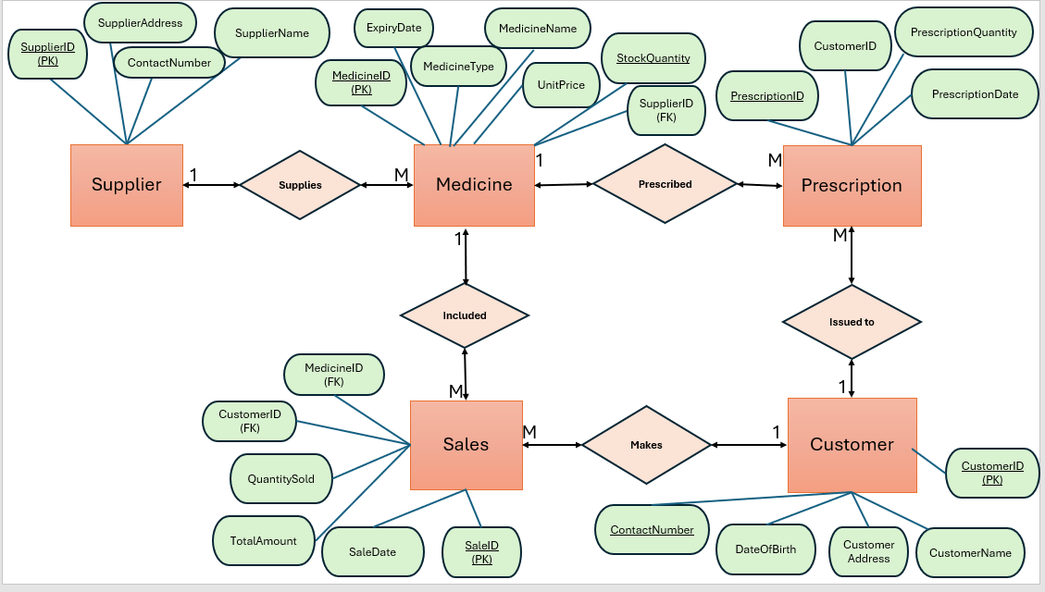
Figure 1: ER Diagram (MediLink) screenshot.
Based on the ER diagram I included above for the MediLink Pharmacy system, I have defined each entity with a primary key to identify each record uniquely. I used foreign keys to create relationships between all entities ensuring data integrity within the database. I done this because Primary key uniquely identifies records, whole foreign keys reference the primary key of another table to maintain referential integrity between data [5].

Supplier Entity
The supplier entity does not have any foreign keys. The primary key SupplierID is referenced by the SupplierID foreign key in the medicine entity to highlight which supplier is providing each medicine.
Medicine Entity
The medicine entity contains the foreign key SupplierID. This references the SupplierID primary key that is in the Supplier entity, making sure that each medicine that is stored within the system is linked to the right supplier.
Prescription Entity Customer Entity
In this entity, two foreign keys are used. These are the CustomerID and MedicineID. The CustomerID foreign key refers to the CustomerID primary key in the customer entity to ensure that each prescription is linked to the right customer. The MedicineID foreign key refers to the MedicineID primary key within the Medicine Entity to identify the medicine that has been prescribed to each customer.
Customer Entity
The Customer Entity does not contain any Foreign keys. The primary key CustomerID is referenced by the CustomerID foreign keys in prescription and sales entities, this is to identify which customer has received a prescription or made a purchase.
Sales Entity
The sales entity also contains two foreign keys, these are the MedicineID foreign key and CustomerID foreign key. The MedicineID foreign key references the MedicineID primary key in the medicine entity to highlight which medicine was sold. The CustomerID foreign key references the CustomerID primary key in the customer entity to show which customer made the purchase.

Normalization
The database for Medilink Pharmacy has been normalized to Third Normal Form (3NF). I used normalization in this database degin as it reduces data redundancy and maintains data integrity. I have organised the database into structured tables that define entities, their relationships, attributes and primary keys and foreign keys. By doing so the system can store information more efficiently and avoid duplication of data or errors [6]. Below are the tables for MediLink Pharmacy (3NF).

Supplier Table
SupplierID (PK) | SupplierName | ContactNumber | SupplierAddress
SP1 | Medicine World | 00213445566 | 13 Bank Street
SP2 | Pharmacy Supply | 00213645789 | 05 Newed Avenue
SP3 | Healthy supplies | 00213673947 | 999 link Street
SP4 | Pharmacy Ltd | 00213874639 | 67 Marks Road
SP5 | Green Cross | 00213758663 | 123 Green Road
Medicine Table
MedicineID (PK) | MedicineName | MedicineType | UnitPrice | StockQuantity | ExpiryDate | SupplierID (FK)
M1 | Night Nurse | Syrup | 01.99 | 300 | 12/2030 | SP1
M2 | Vitamin c | Capsule | 00.80 | 145 | 02/2035 | SP2
M3 | Burn cream | cream | 05.00 | 80 | 11/2028 | SP3
M4 | Paracetamol | Tablet | 12.00 | 258 | 09/2033 | SP4
M5 | Ibuprofen | Capsule | 10.00 | 100 | 07/2039 | SP5
Prescription Table
PrescriptionID (PK) | CustomerID (FK) | MedicineID (FK) | PrescriptionQuantity | PrescriptionDate
P1 | C1 | M1 | 12 | 19/03/2026
P2 | C2 | M2 | 30 | 20/03/2026
P3 | C3 | M3 | 3 | 21/03/2026
P4 | C4 | M4 | 67 | 24/03/2026
P5 | C5 | M5 | 4 | 27/03/2026
Customer Table
CustomerID (PK) | CustomerName | DateOfBirth | ContactNumber | CustomerAddress
C1 | Ann Parkes | 11/01/1997 | 07728364783 | 11 Cold Street
C2 | Jake logan | 08/11/1967 | 07736473892 | 77 Glee Avenue
C3 | Sara Green | 23/03/1993 | 07793864532 | 102 Cast Road
C4 | Puja Rose | 11/07/2019 | 07777346639 | 123 Oaks Street
C5 | Ali Khan | 20/01/2000 | 07738465378 | 77 Apple Lane
Sales Table
SalesID (PK) | CustomerID (FK) | MedicineID  (FK) | SaleDate | QuantitySold | TotalAmount
SL1 | C1 | M1 | 01/01/2026 | 11 | 13.00
SL2 | C2 | M2 | 12/02/2026 | 02 | 21.99
SL3 | C3 | M3 | 02/03/2026 | 07 | 27.00
SL4 | C4 | M4 | 04/03/2026 | 19 | 08.00
SL5 | C5 | M5 | 09/03/2026 | 13 | 03.00

Sample Data Population
I have created tables for MediLink Pharmacy using Microsoft Access to show how the new database would work in real life. In the tables below, there are five rows at least that reflect how it operates. this includes Supplier, Medicine, Customers, Prescriptions and Sales. The screenshots I have attached below show the tables with sample data, this confirms the new system is functional and ready for queries and reporting.

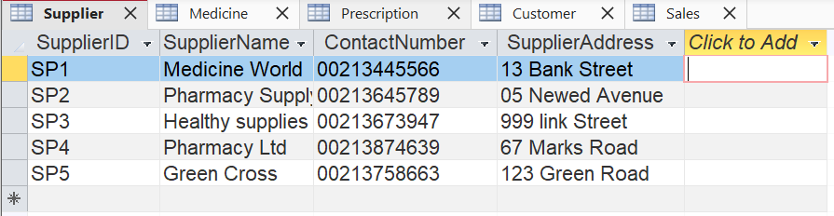Figure 2: Supplier Table with sample data in access.

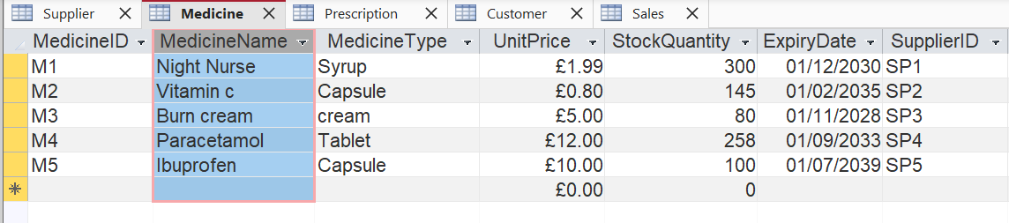Figure 3: Medicine table with sample data in access.

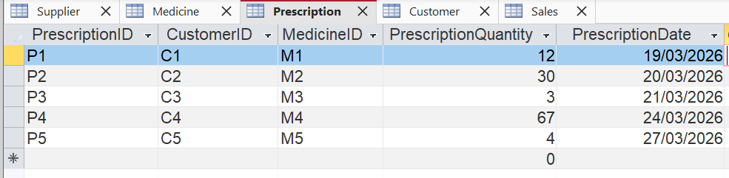Figure 4: Prescription table with sample data in access.

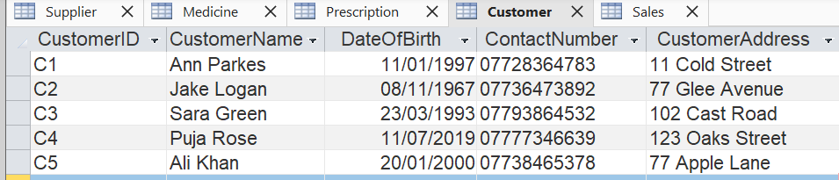Figure 5: Customer table with sample data in access.

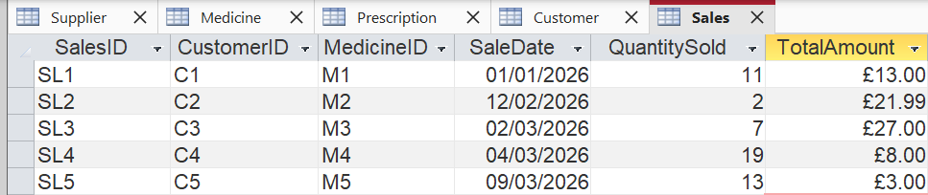 Figure 6: Sales table with sample data in access.

Query Development

Query development is an important part of database systems because it allows users to retrieve and analyse specific information stored in the database, through the use of query language (SQL) or other methods. [7]. Using Microsoft Access, I have demonstrated how the MediLink Pharmacy can be used in real life practice by creating queries. The queries will allow the new system to gain useful information such as, Prescription for a specific customer, Medicine that are low in stock, and sale transactions. I have provided screenshots of the results of each query below.

Query 1: Prescription for a Specific Customer.
I have created this query to display prescription issued to s specific customer, in this case Anne Parkes. It provides information of customers name, the medicine prescribed, quantity and date of prescription from the database.
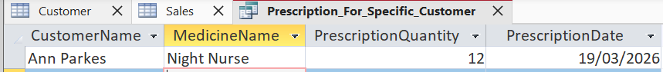Figure 7: Query showing prescriptions issued to a specific customer at MediLink Pharmacy.

Query 2: Medicine that is low in stock Query 3: Total sales per Transaction
I created this query to identify which Medicines are running low in stock at MediLink Pharmacy. The query shows items where the stock quantity is below a specific number. In my case I chose <200. This will allow staff to identify medicines that may need to be restocked through reorder from a specific supplier.
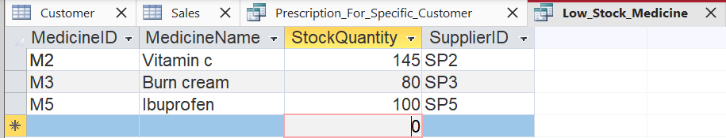Figure 8: Query showing medicine that is low in stock, under 200 units. (<200)

Query 3: Total sales per Transaction
I have created this query below to display total amount of each sale that is recorded in the MediLink Pharmacy Database. The query gets information from the sales table that includes MedicineID, SaleDate, Quantity sold and total amount. This allows the pharmacy to review sales information in the records.
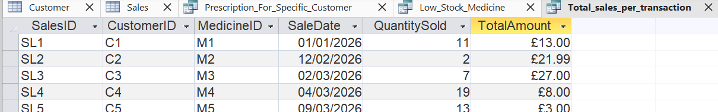Figure 9: Query showing sales information.

Testing and Validation
I have tested and validated the new and improved MediLink Pharmacy database ensure it functions as I expected it to meet all requirements. I did this through checking the tables, relationships and queries are all correct and making sure data is all consistent and accurate. I also tested the new system confirming that the correct links between tables and unique IDs are working properly and up to standard. I focused on keeping the system simple as it is a jump for MediLink to go from using pen and paper to log down information to using a full functioning system.
To test the database, I added suppliers, medicines, and customers and made sure that unique IDs were used for each record. I also created prescriptions, linking them to the right customer and medicines ensuring the relationships work as intended. I also entered sales transactions into the system and confirmed the quantity sold and the total amount was accurate.
All the queries that I created I also tested. The query for prescription of specific customer passed the test and displayed the correct medicine and customer. The query for medicine that may be low in stock identified all medicines that are below the specific threshold. The query for total sales also correctly retrieved the relevant information needed. I also tested the new system by entering non existing customerIDs or Supplier ID in a sale the system prevented these entries, which confirmed that the primary key, foreign key and data type rules were running as expected.
Through testing and validating process, I have confirmed that the MediLink Pharmacy database is accurate when it comes to managing information about medicine, suppliers, customers, sales and prescriptions. The system was a success in maintaining correct relationships within entities and proven to be reliable in producing information for queries and reporting.

Design Decisions and Future Work

- Design Decisions:
The MediLink Pharmacy database that I have created is made easy to manage with information stored clearly, I designed separate tables for Suppliers, Medicine, Prescription and sales to ensure this. I used primary keys to identify each record uniquely and foreign keys to link the tables together, ensuring relationships between customers, medicine, prescription and sales are all accurate. I then normalized the database to Third normal form (3NF) to reduce redundancy which prevents errors. This then maintains stock, tracks all sales and manages customer prescription well. I then created queries to demonstrate how the database can be used in real life. The enquiries included checking prescription for a specific customer, finding medicine that is low in stock and reviewing sales. I faced challenges when making sure all relationships were linked correctly as well as verifying that queries were accurate, these were then resolved by checking the primary and foreign keys and validating the sample data thoroughly.

- Future Work:
In the future, I would like to include extra useful features that would make the MediLink Pharmacy database even more practical. These features could include alerts that notify staff when medicine is running low in stock and allow orders to be placed to the correct supplier with the press of a button. I would also like to improve the interface, making it more user-friendly and easier for pharmacy staff to access data. Another feature could alert staff when medicine is near its expiry date to prevent selling expired products. Finally, I would like to include dose amounts linked to doctor notes, ensuring staff have the correct information if the customer is unable to contact their doctor. I believe these improvements would help MediLink Pharmacy operate more smoothly and provide a better service for customers.

References:

[1] “Primary and foreign keys - Introducing databases - National 5 Computing Science Revision,” BBC Bitesize. https://www.bbc.co.uk/bitesize/guides/zc93tv4/revision/5
[2] “Primary and foreign keys - Introducing databases - National 5 Computing Science Revision,” BBC Bitesize. https://www.bbc.co.uk/bitesize/guides/zc93tv4/revision/5
[3] I. Belcic and C. Stryker, “What is an Entity Relationship Diagram? | IBM,” www.ibm.com, 2024. https://www.ibm.com/think/topics/entity-relationship-diagram
[4] Dušan Petković, Microsoft SQL Server 2019 : a beginner’s guide. New York: Mcgraw-Hill Education, 2020.
[5] M. Sławińska, “Why Do Relational Databases Use Primary Keys and Foreign Keys?,” LearnSQL.com, Sep. 29, 2021. https://learnsql.com/blog/why-use-primary-key-foreign-key/

[6] “Third Normal Form (Normalization),” Relationaldbdesign.com, 2026. https://www.relationaldbdesign.com/database-analysis/module4/intro-third-normal-form.php (accessed Mar. 08, 2026).

[7] “What is the definition of a query in a database? - Tencent Cloud,” Tencentcloud.com, 2026. https://www.tencentcloud.com/techpedia/137137?utm_source (accessed Mar. 08, 2026).

