 | joanne job  European tourism field Studies  BMth5000  Travel review

Anfield Stadium Tour – Travel Review


You don’t need to be an avid football fan to fully appreciate the Anfield Stadium Tour. With over 340, 000 visitors experiencing the tour and visiting the museum in the last 12 months. Fans come in their droves to feel how it is behind the scenes and to walk in the footsteps of some of the Greats.
As Bill Shankly once said, ‘Although I’m a Scot, I’d be proud to be called a Scouser’.

This stadium is drowning in history. Your experience starts from the top level of the main stand with amazing views of the pitch and the whole City beyond, with an interactive experience of how the grounds would look and feel on match day. Then follow in the footsteps of the greatest of Liverpool legends as you walk through the hall of fame, from Bob Paisley to Jurgen Klopp. From there you move onto the Home and Away changing rooms where you will have the opportunity to take a photo with the shirt of your favourite legend, be it a Liverpool player or an away player.



If you ever thought how it looks from the other side during a press conference then you have the chance to sit in the managers seat and experience how he feels, without the press firing questions at you of course!!

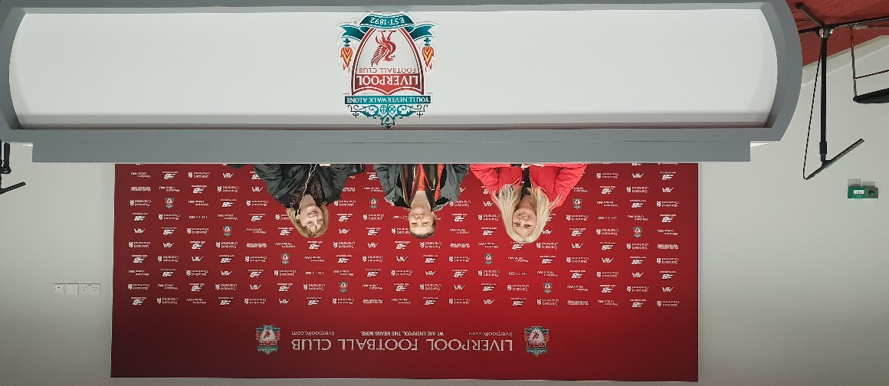

And finally onto the pitch to take a seat in the dugout and imagine the game fold out before you.
Anfield is truly an incredible awe inspiring stadium, you can feel the passion as you stand looking out at the pitch and can almost feel how the fans stand together and support each other through good times and obviously the sorrow that came and that is always there following Hillsborough.

At £20 per adult and £12 per children under 16 it is well worth the money.

‘You ‘ll never walk alone’ really does pull at your heartstrings and you don’t need to be a Liverpool fan to feel it.



