Operating Systems
Operating Systems
Module Name: Computer Architecture and OS
Module Code: ACCA 4022

Student Name: Mohamed Alkahtany
Student ID: 251545
Lecturer Name: Md Shantanu Islam

Contents
Introduction 4
Key functions of general Operating Systems 4
Task Management: 4
Application/Program Management: 5
File/Directory Management: 6
Device Management: 7
Security Management: 8
Use of Windows OS CLI commands 9
Example 1: 9
Example 2: 10
Example 3: 10
Example 4: 11
Example 5: 12
Example 6: 12
Example 7: 13
Example 8: 13
Example 9: 14
Example 10: 15
Use of Linux OS CLI commands 15
Example 1: 15
Example 2: 16
Example 3: 16
Example 4: 17
Example 5: 18
Example 6: 18
Example 7: 19
Example 8: 19
Example 9: 20
Example 10: 20
Use of Windows OS scripts 21
Example 1: 21
Example 2: 22
Use of Linux OS scripts 23
Example 1: 23
Example 2: 24
Conclusion 26
References 26
Appendices 26

Introduction
Operating systems are needed software, which control computer hardware and software resources and enable the user to interact with computer systems. The operating system acts as a mediator between the user and the computer hardware, as it provides services upon which the execution of applications and processes in the system is implemented. These popular operating systems include Microsoft Windows, Linux, and Mac OS. The activities that such systems coordinate include memory allocation, process scheduling, file management, and device control. The most significant role of operating systems has been discussed in this report, and the use of command line interfaces (CLI) in Windows and Linux operating systems. It also provides an example of Windows batch scripts and Linux bash scripts, which are used to automate a system.

Key functions of general Operating Systems
Microsoft Windows is one of the systems that is highly used in the world [1]. This was introduced by Microsoft in 1985, but has since changed a lot with the passing of time. Windows has a graphical user interface and system management features that allow easy servicing of files, devices, applications, and security [2].

Task Management:
One of the significant functionalities of the Windows operating system is task management that provides the user and the administrator with the opportunity to trace and manage the running processes. When considering system processes, Windows apportions the CPU resources to several applications in consideration of their priority and the necessity of the system [3]. Windows Task Manager Utility displays the details of the running applications, background processes, and the performance of our system. Using this tool, one is able to view CPU usage, memory usage, and disk activity. It also allows users to terminate tasks that do not respond or consume excess system resources. Task management is also efficient and renders the system stable, and does not permit any applications to affect the overall system performance.
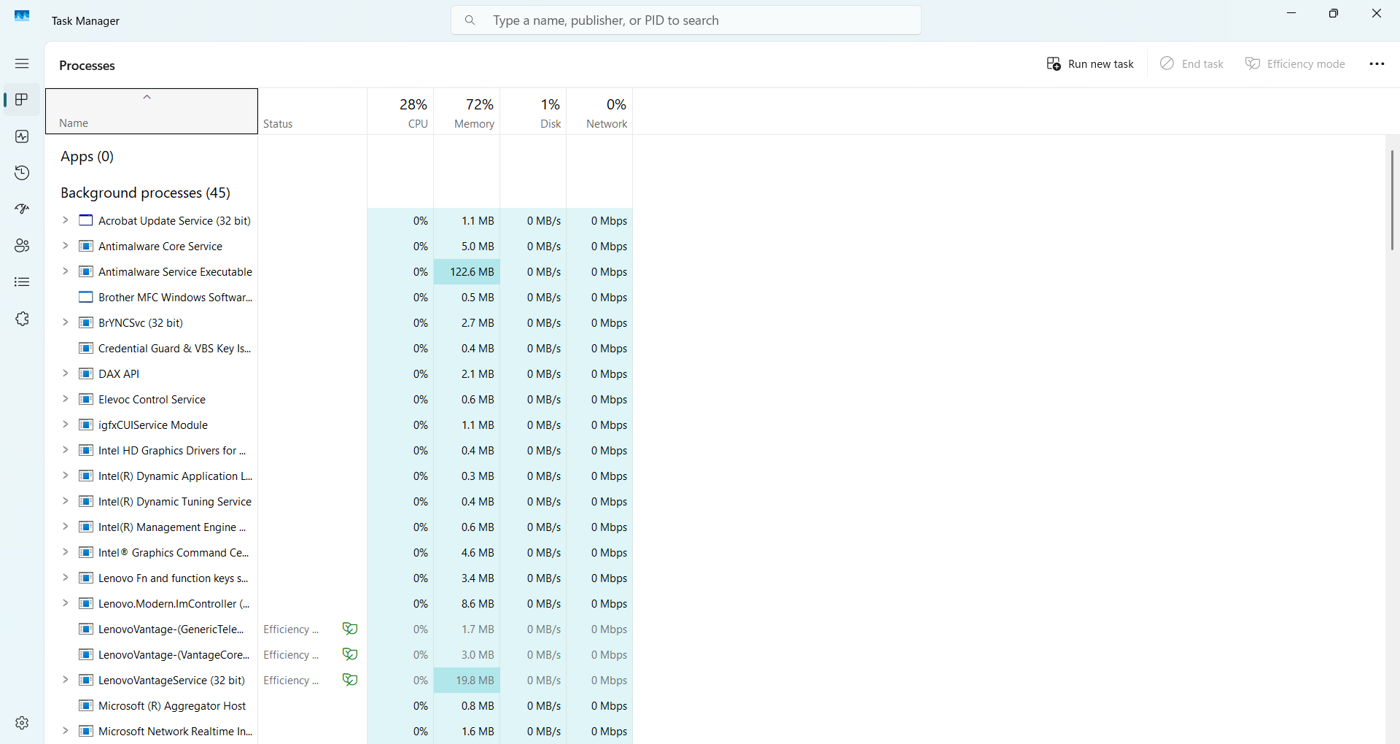
Figure 1: Windows Task Manager displaying running processes

Application/Program Management:
Application management windows can be defined as the ability of the operating system to install, run, monitor, and uninstall software applications [4]. Operation system ensures that all the applications are run under a controlled environment where the other applications will not be interfered with. Windows contains such applications as the control panel and task manager that are utilized to manage the applications and performance installed in it. It also manages dependencies of the programs, memory assignment, and system permissions that the different applications require. There is a need for program management as users can install programs, securely update them where necessary, and remove the undesired programs within the system. This improves effectiveness besides system performance.
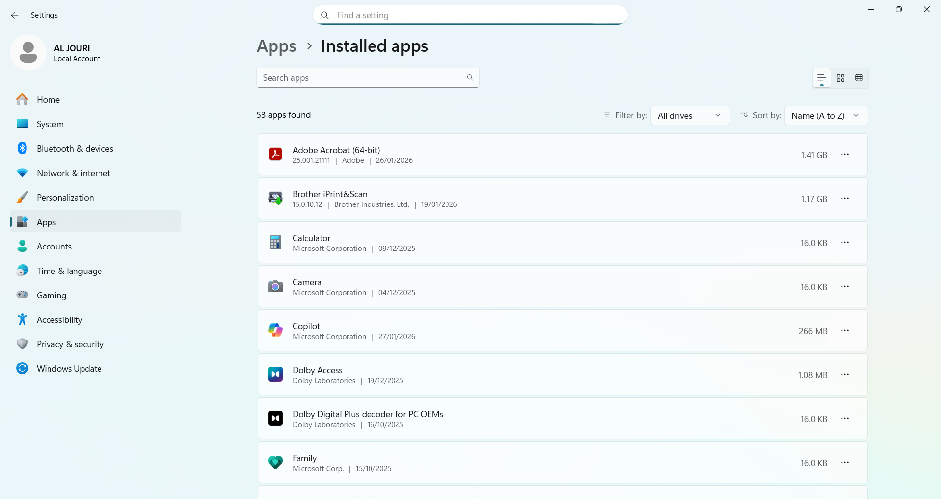
Figure 2: Windows Task Manager showing application processes

File/Directory Management:
Another useful application of the Windows operating system is file and directory management. It enables people to make, arrange, edit, and delete files and folders stored in the storage devices. Windows has a hierarchical file system that is useful in organising data. The interface of the file explorer is used to interact with files and folders and enables easy navigation in the directories. File permissions and access control are also controlled by the operating system to promote data security [5]. The file management supporting features enable users to research, copy, transfer, and rename files in a short time.

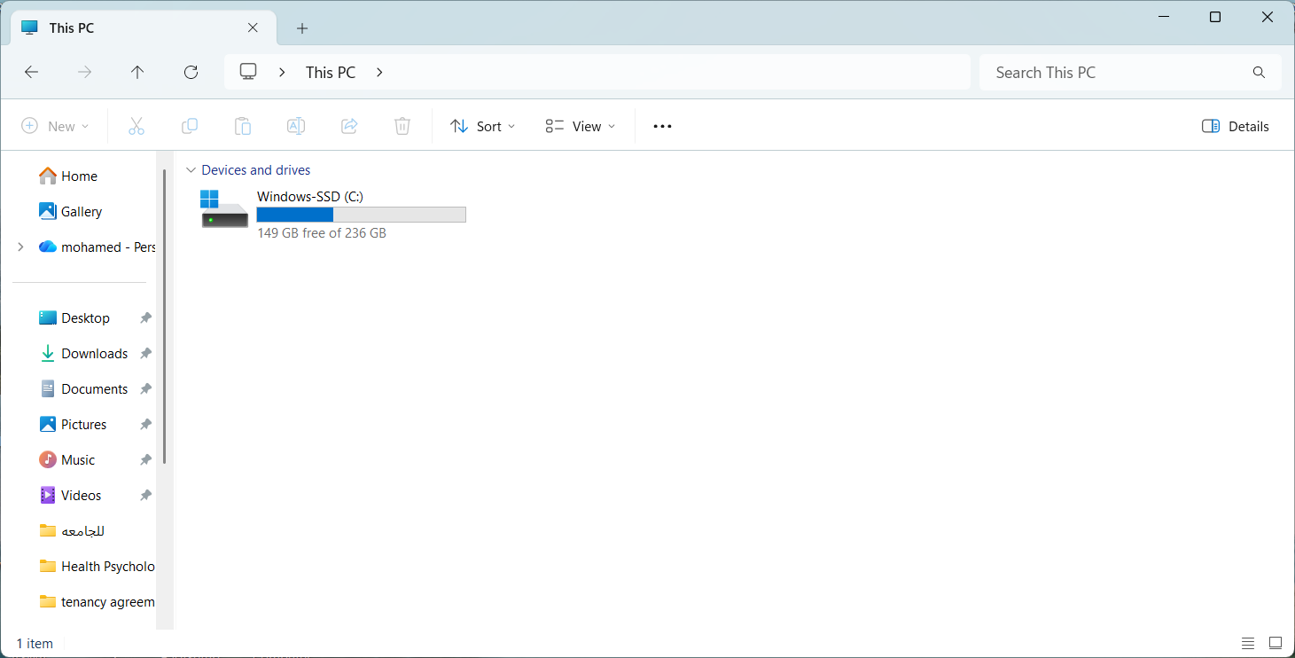
Figure 3: File Explorer showing file and directory structure

Device Management:
The concept behind the device management is that the operating system can manage and or coordinate the hardware devices within the operating system. These pieces of equipment include printers, keyboards, storage equipment, monitors, and network adapters. Windows is used to run such devices through device drivers, which makes communication between hardware components and the operating system possible. The Device Manager tool can help users to view the installed hardware, obtain the available drivers, and determine the issue with devices [6]. Proper maintenance of equipment would ensure that hardware elements work in a proper and effective manner. It is also applicable in preventing hardware interference and improving hardware stability since it will be possible to check that the right drivers are applied to all the devices.
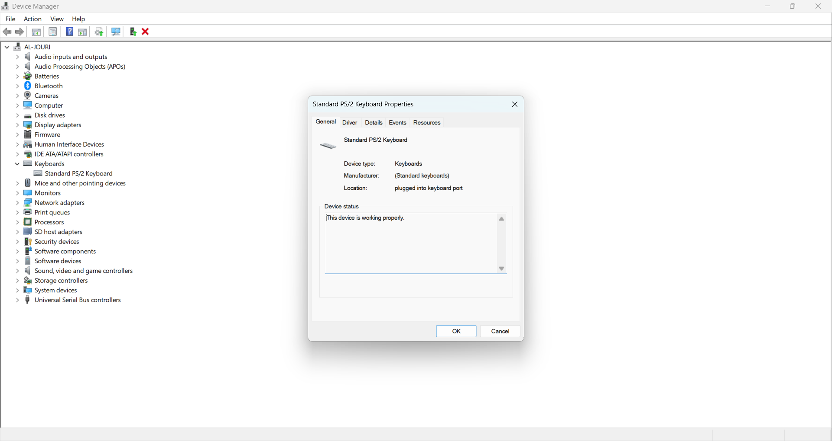
Figure 4: Windows Device Manager showing installed hardware devices

Security Management:
Security management is also a significant operation of windows operating system, which protects the system against unauthorized access and potential threats to the system [7]. The authentication of users, password protection, Firewall protection, and file access permissions are some of the security measures that Windows offers. These security features will permit access to authorized users only to sensitive data and system resources. The windows also have built-in security software such as Windows Defender, which makes sure that no malware or viruses have infected the computer system. Security management also involves monitoring system activities and controlling user privileges. Through appropriate security management, I would make sure that the system is not compromised and important data does not fall into the hands of cyber terrorists and computer hackers.

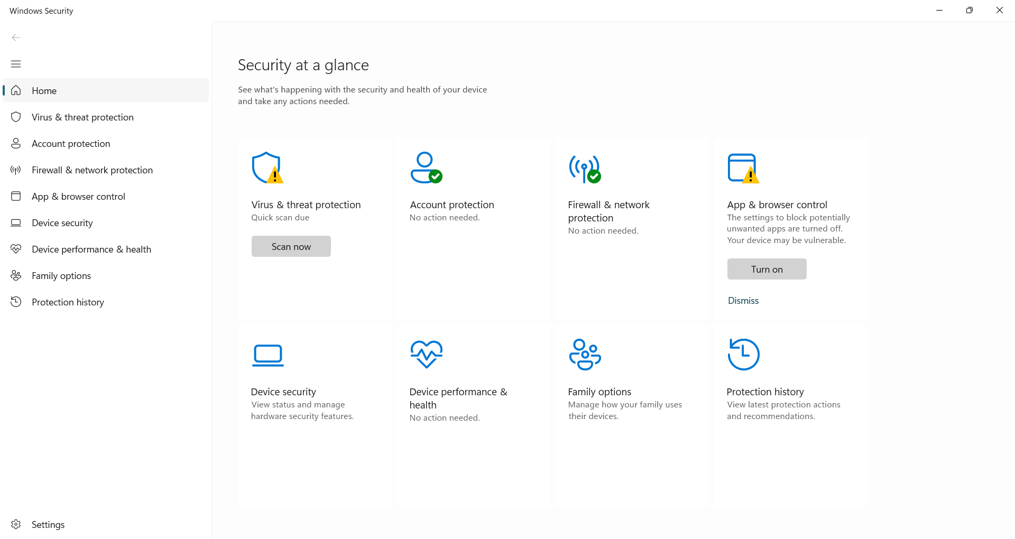
Figure 5: Windows security settings showing system protection features

Use of Windows OS CLI commands
The Windows command line interface (CLI) allows administration of the system in text commands. PowerShell and Command Prompt are effective file management tools, process management tools, and network configuration management tools in addition to a user account management tool [8]. CLI commands are also known to be administered by administrators to effectively perform tasks.

Example 1:
To list all the processes already taking place in the system, one uses the tasklist command. It provides the name of the process, process ID, and the amount of memory consumed by the process that is used to track down the activity of the system.
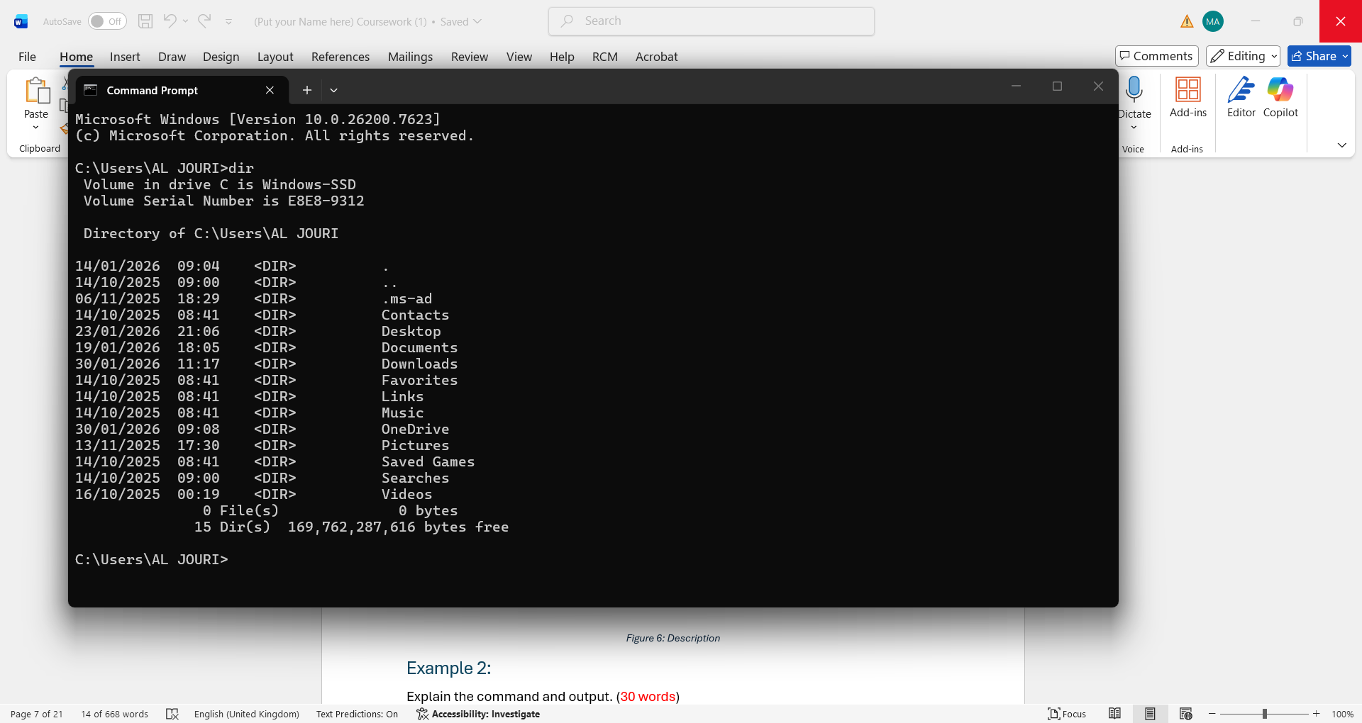
Figure 6: Output of the tasklist command showing running processes

Example 2:
Taskkill is the command used to kill the process that is running, either by process name or process id. This command finds application in cases in which an application has failed.
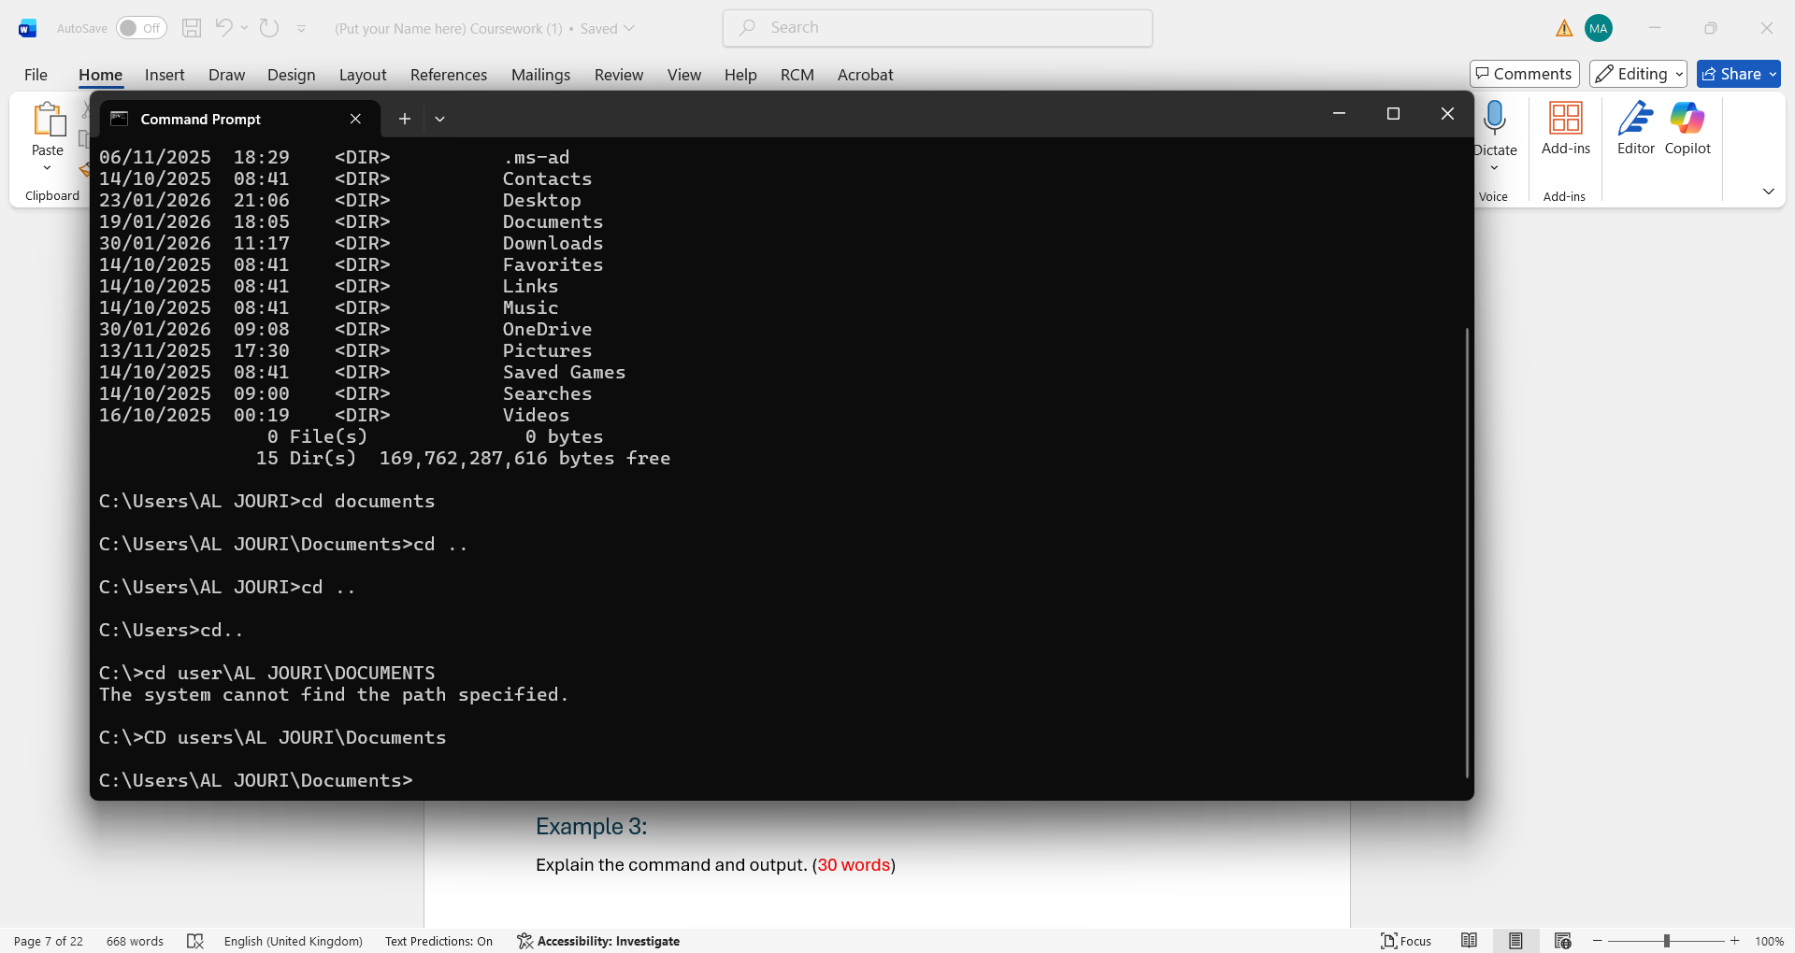
Figure 7: Using the taskkill command to terminate a process

Example 3:
A list of all the files and folders in the specified path is available in the list of the dir command. It helps users to search for information in the directory fast and to determine that the files really exist.
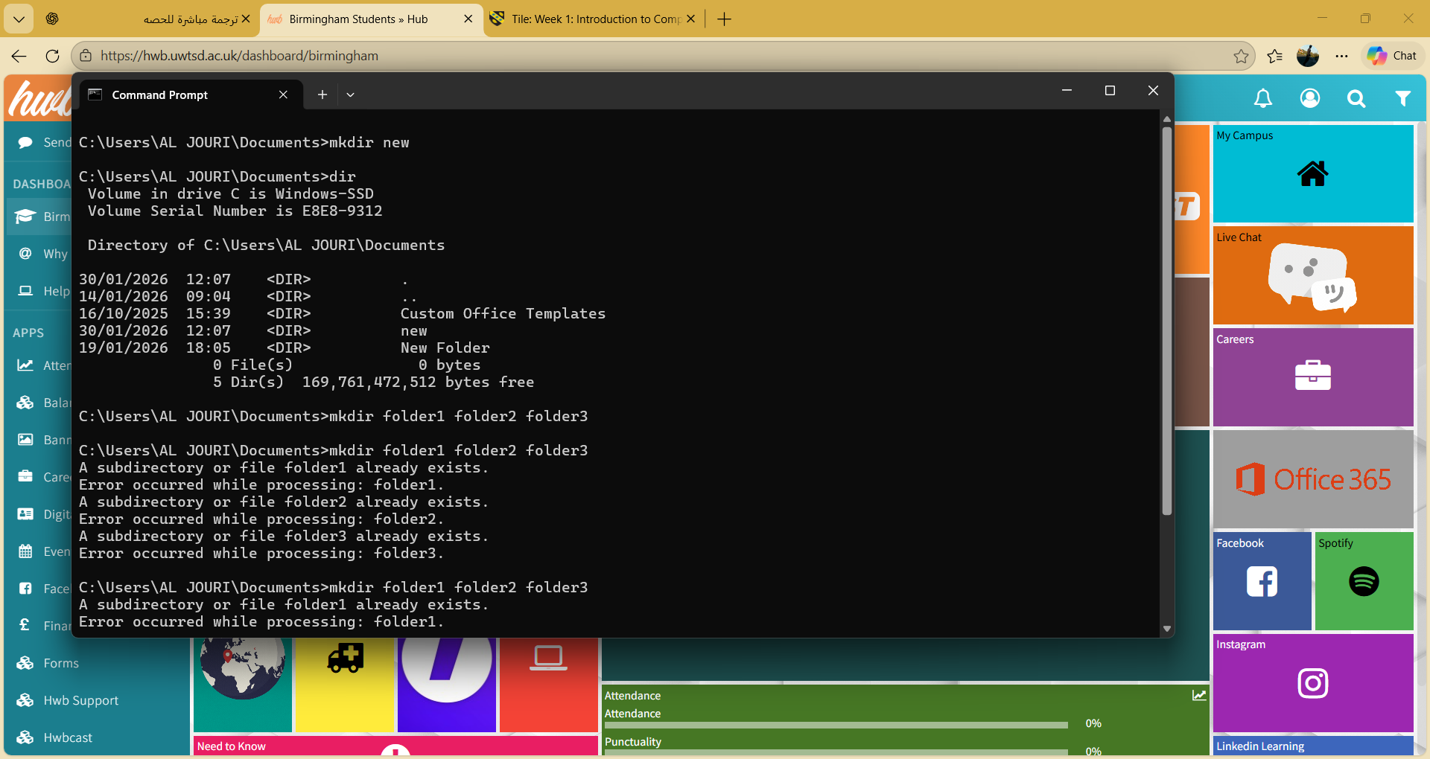
Figure 8: Directory listing using the dir command

Example 4:
The rmdir new could then be used to rename the directory now named new to a new name. This is followed by listing the contents contained in the folder through the use of the command dir to make sure that one is able to check that the folder is cleared by the command dir.
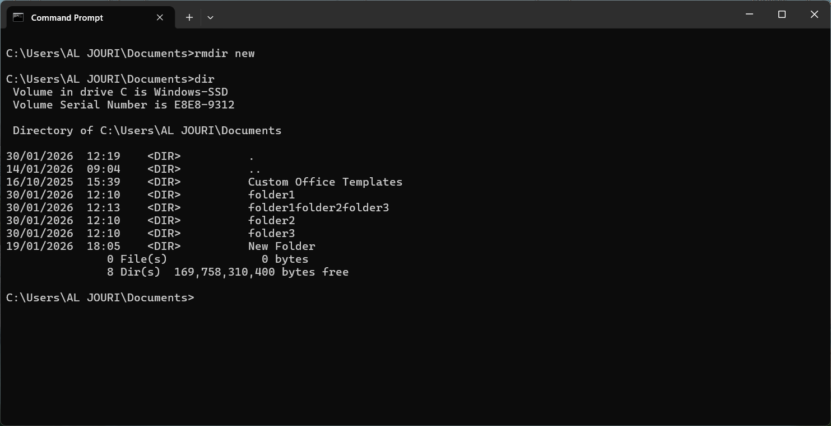
Figure 9: Deleting a directory using the rmdir command

Example 5:
To display a text or to create plain text files, the echo command should be used. It is also used in scripting and automation.
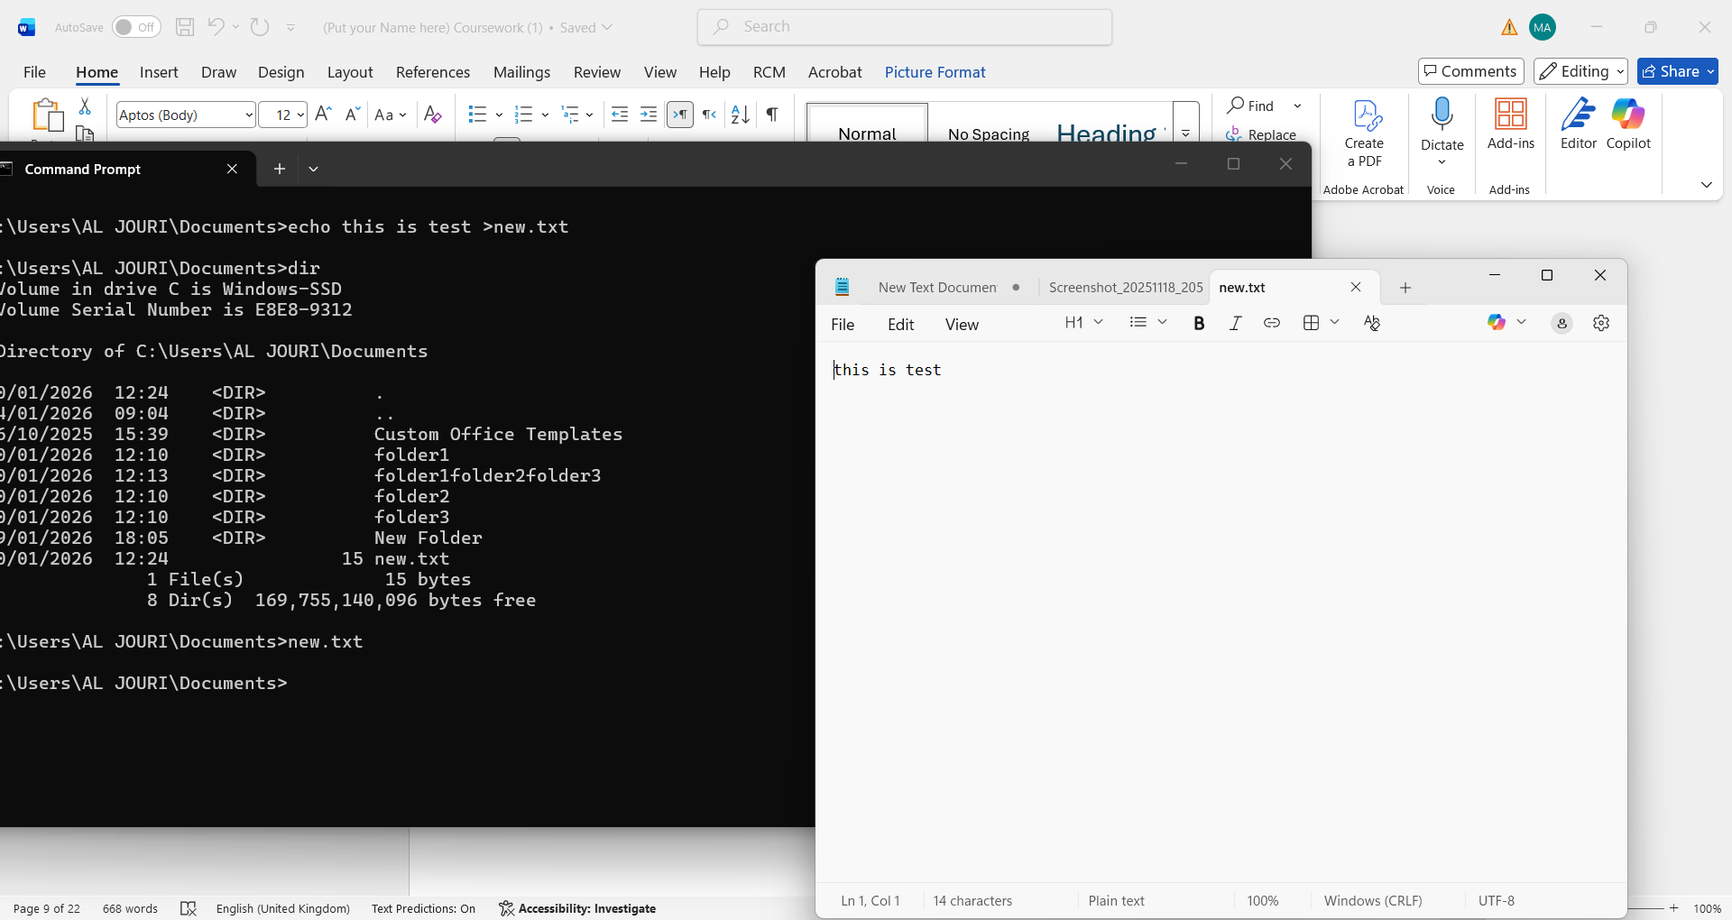
Figure 10: Creating a text file using the echo command

Example 6:
The task list command will be used to display all the processes running on the Windows system. It presents the data concerning such processes as process name, process ID (PID), name of the session, and memory usage of the given process.
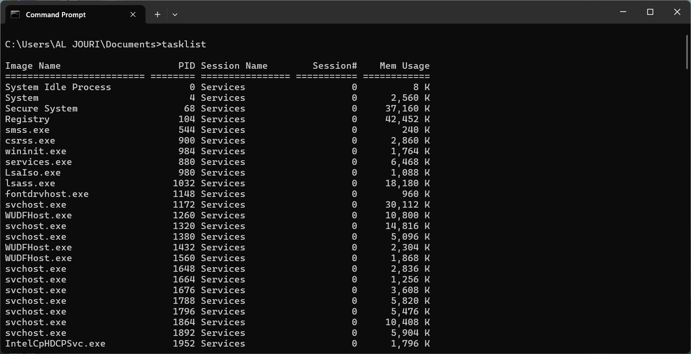
Figure 11: Displaying running system processes using the tasklist command

Example 7:
The systeminfo command will provide much information about the Windows operating system and computer hardware. It also shows such details as the version of OS, processor, type of system, memory, and the date when the system was installed.
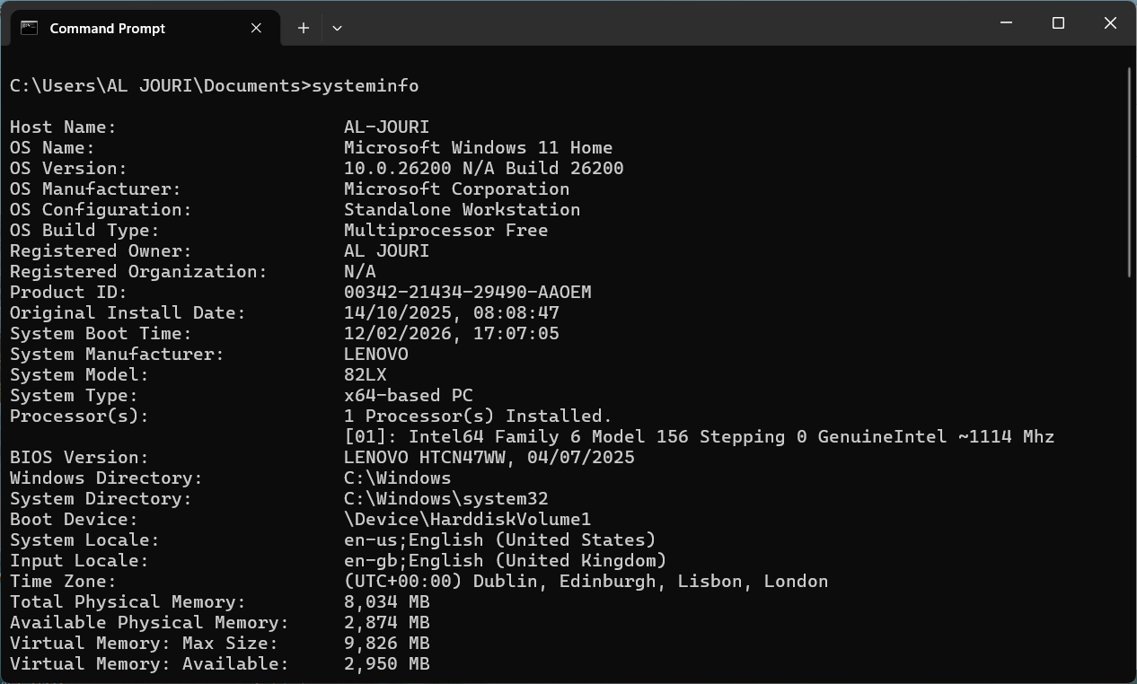
Figure 12: System information displayed using the systeminfo command

Example 8:
The ipconfig /all will provide the computer with details as to the network configuration. It shows IP address, MAC address, DNS settings, and DHCP status, and network adapter details that can be used during the troubleshooting of connectivity.
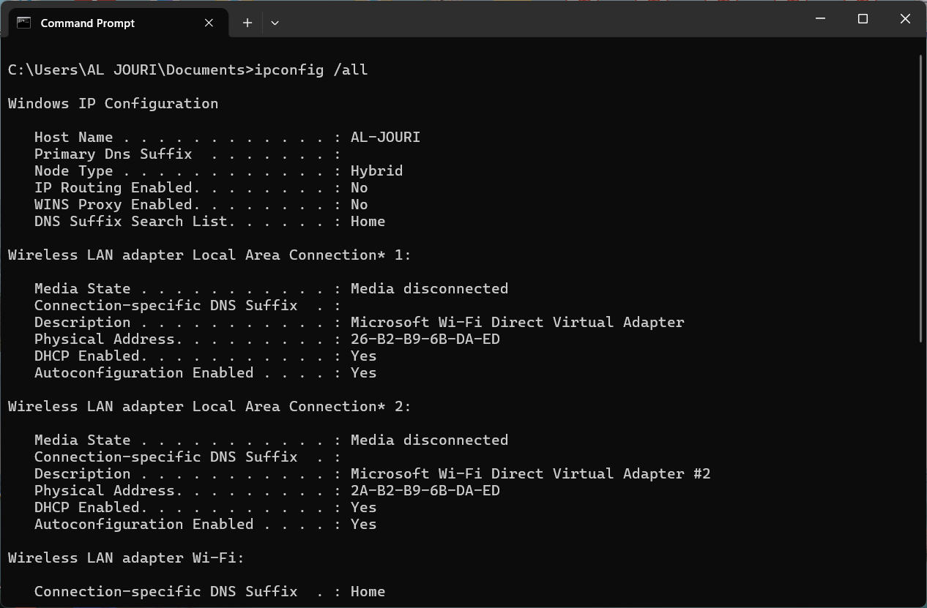
Figure 13: ipconfig /all Command

Example 9:
The ping www.urtsd.ac.uk command checks the connectivity to both the computer and the server. It transmits data packets and response time measurement to track network availability as well as network performance.
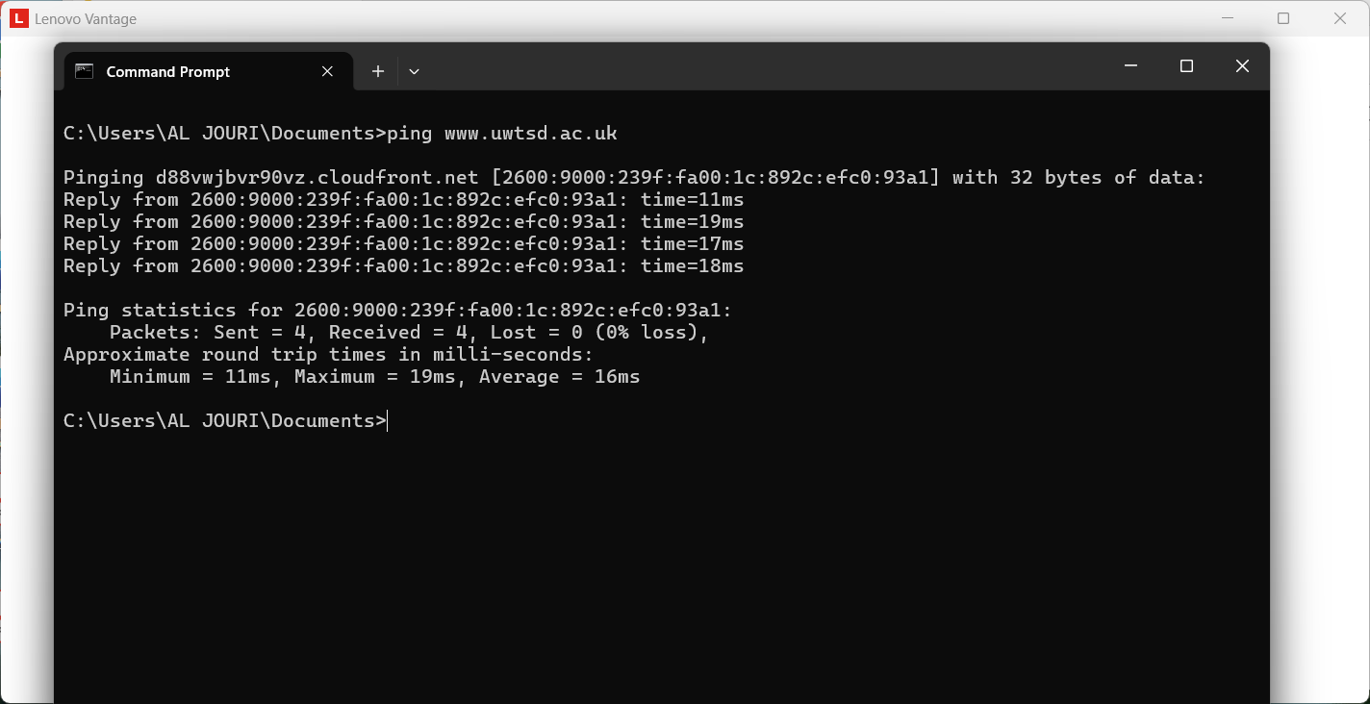
Figure 14: Network connectivity test using the ping command

Example 10:
The tracert www.uwtsd.ac.uk command tracks down the path of the data packets to reach a destination server. It displays all network hops and response times that could mean network delays or issues with connections.
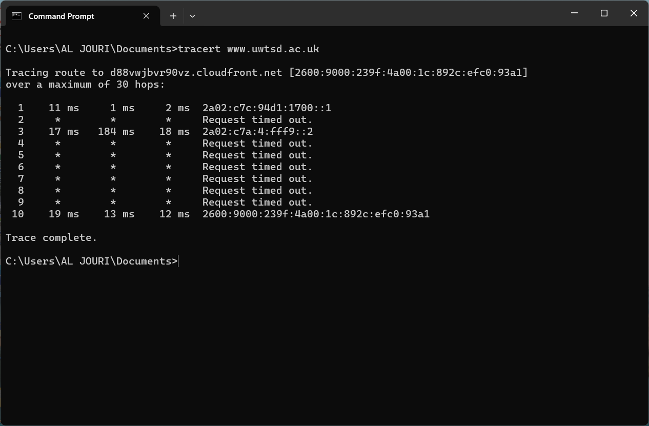
Figure 15: The tracert command showing hops between the local computer and the destination server

Use of Linux OS CLI commands
Linux Command Line Interface provides detailed system management, file management, and network monitoring applications. Bash commands allow the user to perform administrative tasks well and automate. Linux CLI finds good application in servers, the administration, and the development of systems [9].

Example 1:
Linux, being a system capable of user switching, has the command su (switch user) that may be used to alternate between user accounts. In the screenshot, the user attempts to alter access to the root account, but after that, he or she changes the access to the account of the sysadmin.
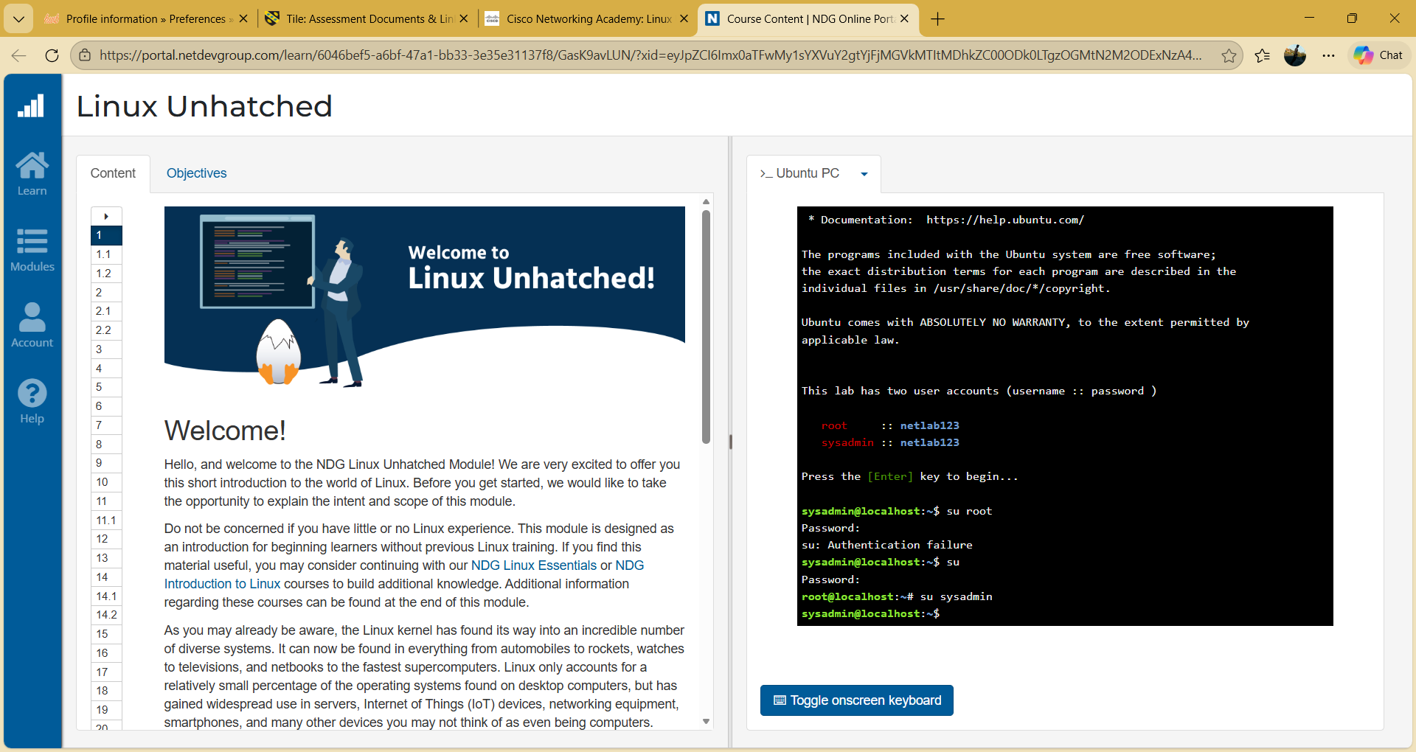
Figure 16: su command

Example 2:
The pwd (Present working directory command displays the directory path, which is the current one on the Linux terminal. In the output, it displays /home/sysadmin, which implies that the user is in the home directory that belongs to sysadmin.
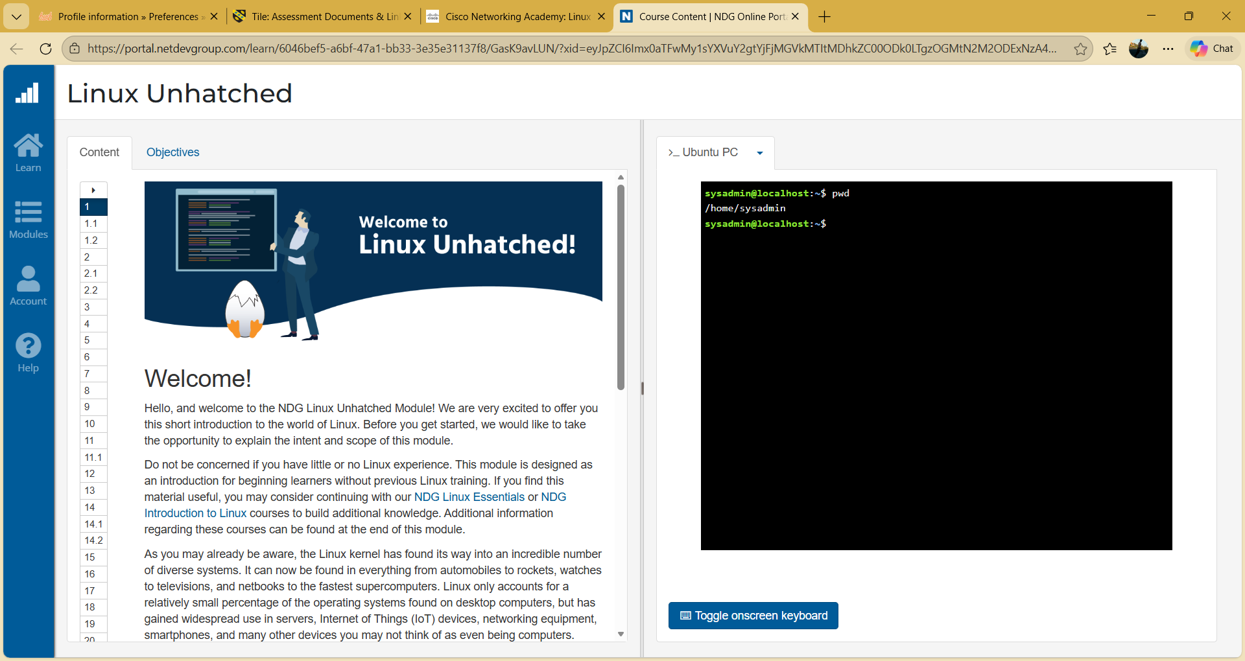
Figure 17: pwd command

Example 3:
ls is a command that is used to list files and directories in the current directory. One can have an option two see a hidden file with option -a, and option two see the extra information about the permissions, owner, size, and date of modification, etc.
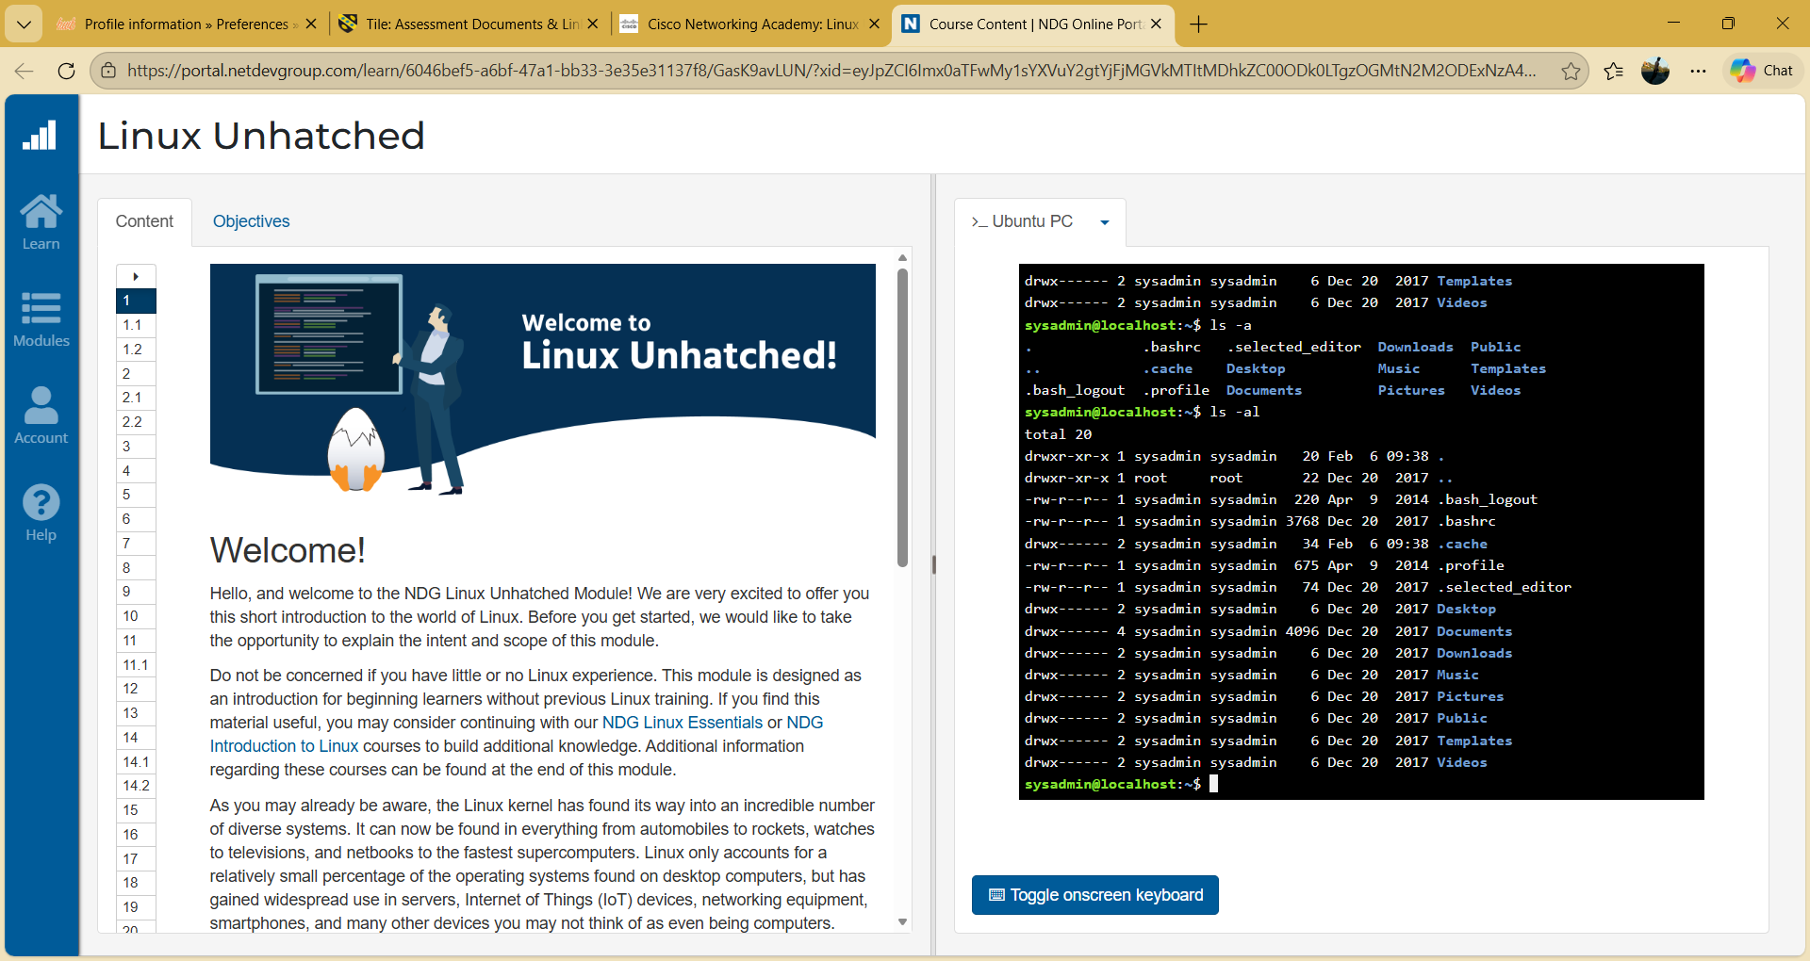
Figure 18: Output of the ls -a and ls -al commands

Example 4:
The change directory command is the command that is used in Linux to change between two directories. In this case, a user alternates between the home directory and the Desktop directory.
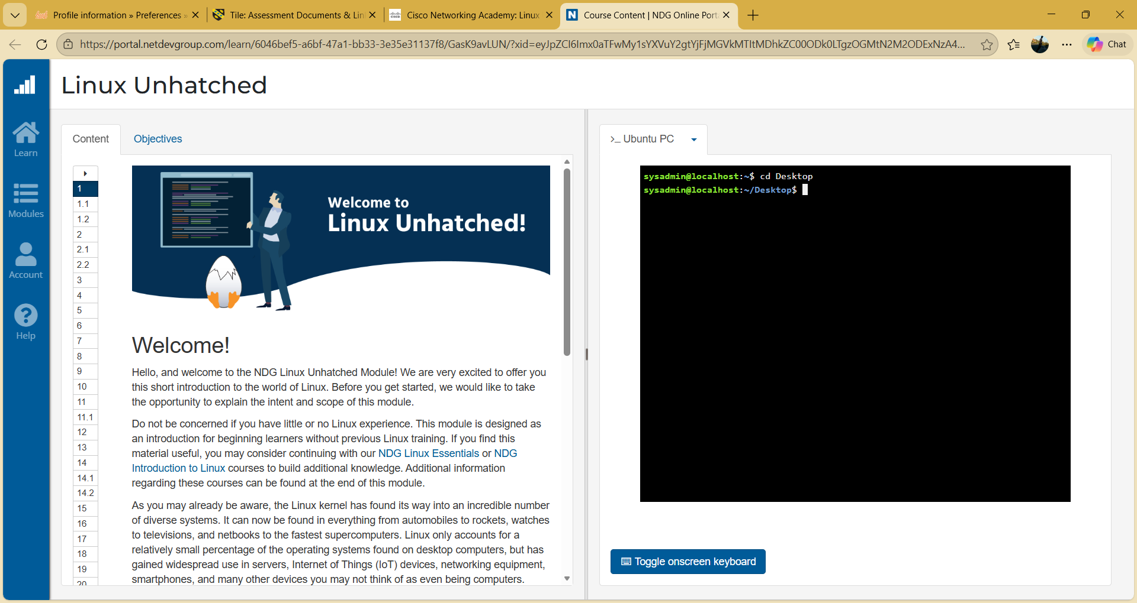
Figure 19: cd Desktop command

Example 5:
The (mkdir) make directory is used to create a folder. This is whereby a directory is generated, which has been referred to as new, and the ls is used to ensure that the directory has been created.
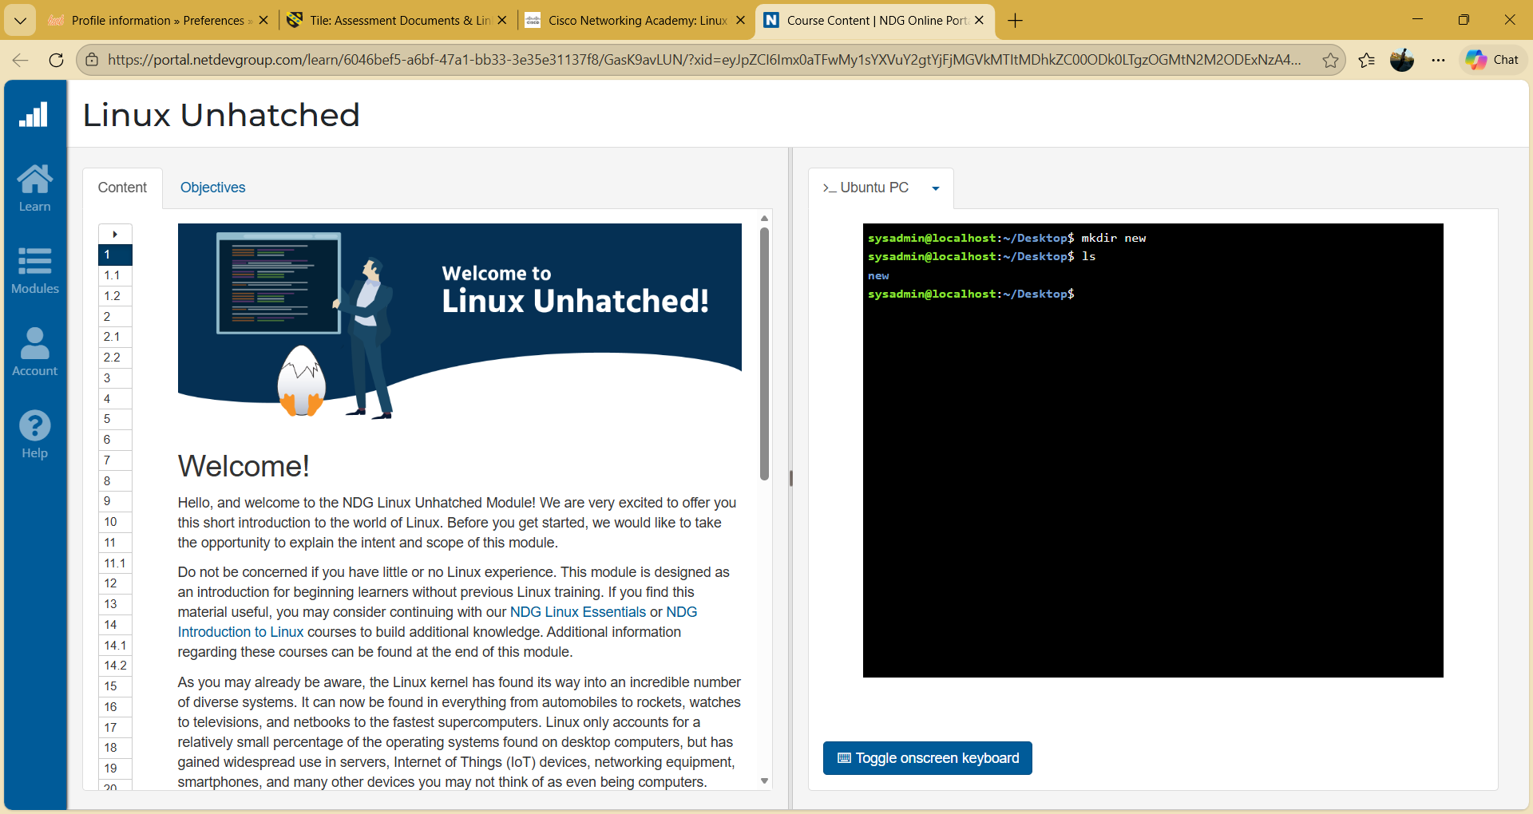
Figure 20: mkdir new command

Example 6:
In Linux, one uses the rmdir command to remove an empty directory. In this case, the deletion of the folder new and the " ls has indicated that the directory no longer exists.
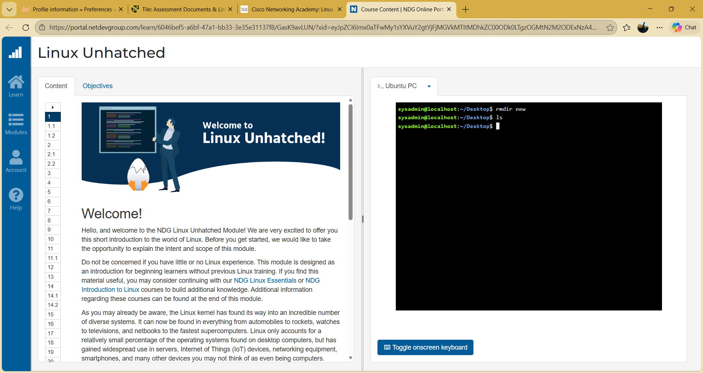
Figure 21: rmdir new command

Example 7:
Linux is a command that is employed to make a new empty file, as per the touch command. Here new file, referred to as new.txt, is generated, and the list program, ls commands used to check the presence of the file.
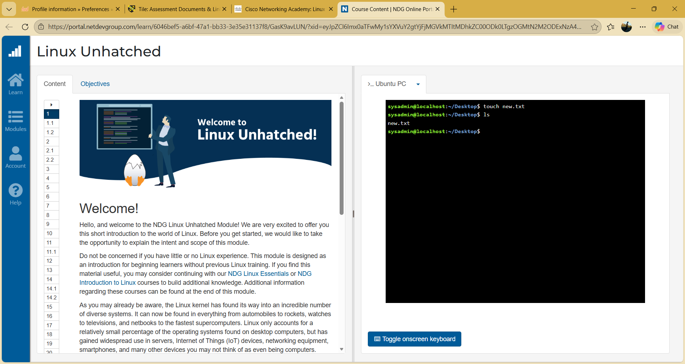
Figure 22: touch new.txt command

Example 8:
The echo command latches text into a file, and the cat command displays what is in a file at the terminal. In this case, the text is saved into new.txt, and finally, the text is read.
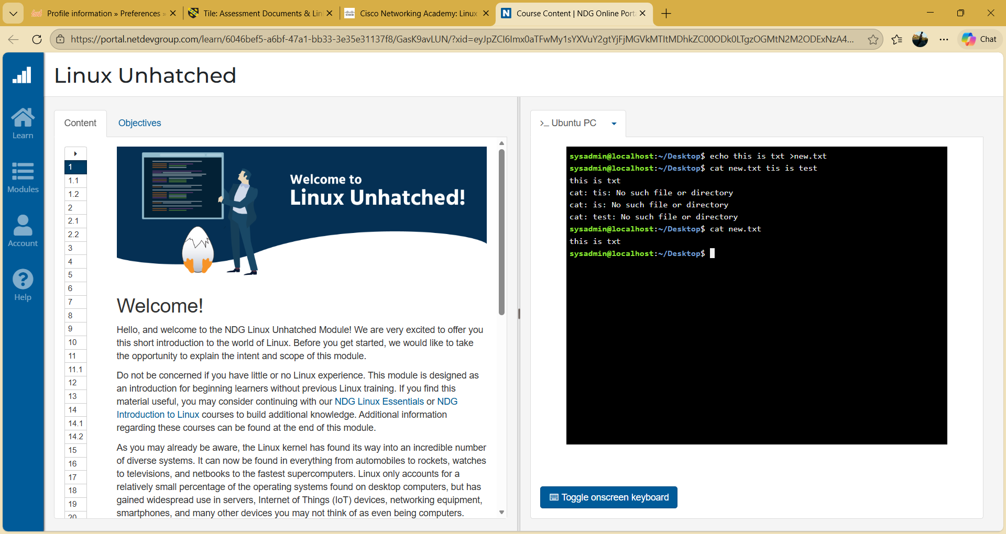
Figure 23: echo and cat commands

Example 9:
The network interface is shown in Linux in the ifconfig command. It shows the information of IP and broadcast address, packet statistic, and network status of interfaces, e.g., eth0 and lo.
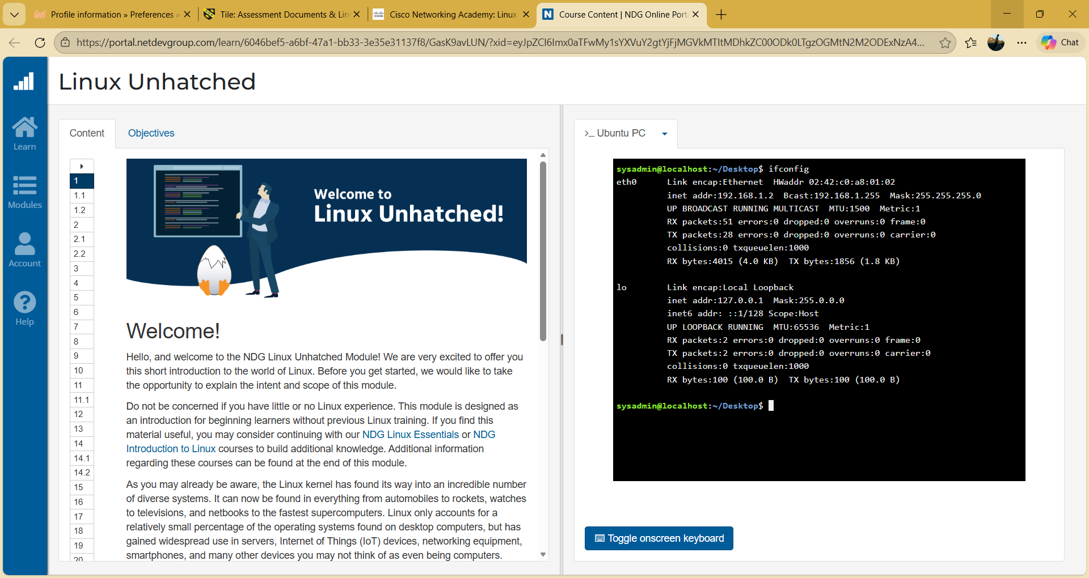
Figure 24: ifconfig command

Example 10:
The whoami command is used to give a list of the current user who is logged in, and the date command gives a list of the current date and time of that system. These scripts are useful to help users to quickly check the identity and time of systems.
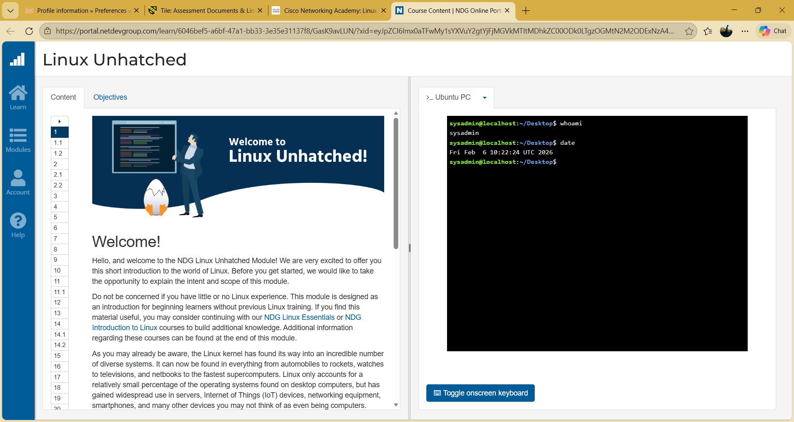
Figure 25: whoami command

Use of Windows OS scripts
Windows is utilized to provide automation of command-line scripts by a group of commands located in an.bat file [10]. It assists in the monotony of work, such as controlling files, examining the systems, and performing calculations. The batch scripts are useful in improving efficiency, and the administrators will be able to automate their daily tasks with ease.

Example 1:
This is a simple arithmetic operation script in the form of a Batch script, and the script could add two numbers as they are entered by the user. The script commences with the script that alludes to script headers: of course, the line that is loaded together with the script: @echo off. The command set /p is used to accomplish the request for user input. In this script, the user will be asked to key in the first number and the second one, which will be represented in the variables number1 and number2.
The following arithmetic calculation is provided by the following command set /a total=number1 + number2, and so on. Mathematical operations are supported as a part of /a option in Batch scripting. It adds up the two figures that have been typed in by the user and saves the sum in the total variable.
The outcome is displayed on the screen with the message being the total. Finally, the pause command keeps the command prompt window, which enables the user to view the outcome before he or she terminates the program. This script shows how Windows can be automated so that simple calculations and interaction with the user can be achieved through Batch scripting.
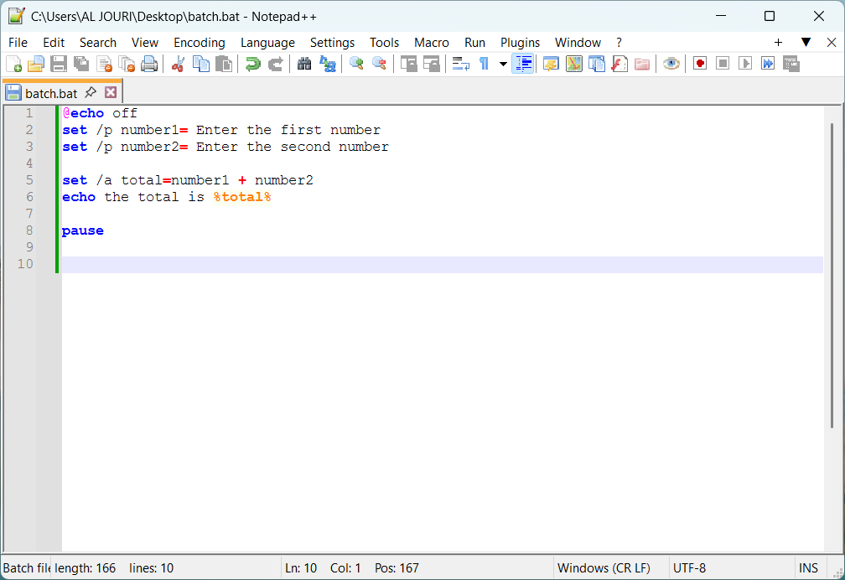
Figure 26: Batch script code

Example 2:
The Batch script can be executed in the Windows command prompt. At the execution of the script, the user types in the first integer, and then types in the second integer. These values are set into the variables number1 and number2 by the set /p command.
After typing the numbers in the script, the command set /a is typed to execute an arithmetic operation. This is then succeeded by the use of the echo command, where the result is presented on the screen with a message stating the total is followed by the value calculated.
The result of the screenshot is 0 (indicating that there were not numbers provided to the user before clicking the enter button). Finally, the pause command displays a message that reads Press any key to continue the marketing plan, the user is able to view the result and close the command line.
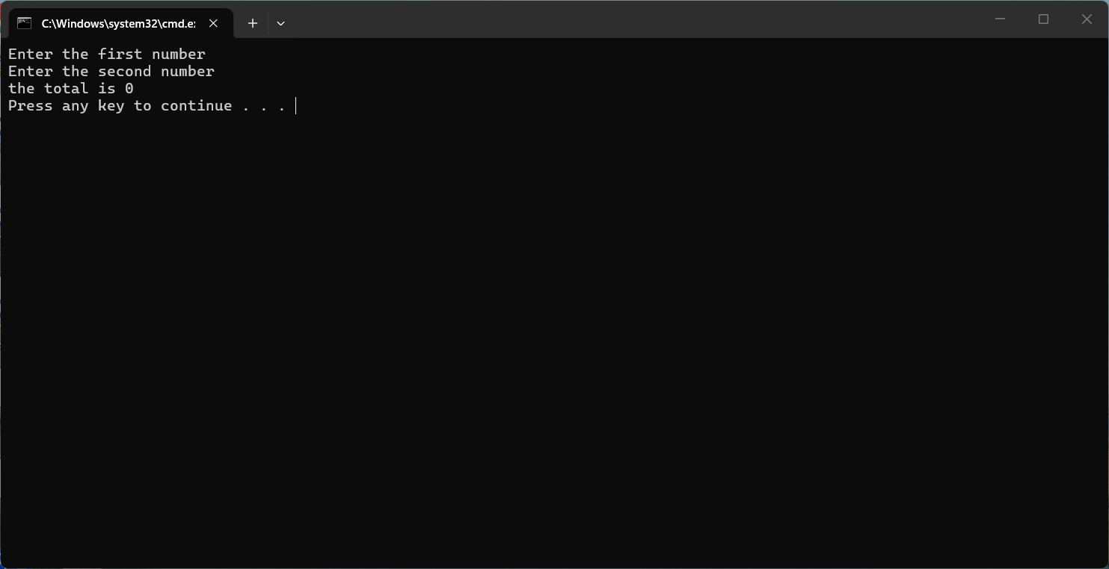
Figure 28: Batch script running in Windows Command Prompt

Use of Linux OS scripts
Linux is a scripting language, bash scripting, which is used to perform automated operations by means of a series of commands in a script file [11]. It helps the system administrator run activities such as file management, system backups, monitoring, and calculation of systems of Linux terminal environment with ease.

Example 1:
The script is a Bash script, which sums two numbers that are entered by a user. The script begins with the use of an echo command, which prints the message on the screen, i.e., Enter the first number. When the read command takes input that a user orders and gives the value to the variable num1. This is repeated, and that is the reason that the second number in the variable num2 is asked.
The second thing to do is to perform an arithmetic operation through the assistance of the expression total= $ ((num1+num2)). This command adds the two figures also typed in by the user, and the value is stored in the variable total.
Finally, the Echo command shows the response in the terminal in the form of a message of total being, which is //total. Through this script, one can see how Bash scripting can take user input, do some calculations, and present the results, which will be useful when automating work and simplifying command-line processes in Linux machines.
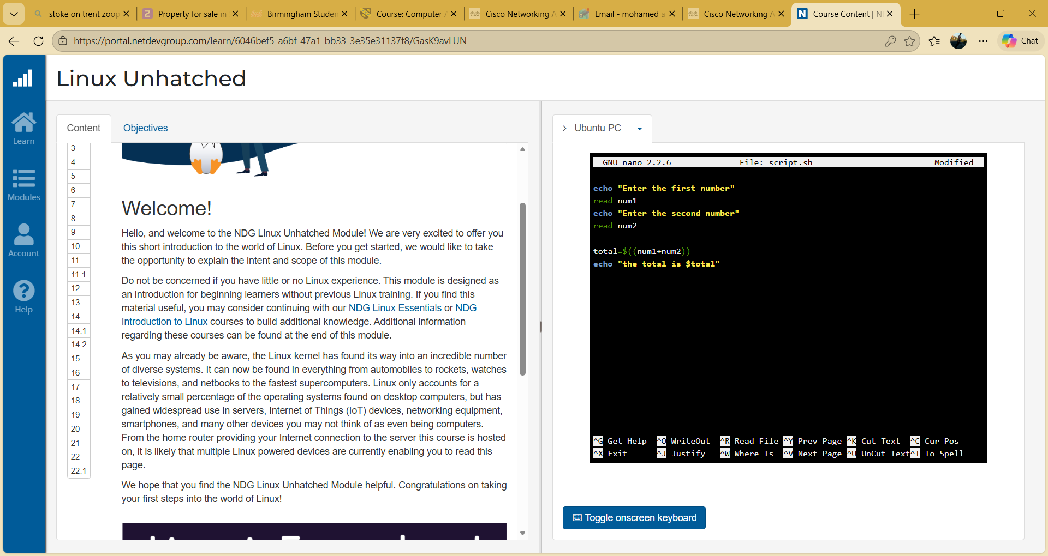
Figure 30: Arithmetic calculation
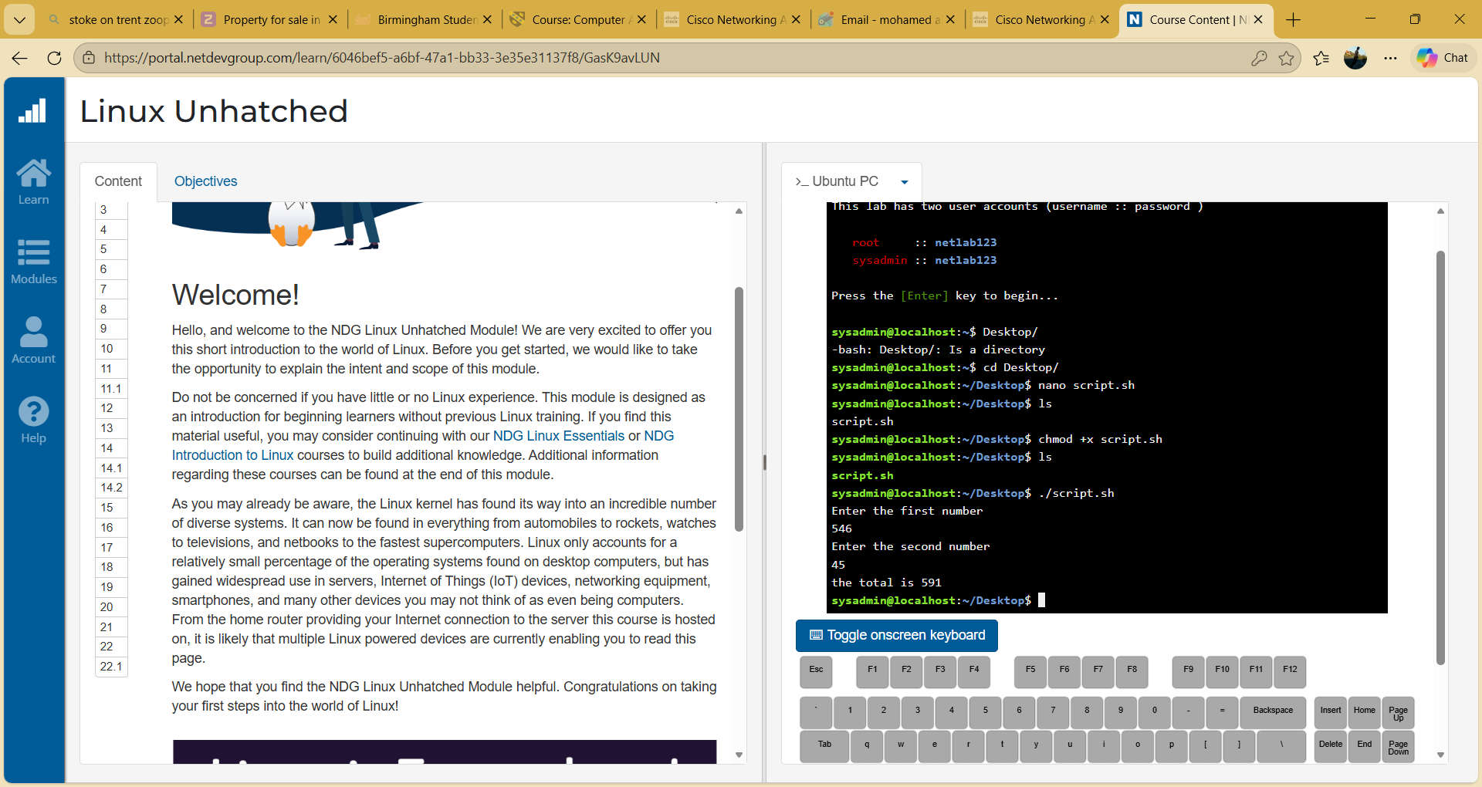
Figure 31: Result displayed

Example 2:
The script below is an example of Linux scripting where user input and loops can be implemented. The script will start with the command echo Enter the final number, where a message to input a number will be displayed to the user. The command read final then launches the value that is entered into the prompt by the user, and stores the value in a variable final.
Then, it contains a for loop within the script coded as for ((i=1; i=final; i=i+1)). This loop starts with counting the value 1 and proceeding with adding 1 to the value of i till the user enters the value. This loop uses the command echo "$i" and it shows the i that is currently on the screen.
When executing the script, one would be presented with a set of numbers beginning with the number one up to the number that the customer has entered. In this script, we have seen that Bash scripting can be applied to automated repetitive processes and give out sequential output in the Linux terminal by utilizing loops and variables.
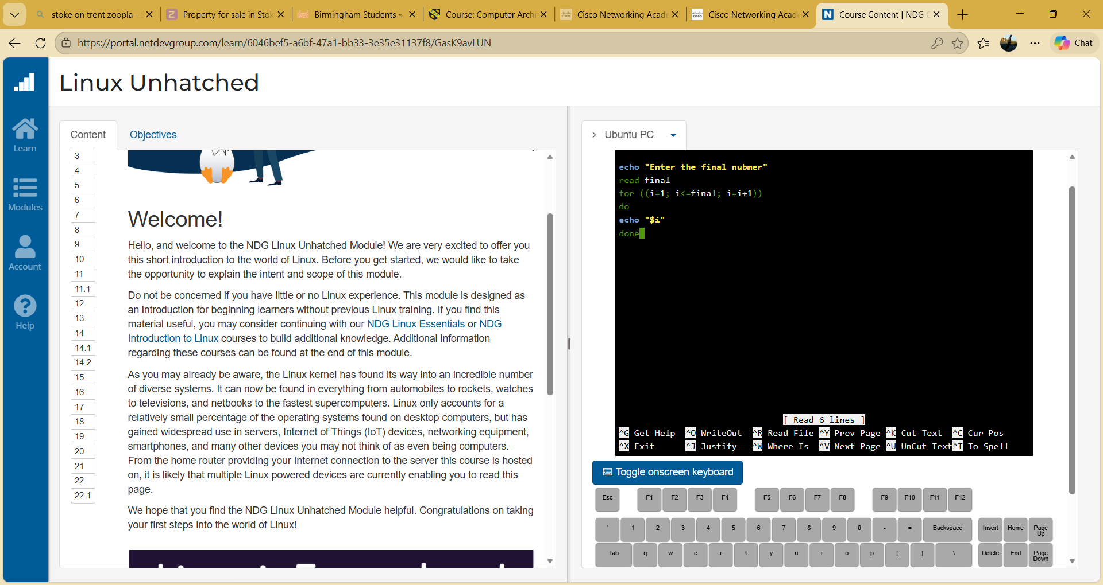
Figure 32: loop that prints numbers
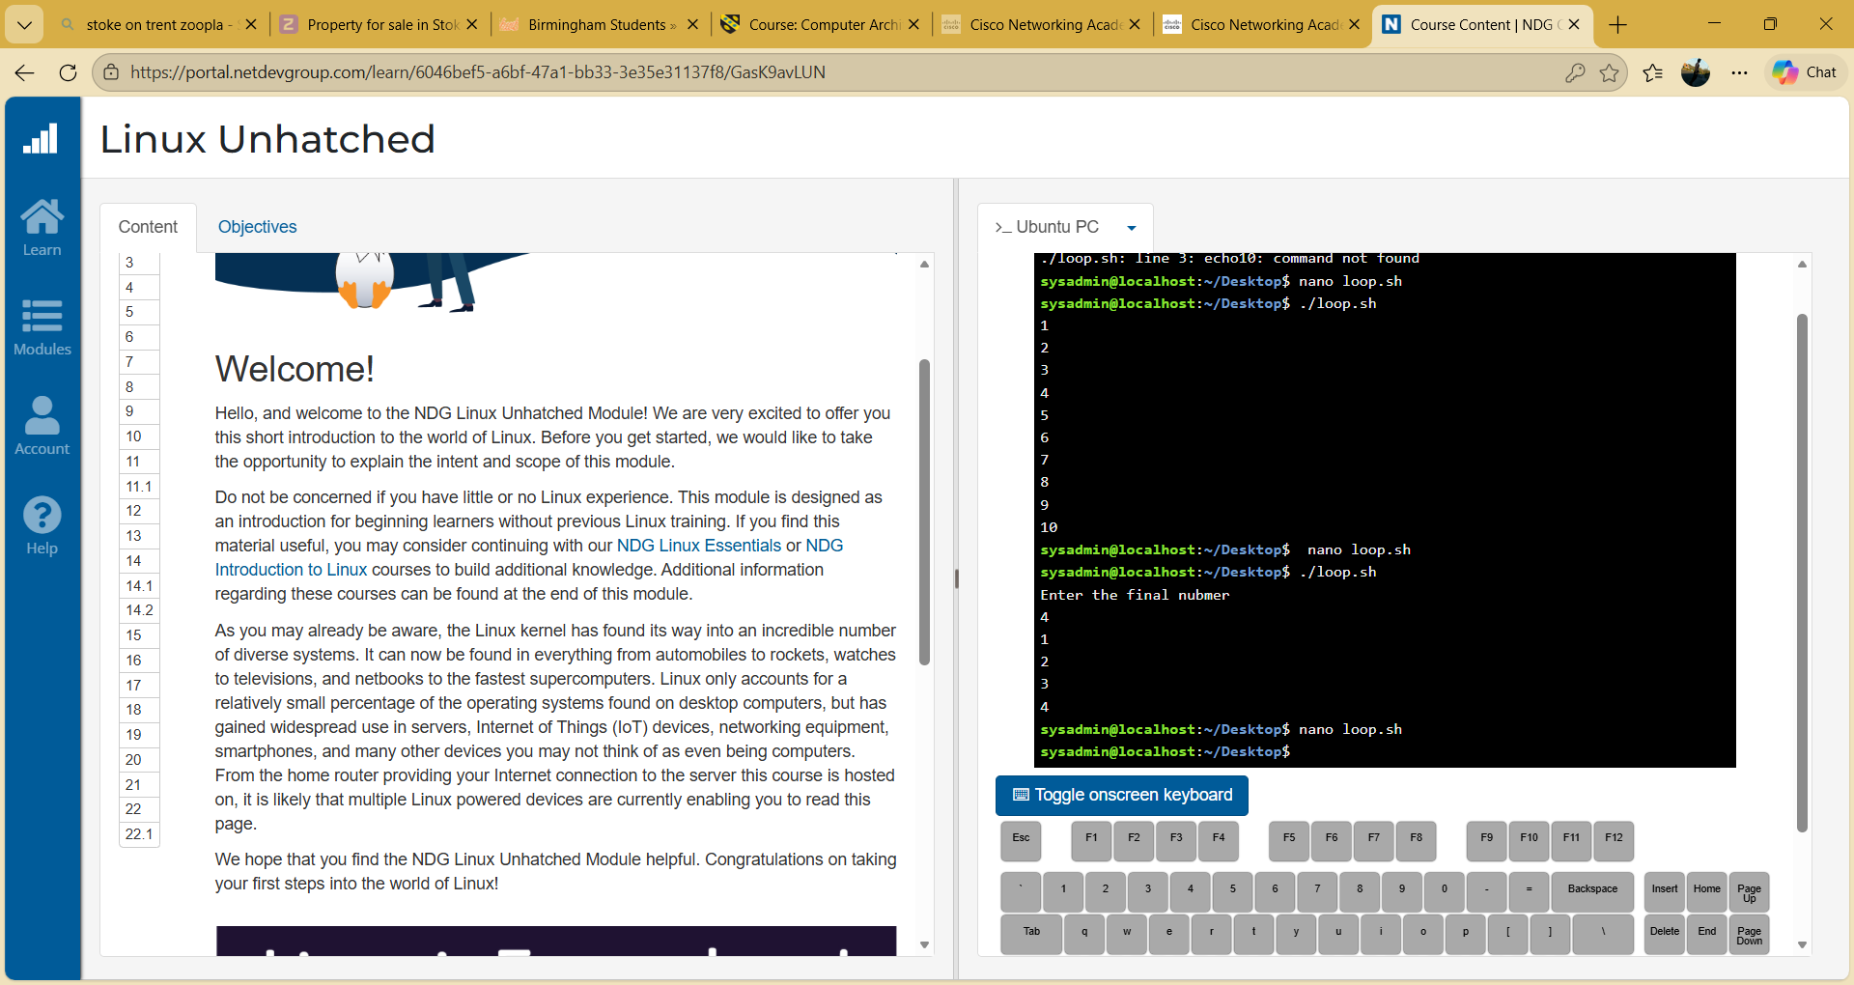
Figure 33: Bash loop script displaying numbers in sequence

Conclusion
In this report, the key functions that operating systems perform and the use of Windows and Linux command line utilities have been described. Another thing that was displayed was the automation of tasks through Batch and Bash scripts. These practical activities assisted me to learn more about managing systems, executing as well as scripting commands on operating systems.

References
[1] M. T. Awan, “Linux vs. Windows: A Comparison of Two Widely Used Platforms,” Journal of Computer Science and Technology Studies, vol. 4, no. 1, pp. 41–53, Jan. 2022, doi: https://doi.org/10.32996/jcsts.2022.4.1.4.
[2] A. Khir and A. Khir, “The Evolution of Windows Systems from Windows 1 to Windows 11.” Available: https://student.wp.odu.edu/aabou004/wp-content/uploads/sites/39320/2025/09/Project-Paper.pdf
‌ [3] A. Atta, K. Eman, B. ali Hassan, M. Azam, and Ali, “PERFORMANCE, SCALABILITY, AND FLEXIBILITY: A COMPARATIVE ANALYSIS OF WINDOWS, LINUX, AND SOLARIS,” Journal of Emerging Technology and Digital Transformation, vol. 4, no. 1, pp. 10–23, 2025, Accessed: Mar. 06, 2026. [Online]. Available: https://www.journalofemergingtechnologyanddigitaltransformation.com/index.php/3/article/view/85
‌ [4] A. U. Umar, & A. Wakili, “A Comparative Study of Modern Operating Systems in terms of Memory and Security: A Case Study of Windows, iOS, and Android,” pp. 131–138, Mar. 2023, doi: https://doi.org/10.56471/slujst.v6i.353.
[5] C. Cho, Y. Seong, and Y. Won, “Mandatory Access Control Method for Windows Embedded OS Security,” Electronics, vol. 10, no. 20, p. 2478, Oct. 2021, doi: https://doi.org/10.3390/electronics10202478.
[6] Ö. Aslan, S. S. Aktuğ, M. Ozkan-Okay, A. A. Yilmaz, and E. Akin, “A Comprehensive Review of Cyber Security Vulnerabilities, Threats, Attacks, and Solutions,” Electronics, vol. 12, no. 6, p. 1333, Mar. 2023, doi: https://doi.org/10.3390/electronics12061333.
‌ [7] B. Burke, “LATEST SECURITY THREATS AND MITIGATION STRATEGIES 1 Windows Management and Cybersecurity: Latest Security Threats and Mitigation Strategies,” 2024. Available: https://sites.wp.odu.edu/brandonburke/wp-content/uploads/sites/34796/2025/04/Windows-Management-and-Cybersecurity-Latest-Security-Threats-and-Mitigation-Strategies.pdf
‌[8] L. E. Garren, “Utilizing Memory Analysis of Windows 10 Systems to Identify Malicious Attacks via PowerShell,” Ph.D. dissertation, Capitol Technology University, 2025. [Online]. Available: https://search.proquest.com/openview/154231d27df4ac8d3dc4811cd1164b9c/1.pdf?pq-origsite=gscholar&cbl=18750&diss=y
[9] V. Svabensky, J. Vykopal, D. Tovarnak, and P. Celeda, “Toolset for Collecting Shell Commands and Its Application in Hands-on Cybersecurity Training,” 2021 IEEE Frontiers in Education Conference (FIE), pp. 1–9, Oct. 2021, doi: https://doi.org/10.1109/fie49875.2021.9637052.
‌ [10] T. Leiritie, “Automated hardening of Linux infrastructure,” Theseus.fi, 2023, doi: https://www.theseus.fi/handle/10024/805686.
[11] O. Nyarko-Boateng, I. K. Nti, A. A. Mensah, and E. K. Gyamfi, “Controlling user access with scripting to mitigate cyber-attacks,” Scientific African, vol. 26, p. e02355, Dec. 2024, doi: https://doi.org/10.1016/j.sciaf.2024.e02355.
‌

‌

‌

‌

‌

Appendices

Appendix A – Online Course Evidence

Online Course name:
Microsoft Learn – Understand the command syntax in Windows PowerShell
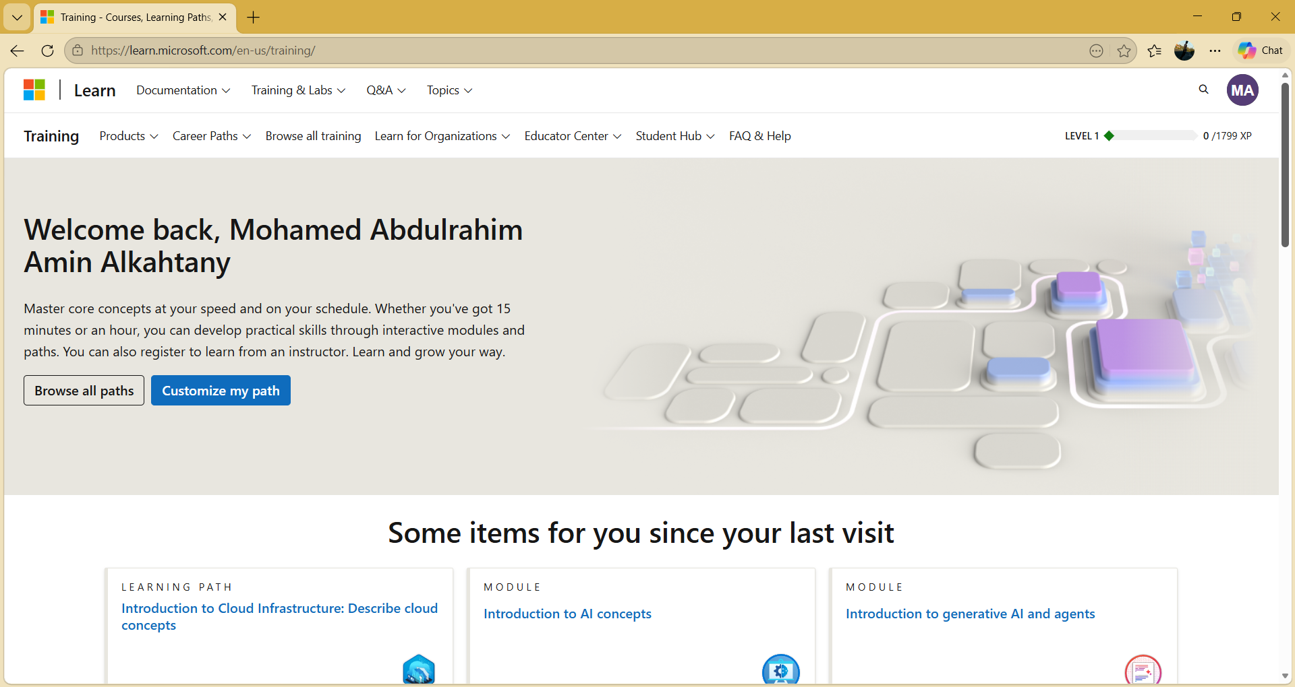
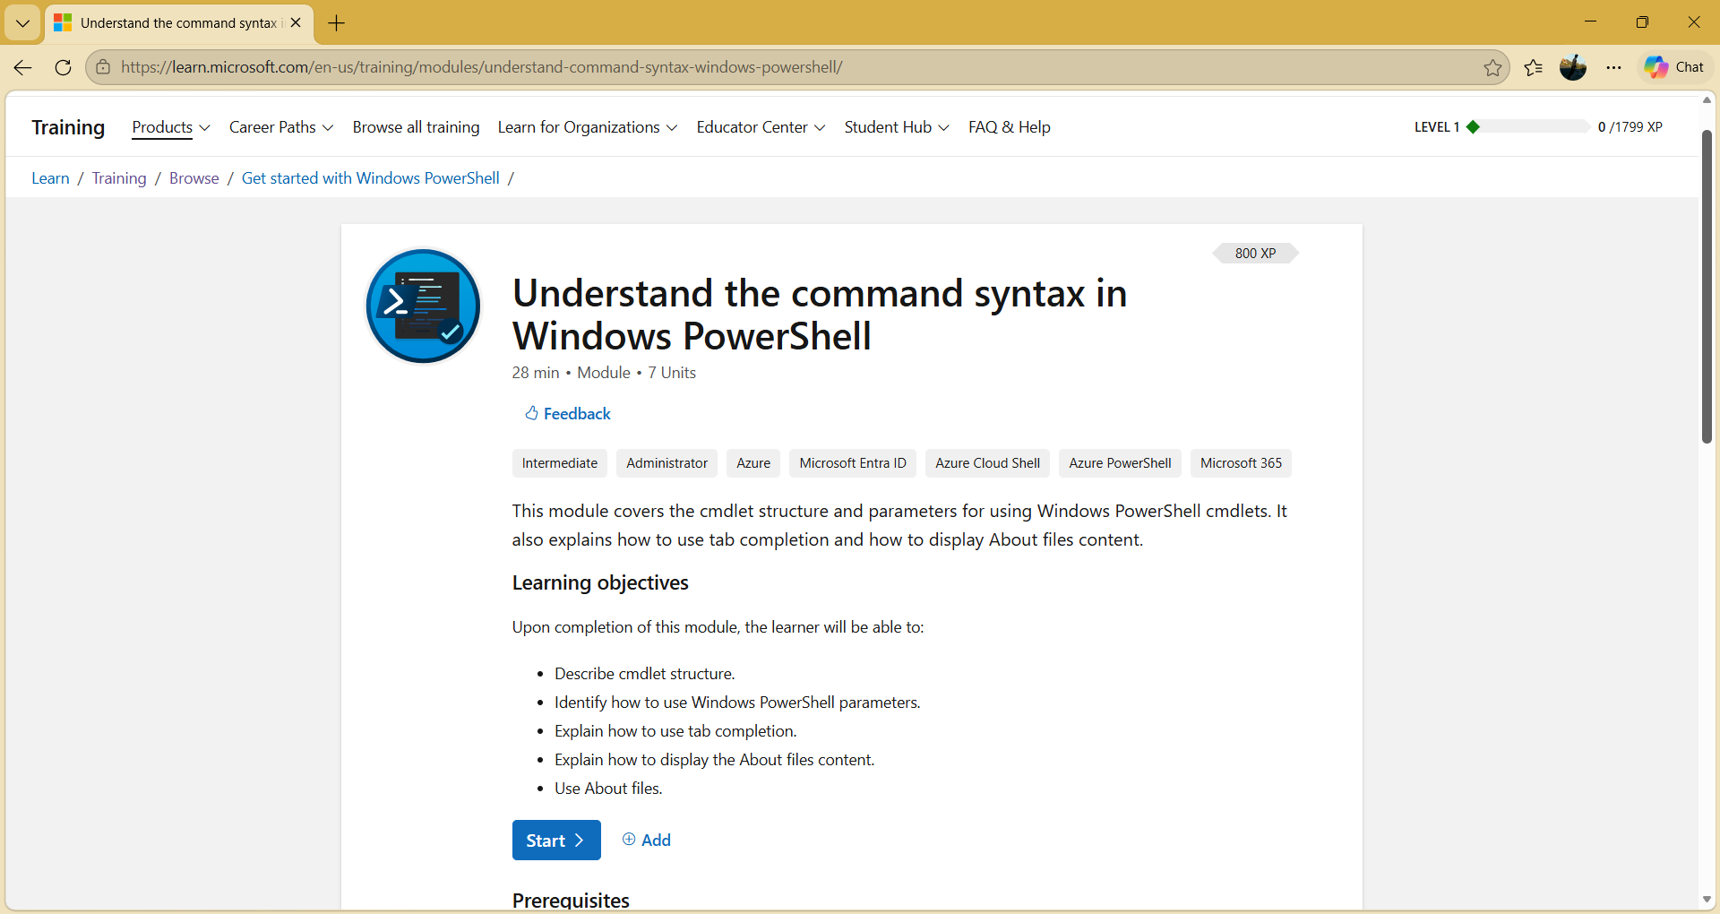
Figure A1 – Microsoft Learn PowerShell training module page

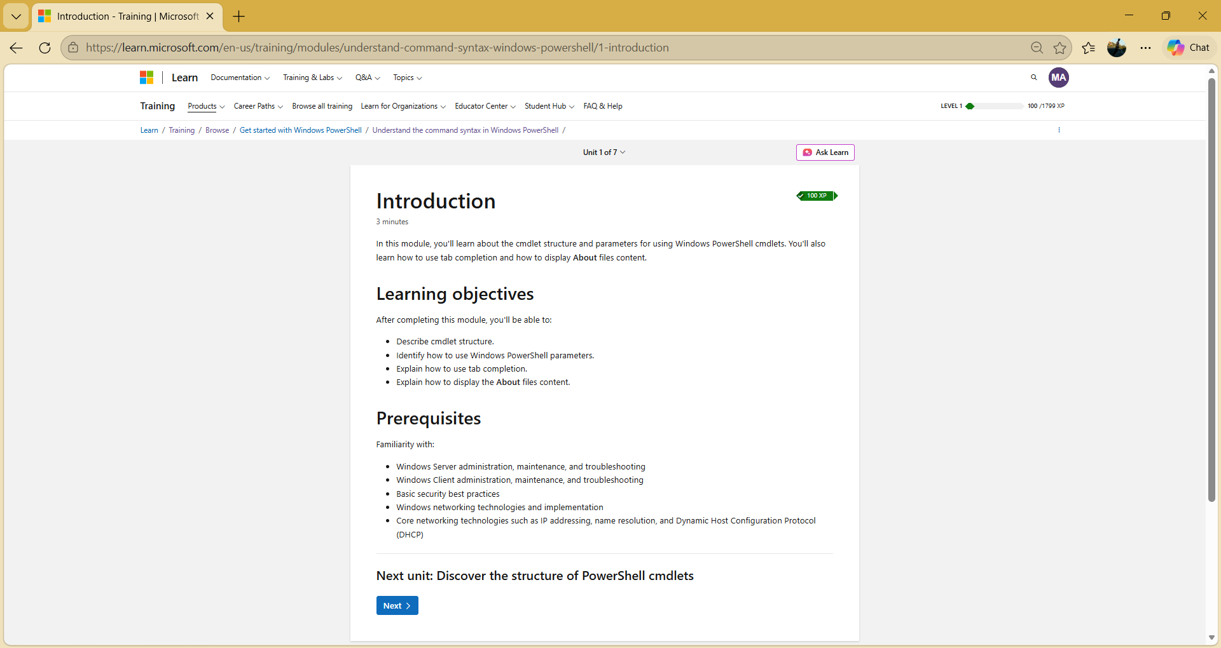
Figure A2: PowerShell training module content
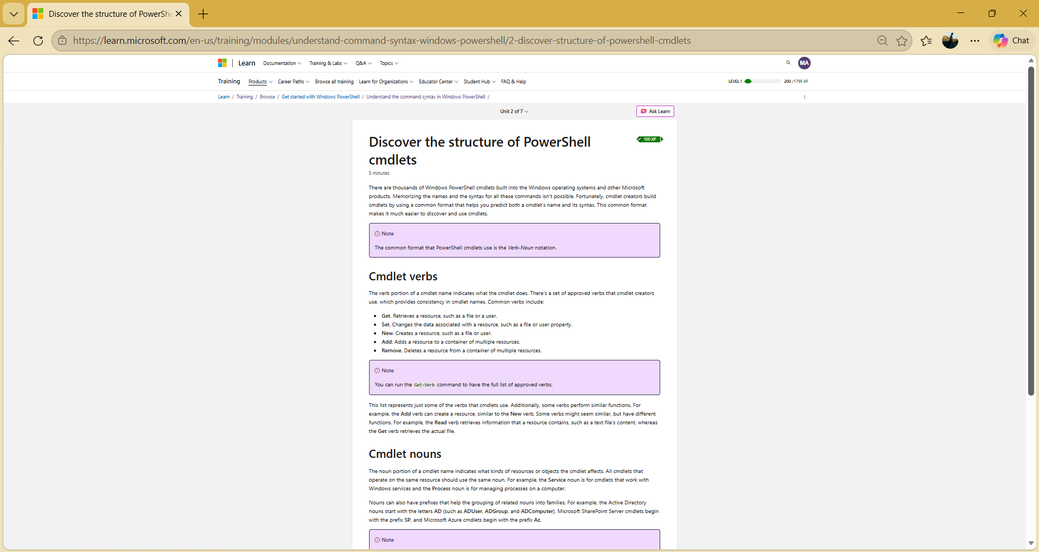
Figure A3: Progress within the PowerShell training module

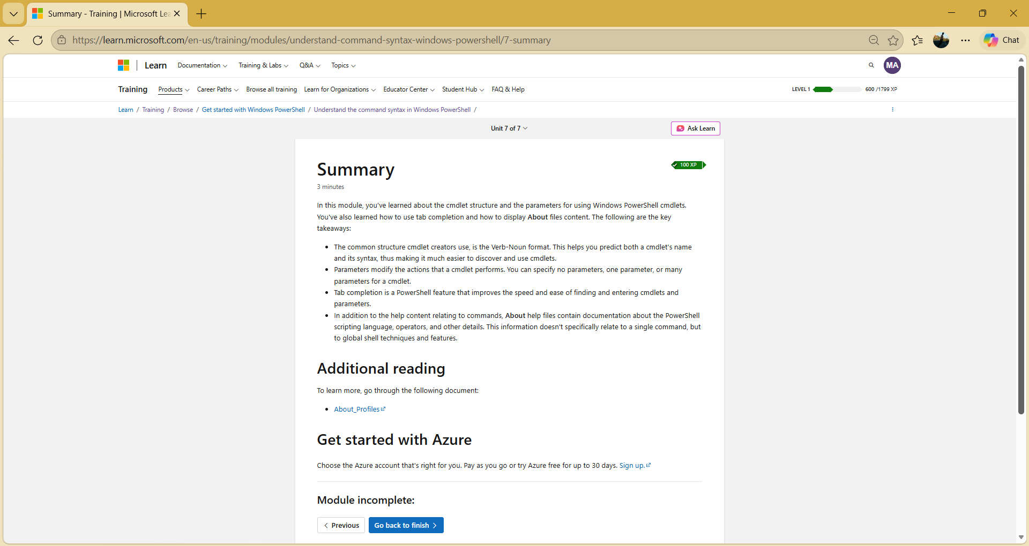
Figure A4: Final summary page of the module

