University Of Wales Trinity St David
School of Engineering
Engine Performance Characteristics
Kieran Dellow
2102899
Motorsport Engineering BEng
23/2/2022
Vehicle / Motorsport Technology
ACHA4003/4004/4012

Contents
1.0 – Introduction 2
1.1 – Aims and Objectives of the investigation 2
2.0 – Method and equipment used 4
3.0 – Topic Discussion 5
4.0 – Conclusion 10

– Introduction
Engine dynamometers are an extremely useful tool in the world of automotive engineering, as they allow the user to measure the output, and check to see if the engine is running as intended, by comparing it to other data sets. With this data, the user can tweak variables within the setup to produce more power, make the vehicle run more smoothly, or make the engine more efficient to run.
This could make all the difference when in a situation such as a race, or when designing a powertrain for a luxury car for example, where comfort comes before raw output. Engine dynamometers can also be a useful tool while designing components, by observing the effect they have on the output, and the geometry of the graphs produced.
These dynamometers can also be used for breaking in newly built engines before races, and engine dynamometers are a great way of getting instant feedback from changing a variable like the air/fuel ratio.

– Aims and Objectives of the investigation
The engine data given should be plotted as multiple graphs, using MATLAB software. These include a SFC Heat map against load and engine speed, a double Y-axis graph of torque and power against engine speed, at 100% load, a doubly Y-axis graph of thermal efficiency and BMEP at full load, and finally a 3D plot of cylinder pressures across all RPM’s and crank angles.
This will require lines of code to be inputted, and variables to be calculated beforehand to the graphing. Graphing this data will give a visualisation of how the engine reacts to different inputs, and at different loads.
After plotting this data, it can be interpreted, by asking questions regarding the findings of the graph. For example, there may be an issue or anomaly within the data set, that is prominent in the final graphs, which would then be questioned as to why it exists, and how it could be prevented next time. The same could be said for the correct data, how could it be improved? Routes of gaining power or creating a more linear output could be explored, further improving the engine. For example, www.pettersolberg.com states
“You can also increase the horsepower of your engine by increasing the octane rating of the fuel. You use a higher-octane fuel or add an octane booster to the fuel. You should use a higher-octane fuel or by adding an octane booster to the fuel.” (Solberg, 2021)
Higher octane fuels can lead to a higher compression ratio, as there is a more energetic explosion inside the cylinder. This is just one way of increasing and improving the dataset, as there are countless ways of improving engine performance, but this was one of the simplest solutions.

2.0 – Method and equipment used
For the engine dynamometer, a fuel flow sensor was used to give values for fuel input, which was measured over 45 seconds, which is shown in the “Litrep45” sheet used in the dyno data excel document.
A throttle actuator box was used to accurately measure and hold throttle, and therefore RPM.
The engine was connected to the dynamometer via the driveshaft, which meant that engine speed and power output were measurable at certain RPMs.
A load is applied to the dynamometer via electromagnetic current, which torque can then be calculated from, as the inner core connected to the engine driveshaft turns the outer core, which has the load applied to it.
RPM of the engine and load of the dynamometer can be controlled from the dyno cell, and test sequences were used to imitate the engine at various loads, at different RPMs.
A test sequence was then run on the engine and dyno, stepping up in 250 RPM increments, up to 2500 RPM, then 500 RPM increments from 2500 to 6500 RPM.
At each step, load was added to the engine, starting at 2%, stepping to 5%, and then in 5% increments up to 100%.
This gave a range of data, which could then later be plotted in MATLAB.

3.0 – Topic Discussion

Graphs were plotted in MATLAB, giving a visible indication of the range of data collected. Peak datapoints were easily conveyable using these graphs.
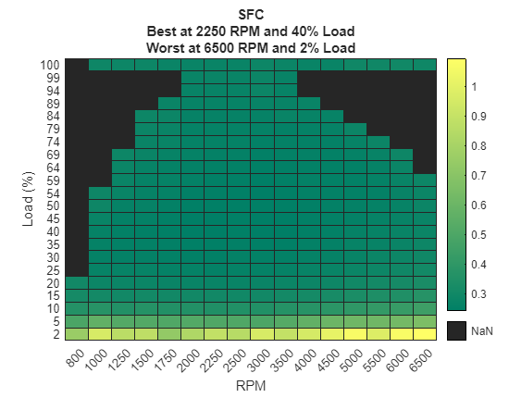
Fig. 1
As shown in the graph, Specific Fuel Consumption varies with engine load, and RPM. Why is this?
Specific Fuel Consumption increases for a multitude of reasons, the most prominent being the fact that the engine needs to create a stronger combustion to overcome the engine load, for the system to keep running.
SFC can also increase when there is a deficit of cold air for the engine to use. Much like a lack of fuel, this causes the engine to stall out, as the combustion is not strong enough to overcome the applied load.
SFC is at its most efficient at 2250 RPM and 40% engine load. This is by design, as most consumer cars are driven at such load & RPM. Therefore, to increase MPG and efficiency, the engines and ECUs have been tuned to run at their most efficient at these parameters.

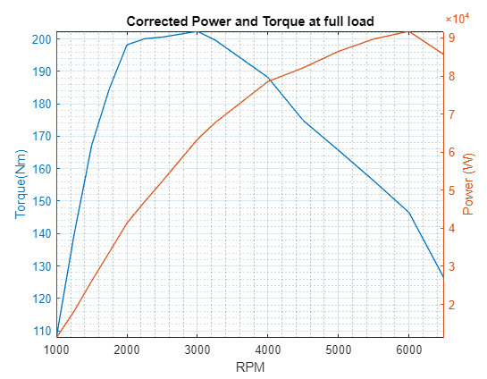
Fig. 2
Torque and Power output vary with engine speed as seen above. Why is this?
Both torque and power are limited by the inputs of air and fuel, and if either of these are bottlenecked, the output value will drop. This is the main reason that the peak power tapers off towards the higher RPMs, as the intake cannot force enough air into the system to satisfy the fuel input, and vice versa.
Another reason power and torque can taper with higher RPMs is because of advancement and retardation of spark timing. If the air/fuel mixture takes longer to burn because there is a greater volume of the two, the spark timing needs to be advanced in order to burn all the mixture at TDC. Doing so can reduce the torque at the low end, and power at the high end, shifting the curve and peak to a different position.

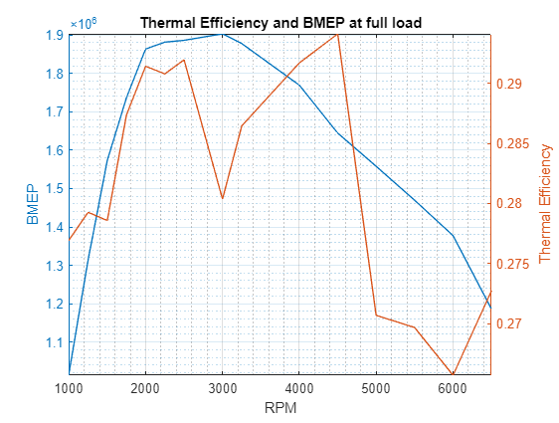
Fig. 3
Both thermal efficiency and BMEP vary with RPM. Why is this?
There is a multitude of reasons for thermal efficiency varying with RPM. One of these being due to friction of the engine. Higher RPM means a less efficient combustion cycle. Therefore, decreasing RPM increases thermal efficiency, as fuel is used to calculate this.
BMEP directly correlates with peak torque of an engine, as peak volumetric efficiency, which is at peak torque, results in a higher BMEP. This is because at peak torque, there is the least friction between components.

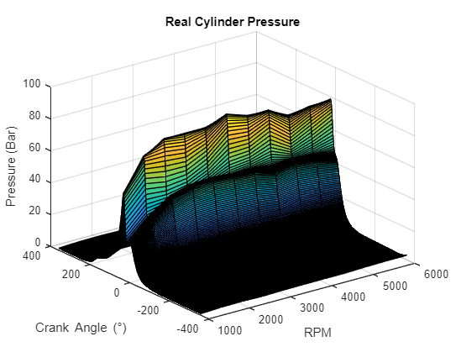
Fig. 4
As shown in the graph above, most of the higher value datapoints are around 30° crank angle.
This is because at TDC, all the air taken in has been compressed to its maximum and mixed with the fuel to the best of the engines ability, making this point in time the highest pressure, of around 80 bar.
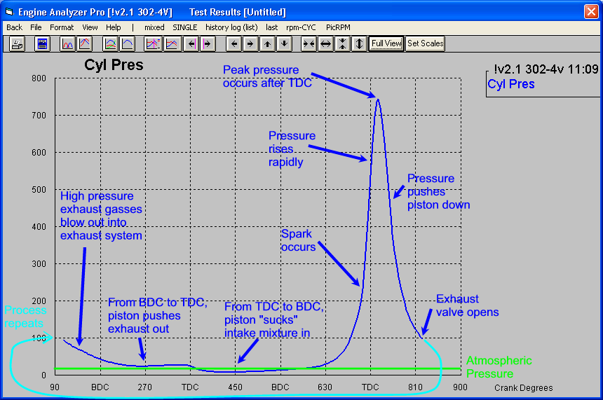
(Performance Trends, NA) Fig. 5
Looking at this data from performance trends, we can clearly see that the peak pressure occurs after TDC, and this data is also consistent with the graph produced by the MATLAB findings. The pressure rapidly increases after an ignition; therefore, it would make logical sense that the highest point of pressure in a cylinder is after TDC.
Looking at figure 4, it is also clear that peak real cylinder pressure also rises with change in RPM.
As RPM increases, so does the density of air/fuel mixture inside the cylinder chamber. When combusted, this creates a higher pressure than that of a lower density. These peak cylinder pressures can also be a visual representation of how an engine increases the quantity of air/fuel added through rising RPMs.

4.0 – Conclusion
Taking findings from the MATLAB task, it is clear to see that everything designed for an engine, is there for a very good reason. For example, Cylinders are designed to withstand extreme pressures, as without this ability, an engine would most likely explode under these huge forces. The internal combustion engine takes advantage of all three of Newton’s laws of motion, and figure 2 is a good example of how these variables can change.
Overall, the MATLAB task gave a good understanding as to how engine performance figures can vary when a variable such as load is introduced, and how this could affect the actual design of the vehicle e.g., an off-road vehicle needing more low-down torque, as it experiences more load than the average consumer car.

Bibliography
Performance Trends, NA. Definitions - Cylinder Pressure. [Online]
Available at: https://www.performancetrends.com/Definitions/Cylinder-Pressure.htm
[Accessed 27 3 2022].
Solberg, P., 2021. How to increase horsepower. [Online]
Available at: https://www.pettersolberg.com/how-to-increase-horsepower/#Upgrade_the_Components_of_Your_Engine
[Accessed 14 March 2022].

