LEVEL 4 ASSESSMENT SPECIFICATION
APPENDIX GA36a
Student name: | Curtis | Student ID number: | 2003711
Programme: | HNC Electrical & Electronic Engineering  HND Electrical & Electronic Engineering  BEng(Hons) Electrical & Electronic Engineering  BEng(Hons) Ordnance Munitions & Explosives  BSc(Hons) Ordnance Munitions & Explosives  BEng(Hons) Mechanical & Manufacturing Engineering  BEng(Hons) Mechanical Engineering  BEng(Hons) Energy & Environmental Engineering
Module: | Electrical & Electronic Principles
Module code: | ACDA4006  ACDB4002 | Contribution to Overall Module Assessment (%): | 50%
Lecturer: | Steve Mosey | Internal Verifier:
Assignment Title: | Investigation into Resonant Circuits | Word count (or equivalent): | 2000 ±10%  See Regulation 7.7
Submission deadline: | TBC | Return date of provisional marks & written feedback: | TBC
Submission method: | All written assessments, where practical and possible, must be submitted via Turnitin unless otherwise instructed by the Lecturer. (Please DO NOT put this assessment specification into Turnitin or it will match many similarities with other students’ submissions.)  Alternative submission method (if applicable):  Late submission of the assessment will result in a late penalty mark. Penalties for late submission: Up to one week late, maximum mark of 40%. Over one week late, 0%. Only the Extenuating Circumstances Panel may approve a change to submission dates.
Academic honesty / referencing: | Academic honesty is required. In the main body of your submission you must give credit to authors on whose research and ideas your work is based. Append to your submission a reference list that indicates the books, articles, etc. that you have used, cited or quoted in order to complete this assessment.

Contents
Contribution to Overall Module Assessment (%): 1
Introduction 3
Series RLC Circuit 3
Parallel RLC Circuit 8
Conclusion 13
Bibliography 14

Introduction
In this report I am going to be performing basic electronic/electrical measurements while recording and later analysing the data. I am going to be looking at two different circuits, firstly an series RLC circuit and then moving onto a parallel RLC circuit. I will be building both circuits in proteus and using the graphs on there to showcase my results. Most fundamental elements of a RLC circuit is a resistor, inductor, and a capacitor that are connected across a voltage supply. All these are passive components, meaning they consume energy rather than producing it. As oppose to linear elements, which have a linear relationship between current and voltage.

Series RLC Circuit
These RLC circuits have many applications. For example the series RLC circuit can be used to act as a low pass, high pass, band pass, bandstop filters depending upon the type of frequency. A low pass filter is a circuit designed to modify, reject or even reshape all the unwanted high frequencies of an electrical signal. The circuit designer can filter out all the unwanted signals and only pass input signals based upon the filter design. High pass filter does the exact opposite the low pass filter and will only pass high frequency signals and block the low frequency signals. A low pass filter can be used in audio amplifier circuits and is to avoid A.C. ripples in the rectifier output. [1] On the other hand a high pass filter would be used in loud speakers to reduce the low level noise. Additionally a high pass filter is used in audio applications to eliminates rumble distortions. [2]

A RLC can also act as a band pass filter. Band pass filter is a circuit which allows only a particular band of frequencies through. These band pass filters are often used in wireless transmitters and receivers. It limits the bandwidth and only outputs the signal within that band, therefore preventing the transmitter from interfering with other stations. On the other hand a band pass filter is used to allow a pre-defined set of frequencies to pass through. Instead of outputting the signal within the band, this time it will output the signal both above and below the set value. It’s a combination of both a high and low pass filter. [3]

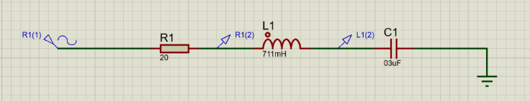

Above is the first circuit that I constructed on proteus, which is a series RLC circuit. As you can from the screenshot the values of the different components are decided by my personal student number. Resistor was 20 ohms because that’s my 1st and 2nd student number, the inductor was 711mH as its my 5th 6th and 7th digit of my student number and finally the capacitor being 3uF because its my 3rd and 4th digit. There is a sine generator labelled R1(1) set to 1V amplitude and a frequency of 1Hz. I then placed a voltage probe between the resistor and the inductor and also a voltage probe between the inductor and the capacitor.

Figure 1

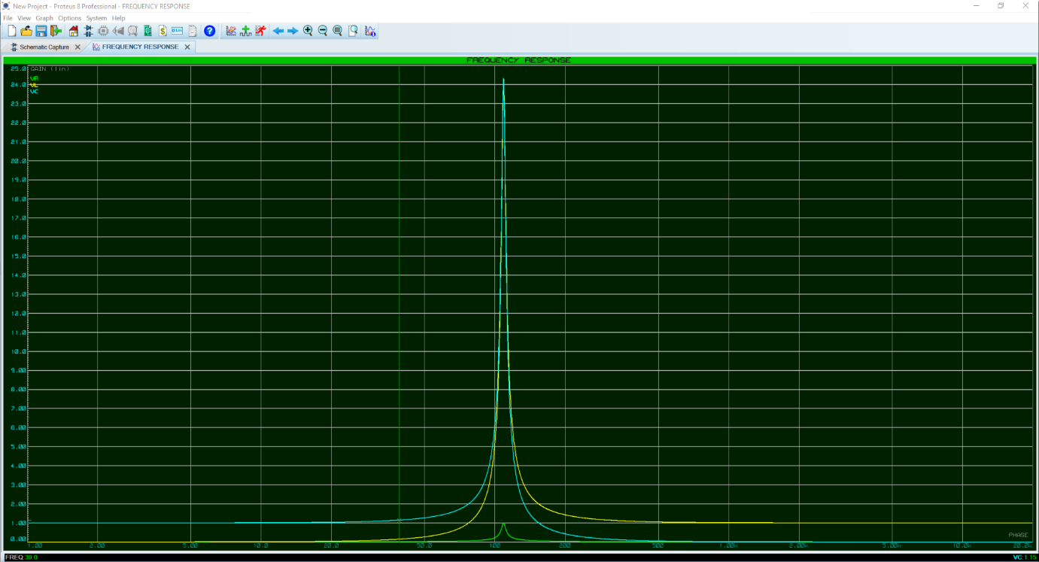
Bandwidth of a Series RLC Resonance Circuit

Current Amplitude (I)
Frequency

Bandwidth of a Series RLC Resonance Circuit

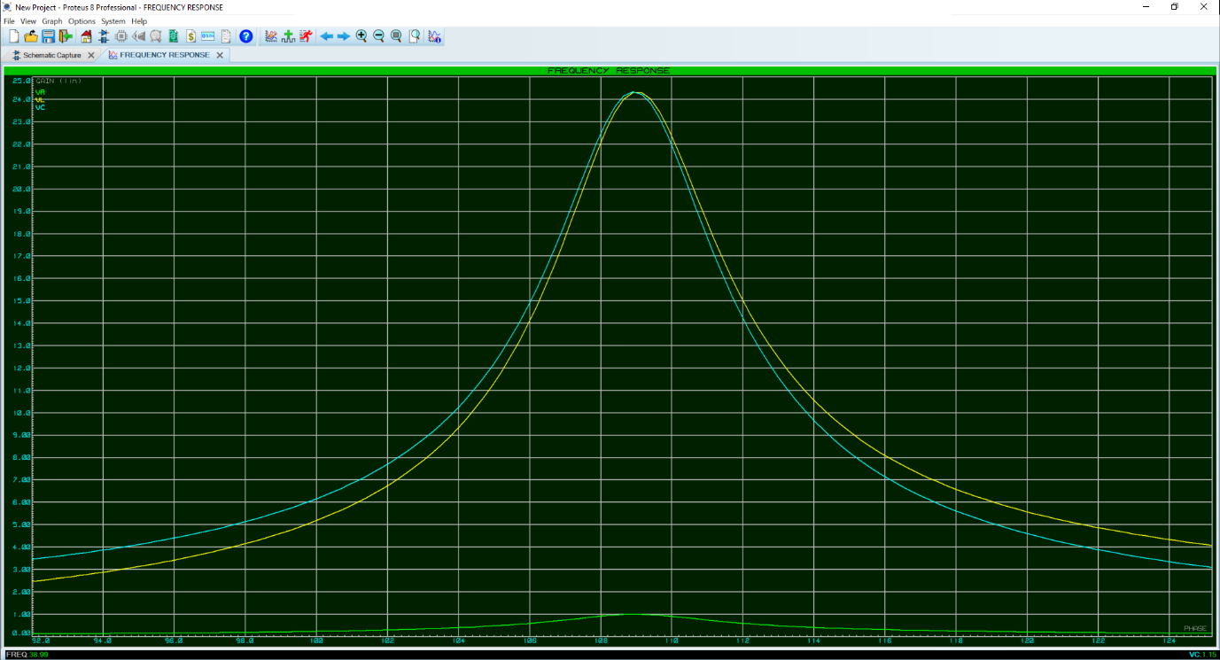
Current Amplitude (I)
Frequency f

Figure 1 shows the frequency graph I then generated in proteus displaying the results of the voltage probes I placed in the circuit with reference to the sine generator R1(1). I then edited the graph to change the start frequency to 1 and the stop frequency to 20k. This was important as it changed the value of the axis to allow us to see the results of the graph easier.

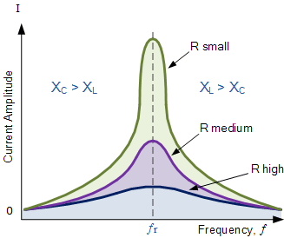
This is the bandwidth of a series RLC resonance circuit. [4] As the frequency increases you can see that there is a peak, which then drops back down. This is known as resonance frequency and is labelled on the graph as ‘Fr’. If the reactance’s were low and the resistor value was high then the result of the graph would be shown as the ‘R high’. However if the reactance’s were high and the resistor value was low then the graph would look more like ‘R small’.

Resonant Frequency from basic theory

$$f_{res}=\frac{1}{2π\sqrt{LC}}$$

$$f_{res}=\frac{1}{2π\sqrt{0.771×3×{10}^{-6}}}$$

=108.97 to 2.d.p

Voltage magnification (Q)

Voltage magnification is particularly useful. They can provide magnification of an AC signal voltages by only the passive components, so without the need for any external power supply. The voltage magnification of my series RLC circuit is shown below:

$$Q=\frac{2πfrL}{R}$$

$$Q=\frac{2π x 108.97.. x 0.711}{20} \\ Q=24.34 to 2.d.p$$

Inductive reactance: XL

$$XL=2π f L$$
$$XL=2 x π x 108.97.. x 0.711 \\ XL=486.826 ohms to 3.d.p$$

Capacitive reactance: Xc

$$Xc=\frac{1}{2π f C}$$

$$Xc=\frac{1}{2π x 108.97.. x 0.000003 }$$

$$Xc=486.826 ohms to 3.d.p$$

Figure 2

Figure 2 is a graph showing ‘Circuit Current vs Frequency’. The graph shows that as phase slightly drops, circuit current raises and keeps doing so until phase reaches a peak, then current rapidly increases, then both phase and current drop to a low amount where they both level off. Additionally it is noticeable that both the frequency and phase(Deg) both peak and the same frequency. At first its an inductive circuit because as the frequency increases the current decreases and vice versa. However as the frequency reaches resonance the current dramatically increases then instantly starts dropping as the frequency goes past resonance.

Figure 3

Figure 3 shows the ‘Output Voltage vs Frequency’. Phase, which is the angle that shows the shift between ac current and voltage is also added to the graph. Similarly to figure 2, the peaks occur at the same frequency. This graph showcases that as the voltage decreases to 0 the phase instantly drops and only starts increasing as the voltage starts increasing. Reason voltage starts increasing is because the frequency has gone past resonance and therefore current is decreasing again while voltage increases. The main point to notice between figure 2 and 3 is that they are inversely proportionate, meaning as the current in figure 2 raises, voltage shown in figure 3 drops.

Parallel RLC Circuit

Now moving onto the Parallel RLC circuit in which a resistor, inductor and a capacitor are all connected in parallel with each other. Its then supplied with a voltage supply and is why it is therefore opposite to a series RLC circuit. The current in a series RLC circuit is flowing through all the three components, being the resistor, inductor and also the capacitor and stays the same. However in a parallel RLC circuit, it’s the opposite, so the voltage across each component stays the same but the current gets divided between the components depending upon the impedance of the different components. [5]

As you can see from the inductive reactance calculation and the capacitive reactance calculation I’ve done that they are equal. This condition is known as resonance. The inductive and capacitive reactance’s both depend on frequency, the inductive reactance is proportional to frequency and the capacitive reactance is inversely proportional to frequency. [4] The ‘Inductance and Capacitance Vs Frequency’ graph below (Figure 4) I made in excel showcases this by the mirroring effect you can see.

Figure 4

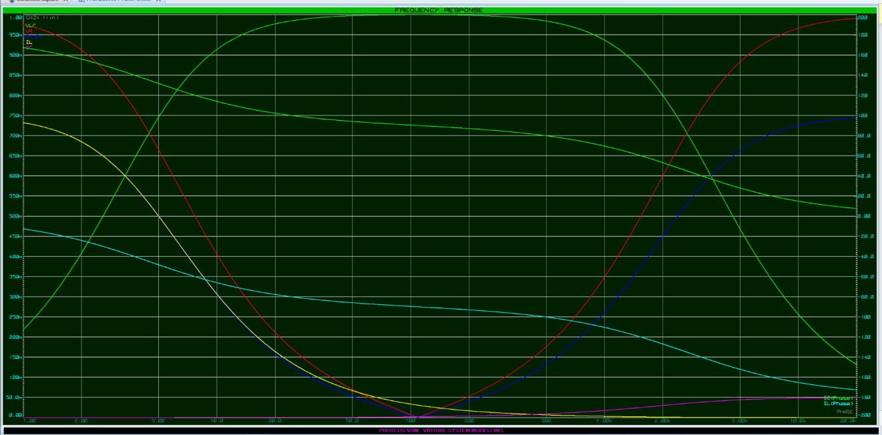
Figure 5

This graph on proteus shows all the different measurements that can be taken from the parallel RLC circuit and allows us to see how they all relate to each other. As the circuit approaches resonance the voltage drop across the resistor decreases to 0 and the voltage on the inductor and the capacitor increases to the supply voltage. The main circuit current drops to a minimum as we are at resonance and then starts climbing again. The resistor voltage then follows the same curve as the circuit current. Voltage and current are 180 degrees out of phase when looking at capacitors and inductors. The Inductor current (Phase difference) is at 90 degrees at resonance and is in relation to the voltage supply of the circuit. Finally the capacitor current (Phase difference) which is 180degrees apart from the current in the inductor.

Figure 6
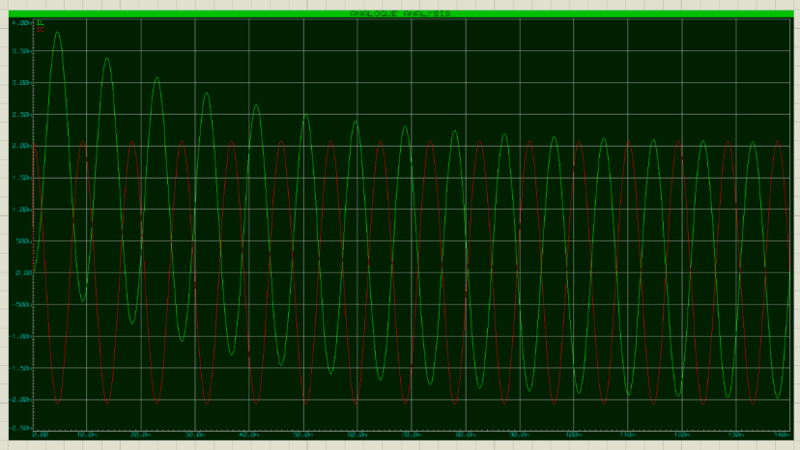

Figure 6 shows an analogue graph showing the currents for the capacitor and the inductor. This graph is very simple and just shows as the current for the capacitor increases, the current for the inductor decreases and vice versa. The current used to charge the capacitor is being drawn from the inductor and the current for the magnetic field around the inductor is drawn from the capacitor. So basically there are feeding off each other and that’s why we see that pattern in the graph.

Figure 7

Figure 7 is a graph I made on excel to show the ‘Circuit Current Vs Frequency’. As this is a parallel RLC circuit you can now see the peak of the wave is at around 100Hz and most importantly there is zero current when at resonance. Previous calculations regarding the resonance frequency I made on the series circuit apply to this parallel circuit also. I calculated the ‘Fres’ to be 108.97Hz which the graph shows is also the case for this circuit.

Figure 8

Figure 8 shows the Output Voltage against the Frequency. This curve was to be expected because I knew as current would decrease until resonance and then increase after then voltage must do the opposite. Voltage and current are both inversely proportionate when being measured over frequency.

Figure 9

This graph shows attenuation, which is a measure of how fast the transient response of the circuit will die, after the stimulus has been removed. So this directly correlates to the resonant frequency. The attenuation will remain on 0dB when its near or at resonance, however when its not you can see it start to die off.

Figure 10

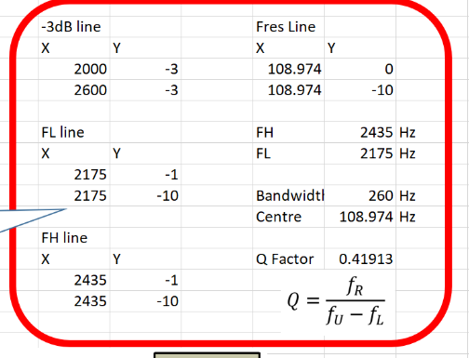
The Q factor for the parallel circuit I built on proteus can be seen in figure 10. The Q factor of this circuit is 0.41913. The calculations for this can be seen on page 11.

Figure 11

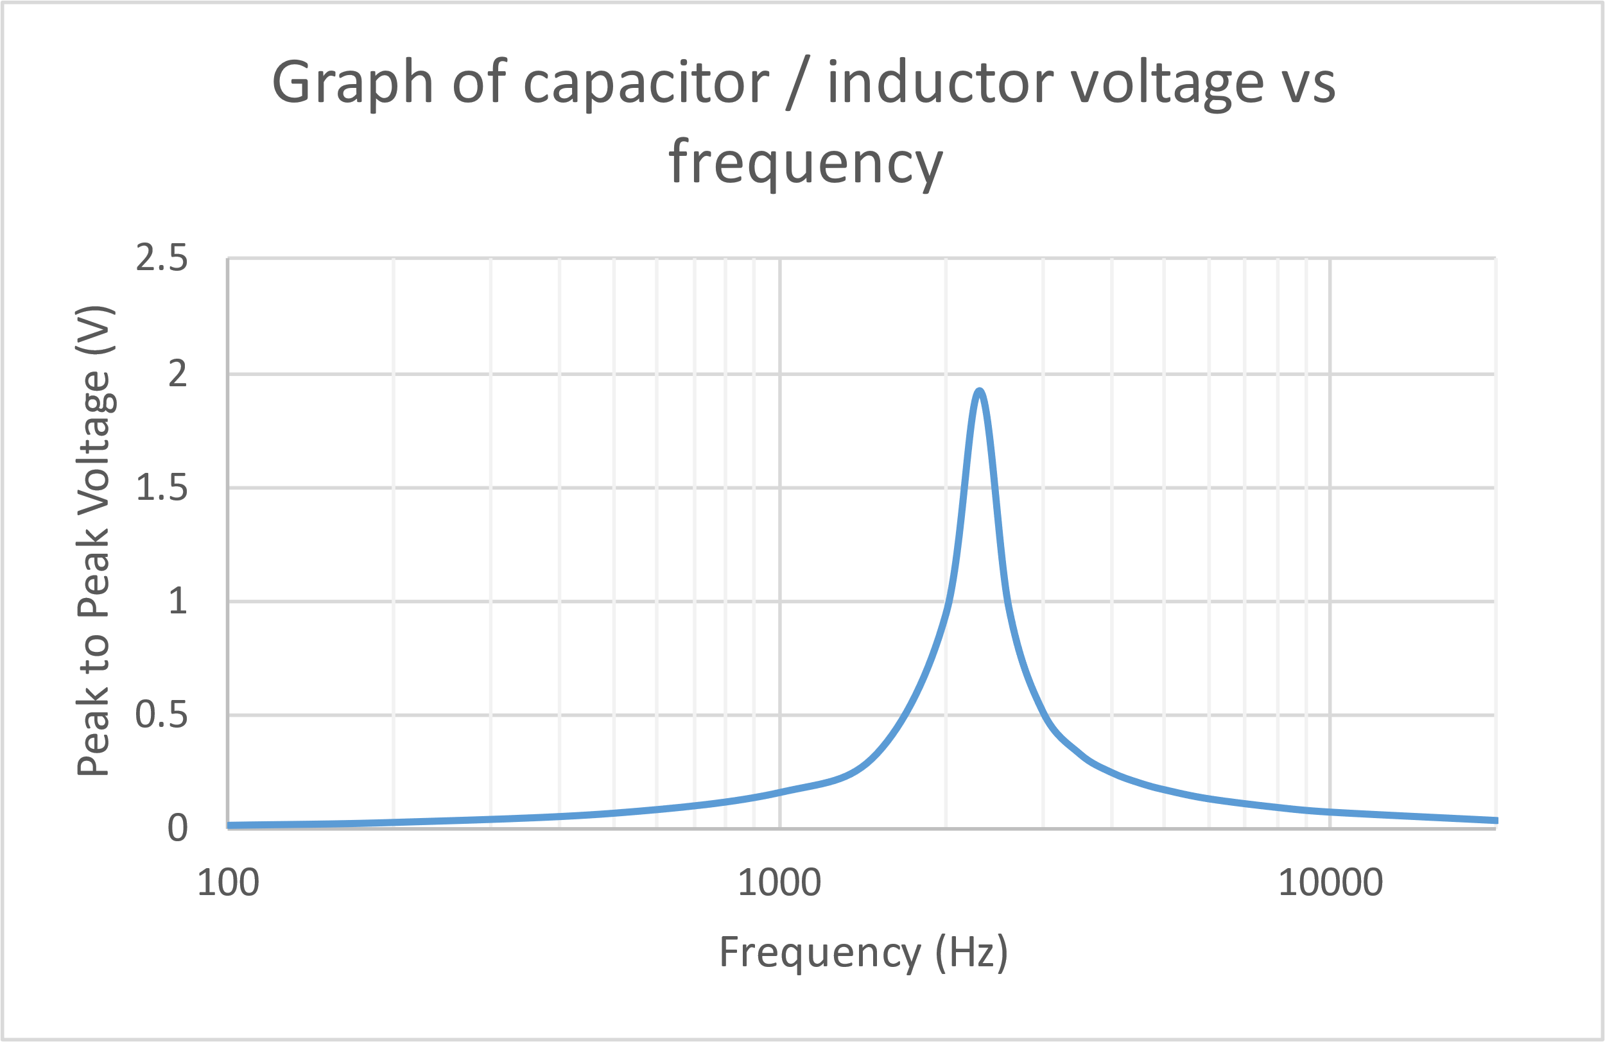

Figure 11 shows the ‘Capacitor/Inductor voltage vs Frequency’. It shows that the voltage flowing through parallel section with the inductor and capacitor stays minimum until resonance, then increases dramatically. After resonance it then decreases again.

Voltage and Current impedance

$$XL=2π f L$$
$$XC=\frac{1}{2πfC}$$
$$\frac{j446.73 x-j530.51}{j446.73-j530.51}$$
$$\frac{{-j}^{2}237000}{j-83.78}$$
$$ZT=\frac{237000}{j-83.78} x \frac{-j-83.78}{-j-83.78}$$
$$Impedance of L+C=-j 2828.837 ohms$$
$$Now need to include resistor$$

$$Current=\frac{V}{Z} \\ I=\frac{12}{\begin{aligned}20-j2828.8.. \\ \end{aligned}}$$

$$I=\frac{12(20+j2828.83..)}{(20-j2828.83..)(20+j2828.83..)}$$

$$I=\frac{240+j33946.048}{8002721.036}$$

$$=2.9989x{10}^{-5}+j4.24181 x {10}^{-3} A$$

$$I=\sqrt{{\left(2.99x{10}^{-5}\right)}^{2}+{\left(4,2418x{10}^{-3}\right)}^{2} }=4.2419x{10}^{-3}$$

$$I=\tan^{-1}{(}\frac{2.99x{10}^{-5}}{4.2418x{10}^{-3}})=89.5949 degrees$$

$$I=4.2419x{10}^{-3} 89.6 degrees$$

Conclusion

In conclusion it is clear to see why these RLC circuits are very useful in electronics and come with many uses. Additionally, being able to see how the different voltages/currents relate to one another in the different components of the circuit is very interesting. The main feature which I’ve previously mentioned and why these circuits are useful in the real world, is that they both can be used to select specific parts of the wavelength. This allowing you to only have the part that you want, and this is why these circuits are often used in communication systems etc.

Bibliography

[1] | '. administrator', “electronics hub,” 17 01 2019. [Online]. Available: https://www.electronicshub.org/passive-low-pass-rc-filters/. [Accessed 20 04 2021].
[2] | '. administrator', “electronics hub,” 20 01 2019. [Online]. Available: https://www.electronicshub.org/active-high-pass-filter/#:~:text=Applications%20of%20Active%20High%20Pass%20Filters%201%20These,signals.%204%20These%20are%20also%20used%20in%20equalizers.. [Accessed 20 04 2021].
[3] | A. Raj, “circuit digest,” 27 02 2019. [Online]. Available: https://circuitdigest.com/electronic-circuits/band-pass-filter-circuit-diagram. [Accessed 20 04 2021].
[4] | --, “electronics tutorials,” [Online]. Available: https://www.electronics-tutorials.ws/accircuits/series-resonance.html. [Accessed 22 4 2021].
[5] | Electrical4U, “Electrical4U,” 25 10 2020. [Online]. Available: https://www.electrical4u.com/rlc-parallel-circuit/#:~:text=In%20series%20RLC%20circuit%2C%20the,the%20impedance%20of%20each%20component.. [Accessed 22 4 2021].
[6] | “AC circuits II - Impedance and Resonance,” -- -- --. [Online]. Available: http://buphy.bu.edu/py106/notes/Resonance.html#:~:text=When%20the%20inductive%20and%20capacitive,reactance%20inversely%20proportional%20to%20frequency.. [Accessed 22 4 2021].

