Entity Relationship Diagram

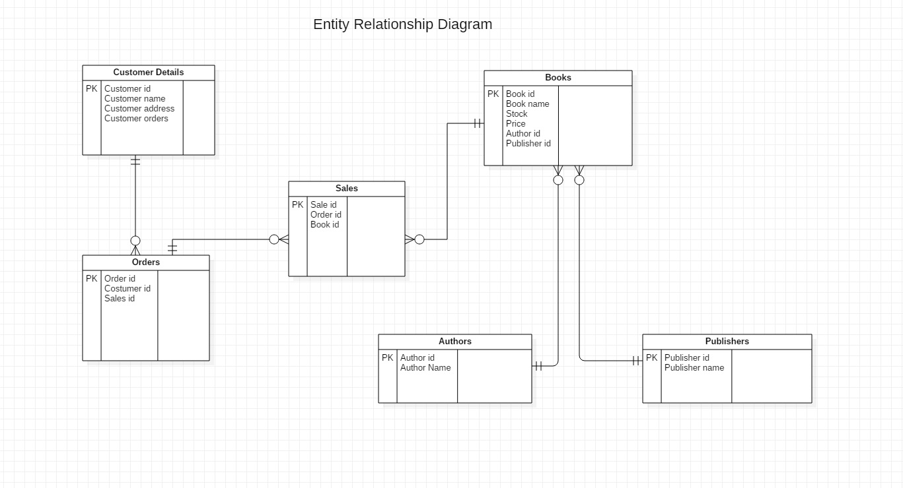
Entities: Customer Details, Books, Sales, Orders, Authors, Publishers.
Relationships:
Costumers – Orders (one-to-many)
Orders – Books (many to many. In this case we created a table, Sales, to bind the 2 tables) so our new relationship will be:
Orders – Sales (one-to-many)
Sales – Books (many-to-one)
Books – Authors (many-to-one)
Books – Publishers (many-to-one)
Use case diagram
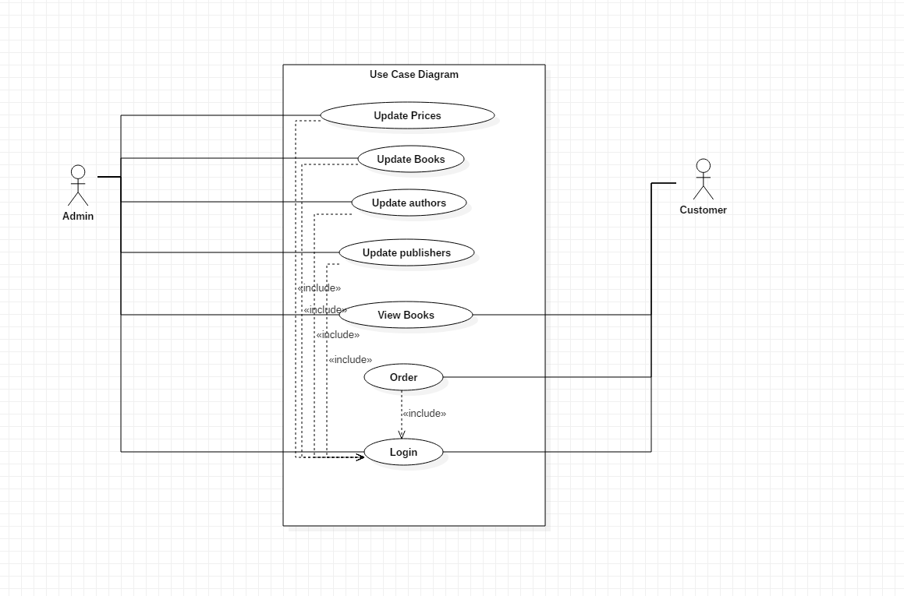
Actors: Admin and Customer
Admin can update prices, books, authors, publishers but they need to login.
They can also view books without being log in.
Customers can view books freely but they need to log in to order.

Data flow diagram


