History and Theory (M4X01975)
An Exemplar of Modern European Architecture
Ella Curr (1803755)
1500 words
Introduction
In this essay I am going to compare the Villa Savoye and the Schroder house with regards to their development of new spatial and structural strategies as well as their inspiration from developments in fine art and the possibilities of creating social utopias.
Historical Background
The architect behind the Villa Savoye was Charles-Edouard Jeanneret, also known as Le Corbusier. The villa was listed as a historic building whilst Le Corbusier was still alive which was extraordinary. (Centre des Monuments Nationaux, n.d.) It is located in Poissy in France and was completed in 1929. The building is a domestic construction with a modern architectural twist unnatural for its time. (Kroll, 2010) The German invasion of 1940 caused the building to be bombed and burned yet the listed status meant that it could be restored. It is now a museum of Le Corbusier’s work.
The architect behind the Schroder House was Gerrit Reitveld and is also a domestic building but was completed four years previous to the Villa Savoye in 1925. It is situated in Utrecht in The Netherlands and is well known for its forward-thinking solutions to major design questions of this period (Sveiven, 2010). The building was originally overlooking a mass of greenery yet now overlooks a highway. The Schroder House was a depiction of the style of De Stijl using primary bright colours and pure ideas. The house was included in the UNESCO World Heritage List in 2000 for its pure ideas and concepts. (House-Buildingfunction, 2014)
Plan and Section
In the Villa Savoye, the main area of the building including the bedrooms, bathrooms, living room and kitchen are on the first floor and the ground floor is home to the hall and offices as well as a garage able to hold 3 cars. This aspect of the house in particular was a great step forward as this hadn’t been done before. The ground floor is built around the movement of a car entering the building and so justifies the orthogonal pillar sequence of a square grid to hold up the villa. The ground floor is curved, again due to the inspiration of car movements. There is a hallway before the front door which is immediately met by a ramp through to the entire building and a spiral staircase. In the aforementioned hallway, everything is white which envelopes the architect’s interests of health and hygiene where society was being overcome with epidemics and microbial life discoveries. This is also prominent through the bathrooms in the house. (Wikiarquitectura, n.d.)
The Schroder House has a core encapsulated by a spiral staircase through both levels of the building with the other rooms working outward from this core. The upper level is divided into four areas that can all access the three cantilevered balconies on the building. The ground floor is more conservative than the previous. When entering through the front door, you are greeted with the small hallway where the stairs are located. This staircase divides the toilet, kitchen-living-dining area, a bedroom for the servants, an office, a studio and a reading room. The servant’s bedroom can only be accessed through the kitchen-living-dining area and the office. In the upper level, the northeast section is open plan with clear access to the balcony. The southeast section merges perfectly with the landscape due to disappearing corner windows. The openness of these two sections are contrasting to the southwest elements which has opaque walls and one exit to the balcony. When reaching the top of the staircase there is a hallway which opens up to a bathroom, bedrooms and living-dining areas. (Red 5, 2012)
Materials and Light
Le Corbusier was the first to see the advancements in materials and so rejected the common use of stone, bricks and timber and continued with steel, glass and concrete. The ribbon windows are sliding and are placed in the centre of the walls on the first floor so that the maximum amount of natural light is let into the space. (Gibson, 2016) Le Corbusier relied on the use of reinforced concrete to execute the frame for the functional flexibility that he desired. This was not common at the time but was in the 1920s as it was seen as more of an engineering material than a construction one. (Bianchini, 2018)
The Schroder House is made with the traditional brick and wood construction of its time. This is because brick with plaster works with heavy loads well and concrete, being another material considered, was still in is infancy so wasn’t chosen to experiment with due to a lack of exposure to the material and also due to the fact that the cost of concrete meant it was unobtainable easily without going wildly over budget. The only elements of the buildings made from concrete were the foundation and balcony slabs as this was all they could afford to use. (Red 5, 2012) This shows an attempt at advancing with the materials which is in itself innovative considering how little concrete was used at this time due to its new discovery.
Ideas and Theories Underpinning the Design
The Villa Savoye is representative of the relationship between classical architecture with the ever-changing technological advances of the 20th Century. It was one of the first of the kind and was a complete rejection of the previously common architecture. Le Corbusier defined this project as a ‘Machine for Living’ reflecting a machine in the functions and compartmentalizing inside in order to ensure an efficiently working house. The Villa Savoye was the first project that encapsulated the ‘Five Points Towards a New Architecture’ as depicted by Le Corbusier in his 1926 Manifesto. The five points consist of: pilotis, free plan, free façade, ribbon windows and roof gardens. The first, pilotis which means column in French was an innovative replacement of the load bearing wall creating the second point, free plan. The third point was the separation of the columns from the building façade meaning this was uninterrupted and therefore a ribbon window could be added into the facades. The final point of roof gardens is enclosed by a transparent sheet meaning light can enter the house as well as framing the landscape. (The Conversation, 2014)
The Schroder House is well known for its interaction with structure, technology and colour. Rietveld believed that “all experience is based on the stimulus of the senses” (Kepes, 1966) This was shown in the design of the building with moving walls, intercom systems and hidden doors which meant that the person residing in the house was interacting with the building itself, thus creating an experience. This was intended to be different for every person, making it their own reality. The architects took this plot of ground and made it into a place with a reality of its own...it was always their main aim to give a yet unformed space a meaning of its own. The furniture within the Schroder House and the formation of the building itself is evidently inherited from the De Stijl movement which idealized primary colours as well as the basic colours of black, white and grey. The building itself resembles a Mondrian painting with its geometric design and the advanced aesthetic using the simplistic colour palette. Rietveld’s use of the moving walls completely revolutionized the way that architecture was viewed. It was no longer restricted to four walls, there was interpretation and customization available and this was the future. (Turtle, n.d.)
Conclusion/Summary
In conclusion, it is clear to see that both the Villa Savoye and the Schroder House, despite being in different countries, by different architects at a similar period were both successful in their attempts at being iconic architectural projects. In the case of the Villa Savoye, Le Corbusier set out to create a domestic dwelling for a family in the French countryside that encapsulated the Machine That You Can Live In concept. He succeeded in this by the way he used his Five Points of Architecture to create a space that not only was laid out like a machine but functioned as one also in all aspects from the shape to the ways you can move through the levels. With regards to the Schroder House, Rietveld sought out to create, again a domestic dwelling, a space that is an experience in itself, which he knew was individual to each person. He was extremely successful in this through his use of the moving walls in the first-floor space to allow for interaction with the house depending on a person’s preferences. This is very important as it is personal and means that those that use that space are having a direct experience with the architecture which will enhance this experience for them.

Appendix
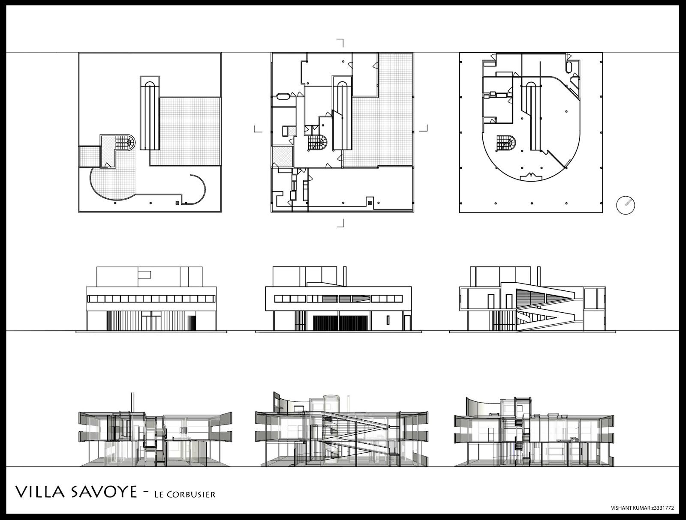
Floor Plans, Sections and Elevations of the Villa Savoye (https://www.pinterest.co.uk/pin/527554543825265319/?lp=true)
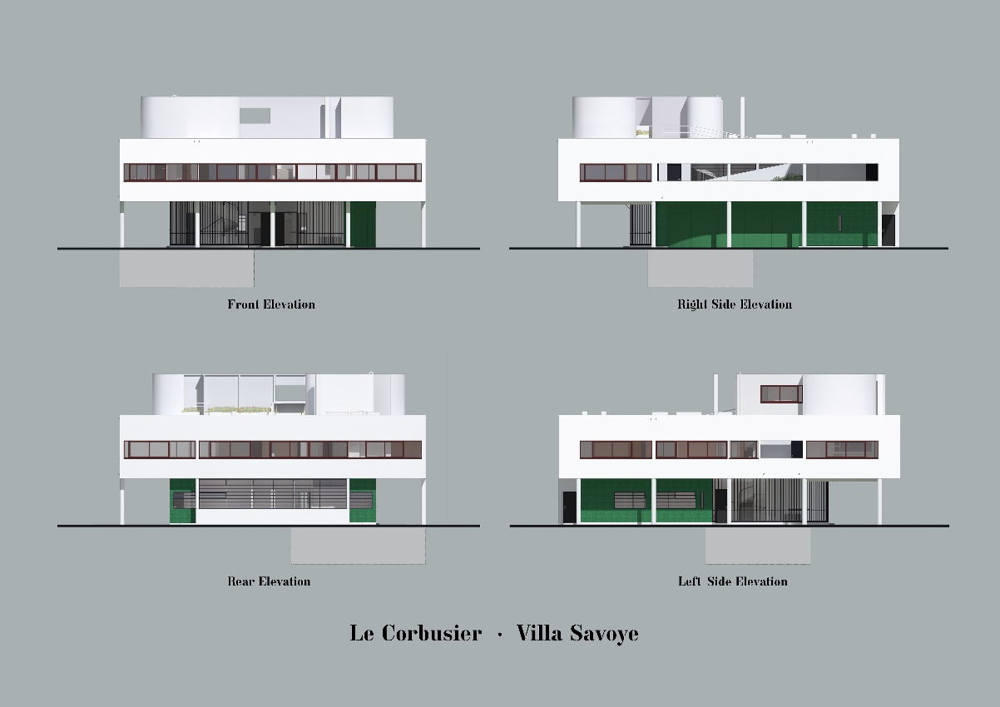
Elevations of the Villa Savoye
(https://www.pinterest.co.kr/pin/334110866090898676/)
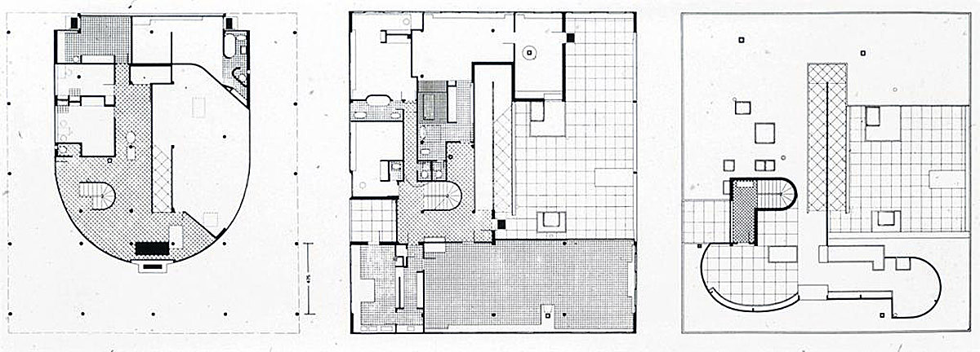
Floor Plans of the Villa S avoye
(http://purehistory.org/5-villa-savoye/)
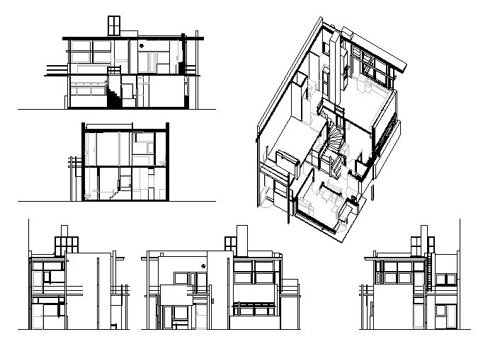
Sections, Elevations and Axonometric of the Schroder House (https://www.pinterest.co.uk/pin/495396027738260578/?lp=true)
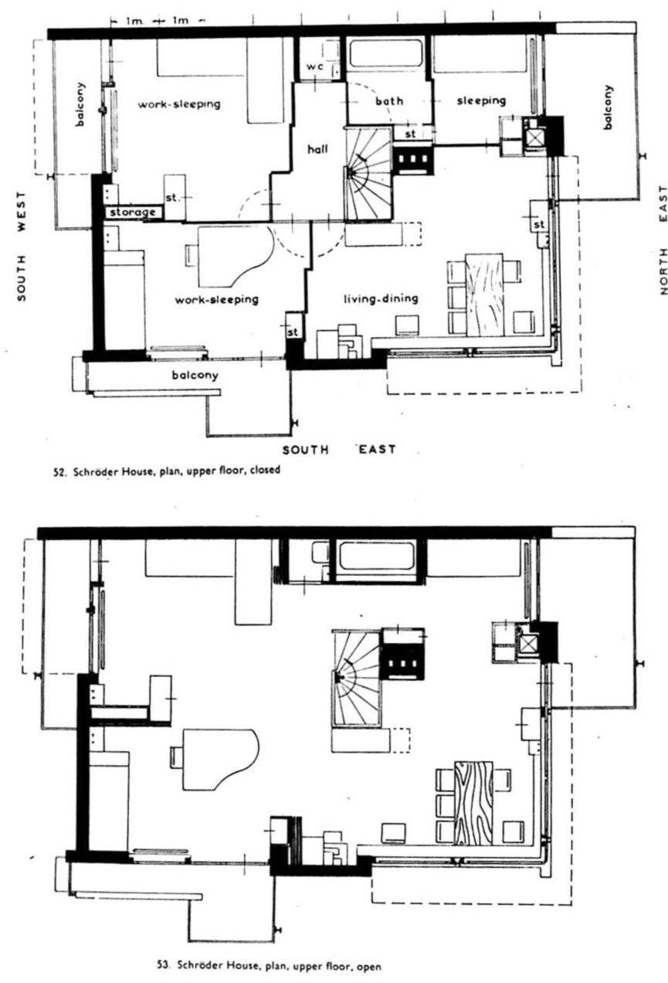
Floor Plans of the Schroder House
(https://histarq.wordpress.com/2011/12/18/aula-5-de-stijl-1918-1927/)
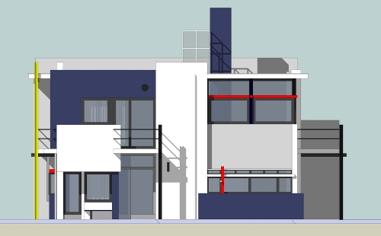
Elevation of the Schroder House
http://oneoffmag.blogspot.com/2011/06/one-house-rietveld-schroder-house.html

References
Bianchini, R. (2018). Le Corbusier - Villa Savoye - part 1, history. [online] Inexhibit. Available at: https://www.inexhibit.com/case-studies/le-corbusier-villa-savoye-part-1-history/ [Accessed 12 Mar. 2019].
Gibson, E. (2016). Le Corbusier's Villa Savoye encapsulates the Modernist style. [online] Dezeen. Available at: https://www.dezeen.com/2016/07/31/villa-savoye-le-corbusier-poissy-france-modernist-style-unesco-world-heritage/ [Accessed 12 Mar. 2019].
House-buildingfunction.blogspot.com. (2014). GERRIT RIETVELD: SCHRÖDER HOUSE. [online] Available at: http://house-buildingfunction.blogspot.com/2014/11/gerrit-rietveld-schroder-house.html [Accessed 8 Mar. 2019].
Kepes, G. (1966). The man-made object. New York: G. Braziller.
Kroll, A. (2010). AD Classics: Villa Savoye / Le Corbusier. [online] ArchDaily. Available at: https://www.archdaily.com/84524/ad-classics-villa-savoye-le-corbusier [Accessed 8 Mar. 2019].savoye.fr/en [Accessed 8 Mar. 2019].
R5. (2012). DIAGRAMS: AN IN-DEPTH ANALYSIS OF THE DESIGN OF THE RIETVELD-SCHRODER HOUSE. [online] Rietveldschroderhouse.blogspot.com. Available at: http://rietveldschroderhouse.blogspot.com/2012/12/diagrams-in-depth-analysis-of-design-of.html [Accessed 8 Mar. 2019].
Sveiven, M. (2009). AD Classics: Rietveld Schroder House / Gerrit Rietveld. [online] ArchDaily. Available at: https://www.archdaily.com/99698/ad-classics-rietveld-schroder-house-gerrit-rietveld [Accessed 8 Mar. 2019].
The Conversation. (2014). Sublime design: Le Corbusier's Villa Savoye. [online] Available at: http://theconversation.com/sublime-design-le-corbusiers-villa-savoye-26625 [Accessed 8 Mar. 2019].
Turtle, M. (n.d.). Rietveld Schroder House, Utrecht, The Netherlands. [online] Time Travel Turtle. Available at: https://www.timetravelturtle.com/rietveld-schroder-house-utrecht/ [Accessed 8 Mar. 2019].
WikiArquitectura. (n.d.). Villa Savoye - Data, Photos & Plans - WikiArquitectura. [online] Available at: https://en.wikiarquitectura.com/building/villa-savoye/ [Accessed 8 Mar. 2019].

