The Tobacco Industry within the U.K - Market Failure and Solution

Billy Clarke
2004276

Introduction
NHS, 2022, explain how smoking tobacco is one of the biggest causes of death and illness in the U.K. Annually causing roughly 76,000 deaths with many more suffering from debilitating illnesses. Through tobacco consumption there is an increased risk of over 50 different serious health conditions with many being considered fatal or irreversible. The implications through either direct smoking or indirect second-hand smoke is proven as detrimental to health.
Gelder, 2023, states the U.K tobacco market as generating £21.8 billion in 2022 with expectance to grow to £23.5 billion by 2027, equating to a current all-time high. Lauren Revie, 2022, details how within the U.K 13.3% of the population, equating to 6.6 million people consumed tobacco in 2021. These two statistics prove the popularity of tobacco products and the magnitude of the market. Ash, 2022, explains how through differing societal implications such as health issues, smoking costs society and the economy £17 billion per year.
The negative externalities of tobacco consumption through both health and environmental implications highlight the market failure of the tobacco industry (Centre for Disease Control and Prevention, 2021). The size of the market may prove significant, however, in terms of the implications to society, the industry is proving as detrimental. In terms of the negative externalities caused by tobacco consumption, there have been several solutions introduced. GOV.UK, 2019, detail these solutions as varying from taxation to mitigate the costs of tobacco on society to support groups, educational programs and enforced control on the marketing of tobacco products.

Market Failure of the Tobacco Industry
Finch et al., 2020, highlight the market failure of the tobacco industry through the cost price of tobacco failing to acknowledge and include the cost of poor health to an individual, the addictive nature of the product and the potential harm to others through second hand smoke. The cost price of tobacco is ignorant to the impact of the product to society. Pettinger, 2019, explains how market failure occurs through the private benefit of consuming tobacco as proving less valuable than the social benefit of tobacco consumption. An individual consuming tobacco for their own personal need, satisfaction or benefit proves much less beneficial to society.
One of the major externalities or implications to society of tobacco consumption is the consequences to the health of individuals. Centre for Disease Control and Prevention, 2021, states how through the consumption of tobacco nearly every organ within the body is damaged and the overall health of an individual depreciates greatly. The consumption of tobacco is seen as the root cause of many diseases with smokers displaying a higher prevalence of cancers, heart disease, stroke, bone health, oral health and infertility. Through the resulting implications of poor health from the consumption of tobacco, the U.K economy is currently suffering in excess of £19 billion annually (Parsey, 2021). CDC, 2022, explains the costs to society through the required expenditure in caring and managing the health of those who have smoked, treating the diseases caused by smoking, providing aids and support to those looking to stop and the loss of productivity generated by those either passing away prematurely or being unable to work as a direct consequence of their tobacco related illnesses.
W.H.O, 2022, explains the environmental impact from tobacco consumption as “Poisoning our planet”, through the carbon footprint of purchasing, littering of toxic chemicals and the emissions caused via the consumption the environment suffers greatly. Through the consumption of the tobacco, University of Bath, 2022, explain how the air is polluted with toxic smoke and the ground, earth and environment polluted from the waste. The entire life cycle, consumption and waste of the product damages the environment.
Action on Smoking and Health, 2017, explain the process of consumption and disposal of tobacco as resulting in the creation of accidental fires which are either destroying households, buildings or the environment. National Fire Protection Association, 2019, explains the unsustainable extra strain placed on their services resulting from the additional resources and funds required to manage the fires generated by the consumption of tobacco. Action on Smoking and Health, 2017, also explain the environmental impact of the fires, with greenhouse gasses, pollution and emissions all resulting from the burning of different materials. Through the resulting implications of tobacco consumption, social and environmental resources are being excessively and unnecessarily utilised or destroyed.
National Institute on Drug Abuse, 2022, explains how through the consumption of tobacco there is a brief feeling of “euphoria” or “high” which fades relatively quickly, therefore, individuals repeat their consumption of the product to experience a continual or repeated feeling. Expose Tobacco, 2022, explain how within the tobacco industry the products being produced are being made more addictive whilst the promotion or information provided displays complete ignorance to the addictive nature. Louise, 2021, states how for the average smoker in the current climate they will spend £4841.20 on tobacco annually. The sources detail the enforced excessive spending inflicted to individuals through the addictiveness of the product. Hourston, 2022, details the current financial climate and cost of living crisis, with a higher proportion of individuals seeking financial support to aid their situations. There is an increase in individuals requiring benefits, utilising food banks or financial relief. The enforced, coerced or unknowingly uncontrollable spending to allow tobacco consumption is directly costing society in public spending.
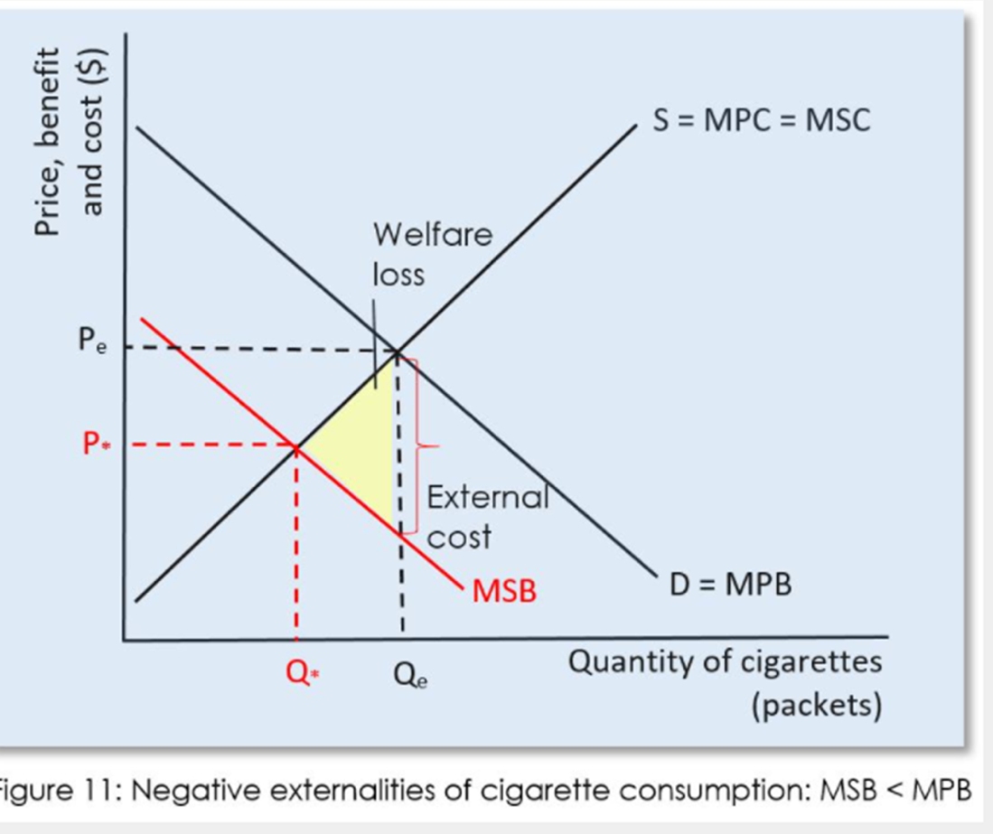
Figure 1: Negative Externality of Tobacco (Pettinger, 2019)
Through the diagram it is possible to understand the market failure of the industry through the marginal private benefit not being equivalent to that of the marginal social benefit. The difference of the two curves displays the market failure of the industry where the marginal private benefit is placed at a higher value than that of the marginal social benefit at any given quantity. The benefit to the individual consuming an additional tobacco product is of higher value than the benefit experienced by society through the additional consumption. The MPB curve is ignorant to any of the societal costs generated through the consumption of tobacco, at any given quantity of tobacco consumed, the benefit to society (MSB) is lower than that to the benefit to the consumer (MPB). The disproportion between the two curves displays the negative externality, with the welfare triangle displaying the societal loss in relation to the costs not factored into the consumption of tobacco at the differing MPB quantities.
To remove the externality or alleviate the market failure, the differing external costs to society generated through the consumption of tobacco need to be absorbed and taken into consideration. This figure is represented through the MSB or marginal social benefit curve. This curve factors the cost of tobacco consumption into the price of tobacco at each quantity bought, therefore, making the product less desirable. Kindness, 2022, explains how the equilibrium point at Q* represents the ideal balance between the cost to society and benefit of consumer, where the negative externality of consumption and market failure is resolved through the absorption of societal costs or price and lower consumption level.
How Market Failure is Resolved
Solution One – Taxation
In order to address the costs to society generated through the consumption of tobacco most governments have introduced a tobacco duty. Office for Budget Responsibility, 2023, explains how for differing tobacco products there are differing levels of taxation, for example, cigarettes are taxed at 16.5% of the retail price plus £5.89 whereas hand-rolling tobacco is charged at £10.53 per 30 grams. UK Gov, 2023, explains how the taxation of tobacco escalates in correspondence to the rate of inflation. The taxation for the consumption of the products is 2% above the RPI at each budget with this current rate introduced until the end of the current parliament. This ensures the purpose of the taxation remains relevant and impactful to the current financial climate.
World Health Organisation, 2023, states how through raising the taxation on tobacco, the price rises and the product becomes less affordable. Through increasing the amount consumers must pay, their demand per additional unit purchased decreased. World Health Organisation, 2023, explains how a 10% increase in price of tobacco products equates to a 5% decrease in consumption, with society benefitting from the decrease in consumption, especially in the areas of youth and low-income consumers. With the disposable income levels typically of a lower value, the increase in price possesses a greater impact. The increase in taxation on the products decreases the demand and viability for a large proportion of the consumer market resulting with a decrease of consumption.
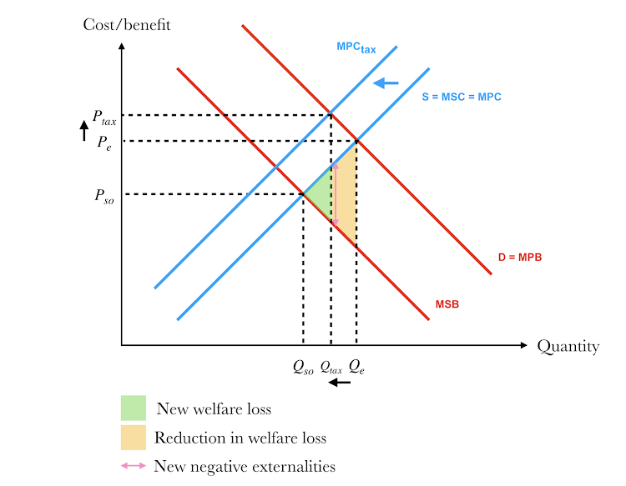
Figure 2 – Indirect Tax on Tobacco
The MPCtax curve indicates the introduction of taxation to tobacco. IB Economics, 2022, through the diagram details the increase of price of tobacco as resulting in the demand decreasing and therefore the cost to society likewise. The image represents the effect of taxation on tobacco with a progression of Qe towards Qso or the socially optimal consumption level. The higher value of the MSCtax curve on the cost axis with the correlating positions on the quantity axis displays the progression towards the resolution of the negative externality. The resolution of the negative externality is symbolised with the reduction of size in the welfare triangle. The new welfare loss highlighted in green is much smaller than that of the original triangle in orange.
Ash, 2023, explains the increase or alteration in taxation of tobacco as occurring in 1993, where the escalation of tax in line with inflation was introduced. NHS Digital, 2020, explain how from 1993 to 2019, there has been a severe decrease in those consuming tobacco and the amount of tobacco consumed. The source explains how between 1993 to 2019, the proportion of adults smoking has dropped from 27% to 16%, the number of cigarettes smoked in a day has fallen from 15 to 10 and the proportion of children who have never has increased by 15%. These three statistics justify the arguments World Health Organisation, 2023, in taxation being the single most important measure for resolving the negative externality of tobacco consumption to society.
Solution 2 - Tobacco Alternatives
Tobacco is considered the most harmful form of nicotine, therefore, there is an increase in the demand, usage and consumption of tobacco alternatives (Philip Morris International, 2023). The addictive component of tobacco is nicotine, it is what maintains and increases the demand for the product. Cancer Research UK, 2023, explains how many of the alternative options in vapes, smokeless nicotine vapours or tablet nicotine releasers are much less harmful than tobacco, whilst still providing nicotine. Consuming nicotine through the alternative methods has been found to reduce the consumption of toxic, harmful and damaging chemicals within tobacco. The demand for the tobacco or nicotine product is met whilst removing the damaging costs to society. Hall, 2022, in the graph below highlights the increase of those utilising alternatives to tobacco in the form of vapes, of which over the past decade there has been a continual growth.
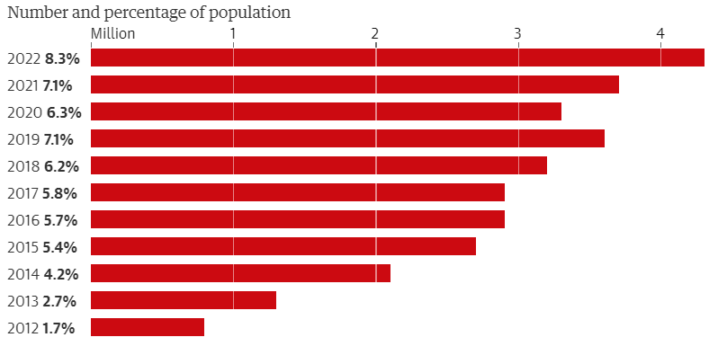
Figure 3 – A Table Showing the Population Usage of Tobacco alternative vapes
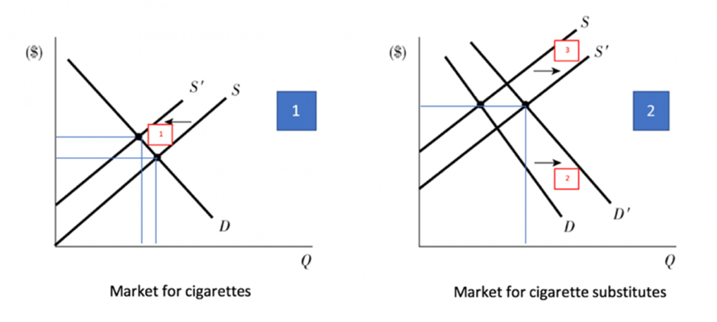
Figure 4 – Two Tables Representing the Consumption of Tobacco and Tobacco Alternatives
The diagram in image 2 displays two individual demand curves, D and D1. Curve D represents tobacco consumption at different quantities whereas curve D1 represents tobacco alternative or vape consumption. Callan & Thomas, 2013, display in table 2 the equal cost or benefit to society at a greater consumption of alternative products compared to tobacco. An individual can consume a much greater quantity of tobacco alternatives whilst inflicting an equal or lesser impact to society. The demand for tobacco products decreases through the introduction and consumption of tobacco alternatives. The cost to society decreases through the uptake of the new product and removal of harmful externalities of tobacco consumption.
Better Health, 2023, explains how roughly two thirds of consumers who use a vape successfully quit smoking. This statistic highlights how through adoption of tobacco alternatives the demand for tobacco is decreasing and resolving the negative externality. Thatcher, 2015, highlights the effectiveness of tobacco alternatives in resolving the externalities of tobacco consumption with 20% of 20-year-olds as reportedly now trying vaping with only 11% having tried tobacco products. Historically the figure for tobacco consumption among this age bracket would have been much higher and with the addictive nature of the product would have led to a much higher, prolonged period of consumption. It is possible to see the resolution of the externality by alternatives in providing a much safer, healthier and less damaging product to consumers which has led to the decrease in demand for tobacco (Blaha, 2022).
Solution 3 - Controlled Marketing
Freeman et al., 2022, explain how within the tobacco industry advertising, promotion and sponsorship are either controlled or banned. There are restrictions placed on point-of-sale displays, packaging of products, spending, incentives, offers, where promotion takes place and the type of promotions or advertising which can take place. Barr, 2018, describes how with the introduction of the regulations the main purpose was to alter the overall perception of the product. Historically the product was marketed as being “A gentleman's pass time” or something which everyone just accepted and completed, this perception has now altered to tobacco know being known as a life-threatening activity and product.
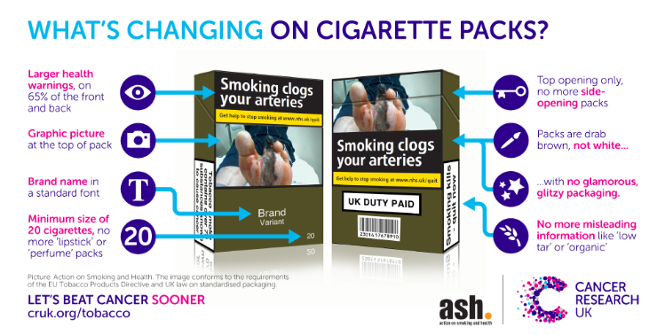
Cancer Research UK, 2016, display the differing enforced changes to the product packaging, symbolising the required alterations and resulting design. The differing restrictions are all being introduced with the purpose of making consuming tobacco products more difficult or less appealing. This purpose is made evident through the point of sale of the products. Smokefree Action Coalition, 2023, detail how since 2012 it has been illegal to display tobacco products. The products must be hidden and purchased upon request with the age of the individual being verified for the transaction to be complete. Through the controlled marketing there is an emphasis placed on educating the consumer on the implications of consumption causing a decrease in demand.

Figure 5 – The Current Tobacco packaging.
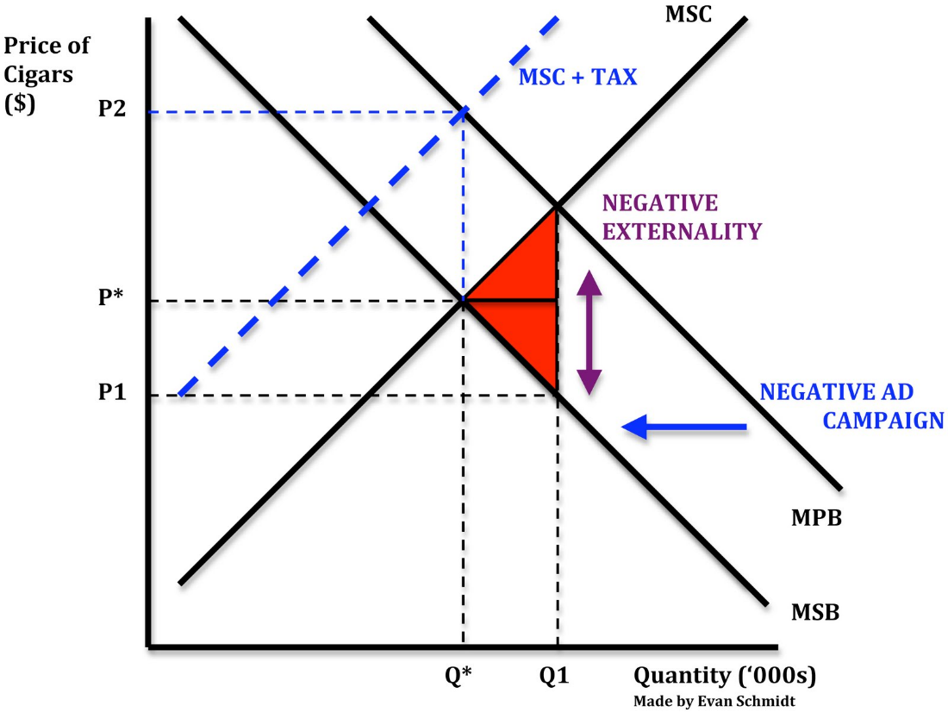
Figure 6 – How Targeted Marketing Impacts Negative Externalities (Schmidtomics, 2015).
The arrow signalling the progression of MPB towards the MSB curve signals the decrease in demand and consumption through the differing marketing measures. Through removing the enticement for the product along with educating those on the different implications of consumption, the demand decreases. Through generating a negative perception and awareness of the product along with reducing the chance of un-intentional sales the demand decreases. The welfare loss triangle reduces through the progression of the MPB curve to the socially optimal point of consumption at Q*.
Haw et al., 2014, state how with the previous unrestricted marketing of tobacco products there was an increased level of the susceptibility to consume tobacco. With the unrestricted marketing of tobacco, individuals were much more likely to increase, begin or try consuming tobacco. Currently, with the restrictions on the marketing of tobacco, this no longer occurs. W.H.O., 2023, report how through the banning and regulation of tobacco marketing, 78% of students aged 13 to 15 are no longer exposed to tobacco advertising, promotion or sponsorship. The organisation consigns the responsibility of decreasing the consumption figures among younger individuals to their lack of awareness of the product. The alteration to a more informative focus of any marketing has decreased the demand and consumption significantly, Ford et al., 2020, explains how through the regulated and ban on certain marketing activities over 15% of individuals either ceased or never began their consumption.

Conclusion
Through the differing externalities as well as the areas in which improvement is required, it is clear to see the market failure. Through the three differing solutions introduced signify the various areas in which the market failure was occurring. The industry prior to any solutions was taking advantage of society and consumers in the cost it was generating and implications causing. The industry prioritised their profit and income streams over the health, financial security and safety of society. Through the consumption of the product, the industry displayed both ignorance and arrogance to the health and welfare of individuals, the environment and society. Through the differing solutions, many of the negative externalities of consumption have been addressed. Through taxation a deterrent of consumption has been created whilst simultaneously raising funds to manage some of the implications generated by consumption. Through the controlled marketing measures demand is decreased through deterring individuals from purchasing the products. Finally, the alternative product introduced ensures individuals can still meet their addiction or needs whilst inflicting a much-reduced cost to society.

Word count: 2746

References
References
Action on Smoking and Health. (2017). The economics of tobacco - ash.org.uk. The economics of tobacco. Retrieved April 26, 2023, from https://ash.org.uk/uploads/Economics-of-Tobacco.pdf?v=1650642285

Ash. (2023). Tobacco taxation and illicit trade. ASH. Retrieved April 28, 2023, from https://ash.org.uk/tobacco-industry/tobacco-taxation-and-illicit-trade

Ash. (2022). Smoking costs society £17bn – £5bn more than previously estimated. ASH. Retrieved April 22, 2023, from https://ash.org.uk/media-centre/news/press-releases/smoking-costs-society-17bn-5bn-more-than-previously-estimated

Barr, S. (2018, October 22). How smoking adverts have evolved over the decades. The Independent. Retrieved April 28, 2023, from https://www.independent.co.uk/life-style/health-and-families/smoking-adverts-cigarettes-tobacco-history-philip-morris-first-world-war-a8596196.html

Better Health . (2023). Vaping to quit smoking. NHS choices. Retrieved April 28, 2023, from https://www.nhs.uk/better-health/quit-smoking/vaping-to-quit-smoking/#:~:text=Did%20you%20know%3F,products%2C%20like%20patches%20and%20gum

Blaha, M. J. (2022, January 20). 5 vaping facts you need to know. 5 Vaping Facts You Need to Know | Johns Hopkins Medicine. Retrieved April 28, 2023, from https://www.hopkinsmedicine.org/health/wellness-and-prevention/5-truths-you-need-to-know-about-vaping

Callan, S., & Thomas, J. (2013). In Environmental Economics and Management (pp. 290-300). Cenagae Learning.

Cancer Research UK. (2016, May 18). Tobacco packs changed forever as the UK introduces Plain Packaging Laws. Cancer Research UK - Cancer News. Retrieved April 28, 2023, from https://news.cancerresearchuk.org/2016/05/19/tobacco-packs-changed-forever-as-the-uk-introduces-plain-packaging-laws/

Cancer Research UK . (2023, April 21). Is vaping harmful? Cancer Research UK. Retrieved April 28, 2023, from https://www.cancerresearchuk.org/about-cancer/causes-of-cancer/smoking-and-cancer/is-vaping-harmful#:~:text=Many%20studies%20show%20that%20vaping,been%20found%20in%20e%2Dcigarettes.

CDC. (2022, July 26). Economic trends in tobacco. Centers for Disease Control and Prevention. Retrieved April 26, 2023, from https://www.cdc.gov/tobacco/data_statistics/fact_sheets/economics/econ_facts/index.htm#:~:text=More%20than%20%24240%20billion%20in%20healthcare%20spending%2C&text=Nearly%20%24185%20billion%20in%20lost,related%20illnesses%20and%20health%20conditions%2C&text=Nearly%20%24180%20billion%20in%20lost,%2Drelated%20premature%20death%2C%20and%2C&text=%247%20billion%20in%20lost%20productivity%20from%20premature%20death%20from%20secondhand%20smoke%20exposure.

Centre for Disease Control and Prevention. (2021, October 29). Health effects of cigarette smoking. Centers for Disease Control and Prevention. Retrieved April 25, 2023, from https://www.cdc.gov/tobacco/data_statistics/fact_sheets/health_effects/effects_cig_smoking/index.htm

Expose Tobacco . (2022, February 9). Modern addiction: Hooking the next generation. STOP. Retrieved April 26, 2023, from https://exposetobacco.org/campaigns/modern-addiction/

Finch , D., Briggs , A., & Tallack, C. (2020). Improving health by tackling market failure. The Health Foundation. Retrieved April 25, 2023, from https://www.health.org.uk/publications/long-reads/improving-health-by-tackling-market-failure

Ford, A., MacKintosh, A. M., Moodie, C., Kuipers, M. A. G., Hastings, G. B., & Bauld, L. (2020, May 1). Impact of a ban on the open display of tobacco products in retail outlets on never smoking youth in the UK: Findings from a repeat cross-sectional survey before, during and after implementation. Tobacco Control. Retrieved April 28, 2023, from https://tobaccocontrol.bmj.com/content/29/3/282

Freeman, B., Watts, C., & Astuti, P. A. (2022). Global Tobacco Advertising, promotion and sponsorship regulation: What’s old, what’s new and where to next? Tobacco Control, 31(2), 216–221. https://doi.org/10.1136/tobaccocontrol-2021-056551

Gelder, K. van. (2023, April 21). United Kingdom (UK): Tobacco products market revenue 2014-2027. Statista. Retrieved April 22, 2023, from https://www.statista.com/forecasts/309142/tobacco-retail-sales-turnover-united-kingdom-uk#:~:text=Revenue%20from%20the%20tobacco%20market,23.5%20billion%20pounds%20by%202027.

GOV.UK. (2019). Health matters: Stopping smoking – what works? GOV.UK. Retrieved April 22, 2023, from https://www.gov.uk/government/publications/health-matters-stopping-smoking-what-works/health-matters-stopping-smoking-what-works

Hall, R. (2022, August 29). Vaping reaches record levels in Great Britain, report reveals. The Guardian. Retrieved April 28, 2023, from https://www.theguardian.com/society/2022/aug/29/vaping-reaches-record-levels-great-britain-report

Haw, S., Amos, A., Eadie, D., Frank, J., MacDonald, L., MacKintosh, A. M., MacGregor, A., Miller, M., Pearce, J., Sharp, C., Stead, M., Tisch, C., & van der Sluijs, W. (2014). Determining the impact of smoking point of sale legislation among youth (display) study: A Protocol for an evaluation of public health policy. BMC Public Health, 14(1). https://doi.org/10.1186/1471-2458-14-251

Hourston, P. (2022, January 7). Cost of living crisis. Institute for Government. Retrieved April 26, 2023, from https://www.instituteforgovernment.org.uk/explainer/cost-living-crisis#:~:text=Despite%20this%20extensive%20support%2C%20household,the%20next%20couple%20of%20years.

IB Economics. (2022). Market failure. Market Failure. Retrieved April 28, 2023, from https://www.blitznotes.org/ib/economics/market_failure.html

Kindness, D. (2022, November 28). How do externalities affect equilibrium and create market failure? Investopedia. Retrieved April 27, 2023, from https://www.investopedia.com/ask/answers/051515/how-do-externalities-affect-equilibrium-and-create-market-failure.asp

Lauren Revie, B. D. and D. M. (2022, December 6). Adult smoking habits in the UK: 2021. Adult smoking habits in the UK - Office for National Statistics. Retrieved April 22, 2023, from https://www.ons.gov.uk/peoplepopulationandcommunity/healthandsocialcare/healthandlifeexpectancies/bulletins/adultsmokinghabitsingreatbritain/2021#:~:text=1.-,Main%20points,Annual%20Population%20Survey%20(APS).

Louise. (2021, March 25). What is the cost smoking? Everyone Health. Retrieved April 26, 2023, from https://everyonehealth.co.uk/what-is-the-cost-smoking/

National Fire Protection Association. (2019). Home fires started by smoking. NFPA report - Home Fires Started by Smoking. Retrieved April 26, 2023, from https://www.nfpa.org/News-and-Research/Data-research-and-tools/US-Fire-Problem/Smoking-Materials

National Institute on Drug Abuse. (2022). Is nicotine addictive? National Institutes of Health. Retrieved April 26, 2023, from https://nida.nih.gov/publications/research-reports/tobacco-nicotine-e-cigarettes/nicotine-addictive

NHS. (2022). What are the health risks of smoking? NHS choices. Retrieved April 22, 2023, from https://www.nhs.uk/common-health-questions/lifestyle/what-are-the-health-risks-of-smoking/

NHS Digital . (2020). Smoking. Health Survey for England. Retrieved April 28, 2023, from http://healthsurvey.hscic.gov.uk/data-visualisation/data-visualisation/explore-the-trends/smoking.aspx

Office for Budget Responsibility. (2023, April 21). Tobacco duties. Office for Budget Responsibility. Retrieved April 28, 2023, from https://obr.uk/forecasts-in-depth/tax-by-tax-spend-by-spend/tobacco-duties/#:~:text=At%20Autumn%20Budget%202021%2C%20the,inflation%20plus%203%20per%20cent.

Parsey, L. (2021, July 30). Smoking costs UK economy in excess of £19 billion a year, new report finds. ILCUK. Retrieved April 26, 2023, from https://ilcuk.org.uk/smoking-costs-uk-economy-in-excess-of-19-billion-a-year-new-report-finds/

Pettinger, T. (2019, November 30). Negative externalities. Economics Help. Retrieved April 25, 2023, from https://www.economicshelp.org/micro-economic-essays/marketfailure/negative-externality/

Philip Morris International. (2023, February 28). Demand for less harmful alternatives to cigarettes. PMI. Retrieved April 28, 2023, from https://www.pmi.com/our-science/demand-for-less-harmful-alternatives

Schmidtomics. (2015, May 3). Negative externalities of consumption. schmidtomics. Retrieved April 28, 2023, from https://schmidtomics.wordpress.com/2010/02/16/negative-externalities-of-consumption/

Smokefree Action Coalition. (2023). Point of Sale display. Smokefree Action Coalition. Retrieved April 28, 2023, from https://smokefreeaction.org.uk/smokefree/point-of-sale-display/

Thatcher, A. (2015). E-cigarettes more popular than tobacco among youth. Canadian Medical Association Journal, 187(6). https://doi.org/10.1503/cmaj.109-5010

UK Gov. (2023). Changes to tobacco duty rates from 15 March 2023. GOV.UK. Retrieved April 28, 2023, from https://www.gov.uk/government/publications/tobacco-duty-changes-to-rates/changes-to-tobacco-duty-rates-from-15-march-2023

University of Bath. (2022, May 30). Tobacco and the environment. TobaccoTactics. Retrieved April 26, 2023, from https://tobaccotactics.org/article/tobacco-and-the-environment/

W.H.O . (2023). Tobacco euro. World Health Organization. Retrieved April 28, 2023, from https://www.who.int/europe/health-topics/tobacco/banning-tobacco-advertising-sponsorship-and-promotion#tab=tab_1

W.H.O. (2022). Who raises alarm on tobacco industry environmental impact. World Health Organization. Retrieved April 26, 2023, from https://www.who.int/news/item/31-05-2022-who-raises-alarm-on-tobacco-industry-environmental-impact

World Health Organisation . (2023). Raising taxes on tobacco. World Health Organization. Retrieved April 28, 2023, from https://www.who.int/activities/raising-taxes-on-tobacco

