Assessment 2

Managing People
LCBB5004

Student: Laura-Andreea Doru (2125338)
Lecturer: Dr Laila Maazouz
Table of Contents
Introduction 3
The causes and effects of employee attrition within the Nursing Industry in the UK 3
Causes of Nurse Attrition 3
Effects of Nurse Attrition 4
Addressing Nurse Attrition 5
Five monetary and five non-monetary existing retention schemes used by NHS for Nursing professionals 6
Monetary Schemes 6
Non-monetary Schemes 10
Balanced Approach 11
Recommendations 12
Short-Term Recommendations 13
Long-term Recommendations 13
Balancing Monetary and Nonmonetary Incentives 14
Conclusion 15
Reference List 16

Introduction
In the context of the nursing industry in the UK, the rapidly increasing rate of healthcare professional attrition has created noteworthy concerns. The engross of 40,365 NHS nurses in the year leading to June 2022, along with the rising tendencies among fresh nurses, underscores a complex obstacle. This tendency is not uniquely attributed to seclusion but also circumscribes factors affecting job contentment and retention (Holmes, 2022). Within this scenario this evaluation searches into the causes and effects of the nurse attrition, inspect both monetary and non-monetary retention programs presently used by the NHS and critically analyse their efficacy. Afterwards, recommendations are presented to recognise these obstacles, targeting to support nurse retention and eliminate the attrition rate in the United Kingdom's nursing industry.

The causes and effects of employee attrition within the Nursing Industry in the UK
Employee attrition, especially among nurses within the UK's National Health Service (NHS), has reflected massive downfall in recent years. The data unfolds the considerable obstacles encountered by the nursing industry in retaining its labour force (Fasbender, Van der Heijden and Grimshaw, 2018). This evaluation describes the fundamental causes and the long-term effects of this attrition, giving spotlight to its intimations for both the healthcare system and nursing professionals.

Causes of Nurse Attrition
- Workforce and Burnout: Nurses frequently encountered enormous workloads, leading to physical and emotional burnout (Johnson et al., 2018). Long working time, high ratio of patient-to-nurse, and challenging accountability donate to stress and discontent.
- Lack of Resources: Insufficient number of staff, limited amount of equipment and improper support system hamper the capability of nurses to provide standard care, outcome in annoyance and lower rate of job pleasure.
- Career progression: The lower rate of clear career progression paths and chances for skill improvement can lead to recession, encouraging nurses to look over advancement or development elsewhere.
- Pay and Benefits: Nurses wages may not be sufficient according to their accountability and contributions (Marufu et al., 2021). Low wages, and the high amount of stress, can navigate nurses to look over more economic offering job options.
- Work-life Balance: The challenging nature of nursing frequently disturbed the work-life balance, affecting family and unique well-being, and supporting some to resign from the profession for a more peaceful lifestyle.
- Youthful Exodus: The astonishing data revealing a high rate of younger nurses create the concerning areas in the profession and job contentment, possibly regulated by unsuitable working situations.

Effects of Nurse Attrition
- Shortage of Skilled Workforce: The most instant and critical effect of nurse attrition is the shortage of qualified medical care professionals (Poon et al., 2022). This can lead to a high number of duties on existing staff, affecting patient care standards.
- Quality of Patient Care: A lower amount of nursing labour force can accommodate patient safety and care standards. High ratio of patient to nurse can show the way of medical errors, slow down the treatments, and lower the amount of attention to the requirements of the patients.
- Financial Strain: Changing the nurses incorporated employment, tutelage, and onboarding costs. Moreover, high amounts of tasks on abide staff can lead to a high amount of sick leave and lower the rate of productivity, affecting process regulation and hospital financial plans.
- Staff Morale: The withdrawal of workmates can create a sense of unpredictability and lower amount of self-esteem among persistent nurses (Fasbender, Van der Heijden and Grimshaw, 2018). This can lead to a negotiated work environment and more distant contributions to attrition.
- Skills Gap: Knowledgeable nurses take over complex skills and understanding. Their egress can create a gap in skills that juvenile, less knowledgeable nurses might grapple to fill, influencing the outcome related to the patient.
- Reputation Damage: High rate of attrition rates can deteriorate the reputation of healthcare establishment, making it hard to attract and keep new skills and possibility influencing the trust of patients.

Addressing Nurse Attrition
- Improved Working Conditions: Giving importance to nurse good health by recognising employment concerns, developing assets accessibility and Incorporating inventiveness for work-life balance can alacrity affect retention (NHS Digital, 2022).
- Career development: Representing clear career footpath, tutelage chances, and professional development can inspire nurses to stay within the occupation.
- Competitive Compensation: Representing competitive remuneration and profits that reflect nurse’s donations can increase job contentment and maintenance.
- Mentor Programs: Putting together encounters of nurses with immigrants can smooth knowledge convey, skill improvement and a sense of belonging.
- Investment in Technology: Incorporating up to date technologies can smooth flow of work and lower amount of directorial implication, and ameliorate overall regulation, leading to lower the rate of strain for nurses (Palmer and Rolewicz, 2022).
- Positive Work Environment: Supporting and encouraging, deferential and collaborative labour force culture can increase the job contentment and friendship, lowering attrition rates.
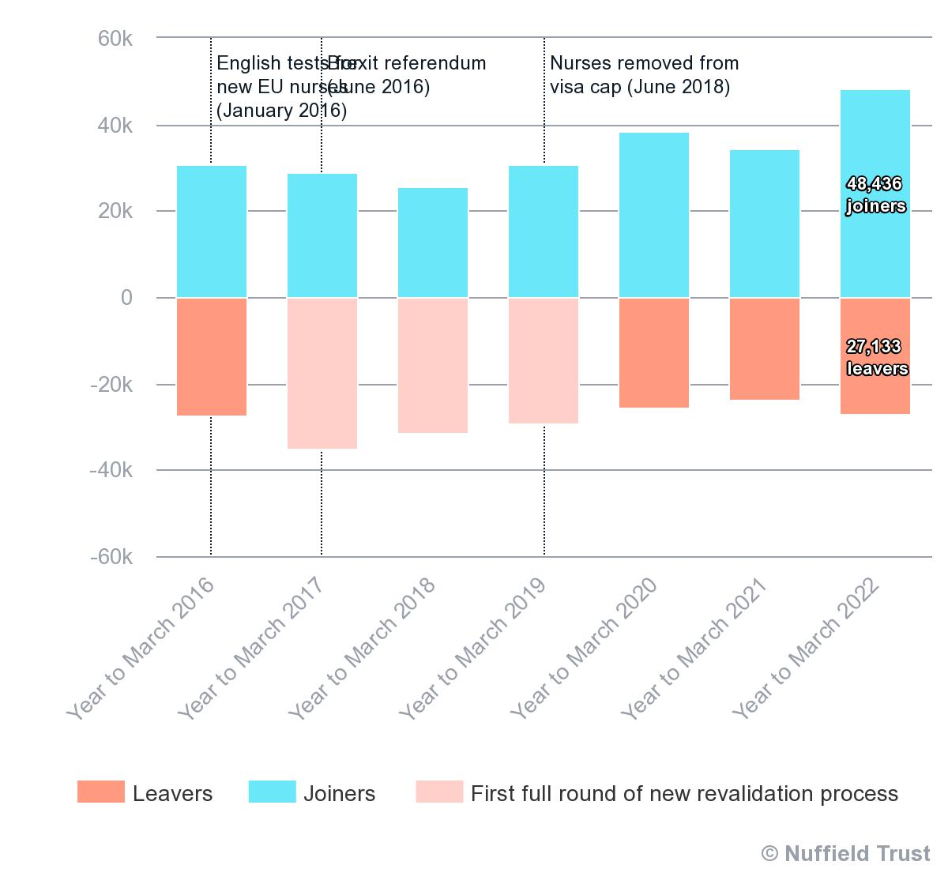
Figure 1: Nurse wage rate
(Source: Palmer and Rolewicz, 2022a)

Five monetary and five non-monetary existing retention schemes used by NHS for Nursing professionals.

Monetary Schemes
The nursing attrition crisis within the UK's National Health Service (NHS) requests contemporary viewpoints to employ and inspire nursing professionals. Monetary motivations are an important aspect of the plans incorporated by the NHS to recognise these issues. By the help of extensive research and evaluation of accessible data, different monetary programs arise as possible solutions. This analysis evaluates five key monetary schemes used by the NHS to train nursing professionals, describing their success, interest, and possible drawbacks.

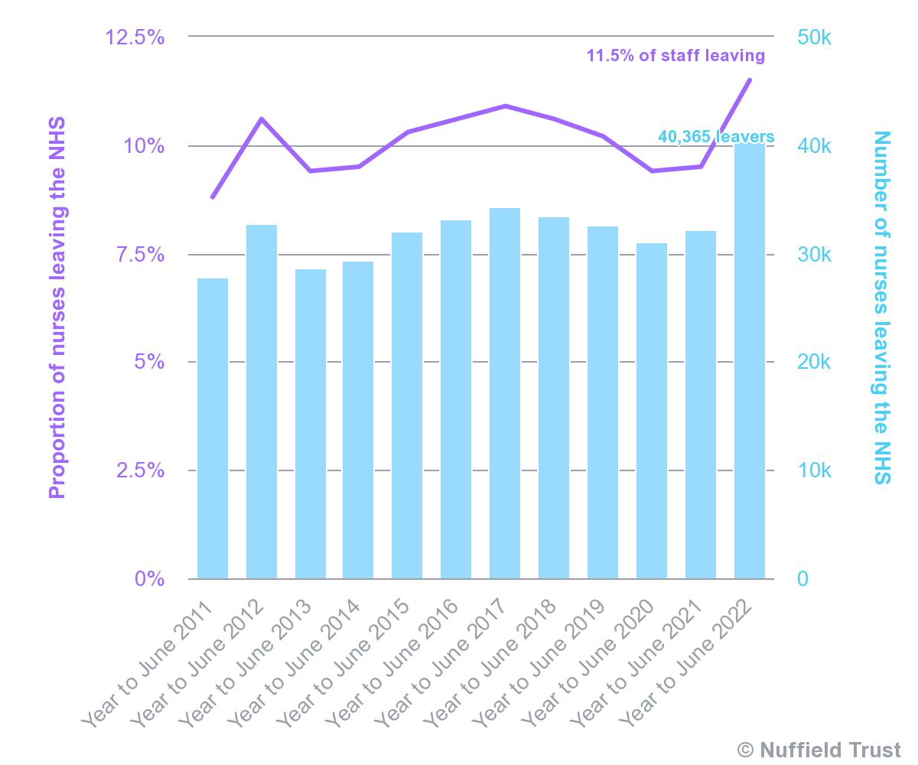
Figure 2: Nurse rate
(Source: Palmer and Rolewicz, 2022b)

Retention Bonuses | Retention bonuses include presuming economic motivation to nursing professions who dedicate themselves to remain within the NHS for a particular duration (Abelsen et al., 2020). These bonuses can be arranged as lump-sum remission or lurch inducement over the contract period. | Effectiveness: Retention bonuses can represent short-term reassurance by discouraging immoderate attrition.
Retention Bonuses |  | Benefits:  - Directly inspire nurses to endure within the NHS.  - Represents instant economical gratification.
Retention Bonuses |  | Drawbacks:  - May not recognise fundamental job discontent or burnout.  - Dependence on economic incentives may threaten intrinsic inspiration.
Pay Progression | Pay progression includes gradual increasing nurses, wages based on skills and experience and work hour in-service. | Effectiveness: Pay progression can inspire nurses to stay within the NHS by representing palpable career advancement and economic addressing for skill improvement.
Pay Progression |  | Benefits: Lining with career progression and professional development.
Pay Progression |  | Drawbacks: May not be enough to counteract other employment challenges.
Skill-Based Pay | Skill-based pay helps nurses get added skills, modifications or certifications related to their parts. | Effectiveness: Skill-based wages increment motivate nurses to increase their capabilities, donating to developed patient care and career development
Skill-Based Pay |  | Benefits:  - Supports a culture of learning and adeptness.  - Foster ongoing professional improvement.
Skill-Based Pay |  | Drawbacks: Incorporation complexity, that includes addressing skill values.
Golden Handshake | A "golden handshake" includes representing a considerable lump-sum remission to nursing professionals who execute to an anchored contract them (Bimpong et al., 2020). This program represent immediate economic recompense for concur to stay within the NHS | Effectiveness: Golden handshakes can attract and keep nurses by representing considerable upfront economic inducements.
Golden Handshake |  | Benefits: represents immediate economic reassurance.
Golden Handshake |  | Drawbacks: May not recognise long-term retention.
Performance-Linked Bonuses | Performance-linked bonuses bind economic rewards to prearranged performance standards, such as patient consequences, standard of care, and coordination. This program is lined with economic incentives with developed patient care. | Effectiveness: Performance-linked bonuses promote answerability, standard development, and a patient-focused viewpoint.
Performance-Linked Bonuses |  | Benefits: Lining with the NHS's dedication to standard.
Performance-Linked Bonuses |  | Drawbacks: Risk of centering uniquely on perceptible metrics, abandoning qualitative viewpoints of care.

Non-monetary Schemes
Amid the increasing nurse attrition crisis in the UK's National Health Service (NHS), the requirement for successful retention strategies is important. Beyond conventional monetary incentives, the NHS has incorporated non-monetary programs to keep nursing professionals.

Flexible working Arrangements | The NHS has flexible working arrangements, that consist of part-time working, job-exchanging, and improbable work options. | Pros: Intrinsic motivation
Flexible working Arrangements |  | Cons: Financial pressure
Career Development and Training | The NHS represents extensive, career Improvement chances, such as special tutelage, certification, and encouragement pathways (Thusini et al., 2022). | Pros: Genuine loyalty
Career Development and Training |  | Cons: Immediate rewards
Mentorship and Support Programs | Mentorship schemes connect knowledgeable nurses with freshers,  representing guidance, suggestions, and fostering networks. | Pros: Positive work environment
Mentorship and Support Programs |  | Cons: Balancing with comprehension
Health and Well-being Initiatives | The NHS accentuates nurses, well-being by wellbeing programs, mental health support and pressure management capabilities (Sayli et al., 2022). | Pros: Sustainable motivation
Health and Well-being Initiatives |  | Cons: Varied preferences
Recognition and Appreciation Programs | The NHS addresses nurses, donated by different valuing programs, consisting of awards, Identifying events, and public understanding. | Pros: Professional development
Recognition and Appreciation Programs |  | Cons: Short-Term impact

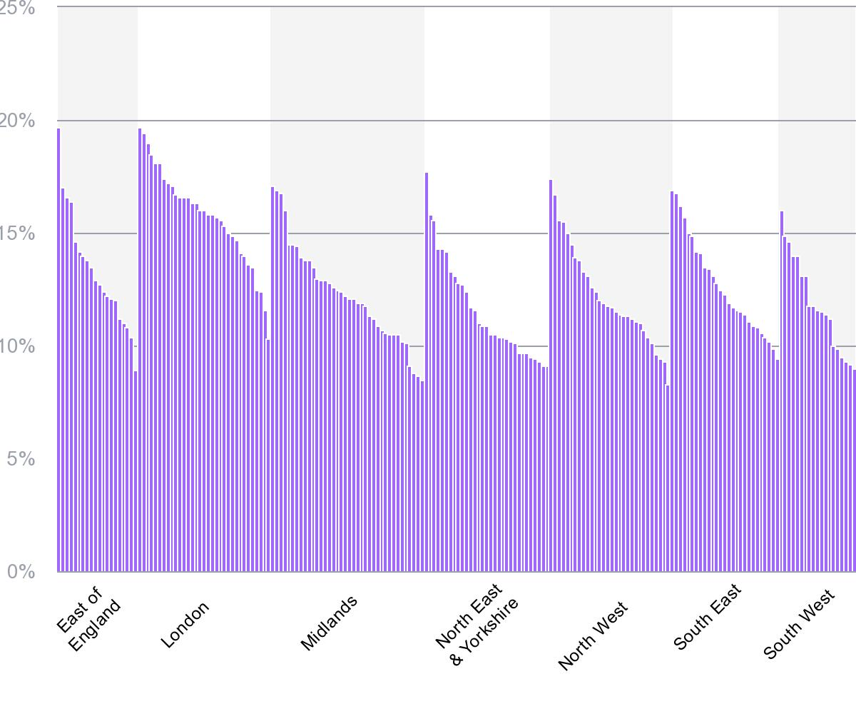
Figure 3: Average rate across region
(Source: Palmer and Rolewicz, 2022c)

Balanced Approach
Successful retention strategies should affect a balance among monetary and non-monetary components to recognise different dimensions of job contentment and inspiration.
- Hybrid Schemes: Amalgamante economic rewards with non-monetary perks secure an extensive viewpoint that attract a huge range of nurses, requirements and preferences (Abelsen et al., 2020).
- Personalisation: Addressing those various nurses value various inducements, representing a catalogue of options that nurses can select for, can customise retention attempts to individual preferences.
- Regular Feedback: Soliciting nurses, insert, and feedback on subsist retention, programs can represent valuable insights into their success and help purify the strategies over time (Sayli et al., 2022).
- Long-term Planning: Rather than depend on a short-term fastener the NHS should centre on generating a culture of retention through ongoing support, Improvement chances, and work environment refinements.

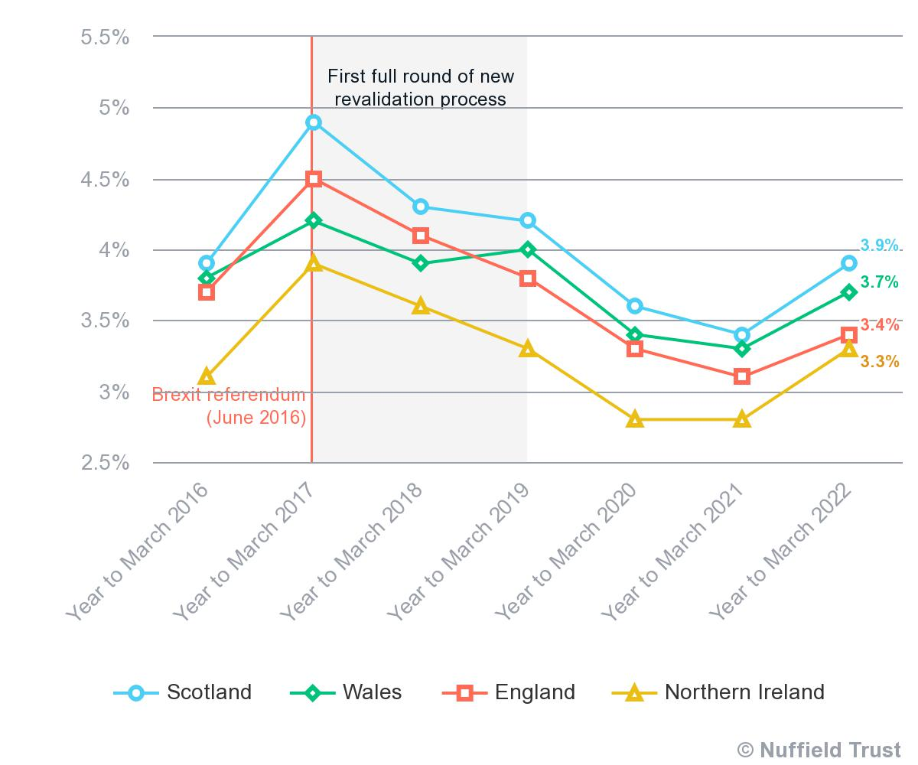Figure 4: Average rate of across regions
(Source: Palmer and Rolewicz, 2022d)

Recommendations
The increasing rapid nurse attrition rate within the UK's National Health Service (NHS) requires extensive strategies to increase nurse retention and stable the medical care labour force. The leaving of 40,365 NHS nurses in the year leading up to June 2022, combined with an enlarging tendency among younger nurses, requires both short-term and long-term recommendations to recognise the complex Issues.

Short-Term Recommendations
- Flexible Scheduling- Representing flexible work schedules, introducing part-time and job-exchanging choices, to assist nurses diversified requirements and supports work-life balance (Buchan et al., 2019). This can lower the rate of burnout and disappointment related to stiff shits.
- Recognition and Appreciation- Creating daily addressing programs to understand nurses' donations and attainments, publicly addressing their attempt can enhance morale, and job contentment, supporting a sense of value.
- Wellness Initiatives- Incorporate wellness schemes that centre on mental and physical health (Harris et al., 2018). Entrance to reassurance, tension management resources, and awareness. Sessions can support nurses’ well-being.
- Immediate Skill Development- Representing daily regular tutelage workshops and skill improvement chances to recognise nurses, desire for professional development. This can involve nurses and describe a dedication to their career improvement.
- Enhanced Feedback Mechanisms- Improve successful feedback processes where nurses can demonstrate concerns. recommendations and ideas. This supports a sense of agency and represents that their obligations are noticed.

Long-term Recommendations
- Competitive Compensation- Observing and adjusting nurse wages to match with accountability and commitment requirements. Competitive compensation is a rudimentary factor in alluring and retaining nurses.
- Career Pathways- Outline clear career development paths represent chances for improvement (Senek et al., 2020). Nurses should have chances of promotions, leadership styles and specific tracks, securing their development is supported.
- Mentorship Programs- Creating mentorship programs that pair experienced nurses with freshers. This information import can escalate skill development and encourage a sense of belonging.
- Technology Integration- Donate in technology that clarifies administrative tasks, lowering paperwork and smooth flow of works (Zeng et al., 2022). This activates nurses to centre on patient care and lowering the administrative load.
- Collaboration with Education Institute- Collaborate with nursing education and establishments to secure that education lining up with industry requirements. This can produce a pipeline of skilled nurses that can donate successfully.

Balancing Monetary and Nonmonetary Incentives
While recognising monetary troubles is important, amalgamating non-monetary programs with competitive compensation yields an extensive viewpoint. A hybrid-energy represents nurses’ innate motivation through addressing, skill development, and career development, while also representing economic development.
Strengthen Organisation Culture
Nurturing a positive work culture that gives importance to nurses ' donations, giving importance to patient care, and uplift collaboration is important (Harris et al., 2018). This necessitates supportive leadership, transparent communication, and a dedication to recognising obstacles collectively.
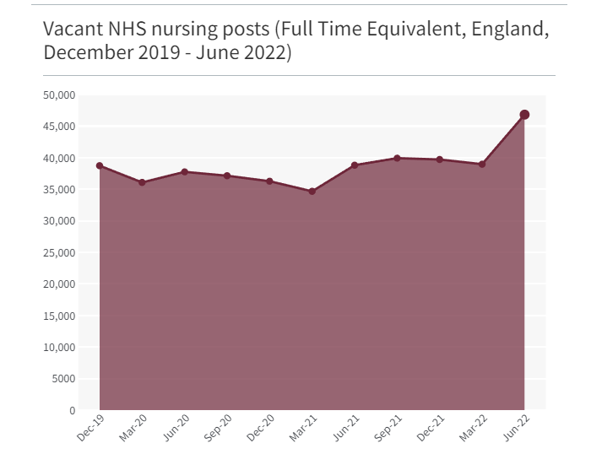
Figure 5: Vacant Nursing Post
(Source: Holmes, 2022)

Collaboration with Nursing Professionals
Engage nurses in decision-making operations, allowing them to represent insights amd donate to strategies for developing nurse retention (Senek et al., 2020). This applied viewpoint promotes possession and high the rate of the likelihood of effective implementation.
Research and Continuous Evaluation
Involve in ongoing research to stay reconciled to the improving requirements and preferences of nurses. Daily analysis the success of executing strategies, making adaptation based on comment and results.

Conclusion
After analysing all the facts, it can be concluded that the alarming attrition rates of nurses within the UK's National Health Service (NHS) requires immediate attention. Reasons such as work pressure, improper resources and career improvement gaps donate to the crisis, affecting patient care and labour force steadiness. Both monetary and non-monetary retention strategies play an important role in supporting different requirements. To eliminate attrition, the NHS should reproduce a balance among rivalry recompense and supporting a positive work condition. Short-term calculations include immediate payment managements, while long-term plans involve Infrastructure career routes, improved work-life balance, and teaching programs. These multifaceted viewpoints can ultimately increase nurse retention, securing a powerful healthcare system and developing patient results.

Reference List
Abelsen, B., Strasser, R., Heaney, D., Berggren, P., Sigurðsson, S., Brandstorp, H., Wakegijig, J., Forsling, N., Moody-Corbett, P., Akearok, G.H., Mason, A., Savage, C. and Nicoll, P. (2020). Plan, recruit, retain: a framework for local healthcare organizations to achieve a stable remote rural workforce. Human Resources for Health, [online] 18(1), p.63. doi:https://doi.org/10.1186/s12960-020-00502-x.
Bimpong, K.A.A., Khan, A., Slight, R., Tolley, C.L. and Slight, S.P. (2020). Relationship between labour force satisfaction, wages and retention within the UK National Health Service: a systematic review of the literature. BMJ Open, [online] 10(7), p.e034919. doi:https://doi.org/10.1136/bmjopen-2019-034919.
Buchan, J., Charlesworth, A., Gershlick, B. and Seccombe, I. (2019). A critical moment: NHS staffing trends, retention and attrition. [online] The Health Foundation. Available at: https://www.health.org.uk/sites/default/files/upload/publications/2019/A%20Critical%20Moment_1.pdf.
Fasbender, U., Van der Heijden, B.I.J.M. and Grimshaw, S. (2018). Job satisfaction, job stress and nurses’ turnover intentions: The moderating roles of on-the-job and off-the-job embeddedness. Journal of Advanced Nursing, 75(2), pp.327–337. doi:https://doi.org/10.1111/jan.13842.
Harris, T., Kerry, S.M., Limb, E.S., Furness, C., Wahlich, C., Victor, C.R., Iliffe, S., Whincup, P.H., Ussher, M., Ekelund, U., Fox-Rushby, J., Ibison, J., DeWilde, S., McKay, C. and Cook, D.G. (2018). Physical activity levels in adults and older adults 3–4 years after pedometer-based walking interventions: Long-term follow-up of participants from two randomised controlled trials in UK primary care. PLOS Medicine, [online] 15(3), p.e1002526. doi:https://doi.org/10.1371/journal.pmed.1002526.
Holmes, J. (2022). The NHS nursing workforce – have the floodgates opened? [online] The King’s Fund. Available at: https://www.kingsfund.org.uk/blog/2022/10/nhs-nursing-workforce [Accessed 23 Aug. 2023].
Johnson, J., Hall, L.H., Berzins, K., Baker, J., Melling, K. and Thompson, C. (2018). Mental healthcare staff well-being and burnout: A narrative review of trends, causes, implications, and recommendations for future interventions. International Journal of Mental Health Nursing, 27(1), pp.20–32.
Marufu, T.C., Collins, A., Vargas, L., Gillespie, L. and Almghairbi, D. (2021). Factors influencing retention among hospital nurses: systematic review. British Journal of Nursing, 30(5), pp.302–308. doi:https://doi.org/10.12968/bjon.2021.30.5.302.
Palmer, B. and Rolewicz, L. (2022a). Peak leaving? A spotlight on nurse leaver rates in the UK. [online] The Nuffield Trust. Available at: https://www.nuffieldtrust.org.uk/resource/peak-leaving-a-spotlight-on-nurse-leaver-rates-in-the-uk [Accessed 23 Aug. 2023].
Palmer, B. and Rolewicz, L. (2022b). Peak leaving? A spotlight on nurse leaver rates in the UK. [online] The Nuffield Trust. Available at: https://www.nuffieldtrust.org.uk/resource/peak-leaving-a-spotlight-on-nurse-leaver-rates-in-the-uk [Accessed 23 Aug. 2023].
Palmer, B. and Rolewicz, L. (2022c). Peak leaving? A spotlight on nurse leaver rates in the UK. [online] The Nuffield Trust. Available at: https://www.nuffieldtrust.org.uk/resource/peak-leaving-a-spotlight-on-nurse-leaver-rates-in-the-uk [Accessed 23 Aug. 2023].
Palmer, B. and Rolewicz, L. (2022d). Peak leaving? A spotlight on nurse leaver rates in the UK. [online] The Nuffield Trust. Available at: https://www.nuffieldtrust.org.uk/resource/peak-leaving-a-spotlight-on-nurse-leaver-rates-in-the-uk [Accessed 23 Aug. 2023].
Poon, Y.-S.R., Lin, Y.P., Griffiths, P., Yong, K.K., Seah, B. and Liaw, S.Y. (2022). A global overview of healthcare workers’ turnover intention amid COVID-19 pandemic: a systematic review with future directions. Human Resources for Health, 20(1). doi:https://doi.org/10.1186/s12960-022-00764-7.
Sayli, M., Moscelli, G., Blanden, J., Bojke, C. and Mello, M. (2022). Do Non-Monetary Interventions Improve Staff Retention? Evidence from English NHS Hospitals. [online] papers.ssrn.com. Available at: https://papers.ssrn.com/sol3/papers.cfm?abstract_id=4188291.
Senek, M., Robertson, S., Ryan, T., King, R., Wood, E., Taylor, B. and Tod, A. (2020). Determinants of Nurse Job Dissatisfaction - Findings from a cross-sectional Survey Analysis in the UK. BMC Nursing, [online] 19(1). doi:https://doi.org/10.1186/s12912-020-00481-3.
Thusini, S., Milenova, M., Nahabedian, N., Grey, B., Soukup, T. and Henderson, C. (2022). Identifying and understanding benefits associated with return-on-investment from large-scale healthcare Quality Improvement programmes: an integrative systematic literature review. BMC Health Services Research, 22(1). doi:https://doi.org/10.1186/s12913-022-08171-3.
Zeng, D., Takada, N., Hara, Y., Sugiyama, S., Ito, Y., Nihei, Y. and Asakura, K. (2022). Impact of Intrinsic and Extrinsic Motivation on Work Engagement: A Cross-Sectional Study of Nurses Working in Long-Term Care Facilities. International Journal of Environmental Research and Public Health, [online] 19(3), p.1284. doi:https://doi.org/10.3390/ijerph19031284.

