

INTERNATIONALIZATION OF BUSINESS

A CASE STUDY OF TOYOTA MOTORS CORPORATION IN CHINA

NAME : MISHAB CHANDAPARAMBIL
STUDENT ID : 2243796

TABLE OF CONTENTS
1 INTRODUCTION 5
2 OVERVIEW OF TOYOTA 6
2.1 BACKGROUND AND HISTORY OF TOYOTA 6
2.2 INTERNATIONALIZATION JOURNEY OF TOYOTA 7
2.3 TOYOTA OPERATIONS IN JAPAN AND CHINA 7
3 INTERNATIONALIZATION STRATEGIES 8
3.1 ETHNOCENTRIC ORIENTATION 8
3.2 POLYCENTRIC ORIENTATION 9
3.3 GEOCENTRIC ORIENTATION 9
3.4 COMPARISON OF THE STRATEGIES 10
4 TOYOTA’S INTERNATIONALIZATION APPROACH 11
4.1 GLOBALIZATION APPROACH ADOPTED BY TOYOTA 11
4.2 FACTORS INFLUENCING TOYOTA’S STRATEGIC DECISION MAKING 13
4.2.1 SWOT ANALYSIS 13
4.2.1.1 Strength 13
4.2.1.2 weaknesses 14
4.2.1.3 Opportunities 15
4.2.1.4 Threats 15
5 PESTLE ANALYSIS 15
5.1 POLITICAL 16
5.2 ECONOMICAL 17
5.3 SOCIAL 18
5.4 TECHNOLOGICAL 18
5.5 LEGAL 19
5.6 ENVIRONMENTAL 20
6 INTEGRATION OF PESTLE ANALYSIS WITH TOYOTA’S INTERNATIONALIZATION STRATEGY 21
7 RECOMMENDATION 22
8 CONCLUSION 23
9 REFERENCES 23
10 APPENDIXES 29
10.1 Toyota Motors company progress 29
10.2 Toyota China Company information 30
10.3 The Toyota Way 2001 30

TABLE OF FIGURES
Figure 1- Toyota Logo 5
Figure 2- EPG Model 7
Figure 3 - Comparison between Ethnocentric, Polycentric, and Geocentric approaches 9
Figure 4- Global software development team of Toyota 10
Figure 5- SWOT analysis 12
Figure 6- Toyota's SWOT analysis in China 14
Figure 7- PESTLE Analysis 15

INTRODUCTION
Any business dealings that occur beyond the boundaries of one's own country are referred to as international business. The term international business covers two different areas. The first is commerce, which includes selling products and services internationally. The second one is the transmission of funds resulting from certain commercial and non-trade activities including foreign grants and loans, inter-functional financing and investment, and so on (Chen, Meng and Zhou, 2017). The broadening of the regional and nationalistic perspective of an interconnected world market that allows for unrestricted flow of cash, products, and services beyond the borders of countries is known as globalization. In globalization, the world economy becomes more united when trade obstacles like export taxes, import limits, and tariffs are removed (Islam et al., 2019).
The major objective of this study is the examination of primary elements that make up the global business environment, its principal organizations, and pivotal choices that support global organizational strategy. This study also aims to examine the various approaches to entering the foreign market and analyze the connections between such approaches and the political, economic, social, technological, legal, and environmental factors. For the study, the Japanese MNC Toyota Motor Corporation has been analyzed, with its host country in China.

OVERVIEW OF TOYOTA
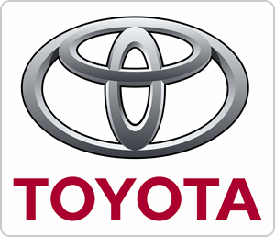
Figure 1- Toyota Logo

BACKGROUND AND HISTORY OF TOYOTA
Toyota Motor Corporation is regarded as one of the most prosperous automobile companies and businesses overall ranking in the top ten worldwide in terms of both yearly earnings and performance rating. Japanese nationals created Toyota Motors Corporation on August 28, 1937. The business produces designs, and sells a range of automobiles, including passenger cars, minivans, and commercial vehicles. Additionally, it produces and sells auto components under its brands, which include, Lexus, Daihatsu, Hino, and Toyota. For an extended duration, the company has maintained its position as the leading business in the automotive manufacturing sector (Ondeng and Nekesa, 2022).
The capital contribution of Toyota Motor Corporation is 3.95 billion euro and the number of employees is 375,235 as of 31st March 2023. The current president of the company is Koji Sato (TOYOTA, 2023a). Since the company’s establishment in the year 1937, Toyota has focused its operations on the production and sales of vehicles to use the manufacturing of automobiles to contribute to a more affluent society. The production of the vehicle started in the year 1947. In 1957 the company expanded its operations to the USA through export and in 1958 the production expanded to Brazil. The company majority focused on the globalization of their business (TOYOTA, 2023b).

INTERNATIONALIZATION JOURNEY OF TOYOTA
Toyota Motors Corporation had received opportunities to get access to global raw materials, human resources, technology, and most importantly, untapped new markets via globalization. They had an easier time working as a result, and they have become the world’s top automakers. Toyota started in the year 1933 and their first offerings were A1 passenger automobile and G1 in the year 1935. In 1957, Toyota made exports to the USA and in 1958 expanded its first overseas production plant in Brazil. Before then it exported a small number of automobiles to Asian nations, but the production in Brazil marked the beginning of proper internationalization (Bose and Uddin, 2013).
In the 1960s and 1970s, the business expanded quickly and began to enter rigorously into foreign markets. In 1962 Thailand became the home to the first Asian car manufacturing outside of Japan. In 1984, in California, Toyota and GM launched their joint venture to build the country’s first auto assembly factory (Kim, 2008). By 2020, Toyota was comprised of 201 affiliated businesses and 528 integrated subsidiaries, 72 of which were accounting for their operations under equity schemes. The company currently distributes its cars in over 200 nations and among that Japan, other Asian countries, North America, and Europe remain its main markets (TOYOTA, 2023b).

TOYOTA OPERATIONS IN JAPAN AND CHINA
The home country of Toyota Motor Corporation is Japan. The manufacturing plans in Japan are adapting to the shifting market circumstances brought about by factors including the low birth rate, elderly population, growing market in Japan, and the industry’s internationalization (TOYOTA, 2023b). The host country adopted for this study is China. Since the first shipment of CROWN sedans to China in 1964, Toyota has had a company there. Toyota was established in China in the year 2001, with the name Toyota Motor (China) Investment Co. Ltd. The number of employees working in China is 725 with a registered capital of $118 million. Toyota has always been dedicated to satisfying its corporate social responsibilities by offering Chinese customers high-quality goods and services (Toyota China, 2021).
Toyota has many activities in mainland China under its local headquarters in Beijing. The first two Toyota projects were in Tianjin and Sichuan. First Auto Works and Tianjin Motors combined in 2002 to become the first Tianjin Toyota, a move that may eventually result in the formation of a full-line automaker. Sichuan Toyota was founded in November 1998 (Liu and Brookfield, 2006). Apart from these, the business distribution in China includes Shanghai, Guangzhou, Chengdu, Changchun, Changshu, and Shenzhen (Toyota China, 2021).

INTERNATIONALIZATION STRATEGIES
The increased tendency of markets to become more globalized forces businesses to reevaluate how they are set up and run, forcing them to think about developing their strategy globally (Roque, Alves and Raposo, 2019). The EPG model is the global business model with three factors, ethnocentric which is home-country orientation, Polycentric which is host-country orientation, and Geo-centric which is the global orientation (Moon and Choi, 2023).
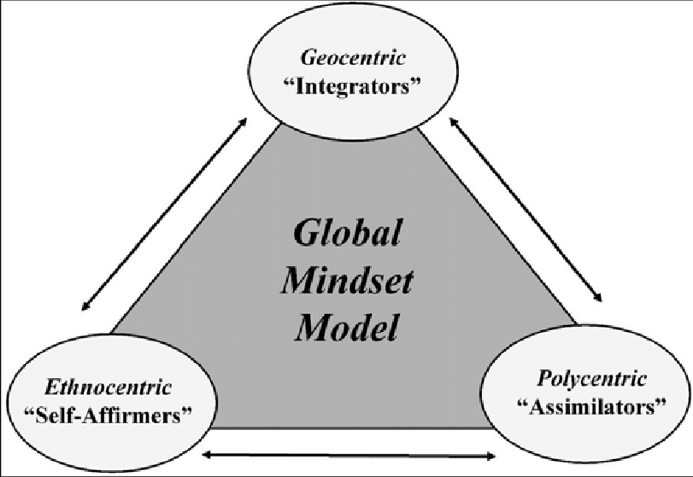
Figure 2- EPG Model
Source: (Guy et al., 2023)

ETHNOCENTRIC ORIENTATION
The ethnocentric approach is where the major decisions of the company are taken at headquarters and international subsidiaries have minimal independence in such a decision-making process. Executives from the home country allocate important posts both domestically and outside (Isidor, Schwens and Kabst, 2011). The hiring in this strategy fills important roles with citizens of the home country. The selection of top executives in such companies reflects the substantial influence of the home country (Stehle, 2004).
Assertiveness, survival, cohesion, conformity, collaboration, loyalty, and effectiveness are all encouraged by the ethnocentric approach. One of the major relevance of ethnocentric orientation is in light of the social interactions. In international management procedures, extremely effective social integration is beneficial. The major issue in adopting an ethnocentric approach is the possibility that important management expertise and knowledge in the regional marketplace are overlooked. Headquarters disregards consumer preferences or requirements that diverge from those in the home nation (Onodugo, Adeleke and Nneka, 2017).

POLYCENTRIC ORIENTATION
To foster cooperation with independent stakeholders, companies with polycentric designs augment their in-house hierarchical decision-making with fair and regional structures (Gil and Pinto, 2018). They impose a more differentiated marketing strategy because they are typically interested in tailoring to the local circumstances in each location (Kraft, Dowling and Helm, 2012). Multinational Companies use human resources from host country nations for senior management roles in a polycentric approach.
The benefits include becoming acquainted with the surroundings, working culture, and customs of the host nation, and the capacity to adapt to the host nation’s needs regarding the products and operations. Polycentric techniques are probably required when local responsiveness is under increased strain (Lakshman, Chandrashekhar and Estay, 2017). Polycentric firms may get a competitive edge by customizing their strategy and goods to meet the demands of their local markets. A high level of customer satisfaction and greater cultural sensitivity which helps the organization to run smoothly are the other advantages of this orientation. One of the major disadvantages of polycentric organizational culture is the lack of communication between the host-country personnel and the home-country personnel due to major differences in their culture and opinions (Azeem Quresh, 2023).

GEOCENTRIC ORIENTATION
The geocentric perspective of a multinational company sets global goals and standards but they also see subsidiaries as contributing specially to the overall company. Globally oriented multinational corporations aim to hire the most qualified candidates from any part of the globe, irrespective of their country, and design their compensation schemes to align with the company’s global goals (Wilks and Verbeke, 2017).
The major advantage of the geocentric approach is that they can adjust to local circumstances without sacrificing their international outlook or brand identity. It also provides the benefit of sharing best practices and expertise throughout the organization and geographical areas. The competitive advantage of the company is also increased under this approach (Azeem Quresh, 2023).
The major disadvantage of the geocentric approach is that it is costly to implement, as the personnel have to be recruited from different nations. It may also result in the loss of autonomy or power for the subsidiaries, the lack of sufficient and qualified personnel may prevent the policy from being implemented, and legal restrictions from the host country such as employing only citizens may also undermine the purpose of this approach (Osibanjo and Adeniji, 2012).

COMPARISON OF THE STRATEGIES
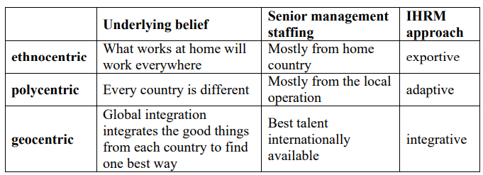
Figure 3 - Comparison between Ethnocentric, Polycentric, and Geocentric approaches
Source : (Stehle, 2004)
In the companies that follow an ethnocentric approach, most of the decisions are taken by the headquarters in the home country and there is very little dependence on the subsidiary in the host country. The role of a subsidiary in the host country is much less in making decisions. The employees or staff of such companies are appointed from the home country. On the other hand, the companies following the polycentric approach, the subsidiaries in the host country have more independence compared to the ethnocentric approach. The human resources are recruited and selected from the host country itself. One of the major differences can be seen in the standardization of the strategies. In an ethnocentric approach, the company follows standardized strategies for all the subsidiaries throughout the world, but in a polycentric, the strategies for different countries are made following the economic, environmental, and political conditions of such other countries. The geocentric approach is a mix of both ethnocentric and polycentric approaches it takes almost all the advantages of ethnocentric and polycentric approaches. The geocentric approach recruits and selects human resources with the best talents globally.

TOYOTA’S INTERNATIONALIZATION APPROACH

GLOBALIZATION APPROACH ADOPTED BY TOYOTA
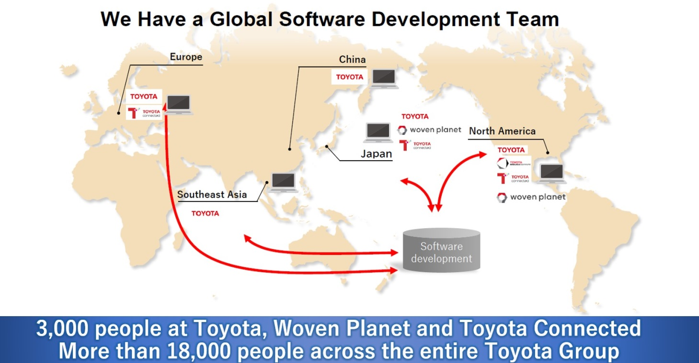
Figure 4- Global software development team of Toyota
Source: (Toyota, 2021)

In 2006, Toyota Motor Corporation had a market share of more than 15% in the US market and has become second for automobile sales internationally. The company has developed its market strategy at three separate levels, national, regional, and global. These levels are depended on the evaluation of the demands and preferences of its customers (Bhandari, 2012). The Globalization approach adopted by Toyota Motors Corporation can be linked to the Ethnocentric approach. The ethnocentric approach of the company can be traced back to 2001 when the company published its training manual “The Toyota Way”. It has been distributed to staff and members to outline the key components and the principles of business and management style (Sosnovskikh, 2016). The “Toyota way” is a clear presentation of the Japanese way of organizational culture. But the Toyota Way also affiliates with some adaptation of the local culture as well.
In 2010, Toyota discovered that it was difficult to introduce new employees to the MNC’s distinctive culture, the “Toyota Way”. The company had concerns about making the employees follow the culture introduced by them (Layne, Uranaka and Krolicki, 2010). Toyota has appointed only Japanese members to its board of directors until 2007. Its 25-member board till 2007 has all been Japanese. In 2007 the company first elected an American, James Press as director to its board for supporting its internationalization (nbcNews, 2007).
Later Toyota expanded the company through internationalization to various parts of the world and the company emphasized the importance of implementing local culture as well. Toyota uses focused local strategies together with international operation methods to strike a balance between localization and standardization tactics to suit with local environment. Toyota views locality as a crucial growth factor and thinks that internationalization may be achieved by meeting the various demands of each location. Sustainable expansion requires both regional production and marketing as well as sales (Linnskog, 2009). Therefore, it is clear that the company adopted an Ethnocentric approach at the beginning of internationalization and then started to adopt geo-centric approaches in later years.
Toyota in China adopted a geo-centric approach. Toyota’s decision to operate in China has been influenced by several issues including the country’s limited industrial infrastructure, its inexpensive labor markets, and its current political framework. Toyota succeeds in the Chinese market through its attempts to cater to regional demands. The company carefully weighs the advantages of its tried-and-tested production methods against the necessity for local adaptation (Direction, 2006) Therefore, it can be concluded that Toyota follows a geo-centric approach as well as an ethnocentric approach. The ethnocentric approach is the majority opted for the company’s production methods.

FACTORS INFLUENCING TOYOTA’S STRATEGIC DECISION MAKING

SWOT ANALYSIS
SWOT analysis helps the organization to identify factors that influence its strategic decision-making. SWOT analyses the internal and external factors as well as variables that may influence strategic decision-making.
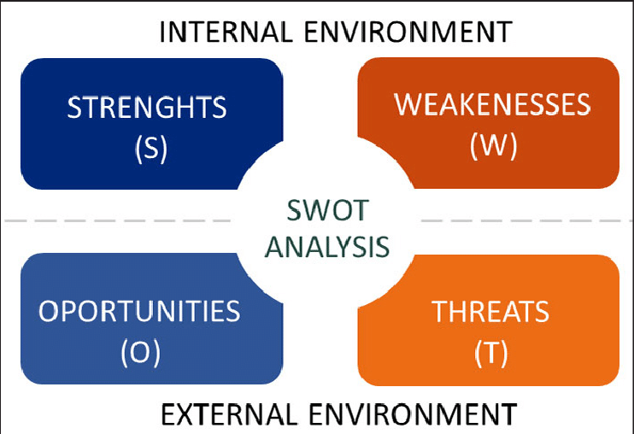
Figure 5- SWOT analysis
Source: (Canizares and Bourotte, 2021)

Strength
Despite having entered the Chinese market later than most automakers, Toyota has an unmatched competitive edge of strength because of its unique TPS (Toyota Production System) and the substantial expertise from global expansion. Direct entry of Toyota’s components suppliers into China and the fusion of Knowledge-based and location-based strategies is a major strength of the company (Gao, 2013).
Another major strength of the company is its brand image and global dominance of the brand. The company has 10.5% of the global automobile market and is currently having sales in more than 170 countries. The company has been titled an international top-selling automobile company for three years since 2020 (Reuters, 2023b). The Diversified variety of vehicles and customized vehicles offered by the company in the host country also serves as a strength for the company (Reuters, 2011). Other strength of the company in the Chinese market includes an extensive supply chain and a strong financial position.

weaknesses
One of the major weaknesses of Toyota Motors can be traced to the rigidity in their hierarchical and organizational structure (Lyskova, 2020) Since the company emphasizes the Japanese culture, the maintenance of the organization in the Chinese market can be difficult. Cross-Cultural issues can become a major issue affecting the company in China. Dependence on specific suppliers due to the implementation of the Just in Time strategy is another weakness of the company. The timely delivery of components for production largely depends on such suppliers (Sugathan, 2021).
Toyota’s technological advancements in vehicle manufacturing are slow compared to other automobile companies. the company has been sluggish in adopting pure electric vehicle (EV) technology despite being a pioneer in the electric vehicle space (Lyon, 2021).
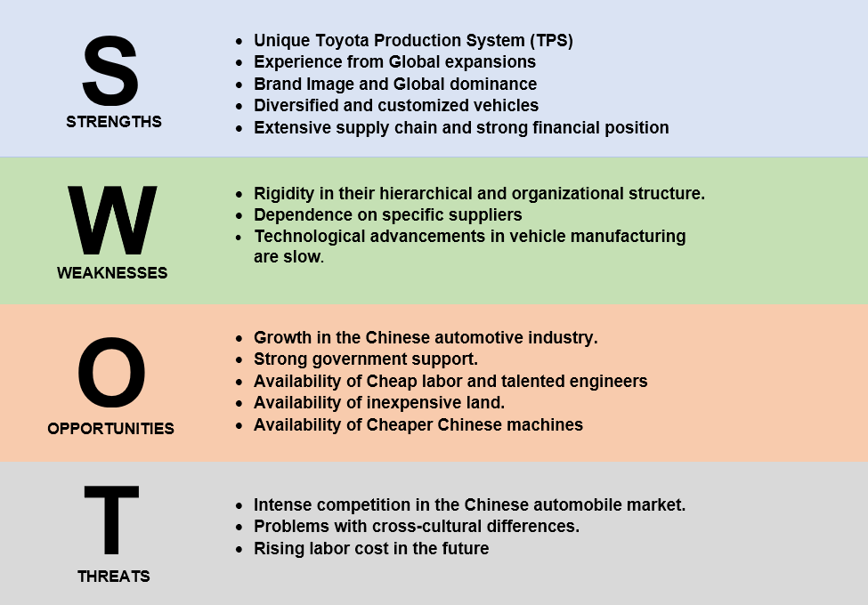
Figure 6- Toyota's SWOT analysis in China

Opportunities
The growth in the Chinese automotive industry is a major opportunity for the company. The Chinese automotive sector has seen unparalleled growth in recent years, transforming into a worldwide powerhouse. The strong government support for the automotive industry in China is also noteworthy (Fawzi, 2023).
The availability of cheap labor is another opportunity for manufacturing in China. Besides cheap labor, the advantage of the flexibility of laborers is also available. Compared to Japan or Korea, China has a higher percentage of contractual workers. The Chinese market also has a large pool of talented engineers and inexpensive land. The cheaper Chinese machinery also provides important opportunities for the company (Gao, 2013). China has a distinct edge when it comes to producing inexpensive dies, Molds, and jigs- all essential components for the automobile industry.

Threats
Intense competition is one of the major weaknesses of the Chinese automobile industry. The change in WTO agreements which lowers the entry restrictions to the auto industry and rapid expansion and investments in research and development by the government attracted many auto companies to the country which increased the competition (Zhang, 2014). General Motors, Volkswagen, and Nissan are the major competitors of Toyota in China.
Another threat to the company can be the dispute due to cultural differences. The organizational culture and the production process adopted by the company in the Japanese way may raise disputes about the cultural differences in the organization. The public will show reluctance to adopt a company with a different culture. The rising labor costs in the future can threaten the company (Zhang, 2014).

PESTLE ANALYSIS
Pestle analysis is a significant and popular technique that aids in providing a broad overview of the company’s external environment, especially about internationalization.
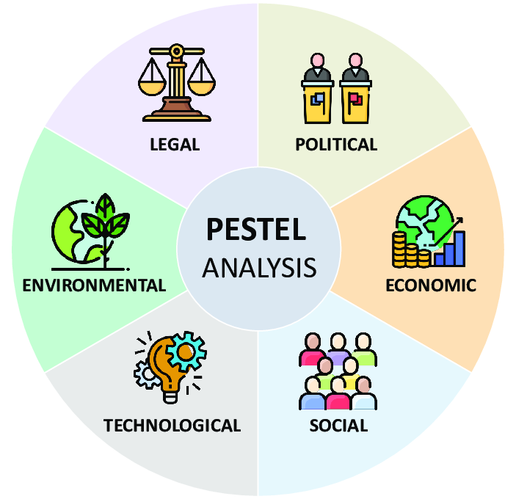
Figure 7- PESTLE Analysis
Source: (Segura et al., 2023)

POLITICAL
Political variables are important when assessing the factors affecting China’s automobile industry’s growth and success in a given market. Toyota is exposed to various political risks and opportunities in China’s automobile market. Looking back to the year 1980, the total number of automobiles produced was 5000. Due to the increase in the number of automobiles, the import of automobiles has increased and the tariffs have been set as high as 250% to safeguard the weak and underdeveloped indigenous Chinese vehicle sector by the government. China’s NDRC has introduced automobile industry policies that entice state-owned companies to establish partnerships with foreign automakers (Chen, Lin Lawell and Wang, 2020). In 2018 Chinese government offered to make it simpler for international automobile companies to establish plants in the nation to defuse the conflicts. Within the next few years, the government of China relaxed regulations that had been imposed on the multinational automobile industries to establish a regional partner before construction facilities in the country (Bradsher, 2018).
After a decade of collaboration with international businesses in joint ventures, the government of China began to enact laws to promote the country’s automobile sector (Niu, 2017). The political distress of China with the US can become a political risk for the international companies operating in the country. Similarly, there has been a reason for alarm about the latest demonstrations in Hong Kong, South China, US sanctions, and China’s retaliatory measures on the US and Canada (Xi Rong Leong, 2023). Other political risks that the company could face are high levels of corruption, anti-trust laws related to auto parts, the introduction of wage legislation, and so on.
While analyzing the political factors of the country, it is identified that Toyota Motors has benefits and problems related to the political environment. The political distress in the country discussed above may lead to strikes or riots where the company has to make decisions on the precautions for production, sales, and inventory management.

ECONOMICAL
Firstly while looking at the disposable income of the country, it has been in an increasing trend by almost 12% annually on average since the beginning of 2007 (C Klein, 2018). The increase in disposable income makes consumers spend more on the automobile sector. The stability of the Chinese currency can also be attributed to the economic factor affecting Toyota. Since the middle of 2016, Yuan has been one of the globe’s most stable currencies. For four years the exchange rate after accounting for inflation has increased by 0.2% (The Economist, 2020).
The consumer spending trends in China has been in a rising trend. Based on a survey of 1300 companies, that was done on August 27, 2023, consumer spending in sectors such as apparel, automotive, food, furniture, and appliances has increased (Cheng, 2023). The financial market of China is found to be inefficient. In an attempt to regulate the currency rate and preserve financial stability, the government tightened capital restrictions and surveillance of foreign investments in 2015 (Forbes, 2018). China’s financial market is vast but immature, centered on a massive banking sector, stock market, and bond market that is expanding quickly, which are underdeveloped (Yelvita, 2022).
While analyzing the economic condition of the country, it is identified that the increase in disposable income will increase consumer spending therefore, the company has to make decisions on planning increased production for the future. Increased consumer spending is crucial to the success of a business like Toyota. It is desirable to see patterns in customer spending that increase the amount of money spent and the number of items sold by the automotive industry. The stability of the Chinese currency makes it easy for the company to plan its business as it lowers the uncertainty in the market.

SOCIAL
The manner of life and culture of the society affect organizational performance and success. The public’s common viewpoints and opinions greatly influence the way the automotive industry performs. China is a country with varied cultures and traditions. Since Toyota is a Japanese company, may arise cross-cultural issues between the company and its host country. Toyota has been adopting a mix of ethnocentric and geocentric approaches which may raise cultural differences. Staff disagreements due to communication gaps may result in low productivity (Wang and Gou, 2016). Religions and practices may lead to cultural issues, and the rigid corporate culture of Toyota may lead to tensions across the organization.
China stands as the second most populated country in the world with the majority of the people or over half of the people, between the ages of 25 and 59 as of 2021. Approximately 62.5% of the people between the ages of 16 and 59 are in the working age group of the country (Textor C, 2023). This vast population and the young working-class people are major consumers of automobiles which makes the market more attractive. Thus, Toyota Motors has a huge customer base for its products in the Chinese market. The Chinese government places a high degree of importance on the education of the people. Chinese population consists of highly educated people. This will benefit Toyota as the consumer's attention will be directed toward constructive consumption. Due to Toyota’s better production facilities and the quality of their product, they can gain a competitive advantage among such a group of highly educated customers.

TECHNOLOGICAL
Technology is quickly upending a wide range of sectors. The company should analyze industries technical landscape as well as the rate of technological upgradation in the automobile industry. The automobile production technologies in Japan are far ahead of China. International investment and knowledge transfer, together with the arrival of international enterprises, have formed the foundation for the growth of China’s automobile sector. Over the last several years, the Chinese government has introduced modifications to reroute development in the direction of high-tech industries. They have endeavored to incorporate foreign expertise to accomplish the objective of advancing the automotive sector. Chinese automakers mostly rely on Japanese and Western companies as their primary providers of technology. Therefore, Toyota will not get many opportunities from the technological sector of China in their production.
The technological development for electric vehicles is high in China's automobile sector. China has made large investments to advance the technology of electric vehicles. The technology of electric vehicles has advanced significantly over the several years and they are now widely used by the industries. Improvements were made to electric motors and traditional battery technology. The broad technological roadmap that takes into account China’s unique national circumstances is progressively becoming apparent (Du and Ouyang, 2013). Therefore, Toyota will get a technological advantage from China to develop their electric vehicles.
Chinese automobile industries have seen that producing foreign technology at a cheap cost and with a lot of labor is no longer a viable approach. As a result, significant research and development expenditure in the automotive sector needs to revolutionize production via the development of new technologies. The government provided automobile manufacturers with subsidies of around ten billion RMB in 2010 to facilitate technological advancements aimed at creating new engines (Abt and Erath, 2014). The government of China has been taking actions to improve the technology which shows an advantageous position for the company in the future.

LEGAL
The Chinese government has implemented numerous rules, limitations, and provisions about foreign investments in the market. These problems are accompanied by an absence of openness on the part of the authority and associated organizations. However, the government of China has been striving to simplify the legal and regulatory landscape. Yet, there are several unclear rules imposed and legislation that is either hard to comprehend or is simply not well conveyed amongst the relevant people (Abt and Erath, 2014)..
The government of China has been introducing several actions to boost the sales of the automobile industry. To increase automobile sales the Ministry of Finance implemented a tax reduction policy on passenger vehicles, Cutting the purchase tax on small-engine vehicles in half. The government reduced the taxes on vehicles with two-liter engines or less which cost no more than 45000 dollars (Economic Times, 2022). Since Toyota Motors' major production line is the passenger vehicle, this move helps the company in boosting its sales.
Strict vehicle emission policies have been adopted by the country and this will affect the old stock of inventories of the company. The government of China begin to enforce updated emission limits for automobiles nationally from July 2023. This will put pressure on the company to move out of its old inventory in preparation for the implementation of updated regulations. As a part of this China will prohibit the manufacture, importation, and sale of automobiles that do not comply with the country’s VI B emission criteria (Reuters, 2023a).
While analyzing the legal aspects of the country it is identified that the complications in such legal aspects of the country pose a threat to Toyota Motors, which may attract legal complications for the business. The government programs that reduce the taxes for passenger vehicles make the company decide to produce more passenger vehicles in that category which the demand may increase.

ENVIRONMENTAL
Environmental protection and sustainable business have gained much importance recently. The situation in China is no different, the Chinese society and government are emphasizing environmental protection and sustainability. In addition, an increase in population has resulted in excessive resource usage, dangerous chemical emissions from manufacturing facilities, and heavy traffic. People are concerned about this trend and consider the Electronic vehicle as a positive move (Abt and Erath, 2014). The pressure to follow sustainable measure of manufacturing become crucial for the success of the company. Therefore, it becomes essential for Toyota Motors to invest more in a sustainable approach to business. Introducing electric vehicles also becomes a major part of obtaining a competitive advantage in the market.

INTEGRATION OF PESTLE ANALYSIS WITH TOYOTA’S INTERNATIONALIZATION STRATEGY
The internationalization strategy adopted by Toyota Motors Corporation in China has been identified to be a combination of geocentric and ethnocentric approaches. The analysis of the Political sector in the country shows that the country is facing certain political distress which may result in riots and strikes. Therefore, adopting a geocentric approach may help the company to reduce such risks as it does not concentrate on the local market alone. The analysis of the Economic factors of the country shows that the disposable income of the people has been increasing and the consumption habit of the people has been rising. The adaptation of a geocentric internationalization strategy helps the company to produce the vehicles while taking into consideration the requirements of the local market as well. Hence the demand for the product will increase as it suits the preferences of the Chinese market. Therefore through increasing disposable income consumers will be willing to spend more on Toyota’s vehicles.
The implementation of a geo-centric approach’s advantages can be traced majority to the social sector. China is a country with varied cultures and traditions. Since Toyota is a Japanese company, there may arise cross-cultural issues between the company and the Chinese market. Adopting an ethnocentric approach alone may create cross-cultural issues in the company. Toyota faced several issues regarding cultural differences when it adopted ethnocentric approaches at the beginning of internationalization in China. However, the transition to a geo-centric approach helped the company to reduce such cultural differences arising in the Chinese market. The geo-centric approach places importance on the local culture without sacrificing the brand image of the company. Therefore one of the major areas of consideration for choosing the internationalization approach is the impact of cultural differences.
Since the Chinese population is the second highest in the world with highly educated and talented people, adopting a geo-centric approach helped the company to choose talented personnel from China as well as Japan. The low-cost labor in the Chinese market also led the company to choose a geo-centric internationalization strategy. So that they could employ labor from the local market as well. While analyzing the technological aspect of the country, it is evident that the production technology of China in automobiles is far behind that of Japan. The production technology adopted by Japan in the Japanese way is one of the most successful technologies around the world. Therefore, it forces the company to choose the production technology in their way which leads to the ethnocentric choice for the company. while analyzing the environmental aspect, the Chinese government has emphasized on sustainability and promotion of electronic vehicles which forces the company to improve its research and development on the production of electronic vehicles. The adoption of a geo-centric approach is also important here because the company has to consider the preferences of the Chinese market.

RECOMMENDATION
On Analysis of the internationalization policy of Toyota Motors in the host country China, several challenges and issues have been identified. One of the major areas was related to the cross-cultural issues. It is recommended that the company should reexamine its hiring practices. The senior management roles must be filled by Chinese personnel as they are familiar with the local and regional culture and have influence over the political environment. It is also recommended that the personnel from China should be involved in the decision-making of the company.
Another recommendation for the company is that they should align their production with the demands of the market. Since the demand for the electronic vehicle is increasing, companies should consider manufacturing the EVs to expand their market. It is also recommended that the company should invest more in sustainable practices for the host country. Providing free driving classes for underprivileged classes of people, and providing free factory visits for the people will increase the company’s acceptance among the local population. Another recommendation is that the company should encourage innovation to welcome transformations. Novel concepts must be valued by the company, particularly if they are impacted by manufacturing technology or market trends.

CONCLUSION
This study analyzed the internationalization strategies adopted by the company and their impact on the organizational performance of the host country. For the study, the Japan automobile MNC, Toyota Motors Corporation has been taken. The home country of the company is Japan and the host country is China. The internationalization strategy adopted by the company at the beginning in the Chinese market was an Ethnocentric approach. But then the company transitioned to a geo-centric approach in certain areas of business due to the rise of certain cultural issues. The company has applied an internationalization strategy which provided them with numerous advantages in the Chinese market. At the same time, there were several challenges faced by the company. One of the major issues was the difference in culture between the home and host countries. Therefore, it is recommended that the company should place more importance on the culture of the host country and they should adapt to the host country's cultural practices.

REFERENCES
Abt, T. and Erath, F. (2014) ‘Power of E-Motion Business Model Innovation for the Introduction of Electric Cars to China’.
Azeem Quresh, M. (2023) (10) Ethnocentric, Polycentric, and Geocentric Attitudes toward Global Business | LinkedIn, Linkedin. Available at: https://www.linkedin.com/pulse/ethnocentric-polycentric-geocentric-attitudes-toward-global-qureshi/ (Accessed: 7 November 2023).
Bhandari, S. (2012) ‘An Analysis of Toyota’s Marketing Strategy’, SSRN Electronic Journal. doi: 10.2139/ssrn.1624068.
Bose, T. and Uddin, M. R. (2013) ‘International Trade: Opened the Door of Creativity, Exploitation, Expansion and Diversification: A Case Study on Automobile Giant Toyota’, 3, pp. 57–62.
Bradsher, K. (2018) China Loosens Foreign Auto Rules, in Potential Peace Offering to Trump - The New York Times, The Newyork Times. Available at: https://www.nytimes.com/2018/04/17/business/china-auto-electric-cars-joint-venture.html (Accessed: 9 November 2023).
C Klein, M. (2018) ‘China’s household debt problem’, Financial Times, 7 March. Available at: https://www.ft.com/content/da975440-1d45-35d7-8118-bf4340949d20 (Accessed: 10 November 2023).
Canizares, A. and Bourotte, C. (2021) ‘Journal of the Geological Survey of Brazil Strategic diagnosis of geocommunication using SWOT analysis in the Varvite Geological Park, São Paulo, Brazil’, Journal of the Geological Survey of Brazil, 4, p. Issue in progress. doi: 10.29396/jgsb.2021.v4.SI1.1.
Chen, F., Meng, S. and Zhou, W. (2017) Overview of International Business. doi: 10.2991/isbcd-17.2017.51.
Chen, Y., Lin Lawell, C. Y. C. and Wang, Y. (2020) ‘The Chinese automobile industry and government policy’, Research in Transportation Economics, 84(December 2019), p. 100849. doi: 10.1016/j.retrec.2020.100849.
Cheng, E. (2023) ‘Consumer spending in China bounced back in August, survey finds’, CNBC, 30 August. Available at: https://www.cnbc.com/2023/08/30/consumer-spending-in-china-bounced-back-in-august-survey-finds.html (Accessed: 10 November 2023).
Direction, S. (2006) ‘It’sa Toyota, but not as we know it, Jim: Toyota overturns its traditional strategies to succeed in China’, Strategic Direction, 22(9), pp. 24–26.
Du, J. and Ouyang, M. (2013) ‘Review of Electric Vehicle Technologies Progress and Development Prospect in China’, World Electric Vehicle Journal, 6, pp. 1086–1093. doi: 10.3390/wevj6041086.
Economic Times (2022) ‘china vehicle tax: China announces reduction of vehicle purchase tax for some PVs - The Economic Times’, Economic Times, 31 May. Available at: https://economictimes.indiatimes.com/news/international/business/china-announces-reduction-of-vehicle-purchase-tax-for-some-pvs/articleshow/91911335.cms (Accessed: 10 November 2023).
Fawzi, M. (2023) (10) How China’s Automotive Industry Rose from Zero to Hero: Unveiling the Roadmap to Global Dominance | LinkedIn, Linkedin. Available at: https://www.linkedin.com/pulse/how-chinas-automotive-industry-rose-from-zero-hero-unveiling-fawzi/ (Accessed: 9 November 2023).
Forbes (2018) China, Forbes. Available at: https://www.forbes.com/places/china/?sh=198a291838fc (Accessed: 10 November 2023).
Gao, G. (2013) ‘A Case Study of Toyota’s Globalization Strategy while Entering Chinese Market’, Proceedings of the 2013 International Conference on Advances in Social Science, Humanities, and Management, 43(Asshm). doi: 10.2991/asshm-13.2013.149.
Gil, N. and Pinto, J. (2018) ‘Polycentric Organizing and Performance: A Contingency Model and Evidence from Megaproject Planning in the UK’, Research Policy, 47. doi: 10.1016/j.respol.2018.02.001.
Guy, G. et al. (2023) ‘Global Orientation and Sociolinguistic Accommodation as Factors in Cultural Assimilation Edited by’.
Isidor, R., Schwens, C. and Kabst, R. (2011) ‘Human resource management and early internationalization: Is there a leap-frogging in international staffing?’, The International Journal of Human Resource Management, 22, pp. 2167–2184. doi: 10.1080/09585192.2011.580186.
Islam, R. et al. (2019) ‘GLOBALIZATION AND ITS IMPACT ON INTERNATIONAL BUSINESS’, Humanities & Social Sciences Reviews, 7, pp. 256–265. doi: 10.18510/hssr.2019.7130.
Kim, C.-R. (2008) TIMELINE: Milestones in Toyota’s 70-year history | Reuters, REUTERS. Available at: https://www.reuters.com/article/us-toyota-history-idUST13898620080210 (Accessed: 7 November 2023).
Kraft, P., Dowling, M. and Helm, R. (2012) ‘International orientation, marketing mix, and the performance of international German “mittelstand” companies’, International Journal of Business and Globalisation, 8(3), pp. 293–315. doi: 10.1504/IJBG.2012.046207.
Lakshman, S., Chandrashekhar, L. and Estay, C. (2017) ‘The relationship between MNCs’ strategies and executive staffing’, International Journal of Organizational Analysis, 25. doi: 10.1108/IJOA-10-2015-0913.
Layne, N., Uranaka, T. and Krolicki, K. (2010) SPECIAL REPORT - Inside Toyota’s epic breakdown | Reuters, REUTERS. Available at: https://www.reuters.com/article/idINIndia-46038520100209 (Accessed: 8 November 2023).
Linnskog, L. (2009) ‘Title: Managing Multinational Corporation: Coordination Mechanisms within the MNCs’, International Journal of Production Economics, 161(19811002), pp. 217–227.
Liu, R. J. and Brookfield, J. (2006) ‘Japanese subcontracting in mainland China: A study of Toyota and Shanghai Koito’, Supply Chain Management: An International Journal, 11(2), pp. 99–103. doi: 10.1108/13598540610652465.
Lyon, P. (2021) Hybrid Pioneer Toyota Pushes Congress To Slow Down Transition To Electric Cars, Forbes. Available at: https://www.forbes.com/sites/peterlyon/2021/07/29/hybrid-pioneer-toyota-pushes-congress-to-slow-down-transition-to-electric-cars/?sh=60c2a0fe629b (Accessed: 9 November 2023).
Lyskova, I. (2020) The Japanese Experience in Building the System of Human Resource Quality Management in the Organization. doi: 10.2991/aebmr.k.200908.022.
Moon, H.-C. and Choi, E.-K. (2023) ‘Cultural Impact on National Competitiveness’.
nbcNews (2007) Toyota names first non-Japanese to board, nbcNews. Available at: https://www.nbcnews.com/id/wbna18076235 (Accessed: 8 November 2023).
Niu, M. (2017) ‘Digital Commons @ DU The Political Economy of the Automobile Industry Development in China Recommended Citation’. Available at: https://digitalcommons.du.edu/etd/1359.
Ondeng, T. and Nekesa, T. (2022) ‘Case Study Critical Analysis for Toyota Motor Corporate Strategy’.
Onodugo, V., Adeleke, B. and Nneka, R. (2017) ‘Ethnocentric Behaviour and Business Performance of Multinational Enterprises (MNES): Evidence From South-West Nigeria’, International Journal of Advanced engineering, Management and Science, 3, pp. 98–106. doi: 10.24001/ijaems.3.2.17.
Osibanjo, O. and Adeniji, A. (2012) Human Resource Management: Theory and Practice.
Reuters (2011) UPDATE 1-Toyota to customize vehicles for emerging mkts - Nikkei | Reuters, REUTERS. Available at: https://www.reuters.com/article/toyota-idUSL3E7E41QZ20110304 (Accessed: 9 November 2023).
Reuters (2023a) ‘China to implement stricter vehicle emissions standards from July 1 | Reuters’, Reuters, 9 March. Available at: https://www.reuters.com/world/china/china-implement-stricter-vehicle-emissions-standards-july-1-2023-05-09/ (Accessed: 10 November 2023).
Reuters (2023b) Toyota defends title as world’s top-selling automaker in 2022 | Reuters, REUTERS. Available at: https://www.reuters.com/business/autos-transportation/toyota-defends-title-worlds-top-selling-automaker-2022-2023-01-30/ (Accessed: 9 November 2023).
Roque, A., Alves, M. do C. and Raposo, M. (2019) ‘Internationalization Strategies Revisited: Main Models and Approaches’, IBIMA Business Review, pp. 1–10. doi: 10.5171/2019.681383.
Segura, E. et al. (2023) ‘A Strategic Analysis of Photovoltaic Energy Projects: The Case Study of Spain’, Sustainability, 15, p. 12316. doi: 10.3390/su151612316.
Sosnovskikh, S. (2016) ‘Toyota Motor Corporation: Organizational Culture’, Philosophy Study, 6, pp. 442–454. doi: 10.17265/2159-5313/2016.07.005.
Stehle, W. (2004) ‘Transfer of human resource policies and practices from German multinational companies to their subsidiaries in South East Asia University of Southern Queensland , Australia Faculty of Business Transfer of human resource policies and practices from German’, (July).
Sugathan, S. (2021) ‘An empirical study on growth of supply chain management in Toyota Motors’, IARJSET, 8. doi: 10.17148/IARJSET.2021.8802.
Textor C (2023) China: population distribution by age group | Statista, Statista. Available at: https://www.statista.com/statistics/1101677/population-distribution-by-detailed-age-group-in-china/ (Accessed: 10 November 2023).
The Economist (2020) ‘The yuan has been one of the world’s most stable major currencies’, The Economist, 11 June. Available at: https://www.economist.com/finance-and-economics/2020/06/11/the-yuan-has-been-one-of-the-worlds-most-stable-major-currencies (Accessed: 10 November 2023).
Toyota (2021) Toyota’s Discerning Approach to Car-making and Challenges for the Future | Corporate | Global Newsroom | Toyota Motor Corporation Official Global Website, TOYOTA. Available at: https://global.toyota/en/newsroom/corporate/35891478.html (Accessed: 8 November 2023).
TOYOTA (2023a) Overview | Profile | Company | Toyota Motor Corporation Official Global Website, TOYOTA. Available at: https://global.toyota/en/company/profile/overview/ (Accessed: 7 November 2023).
TOYOTA (2023b) TOYOTA MOTOR CORPORATION GLOBAL WEBSITE｜75 Years of TOYOTA, TOYOTA. Available at: https://www.toyota-global.com/company/history_of_toyota/75years/ (Accessed: 7 November 2023).
Toyota China (2021) Toyota China official website - About Toyota - Company Profile. Available at: https://www.toyota.com.cn/about/profile/ (Accessed: 7 November 2023).
Wang, L. and Gou, W. (2016) Cross-cultural Management of Multinational Companies in China. doi: 10.2991/mcei-16.2016.58.
Wilks, L. and Verbeke, A. (2017) ‘The Palgrave Encyclopedia of Strategic Management’, The Palgrave Encyclopedia of Strategic Management, pp. 1–5. doi: 10.1057/978-1-349-94848-2.
Xi Rong Leong, S. (2023) (10) Review of PESTEL analysis in China | LinkedIn, Linkedin. Available at: https://www.linkedin.com/pulse/review-pestel-analysis-china-dr-stephen-x-r-leong-梁錫榮博士/ (Accessed: 9 November 2023).
Yelvita, F. S. (2022) ‘No Titleהכי קשה לראות את מה שבאמת לנגד העינים’, הארץ, (8.5.2017), pp. 2003–2005.
Zhang, L. (2014) ‘The Chinese Auto Industry: Challenges and opportunities for management and labor’, Perspectives on Work, 18, p. 54.

APPENDIXES

Toyota Motors company progress
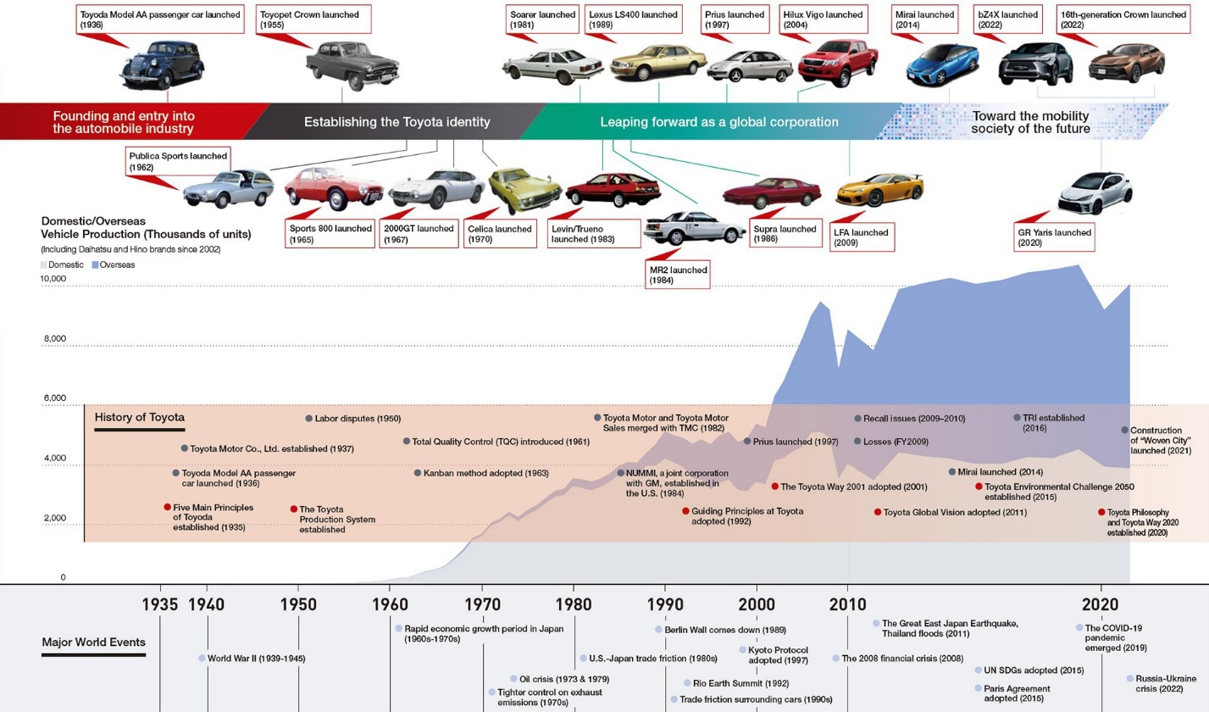

Toyota China Company information
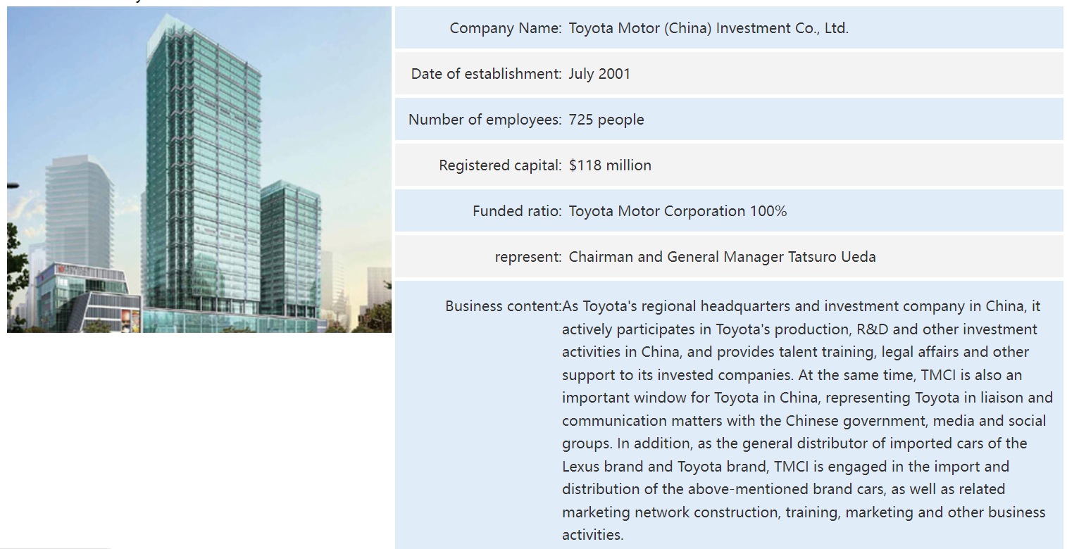

The Toyota Way 2001


