


Matthew Howells
University Of Wales Trinity Saint David

Name - Matthew Thomas Howells
Student Number - P1702520
Facility - (WISA)
Module Lecturer- Professor John Rees

Deadline - Friday, 1st May 2020
Differentiated Deadline - Friday, 8th May 2020

An Investigation of the use of Social Media within Enterprise and Individual lives

Contents

1. Introduction: 3
1.2. Aims of the project: 4
1.3. Objectives: 5
2. Research Questions: 6
3. Resources & Planning: 7
3.2. List Of Services Required: 7
4. Timescales: 8
5. Literature Review: 9
5.1. Overview: 9
5.2. Background research: 10
5.3. Types of intended use sources: 13
5.4. Key themes and debates: 14
5.5. List Of Key words: 15
6. Methodology: 16
6.1. Data collection methods: 17
7. Conclusion: 19
8. References 20

Introduction:

This project proposal intends to look at how the how the online world is used. Here we discussed various topics including how individuals use social media platforms, throughout their daily everyday lives. However, most of these matters can be explained by using modern context, demonstrating how these services can be identified and securely developed further. This includes considering the members of the online community. This can be comprised in different ways including looking at the selection of potential security risks that must be considered, while people are using these online platforms for the accurate reasons. This can also help demonstrate different examples of online safety. As time progresses, a selection of new communication methods shall be traditionally rolled out, creating a choice of extra opportunities that can be used to be able to communicate. This may cover further improvements such as company’s online presence as well as peoples everyday use. In order to approach this development properly it would seem supportive to collate together useful information, by addressing alternative samples of categorised online trends, based around different ages or genders. This evidence may lead to a possibility of underlining how these categorised online trends may have an overall influence on these, strong platforms, during certain situations. Therefore, to commence the investigation around the chosen topic, the aim shall be to apply my own personal background knowledge around the matter while planning to expand it even further. This can be conducted by addressing a selection of various possible methods that can be taken further, in order to collect, assess and carry out key examinations on the collected data. Each piece of data shall be separated in order to be able to explore matters further by using certain analytics in addition to carrying out additional surveys. In addition to feedback possible interviews may be carried out if arrangements can be made by approaching various companies.

  - Industry:
For parts of this major project I hope to be able to work with a selection of enterprise companies and individuals to conduct a questionnaire and possible interview to discover exactly how certain people attend to use social media within their everyday working environment. Throughout this proposal key investigations shall be examined by looking at the key aspects used to by businesses to reach out to their customers and to gain the attention of more potential clients. This shall help to determine if there are any potential areas for improvement in terms of future developments.

Aims of the project:

The aims of this project is to consider a selection of points that shall be evaluated further throughout the process. This can be carried out by using a selection of methods to allow this investigation to go into further detail. Throughout this investigation, all established aims shall be managed by applying a common criterion to guide the setting of any objectives known as the S.M.A.R.T method. This can be recognised as Specific, Measurable, Achievable, Reliable and Timed [1].
Overall, the aims of this investigation is to: -
- Identify the different types of social media platforms available
- To investigate the use of social media and its inferences on individuals and business industries
- To discover further information around the topic area and how it has impacted society
- To assess how different behaviour changes are caused using online platforms
- Identify the various styles of language commonly used while working with online platforms
- To classify social media as a significant influential factor on peoples lives
- To classify social media platforms as key factor within marketing environments
- Identify key potential improvements that can be developed on social platforms further

Objectives:

The objectives can be used to define the selected actions that can be managed while discovering further information on the, topic including, how much it has impacted society. The overall objectives are: -
- To gain an extensive understanding of social media studies, to identify and explore various foundations from the research
- To propose a questionnaire in order to gather information on people’s usage of social media platforms within organisations and daily lives
- Further investigation to examine the positive and negative impacts of social media platforms throughout society
- To provide detailed changes on how potential improvements on social media can be carried out
- Steps on how social media can be used safely and correctly if used appropriately
While sticking to the chosen objectives that are being defined most people would usually wish to investigate strictly: how social media impacts people’s overall lives, why people bother using it, how reliable the procedures of social media has been, as well as how it impacts the production of both enterprise within self-employment, including, well-known popular brands?. A recognised example can be university’s who rely on using social media as a way of promoting. The research questions that support these objectives are stated within Research & Development Methods under point 2.1. By the end of the study further knowledge around the topic should have be collected and implemented into future reviews around the social media environment.

Research Questions:

Below are the types of question that this project will be looking to answer. This can support by providing a better understanding of the problem that is being discussed. As a writer who is interested in gathering further additional facts the questions that should be addressed consist of: -

- How did society communicate before the digital era?
- What are the different platforms of social media available?
- What effects can social media platforms have on individuals?
- Why are people using social platforms in the different ways they do?
- Can social media help different types of enterprise projects?
- Does online platforms have an impact on the overall society?
- Does social media increase user engagement with the online world?
- Are there any pros and cons of using online platforms within these establishments?

These questions have been developed in order to help learn and accomplish the aims of the research. The first question provides an additional understanding of how society used to communicate before the digital era commenced while the second question expands on the wide selection of different social media platforms that are available.

Resources & Planning:

  - List Of Resources Required:

- Laptop
- Questionnaire Software
- University IT facilities
- Printer
- Notepad
- Stationary

List Of Services Required:

- UWTSD IQ Building to have access to supervisor/staff/classrooms
- UWTSD Y Fforwm Library building to access books, journals etc.
- Online Internet access to access online social media platforms /research
- Microsoft office package (Microsoft Word, Microsoft Project, Microsoft excel)
- Survey Software to conduct surveys
- Social Media Users to conduct questionnaires/interviews
- External Company to conduct questionnaires/interviews
- University Email to contact supervisor
- Microsoft teams’ package to communicate

Timescales:

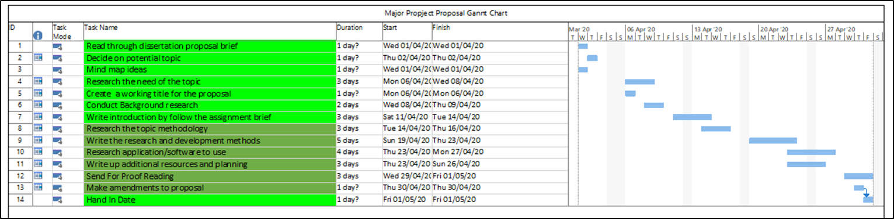

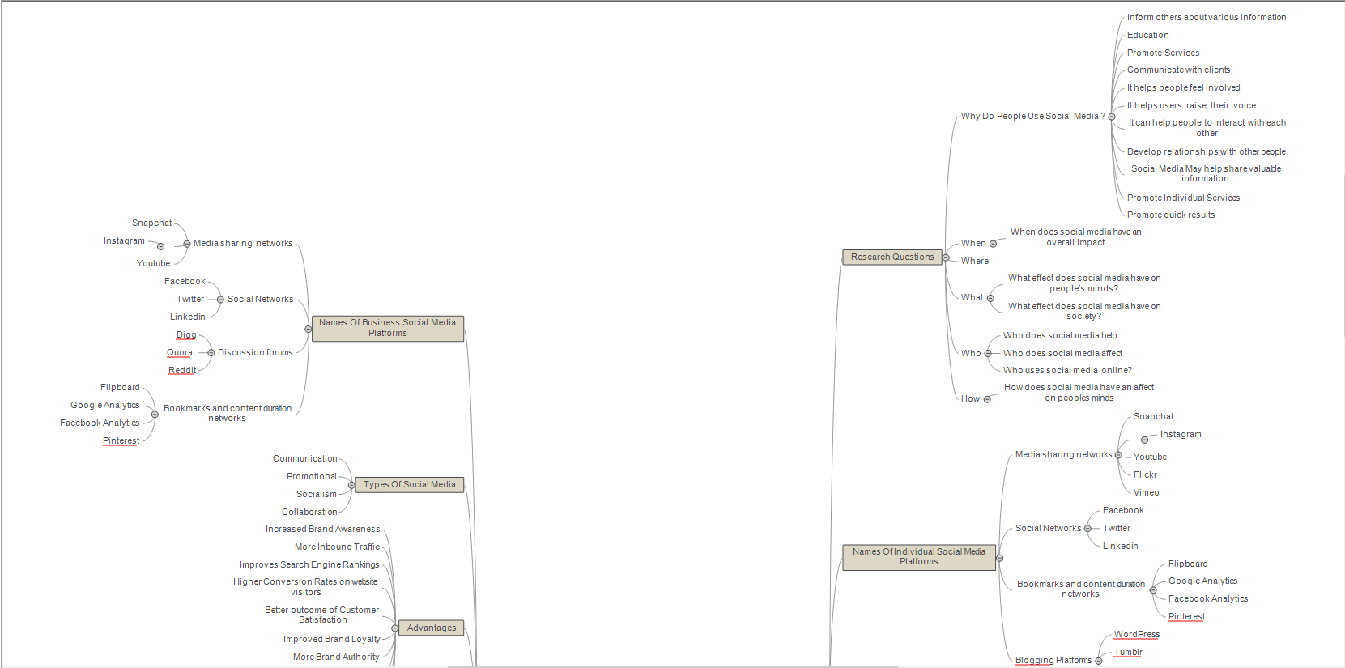

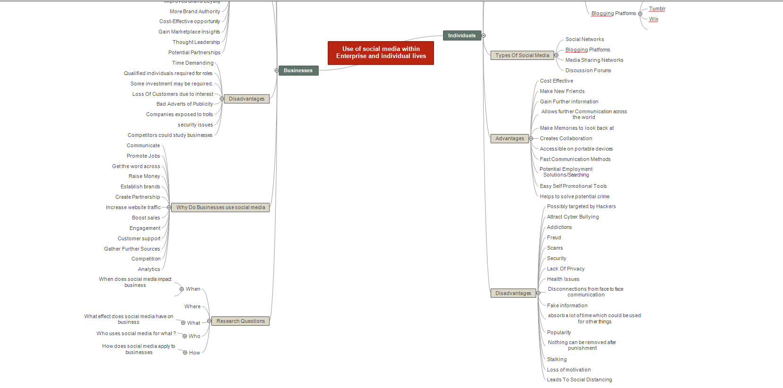

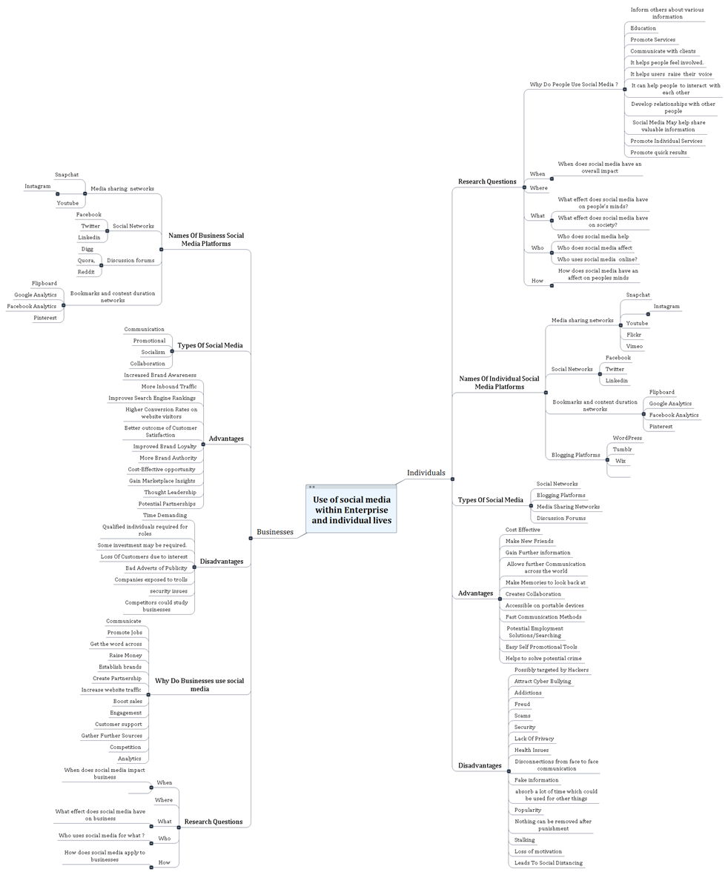

Literature Review:

Overview:

This section aims to evaluate previous literature related to the topic of Social Media studies and companies, in order to give an overall understanding of the possible impacts of Social Media Platforms as well as the potential factors associated with adapting the use of social networks within an enterprise company. While beginning to complete further research and selecting what sources would be best to proceed with, it would be beneficial to focus around how society originally communicated before modern online resources became accessible. It is intended to have the ability to investigate further around this argument; look at how businesses and individuals used to respond, what influences these developments have had and what differences were solved later. This research effort is targeted at finding and addressing the countless effects of social media on people’s lives and performance. Therefore, the literature review remains a perfect idea to commence by discussing the relevant research that is useful to the objectives of this research project. A selection of research studies support the process of investigating, the topic under view in order to find out if the chosen topic being reviewed is found to be relevant to the proposal being discussed; which could help to back up the overall research process.

Background research:

Over the past decade communication methods have changed in different ways. At this present period, it would be hard to imagine life without social media platforms. Over the last few decades, the ways in which people connect and how many people can be reached remained as limited. “During the 1980s to mid-1990s, the main method of communication through others was either through using the telephone or speaking in-person by exiting the household in order to socialise” [2]. The writer Katie Gilsenan discusses how throughout the times when the internet originally progressed to became available it even required a dialling tone for users to connect to the internet, which sometimes had a long waiting time, often, making it unsatisfying for some individuals to use. As times developed further Social Media Sites (SNS) overcame these barriers as online social networks and online discussion forums were implemented; encouraging the public to engage in social contact regardless of their location, distance or time differences [3]. As expected, based around these reasons social media websites have rapidly spread across the globe. This shows that the topic of online social network usage within the workplace is high on the agenda for various organisations [4]. These social media networks provide straightforward, accessible and easily usable platforms enabling users to communicate with each other freely. This can help to form additional online communities for individuals to be part of. It has been discovered there has been an extraordinary eruption in social media usage throughout the decade. The online presence is, increasingly, on the rise as program developers come up with multiple online applications containing up to date features. As of December 2019, the world’s population stands at 7.5 billion with 3.8 billion people using the internet. Research shows that around 73% of the adult users of the internet use the social networking sites [5]. In 2019, an estimated 2.95 billion people were known to be using social media worldwide [6]. This evidence shows that social media is, increasingly, now being recognised as a significant practical tool; offering businesses and individuals a selection of opportunities in order to achieve more sustainable developments online within their category.

Social media holds a wide variety of key parts within the lives of individuals, especially youths. This shows that most youths rely on these key communication platforms, which stands as easy to use and remains constantly available on multiple devices [7]. Through social media, many people can connect greatly and share life experiences while accessing online trending news. Throughout the present world, many enterprise environments and sellers turn towards the direction of social media, using online websites as their promotional platforms [8].This can possibly involve using numerous strategies such as online promotional adverts, or email marketing in order to work towards persuading and attracting clients, as this allows further awareness to be made to their targeted customers of interest. Throughout the world, it has been discovered that during February 2020, the immense majority of UK social media have been identified to be between the ages of 18-34 ;this age bracket accounting for more than 80% of the total users [9]. This is due to the various ways of how online information can be accessed twenty-four hours a day through devices while on the go. Social networks provide constant access to information from the news, political information as well as job searching pages. With these ideas in mind: by considering popular worldwide platforms like Facebook produced by Mark Zuckerberg in 2004, it is important to consider how people interact with each other over the internet. Facebook is a well-known, popular platform containing selected features where individuals have the option to communicate by sharing certain photographs, personal information and comments with close friends [10]. Even though alternative websites, such as are designed, to offer these facilities, Facebook remains to be the most popular option active; currently consisting of over a million users spread all across the world from 2008-2020 [11].
Research has identified use of the internet as an impact on digital behaviour and a consumer on overall behaviour as a whole [12]. Consumers and large firm impressions tend to cause different affects as marketers can identify the best possible solutions in order to work towards attracting, accessing and disrupting new potential customers as a way of publicising their services. As expected, every entrepreneur seeks the carefully chosen opportunities as a way of fulfilling the needs of existing customers in order to keep refining current services that are running; this is done through the presentation of products [13].The world wide web has demonstrated what is identified as digital influence in consumer behaviours [14]. Digital consumer behaviour, in terms of marketing, boils down to everything that a person does online [15]. This can include what devices people use, the sites that are being visited, the engagement with online adverts plus the pages that users can navigate between. It has been identified that Digital consumer behaviour is one of the most important metrics that any modern vendor can measure [15]. This involves the ease of access most people may have while using online resources. These days most people have constant everyday access to common online social platforms [16]. Due to this reason the use of social media is now being used as an online shopping marketing platform. This is due to certain businesses are working hard on adjusting their strategies by moving their business online in order to cut costs on certain stores. A well-known example can be Facebook who offer users opportunities to access a wide range of online buying or selling pages. At times this can lead to potential dangers mostly identified as addictions in a few ways. Some people develop shopping addictions because they van essentially get addicted to how their brain feels while shopping. Many shopping addicts unfortunately face various financial problems, and they may become overwhelmed with debt. Certain categorised groups may possibly choose to turn towards these platforms as a way of general activity or spending financially. Certain people rely on social media platforms in order to assist with their purchasing decisions [17]. This can be due to the direct connections people can establish with companies through using social platforms. Social media is very effective when it comes to convincing consumers to buy, particularly the minute they see that their family or friends have purchased a product. Each of the key insights and arguments that has been identified throughout this passage state a full example of how individuals rely on social media throughout their daily lives. This can be improved further throughout the passage as we go into further detail discussing potential ideas of how social media can be used for a selected number of reasons. Key developers wish to keep their marketing brands looking fresh encouraging new clients to subscribe and support their services. A list of key books, journals and websites that may be used in the interior of the project can be identified under section 5.3. Further courses shall be added throughout the process of completing the project.

Types of intended use sources:

Below stands a list of beneficial documents, websites and books that have not read yet but are intended to be used to support the overall dissertation process. Each source could support any information that shall be defined further.

- Social Media Marketing Workbook: How to Use Social Media for Business (2020 Updated Edition) by Jason McDonald
- [1] Social media + society. 2015.
- C. L. Milton, “Ethics and Social Media,” Nursing Science Quarterly, vol. 27, no. 4, pp. 283–285, 2014.
- L. M. Mon, Social media and library services. 2015.
- E. Brown, British Computer Society, London Computer Group, and BCS, The Chartered Institute for IT, Working the crowd: social media marketing for business, 2nd ed. London: BCS, 2012.
- S. B. Park, J. Kim, Y. K. Lee, and C. M. Ok, “Visualizing theme park visitors’ emotions using social media analytics and geospatial analytics,” Tourism Management, vol. 80, 2020.
- Y. Sun, X. Zhou, A. Jeyaraj, and F. Hu, “The impact of enterprise social media platforms on knowledge sharing,” Journal of Enterprise Information Management, vol. 32, no. 2, pp. 233–250, 2019 [Online]. Available: http://search.proquest.com/docview/2209962668/
- L. Kelly, J. A. Keaten, and D. Millette, “Seeking safer spaces: The mitigating impact of young adults’ Facebook and Instagram audience expectations and posting type on fear of negative evaluation,” Computers in Human Behaviour, vol. 109, 2020.
- https://www.ketchup-marketing.co.uk/a-z-of-marketing/the-power-of-social-media-in-marketing/
- Hilde A.M. Voorveld (2019) Brand Communication in Social Media: A Research Agenda, Journal of Advertising, 48:1, 14-26, DOI: 10.1080/00913367.2019.1588808
Each source will be elaborated further throughout the proposal review process.

Key themes and debates:

Throughout the process of carrying out preparation for this proposal certain themes have been noticed that can apply within online businesses. As time periods move forward big-budget companies may wish to hold online commercials as a way of promoting their products. This can include broadcasting videos of individuals reviewing a selection of products that are available in order to attract new possible customers to make a purchase supporting enterprise services. These days as times move forward certain companies may work towards opting to hold online adverts instead of television appearances due to more people subscribing to online streaming services instead of watching television. These services can be provided using smartphones instead of camera crews. This method speaks to their audience and to the platforms making promotions more real, relatable, and social. It can be debated whether this is the correct way forward especially for elderly individuals who may not have full use of technology throughout their daily lifestyle. It can be questioned whether it is ethical to use these online websites to advertise. Secondly as part of the commitment companies make to protecting young people or vulnerable users is ensuring people fully understand how they use social media for the correct reasons. Due to these points a survey shall be produced in order to find out what adverts young people see and engage with online and discuss whether companies should promote children’s services online in order to stick to the United Kingdom advertising rules. Each identified point can be debated further by collecting suitable evidence as a way of investigating these points further.Overal It can be questioned whether each social media platform remains as secure as what people may think as well as important positive and negative opinions that must be considered as part of safety. This can help reflect on the fact to identify whether some people are against social media platforms for a variety of reasons and how alternative changes can change people’s thoughts.

List Of Key words:

- SMP
- Marketing
- Enterprise
- Ethics,
- History of SMP and communication
- Groups
- File sharing
- Media sharing
- News sharing
- Sites
- Apps
- Adverts
- SMP Audiences
- Analytics
- Behavioural differences across platform
- Conversation
- Define
- Positive
- Negative
- Alternative
- Applications
- What is social media
- Social media management
- Social media strategy
- Jobs
- Campaign
- Marketing strategy

Methodology:

This proposal approach shall be categories under phenomenology. The primary research procedure for this study is a descriptive literature review which focuses around collecting different types of data in order to address a specific problem. As part of this procedure it would be sensible for this study to first review and consider various types of approaches that could be taken in order to gather further evidence to guarantee a reasonable outcome of the investigation being carried out. This can help define how social media platforms are structured as well as the characteristic that these platforms offer. One of the key approaches that shall be taken includes conducting sensible surveys. This represents Phenomenology. Due to the project requiring the support of surveys this has been categories as explanatory. Online questionnaires shall be carried out in order to be able to collect useful information from other members of the public allowing their views to be heard in a fair-minded manner. This method can help address the correct procedures that must be taken and followed for this investigation to remain fair as well as meeting the user’s needs. This can be identified as qualitive research involving the collection of extra data in order to back up points that are being discussed and demonstrated. While addressing these useful sources for collecting information certain questions must be considered. This can include querying if the correct questions are being asked as well as ensuring the correct companies are being questioned. This can help while ensuring that the collected data that is outputted remains reliable and useful to the examination. All questions that shall be asked shall also be based on the overall experience of online platforms within the real world due to the study investigating social media within the real world and around marketing. This can be recognised as a real phenomena while looking into companies’ analytics to prove how popular these online platforms can be. In modern cases social media can be proposed as a key instrument for today’s businesses as a way of taking industries further into the digital environment. All points shall be managed by sticking to a strict time management schedule which shall be discussed. Consequently, based on these descriptive motives it has been decided to collate together all information in this digital environment and expand it even further by conducting additional research. This shall allow for analysis and evaluation, of how these platforms perform, in both individual and enterprise categories identifying both positive and negative impacts. Surveys are mostly used to explain causes and effects.
Based on phenomenology a selection of case studies shall be researched and collected while examining various documents linked to the questions that are being asked. This shall help while trying to collate further answers for each question appropoaitely. It is important to considering the reliability of each source as well as questioning whether each point addressed remains valid and why the answer remains useful to the investigation. In order to break down each point a deductive approach could be taken if necessarily.

Data collection methods:

As expected, it remains important and essential to identify each data collection method that shall be used throughout the investigation of the proposal being made. Each objective can require different approaches of collecting information using different methods. Based on the type of investigation it would be beneficial to collect additional information by: -
- Holding key Interviews with individuals and approaching selected companies to discuss their views
- Distributing an online accessible questionnaire in order to collect people’s views, opinions and extra evidence
- Reviewing key documents based around how companies implement social media platforms within businesses
- Reviewing Social Media policies to identify rules and regulations that must be followed as part of online safety

  - Potential risks:
Stated below are some Identified risks/limitations/ethical/legal issues and various ways the identified risks can be dealt with appropoaitely. Further risks can appear throughout the process.
- Copyright – Read online policies
- Cyberbullying – Address the matters further
- Lack of information – Carry out further research
- Using information without attribution – follow guidelines
- Failure to properly disclose influencer marketing campaigns - follow assigned guidelines
- Revealing Confidential Information - revising the policies in place with the university or company to avoid future problems
- Fake Requests from Spam Profiles - stay alert while using social media websites.

  - How to analyse the data/evaluate results
Data can be manipulated using different ways. This can include: -
- Creating graphs
- Pivot tables
- Databases
- Filtering results
- Using Statistical programmes
- Write reports

Conclusion:

Most enterprises which offer rich accessible internet applications may attract better usability compared to corporations only relying on using standard websites alone. It can be expected that the use of social media platforms shall continue to rise for a wide variety of reasons. This can include full establishments of information sharing included key events being held online. During extenuating circumstances Social Media Communication could be expanded further to support those who wish to use the services for seeking or rendering help along the line. Based on information that shall be gathered a wide selection of question based around social media including various guidelines could be produced in order to help make people feel more secure and comfortable while using these online resources.

References

[1] | M. T. C. Team, “SMART,” Mindtools.com, November 1981. [Online]. Available: https://www.mindtools.com/pages/article/smart-goals.htm. [Accessed 13 April 2020].
[2] | K. Gilsenan, “2019 in Review: Social Media is Changing, and It’s Not a Bad Thing.,” globalwebindex, 27 September 2019. [Online]. Available: https://blog.globalwebindex.com/trends/2019-in-review-social-media/. [Accessed 1 March 2020].
[3] | Daniel Miller, “How the World Changed Social Media,” in How the World Changed Social Media, London, University College London, 2016, pp. 50-62.
[4] | K. T. K. R. Kapoor, “Advances in Social Media Research: Past, Present and Future,” Inf Syst Front, vol. 2018, no. 18, p. 531–558, 2017.
[5] | JOANNA BRENNER,AARON SMITH, “72% of Online Adults are Social Networking Site Users,” pew research centre, 5 Aug 05. [Online]. Available: https://www.pewresearch.org/internet/2013/08/05/72-of-online-adults-are-social-networking-site-users/. [Accessed 25 April 2020].
[6] | J. Clement, “Number of social media users worldwide from 2010 to 2023,” Statista, 1 April 2020. [Online]. Available: https://www.statista.com/statistics/278414/number-of-worldwide-social-network-users/. [Accessed 14 April 2020].
[7] | LAURA SILVER, AARON SMITH, COURTNEY JOHNSON, JINGJING JIANG, MONICA ANDERSON AND LEE RAINIE, “ Use of smartphones and social media is common across most emerging economies,” MOBILE CONNECTIVITY IN EMERGING ECONOMIES, 07 March 2019. [Online]. Available: https://www.pewresearch.org/internet/2019/03/07/use-of-smartphones-and-social-media-is-common-across-most-emerging-economies/. [Accessed 26 April 2020].
[8] | D. a. P. J. Schultz, “Social media's slippery slope: challenges, opportunities and future research directions,” Journal of Research in Interactive Marketing, vol. 7, pp. 86-99., 2013.
[9] | talkwalker.com, “Social media statistics in the UK,” talkwalker, 05 Feb 2020. [Online]. Available: https://www.talkwalker.com/blog/social-media-statistics-in-the-uk. [Accessed 03 March 2020].
[10] | R. Buckman, “Too much information?,” The Wall Street Journal, 2005.
[11] | J. Clement, “Facebook: number of monthly active users worldwide 2008-2020,” statista.com, Apr 30, 2020.
[12] | C. -. C. a. m. authority, “Consumer and firm behaviour review,” 2017 April 2017. [Online]. Available: https://assets.publishing.service.gov.uk/government/uploads/system/uploads/attachment_data/file/607077/online-search-literature-review-7-april-2017.pdf. [Accessed 25 April 2020].
[13] | David Court,Dave Elzinga, Susan Mulder, and Ole Jorgen Vetvik, “The consumer decision journey,” June 2009. [Online]. Available: https://www.mckinsey.com/business-functions/marketing-and-sales/our-insights/the-consumer-decision-journey. [Accessed 25 April 2020].
[14] | Appel, G., Grewal, L., Hadi, R, “The future of social media in marketing,” Journal of the Academy of Marketing Science , p. 79–95, 2020.
[15] | P. C. I. Team, “Why you should care about digital consumer behaviour,” Perceptive , 23 November 2018. [Online]. Available: https://www.customermonitor.com/blog/why-you-should-care-about-digital-consumer-behaviour. [Accessed 25 April 2020].
[16] | M. Mohsin, “10 Social Media Statistics You Need to Know in 2020,” oberlo, 07 feb 2020. [Online]. Available: 10 Social Media Statistics You Need to Know in 2020. [Accessed 25 april 2020].
[17] | R. Garvin, “How social networks influence 74% of shoppers for their purchasing decisions today,” awario, 11 May 2019. [Online]. Available: https://awario.com/blog/how-social-networks-influence-74-of-shoppers-for-their-purchasing-decisions-today/. [Accessed 25 April 2020].

