Fozlul Hoque (1806358)

A Report on communciation within the workplace
Effective Team-working and Communication

Executive Summary

Michelle Sullivan is an owner of a medium sized store in Swansea. Michelle has asked the business consultant to advise on possible team structures to facilitate and enable effective channels of communication amongst the rapidly expanding workforce, to prevent small issues becoming big problems.

Contents Page

Overview
A medium sized store which sells toys and is opened between the hours 8:00AM – 10:00PM. It was a small shop with 5 employees but has grown rapidly in a year and now employs 27 people of varying ages and experience. There are 3 Managers, 6 Stockroom Assistants, 14 Sales Assistants, 2 Security Guards and 2 Cleaners. There are part time roles and night shift roles which doesn’t have a manager on duty.

Findings
The business has grown rapidly over a year due to its effective communication inside the workplace. Communication is a two-way process of reaching mutual understandings, in which participants exchange information (Steinberg, 2007).

There are two types of effective communication which are important in the workplace. Verbal and Non-Verbal communication can be done separately and also interlink with each other during any conversation.

Verbal Communication
Verbal communication is when two parties are conversing with each other, this can be through speaking, phoning, texting, emails and so on (Rocci and Saussure, 2016). It is important in the workplace in many ways.

Here are some reasons why:
- Correcting Wrong – apologising for mistakes when an employee makes an error will save them
- Persuasion – getting every team member involved in the objective so it is completed
- Relationship building – building trust in capabilities each employee have will make it easier for the management
- Bringing clarity – understanding the objective clearly will make it easier and get the job done correctly
- Increases productivity – better performances between the employees and better contribution
- Increasing satisfaction of job – keeping the employees happy will make the environment easier to work in
- Positive effect on employee absences – less absences from employees if they realised, they are valued
- Idea sharing – creating ideas and finding the best solution from these ideas
- Removes barriers – eliminates negativity between employees and management
- Motivation to employees – being valued and supporting towards the objective will get the work done efficiently

Non-Verbal Communication
Non-verbal communication is the behaviour given during the communication. This is through facial expressions, tone of voice, gestures, body stance and even eye contact (Mehrabian, 1972). In the workplace this is important.

Here are some reasons why:
- Showing agreement and disagreement – giving and receiving gestures will ensure a more of a ‘yes’ or ‘no’ answer
- Maintaining relationships – a pleasant gesture can make the chemistry of the relationship good
- Lack of interest – if the management isn’t bothered with the objective, the employees will lose interest and focus in the job role
- Tone of voice – being clear and understanding will help others know the job better and will complete it correctly
- Confidence – If there is no confidence from management, the employees will not feel motivated and will question the management’s capabilities
- Detachment – signs of this will get employees not interested and is given out wrong signals
- Reassuring – facial expressions and gestures can keep the employees believing in their management
- Culture – knowing the culture of any person can keep problems from occurring
- Giving space – giving the employees space from time to time will keep them satisfied

The effectiveness of verbal communication is parallel to the role of non-verbal communication inside the business. Individuals would need to review their communication skills that they have and should try to improve them if necessary. The most important aspect of both the modes of communication is that both are used towards mutual understanding and finally bring about productive and sufficient results.

Two-Way Communication

Every organisation must be able to communicate with each other inside to get targets completed. Information is exchanged and this is called a two-way communication (Fielding, 2006). It is important to have two-way communication inside the company and here are some reasons why:

- Dynamic Process – in two-way communication, the process of a message is directed by the sender and given to the receiver. After the message has been received, the message will be reviewed and a feedback will be sent back to the sender. This dynamic process makes the communication complete and effective.
- Application of Guidance – the employer will give information, instructions and advice on different issues. The employee should understand and clarify these messages. This information acts as a link which connects the source and destination between the employer and employee.
- Job Satisfaction – Employers and employees can trade information about problems through two-way communication. Employees can face problems and employers should know about them. Employers will give feedback about these problems and can motivate the employees through job satisfaction. This will lead to the goals being achieved.
- Suggestions – Employers and employees can suggest ideas to solve many problems or even new ideas for efficient productivity. This makes a job or activity to be properly completed. Ideas that are shared can be given feedback there and then which causes better decisions.
- Better Relationships – relationships will be better if there is a two-way communication between each staff member. Trust is built and friendships can be created. This will include idea sharing and decision making.

Models of Two-Way Communications

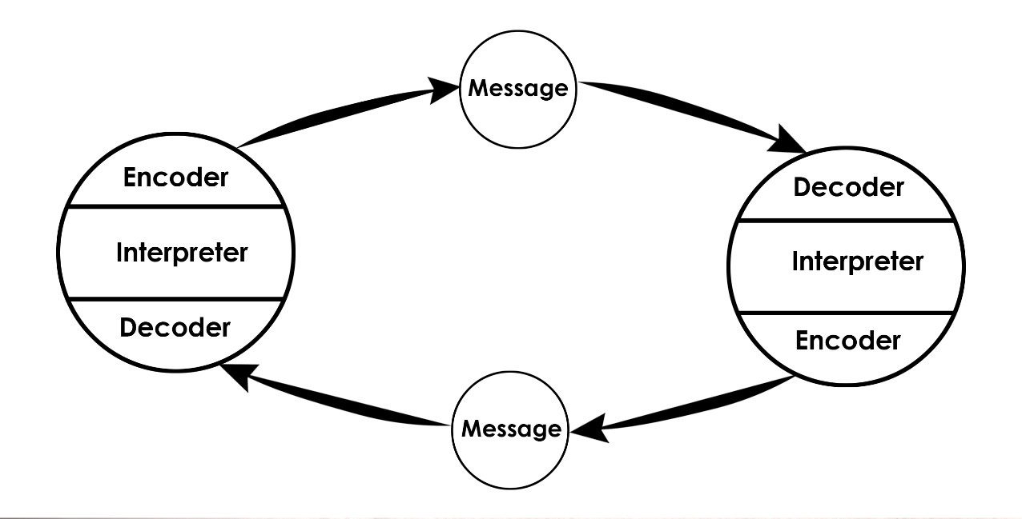

This is a two-way communication model (Schramm, 1960) where both the sender and receiver take turns to send and receive the message.


This is the expanded version of the Shannon-Weaver model (Berlo, 1960) where it is explaining the factors affecting the individual components in the communication making the communication more important.

Effective Methods of Communication

There are many ways for communication to be effective throughout the workplace (Arrendondo, 2000)

Creating teams
Teams within the workplace will get the work done on time and correctly. Team members can bond with each other and create trust in each other’s capabilities. If one team member is not performing then the other team members are going to perform harder so that is also a big role as no team member would not want to let their team down.

Meetings
Holding meetings with staff members will create more ideas to make the progress of work more productive. Also having one-to-one meetings with each staff can help improve the relationship between the management and employee. Reviews of the staff and given feedback will help staff get motivated.

Emails
Sending out emails to staff members about information will reassure the staff in trusting the management. As the staff can rely on the management for any news or problems that may occur. This helps as well as it isn’t time consuming for management to meet each staff member one by one and also the workflow will keep on running as normal.

Friendly Atmosphere
If there is a friendly atmosphere, then the management and staff will avoid negativity and problems from occurring.

Appreciative
Being grateful to the staff will make them feel valued and keep them satisfied.

Training
Training should be shown and provided to each member of staff as it will give them a clear understanding on what to do on their roles.

Confidence and Seriousness
Displaying these will show the staff members that the management mean business. When talking to the staff members, the staff will listen and be more focused on the objective.

Teamwork Theories

Teamwork is important inside any work place. Applying a theory will improve the teamwork in the company.

Bruce Tuckman’s Team Development Model (Tuckman, 1954)
There are four stages of development when it comes to teams and teamwork. When going through the stages the effectiveness of teamwork grows. The 4 stages are:

Forming is when the team is created. The team leader which would be chosen from the management will have to delegate roles to each member of the team. There will be a lot of confusion as no team member has information on any other team member’s attributes. The team will be explained to about what the actual goal is. The leader of the group will have many questions asked about the objective.

Storming is when the team is having problems with each other as they can’t trust each other member’s abilities. There will be a lot of disagreements during this stage. Cliques and factions form and there will be power struggles. There will also be a lot of uncertainties inside the team.

Norming is now the team has agreed to trust each other. Plans will be made and team members will be able to co-operate with each other. The goals will be set and every member will work towards that goal. The team leader has also been accepted by each team member.

Performing is the team getting out and doing the job their allocated to do. Each member know what they are doing to work towards that goal which was set. If a one team member needs support then the other team members will help. This will lead to achieving the goal.

Meredith Belbin’s Team Roles (Belbin, 1981)
Here are 9 roles (Belbin.com, 2019) inside 3 types which are used inside teamwork. Each team role has strengths and weaknesses and are equally important.

Action Oriented Roles
A Shaper provides the drive and makes sure the team does not lose its focus.
Strengths: Challenging, dynamic, thrives on pressure, courage to overcome obstacles
Weaknesses: Can be prone to provocation and may be offending other’s feelings

An Implementer is needed to plan a strategy and carry it out efficiently
Strengths: Practical, reliable, efficient. Plans ideas and put them into action.
Weaknesses: Inflexible and slow to respond to new possibilities.

A Complete Finisher is used at the end of the task to complete it at high standards
Strengths: Careful, diligent, searches for errors, polishes and perfects.
Weaknesses: Inclined to worry too much and hesitant to delegate

People Oriented Roles
A Resource Investigator uses their inquisitive nature to find ideas to bring back to the team
Strengths: Outgoing, enthusiastic, explores opportunities and develops contacts
Weaknesses: Optimistic, lose interest once initial enthusiasm has passed

A Teamworker is versatile and get the team banded and completes it for the team
Strengths: Co-operative, perceptive, diplomatic, listens and averts friction
Weaknesses: indecisive in crunch situations and avoids confrontation

A Co-Ordinator needs to focus on team’s objectives, compose and delegate roles
Strengths: Mature, confident, identifies talent and clarifies goals
Weaknesses: Manipulative and may offload their work to another team member

Thought Oriented Roles
A Plant are creative and good at problem solving in unconventional ways
Strengths: Creative, imaginative, free-thinking, generates ideas and solves problems
Weaknesses: ignoring incidentals and be preoccupied to communicate

A Monitor Evaluator are logical, making judgements where required and tells options
Strengths: Sober, strategic, perceptive and sees all options
Weaknesses: Lack of drive and ability to inspire others and be over critical

A Specialist brings in-depth knowledge of a key area to the team
Strengths: single minded, dedicated, providing specialist knowledge and skills
Weaknesses: contribute on a narrow front and dwell on technicalities.

Action Plan
Action | Who | When | Costs
Team forming | Management | 06/04/2019 | Disbanding cliques
Training policies | Management | 06/04/2019 | Time consuming
Emails provided | Management | 06/04/2019 | Setting everyone up may cause confusion
Meetings | Michelle Sullivan | 06/04/2019 | Slow on workflow

Conclusion
The research given, it is clear to see that the toy store can use these methods. Using these methods will help achieve targets and the communication between the staff members will be more efficient. The productivity and performances of each member will rise and the moral and chemistry will be better.

Reference

Steinberg, S. (2007), An Introduction to Communication Studies, South Africa: Juta and Company Ltd.

Rocci, A. and Saussure L. d. (2016), Verbal Communication, Switzerland: Walter de Gruyter GmbH & Co. KG.

Mehrabian, A. (1972), Nonverbal Communication, USA: Transaction Publishers

Fielding, M. (2006), Effective Communications in organisations, South Africa: Juta and Company Ltd.

Schramm, W. (1960), Mass Communications (2nd Ed). USA: University of Illinois Press

Berlo, D. (1960), The Process of Communication, USA: Reinhart & Winston

Arrendondo, L. (2000), Communicating effectively, USA: McGraw Hill Professional

Tuckman, B. (1965), Development Sequence in Small Groups, Psychological Bulletin, Vol. 63

Belbin, M. (2010) Management Teams: Why They Succeed or Fail, UK: Routledge

Belbin.com (2019) ‘Team Roles’, [Online] Available: www.belbin.com, [2019, April, 04]

