"Czech Republic Easter Traditions and History"

Katerina Sugarova
2220482
UWTSD
04/01/2024

Introduction
Historical Roots of Czech Easter Traditions
Easter Monday: Pomlázka and Šibačka
Czech Easter Foods and Symbolism
Easter Traditions in Churches
Incorporation of Folklore in Czech Easter Celebrations
Modern Adaptations and Contemporary Celebrations
Conclusion
Bibliography
Articles
Book

Introduction
Easter customs are very important in culture and religion all over the world, showing new life, hope and growth. In the centre of Europe, the Czech Republic has special Easter traditions that give a cool look into its deep history. Knowing the history that stands behind these customs makes our society even richer. In Czech countries, Easter is not just a religious party but also a time when old ways match perfectly with modern habits. The special mix of stories, signs and shared love for the people makes Czech Easter Ways an interesting show. From beautiful eggs with lots of details to the old ways people used to walk in lines, each tradition comes from deep inside our country's history. Looking into these traditions helps us understand how the past events, ties between people and their beliefs have made Czech Easter what it is today. As we pull apart old ways, we find a story that is older than time itself. It links people from different ages and helps them know who they are. Looking into the past makes us understand how every move matters, and so, Czech Easter becomes a party that is closely linked with their country's history.

Historical Roots of Czech Easter Traditions
The start of Czech Easter customs goes far back into the history of this country in central Europe. To really understand these traditions, you need to start on a trip back in time and discover the many things that have formed them. Old pagan ways mix smoothly with Christian customs as they both ring out in the festivities. Many years before Christianity reached them, the Czech lands were covered in old beliefs linked to loving nature and changes throughout the year. These early customs were mainly about the time of equal day and night, setting a base for what would grow into today's Easter celebrations. When Christianity came, old pagan ways mixed well with Christian ideas. This mix can still be seen in modern Czech Easter parties. From the way eggs show growing life to how old stories mix with Bible tales, Czech Easter customs are a part of both non-religious and Christian history. Getting how this complicated back-and-forth works better makes us value the special mix of history and belief that characterises Czech people's way of celebrating Easter.

Easter Monday: Pomlázka and Šibačka
Easter Monday in the Czech Republic is full of life and meaning with the active customs of Pomlázka and Šibačka. Pomlázka is an old custom where young men softly hit young women with willow sticks that are bright and pretty. This tradition is not seen as a punishment but rather thought to help women get better and have more babies. It represents the start of new life in springtime. Šibačka, an extra part of Easter Monday, is about softly hitting or jokingly flicking friends and family. This kind of act is based on the idea that hitting something symbolically will pass energy and power. The importance of these traditions comes from their link to making nature fresh again, a topic shown in many ways in the history of Czech. These traditions, which go back to before Christian times, show a mix of pagan celebrations for life growth with rebirth and renewed themes from the Christian belief. Holding Pomlázka and Šibačka on Easter Monday is more than a move; it extends an old way of life that connects people from different ages, marking the repeating circle nature of life.

Czech Easter Foods and Symbolism
In the Czech Republic, Easter is not just shown by bright customs but also through a big selection of tasty foods that hold deep, important ideas. Mazanec, a sweet bread made most of the time for Easter, shows the feeling of joy and having lots. Its round form shows how life goes in circles and the never-ending trip of our spirit. Putting in spices and dried fruits shows the return of taste after the plainness during Lent. Czech Easter traditions are focused around Kraslice, very fancy eggs with a lot of decoration on them. Each egg is a place for imagination, decorated with bright shades and detailed designs. These eggs not only look beautiful but also represent new beginnings and the ability to have children. Sharing and getting Krallice helps to build a feeling of being together in a group and having good things among us. The link between Easter foods and beliefs is very strong because Czech people deeply respect nature and the changing seasons. Czech people use their cooking habits to show thanks for what the earth provides and recognise how Easter brings life back again. When families sit together to eat these special foods, they join in a shared party that goes beyond ages. This makes Easter even more important for Czech people as it keeps their culture alive.

Easter Traditions in Churches
In Czech churches, Easter is celebrated with many services and customs that show deep respect for this important week using a mix of old traditions. The seriousness of Good Friday is watched with walks and words, getting ready for the happy party on Easter Sunday. Holy Saturday is unique because the blessing of Easter baskets stands for waiting on new life. Important church happenings during Holy Week, like dark services and the Cross stations walk, help people feel what Jesus felt when he gave up his life. These happenings help build a strong tie to the Christian story, enabling believers to think deeply about how important Easter is. Easter songs, sung with true love and belief, hold a cultural value that goes beyond different religions. These songs heard for hundreds of years, bring together people who believe in the same spiritual feeling. When people sing together, the songs become a strong way of showing belief and highlighting how Easter traditions in Czech churches connect to their culture.

Incorporation of Folklore in Czech Easter Celebrations
Czech Easter parties are made special with the exciting stories of old, where legends and tales from people add a bit of magic to their way of life. These stories, handed on from one family member to another for years, add a fun feeling to the time of year. They make our habits richer by giving them deeper meaning in words and tales. Stories told by older people are very important in making Czech Easter traditions what they are, giving them a special magic. Stories about made-up animals like the Easter Lamb thought to bring luck, mix perfectly with Christian stories. This makes a nice joining of different belief systems. These stories are fun and also share a cultural setting for the traditions followed in this happy season. There are many examples of folk customs, from the magical stories about water spirits to animals like roosters and lambs that we use in Easter art. Every story in these tales has a deeper message, linking now to then and building up the feeling that Czech Easter celebrations go on without end. By using old stories and traditions, the celebrations turn into a happy mix of past events, creative thoughts, and group joy.

Modern Adaptations and Contemporary Celebrations
As time passed, Easter customs in the Czech Republic smoothly changed to fit the modern world while still keeping their roots in culture. Current parties in the Czech Republic show a mix of old traditions and new styles, making lively patterns of celebration. In today's Czech people, old Easter ways live together well with new parts. Even though Pomlazka and Sibacka's ageless appeal stays the same, there is a rising fashion of adding new ornaments and styles to these celebrations. New tech is also a part of this, as social media sites are being used to share and record these loved times. Mixing old ways with new changes highlights how the Czech people are able to change their Easter celebrations. Families can still do egg painting and eat old-time foods, but now with a modern touch. Mixing old and new makes sure the feeling of Easter stays strong, changing with time while keeping what's different about Czech Easter alive.
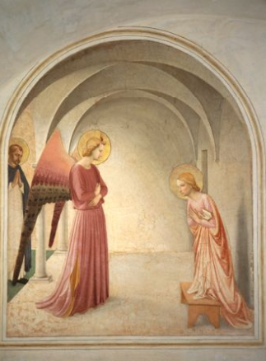
"The Convent's Frescoes: Daily companions for Dominican friars, these paintings, including St Peter Martyr in contemplation, guide them towards conformity with Christ and the Virgin's humble yet glorious vocation."

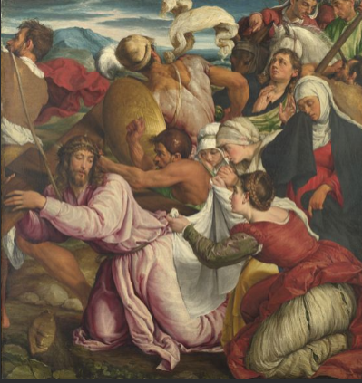
A beautiful picture by Bassano shows her meaningful following of Christ through how she stands and what she wears. It highlights the powerful change that will come with putting on a blessed cover over her head soon.

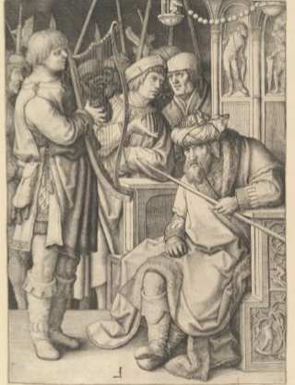
In this drawing, Lucas van Leyden puts his surprising ideas into the Bible story. He makes Saul look angry and maybe even confused when David's music doesn't meet expectations. This adds a touch of strange art style from the North to a well-known old tale we all know about in history books.
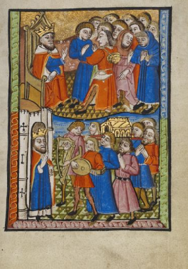
A book with pictures shows two different scenes of King David. One part arranges the time when he brings back a special box called Ark to Jerusalem. It's shown by putting together thirty thousand men in the top view and connecting this event strongly below it, which talks about Mary, Jesus' mother, from the heavenly viewpoint.

Conclusion
In the end, Czech Easter traditions give an interesting trip through time that shows their mix of culture and history with many different types of influences. The beginnings of these traditions go deep into both old ways and Christian history, making a one-of-a-kind fabric that ties together the past with now. From the special beating of Pomlázka to the magic pull of old stories, every custom has a meaning that goes beyond years. The old ways of celebrating Easter in Czech history show a mix of very old rituals and Christian customs, proving how traditions can change over many years. The traditions of Pomlázka and Šibačka on Easter Monday, which are all about growth and starting again, show how Czech people kept their culture going during this time. Moreover, tasty foods like Mazanec and Kraslice make Czech Easter even more culturally rich. These special foods don't just make us happy to eat; they also show thanks for all the good things Earth gives and how life comes back around in cycles. Today, Czech Easter parties smoothly connect old and new traditions. The change of ways, blended with the mixing of tech and new parts, shows an active spirit in our culture. The lasting beauty of Czech Easter is its way of changing and keeping the core customs, making a party that's always there but also keeps growing. In general, the Easter customs of the Czech Republic show how important their past is and how much we need many different cultures to make holiday traditions.

Bibliography

Articles
Asongu, Timothy Terna. "Lekce z historie: česká kultura a řecký příklad." (2022). Cravens, Craig. Culture and customs of the Czech Republic and Slovakia. Bloomsbury Publishing USA, 2006.
Honzíková, Jarmila, Jan Krotký, Pavel Moc, and Jan Fadrhonc. "Weather Lore (Pranostika) as Czech Folk Traditions." Heritage 6, no. 4 (2023): 3777-3788.
Smart, Culture, and Kevan Vogler. Czech Republic-Culture Smart!: The Essential Guide to Customs & Culture. Kuperard, 2022.
Spanosová, Bubulina. "Sentiment and Manifestation of Greekness in the Czech Republic." (2010).

Book
Moravcová, Mirjam. Ethnic Diaspora Festivities in the Czech Republic: Cultural Traditions Between Isolation, Integration and Hybridization. Charles University in Prague, Karolinum Press, 2023.
Wein, Martin. A history of Czechs and Jews: a Slavic Jerusalem. Routledge, 2015.

Picture source
https://thevcs.org/

