The Recognition of Faces Following a Distractor Task
Alexander Harries
Student No. 1704208
University of Wales Trinity St David

Abstract

Previous studies in the field of facial recognition have shown a clear own-race bias when challenging people to identify faces they have previously seen. However, no clear reason has proved why, this may be case. To further test this idea, a study was undertaken featuring 29 participants. The study was split into two parts. In the first part, participants were shown 12 images of black and white faces. In the second part of the study, all participants were shown 6 pages, with each page featuring 6 faces, some of which they’d seen before. They were then asked to recall what faces they had previously seen. At the same time as this, a distracter task took place. The results totally disapproved the hypothesis, meaning there is need for further research into this subject.

Introduction

The topic that this report examines is facial recognition in terms of race and racial groups. The study within this report tests whether or not there is any racial difference or indeed own-race bias, when identifying or recalling people’s faces.
Previous studies such as Brigham & Malpass, (1985) Bothwell, Brigham, & Malpass (1989) and Chiroro and Valentine (1995) have shown that there can indeed be a difference based on race and racial groups when it comes to remembering people’s faces. With people being more likely to recognise other people who are in their ‘in-group’, meaning someone who is of the same ethnicity as them.
An equally fascinating and famous example of this is the case of the ‘Quincy Five.’ A group of five African-American men who were wrongfully found guilty of the murder of Khomas Cellus Revels, a Leon County Deputy Sheriff in Tallahassee, Florida in 1970. Intriguingly, although the court was not presented with any DNA evidence against the five men, they were still indicted after five white eyewitnesses testified to have seen them at the scene of the crime. In the trial of one of the five men, David Charles Smith, investigators working for the defence managed to track down three black men who were actually guilty of the offence and secured a guilty verdict from DNA and fingerprint evidence at the scene of the crime. It was then put to the court that although five eye-witnesses had testified against the Quincy Five, saying that it was indeed them they’d seen, as the eye-witnesses were all white and the defendants were all black, there was a genuine likelihood of mistaken identity based on different races and perceived racial characteristics. This could be possibly due to ‘cross-racial identification’, which is the idea that people are more likely recognise faces of a race that they are familiar with namely their own, and less likely to recognise one of another race.
Doctor William Haythorn, a Social Psychologist at Florida State University was prepared as an expert witness to discuss the theory of cross-racial identification but was blocked from doing so as at the time, as there wasn’t thought to be enough scientific evidence to back up this point. However, the Quincy Five were later cleared of all charges and freed from custody regardless. Three black males from Jacksonville, known as the ‘Jacksonville Three’ were jailed in their place.
At the time of the case of the Quincey Five the world and indeed America were much more racially segregated places, but is this still the case? The world is becoming more globalised each day. Different racial groups are now intermixing and coming into regular contact with one-another in ways they did not before e.g. living and working together. With this in mind, and also considering that the previously mentioned studies all took place at least over 22 years ago, there is a chance that there will no longer be any own-race bias.
All things considered, it is hypothesised that there will be a racial bias of a person’s own race when identifying and recalling the faces of other people. The reasoning behind this idea is due to the results and findings of the previously mentioned reports, and historical examples of this phenomenon such as the Quincy Five.

Methods

There were exactly 29 Participants who took part in the study. The participants were made up of 22 females and 7 males. All those taking part in the study were recruited from the students that attended a lecture at the University of Wales Trinity St David in Swansea, Wales. The age of the 29 participants ranged from 18-60 years of age. The mean age of the participants was 27.31 years. This gave a Standard Deviation of 10.81. In terms of the demographics, all 29 people who took part in this study were white.
The study was designed ‘within-subjects.’ This means that it was looking to establish if there would be any changes within the same group of participants. A ‘paired samples t-test’ was later used to analyse the results. This sees data collected from a single set of participants at two separate times and with varying conditions. Then with the data obtained, seeks to establish if the mean average of one score is noticeably different to the mean average score of the other score. For this study, the Independent Variable (IV), which is the variable that was influenced, was the different races of people in the images. The researcher had control over what races that the participants had seen. The Dependent Variable (DV), which is the variable that was measured, was a person’s ability to successfully remember people’s faces being shown to them on an interactive whiteboard screen.
The study was undertaken in a university classroom. The classroom was modern and included such features as an interactive whiteboard screen. The study used 29 participants, with one university lecturer overseeing proceedings. Within the classroom, the materials included chairs which participants sat on whilst looking at the screen and wrote on desks using paper and pens to record their responses.
Before the study began, the participants were asked to read through and sign a consent form (Item A.) All 29 participants being shown 12 images of black and white faces for 2 seconds each on the interactive whiteboard screen. This was done in silence. In the second part of the study, all participants were shown 6 pages, with each page featuring 6 faces. Some pages contained a number of faces that the participants had previously been shown, whereas others featured no faces from the previous part of the study. Participants were then asked to write down the page numbers featuring the faces that they could recall from having from the first part of test. During the second part of the test, a distracter task took place. When the study was completed, participants were asked to place their response sheets face down on the table, to ensure no conferring. After the study was concluded, the participants were given a debrief form to read through (Item B.)

Results
In order to calculate the results, a pair-samples t-test was undertaken. This was done to see if the participants would indeed be able to recognise more white faces than black faces after a period of being distracted, and possibly being unable to focus all their attention on the task in hand. The results showed that participants remembered a greater number of black faces (M=3.34, SD=2.42) than white faces (M= 2.67 SD=1.97.) With the t-test value calculated at T = (28) = 3.13 P <.05. The hypothesis for this study was that the participants would recall a greater number of white faces, considering the ethnicity of all 29 participants was white. The hypothesis must now be discarded.

Discussion
The aim of this study was to establish if there was any own race bias when, when identifying or recalling people’s faces. Essentially looking to establish whether or not people recognise members of their own race or in-group better than those of another one. A hypothesis was made that people would indeed recognise others who shared their ethnicity better than those who did not. This was backed up by previous studies such as Brigham & Malpass, (1985) Bothwell, Brigham, & Malpass (1989) and Chiroro and Valentine (1995), and legal cases that have played out in the public eye such as the case of the Quincy Five.
However, this was not found to be the case. Results showed the complete opposite outcome to any perceived own-race bias, with significantly more black faces successfully recalled than white faces. This was extremely interesting seeing as all 29 participants in this study were white.
What are the reasons for this? As previously touched on in the introduction of this report, the world is more globalised and interconnected than ever before. Different racial groups now intermix more than ever before (The Telegraph.) Also, racial segregation in countries is much reduced (The New Republic.) Another factor as to why people remembered more faces of a different race to their own, could be the fact that people overcompensated when trying to remember them, as they were afraid to seen as racist (BBC News.)
In conclusion, the results of this study do not show any own-race bias and totally disprove the hypothesis. In fact, they actually showed the complete opposite, that the participants actually remembered more faces of those in other racial groups. There could be various reasons for this. When they are considered, as well as results of numerous reports that did in fact show own race bias, there definitely the need for more research into this subject.

References

Bothwell, R.K., Brigham, J.C., & Malpass, R.S. (1989). Cross-racial identification of faces,
Personality and Social Psychology Bulletin, 15 (l), 19-25.
Brigham, J.C., & Malpass, R.S. (1985). The role of experience and contact in the recognition
of own- and other race-faces. Journal of Social Issues, 14, 139-155.
Chiroro, P. & Valentine, T. (1995). An Investigation of the Contact Hypothesis of the
Own-race Bias in Face Recognition, The Quarterly Journal of Experimental Psychology,
48A (4), 879-894.
Frey, W.H. (2014 November 26th). Glimpses of a Ghetto-Free Future. The New Republic.
Retrieved From: https://newrepublic.com/article/120385/black-white-segregation-
steadily-declining
Howell, D. (2014, August 30th). The fear of being seen as racist. BBC News Online.
Retrieved from: http://www.bbc.co.uk/news/magazine-28967427
Smith, L. (2014, November 8th). Mixed race in the UK: am I the future face of this country?
The Telegraph.
Retrieved from: https://www.telegraph.co.uk/women/womens-life/11205165/Mixed-
race-in-the-UK-am-I-the-future-face-of-this-country.html

Appendices

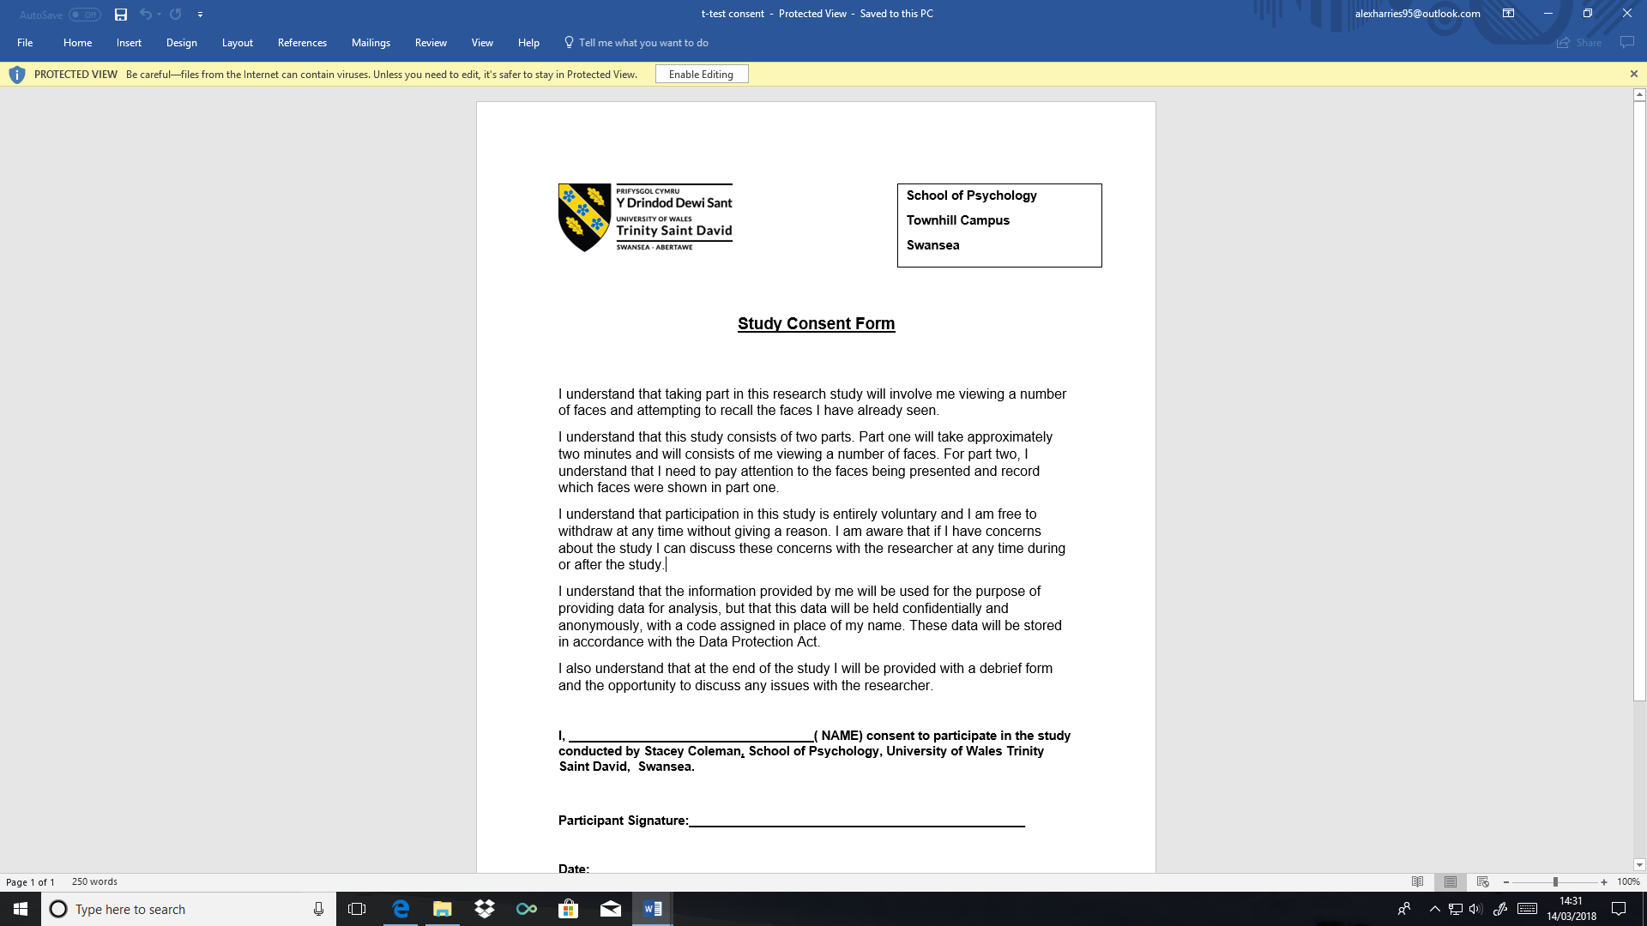
Item A: Consent form
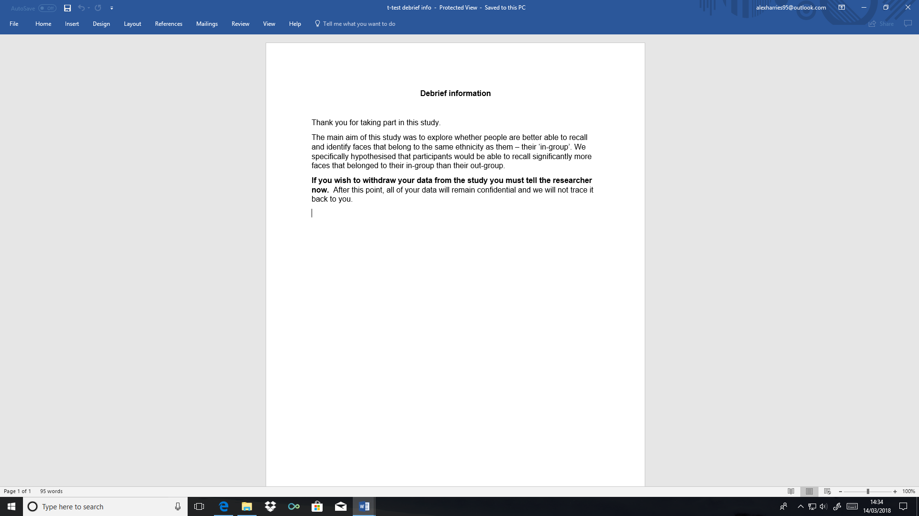
Item B: Debrief Form

*Calculations and Workings out of t-test can be found on the hard copy submitted by hand*

