Jocasta Napier
Student Number - 2316860
ACBA 5024
Research project design

Table of Contents
Abstract 2
Introduction 3
Background of Study 3
Research Questions 4
Aims/ Objective of Study 5
Literature Review 6
Review of relevant literature 7
Identification of gaps in current research 8
How your research will address these gaps 8
Research Design and Methodology 9
Research design (e.g., qualitative, quantitative, mixed methods) 9
Qualitative 9
Quantitative 9
Mixed Methods 9
Data collection methods (e.g., surveys, interviews, experiments) 10
Experiments 10
Surveys 10
Interviews 11
Sampling Methods 11
Data analysis plan 12
Ethical consideration 12
Timeline 13
Detailed timeline of the research activities 13
Expected Outcomes 15
Potential Findings 15
References 16

Abstract
This report is going to be looking into what steps need to be taken when carrying out a research project. It will be explaining they types of methods used to collect the data and how this information is then used to help support the researcher’s findings, it will then go on to discuss how these findings will be used to create the final outcome of the research project.

After explaining each step, the report will also discuss how this information is linked to the research question and advise if they are relevant to the subject or if they research method type would be better suited to a different question.

The research question for this report will be focusing on the amount of waste accumulated on a construction site and is there a way to reduce the amount of unnecessary waste being produced, by finding ways to repurpose the waste. It will also look at whether the company is saving money by not spending it on removing the waste from site.

Introduction

Background of Study

When it comes to writing a research project report, it is important to make a plan before starting the report of what topic is going to be consider for the report, as well as what step you need to take to find out the information needed. Using Research Proposal, a practical guide they have suggested seven basic questions (as shown in figure 1).

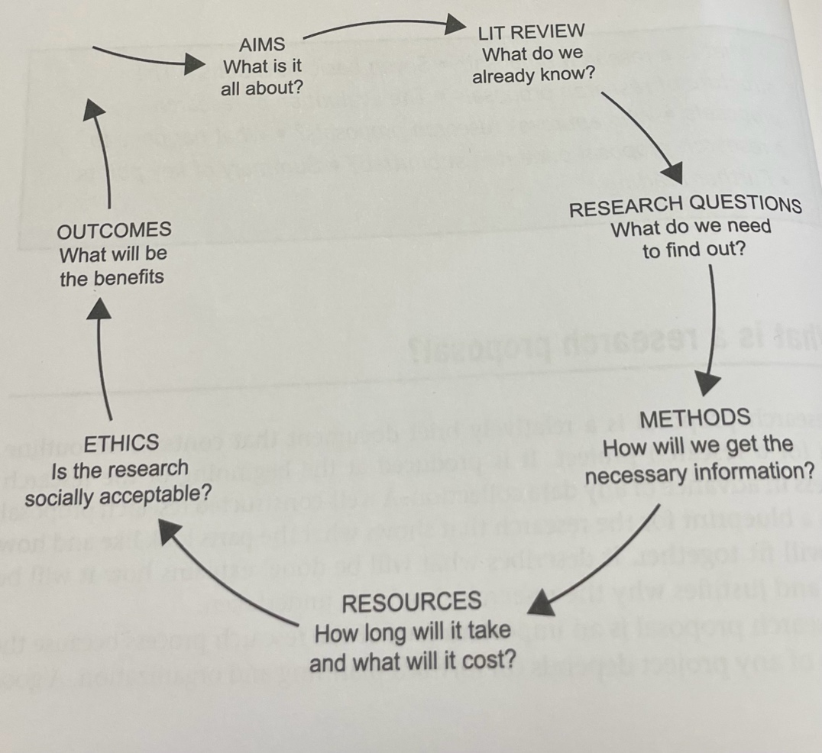
Figure 1 Research Proposal questions (Denscombe, 2012, p6)

By following this method, it can allow a structure to be created before even starting the report of how the research will carry out, which can also allow the researcher to decide whether the information gathered will help make the research worth it or whether it would be better for the researcher to look at a different topic all together.

The researcher has been working within the construction industry and they have noticed how much waste is accumulated which is then wasted, along with how much it costs for the company to remove the waste from sites.

The researcher has decided to investigate waste management and to look into how money could be made from some of the waste materials produced on site, it could also help by repurposing some materials and using them in the local areas to help the community.

An example of this would be when trees are cut down on a construction site to make room for works to take place, these trees could be used for firewood and sold or it could be used to make benches for the local community.

The researcher felt this topic would be interesting for traders as there seems to be a gap in the market for a company to be created where there are different departments to help reduce the amount of waste produced. By having multiple departments, it would produce lots of jobs but in turn it will bring in money to the business by the different avenues such as wood, metals, earthworks, etc. as well as reducing the amount of unnecessary waste.

Research Questions

When it comes to writing a report, it is important to make a plan before starting the report of what topic you are going to consider for the report, as well as what step you need to take to find out the information needed. (Denscombe, 2012, p7)

While thinking about what topic to choose for this report, a conversation started in work about how much money the project would have made from selling, the tree which had been cut down for the project, which would have been around £20,000 if they had cut the wood and sold them for the sole purpose of firewood. This then brought up the topics of what other waste material accumulated could have saved money on the project also, as any waste that is produced on site which isn’t been re used needs to be removed from the project, which usually comes at a high cost to the project.
When thinking of all the costs spent on a project, it all adds up very quickly from the plant, labour, materials and then it needs to be factored in all the additional costs which come with this, site office and supplies for the office such as furniture and stationary, for working staff members it will also include PPE (Personal Protective Equipment) and if is not something they have bought themselves, their gloves and glasses only tend to last 2 days before they come asking for more. This will then become part of unnecessary spending on site.

In addition, working out how depending on the size of the site and the volume on what needs to be removed this cost can cause extenuate costs to a job, as they are usually removed from an external company. This brings up the question how can we reduce these costs and is there a way for a company to be able to dispose of the external waste themselves?

With this said the main question being asked is –

‘Is there a way to efficiently reduce the amount of waste accumulated on a construction site, and can this waste be reused to put money back into the project?’

Aims/ Objective of Study
The aim of a research proposal is to allow the reader to understand what the primary question of what the topic will be investigating and allowing them to ask their own questions regarding the research by allowing the reader early on to see what the question are they can evaluate whether the methodology and findings are appropriate for them early on which will avoid any disappointment or frustration, if they have were to end up reading the entire report and finding information is not relevant for them. (Denscombe, 2012, p7)

Construction sites are known for having a large impact on the environment for the amount of waste accumulated on each site each year.

The researcher wants the aim of this study to investigate if there is a more sufficient way to run a construction site to earn more money for the job and be able to give back to the local area, by utilising the waste made on site and repurposing this in a way where it will bring money back into the business.

To do this the researcher would research how and what materials are found on sites, then separate these items into if the items to which can be repurposed or not, such as a broken drainpipe, cannot be used again on site but could be repurposed for the community. By being remade into something else. By seeing which items can be reused the researcher will then be able to narrow down which items will be more beneficial to re-use. With the hope in doing this they will be able to clearly outline, what other roles could be added to the construction site, to bring more money into the business.

Literature Review
Now that the question has been decided the research will need to investigate past research which has been carried out regarding the subject or similar. Along with collecting any data relating to the study such as waste reporting.

This then allows the researcher to investigate, what we already know about the subject and how the information can be used. Having picked the research question the researcher, will then investigate if their question has been asked before or anything like the question. This will then prevent the researcher from repeating past research, which would be unnecessary. This will then save sometime for the researcher to allow them to focus on if there is any new research would need to carry out validity check on the earlier research. (Denscombe, 2012, p7)

Review of relevant literature
When thinking about what information needs to be collected for this project, the researcher will need to have the background information they will need to look at waste reports from the construction industry such as this from Quails flow –

‘In a construction waste report from 2023, states that the construction industry generates 62% of all UK waste with 32% being sent to landfills. The target to divert waste going to landfill in construction is aimed at 99%, but this is currently not being met as 13% of all construction waste is sent straight to landfill.’ (Quailsflows.com, 2024) Which states that 62% of the waste generated from construction sites, with 32% of this going to landfill sites. Looking at this it shows that there is too much waste being left for landfill from construction sites and it is something which can easily be reduced. The researcher should also look at other websites to find out more information on the amount of waste produce, so they are able to show that it is a significant amount, and it will show the finds are correct.

Interviews can also be carried out asking workers who have been in the industry for multiple years to find out how waste use to be dealt with compared to now. From past conversations the researcher has had, there appears to be unorthodox methods to remove unwanted waste from site and some workers may not see the need to change as drastically to minimise the impact of waste on site. The research can also hold interviews with people who are new to the industry, who may be more aware and want to make changes to help the environment. This will give the researcher a chance to compare the results of this and see if there is any correlation with between age ranges and waste.

The next step which would be beneficial for the research and help with the findings, would be to contact sites to try and get an accurate measure on what waste is taken from sites, they can do this by looking at waste notes, this will allow the researcher to see how many loads of each type of product is moved, how large the weight of each load which are being removed and the cost of the load.

The researcher can then use the information to calculate the cost per load and see the amount of waste which is being removed off site and determine what is unnecessary waste and can calculate what money can be saved by repurposing these items into other areas.

The research can also collect data to see if there is a correlation with age and how item should be recycled and how often are they doing it. This can also incorporate how PPE is handle, as there is often work men’s gloves left lying around not only construction sites but in many public areas, do worker have much care for these items, both can help a researcher collect more data on waste and costs on site but from different angles.

It is important for the researcher too look how much plant and labour costs for companies, if it is cheaper to have in house machinery or is it most cost effective to hire the plant in from another company, due to stand down time or if it is possible to have in house machinery which can also be rented out to other parts of the company or outside of the business. As well with labour, the researcher will need to look into what costs more to have hire in staff or have staff fully employed to the company.

When looking at the research it is important for the researcher to look at the alternative ways the waste can be used, not just to make money but different ways for the items to be up cycled and how this has been done previously.

Identification of gaps in current research
A gap in the research is when or if there are any areas of the existing research which has missing information or if the information available is lacking knowledge on the subject. Which could cause more questions than answers, as some areas have been left unexplained.
From the researched carried out, it looks like the gap in research is how the construction industry is working on reducing their waste, there is a lot of information on why and how but not how to make the changes needed.

How your research will address these gaps
The research being carried out, is to help find different ways for the construction industry to reduce their waste, as well as hopefully find a way to encourage works to start reducing their waste with encouragement or rewards for recycling their waste. By having some of the waste, to bring money back into the industry, this could be a positive incentive for worker and the industry as a whole, could get behind.

Research Design and Methodology

Research design (e.g., qualitative, quantitative, mixed methods)

Qualitative
Qualitative data, is when a researcher is looking for more information on a subject, this information is usually collected with open questions, such as ‘why do you think this?’ ‘is there anything else you would like to add?’, ‘how could we improve?’. This allows the researcher to collect more of people own opinions or their beliefs or motivations on the subject. Depending on your subject matter, qualitative questions can be very helpful, but they are also harder to determine a clear result, when looking at the findings. The research would probably need to add these results to more general categories if they were going to extract data from these findings later, such as using key words.

Quantitative
Quantitative data is data collected mainly from numbers and then using these fining to analyse to try and identify a pattern, to test hypotheses and try and make predictions on any trends in the data, this information can be collected mainly from closed questions, where the researcher is either asking people’s opinion on a scale of one to 10 or by answering yes / no questions.

Mixed Methods
Mixed methods are where both Qualitative and Quantitative methods are used to together so that the research is able to find a more comprehensive information on the subject, allowing the researcher to have more in-depth information being collected.

For this research project, the researcher is looking to use both qualitative and quantitative data. As they will be asking worker for the opinions on how they feel about the amount of waste generated and the recycling in the industry, if they think there are any changes can be made, as well asking them more general questions about the industry such as –

Do you think the construction industry produces to much waste? (Quantitative)
Yes or No,

and then it could have a follow up question -
If yes, why do you think this? (Qualitative)

Data collection methods (e.g., surveys, interviews, experiments)

Experiments
Experiments can be using method for researching data as it allows trials to be carried out multiple times and in different way to see what gives the best outcome. This can be done with groups of people or can be carried out on objects, such as concrete blocks. There is usually a control group, so that the results can be compare and analysed.

Using experiments can be good way to narrow down findings for a report as they will show both positive and negative results, meaning that the researcher will be able to use this information to produce clear finds to share with others.

Although this is a very effective way to collect data, for this research, it wouldn’t be possible to carry out experiments effectively on this research project, as most of the information needed will be collected through data.

Surveys
A survey is a way the researcher can gather information by creating questions relevant to the subject, the objective of try and gain information from a group of people which can then reflect the population’s view.

Surveys are a keep part of this project research, as it allows the researcher to get a feel for what people think about the subject matter which will help reduce the chances of a bias view being used, which could happen if the research had already pre-determined the outcome of their research.

Interviews
Interviews are often carried out during research, to allow the research to gather more informative information.

Before the interview is carried out the researcher will often write down exactly what they want to ask, this can range for question regarding all their research, or it will be focused on certain aspects. By preparing the questions before hand, it means that the research can keep on topic when asking the questions, this also allows them to ensure that they are able to collect data which they able to ensure they can compare they finding to gather a clear result. Both open and closed question are usually asked when carrying out interviews.

Sampling Methods
For the sampling method for this project it will target just people who work in the construction industry which minimise the size of sample group, although it may reduce the size or participants, it is important for the research, to try and get firstly different age groups, secondly have different experience levels and how long they have worked in construction, thirdly to have different types of workers in the group (office workers, site supervisors, ground workers etc.) and then finally it would be interesting to have male and female participation. This should hopefully give insightful results for the researcher and see the different prospective.

Data analysis plan
A data analysis plan is where the research is outlining how their findings will be organised and presented to ensure a reliable and systematic approach to the research which will be easier for readers to understand this information. Although the project will be conducting interviews and surveys, it will also be taking on statistical information regarding any fact and figures on waste management findings and procedures already carried out.

Ethical consideration
Ethical consideration are the steps that need to be considered when carrying out any research, especially when questions are being asked by anyone related to the business. The main principles which need to be considered when carrying out any study are –
- Informed consent – Before asking a participant any questions about any research, the researcher must advise the purpose of the study, any potential risks which may occur and any procedures being carried, this allows the participant to make a clear decision if they want to in the study or not.
- Confidentiality – ensuring all participants personal information is kept private and secure.
- Anonymity – is different to confidentiality in where it can ensure the information the participants give, remains anonymous in the study, this is an important aspect of the study as participant, will be more willing to share their true feeling, if they know there identity is kept private which will ensure if the company they work for reads the report, they cannot link it too anyone who works for them.
- Minimising potential harm – It is important for the researcher to take responsibility to ensure the participants taking part have a little if any exposure to harm during their participation, this includes – social, physical, or psychological.
By taking all these factors into consideration when asking people to participate in the research it will allow them to have trust within the researcher as well to feel free to answer any questions open and honestly.

Timeline

Detailed timeline of the research activities

It is important for the researcher to make a timeline for carrying out their research, by making a schedule of what data needs to be collected. If they want to carry out surveys, interviews, or questionnaires, they will also need to decide what data they are looking to collect and then how long this data will take to read through and how quickly they can put that data into useful information for them.

It will also need to be taken into consideration how long it will take to find people to answer the researcher questions, if they are arranging interviews, it will be slightly easier to get all questions answered. Once you have some to be interviews then it shouldn’t take long from start to finish, whereas if you are just leaving your research to the chance people will fill in the survey posted, it is usually harder to get these back quickly, as a lot of people will look the other way, there will also be a higher chance they will miss out questions, which can make the research harder to get a clear result.

With this as well, you once they have inputted this information it is an easier way for them collect the information, the researcher then needs time to the decipher through their data and decided what will be beneficial to them and what isn’t, it will also become clear to the researcher if they need to do anymore investigate or need to collect more data, and by having planned to collect this data early on the researcher knows they have the time to be able to do this.

For this project –

The timeline is most probably going to be from September to April, this allows the researcher, 8 months in total, not only will they need to collect their data in this time they will also need to write about their findings and come to a conclusion whether or not they have come to the conclusion they were expecting.

Dates | Objectives
Month 1 | Have a look into different research topics and decided which topic researcher would like to investigate further.
Month 1 - 2 | Start literature review do background research on topic look at past research, past reviews and see where there is a gap for further investigation
Month 2 - 3 | Decided which method they would like to collect data with and then create surveys, write interview questions and decided which pool of people you want the research to come from, think about how many people will be needed to have realistic results, would also decide if you want quantitively or qualitative data.
Month 3 - 4 | The researcher should plan to hand out their survey and hold interviews, for the surveys they should give a 14 day turn around. The researcher can then use this information to correlate the data, by doing this early the research can also decide if they need to go back out, if they need to issue any more questionnaires or interviews.
Month 4 – 5 | The researcher should now have all the data they need and will need to create a data analysis plan, so they can start the process of going through the date more in depth and decided how they want to show their findings.
Month 5 – 6 | Once the researcher is happy with all the information, they have they can then start writing about their findings and advise if they are what the researcher expected or not.
Month 6 - 7 | The researcher should have most of the information captured, they will be able to take this time to review what they have and see if they need to add anymore and potentially have an outside person to review the work so far.
Month 7 – 8 | The final two months on this the researcher will review their work and make sure they are happy with their report and ready to have it published.

Expected Outcomes

Potential Findings
After the researcher has been through all their research the findings will hopefully show that the amount of waste which is gathered on site has a large percentage and how although there are being steps taken to reduce the amount of waste on site, there still needs to be a much big change within the industry to help make these changes more efficient and long term.

It should also allow the researcher to put together a plan of how they would create a business plan, for one company to handle all different services within the company which will in fact make a profit for the company rather adding to the costs.

References
Creswell, J.W., Creswell, J.D. (2023) Research Design Qualitative, Quantitative and Mixed Methods Approaches. 6th Edn. Thousand Oaks, California: SAGE.

Denscombe, M. (2012) Research Proposals, A practical guide. Berkshire: Open University Press.

Qualis flow [QFlow] (2025) The UK Construction Industry Waste Report 2023 Available at: https://www.qualisflow.com/uk-construction-waste-report-2023/#:~:text=As%20an%20industry%2C%20construction%20consumes,over%2040%25%20of%20landfill%20waste. (Accessed:17th March 2025)

UK Government [GOV.UK] (2024) Offical Statistics, UK statistics on waste, Available at: https://www.gov.uk/government/statistics/uk-waste-data/uk-statistics-on-waste (Accessed 20th March 2025)

UK Government [GOV.UK] (2021) Construction and demolition site – Do you know what’s in your waste? Available at: https://environmentagency.blog.gov.uk/2021/03/28/construction-and-demolition-sites-do-you-know-whats-in-your-waste/ (Accessed 20th March 2025)

Clear it Waste (2024) The importance of reducing your construction waste, Available at: https://www.clearitwaste.co.uk/construction-waste-removal/reducing-construction-waste/ (Accessed: 1st April 2025)

Cousins, S. Royal Institution of Charted Surveyors [RICS] (2022) Change constructions throwaway culture, Available at: https://ww3.rics.org/uk/en/modus/built-environment/construction/what-a-waste--changing-construction-s-throwaway-culture.html (Accessed:2nd April 2025)

Waste Management (2025) Construction Waste Guide, Available at: https://www.wastemanaged.co.uk/our-news/construction/construction-waste-guide/ (Accessed: 29th March 2025)

