
Programme: BA (Hons) Business Management
Module: Stakeholder Engagement
Module code: LCBB4013
Component 1: Coursework-Portfolio

Stakeholder Management Plan for an Urban Regeneration Public Park Project

Name: Ionela Turcanu
ID:2321536

Table of Contents
Element 1: Introduction 3
Element 2: Application & Stakeholder Engagement Strategies 4
Element 3: Ethical Considerations in Consultation, Participation & Feedback 7
Element 4: Conclusion & Reflection 9
References 12

Element 1: Introduction
The suggested project is a case of new urban regeneration zone as a public park development on a formerly unused and poorly maintained parcel of land in a highly populated urban environment. The project goal is to turn this abandoned location into a green facility that brings back life to this area by use of various functionalities that promote the social and environmental welfare. Since the lack of green areas, increased pollution, and the reduction of the level of community unity are the challenges of many cities’ communities, the transformation of this region into a park is the opportunity that may be successfully used to improve the quality of life in the area. The project will provide a clean, safe, and beautiful place where people can meet each other and work out and rest, and also offer a home to the urban biodiversity. Besides that, the park is potentially capable of enhancing the visual quality of the landscape, causing the local economy to become active and supporting broader sustainability efforts like climate resilience and urban greening efforts.
A number of important stakeholders would be benefiting out of this project. The most tangible benefits of the local residents will be the better access to recreational space, physical and mental health, and the feeling of community pride (Allan et al., 2024). The Local Council or Municipal Authority will gain with the successful implementation of high-impact regeneration project, which correlates with urban development strategies and is the evidence of responsible investment in the infrastructure of the population. The environmental NGOs and sustainability groups will be given a chance to work together on projects concerning biodiversity, conservation and environmental education which will enable them to promote their organisational missions.
It can also boost the number of visitors to the area through the park which in turn may boost the footfall and economic activity of the local businesses. Contractors and construction firms working on the project also gain by getting to work and gain professional experience on a socially worthy project. Youth organisations and other community groups will have access to new spaces of activities, events and programmes of engagement (Bai and Zhang, 2023). Lastly, the recreational facilities will be better and the environment healthy and more attractive in the eyes of the visitors and the general population. By implementing all these benefits, the urban regeneration public park could bring about a substantial social, economic, and environmental value to a large number of stakeholders.

Element 2: Application & Stakeholder Engagement Strategies
2.1 Power, Influence, and Interest Table
Stakeholder | Power | Interest | Influence | Justification
Local Council / Municipal Authority | High | High | High | The council controls planning approval, funding, and policy direction. They have a strong interest as the project contributes to local development goals.
Local Residents | Medium | High | Medium | Residents have a high personal interest as the park affects their living environment. Their power is medium as they can support or oppose through public consultations.
Environmental NGOs / Sustainability Groups | Low | High | Medium | They have high interest due to environmental objectives but low formal power. Their influence is medium through advocacy and public campaigns.
Local Businesses | Medium | Medium | Medium | Businesses may benefit from increased footfall and economic activity. Their moderate power comes from community partnerships and lobbying potential.
Contractors / Construction Company | High | Medium | High | They have high power in delivery and decision-making during construction. Their interest is medium, primarily focused on project execution.
Community Groups / Youth Organisations | Low | High | Low | These groups have high interest in community facilities but limited power. Their influence is low unless mobilised collectively.
Visitors / General Public | Low | Medium | Low | The general public benefits from park use but has low power and influence in formal decision-making.

2.2 Stakeholder Map (Power–Interest Grid)
The Power-Interest grid is an effective tool to comprehend the degree of interaction to be established with each of the stakeholder groups. The Local Council or the Municipal Authority and the Contractors or the Construction Company are located within the High Power-High Interest quadrant. These stakeholders have a lot of power on approvals on planning, funding, and delivery of the project in terms of operations (Zhang, Kang and Koo, 2021). They also have a great interest since the success of the park is directly proportional to their governance and professional lives. Close observation of this group should therefore be carried out by regularly updating them, making decisions together and communicating with them directly. They play an important role in making sure that compliance and quality standards and timelines are always achieved during the lifecycle of the project.
Local businesses will be in the High Power-Low Interest quadrant. Though the businesses might not be interested in the specific design or environmental aspects of the park, they still have a significant authority in the economical aspect and possibility to impact the mood of the population (Brorström and Willems, 2023). They might not be interested at all, especially when the construction does not directly affect their operations or when they can recognise the opportunities to commercially benefit. Their satisfaction should be maintained by providing them with information on disruptions and possible benefits in time so that they do not show opposition and continued collaboration.
This is the Low Power-High Interest group, which encompasses the local residents, environmental NGOs and sustainability groups, community groups and youth organisations. The reason why these stakeholders show great interest is the direct impact that the park will have on the living conditions, environmental welfare, and community activity opportunities (Xuili and Maliene, 2021). Nonetheless, their formal power in the decision-making process is relatively low, however, they can impact on the social thought or create advocacy pressure. It is also important to keep them posted so as to inspire confidence, to participate in activities and to get useful information on design requirements, safety issues, cultural practises, and access factors.
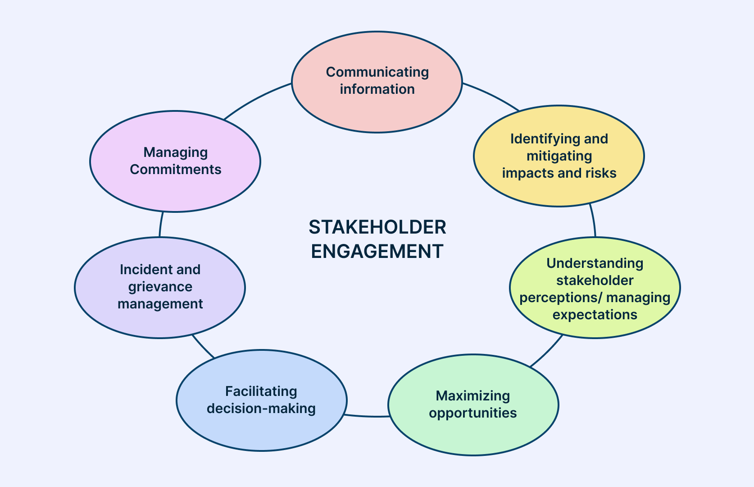
Figure 1: Stakeholder Communication and Consultation Strategy Framework
(Source: Della Spina and Giorno, 2022)
At last, the Low Power-Low Interest quadrants are occupied by visitors and the general population. This group is the least concerned with planning and development yet, will enjoy the recreational facilities when the project is opened (Della Spina and Giorno, 2022). They are interested but not obsessed by it to the point where they need to engage in it constantly. It is adequate to monitor their feedback via the general communication channels including once the park is operational.
2.3 Communication Plan and Consultation Strategy
There must be a clear and defined communication plan that will guarantee every stakeholder group is provided the right information during the project. In the case of the Local Council or Municipal Authority, the communication should be elaborate and regular as they have great power and are highly interested in the development of the project. They need to plan updates, progress, budget and risk assessment reports submitted monthly, as a formal presentation and periodical email reports. The method will enhance compliance, accountability, and shared decision making towards important project phases.
The accessibility and open communication are needed by the local residents since they are directly involved in the development of the park itself. Data provided to them will be the design proposal, updates on environmental impact, consultation, and construction schedules. It should communicate after every two-three month or ahead of significant changes through community meetings, social media updates, printed leaflets, and special project website. These approaches provide a chance of bilateral communication and make residents informed and capable of sharing their needs and concerns.
The environmental NGOs and the sustainability organisations will be inform updated on the biodiversity plans, sustainability assessment and environmental monitoring. This group should be reached by quarterly communication (using email newsletters, virtual consultations and joint workshops). Their technical knowledge may be used to enhance the environmental performance, and the workshops may solve problems together and organise the environment.
The information that the local business needs is focused on construction effects, collaboration opportunities, and foot traffic changes. The communication will be done on a bi-monthly basis and communication methods will be done through means like letters, emails and business round-table meetings. Such strategies will make sure that the businesses will be able to plan in case of delays and engage in conversations about the opportunity to conduct more economic operations once the park is opened.
There is a high level of detail and consistency of the communication between the contractors and the construction company since they are the operational party in the delivery of the project. The coordination meetings held weekly accompanied by emails, construction management platforms, site inspections, and telephone calls ensure that the technical information, deadlines, and safety requirements are well understood and implemented (Liu et al., 2022). The result of this constant involvement is effective planning and prompt elimination of problems.
Information on opportunities of activities, volunteer positions, and development of specified community areas in the park will be disseminated to the community groups and youth organisations. When communicating with the community, every three to four months through workshops, community forums, social media, and updated through email is suitable. Such techniques can be used to reinforce inclusivity and communicate a sense of ownership of the new park facilities by the community.
The communication among the visitors and the general population will be reduced and will focus on the key achievements like the progress of the construction process, the events and the official opening date of the park. It will inform via local newspapers, social media, public notices and updates in the project websites. This also means that it has a wide visibility and only minimal communication is required and this is suitable in cases of low power and low involvement stakeholders in decision making.

Element 3: Ethical Considerations in Consultation, Participation & Feedback
The central issues surrounding the consideration of engagement of the stakeholders in the urban regeneration public park are ethical considerations, which will be carried out with responsibility, fairness, and transparency. Since the project directly impacts a diverse urban population, it is important to make sure that the consultation process is characterised by the elements of moral integrity and the desire to participate in an inclusive manner. In order to realise this, the project will employ a blend of consultation techniques, which will involve holding meetings with the people, conducting workshops in the community, engaging in focus groups, as well as using online media and surveys (Xie, Liu and Zhuang, 2021). All these approaches present various strengths and are beneficial to support diverse needs of stakeholders. The use of public meetings also provides an open, direct dialogue and the stakeholders have the opportunity to bring up concerns or pose questions without any type of secrecy. Focus groups and workshops will help in more specific dialogue, especially to stakeholder organisations: youth organisations, local residents, and environmental NGOs. Meanwhile, online services and online surveys help to engage more people and be more versatile because those who are not able to attend the real-life events can also participate in them.
One of the ethical issues in this engagement process is the security of personal information and a confidentiality agreement. The data that is gathered in surveys and event registration process or in any other online form should be safely stored and handled according to the principles of data protection. The use of their data, access and retention period should be communicated to the stakeholders on how their data will be utilised (McKay and Tantoh, 2021). By presenting such information in an open manner, it is possible to foster the trust of the consultation process and make people feel comfortable sharing their honest and valuable feedback. It is also necessary not to be biased in gathering information. The written materials in consultation should be in a neutral language, i.e., surveys or discussion guides should not affect the participants to a certain opinion. Facilitators of the discussions will also need to be trained on how to be unbiased so that no side of the discussion prevails and that the discussion is balanced.
Another notable ethical obligation is inclusive participation. City communities are usually diverse, with the stakeholders varying in age, culture, language, mobility, and access to digital technologies. In this regard, it is important that the consultation process is vigorously used to eliminate obstacles that can exclude some groups of people (Mirzakhani et al., 2021). The contents must be presented and explained in simple and easy to understand language and there should be provision of translations where necessary. The venues of consultation have to be decided keeping accessibility in mind that is whether they are accessible to the people with disabilities or limited mobility. The tools of digital participation must also be easy and not complex so that the individuals having limited technical abilities can use them fully (Wang et al., 2022). By maintaining the principles of Diversity, Equity and Inclusion (DEI), it is possible to make sure that the stakeholders who are frequently neglected or less assured have equal chances to voice their opinion.
Another important ethical requirement during the consultation process is transparency. The stakeholders should clearly comprehend the aim of the engagement, which aspects of the project can be affected, and which aspects are determined because of regulatory or financial limitations. Delivering sincere and thorough information will avoid any misinterpretation and will not create the impression of tokenistic action (Simons et al., 2024). It is vital to make sure that the project representatives do not selectively disclose information or manipulate the results of the consultations because this kind of behaviour causes a lack of trust and decreases the project credibility.
Lastly, the ethical involvement of the stakeholders will entail a clear and strong methodology of the collection and review of the feedback. The feedback will be collected with the help of surveys, online forms, comment boxes in community places and the input that will be received during the events. Upon collection, the feedback shall be analysed in order to determine certain prevailing themes, issues and priorities. This feedback will be included in project planning where applicable and implemented in design modification or implementation strategies. In order to close the feedback loop, the stakeholders will receive updates that give a summary of what was learned and the impact of their input on decisions.

Element 4: Conclusion & Reflection
To sum up, stakeholder engagement is an essential part of successful implementation of the urban regeneration public park project. The planning of an open park in the city that had been left to waste necessitates an open and participatory strategy that should take into account the opinions of various stakeholder groups (Wang et al., 2022). The project through a systematic framework of engagement can be in a better position to find out the community needs, match the expectations, and discuss the concerns at an early stage of planning. This is achieved by applying tailored communication plans whereby high-power stakeholders, including the Local Council and the contractors, are kept at the forefront by updating them frequently in a detailed manner to enable them make informed decisions and govern the situation well. In the meantime, high-interest stakeholders, such as the local inhabitants, environmental organisations, and community groups, are updated and made to participate in the process of the project development by the means of consultation events, workshops, and open exchange of information. Such non-exclusive involvement does not only empower communities but also contributes to the project outcomes with the incorporation of local knowledge and aspirations.
The analysis of this process as a Junior Stakeholder Manager points to the complexity and significance of a coordinated stakeholder involvement in an infrastructure project based on communities. Among the important lessons acquired in the course of the exercise is the importance of patience, flexibility, and empathic knowledge when dealing with various people with different priorities, concerns, or expectations (Zhu and Li, 2024). Residents and community groups are among stakeholders that tend to be very emotional with the neighbourhoods, and therefore, their opinions will have to be addressed with a lot of sensitivity and respect. Conversely, technical stakeholders (i.e., contractors or the Local Council) are normally concerned with compliance to regulations, budget and project schedules. The relationship between these two opposing views must be negotiated carefully and any disagreements must be avoided by communicating clearly to prevent conflict within the lifecycle of the project and ensuring trust in the project.
The other lesson is associated with the importance of communication. Effective communication, timely, and clear communication helps a great deal in reducing misunderstanding and makes sure that stakeholders are informed about decisions, progress and possible effects. Open and constant communication will make the stakeholders feel important and less likely to feel that they are being imposed on the project. This supports the idea that communication is not merely logistic exercise but a strategic weapon that can either consolidate or destroy the relationship among the stakeholders.
Another crucial issue that is noted in the reflection is the role of the ethical aspect of the engagement activities. Leveraging on the personal information gathered either via surveys or by consulting with the relevant individuals should be done with care to ensure the information remains confidential and its use adheres to the existing laws. When consultation processes are conducted without bias, with all sense of impartiality, it also helps in ensuring that there is a fair and credible engagement environment. This involves formulating the questions in surveys that do not bias participants to a particular set of responses and creating discussions in a manner that enables everyone, particularly members of marginalised and less assertive groups to be heard.
Another important aspect of effective stakeholder engagement was the Diversity, Equity and Inclusion (DEI) practises. Having people with varied backgrounds, ages, and skills involved in consultations in a meaningful manner will help to make the project outcomes more balanced and representative. Engagement activities should also be available, culturally aware, and attentive towards any possible barriers like language barriers, physical disability, or digital disparities. This inclusivity is not only beneficial to maintain social equity but also enhance the overall design and functionality of the park since this way it can be assumed that the park will need the needs of a wide variety of users.
At the end of it all, the experience highlights the fact that engagement of stakeholders is not just a formal issue but a pillar in the aspect of sustainable urban development. When the community voices are included at the beginning of projects, then there are higher chances of implementing the projects to attain long term acceptance, community ownership and a constant use by the people. When the stakeholders have a true sense of being heard and respected, they will be more willing to contribute towards the project and help maintain it and develop it with time. This reflection as a Junior Stakeholder Manager has highlighted the importance of ethical, transparent, and inclusive practises in developing long-term relationships with communities as well as in the provision of infrastructure projects that are sustainable, socially-responsible, and in line with the vision of long-term sustainability.

References
Allan, M., Rajabifard, A. and Foliente, G.,(2024). Climate resilient urban regeneration and SDG 11–stakeholders’ view on pathways and digital infrastructures. International Journal of Digital Earth, 17(1), p.2385076.
Bai, Y., Wu, S. and Zhang, Y., (2023). Exploring the key factors influencing sustainable urban renewal from the perspective of multiple stakeholders. Sustainability, 15(13), p.10596.
Brorström, S. and Willems, J., (2023). Getting integrative urban regeneration strategies done: Insights from Antwerp and Gothenburg. International Review of Administrative Sciences, 89(2), pp.346-362.
Della Spina, L. and Giorno, C., (2022). Waste landscape: urban regeneration process for shared scenarios. Sustainability, 14(5), p.2880.
Liu, B., Lu, X., Hu, X., Li, L. and Li, Y., (2022). What's wrong with the public participation of urban regeneration project in China: a study from multiple stakeholders' perspectives. Engineering, Construction and Architectural Management, 29(1), pp.91-109.
McKay, T.J.M. and Tantoh, H.B., (2021). A dialogue approach to stakeholder engagement with urban communities: The case of Mofolo Park, Soweto, Johannesburg, South Africa. Journal of Environmental Planning and Management, 64(12), pp.2172-2191.
Mirzakhani, A., Turró, M. and Jalilisadrabad, S., (2021). Key stakeholders and operation processes in the regeneration of historical urban fabrics in Iran. Cities, 118, p.103362.
Simons, S., Kinjawadekar, A. and Kinjawadekar, T.A., (2024). Assessing the impacts of ecological framework of Indian riverfront revitalization projects. Environment, Development and Sustainability, 26(11), pp.27553-27583.
Wang, J., Yang, Y., Huang, H. and Wang, F., (2022). Stakeholder management in government-led urban regeneration: A case study of the eastern suburbs in Chengdu, China. Sustainability, 14(7), p.4357.
Wang, Y., Yao, Y., Zhang, Y. and Xiang, L., (2022). A framework of stakeholder relationship analysis for an urban regeneration project based on social network analysis: A dynamic perspective. Journal of Urban Planning and Development, 148(4), p.04022035.
Xie, F., Liu, G. and Zhuang, T., (2021). A comprehensive review of urban regeneration governance for developing appropriate governance arrangements. Land, 10(5), p.545.
Xuili, G. and Maliene, V., (2021). A review of studies on sustainable urban regeneration. EPiC Series in Built Environment, 2, pp.615-625.
Zhang, Y., Kang, S. and Koo, J.H., (2021). Perception difference and conflicts of stakeholders in the urban regeneration project: a case study of Nanluoguxiang. Sustainability, 13(5), p.2904.
Zhu, Y. and Li, Z., (2024). ‘Sharing’as a Critical Framework for Waterfront Heritage Regeneration: A Case Study of Suzhou Creek, Shanghai. Land, 13(8), p.1280.

