University of Wales Trinity Saint David
School of Engineering
Technical Report: Series Hybrid Vehicle (Part A)

Written by: James Thomas
Student Number: P146546

BSc Motorsport & Automotive Engineering
December 2017
Electric and Hybrid Propulsion Control (M3X8668)

Abstract

This report explores the performance of a buggy throughout a duty cycle – the performance will be assessed on its power requirements to overcome its total resistance.

Its total resistance is determined by the aerodynamic resistance, gradient resistance, acceleration resistance and rolling resistance – each resistance acting on the buggy during the duty cycle is calculated and is used to determine the total resistance acting on the buggy, and to identify the power requirements to overcome the resistances.

The duty cycle has been created and involves 5 sections, with different terrains which effect its rolling resistance due to the rolling resistance coefficient between the buggies tyres and the terrain surface. Each section of the duty cycle has varying gradients which as shown in the report affect its gradient resistance and velocity – it was further determined within the report that the velocity as a result of gradient changes also changed the acceleration and aerodynamic resistance.

Table of Contents
Abstract 2
Table of Figures 4
1. Introduction 5
1.1. Background 5
2. Duty Cycle Analysis 7
2.1. Sector 1 - Wet Grass Field Terrain 7
2.2. Sector 2 - Gravel Track Terrain 9
2.3. Sector 3 - Soft Loose Soil Terrain 11
2.4. Section 4 - Wet Grass Field Terrain 12
2.5. Section 5 – Loose Sand Terrain 13
3. Summary of Findings 14
4. References 18

Table of Figures

Figure 1: Polaris ACE 150cc (left) (Source: Blitzworld, 2017) 5
Figure 2: Polaris ACE 150cc Engine specs (Source: Polaris, 2017) 6
Figure 3: Polaris ACE 150cc Body Specs and Dimensions (Source: Polaris, 2017) 6
Figure 4: Coefficients of Rolling Resistance for Terrains used (Source: EngineeringToolbox, 2017) 7

Introduction

The main aim of the report is to evaluate through critical analysis, the performance of an off-road buggy for corporate entertainment. The off-road buggy will be undergo a duty cycle at an off-road track at a corporate entertainment event.
The buggies performance that will be determined and analysed is the vehicles top speed, acceleration and grade-ability.
In order to assess the buggies performance in these aspects the buggy will endure a small off-road track, and the following will be calculated and determined:

- Resistive forces and total tractive force.
- Power requirement for each section of the track.
- Maximum power and average power requirements.

Background

The buggy chosen for the event is a Polaris ACE 150cc with the following specifications:


Figure 1: Polaris ACE 150cc (left) (Source: Blitzworld, 2017)

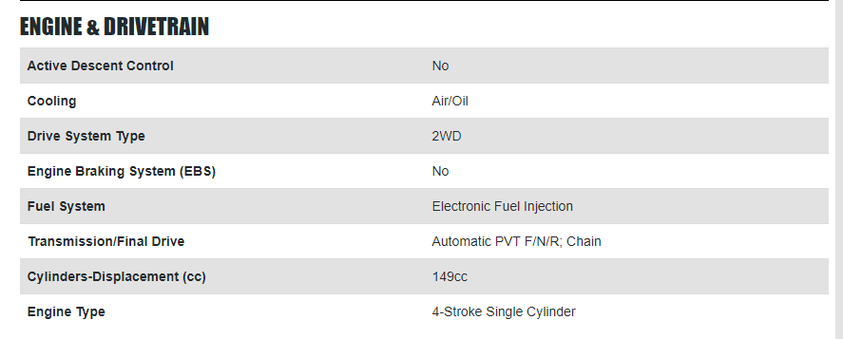
Figure 2: Polaris ACE 150cc Engine specs (Source: Polaris, 2017)

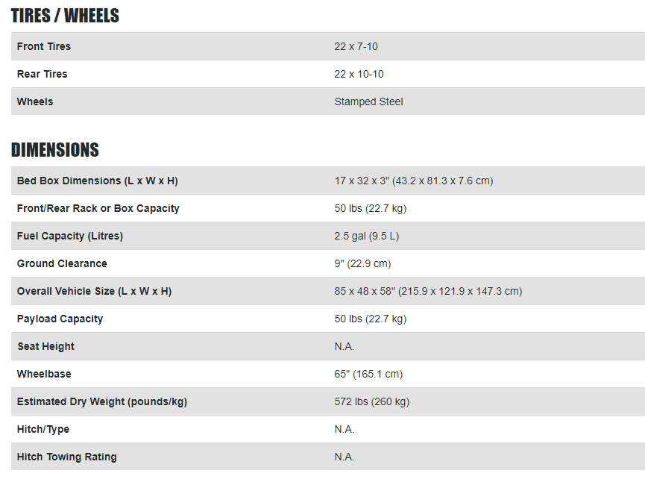
Figure 3: Polaris ACE 150cc Body Specs and Dimensions (Source: Polaris, 2017)

The mass of the buggy was combined with the average mass of a human (70kg) to obtain the total mass of the buggy which is 400kg.
The dimensions of the buggy were obtained and used to calculate the area of the buggy, which was calculated as 3.88$m^{2}$. This was used along with the density of air (1.2) and coefficient of drag (0.6) to calculate the aerodynamic resistance of the buggy.

Duty Cycle Analysis

The duty cycle consists of off road track, with various types of terrain. The coefficient of rolling resistance was researched between the tyres and the different terrains as shown below:

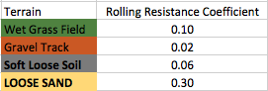
Figure 4: Coefficients of Rolling Resistance for Terrains used (Source: EngineeringToolbox, 2017)
The rolling resistance was calculated for each terrain using the above coefficients, and the below equation:

$$Rolling Resistance=Mass × Gravity × Coefficient of Rolling resistance$$

Using the above equation, the following rolling resistance values were determined for each sections terrain:
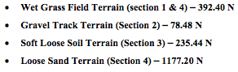

Sector 1 - Wet Grass Field Terrain

The off road buggy sets of on a flat wet grassy terrain, and can accelerate up to top speed and maintain a constant velocity for 3 seconds prior to an incline hill which has a total length of 10m as shown below, 17 seconds of flat surface, then 8 seconds of incline and 8 seconds of flat surface at 10m height.
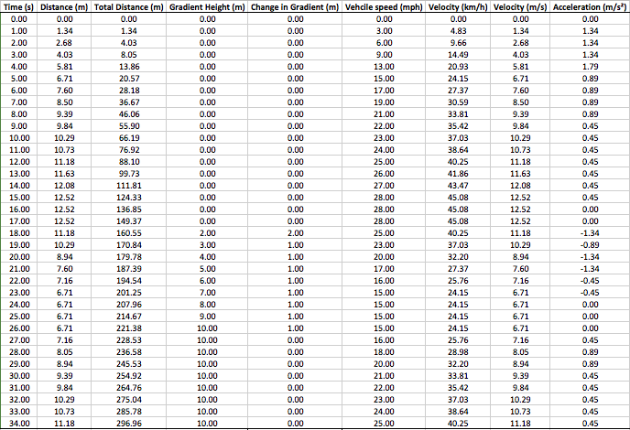

The velocity of the buggy is a realistic assumption made, and therefore in accordance to the velocity per second the total distance travelled by the buggy can be calculated by multiplying the velocity (m/s) by the time taken in seconds.
The acceleration of the buggy at each second is calculated by subtracting the initial velocity by the current velocity and dividing the sum by the take taken i.e. acceleration at 2seconds is $\frac{(2.68-1.34)}{1}$ = 1.34${m/s}^{2}$.
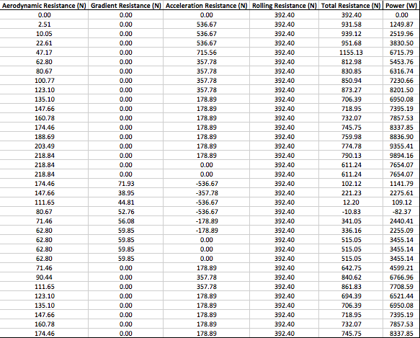
The Aerodynamic resistance was calculated at all terrains using the following equation:
$$Aerodynamic Resistance=\frac{1}{2}{ × Area × Coefficient of Drag × Density of Air × velocity}^{2}$$
for example, at 3 seconds;
The buggy is at 4.03m/s, $Aerodynamic Resistance=\frac{1}{2}{ × 3.88 × 0.6 × 1.2 × (4.03)}^{2}$ = 22.61 N.

Sector 2 - Gravel Track Terrain

While still at a gradient height of 10m the track moves from a wet grass field to gravel track and the gradient begins to reduce to downhill decline, the duty cycle then has a flat surface at 1m height, the gradient begins to increase to a total of 20m incline.
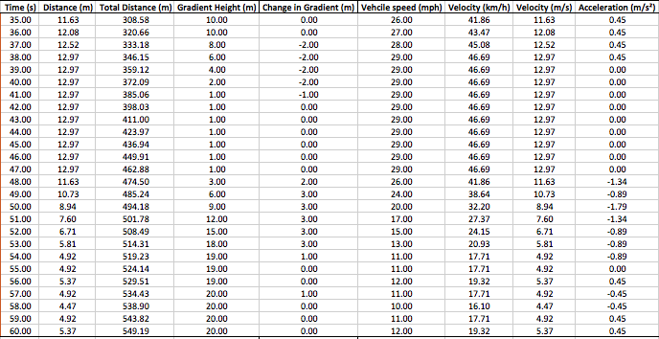

As shown above there is 2seconds of flat surface at 10m height, 5 seconds of declining gradient, 6 seconds of flat surface at 1m height and 7 seconds of sharp incline, followed by 1 second flat, and 1 second gentle incline and 3 seconds of flat surface at 20m height.
The resistance values were also calculated for the gravel track section of the duty cycle as shown below.

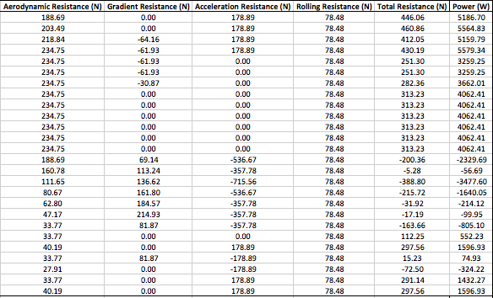

Gradient resistance was calculated for each section terrain using the below equation:

$$Gradient Resistance=Mass × Gravity × \sin{θ}$$

where θ = gradient i.e. angle from horizontal to incline. The angle was calculated using the below equation:

θ = tan $\left(\frac{Change in height}{Change in length}\right)$

Sector 3 - Soft Loose Soil Terrain

While still at a gradient height of 20m but flat the track moves from gravel track to soft loose soil where it remains flat for 4 seconds before the gradient begins to gently reduce to downhill decline, where the hill goes down from 20m to 0, in 25 seconds/282.2metres.

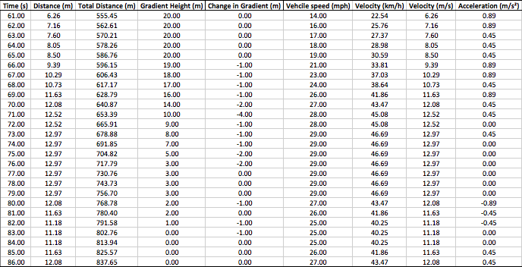

As shown above the gentle decline in gradient is shown by the change in gradient, the maximum decline is 4m which occurs only at 71s, other than that the majority of the change in gradient is 1m per second.
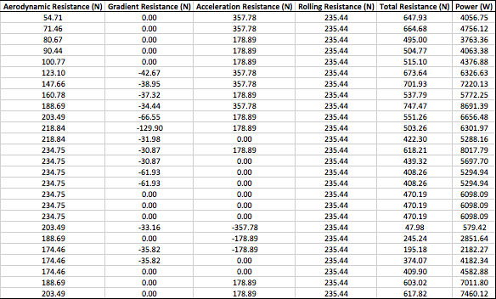

Acceleration resistance was calculated for each section terrain using the below equation:

$$Acceleration Resistance=Mass × Acceleration$$

For example, at 86 seconds the acceleration is 0.45${m/s}^{2}$.
$Acceleration Resistance=400 × 0.45$= 178.89 N Approx. 180N.

Section 4 - Wet Grass Field Terrain

While still at 0m, flat surface the track moves from soft loose soil to wet grass field where it remains flat for 3 seconds, there is a small ditch represented by the declining gradient for 4 seconds.

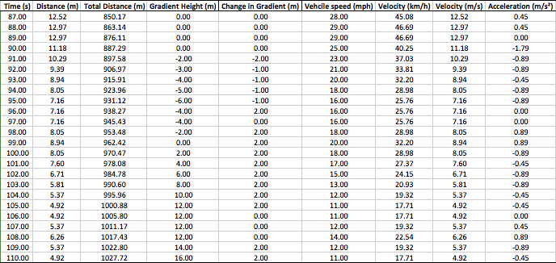
The small ditch has a total distance of 40.69m, there is then a gradient increase to an incline to a total of 16m.

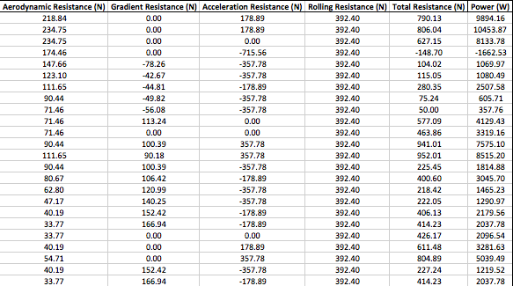

Above is the resistance values for the section 4 terrain with wet grass field.

Section 5 – Loose Sand Terrain

While still at a gradient height of 16m the track moves from wet grass field to loose sand where it begins to gently reduce to downhill decline, 2m per second down to 2m height.

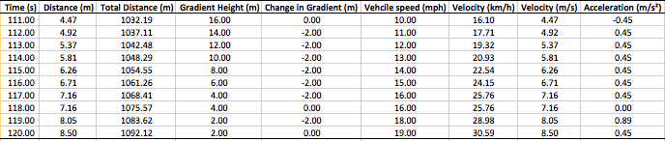

Below are the resistance values of the duty cycle during the loose sand terrain.

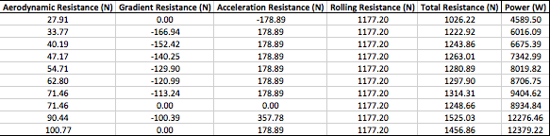

Summary of Findings

The total resistance and power requirements were calculated for each second in each section and its terrain as shown in the duty cycle analysis spreadsheets, as shown below:
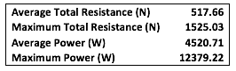
The Average total resistance for each section are as shown below:

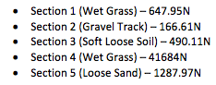

Although the loose sand had the shortest section and was consisted of all downhill travel, it had the greatest average resistance (above) and power requirement (below), this is most likely due to the high rolling resistance of the loose sand terrain.

Average Power requirements for each section:
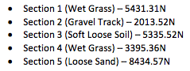

The Gravel track had the lowest average total resistance and power requirement also, much like but opposite to the loose sand this might be due to its rolling resistance, the gravel track had the lowest rolling resistance and therefore reduces the average total resistance and power requirement value.
As shown below in the total resistance and power requirement graphs.

It can be seen that as the total resistance increases, the power requirement for the buggy increases also. Overall the total power requirement in order to overcome the total resistance is 12.38Kw.

The gradient vs time graph represents the duty cycles course and inclines/declines, the velocity vs time, represents the velocity of the buggy during the duty cycle, it can be seen that the velocity of the buggy is increased during flat/decline sections where the gradient resistance is reduced (as shown below), however as the gradient increases the buggy’s velocity decreases accordingly, this can be seen between time periods 17s – 26s and 48s – 60s, where the gradient has increases and velocity decreased accordingly.

As discussed, the gradient resistance increases with height increases, and reduces as height decreases accordingly.

It was found that the aerodynamic resistance increased and decreased with velocity accordingly, with velocity being the only variable in the aerodynamic equation throughout the duty cycle it was the factor which altered the resistance throughout the duty cycle, while at a constant velocity the aerodynamic resistance remained the same.

It was seen that the acceleration resistance was greater when the buggy had an increased velocity, during the periods of flat surface or downhill gradients, however, during periods where the velocity decreases due to gradient increases, the acceleration resistance increases negatively.

It can be seen that the rolling resistance during the Gravel track section had the lowest rolling resistance and gradually increased from this through soft loose soil and wet grass field, however the loose sand section had the highest rolling resistance, which was a significant increase in comparison to the other sections.

References

Blitzworld, 2017. Hammerhead GTS 150cc (USA spec). Duo 150 (Hammerhead) as seen on the gaget show. Available at: http://www.blitzworld.co.uk/hammerhead-gt-150cc-i1569.html [Accessed November 28, 2017].

Engineering Toolbox, 2017. Rolling Resistance. The Engineering ToolBox. Available at: https://www.engineeringtoolbox.com/rolling-friction-resistance-d_1303.html [Accessed November 29, 2017].

Polaris, 2017. RZR®. 2018 Polaris ACE 150 EFI ATV | Polaris ACE. Available at: https://ace.polaris.com/en-us/ace-150-efi/ [Accessed November 29, 2017].

