The museum started as the ‘Welsh Folk Museum’ although, in 1995 it became the much broader ‘Museum of Welsh Life’. The museum is based in Saint Fagans. Situated near Cardiff, there will be a focus on the virtual aspects, such as the positives and negatives of the website and how it can be improved. Additionally, a look into the Museums physical content that is shown on the website. How the museum of Saint Fagans can be changed to create a better environment of learning. Also, how good is Saint Fagans at promoting Welsh culture – and whether the museum does it in a respectful manner. It is best to use theory and opinion-based criticism in order to help the argument of this paper – notably from Michael Shanks and others like Peter Lord. Furthermore, it is the museum’s responsibilities to its physical and virtual collections which must be made paramount to them – as without their collections there is no museum to be had, and the duty of care of the collection must also be a central rule to the museum’s work and must be in the museums goal and objectives.
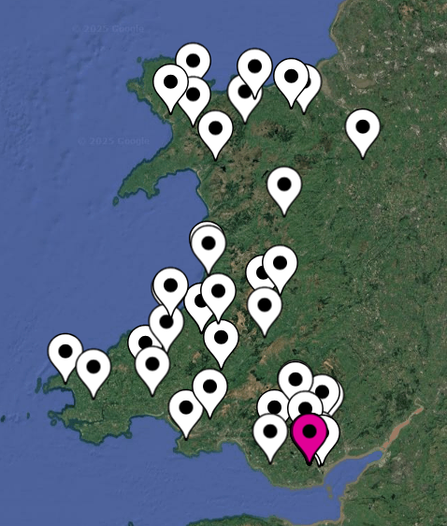
The Museum of Saint Fagans is rather limited – mainly focusing on the historical buildings and mostly neglecting the exhibitions that the site offers. Despite it being fairly minimal as a website, it is easy to navigate for those who are not ‘computer savvy’. Therefore, this is a positive as simplicity can create a comfortable space for newcomers to the museum/website. The website provides blogs and other events that are happening at the museum such as the Plygain Service on the 11th of January 2026, as well as an exhibition ‘blog’ on Women and Sport in Wales. This is a very simple and affective way of engaging with consumers, and it is clear and navigable. The website is also clear on opening times for the museum – making it feel like it is trying to bring visitors in, rather than to allow them to enjoy the objects online. Once you click onto the Historic Buildings tab on the website – it takes you to a separate page and the first thing the visitor sees, is the original locations of the buildings (see fig 1), through a satellite view. At first when viewing this image one is bewildered by the amount of buildings and how many throughout Wales have been used to create what is known today as Saint Fagans. But one cannot help to feel a little bit of dread when looking at the satellite image a little longer, as a realisation hits on the removal of all these unique buildings, with real histories and not just reconstructions of the past. There is a total of 46 pages for the historical buildings on the website. A negative with the easy navigation of the website for Saint Fagans Museum is that it lacks innovation, the website feels like a boring browser for historical buildings, which also lacks comprehensive information, and is very dull, but easy to understand. Furthermore, the ‘historic buildings’ tab is structured alphabetically, which again makes it easier to navigate – but it creates a boring environment for the visitor in searching and understanding the buildings altogether. A way to fix this negative aspect of the museums website could be by making it chronological, to have the visitor feel like they are viewing Welsh history as it happens – or to create spaces for each location, North Wales and South Wales respectively. 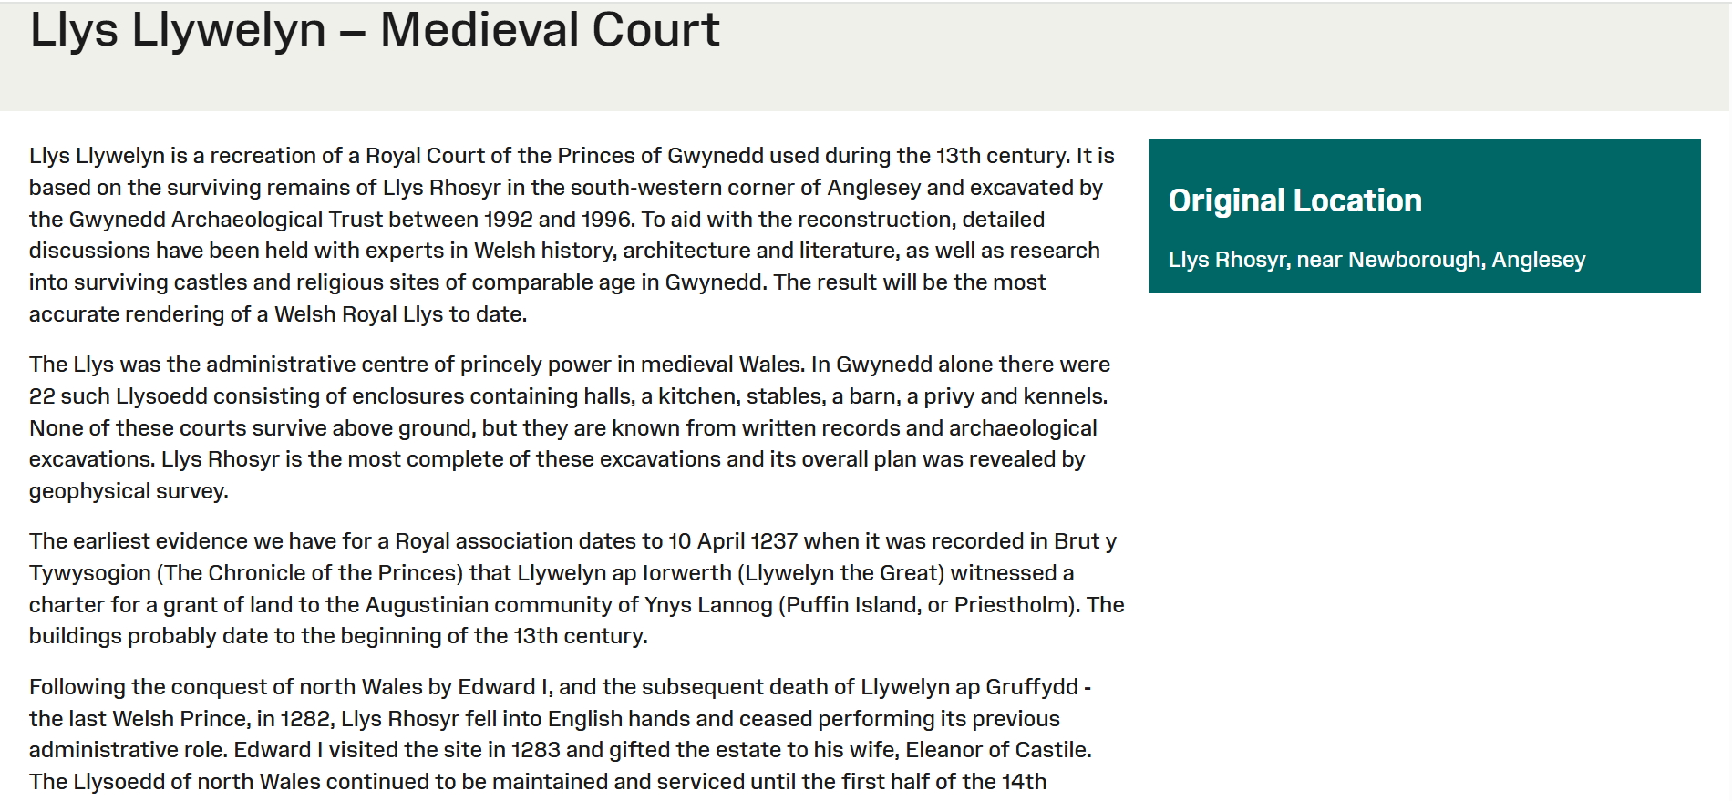
Figure 1, Historical Buildings Original Locations and Saint Fagans (Amgueddfa Cyrmu, n.d).
Figure 2, Llys Llywelyn – Medieval Court (Amgueddfa Cyrmu, n.d).
A positive to virtual museums is that the communicational infrastructure that the internet creates, aids users to navigate between institutional gatekeepers and access their digitised cultural heritage directly. The digital museums present a radical democratisation of cultural memory, allowing anyone in the world to access the knowledge instantaneously. Despite this argument for digitisation, a curator of Solomon R. Guggenheim Museum Jon Ippolito argues that the memory of institutions no matter how digitized they are “hamstrung by their own history as centralised repositories”. Many museums of the 21st century utilise digitalisation programmes far more than that of Saint Fagans, for example the documentation of artefacts through high-resolution photography, video, and analytical scanning – this is a positive aspect of virtual museums and can make the viewership of the websites far more enjoyable and unique – it can also ensure that the objects are highly documented for the future, however, Saint Fagans does not utilise this form of technology and mostly focuses on the physical buildings rather than digitising them. There have been studies which suggests that digital copies can create the ability to evoke emotion and memory, which would benefit Saint Fagans. Walter Benjamin writes in his works that ‘Aura’ is bound to the objects authenticity, where the object is rooted in cultural history and mystique amongst other descriptions. He also mentions that ‘Aura’ becomes destabilised through mechanical reproduction, and that reproduction substitutes the singular existence of the objects original form. Saint Fagans represents this issue almost too well, as most of the buildings despite being ‘original’ are to some degree reproductions – there is a clear difference between visiting a farmstead that has not been deconstructed, renewed, and moved to another location than one that has been. When visiting historic buildings in their original location they possess a contextual authenticity to them, whereas in Saint Fagans this nature is almost removed. Specifically, through the building’s contextual authenticity. Despite Saint Fagans creating many reconstructions, it does support visitors in having an authentic experience when visiting the buildings, due to the carefully crafted environment and the curators’ best abilities in remaining as ‘authentic’ as possible.
Ruins are a gateway into human history which gives an opportunity in understanding how the ancestors of the population lived, worked, worshiped and spent their time. The ruins are a time capsule which becomes vulnerable, and some sites disappear altogether, leaving behind the archaeological record as evidence, others do not. Through reconstructions of ruins it can help in understanding the past, especially for the common people, helping those who are not historians or archaeologists. The issue with reconstructions and Saint Fagans – is that it is created by them, which they push a narrative for Welsh culture in its whole. This can be good for those who are not Welsh to gain a sense of what Welsh culture is. However, it is also a negative aspect of the Museum as it also neglects other parts of Welsh cultures. The main goal of reconstructions is that the site must give relevance and meaning to the visitors and allow them to interpret Welsh culture through the objects. It does this effectively, particularly with field trips arranged by educational institutions. But it also homogenises and simplifies aspects of Welsh culture. Furthermore, national museums that are built to reinforce cultural and ethnic nationalism can be thought as a way of consolidation and performativity. Which the public are presented with a national story as celebration and affirmation but also with instruction for locating themselves within that national story. Saint Fagans does this to some extent, it inadvertently leads to a misunderstanding of Welsh culture, due to its lack of diversity/nuance. For example, there are many differences between many parts of North Wales and the South of Wales. For some North Walians, Welsh culture and the Welsh language are linked, one cannot exist without the other. However, in the South of Wales, respectively the Valleys, language is not as important, and the way one acts and where they come from is their understanding of Welsh culture. Peter Lord considers that the Museum of Welsh Life of a much larger polemic on the treatment of visual cultures in Wales – he claimed that the National Museums and Galleries of Wales (NMGW) had played in marginalising the native culture in favour of an Anglicised and Europeanised aesthetic canon. Lord also writes that the museum was complicit in this process because of its self-identification as the supposedly most Welsh of all Wales’ museums. Which cannot be the case, due to Welsh culture being so different wherever you go, from town to town, an example can be that of the Heritage museums in the Valleys, which explore the coal mining industry, or that of Port Talbot which focuses on steelworks. Additionally, to Peter Lords arguments on Saint Fagans, Bella Dicks mentions that the museum present a past that was too static, too unified and simplified. Lord also mentions that the Museum is too static, devoid of politics, and a closed version of history. Rhiannon Mason believes in a more open ended idea, and that her argument is that the museum operates as a space where it is possible to identify the competing definitions of ‘Welshness’, that close examination reveals the evidence of the processes of remembering and the remaking of cultural memory in response to the demands of the present. Which is important in creating a nation – a shared identity can certainly help a people be seen on an international level, and this is precisely what Saint Fagans’ Museum of Welsh Life attempts to achieve, and does to a degree. It is also vital to understand that Peate conceived the idea of folk culture as a holistic and authentic representation of the ‘true’ character of a nation. Michael Shanks writes that authenticity is a concern of cultural identity – therefore with the buildings that are in Saint Fagans as we see them on the website, are they truly authentic enough for it to be relative enough for Welsh identity. Shanks also reports that the Museum presents a particular idea of Welshness, focusing on rural industry, farmhouses and cottages. Another issue of Saint Fagans is that it creates a distorted idea of the past. Cultural identities are not inherent or essential to each individual human being, the archaeological record is often taken as ‘the’ component of a national and ethnic heritage and identities – and monuments and artefacts are used to create narratives which help provide a meaning to the experience of cultural groups. Furthermore, Saint Fagans creates a fantastic location for many that are not particularly in tune with their idea of their Welshness, and use it as the basis of their identity, but this skews the true nature of what a culture is – as the public in some instances view culture to be merely traditional due to institutions like The Museum of Welsh Life, Saint Fagans.
In conclusion, Saint Fagans as a virtual museum does lack in comparison to other national museums. However, because Saint Fagans has the reconstructed buildings, it is a waste of resources and potential of the museum to create 3d scanning’s of the buildings, like that of Whitland Abbey. However, having the website to be more enjoyable to the viewer is something it must work on – as it lacks in creativity and innovation, arguably the reason Saint Fagans does this is to entice the visitor to view the museum in person, and use the website as merely a gateway to the physical museum. The virtual museum of Saint Fagans also allows anyone to visit and gain a limited understanding of Welsh culture through its contents. However, due to this – when someone visits the websites, they are told the narrative that Saint Fagans is the collection of all of Wales as one culture. This has negative side effects on Wales, as the homogenisation of a culture neglects certain population’s need. The arguments other academics have in regards to the reconstructions is plausible. They create an understand of authenticity which Saint Fagans does not achieve in a contextual sense but does attempt in the setting of the scenes. Overall, Saint Fagans and its website are effective at creating a learning environment, and a reactive one – despite its negatives, it creates discourse which in turn allows improvement. However, the website lacks in innovation.

Bibliography
Ambrose, Tim, and Crispin Paine, Museum Basics : The International Handbook, Fourth edition. (Routledge, Taylor & Francis Group, 2018)
Amgueddfa Cymru (N.D) < https://museum.wales/> [accessed 27 December 2025]
Månsson, Maria, ed., The Routledge Companion to Media and Tourism, 1st ed. (Routledge, 2021)
Rhiannon Mason, ‘Nation Building at the Museum of Welsh Life’, Museum and Society, 3.1 (2004), pp. 18–34
Shanks, Michael, Experiencing the Past : On the Character of Archaeology (Routledge, 1992)
Walsh, Kevin, The Representation of the Past : Museums and Heritage in the Post-Modern World (Routledge, 1992)
Woltz, Catherine. "Ruin and Reconstruction: Understanding the Constructed Past." Muséologies, volume 4, number 2, spring 2010, p. 112–131. https://doi.org/10.7202/1033542ar
Kenderdine, Sarah, and Andrew Yip, ‘The Proliferation of Aura: Facsimiles, Authenticity and Digital Objects’, in The Routledge Handbook of Museums, Media and Communication, 1st edn (Routledge, 2019), i, pp. 274–89, doi:10.4324/9781315560168-23

Rhiannon Mason, ‘Nation Building at the Museum of Welsh Life’, Museum and Society, 3.1 (2004), p. 19
Ambrose, Tim, and Crispin Paine, Museum Basics : The International Handbook, Fourth edition. (Routledge, Taylor & Francis Group, 2018), p. 246.
Amgueddfa Cymru, St Fagans National Museum of History (no date) <https://museum.wales/stfagans/> [accessed 27 December 2025].
Ibid.
Ibid.
Amgueddfa Cymru, Historic Buildings (no date) <https://museum.wales/collections/historic-buildings/> [accessed 27 Decemeber 2025].
Ibid.
Amgueddfa Cymru, Historic Buildings (no date) <https://museum.wales/collections/historic-buildings/> [accessed 27 Decemeber 2025].
Ibid.
Månsson, Maria, ed., The Routledge Companion to Media and Tourism, 1st ed. (Routledge, 2021) p. 61.
Månsson, Maria, ed., The Routledge Companion to Media and Tourism, 1st ed. (Routledge, 2021) p. 61.
Ibid.
Kenderdine, Sarah, and Andrew Yip, ‘The Proliferation of Aura: Facsimiles, Authenticity and Digital Objects’, in The Routledge Handbook of Museums, Media and Communication, 1st edn (Routledge, 2019), i, p. 274.
Kenderdine, Sarah, and Andrew Yip, ‘The Proliferation of Aura: Facsimiles, Authenticity and Digital Objects’, in The Routledge Handbook of Museums, Media and Communication, 1st edn (Routledge, 2019), i, p. 274.
Ibid p. 275.
Ibid.
Woltz, Catherine. "Ruin and Reconstruction: Understanding the Constructed Past." Muséologies, volume 4, number 2, spring 2010, p. 116.
Ibid.
Woltz, Catherine. "Ruin and Reconstruction: Understanding the Constructed Past." Muséologies, volume 4, number 2, spring 2010, p. 119.
Ibid p. 124.
Ibid p. 127.
Rhiannon Mason, ‘Nation Building at the Museum of Welsh Life’, Museum and Society, 3.1 (2004), p. 19.
Ibid.
Shanks, Michael, Experiencing the Past : On the Character of Archaeology (Routledge, 1992), p. 85.
Rhiannon Mason, ‘Nation Building at the Museum of Welsh Life’, Museum and Society, 3.1 (2004), p. 21.
Ibid.
Ibid.
Ibid.
Ibid.
Ibid p. 22
Ibid.
Shanks, Michael, Experiencing the Past : On the Character of Archaeology (Routledge, 1992), p. 80.
Ibid p. 85.
Shanks, Michael, Experiencing the Past : On the Character of Archaeology (Routledge, 1992), p. 85.
Ibid p. 92

