Part 2 – Research Report

Importance of digital skills in studying and in work

Student Name: Asos Abdolla
Student Number: 2223216
Lecturer Name: Daminabo Pokubo
Module: Digital Skills and Research Methods
Module Code: LCHS4002

Table of Content
- Introduction: ……………………………………………………………………………3
- Research Design: …………………………………………………………………….4
2.1 Research Question: ………………………………………………………….5
2.2 Methodology: ………………………………………………………………...6
  - Ethical Consideration: …………………………………………………….7
- Results and Discussion: ……....…………………………………………………….9
- Conclusion: …………………………………………………………………………...12
- Reference List: ……………………………………………………………………….13
- Appendix – A questionnaire: ………………………………………………………15

- Introduction:

This report aims to supply a comprehensive understanding of the importance of digital skills for study and work in the context of higher education.
This report shows the importance of digital skills for studying and working to analyse the information received from a survey/questionnaire distributed to students at the University of Wales Trinity Saint David (UWTSD). The aim of the survey was to gather views on the current level of digital skills of students, their attitudes towards digital technology, and how they realize the importance of digital skills for their future professions.

The digital revolution has transformed the way we live, work, and learn. With the rapid advance of technology, digital skills have become the basics of success in today's workforce (Nobile, (2016). The ability to use digital tools and technologies is no longer a choice but a requirement in industries (O’Donnell, 2016). In the education sector, digital skills are also increasingly important with the transformation of universities and colleges towards online and mixed learning models (van Deursen & van Dijk, 2014).

Digital skills refer to the abilities and knowledge needed to effectively use digital technology and tools to conduct various tasks, such as communication, problem-solving, creating, and sharing information (Van Deursen, et al. (2014). These skills can encompass a wide range of broad skills, from basic computer literacy to more advanced technical abilities such as programming, data analysis, and cybersecurity (Nobile, 2016).
In today's world, which is increasingly digital, digital skills are essential for success in industries and career. People with strong digital skills have the best necessary equipment to travel and adapt to technological changes, communicate and cooperate with others online, and access and analyze information effectively (Dijk, & Deursen, 2014).

The importance of digital skill:
According to (Government Publication, 2019)
- Digital skills are becoming essential for employment in almost every sector. Employers now expect employees to have basic digital literacy skills, such as ability in Microsoft Office, email, and social media.
- Digital skills allow people to communicate effectively in a variety of digital formats, including email, WhatsApp, and Teams. This has been particularly important during the pandemic.
- Digital skills enable individual to develop new products and services, create new business models, and innovate in a variety of fields, including healthcare, education, and entertainment.
- The internet has offered multidimensional information available to people all over the world. Digital skills enable people to find, and analyze information effectively, making it easier to be informed and make decisions.
- Digital skills can help individuals in Personal Development professionally and personally, enhancing their ability to learn, communicate, and collaborate with others.
- Digital skills enable people to connect with others through social media, online communities, and other digital platforms. This can be especially important for people who are isolated or have limited social contact in their offline lives.

- Research design:

Primary research is a type of research that involves gathering original information directly from the source, rather than relying on existing information or data already collected by others (Saunders, et al. (2019). In primary research, researchers design and conduct their own research, collect their own data, and analyze that data to answer their research questions or evaluate their hypotheses (Ohgaki & Kleihues, 2013). This type of research design is different from secondary research. the key difference between primary and secondary research are illustrated in the table below (Sonyel & Oflazoglu, (2017)

Primary Research | Secondary Research
Collection of first-hand data through various methods such as survey, interviews. | It uses existing data sources such as books, reports, journals, and data base
The researcher has full control over the research process and the type of data collected. | The researcher has limited control over the research process and the type of data collected.
It is more time-consuming and expensive as it involves designing research instruments, recruiting participants, collecting and analyzing data. | It is less time-consuming and less expensive as the data is already available
The results are specific to the specific research and cannot be generalized to other contexts or populations without further research. | The results may be generalized to other contexts or populations, depending on the quality of the data and the research methods used.
It allows the researcher to explore new research questions and product new knowledge. | It helps to confirm or refute existing research findings

the use of a questionnaire to collect data directly from UWTSD students is an example of primary research. By designing our own questionnaire and collecting data from our own sample, we will conduct preliminary research to investigate the importance of digital skills for UWTSD students.

2.1 Research Question:
This research aims to answer the research question below.
Are digital skills important for study and work?

2.2 Methodology:
Quantitative research is a research method that focuses on collecting and analyzing numerical data to generate statistical models and theories about a phenomenon. This type of research uses a structured method to measure and quantify variables and relationships between them (Heyvaert& Onghena, 2013). The aim of quantitative research is to evaluate hypotheses, show cause-and-effect relationships, and generalize findings to a broader population (Saunders, et al. (2019)).
There are types of quantitative research, including experimental research, survey research, and correlational research. Experimental research involves manipulating independent variables to see the effects on dependent variables. Survey research involves collecting data through questionnaires, interviews, or observation (Saunders, et al. (2019)).
Quantitative research differs from qualitative research, which is a research method that focuses on collecting and analyzing non-numerical data to understand the complexity and diversity of human behaviour and experiences. Qualitative research involves collecting data through methods such as interviews, observations, and analyzing it thematically to generate insights into the incident being studied (Sonyel & Oflazoglu, (2017)).
In this report, a quantitative method was used, and data was collected using a questionnaire. A questionnaire is a research instrument that consists of a set of questions designed to elicit specific information from respondents. The questionnaire was designed using Google Forms, which is an online tool that allows the creation of customized forms and surveys.
The questionnaire was shared with a sample of respondents via email, and they were asked to complete it within a specified time limit. The questionnaire consisted of a mixture of closed and open-ended questions. The questions were designed to gather information on the demographic characteristics of the respondents, their feelings of the research topic, and their experiences and attitudes towards the topic.
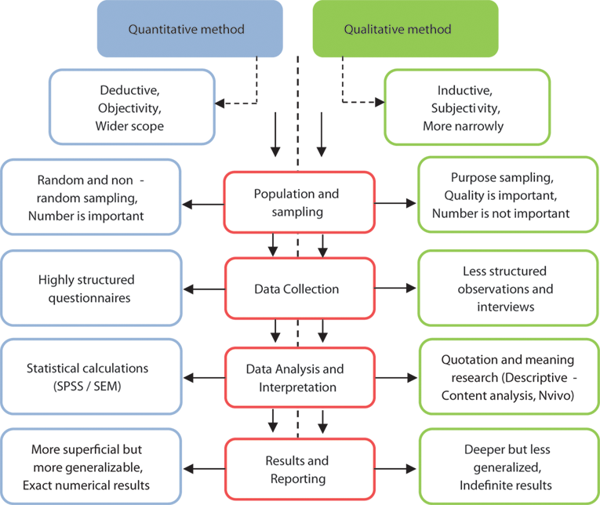

Figure -1 Difference between qualitative and quantitative methods.
. source from (Sonyel & Oflazoglu, (2017)

  - Ethical Consideration:

Ethics refers to a set of moral principles that guide human behaviour and decision-making. In research, ethics involves the principles and guidelines that govern the method of research to ensure that it is conducted in a responsible and ethical manner that protects the rights and well-being of participants and promotes scientific integrity (Paradice, D. et al. (2018)).
Ethics in research is particularly important because it helps to ensure that research is conducted in a manner that is respectful, fair to all participants involved. Ethical considerations help to ensure that research is conducted in a manner that respects participants’ dignity, protects their privacy and confidentiality, and minimizes any potential harm or risk associated with the research (Paradice, D. et al. (2018)).

The ethical issues that could arise because of conducting research include:
Informed consent: Participants must supply informed consent before taking part in research. However, obtaining informed consent can be challenging in cases, such as when participants are vulnerable, or when the research involves sensitive topics.
To prevent this issue, researchers should ensure that participants have a clear understanding of the purpose, nature, and potential risks and benefits of the study before they supply their consent.
Confidentiality and privacy: Researchers should ensure that the data collected from participants are kept confidential and that participants' privacy is protected. However, supporting confidentiality can be challenging, especially when the research involves sensitive topics.
To prevent this issue, researchers should use right measures to ensure the anonymity and confidentiality of participants, such as removing identifying information from the data.
Risk of harm: Research can potentially cause harm to participants, either directly or indirectly. To prevent this issue, researchers should act appropriately to minimize the risk of harm to participants and ensure that the benefits of the study outweigh any potential risks.
Fairness and equity: Researchers must ensure that the research is conducted in a manner that is fair to all participants involved.
To prevent this, researchers need to ensure that they do not discriminate against any participant based on their gender, ethnicity, or any other personal characteristic.

- Results and Discussion:
This section describes the conclusions drawn from the data collection for this study. The results are presented using basic statistical analysis. These are visualised by graphs, bar charts, pie charts.

- Are digital skills important?

Figure -1 Importance of digital skill

In asking students they believed that the use of digital skill is important, a 100% of the respondents show that digital skills are an important skill for student to be successful. The reason for this answer is that digital skill support students in completing their university assignment also it is extremely helpful in their daily routine.

- Do you use One Drive more than other digital tools?

Figure-2 Importance of One Drive as compared to another digital tool.

In response to this question show that 80% of the candidate believed that the other digital tools are more important while only 20% of the respondents thought that One Drive is important. This result show that UWTSD student prefers to use all digital tools according to requested task rather than using one digital tool.

- Rank these applications in order according to how frequently you use them on One Drive.

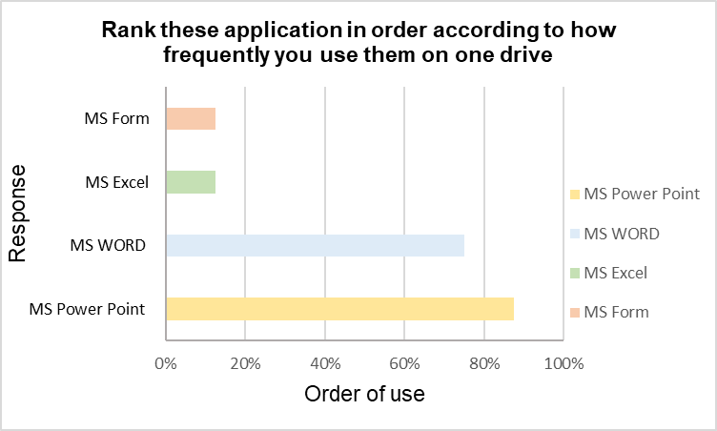

Figure-3 How frequently using this application on OneDrive.

The figure above shows that MS Power Point with 87.5% and followed by MS Word 75% are the next most used by respondent followed by both MS Excel and MS Form coming in the same level. This result show that UWTSD students prefer the use of MS Power point and MS Word over MS Excel and MS Form in this module.

- I use MS Power Point more than MS Team

Figure-4 Using Power Point and MS Team

In response to this question, it was found that most of UWTSD students agreed with the use MS Power Point than MS Team. As 50% each sign strongly agrees and agree showed by the above figure. Probably the reason for using Power Point is to do the presentation task.

- I use MS Excel is more important than MS Word

Figure-5 Importance of MS Excel relative to MSWord

According to the figure show that the maximum responses were neutral with placing MS Excel as more important than MS Word followed by 25% disagree, and then 12.5% strongly disagree, after agreeing and strongly agree each came with 13%. This show that each tool is fundamental, and each has its own characteristics and functions.

Conclusion:
In conclusion, it is obvious that digital skills have become increasingly important in both work and study.as mentioned earlier in this report, a quantitative method was used, and data were collected using questionnaires, using the data from a survey/questionnaire distributed to students at the University of Wales Trinity Saint David (UWTSD). the survey shows that students are all interested in using digital tools such as MS Power point, MS Words, MS Excel, and MS Form to give their assignment. Digital skills development is essential in this digital universe individuals need to be up to date to remain competitive and productive for their future career, ultimately it is vital that everyone is challenged to upskill and stay relevant in their respective fields.
References:
Dijk, J.A.G.M. van. and Deursen, A.J.A.M. van. (2014) Digital Skills Unlocking the Information Society. New York: Palgrave Macmillan US. Available at: https://doi.org/10.1057/9781137437037.

Government Publication (2019) essential-digital-skills-framework at https:// www.gov.Uk (06 February 2023).
​
HEYVAERT, M., MAES, B. and ONGHENA, P., 2013. Mixed methods research synthesis: definition, framework, and potential. Quality and Quantity, 47(2), pp. 659-676.

Nobile. (2016). Book Review: Digital tools for qualitative research [Review of Book Review: Digital tools for qualitative research]. Research on Social Work Practice, 26(7), 836–837. SAGE Publications. https://doi.org/10.1177/1049731516656058​

O’Donnell, S. (2016) ‘Digital skills: unlocking the information society’, Information, Communication & Society. Abingdon: Routledge, pp. 1770–1772. Available at: https://doi.org/10.1080/1369118X.2016.1235719.

Ohgaki, H. and Kleihues, P., 2013. The Definition of Primary and Secondary GlioblastomaDefinition of Primary and Secondary Glioblastomas. Clinical cancer research, 19(4), pp.764-772.
Paradice, D. et al. (2018) Review of ethical issue considerations in the information systems research literature. Boston, Massachusetts: Now Publishers. Available at: https://doi.org/10.1561/2900000012.

Saunders, M.N.K., Lewis, P. and Thornhill, A. (2019) Research methods for business students. Eighth Edition. New York: Pearson.

Sonyel Oflazoglu and Oflazoglu Dora, S. (2017) Qualitative versus quantitative research. Edited by S. Oflazoglu Dora. Place of publication not identified: IntechOpen.

van Deursen, A.J.A.M. and van Dijk, J.A.G. (2014) ‘The digital divide shifts to differences in usage’, New media & society, 16(3), pp. 507–526. Available at: https://doi.org/10.1177/1461444813487959.
Van Deursen, A.J.A. et al. (2014) ‘Primary school children’s internet skills: a report on performance tests of operational, formal, information, and strategic internet skills’
Appendix:
DIGITAL SKILLS AND RESEARCH METHODS


