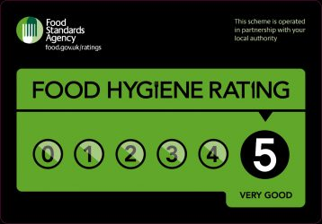

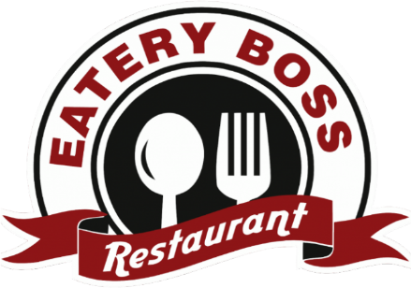
Eatery Boss from the House of the Trinity Hotel

Opening timings:
Monday-Thursday 12pm-9pm
Friday-Saturday 12pm-10 pm
Sunday 12pm-5pm
To place order contact: 05876199678
(Card Payments are accepted only)
Takeaway order pickup at the front counter
On

Attention:
- The food in the menu might contain nuts and other allergens.
- Please inform the staff at the time of ordering if there are any food allergy issues or dietary issues.
- We prepare food following contactless policy to maintain food safety.
Ewch i food.gov.uk/ratings i ganfod sgôr hylendid bwyd ein busnes neu gofynnwch inni beth yw ein sgôr hylendid bwyd wrth archebu / Go to food.gov.uk/ratings to find out the food hygiene rating of our business or ask us for our food hygiene rating when you order.

Starters
Cabbage spring roll served with a side of chilli chicken 7.50 110 calories
- Deep fried potato croquette filled with taleggio cheese and served on a bed of charred leaks sprinkled with chives and garlic oil. 6.50 95 calories

Vegan Starters
Chickpea hummus with pine nuts and olives 3.50 75 calories
Smoked aubergine served with a combination of pepper, walnut and pomegranate salad 5.25 60 calories
Roasted cauliflower served with a side of hummus or spiced yoghurt 4.25 65 calories

Soups
Tomato soup served with olive oil and freshly chopped parsley with breadsticks 5.55 65 calories
Tom Yum Kung served with lemongrass and coriander 5.99 80 calories
Pumpkin soup served with crispy croutons and a drizzle of cream 5.75 68 calories
Tofu soups served with chicken broth and assorted vegetables 5.55 95 calories
French onion soup served with crispy bread 5.75 78 calories

Main Course
- Vegetable lasagna baked with layered pasta sheets 15.99 180 calories
Scottish Rib Eye Steak (cooked to the liking of the customer) served
with onion rings, mushrooms and tomatoes with Night reserve Merlot or
Duckhorn Cabernet Sauvignon, Napa 57 250 calories
Grilled Sirloin Steak (cooked to the liking of the customer)
served with sautéed carrots and peas 13.99 280 calories
Ravioli and ricotta braised and served with walnut cream sauce with Substance Cabernet Sauvignon, Medocino or Cade Howell Mountain Cabernet Sauvignon, Napa 78 300 calories

Vegan main course
Italian style roasted cabbage wedges served
with lentils tossed in tomato puree 12.99 160 calories
Vegan meatballs tossed in tomato sauce and
served with a choice of spaghetti or polenta 15 150 calories

Children’s menu
Penne Pasta served with Bolognese sauce 9.90 95 calories
A choice of Carbonara spaghetti or Penne pasta served in Carbonara sauce 9.90 80 calories
Chicken Tenders with a choice of chips or mashed potatoes and with a side of sautéed vegetables 9.90 110 calories
Margarita pizza or Pepperoni pizza with a choice of soft drinks 8.75 120 calories

Desserts
Deep fried Mars bar served with a choice of vanilla, butterscotch or chocolate
ice cream with caramel or chocolate drizzle on top 7.99 250 calories
Nutella mini pancakes served with a generous topping of chocolate chips, white chocolate drizzle and nutella 6.99 270 calories
Red velvet cheesecake waffle served with a topping of
chef’s signature cream cheese sauce 6.50 285 calories

Wine List
Shypoke 750 ml 37
Brian Arden Cab Franc 750 ml 40
Bouchon Merlot, California 750 ml 30
Kono Sauvignon Blanc, Napa 750 ml 35
Thomas Schmitt Riesling, Germany 750 ml 42

References

FOX, S., MITCHELL, G. and PASCUCILLA, M., 2018. A Matter of trust: A quantitative study to explore allergen awareness and compliance in takeaway food businesses in the Borough of Knowsley. International Journal of Sanitary Engineering, 12(1).
Mitchell, G., Fox, S. and Pascucilla, M., 2018. A Matter of Trust: A Quantitative Study to Explore Allergen Awareness and Compliance in Takeaway Food Businesses in the Borough of Knowsley. International Journal of Sanitary Engineering Research, 12(1), pp.15-26.
Theis, D.R. and Adams, J., 2019. Differences in energy and nutritional content of menu items served by popular UK chain restaurants with versus without voluntary menu labelling: A cross-sectional study. PLoS One, 14(10), p.e0222773.

