ECAD7003
Assignment title:
How a school develops one aspect of its SDP: a report that critically reflects on the actions, impact and evidence. base.
Sara Williams
(2210335)
Targedau / Targets | Sut rydych wedi gweithio ar hwn /  How you have worked on this | Ceir enghraifft ar /  An example can be found on
Targed/Target 1  ‘Ensure that you link theory and practice - make sure you consider what this might mean in terms of your chosen method or for your future practice’. | I have worked on this by looking closely at the professional teaching standards, in particular, collaboration, I was concise with how I was going to effectively collaborate in future practice and linked this with supporting literature. | Examples of this can be found in the conclusion of my assignment.

Table of Contents
Abbreviations table 3
Introduction 4
Overview of Relevant Literature 5
Developing an action point 9
Reflection and evaluation 12
Conclusion 14
Reference List 15
Appendices 24
Appendix 1 – SDP – HOTS Priority 24
Appendix 2 – Leaflets to parents/carers 27
Appendix 3 – Information for the governing body 28
Appendix 4- Qualitative data collection- Pre-and post-questionnaire for foundation phase and KS2 and teachers. 29
Appendix 5- Pre-and post-questionnaire results on HOT (Evaluating) 30
Appendix 6- HOTS development- Listening to learner’s analysis 31
Appendix 7 - Consistent whole school approach towards developing HOTS. 32
Appendix 8 – Developing HOTS. 33

Abbreviations table

WG | Welsh Government
HOT  HOTS | Higher order thinking  Higher order thinking skills
LOT  LOTS | Lower order thinking  Lower order thinking skills
SDP | School development plan
SIP | School improvement plan
CPD | Continued professional development
SMT | Senior management team
LA | Local Authority
SI | Self-improvement
SE | Self-evaluation
UN | United Nations

Introduction

The school concerned in this report is a small school located in South Wales. According to Estyn, (2018) and GOV.UK (2022) the school has 212 pupils on roll and the average proportion of pupils eligible for free school meals is 27%.

Privacy and anonymization are maintained to comply with BERA (2018), 'The confidential and anonymous treatment of participants' data is considered the norm for the conduct of research' (BERA, 2018: 21). Therefore, identifying information and names anonymised, to safeguard the school, staff, and learners. Furthermore, School X will be discussed professionally and with due respect when analysing aspects of its school development plan in support of The Education Workforce Council guidelines of professional integrity and conduct (EWC, 2022).

This report is composed of four sections. The first section proceeds with a literature review surrounding school development plans (SDP), and Blooms Taxonomy. The second section of the paper is organised by laying out the processes which school X follows in developing the chosen action point considering the evidence-based criticalities. The third section presents critical reflections and evaluations of the SDP findings, focussing on differing approaches based on theoretical knowledge and understanding to potentially strengthen the development of the SDP. Concluding with descriptions concerning future teaching practice.

Overview of Relevant Literature

A school development plan (SDP) is a live strategic plan that is annually reviewed for improvement. They are statutory for schools in Wales and must comply with the Education (SDP) (Wales) Regulations (WG, 2014) but schools will decide the content (WG, 2021: 2022) School stakeholders should be involved and committed to the improvement agenda (WG, 2014: 2016: 2022). SDPs should be transparent and accessible to bring about improvement (WG, 2014: 2016: 2022). SDPs must be acted upon to improve with learners at the heart of it, so they reach their full potential, regardless of their background (CfW, 2022; WG, 2022). The SDP should be set against a clear, shared vision of what the school is aspiring to achieve (WG, 2014). Beverborg et al., (2021: 75) argue that when teachers share the vision, targets can have a direct impact on teaching.

The Welsh Government (2022) asserts that the SDP should be driven by honest findings from self-evaluation using qualitative and quantitative data. Ylimaki and Brunderman (2022: 114) support the WG assertions as they maintain that evidence is an influential element in the SDP’s creation, highlighting that analysing summative data is valuable in identifying improvement, such evidence can be the justification of the SDP targets. Furthermore, targets based on evidence can have a positive impact on learners from poor socio-economic backgrounds (Ian and Iyinson, 2020: 3). Further reiterating that SDPs should be utilised to aid learners in reaching their full potential regardless of their backgrounds (WG, 2022).
In contrast, Schmoker (2003: 22) contends that schools should be aware of over analysing data as this can contribute to an overload of improvement plans. Schildkamp (2019: 257) expresses that it is important to use data to determine the causes of a problem before taking improvement actions. A differing viewpoint is that assessment results do not always represent a learner's full potential, therefore, informal data collection in the form of classroom observation can provide sincere insight (Schildkamp, 2019). In addition, the data-based decision should be purposeful ensuring it is not manipulated (WG, 2022).

As part of school development, it is paramount that schools have a culture for improving standards and have a level of readiness for change (Thomson, 2010, Estyn, 2016: 2020). Cornwall and Graham-Matheson, (2012) maintain that resistance should be challenged to positively involve and drive staff. Conversely, this can be challenging if internal contributors like the quality of teaching are considered inadequate and if staff morale is low (Demetriou and Kyriakides, 2012: 150). On the contrary, an effective SDP should address staff professional development needs concerning school improvement priorities (WG, 2014). In support, a culture for ongoing professional learning for staff should be embodied as a high-quality teaching profession is key to the future success of schools (OECD, 2014: 2017).
In support, Estyn (2012: 2013: 2016) stated that excellent leadership and teaching commonly occurred when individual professional development focussed on school priorities. In similar conclusions, the school's vision must centre around a culture of supporting the professional learning of staff (OECD, 2016: 2020; Estyn 2018). Similarly, Cobbinah (2022) expresses that leaders can instil a positive culture through a shared vision where everyone feels part of the change through a clear understanding of roles and responsibilities. McAleavy et al., (2016) and Estyn (2018: 2020) highlight that a positive culture can be achieved through distributed leadership amongst teachers as it can empower and provide ownership in developing the priorities, it permits staff to use their professional judgement, this, in turn, enables staff to trust leaders. Furthermore, the SDP must contain clear details of responsibilities, actions, timescales, and accountability to prevent confusion and duplication and to ensure the effective use of resources (WG, 2014: 2022).

School X identified the action point ‘To develop pupils higher order thinking skills’ in light of Blooms Taxonomy which involves a hierarchical system of classifying thinking abilities from LOT to more complex processes called HOT (Jaiswal et al., 2020: 5).

There is consensus that the Taxonomy organises learning objectives effectively due to its easy-to-follow structure and is useful for differentiation (Jaiswal, 2020; Agarwal, 2019: 189). Prasad (2021: 50) highlights that LOT is not for lower-ability learners as they also need to access HOT, and the same approach is said for higher-ability groups. Bloom and Krathwohl, (1956) argue that educators should move students up the taxonomy as they make progress and be consistent with processes (Kastberg, 2003: 402).

Furst (1981: 441) and Prasad (2021: 51) acknowledge that the Taxonomy is useful for educators when teaching and assessing skills and it enhances language skills. Prasad (2021) argues that it supports teachers to understand the depth of their pupil's learning. Kastberg (2003) would agree as similarly he concludes that the Taxonomy is successful in augmenting learners’ vocabulary in language learning.

In light of CfW, the Taxonomy is useful in developing a curriculum that contributes to learners' acquisition of integral skills. In support, it could be embedded across a whole school to develop skills (WG, 2022) which supports Furst (1981), Prasad (2021), and Grebin et al., (2020: 61) as they argue the framework is useful for developing skills in education.

The studies, however, have not addressed the hierarchal structure of the framework. Critics question the existence of hierarchal links between each level as learning is not a hierarchal or linear process (Berger, 2018). Furthermore, the hierarchal pyramid infers that skills are ranked in importance, with LOTS as the least important. Therefore, students who wish to reach the HOTS cause a problem with the function of the logical sequence as some children may never reach the top (Saxena, 2021: 5). This view is supported by Deci and Ryan (2012: 85) who deduce that the taxonomy focuses on the cognitive domains rather than on learners.

Many scholars contend that the Taxonomy should not be considered as levels or a hierarchy, but rather fragmented into lower-level and higher-level learning. Some express that an inverse pyramid to be a better depiction (ICT, 2021).

A recommendation is for educators to instil an ethos whereby all skills are of equal importance, enabling learners to realise that HOT is improbable without LOT (Lemov, 2012).

Developing an action point

School X undertook a cycle of processes that informed their SDP writing. Before the cycle began the school reviewed its motivational vision which provided a purpose to make achievable improvements and move the school forward underpinned by CfW (WG, 2014: Appendix 1).

The starting point for the school in the search for SI was SE (Demetriou and Kyriakides, 2012: 149). School X honestly reflected and evaluated its performance, aligning with the assertions that a system that is reflective, analytical, and examines performance can enable a level of readiness for change and improve what is being done (Chang, 2008: 3). Furthermore, school X called upon a range of evidence, including the national priorities, policies, LA drivers, and CfW guidance to stimulate areas for improvement (WG, 2014: 2022, BERA, 2022). Following a professional conversation (Headteacher, 2023) the school identified the target (Appendix 1), due to curriculum policy which is driven by the four purposes which are underpinned by several 'integral skills', furthermore, evidence-informed research (Estyn, 2018) and external LA drivers drove the school to apply Blooms Taxonomy as a way of embedding HOTS to support with implementing integral skills in line with CfW (WG, 2022).

In developing the target, school X collected qualitative data (Appendix 4) which identified areas of need and next steps (appendix 5). The WG (2022) recommends the collection of data from the summative and formative assessment, however, Schmoker (2003) found that looking at a broad range of data can result in an overload of goals and initiatives. The school supported the assertions of actions Schildkamp (2019) and WG (2022) and used manageable qualitative data in a meaningful and purposeful way and was to identify problems and take improvement actions (Appendix 5). A recommendation is for semi-structured interviews to be used to enable the learner and teachers to have a greater say on important issues concerning HOTS, this can provide a deeper insight for the HOTS lead when taking action (Denzin and Lincoln, 2018).

Furthermore, in developing the action, all school partners and stakeholders were involved to bring about improvement and to ensure transparency (WG, 2014: 2016: 2022). Leaflets were sent to parents and the governing body was consulted (Appendix 2, 3). A teacher was appointed as the HOTS lead and was responsible for developing the action (Appendix 1). McAleavy et al., (2016) and Estyn (2018: 2020) would argue that this enabled the teacher to have ownership and enable the use of own professional judgement in developing the priority. In corresponding thoughts, in line with WG, (2014: 2022) SMT should ensure the teacher is clear of responsibilities to prevent ineffectiveness or confusion. In addition, all the teaching staff implemented and developed HOTS daily within the classroom. The challenge advisor from the LA was involved and provided CPD sessions in ADDS (Appendix 1) to support the professional learning of staff (Estyn, 2018; OECD, 2016).

As part of strategic planning, success criteria were formed for a clear focus on achieving the target (Appendix 1). Resources and costs were considered to develop the target. It was identified that staff required time out of class to develop classroom-ready resources and to receive training, therefore, supply teacher costs were incurred (Appendix 1). A drawback of supply teacher cover is that learners are omitted from being taught by their class teacher, a counterargument could be proposed that teachers need to be released to enable learners the opportunity to progress with their integral skills to achieve high standards and aspirations in line with CfW, (2022), a fundamental part of it is ensuring that schools are supporting every learner to make progress, contributing to the four core purposes (CfW, 2022; WG, 2022).
The HOTS lead oversaw the development of the target and involved staff in the creation of resources as co-development and collaboration are key in strategic planning as it ensures all commit to the improvement agenda (WG, 2014: 2022). Resources were consistent and were able to be embedded across the whole school (Appendix 7, 8). This approach aligns with Kastberg (2003) as she supports that educators should be consistent with processes when using the taxonomy.

Moreover, the target will be developed, reviewed, and refined termly throughout the year and will run over three years (Appendix 1) therefore, in support, school X has developed suitable milestones to measure and evaluate progress throughout the year (WG 2014: 2022).

The impact will be measured by the HOTS lead through a post-questionnaire (Appendix 4). Learners were actively involved (Appendix 6) in line with the UN, (1989), Article 12; children have the ‘right to say what they think and should be listened to’, in support, learner involvement in aspects of school life is key in an improving education system (Education Scotland, 2018). The impact was further measured by learning walks and book scrutinies conducted by SMT and the governing body, complying with the WG, (2022) as governing bodies should support schools in fulfilling their accountability function drawing attention to any strengths and issues. Monitoring and triangulation of evidence findings determined progress in developing HOTS for learners and offered an insight to its effectiveness.

Reflection and evaluation

Upon reflection, when trying to source the SDP, the school's website was explored, unfortunately, it was not published, to ensure further transparency, the SDP could be shared with parents/carers on the school website to ensure accessibility for all stakeholders. In line with the WG (2014: 2016: 2022) SDPs should be accessible to the wider community, providing parents and learners with up-to-date information about the school to bring about improvement (WG, 2014: 2016: 2022).

Furthermore, upon evaluation of exploration into stakeholders' involvement, it is recognisable that the governing body is involved as part of monitoring (Appendix 1) however, after identifying involvement in HOTS CPD sessions, it is apparent that only staff are targeted. A recommendation is to improve the governing bodies' knowledge and understanding of HOTS through training, to ensure that the governing body is fully supporting the development of HOTS school improvement action, in support, McAleavy et al., (2016) argues that governing bodies undertaking training will provide skills, behaviours, and knowledge to challenge the school effectively in a productive and supportive way during school improvement. In corresponding thoughts, the school could further engage parents/carers by inviting them into the school to observe HOTS in lessons. They could appoint parental councils and encourage parents to provide feedback to teaching staff as in line with McAleavy et al., (2016), as this can give a parental/carer insight into their child's capabilities and how they can support their child's HOTS at home and furthermore, the parents will have an awareness and shared vision of the school.

School X developed the target through a range of processes (Appendix 1,7, 8). To further strengthen the development of HOTS in the school; as the target was driven by the LA, other schools in the LA were also doing work on the development of HOTS. Therefore, in support of the WG, (2022) it could be suggested that collaborative work with other schools can provide a greater understanding of progress as part of improvement planning, this view is supported by McAleavy et al., (2016) and Estyn (2020) as school-to-school collaboration can ensure a challenge, through using the best schools to challenge each other and to enable staff to professionally develop, this can be attained by good practice being observed elsewhere and schools being open to critical perspectives and impartial feedback, in accordance with BERA, (2022) and Thomson, (2010), it is said that 'critical friends' are the most effective in supporting school improvement as the feedback is mutually devised

Upon reflection, it is critical that there must be equal focus on LOTS and HOTS in line with (Lemov, 2012), it could be inferred that as HOTS is the main focus in School X due to it being a SDP target, it can be interpreted that LOTS are 'left behind' and treated as less important (Saxena, 2022). Furthermore, following a conversation with Headteacher, (2023) this inference was mitigated as it was outlined that LOTS are already well established in the school unlike HOTS, and staff understand the importance of treating all levels of thinking with equal importance.

Conclusion

From understanding the theoretical processes of school development planning, the findings provide insights for future teaching practice. It is the teacher's role and responsibility in being proactive in the improvement of the school as it is the learners who are at the heart of it (CfW, 2022; WG, 2022). There will be continued efforts when collaborating with stakeholders and with all partners in learning in line with the professional teaching standards (WG, 2019) to enable school improvement. Furthermore, this thesis has provided a deeper insight into the paramountcy of professional dialogue and positive relationships, therefore, personal strengths and areas for improvement will be discussed in the future supportive, collaborative school environment.

An important practical implication is to implement lower and higher-order thinking skills in future practice, in line with CfW (WG, 2022) to enable learners to develop their integral skills which are key to the four core purposes. In future practice, a course for action is to ensure LOTS and HOTS are of equal importance, enabling learners to realise that analysing or evaluating is improbable without knowledge, remembering, and understanding skills (Lemov, 2012). In support of Kastberg, (2003: 401) a reasonable future approach is to be consistent with interpretations of the processes and placement of items in the Taxonomy framework to ensure that every learner makes progress.

Reference List

Agarwal, S. (2019) ‘Retrieval Practice and Bloom’s Taxonomy: Do Students Need Fact Knowledge Before Higher Order Learning?’, Journal of Educational Psychology, 111(2), pp. 189–209. DOI: 10.1037/edu0000282

Bera (2022) ‘School self-evaluation for school improvement: Principles of effective practice’ [blog] 2 April. Available at: https://www.bera.ac.uk/blog/school-self-evaluation-for-school-improvement-principles-of-effective-practice (Accessed: 2 April 2023).

BERA, (2018) Ethical guidelines for educational research. 4thedn. Available at https://www.bera.ac.uk/publication/ethical-guidelines-for-educational-research-2018-online (Accessed: 7 April 2023).

Berger, R. (2018) Here’s what wrong with Blooms Taxonomy: A deeper learning perspective. [blog] 14 March. Available at: https://www.edweek.org/education/opinion-heres-whats-wrong-with-blooms-taxonomy-a-deeper-learning-perspective/2018/03 (Accessed: 5 April 2023

Beverborg, A.O.G. et al. (2021) Concept and design developments in school improvement research longitudinal, multilevel and mixed methods and their relevance for educational accountability. Cham: Springer International Publishing AG.

Bloom, B. S., and Krathwohl, D.R. (1956) Taxonomy of Educational Objectives: The classification of Educational Goals by a committee of college and university examiners. Handbook I: Cognitive Domain. New York: Longmans Green.

Chang, G.C., (2008) ‘Strategic planning in education: Some concepts and methods’, International Institute for Educational Planning, 30(6), pp. 2-12. Available at: http://www.dr-ama.com/wp-content/uploads/2013/04/strategic-education.pdf

Cobbinah, J. (2022) Leading and managing change for School Improvement. 1st edn. Hershey: Information Science Press.

Cornwall, J. and Graham-Matheson, L. (2012) Leading on inclusion: Dilemmas, debates and New Perspectives. 1st edn. Abingdon: Routledge.

Curriculum for Wales (2022) Developing a Vision for Curriculum Design. Available at: https://hwb.gov.wales/curriculum-for-wales/designing-your-curriculum/developing-a-vision-for-curriculum-design (Accessed: 27 February 2023).

Curriculum for Wales (2022) Developing a Vision for Curriculum Design. Available at: https://hwb.gov.wales/curriculum-for-wales/designing-your-curriculum/developing-a-vision-for-curriculum-design (Accessed: 7 April 2023).

Deci, E. L., and Ryan, R. M. (2012) ‘Motivation, Personality and Development within Embedded Social Contexts’, An overview of self-determination theory, 15(3), pp. 85-107. DOI: 10.1093/oxfordhb/9780195399820.001.0001
Demetriou, D and Kyriakides, L. (2012) ‘The impact of school self-evaluation upon student achievement: a group randomisation study’, Oxford Review of Education, 38(2), pp. 149–170. DOI: 10.1080/03054985.2012.666032

Denzin, N.K. and Lincoln, Y.S. (2018) The Sage handbook of qualitative research. 5th edn. California: SAGE.

Education Scotland (2018) How good is OUR school. A resource to support learner participation in self- evaluation and school improvement. Available at: https://files.eric.ed.gov/fulltext/ED604830.pdf (Accessed: 2 April 2023).

Estyn (2012: 2013) The Annual Report of Her Majesty’s Chief Inspector of Education and Training in Wales. Available at: https://www.estyn.gov.wales/system/files/2020-07/The_Annual_Report_of_Her_Majestys_Chief_Inspector_of_Education_and_Training_in_Wales_2012-2013.pdf (Accessed: 4 April 2023).

Estyn (2016) Leadership and primary school improvement. Available at: https://www.estyn.gov.wales/system/files/2020-07/Leadership%2520and%2520primary%2520improvement%2520-%2520new%2520links_0.pdf (Accessed: 2 April 2023).

Estyn (2018) Improving teaching. Available at: https://www.estyn.gov.wales/system/files/2020-07/Improving%2520teaching.pdf Accessed: 2 April 2023).

Estyn (2020) Including all staff in the self-evaluation process. Available at: https://www.estyn.gov.wales/effective-practice/including-all-staff-self-evaluation-process (Accessed: 2 April 2023).

Estyn (2020) Preparing for the Curriculum for Wales – case studies and cameos from secondary, all- age and special schools. Available at: https://www.estyn.gov.wales/system/files/2022-01/Preparing%20for%20the%20Curriculum%20for%20Wales%20en.pdf (Accessed: 2 April 2023).

Estyn, (2018) Inspection report Cwmnedd Primary School. Available at: https://www.estyn.gov.wales/provider/6712137 (Accessed: 8 February 2023)

EWC (2022) Code of Professional Conduct and Practice for Registrants with the Education Workforce Council. Available at: https://www.ewc.wales/site/index.php/doclink/code-of-professional-conduct-and-practice-2022/eyJ0eXAiOiJKV1QiLCJhbGciOiJIUzI1NiJ9.eyJzdWIiOiJjb2RlLW9mLXByb2Zlc3Npb25hbC1jb25kdWN0LWFuZC1wcmFjdGljZS0yMDIyIiwiaWF0IjoxNjYyMDE4MzY3LCJleHAiOjE2NjIxMDQ3Njd9.Lpgr-UTtSHP-_LVwVqK-6SWZjQbuHOx6qpjd0OSqP_c (Accessed: 6 April 2023).

Furst, E, J. (1981) ‘Bloom’s Taxonomy of Educational Objectives for the Cognitive Domain: Philosophical and Educational Issues’, Review of Educational Research, 51(4), pp. 441–453. DOI: 10.2307/1170361.

GOV.UK (2022) Cwmnedd Primary School. Available at: https://get-information-schools.service.gov.uk/Establishments/Establishment/Details/400971 (Accessed: 8 February 2023).

Grebin, G. et al., (2020) ‘Applying Benjamin Bloom’s Taxonomy Ideas in Adult Learning’, Journal of Education, Culture and Society, 11(1), pp. 61–72. DOI: 10.15503/jecs2020.1.61.72

Headteacher. (2023) Professional conversation with Sara Williams, 27 March.

Ian, T. and Ivinson, G. (2020) The landscapes of poverty and education across the UK, in Poverty in education across the UK: A comparative analysis of policy and Place. 1st edn. Bristol: Policy Press.

Intentional college teaching, (2021) Blooms Taxonomy: Benefits and limitations. Available at: https://intentionalcollegeteaching.org/2021/04/30/blooms-taxonomy-benefits-and-limitations/ (Accessed: 5 April 2023).

Jaiswal, A. et al., (2020) ‘Enhancing Learners’ Academic Performances Using Student Centered Approaches’, International Journal of Emerging Technologies in Learning, 15(16), pp. 4-16. DOI: 10.3991/ijet.v15i16.14875

Kastberg, S. E. (2003) ‘Using Bloom’s Taxonomy as a Framework for Classroom Assessment’, The Mathematics Teacher, 96(6), pp. 402–405. Available at: http://www.jstor.org/stable/20871367

Lemov. (2012). Teach like a champion field guide: a practical resource to make the 49 techniques your own. London: Jossey-Bass.

McAleavy et al,. (2016) Rapid School Improvement. Berkshire: Education Development Trust. Available at: https://www.educationdevelopmenttrust.com/EducationDevelopmentTrust/files/2c/2cf47b83-39d7-402f-929f-4858539c123a.pdf (Accessed: 2 April 2023).

OECD (2014) Improving School Leadership. Available at: https://www.oecd.org/education/school/Improving-school-leadership.pdf (Accessed: 14 April 2023).

OECD (2016) Education at a glance. Available at: https://www.oecd.org/education/skills-beyond-school/education-at-a-glance-2016-indicators.htm (Accessed: 14 April 2023).

OECD (2017) The Welsh Education Reform Journey a Rapid Policy Assessment. Available at: https://www.oecd.org/education/The-Welsh-Education-Reform-Journey-FINAL.pdf (Accessed: 14 April 2023)

OECD (2020) ‘Achieving the New Curriculum for Wales’, Implementing Education Policies, 16(3), pp. 1-169. DOI: 10.1787/4b483953-en

Prasad, J. (2021) ‘Evaluating student performance based on Bloom’s Taxonomy Levels’, Journal of Physics and Conference Series, 1797(1), pp. 50-75. DOI: 10.1088/1742-6596/1797/1/012063

Saxena, A. et al., (2021) ‘Application of the Blooms Taxonomy Model of Teaching and Learning in Character Education for Designing Effective Program’, Academy of Marketing Studies Journal, 25(6), pp. 1–12. Available at: https://www.researchgate.net/publication/354332169_Application_of_the_blooms_taxonomy_model_of_teaching_and_learning_in_character_education_for_designing_effective_program

Schildkamp, K. (2019) ‘Data-based decision-making for school improvement: Research insights and gaps’, Educational Research, 61(3), pp. 257-273. DOI: 10.1080/00131881.2019.1625716

Schmoker, M. (2003) First Things First: Demystifying Data Analysis, 60(5), pp. 22-40. Available at: http://mikeschmoker.com/data-analysis.html (Accessed: 2 April 2023)

Thomson, P. (2010) Whole school change: a literature review. 2nd edn. Newcastle upon Tyne: Creativity, Culture and Education.

United Nations (1989) Convention on the Rights of the Child. Available at: https://www.ohchr.org/en/instruments-mechanisms/instruments/convention-rights-child (Accessed: 14 April 2023).

Welsh Government (2014) School development plans. Available at: https://gov.wales/sites/default/files/publications/2018-03/school-development-plans.pdf (Accessed: 2 April 2023).

Welsh Government (2016) Family and community engagement toolkit. Theme 1: Leadership for a self-improving system. Available at: https://www.gov.wales/sites/default/files/publications/2018-12/theme-1-leadership-for-a-self-improving-system-resources-1-7.pdf (Accessed: 2 April 2023)

Welsh Government (2019) Professional standards for teaching and leadership. Available at: https://hwb.gov.wales/api/storage/19bc948b-8a3f-41e0-944a-7bf2cadf7d18/professional-standards-for-teaching-and-leadership-interactive-pdf-for-pc.pdf (Accessed: 9 April 2023).

Welsh Government (2021) The national resource: evaluation and improvement. Available at: https://hwb.gov.wales/evaluation-improvement-and-accountability/the-national-resource-evaluation-and-improvement/ (Accessed: 2 April 2023).

Welsh Government (2022) School Improvement guidance: framework for evaluation, improvement and accountability. Available at: https://hwb.gov.wales/evaluation-improvement-and-accountability/school-improvement-guidance-framework-for-evaluation-improvement-and-accountability/ (Accessed: 2 April 2023).

Welsh Government (2022) School Improvement guidance: impact assessment. Available at: https://www.gov.wales/school-improvement-guidance-impact-assessment-html (Accessed: 2 April 2023).

Welsh Government (2022) Schools as learning organisations. Available at: https://hwb.gov.wales/professional-development/schools-as-learning-organisations/(Accessed: 2 April 2023).

Welsh Government, (2022) Developing a vision for curriculum design. Available at: https://hwb.gov.wales/curriculum-for-wales/designing-your-curriculum/developing-a-vision-for-curriculum-design (Accessed: 5 April 2023).

Appendices

Appendix 1 – SDP – HOTS Priority
Success criteria
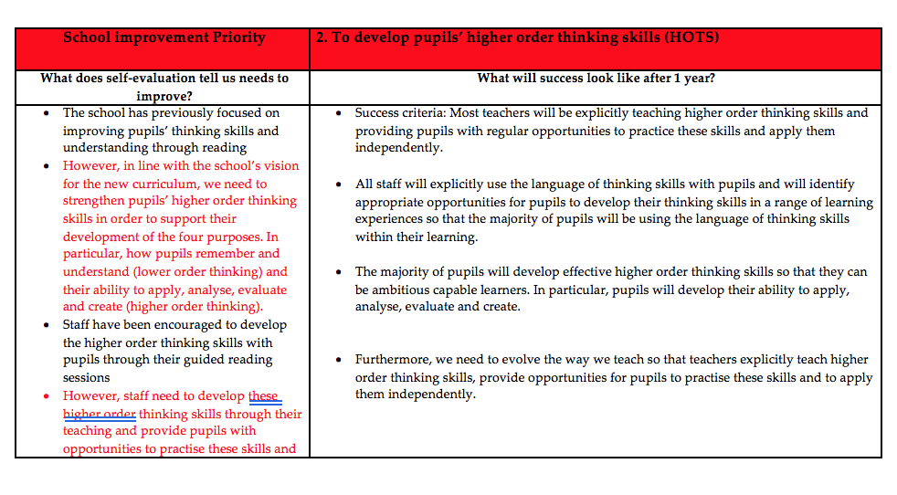

SDP Target/
Priority

Schools Vision

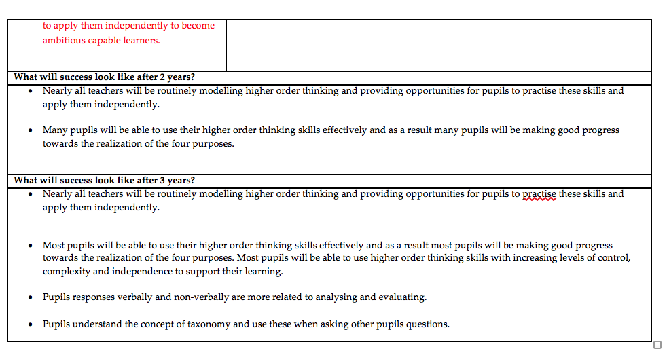

Teacher leading the action/priority/target under SMT direction.
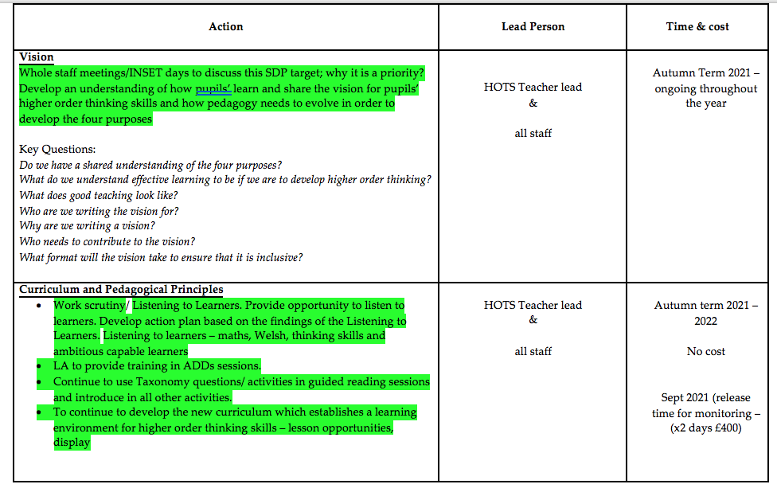

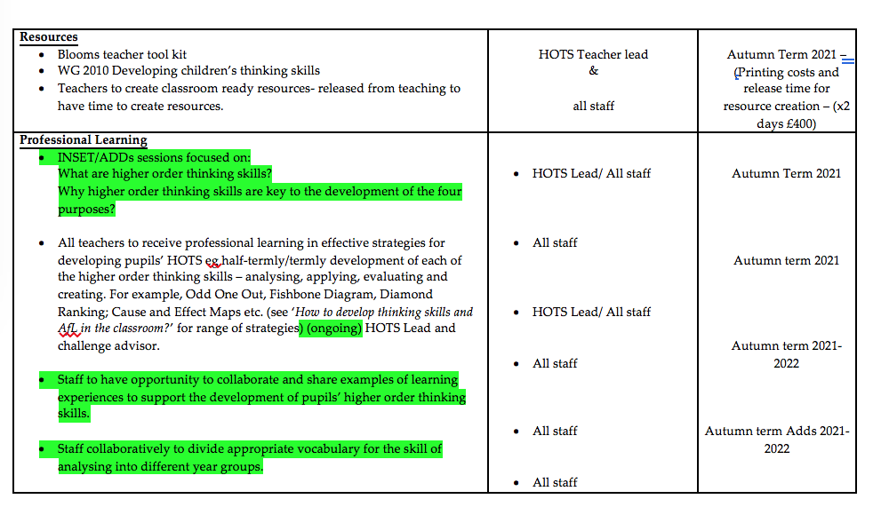
Cost
implications

Developing the target.

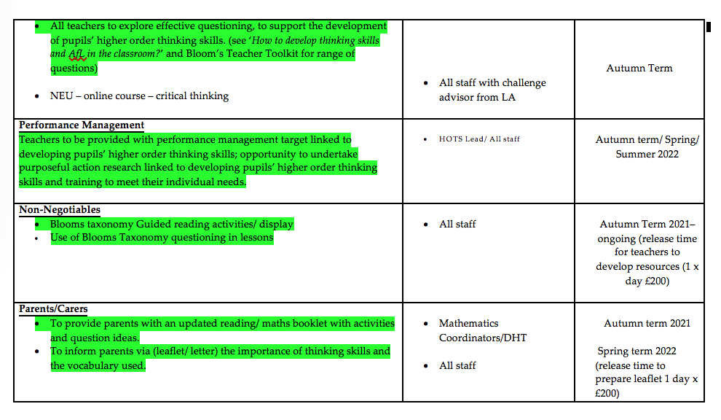
CPD- Training
Stakeholder
Involvement

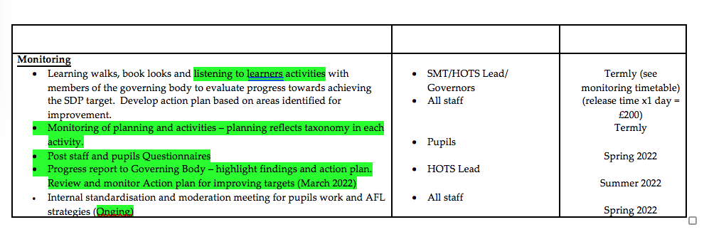

Stakeholder
Involvement

Pupil
voice

Measuring the impact

Appendix 2 – Leaflets to parents/carers

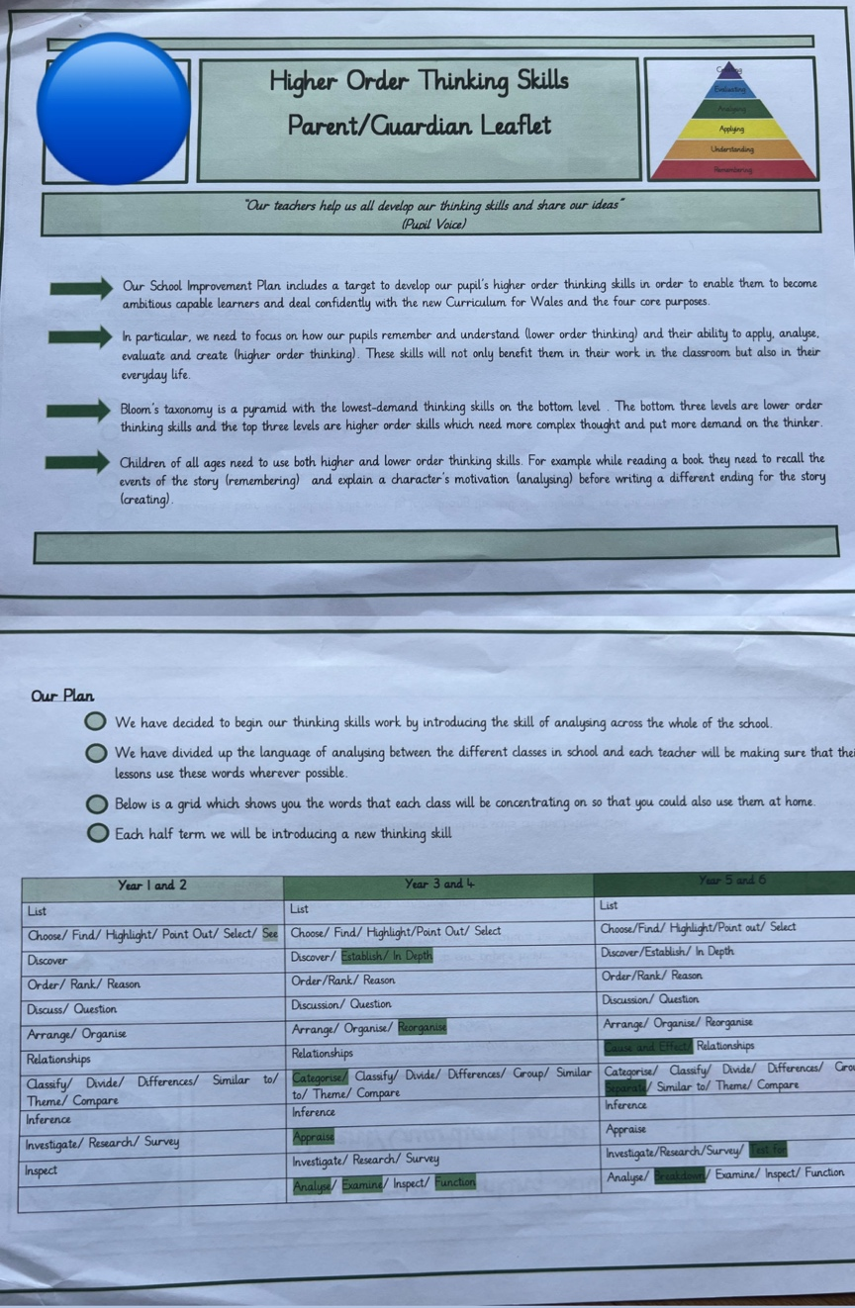
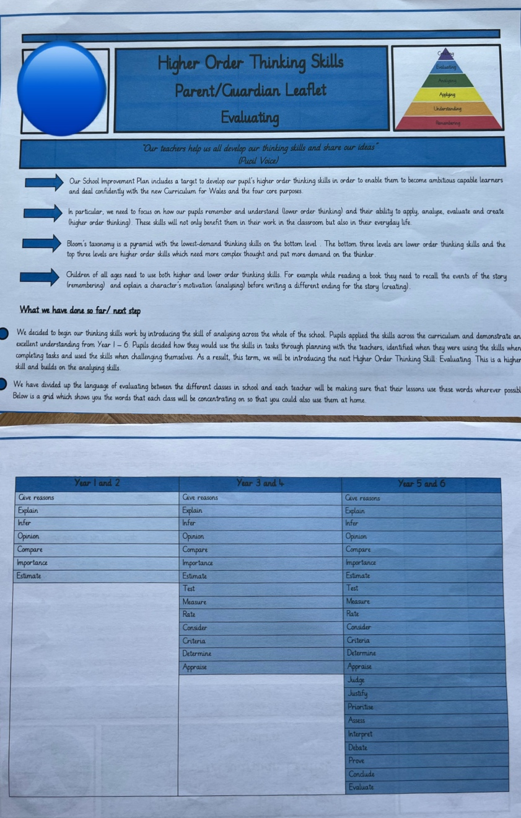

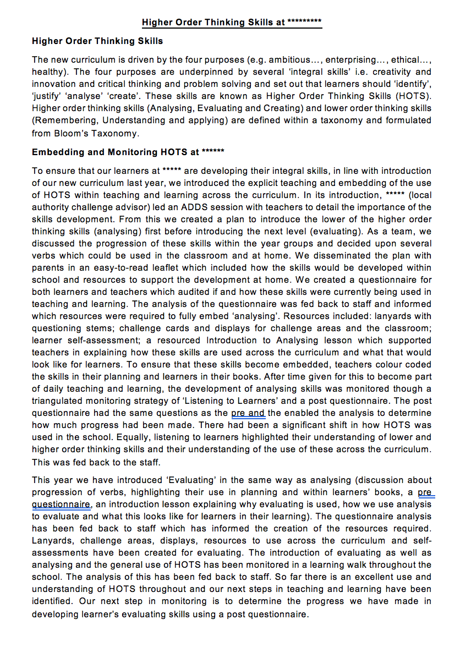
Appendix 3 – Information for the governing body
Governing body consulted and informed of the HOTS priority.

Appendix 4- Qualitative data collection- Pre-and post-questionnaire for foundation phase and KS2 and teachers.
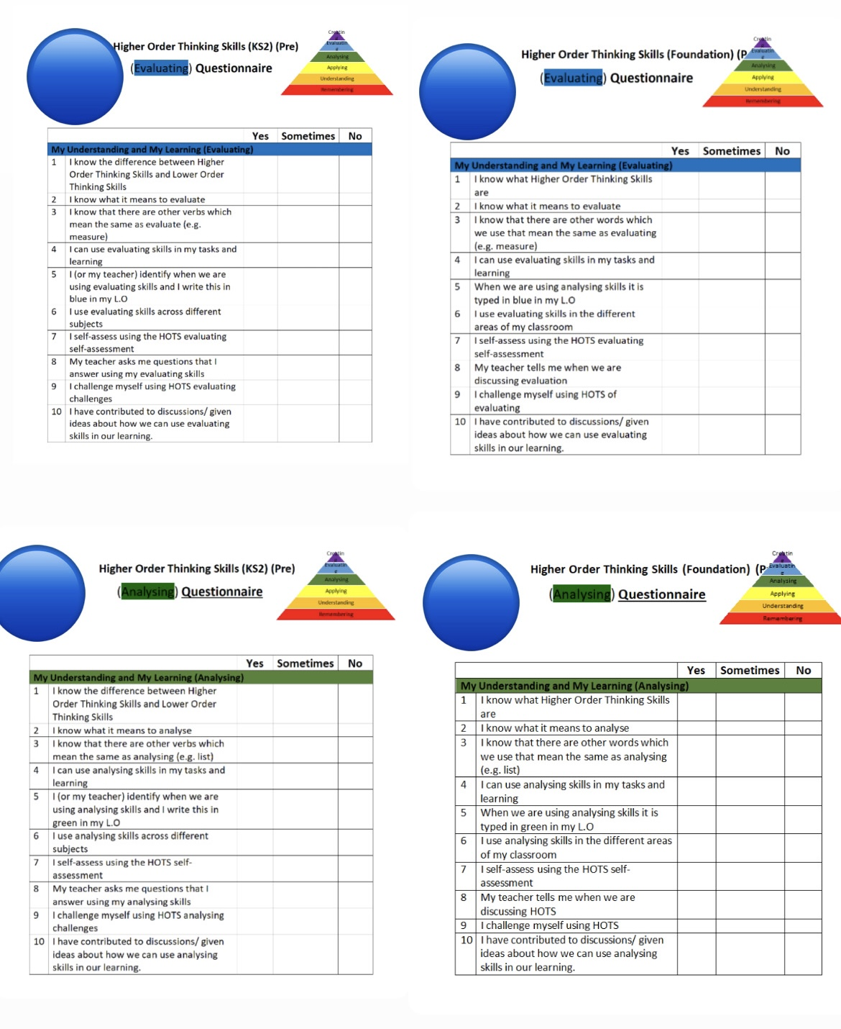

Appendix 5- Pre-and post-questionnaire results on HOT (Evaluating)
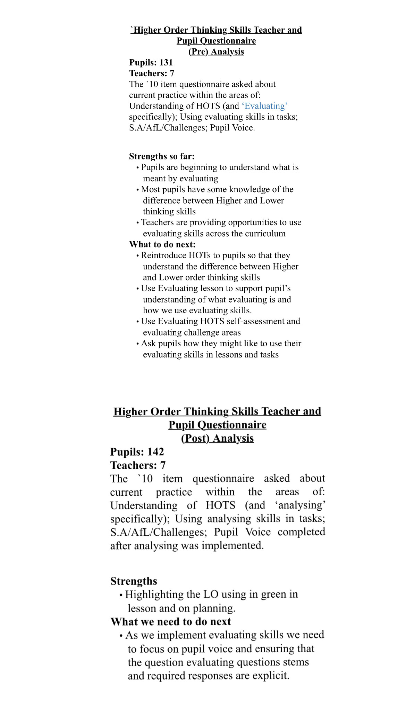

Pre- Questionnaire results from staff and pupils illustrating areas of need in developing HOTS.

Pre- Questionnaire results from staff and pupils used to take moving forward improvement actions.

Post- Questionnaire results from staff and pupils used to for monitoring and measuring impact.

Appendix 6- HOTS development- Listening to learner’s analysis

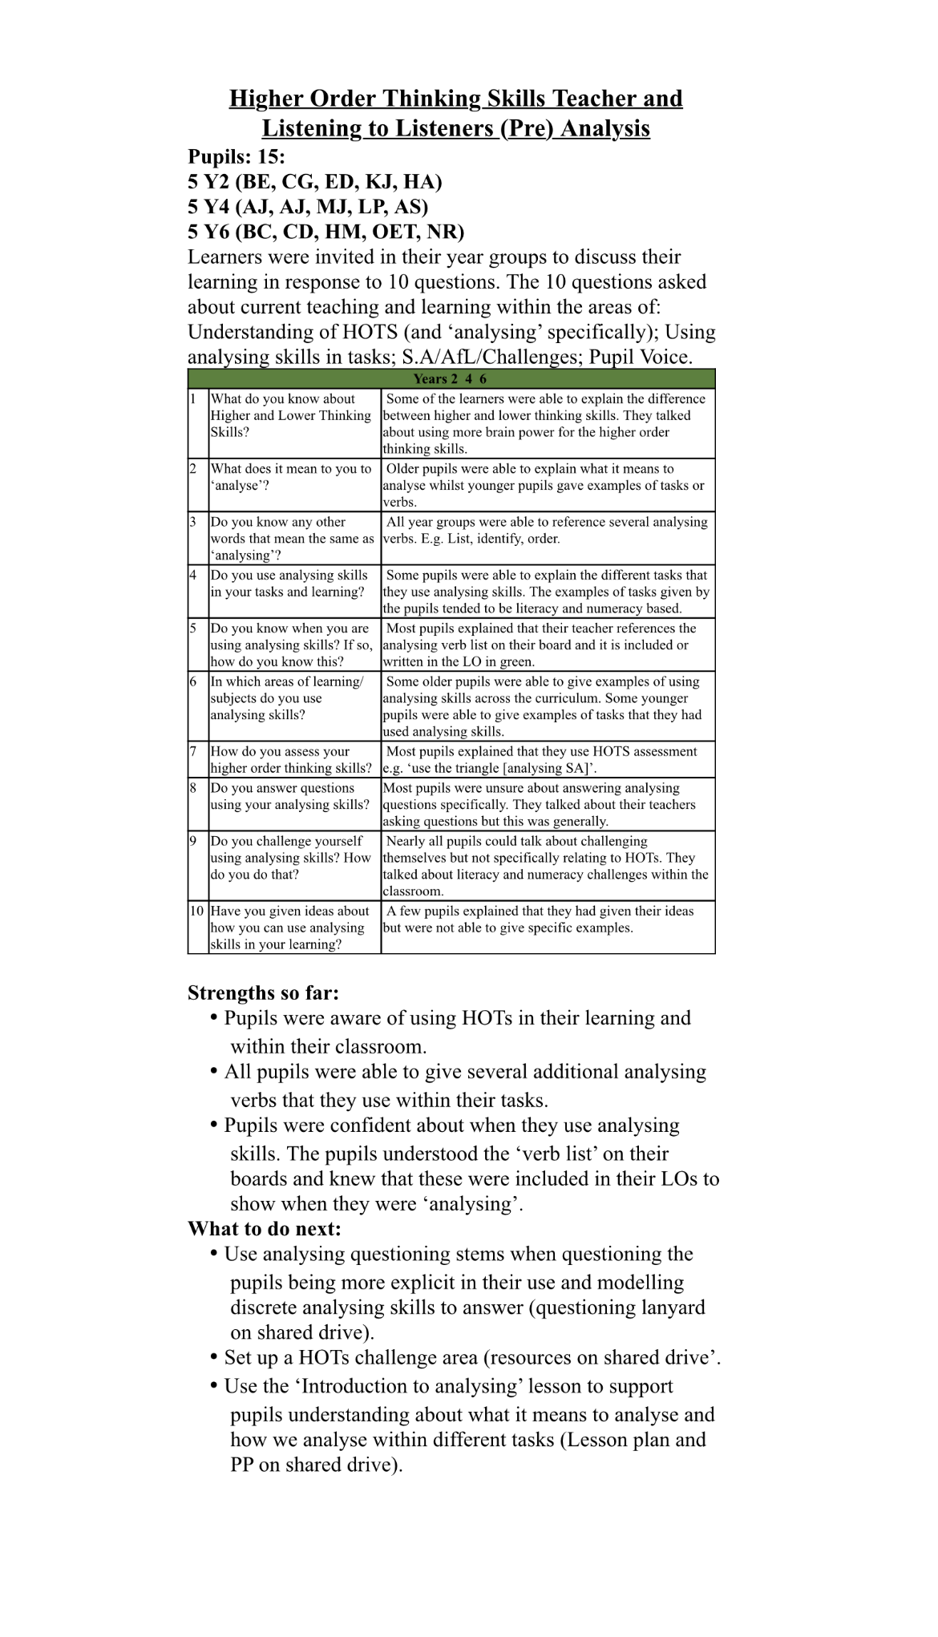
Involving learners
Pupil voice…
Taking on board their voices to drive improvement.

Appendix 7 - Consistent whole school approach towards developing HOTS.

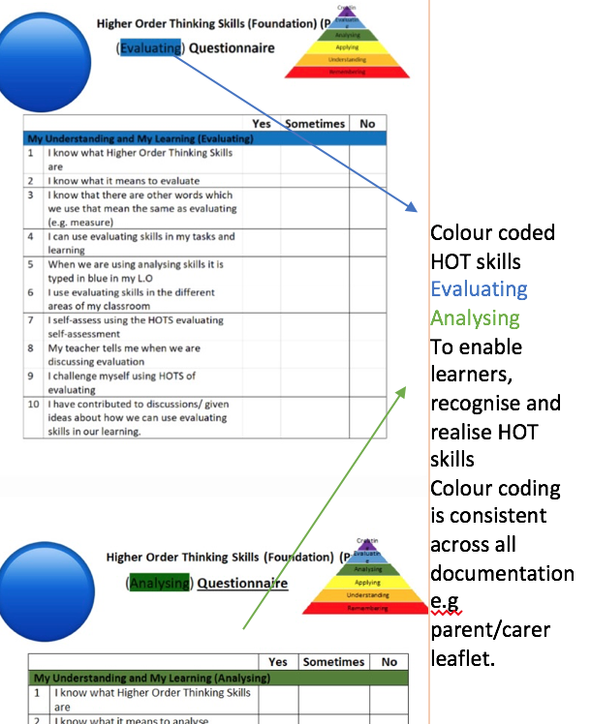
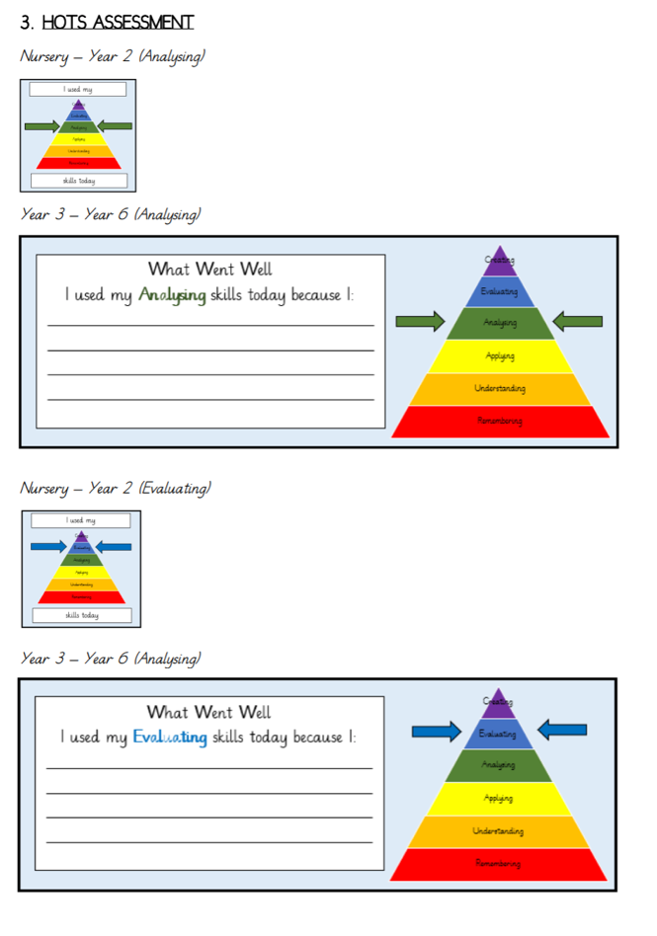
Additional consistent approaches in developing HOTS throughout the school involve…

-HOTS display boards

-HOTS question stem lanyards to support teachers with HOTS questioning.

Appropriate year group differentiated end of lesson HOTS assessment slips.

Consistent throughout the whole school.

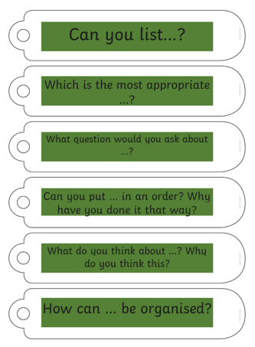

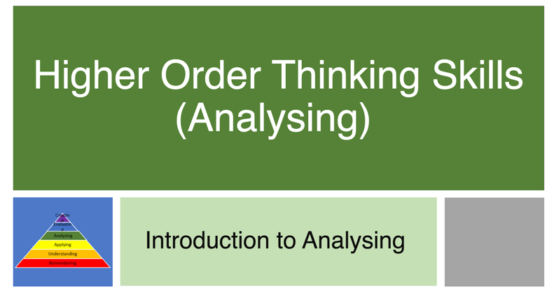
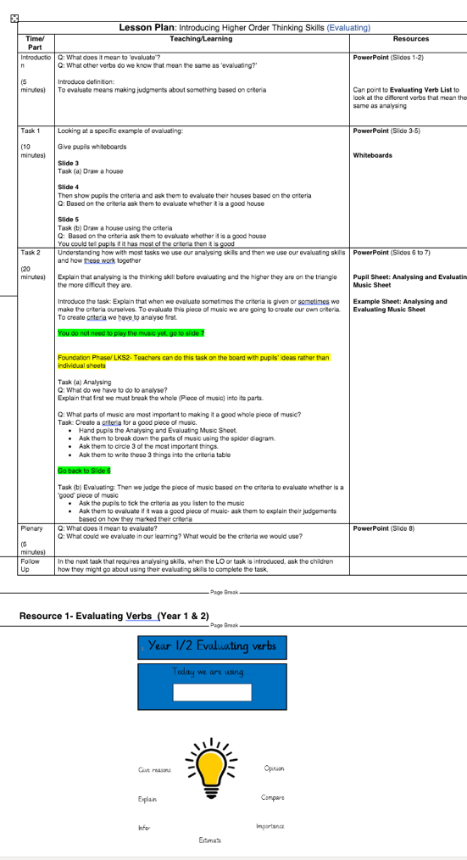
Appendix 8 – Developing HOTS.
Introductory PPT to support teachers in developing HOTS in teaching and learning.
Model/example lesson plans to support teachers in developing HOTS in teaching and learning.

