UWTSD
FORMS PROCESSING CHARACTER RECOGNITION METHODS
RESEARCH PROPOSAL
Rhysian Jones – 1809710

FORMS PROCESSING CHARACTER RECOGNITION METHODS
RESEARCH PROPOSAL
RHYSIAN JONES – 1809710

Contents:
FIGURES: 1
INTRODUCTION TO PROPOSAL: 2
LITERATURE REVIEW: 3
AIMS: 12
RESEARCH METHODS: 13
SOFTWARE DEVELOPMENT METHODOLOGY: 15
RESOURCES AND PLANNING: 15
REFERENCES: 17

FIGURES:
Figure 1 - Word Cloud Preliminary Research 3
Figure 2 - Levels of Recognition (N=102)[1] 4
Figure 3 - Benefits of ICR (N=25)[1] 4
Figure 4 - Binary Image. Red Lines = Cross Section Sequences[27] 7
Figure 5 - 100 Has Been Separated[27] 7
Figure 6 - 14° vs 8° Water Flow[28] 7
Figure 7 - Roger with Connected Nodes[30] 8
Figure 8 - Character Adaptive Mask[32] 8
Figure 9 - Row Segmentation[33] 9
Figure 10 - Character and Word Segmentation[33] 9
Figure 11 - Character Zones[35] 10
Figure 12 - Example of Topology Differentiating Characters[35] 10
Figure 13 - Key Points[36] 10
Figure 14 - Approximate Curve in Topological Representation[36] 11
Figure 15 - Edge Walking[37] 11
Figure 16 - Gantt Chart 16

INTRODUCTION TO PROPOSAL:
This document will outline the proposed research direction of the final project. A literature review will be carried out in order to investigate background information and any prior research which might aid in forming a plan for the final project. The aims of the research will be discussed along with the strategies to be implemented at each stage.
The area of study being investigated is forms processing. Forms processing is essential for any organisation which deals with large amounts of data being collected via physical documents. By facilitating the quick and accurate extraction of data from physical forms, the efficiency of data processing can easily be greatly increased. Forms processing is a well-researched area with a decades-long history and many popular applications and is ever-changing and improving. There are many different methods for different applications and the differences in languages present a wide array of challenges (such as the difficulty in separating handwritten characters in languages which are written in cursive and with overlaps or languages containing accents). In a field with a large number of techniques and algorithms in place for many different circumstances, it is useful to compare some of these to assess their function and usefulness in a specific case. This will allow for a tailored system which should provide the best possible results for the organisation. The case being taken into account in this study will be the DVLA’s (Driver and Vehicle Licensing Agency) forms processing. Some unique traits of this organisation are listed below:
- Language: English(primarily), Welsh
- Accessibility: All forms are available in large print
- Identifiers: All forms must include the DVLA and .gov icons.
These traits offer some challenge as while English processing has been widely studied, Welsh has not. While Welsh has no additional characters, it contains accents which don’t appear in English and must be accounted for as well as the obvious challenge of different words if word recognition is in use. The accessibility options offer an additional challenge as the forms will not all be identical as they would if no options were offered. The identifiers offer a helping hand. Since these always appear and always look the same, they can be used to line up the form. For example, if the logo is upside-down, the form is probably also upside-down. If the logo is slanted, the form is probably also slanted. This information can be used to perform corrections before any data is actually processed which should improve the accuracy of the process.
As the DVLA handles hundreds of thousands of forms and applications, any increase in efficiency or accuracy should make a difference to the work of the organisation.

LITERATURE REVIEW:
The purpose of this literature review is to investigate forms processing and the methods and algorithms involved. The key themes already identified in preliminary research are: forms processing, optical character recognition and intelligent character recognition. These key terms will be used to inform the research carried out in this section.
By the end of this review, the proposed project should have a clear direction based on existing research.
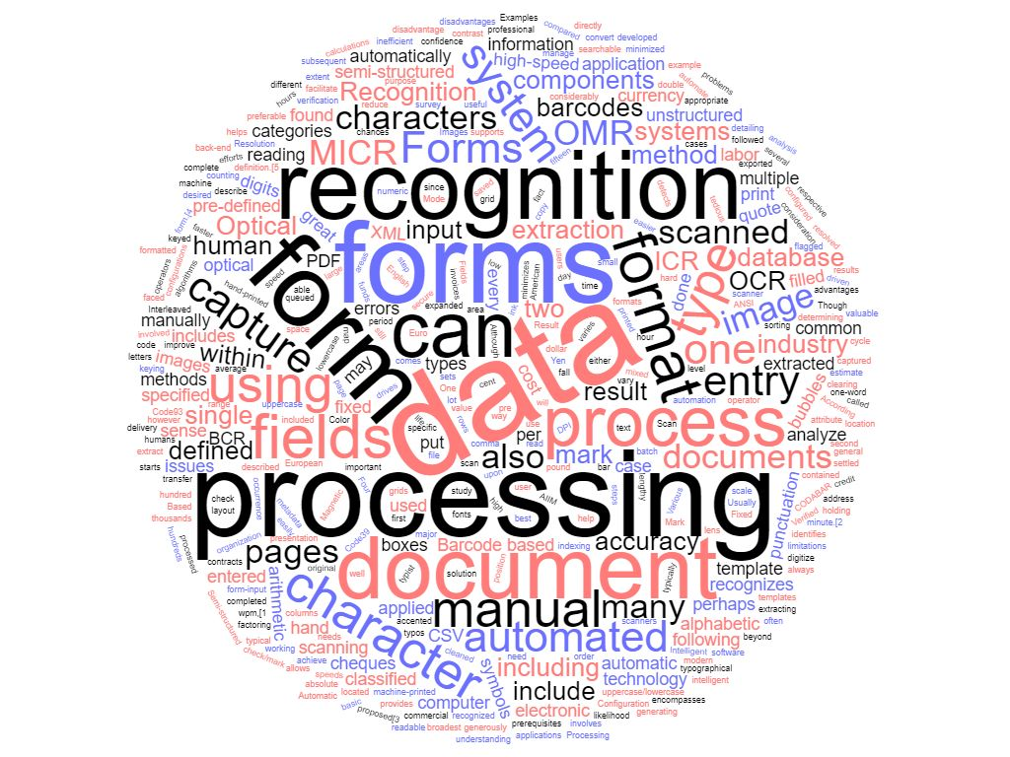
Figure 1 - Word Cloud Preliminary Research
-FORMS PROCESSING
Forms processing is the process of converting a physical form (for example, a student finance paper application) into an electronic format (for example, a database) for easier data handling[1]. The most basic method in terms of technology is manual data entry where a human will read the form and type the data into the appropriate fields. This takes a long time and is prone to human error such as typos[2].
Automated forms processing aims to reduce the time, effort, cost and errors associated with the process. A template can be used to identify where the data fields are located on the form[3].
The two types of form are fixed and semi/un-structured. In fixed forms, the data is always found in the same place on the form which makes processing easier. In semi-structured or un-structured forms, the data is not necessarily in the same place on the form every time[4][5].
Forms can have different types of input: checkboxes, printed fields or handwritten fields (plus barcodes and magnetic ink). Each of these inputs requires a different processing method[6][7]. The simplest being optical mark recognition (OMR) for reading coloured or checked fields. The next simplest method is optical character recognition (OCR) for reading printed characters[8]. Optical word recognition (OWR) is similar to OCR but it targets whole words rather than individual characters. The most complex forms processing techniques are intelligent character recognition (ICR) and intelligent word recognition (IWR)[9]. ICR and IWR are a version of OCR and OWR which aim to parse handwritten characters and words[10][11]. While OCR and OWR can match inputs to stored characters and fonts, ICR and IWR must take a more intelligent approach to processing as handwriting is far more unique and unpredictable than typed input[12].

-RECOGNITION METHODS
As previously mentioned, different input types require different recognition methods. The AIIM white paper’s[1] survey investigated the levels of recognition implemented by a selection of organisations. Their findings are below:
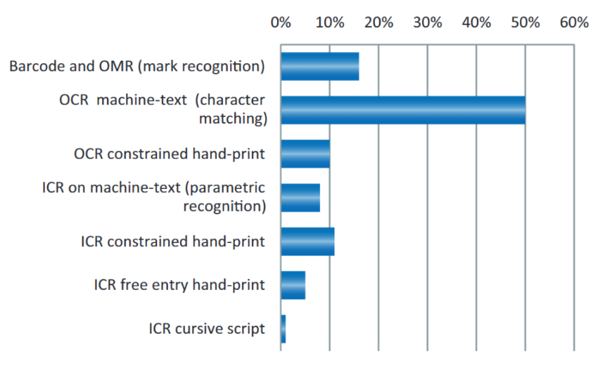
Figure 2 - Levels of Recognition (N=102)[1]
This shows that many companies are using some level of recognition with the simpler (and usually cheaper) methods being employed more often. OCR is being used to read machine-text in 50% of the organisations surveyed while hand-print is analysed using OCR and ICR in roughly 10%. This data can be used to infer that many companies are either constrained to offering only machine-text forms or hand-filled forms in which the handwritten data fields must be processed manually. The same study also found that a third of the companies offered forms with free-form unconstrained fields. For the companies that did use ICR handwriting recognition, the main benefits they found are below:
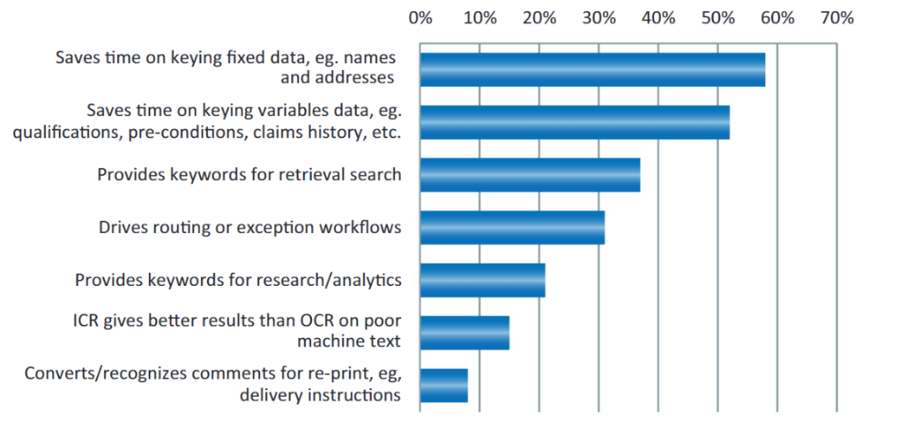
Figure 3 - Benefits of ICR (N=25)[1]

ICR is a process with many steps. Pre-processes such as de-skewing and monochrome conversion help to maximise the accuracy of the recognition. As far as algorithms are concerned, there are two main types commonly used in character recognition: matrix matching and feature extraction. Matrix matching involves isolating the character and matching it to a stored character. This approach is limited in its usefulness with handwritten characters as it compares a whole character to another whole character so it is most effective when dealing with typed text in known font. Feature extraction breaks down a character into features such as lines and loops which are then compared to character prototypes to decide which character is the most likely fit. This approach is better suited to processing handwritten text as it does not simply compare an image to another image and return a yes/no answer but instead identifies the features of the image to produce a match based on non-exact components. This allows for the greater variability of handwritten text to be accounted for.

-EXISTING SOFTWARE
There are many commercial products available to help with forms processing. One popular example is Omnipage. This software is designed to read printed text but will also attempt to read handwritten text, resulting in nonsensical outputs[13].
The reCAPTCHA project offers a security feature for websites to ensure only legitimate, human users are able to access the site as opposed to bots. The service shows users images of words (and other images or sounds in more recent versions) which have been tested using OCR and found to be unreadable by software[14]. Users deciphering these words allow the project to collect data in order to improve ICR software. This is then used to process difficult-to-process books. Training character recognition algorithms improves their accuracy[15].

-ALGORITHMS
When investigating existing research in the field of ICR and feature extraction, several themes recur: neural networks, segmentation, SVM (Support Vector Machine) and nearest neighbour along with a number of feature extraction algorithms including the use of wavelet transforms[16].
Artificial neural networks can be used to train the algorithm to improve its outcome[17], [18], [19], [20], [21]. SVMs can also be used for this purpose[22], [23] and distributed environments can be used to share work across nodes[24]. While these machine learning methods are often used and can improve the outcomes of a system, it is slightly beyond the scope of this project.
Nearest neighbour algorithms are simple machine learning algorithms used for classification or regression. They classify an object as belonging to a particular set based on the number of its neighbours that belong to that set. In character recognition, k-NN is used to classify extracted features[25], [26]. k-NN is widely used because of its simplicity but leaves room for improvement as it is not particularly intelligent.
Segmentation is needed in forms processing in order to split an image into segments which allows characters to be processed individually. This process is essential in cases where characters touch or overlap. There are many methods of segmenting an image and the best choice often depends on the situation. Some examples include the use of a cross-sectional sequence graph[27] a water flow algorithm[28] or region of interest extraction[29] though many others exist[30], [31], [32], [33]. These methods are often developed in response to failings of other methods under specific circumstances such as when processing old texts with unfamiliar styles so comparisons are difficult to draw in a general sense.
In order to find the boundary of a field, cell extraction can be performed[3].
Feature extraction algorithms are used to break down a characters into features such as lines and loops[31], [34]. A horizontal energy profile can be used to classify the type of character being analysed which can provide insight into the orthography of the text[12]. Statistical feature extraction calculates the percentage of black pixels in a region while geometrical feature extraction calculates the angles of a character, topological feature extraction calculates the number of black-white transitions and directional feature extraction finds the direction of strokes[35]. Structural component extraction might use a planar graph to represent a character for analysis[36].
Feature detection can be summarised with the following categrories:
- edge detection
- corner detection / interest points
- blob detection / region of interests
Skeletisation of the character must be carried out before any topological processing which requires the use of algorithms. Among many well-known algorithms, two possibilities for investigating a character’s skeleton are edge walking and path finding[37] which can be used for segmentation as well.
Once a character has been extracted, fuzzy logic can be used to represent how well an image matches a character[10] and genetic algorithms can be used to mimic the process of Darwinian evolution to decide on a best match for a character[38].

-EVALUATION OF SEGMENTATION ALGORITHMS
Dawoud[27] describes a method of using a cross section sequence graph for segmentation. This process involves boundary pixel extraction followed by the creation of the cross section sequence which analyses each pixel in relation to other pixels in order to find cross sections of regular sections of the image.
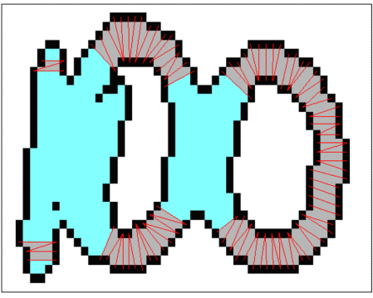
Figure 4 - Binary Image. Red Lines = Cross Section Sequences[27]
This iterative process is repeated until only regular sections are found. This means that the characters have been separated.
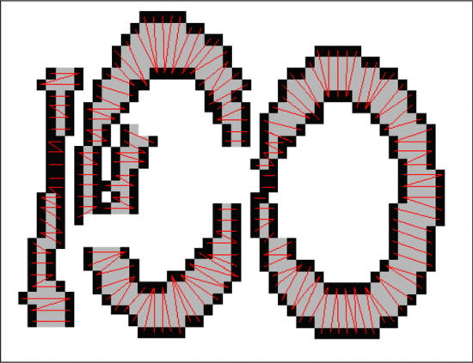
Figure 5 - 100 Has Been Separated[27]
This data can then be used to create the skeletons of the characters.
Brodic[28] describes the extended water flow algorithm. This builds upon the original water flow algorithm by introducing a slope direction variable. This algorithm simulates water flowing across the image and leaving certain areas dry. The difference between a shallow slope angle and a steeper one can be seen in the image below:
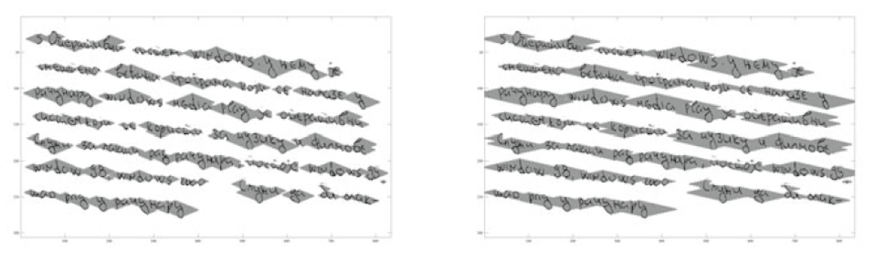
Figure 6 - 14° vs 8° Water Flow[28]
The steeper angle results in greater segmentation. The advantage of this algorithm is that it can identify lines of text rather than individual words. This should be used in conjunction with a character segmentation algorithm, not alone.
Nguyen[29] investigates handwriting symbol detection using colour differential before OCR. A heuristic filter is applied to remove noise and dilation is used to enhance the quality of the characters. The work makes use of a neural network for OCR which is beyond the scope of this project but the very basic detection of handwriting may still be applicable.
Ting[30] discusses connected character segmentation and points out that the top of a character (in English) carries more information than the bottom. The process outlined here involves skeletonisation and extraction of nodes and branches before segmentation. The segmentation process involves the algorithm attempting to match features to stored characters to form a test image which is then analysed. The focus is on the connection of pixels to find a path. In the case to joined nodes (when pixels appear in more than one character), the degree of membership is calculated to decide what belongs to each character.
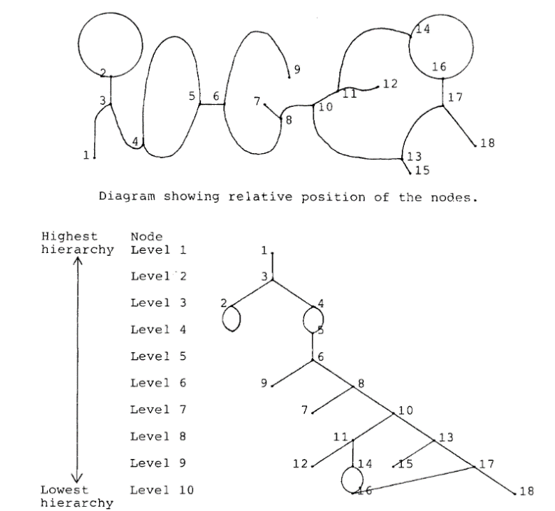
Figure 7 - Roger with Connected Nodes[30]
Pachpande[31] outlines the different layers of segmentation: structure, line, word and character. The work’s word segmentation utilises a vertical projection histogram of each line. This histogram is analysed to find the width of gaps between and within words which is used to determine the number of words present.
Song[32] discusses forepart prediction as a segmentation method. The method uses forepart prediction to take the height of each line among other features and character-adaptive masking in order to be able to recognise a subset of characters.
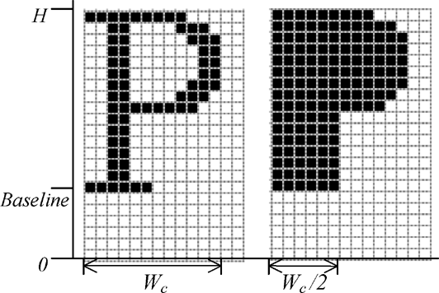
Figure 8 - Character Adaptive Mask[32]
Ashir[33] discusses a segmentation method using the white spaces between lines, words and characters. First, the document is processed along the vertical axis to find the rows and then these rows are processed along the horizontal axis to find words and characters.
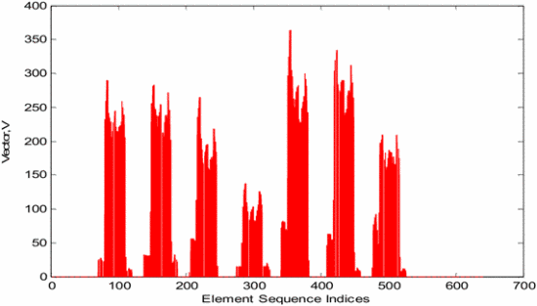
Figure 9 - Row Segmentation[33]
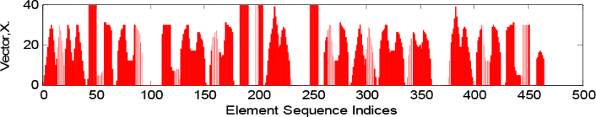
Figure 10 - Character and Word Segmentation[33]
Adaptive clustering is then used in cases where the width of the gap between characters is greater than average. This calculates the connectivity of pixels to extract blobs.

Of these researched methods, it is likely that the best suited for this project will be Ashir’s work due to its relative simplicity. Pachpande’s work similarly focuses on white space. This is subject to change after brief experimentation. It is possible that this method of segmentation will be wholly unsuitable in which case, either Ting or Dawoud’s methods will most likely be explored.

-EVALUATION OF FEATURE DETECTION ALGORITHMS
Cowell[34] describes a statistical approach to feature recognition. Rather than extracting features, the number of pixels in a character is used to match each character to template using probability. This approach seems very simple to the point that its usefulness is dubious. The work also utilises a confusion matrix which indicates the possibility of each character being confused with another.
Brodic and Amelio[12] discuss texture analysis. Run-length statistics is used to sequence the consecutive pixels along a line. This information is used to generate features such as what the work calls ‘short run emphasis’. The features are used to determine the texture which is in turn used to analyse the text’s orthography. As the work focuses on determining between two orthography styles rather than reading text, this process is not likely to be especially useful in the case of this project.
Sharma[35] outlines a feature extraction approach which utilises statistical, directional, geometrical and topological features to identify characters. Statistical feature extraction calculates the percentage of black pixels in each zone of each character. Thinning and normalisation are used to extract geometrical features; the centre of the skeleton of each character and the character is divided into zones and the pixels’ distances from the centre and angles are calculated. 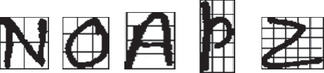
Figure 11 - Character Zones[35]
Topological analysis is used to reduce possible confusion between characters. This involves analysing the number of transitions from black to white and vice versa both horizontally and vertically.
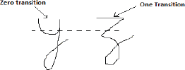
Figure 12 - Example of Topology Differentiating Characters[35]
A chain code histogram is used to analyse directional information; the contour of the character is traced to find external boundary pixels and their directions. Together, these features can be used to identify a character. This aspect of Sharma’s work appears to be suitable for this project and will likely be one of the implemented methods.
Khaustov[36] discusses using a topological model to build a graphical representation of a character. This representation can be analysed to find the vertices which can be used as key points. After skeletonisation, the key points are selected (vertices and ends of lines).
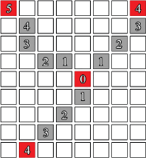
Figure 13 - Key Points[36]
The key points are used to find bends between them which are then used to create a topological representation of the character.
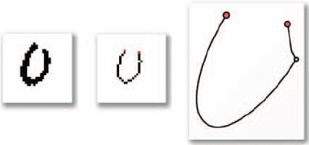
Figure 14 - Approximate Curve in Topological Representation[36]
A bipartite graph is used to connect key points. This is used in matching characters. This part of Khaustov’s work appears to be suitable for this project and will possibly be one of the implemented methods.
Reed[37] investigates the creation of an OCR system which uses thinning to skeletonise characters, normalisation to scale the characters, templating to construct a representation of each known character which can be compared using edge filtering and edge walking for defining the characters.
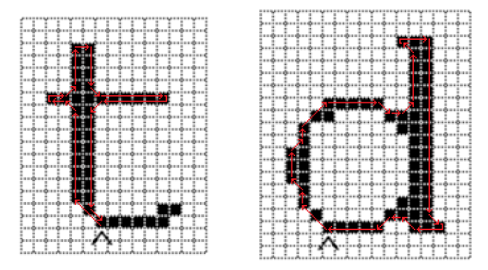
Figure 15 - Edge Walking[37]
Reed’s work goes into great depth, investigating many techniques and analysing data. The bulk of the work is outside the scope of this project but the edge walking algorithm might be an interesting addition and will possibly appear as one of the implemented methods.

Of these researched methods, it is likely that the best suited for this project will be Sharma’s compound feature extraction and either Reed’s edge walking algorithm or Khaustov’s topological method, possibly all three if time permits it. This is subject to change after brief experimentation and it is possible that a very simple homemade pixel analysis method will be implemented to test against instead.

-IMPLEMENTATION OF RESEARCH
Based on the research undertaken in this section, the proposed structure of the software can be outlined as follows:
- Input
- Pre-processing
- Segmentation
- Skeletisation
- Feature extraction
- Matching
The input stage will take in the image of the text which in this case, will consist of single handwritten words and short phrases. This will likely be carried out using ImageJ.
The pre-processing stage will involve de-skewing if necessary and conversion to black and white images and then a binary matrix[39].
Segmentation will be performed using one of the seven aforementioned methods. The exact method will be selected upon some further research and light experimentation but should remain the same in every tested program.
Skeletisation will be attempted using path finding but this is subject to change if it is found to be unsuitable during development.
Feature extraction will be carried out using a very basic edge detection method for the first program. For the second program, one of the aforementioned methods will be selected. This will be chosen based on further research and some light experimentation.
The matching stage will be carried out using fuzzy logic to match the characters to a collection of stored characters and features.

-LITERATURE REVIEW CONCLUSION
This literature review has investigated prior research into forms processing, the stages involved and some methods and algorithms used. The research conducted here has been used to inform the direction of the project as a whole with candidates for segmentation and feature extraction methods being selected from the literature.

AIMS:
The aim of this project is to investigate different techniques and algorithms for recognising handwritten characters by developing a selection of them. These will then be tested to find the strengths and weaknesses of each one for a given case in order to rank them by effectiveness.

RESEARCH METHODS:
PHILOSOPHY:
The research philosophy to be employed in this project is positivism. Positivism deals with real, objective outcomes and experiments meant to observe the physical. This philosophy was chosen because the aim is to test different algorithms based on outcomes and not user experience. The lack of human participants means that this must be a positivistic project.

APPROACH:
The approach to be taken in this project is deductive. A deductive approach involves a hypothesis and an experiment to test it rather than a theory to explain the research. This approach was chosen because there is no existing hypothesis as to which algorithm is best suited in this case. The aim is to investigate the algorithms to find the best suited one which requires an experiment which is a deductive approach.

STRATEGIES:
The strategies employed in this project will be a literature review to research the background of the topic and plan out a course of action, software development to create some software based on the background research and an experiment to compare the outputs of the developed software. Three strategies were chosen in order to triangulate the research and these particular strategies were chosen because they allow for a sensible project flow:
  - Literature review – investigate existing research
  - Software development – implement the findings of the literature review to create programs to test
  - Experiment – test the developed software in order to investigate the different outcomes of different algorithms

SOFTWARE DEVELOPMENT:
The selected methods and algorithms for character recognition will be developed in order to investigate their effectiveness in a given case. By the end of the project, at least two methods should be developed into functioning programs. The aim of the software development stage is to implement the findings of the literature review by developing some of the researched algorithms. The programs developed will be used in the experiment stage.

EXPERIMENT:
The developed software will be compared in an experiment. The experiment will entail testing each program by processing the same or similar information and gathering data on accuracy and efficiency. This data will then be compared to draw conclusions.

RISKS AND LIMITATIONS:
As this project does not involve participants, there are few risks involved. The data being handled will not contain any personal information or any government information aside from possible agency logos so there is no concern over GDPR or privacy.
As a deductive approach is being taken, time is in short supply which will limit the possible scope of the project but risks are limited and prior research is abundant.
The project will be restricted to only using free resources or resources available through the university at no extra cost.
As this research is being undertaken as part of a partnership with the DVLA, a government organisation, it is possible that DVLA forms and processes might be discussed when seeking advice. None of the content of this project should contain any material retrieved from the DVLA and no DVLA processed should be detailed.

DATA EVALUATION:
The data being evaluated will be the results from the experiment. The success rate of each algorithm will be recorded and compared as well as any other useful information such as processing speed. The data will be analysed, compared and ranked. In order to produce data with acceptable accuracy, each test will be performed multiple times and the results will be averaged. Reliability will also be tested by repeating the tests. The data produced by the experiment and analysed during evaluation will be presented with graphs and rank tables.

SOFTWARE DEVELOPMENT METHODOLOGY:
The methodology used when developing the software will likely (subject to change if found
unsuitable) be waterfall development. As this is a solo project and the desired final product is a selection of small programs intended to be used in a comparison experiment and not a complete, market-ready program, this methodology appears to be the best fit. The steps involved in waterfall development are as follows:
- Requirements
- Design
- Implementation
- Testing
- Maintenance
This linear, sequential development style should help to reduce the number of problems encountered in the later stages as they should be found in the requirements and design stages. It should also reduce the time needed to build the programs as once the first algorithm has been developed, the second (and any optional others) will be based on very similar design which should streamline the process.

RESOURCES AND PLANNING:
RESOURCES REQUIRED:
  - DVLA issued laptop.
  - University access to Microsoft office and onedrive.
  - Intellij community edition for programming
  - ImageJ for image processing
  - Database software (mongodb or postgresql) for storing character maps
  - Online research materials (including university online library)
  - University library access
  - Possible additional image processing tools to be determined in design stages

GANTT CHART:
 |  |  |  |  |  | Month: | May-19 |  |  |  | Jun-19 |  |  |  | Jul-19 |  |  |  | Aug-19 |  |  |  | Sep-19 |  |  |  | Oct-19 |  |  |  | Nov-19 |  |  |  | Dec-19
ACTIVITY: |  | RESOURCE: |  | STATUS: |  | Week: | 1 | 2 | 3 | 4 | 1 | 2 | 3 | 4 | 1 | 2 | 3 | 4 | 1 | 2 | 3 | 4 | 1 | 2 | 3 | 4 | 1 | 2 | 3 | 4 | 1 | 2 | 3 | 4 | 1 | 2 | 3 | 4
RESEARCH
Preliminary research |  |  |  | C
Literature review |  |  |  | C
Decide on algorithms |  |  |  | In prog
DEVELOPMENT
Design system 1
Build system 1
Design system 2
Build system 2
Possible other systems
EXPERMIENT
Design experiment
Perform tests
ANALYSIS
Compile data
Analyse data
Rank results
DOCUMENTATION
Project proposal |  |  |  | C
Final project
Figure 16 - Gantt Chart

REFERENCES:
[1] M. D, “Forms Processing - User Experiences of Text and Handwriting Recognition (OCR/ICR),” 2012. [Online]. Available: www.aiim.org/pdfdocuments/MIWP_Forms-Processing_2012.pdf.
[2] X. Lu, S. Kataria, W. Brouwer, J. Wang, P. Mitra, and C. L. Giles, “Automated Analysis of Images in Documents fir Intelligent Document Search,” 2009.
[3] R. D. Felipe and L. A. P. Neves, “Pre-Printed and Hand-Filled Table-Form Analysis Aiming Cell Extraction,” in 2008 The Eighth IAPR International Workshop on Document Analysis Systems, 2008, pp. 439–443.
[4] S. Golubev, “‘Construction of Model of Structured Documents Based on Machine Learning’, in Pattern recognition and machine intelligence : 4th international conference, PReMI 2011, Moscow, Russia, June 27 - July 1, 2011 : proceedings,” 2011, p. 424.
[5] “CAPTURING SEMI-STRUCTURED FORMS AND DOCUMENTS: CHALLENGES AND AVAILABLE TECHNOLOGIES,” 2005. [Online]. Available: https://c.ymcdn.com/sites/www.bfma.org/resource/resmgr/articles/05_04.pdf. [Accessed: 23-May-2019].
[6] S. Mozaffari and P. Bahar, “Farsi/Arabic Handwritten from Machine-Printed Words Discrimination,” in 2012 International Conference on Frontiers in Handwriting Recognition, 2012, pp. 698–703.
[7] S. N. Srihari, Yong-Chul Shin, V. Ramanaprasad, and Dar-Shyang Lee, “Name and Address Block Reader system for tax form processing,” in Proceedings of 3rd International Conference on Document Analysis and Recognition, vol. 1, pp. 5–10.
[8] Zhi-Hong Zhao, Xue-Dong Tian, and Bao-Lan Guo, “A study on printed form processing and reconstruction,” in Proceedings. International Conference on Machine Learning and Cybernetics, vol. 4, pp. 1730–1732.
[9] S. Mandal, S. Sur, A. Dan, and P. Bhowmick, “Handwritten Bangla character recognition in machine-printed forms using gradient information and Haar wavelet,” in 2011 International Conference on Image Information Processing, 2011, pp. 1–6.
[10] P. Mahasukhon, H. Mousavinezhad, and J.-Y. Song, “Hand-printed English character recognition based on Fuzzy theory,” in 2012 IEEE International Conference on Electro/Information Technology, 2012, pp. 1–4.
[11] F. Yasmin, S. M. M. Hossain, and M. S. Arefin, “APSD: A framework for automated processing of survey documents,” in 2017 International Conference on Electrical, Computer and Communication Engineering (ECCE), 2017, pp. 411–416.
[12] D. Brodic and A. Amelio, “Classification of the hand-printed and printed Medieval Glagolitic documents using differentiation in orthography,” in 2017 40th International Convention on Information and Communication Technology, Electronics and Microelectronics (MIPRO), 2017, pp. 1110–1115.
[13] K.-H. Steinke, “Improvement of Omnipage 18’s efficiency,” in 2012 IEEE International Conference on Computer Science and Automation Engineering (CSAE), 2012, pp. 434–438.
[14] “reCAPTCHA: Easy on Humans, Hard on Bots.” [Online]. Available: https://www.google.com/recaptcha/intro/v3.html. [Accessed: 26-May-2019].
[15] S. Gunter and H. Bunke, “Optimizing the number of states, training iterations and Gaussians in an HMM-based handwritten word recognizer,” in Seventh International Conference on Document Analysis and Recognition, 2003. Proceedings., vol. 1, pp. 472–476.
[16] A. M. Sabu and A. S. Das, “A Survey on various Optical Character Recognition Techniques,” in 2018 Conference on Emerging Devices and Smart Systems (ICEDSS), 2018, pp. 152–155.
[17] A. M. El-Gabaly, P. Liang, M. Barth, and E. Tuncel, “UNIVERSITY OF CALIFORNIA RIVERSIDE Expectation and Knowledge Guided Neural Networks for Image Recognition,” 2016.
[18] S. Afroge, B. Ahmed, and F. Mahmud, “Optical character recognition using back propagation neural network,” in 2016 2nd International Conference on Electrical, Computer & Telecommunication Engineering (ICECTE), 2016, pp. 1–4.
[19] T. C. Wei, U. U. Sheikh, and A. A.-H. A. Rahman, “Improved optical character recognition with deep neural network,” in 2018 IEEE 14th International Colloquium on Signal Processing & Its Applications (CSPA), 2018, pp. 245–249.
[20] M. M. Farhad, S. M. N. Hossain, A. S. Khan, and A. Islam, “An efficient Optical Character Recognition algorithm using artificial neural network by curvature properties of characters,” in 2014 International Conference on Informatics, Electronics & Vision (ICIEV), 2014, pp. 1–5.
[21] B. Vani, M. S. Beaulah, and R. Deepalakshmi, “High accuracy optical character recognition algorithms using learning array of ANN,” in 2014 International Conference on Circuits, Power and Computing Technologies [ICCPCT-2014], 2014, pp. 1474–1479.
[22] K. Tsegay Fitsum and Y. Patel, “Optical Character Recogniation for Tigrigna Printed Documents Using HOG and SVM,” in 2018 Second International Conference on Inventive Communication and Computational Technologies (ICICCT), 2018, pp. 1489–1494.
[23] J. Xie, “Optical Character Recognition Based on Least Square Support Vector Machine,” in 2009 Third International Symposium on Intelligent Information Technology Application, 2009, pp. 626–629.
[24] D. Pop, B. Irimie, and D. Petcu, “Distributed Optical Character Recognition for Old Romanian Prints,” in 2017 19th International Symposium on Symbolic and Numeric Algorithms for Scientific Computing (SYNASC), 2017, pp. 416–418.
[25] T. K. Hazra, D. P. Singh, and N. Daga, “Optical character recognition using KNN on custom image dataset,” in 2017 8th Annual Industrial Automation and Electromechanical Engineering Conference (IEMECON), 2017, pp. 110–114.
[26] P. Romulus, Y. Maraden, P. D. Purnamasari, and A. A. P. Ratna, “An analysis of optical character recognition implementation for ancient Batak characters using K-nearest neighbors principle,” in 2015 International Conference on Quality in Research (QiR), 2015, pp. 47–50.
[27] A. Dawoud, “Iterative Cross Section Sequence Graph for Handwritten Character Segmentation,” IEEE Trans. Image Process., vol. 16, no. 8, pp. 2150–2154, Aug. 2007.
[28] D. Brodic, “Advantages of the Extended Water Flow Algorithm for Handwritten Text Segmentation,” in Pattern Recognition and Machine Learning, 2011, p. 418.
[29] N. Q. Nguyen, Q. T. Nguyen, H. V. D. Nguyen, T. D. Chau, and T. A. Tran, “Automatic Extract Handwriting Marked Regions in Business Document Images,” in 2018 International Conference on Advanced Computing and Applications (ACOMP), 2018, pp. 112–116.
[30] V.-C. R. Ting, “Separation and recognition of connected handprinted capital English characters,” 1986.
[31] S. Pachpande and A. Chaudhari, “Implementation of devanagri character recognition system through pattern recognition techniques,” in 2017 International Conference on Trends in Electronics and Informatics (ICEI), 2017, pp. 717–722.
[32] J. Song, Z. Li, M. R. Lyu, and S. Cai, “Recognition of Merged Characters Based on Forepart Prediction, Necessity-Sufficiency Matching, and Character-Adaptive Masking,” IEEE Trans. Syst. Man Cybern. Part B, vol. 35, no. 1, pp. 2–11, Feb. 2005.
[33] A. M. Ashir and G. S. Shehu, “Adaptive clustering algorithm for optical character recognition,” in 2015 7th International Conference on Electronics, Computers and Artificial Intelligence (ECAI), 2015, p. SG-13-SG-16.
[34] J. Cowell and F. Hussain, “Amharic character recognition using a fast signature based algorithm,” in Proceedings on Seventh International Conference on Information Visualization, 2003. IV 2003., pp. 384–389.
[35] N. Sharma, B. Kumar, and V. Singh, “Recognition of off-line hand printed English Characters, Numerals and Special Symbols,” in 2014 5th International Conference - Confluence The Next Generation Information Technology Summit (Confluence), 2014, pp. 640–645.
[36] P. A. Khaustov, V. G. Spitsyn, and E. I. Maksimova, “Algorithm for optical handwritten characters recognition based on structural components extraction,” in 2016 11th International Forum on Strategic Technology (IFOST), 2016, pp. 355–358.
[37] J. Reed, “An Optical Character Recognition Engine for Graphical Processing Units,” Theses Diss. Sci., Jan. 2016.
[38] L. Niharmine, B. Outtaj, and A. Azouaoui, “Tifinagh handwritten character recognition using genetic algorithms,” in 2018 International Conference on Advanced Communication Technologies and Networking (CommNet), 2018, pp. 1–6.
[39] A. Nectoux, “Matrices and Digital Images | Klein Project Blog,” 2015. [Online]. Available: http://blog.kleinproject.org/?p=588. [Accessed: 24-May-2019].

