ASSIGNMENT PART 1
Submitted by Judith Nthere
Student: 1601947

MODULE SBMA7101D
HUMAN RESOURCE MANAGEMENT

In agreement with Dr, David Griffiths
‘ENGAGEMENT IS THE WAY FORWARD’
Raspberry P1. Foundation

30th April 2018

Table of Content
1.0 Introduction………………………………………………………………………….3
2.0 Executive Summary …………………………………………………………...……3-4
3.0. Enhancing Raspberry P1 employee motivation/morale, Intrinsic/Extrinsic……………………………………………………………………5-6
3.1. ERG Content Theory of needs by Alderfer (1972) …………………………6-7
3.1.1. Concepts of Employee Engagement and Involvement………………………7-8
3.2 How Raspberry P1 Foundation can build an Engaged workforce…………..8-9
3.3 Employee Involvement: ……………………………………………………..9
3.4 Employee voice……………………………………………………………….9
3.5 Psychological Contract …………………………………………………9
4.0. Advantages of improved employee engagement/involvement and what problems may arise: ………………………………………………………………………………….9
4.1. Outcomes of high levels of employee Engagement/Involvement …………..10
4.2. Advantages and disadvantages of employee Engagement and Involvement.10.
5.0. Strategic role of HR at Raspberry P1 Foundation……………………………………10
5.1. Ulrich (1997a) HR Champion model to enhance HR role at P1 Raspberry10-11
6.0. Recommendations
6.1. Recommendation 1: The Harvard HRM Model of Beer et al (1984)….10-11
6.2. Recommendation 2:High Performance/Commitment model of Pfeffer (1998)
…………………………………………………………………………….11-12
7.0. Conclusion……………………………………………………………………………12
References……………………………………………………………………………...…12-13
Appendices…………………………………………………………………………..……14-16

- Introduction

The charitable non-profit Raspberry PI Foundation was set up in 2006 by ambitious
entrepreneurs, Dr. E. Upton who resigned in 2012, Dr. R. D. Mullins, Professor A Mycroft and
J.A. Lang. The objective of Raspberry Foundation with a charity status, was to provide
outreach and education to help people through their free resources to learn about computers,
create things with the computer and train educators to help solve computer problems all over
the world. Raspberry PI Foundation’s vision was that everyone should be able to afford their
own programable computer hence their objective to further the education of both adults and
children in computers.

PI Raspberry Foundation currently employs 100 staff at Pencoed, Mid Glamorgan and the
figure is set to increase dramatically. As a newly appointed HR middle Manager at the
Foundation, I have been asked to write a report on ‘Employee engagement is the way forward’
and recommend to senior management what needs to be done,

A report will be written to explore how to enhance employee motivation,
involvement/engagement, what Raspberry Foundation can do and the recommendations using
theory models to underpin the recommendations. Employee engagement and involvement will
enable employees at Raspberry P1 Foundation to be the best they can, and perform at work if
they feel respected, well-led, valued, involved and heard through employee voice mechanisms,
be it upward problem-solving, or worker’s representative participation and be involved in
work-related decision-making, can contribute and get positive feedback through feedback
loops.

2.0 Executive Summary

This report has been written using academic research informed literature, secondary research
through Human Resource Management text books, management Journals and scholarly
websites to underpin evidence for employee engagement and involvement as the way forward,
what needs to be done and recommendations. Raspberry P1 Foundation, a charitable
organisation believes that they will function best when the employees’ engagement is central
to their operation. Having a clear strategy only is not enough but how people behave at work
can make a difference between business success or failure.

This report examines the nature of employee engagement and involvement, its concepts,
success factors, benefits for both employee and employer, outcomes, enablers and its
relationship to employee voice, upwards communication, feedback loops, psychological
contract and the advantages and disadvantages of employee involvement and engagement.
Research has shown that when employees are engaged and well managed, they are not only
happier, healthier, fulfilled, motivated and have job satisfaction, but also use discretionary effort or go an ‘extra mile’ to do their job and deliver improved business performance which in turn brings in enhanced customer satisfaction and loyalty, higher profitability, less absenteeism and sick rates, higher retention and faster business growth.
Building on this, P1 Foundation needs to be careful to avoid burnouts by not overworking employees, instead introduce flexibility, job autonomy, good leadership, managers to plan and design clear job specifications to avoid employees getting frustrated and also encourage work-
life balance especially for the millennial generation who seek purpose in their job.
The report will also outline how Raspberry P1 Foundation can build a motivated and engaged
workforce using a combination of Intrinsic motivation which takes place when employees feel
that their work is important interesting and provides not only autonomy to act but also
opportunities to use their skills to advance and develop themselves and the ERG Alderfer
(1972) motivation theory which postulated three primary categories of need; existence needs
such as hunger and thirst, pay, fringe benefits and working conditions, relatedness needs which
acknowledge that people are not self-contained units but must engage with their human
environment in terms of acceptance, understanding, confirmation and influence and growth
needs which allow people to find opportunities to be what they are and to become what they
can. The ERG Model recognises that an employee has multiple needs to satisfy simultaneously
and focussing on need will not effectively motivate.

Raspberry P1 Foundation will deliver HR function using the Ulrich (1997a) HR Champion
model, enhance engagement through the Pfeffer (1998) High Performance model and the soft
approach ‘fit’ of the Harvard Model of HRM by Beer et al to enhance performance as
recommendations.

3.0 Enhancing Raspberry P1 employee motivation/morale
Motivation in a charitable organisation is purely intrinsic from within as shown in figure below.
Intrinsic motivation is based on the intrinsic or psychological rewards that employees get from
doing work, they like and the need to be competent and self-determining, meaning having a
choice Deci and Ryan (1985). Extrinsic motivation are external rewards like pay, bonuses and
are usually short term. Intrinsic motivation can be enhanced by job design which means that
Raspberry P1 should be able to give jobs which should provide variety, complexity and
challenge to engage abilities of the employee Armstrong (2017). Intrinsic motivation takes
place when an employee feels that their work is important, interesting and challenging that it
provides them with a reasonable degree of autonomy, opportunities to achieve and advance in
their career. The Manager at Raspberry should therefore improve motivation by giving: -

- Autonomy and encouraging employees to set their own schedule and have the focus to do their work and not how it should be done.

- Mastery, help employees identify steps to improve and take responsibility for their progress.

- Purpose, when giving instructions, explain the why as well as the how.

Employees at Raspberry will be motivated and committed to a meaningful purpose and will be
able to choose how to fulfil that purpose by performing multiple tasks and will progress to
achieve the purpose.
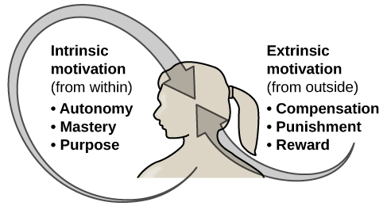
Figure 1. Source: Armstrong (2017) & Google search for image.

2.1 The ERG Content theory of needs by Alderfer (1972) to identify employee needs

The aim of the ERG Alderfer theory shown below on figure II. of motivation is to identify the
employees’ motivational needs. The theory postulates three categories of needs, existence
needs, relatedness needs and growth needs. The model emphasises that an individual’s needs
must be met simultaneously. Raspberry must therefore identify the Existence needs like
hunger, pay working conditions, Relatedness needs like acceptance, understanding which
acknowledge that man should engage with their human environment and growth needs which
involve people being what they are and want and must all be met. This theory proves that it is
not only financial rewards that can motivate people and P1 Foundation can learn that
employees can still perform to their fullest even when the money is unavailable. The
employees do not need a Manager if they are given autonomy to fulfil their purpose especially
millennials who are always seeking purpose in what they do. Intrinsic rewards can also
promote a highly engaged culture when people like what they do and get pleasure from what
they do.

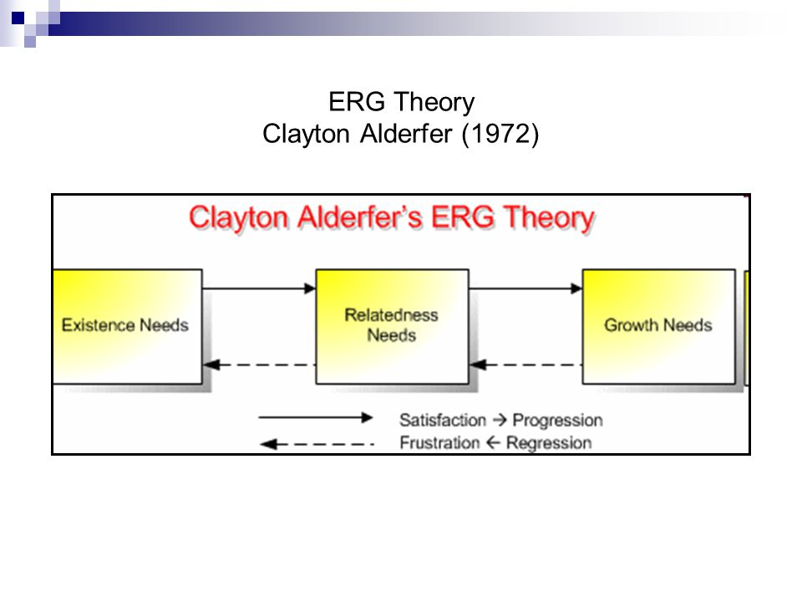
Figure II. Source Armstrong (2017, p194) and Google for image.

3.1.1. The Concepts of Employee Engagement and Employee Involvement

Employee engagement is a combination of commitment to the organisation and its values and
a willingness to assist colleagues CIPD (2017). It goes beyond the job description and is not
just a motivation. Engagement is something employees need to offer and cannot be asked,
Henderson (2017, p 148). Highly engaged employees will be much happier, healthier, fulfilled
and will also drive productivity which will have numerous benefits for Raspberry P1.
Raspberry P1 should therefore aim at engaging its employees because they can deliver business
performance bottom line Henderson 2017, p.148). The aim will be to leverage discretional
behaviour and exceed the expected requirements of their employment contracts. Raspberry P1
needs to have a strong employee brand to help attract and retain top talent. Employee
engagement and involvement is the key as engaged employees will protect the brand from
being damaged by poor levels of service Henderson 2017, p. 148). The main engagement
driver is a sense of feeling valued and involved.

3.2. How Raspberry P1 Foundation can build an Engaged workforce

Employee Engagement can be defined as the harnessing of organisation members’ selves to

their work roles; in engagement, people employ and express themselves physically,

cognitively, and emotionally during role performances Kahn (1990, p. 694). Raspberry P1
must first understand the factors that affect Employee Engagement and Involvement as

indicated below Crawford et al (2014, p. 59-62) before building an Engaged and Involved

workforce: - Source: Armstrong (2017, p. 218).

- Job Challenge: High work load will enhance engagement for the P1 Foundation employees because there will be potential to develop skills for career growth, however, there would be a risk of burnouts to be avoided.

- Autonomy: the freedom and discretion for employees to be allowed to mployees at Raspberry p1 to schedule their work and determine the procedures to execute it. This will provide a sense of ownership and control which will create trust between Raspberry P1 and the employee.

- Variety: Raspberry P1 should offer variety in jobs to enhance skills.

- Feedback: Raspberry should offer employees direct and clear information regarding employee growth.

- Fit: Raspberry should offer compatibility to employers to allow them to be themselves.

- Opportunities for development: Raspberry to offer meaningful work to employees to enhance employee growth and fulfilment.

- Rewards and Recognition: Reward for personal or team contribution for fulfilling work role and celebrate success.

- Leadership: Quality leadership at Raspberry P1 is also an enabling driver. Supervisory support is positively related to employee engagement as is involvement in decision-making and day today control over tasks and schedules Hakanen et al (2006). Employees at Raspberry must understand the purpose and strategy and their contribution to it.

- Employee voice: Need to involve employees in management decision-making where they can voice their ideas for positive feedback

3.3. Employee Involvement

Employee involvement is not the same as Employee Engagement. Employee Involvement
refers to management led practices where employee input is seen to assist in the achievement
of organisational objectives Truss (2017, p. 212).

3.4. Employee voice

P1 Foundation can directly exchange information between employees and line Managers and
can replace the traditional communication channels like joint consultation Henderson (2017;
p.148-149). The mechanisms that provide employee voice can be classed as ‘upward problem-
solving’ and representative participation’ (CIPD, 2007c). These are illustrated in Figure
Success factors and benefits of employee voice for both P1 and employees are shown in Figure

3.5. Psychological Contract

Psychological contract exits purely in the mind of the employee and employer and is highly
linked to higher commitment to the organisation and fosters better relations. P1 should note
that a psychological contract is not part of an employees’ contract and cannot be demanded.
Henderson (2017; p. 148-149).

4.0. Advantages of improved employee engagement/involvement and what problems may arise

The advantages and disadvantages of employee engagement and involvement are listed in the
table below. Research has shown that engaged employees could experience higher levels of
work-family conflict because they enact more helpful behaviours in the workplace leading to
personal resource drain and burnouts than other groups Truss (2017, p. 228). P1 should
develop apps to relieve stress amongst employees and encourage flexibility and work-life
balance. Employees with young children can suffer burnouts especially females than men.

4.1. Advantages and disadvantages of employee Engagement and Involvement
Advantages and disadvantages of employee Engagement and Involvement are on Appendix I.

4.2. Outcomes of high levels of employee Engagement/Involvement

When employees are highly engaged and involved, the outcomes for both P1 Foundation and

the workforce will be highly beneficial as shown in Appendix II.

5.0. Strategic role of HR at Raspbery P1 Foundation
The strategic role of HR at P1 Raspberry Foundation is to promote the goals and values of the
organisation by developing and implementing HR strategies integrated with the business
strategy, adopting a strategic support to support and add value to the business Armstrong (2017,
p. 45). HR Professionals at P1 Foundation will need to perform a STEEPLE analysis of the
business and find out the needs and recommend appropriate solutions. HR Strategy at P1 Foundation could be influenced by
internal factors like culture, organisational structure, technology and external factors like
supply and demand within local labour markets Truss (2017, p121). P1 Foundation can
implement the 2-by-2 matrix Ulrich (1997a) HR ‘Champion’ model to focus on day to day or
future roles and on either people or process Truss (2017, p. 70). The model comprises of four
roles; change agent, employee champion, administrative expert and strategic expert shown
as Appendix III.

6.0 Recommendations
6.1. Recommendation 1: The Harvard HRM Model of Beer et al (1984).

Raspberry P1 Foundation can use the Harvard Model of HRM, a ‘soft approach’ developed by

Beer et al (1984) as a framework to enhance performance and achieve positive HR outcomes.

Another outcome will be a committed workforce working in harmony with the objectives of

the organisation and achieving competence and cost effectiveness. The Harvard model consists

of stakeholder interests, Situational Factors, HRM Policy choices, HR Outcomes and Long-

term Consequences is a Soft Approach to be used by Raspberry P1 Foundation. If P1

Foundation uses the Harvard Model below.

Source: Henderson (2017, p. 11)
Beer et al (1984; p.16 ‘Map of the HRM territory’)
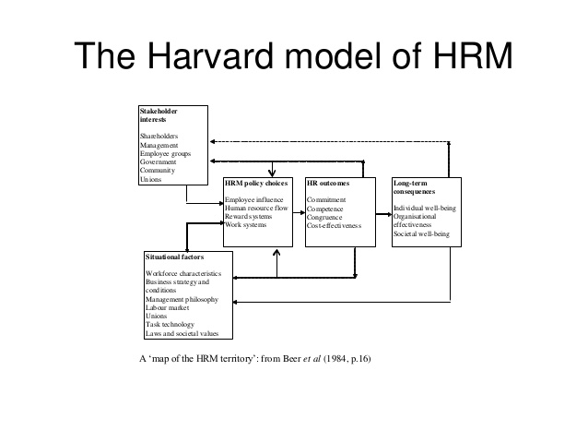
6.2. Recommendation 2: High Performance/Commitment model of Pfeffer (1998)
I would recommend the Pfeffer (1998) high performance/commitment performance model to
Raspberry P1 being the best practice approach to enhance organisational performance and it is
the task of the HR Professional to implement it Delery and Doty (1996). Below are the
interrelated best practices: -

- Employment Security: When employees are offered employment security, they will most likely remain in that employment for a long time and will in turn show commitment and high levels of commitment.

- Selective hiring: Raspberry will need to select top talent using rigorous processes. This will enhance skills.

- High compensation contingent on performance: Raspberry needs to attract top talent and will have to offer competitive pay to retain staff.

- Training to provide a skilled and motivated force.

- Reduction of status differentials: Flexibility should be encouraged to enhance work-life balance.

- Information sharing to all employees at Raspberry P1 for better performance.

Conclusion

This Report has explored ways and means of motivating the staff at PI Foundation and has
touched upon the advantages and disadvantages of employer versus employee involvement and
engagement as a way forward at Raspberry PI Foundation. Research has shown that employee
engagement versus employer involvement is associated with massive benefits for both
employer and employee. When employees have a voice, are involved in decision-making
policies of the organisation, given autonomy to carry out their tasks in a flexible environment,
given career opportunities and training, and a platform to enhance their skills, they will go an
extra mile to carry out their tasks for their organisation which will be a competitive advantage
for organisation.

References

Armstrong, M. (2017). Armstrong’s Handbook of Human Resource Management Practice
(Fourteenth Edition) London: Kogan Page.

CIPD. (2017). Employee engagement and Motivation. Chattered Institute of Personnel Development. Retrieved on 15/03/2018.
https://www.cipd.co.uk/knowledge/fundamentals/relations/engagement/factsheet

CIPD (2015). Big Data, social Media and HPWS for the intelligent
Office. Retrieved on 11/03/2018. https://www.cipd.co.uk/Images/big-data-social-media-hpws_2015_tcm18-15586.pdf

CIPD (C) (2007). Employee Voice. Factsheet. London: CIPD. Retrieved on 12/04/2018. http://www.cipd.co.uk/online
CIPD (2015) Big Data, social Media and HPWS for the intelligent Office. Retrieved on
15/04/2018. https://www.cipd.co.uk/Images/big-data-social-media-hpws_2015_tcm18-15586.pdf

Deci, E. L, and Ryan, R, M. (1985) Intrinsic Motivation and Self-determination in Human
behaviour, New York, Plenum.

Delery, J. and Doty, D. (1996). Modes of theorising in Strategic Human Resource Management: tests
of universalistic, Contingency and Configurational Performance Predictors. Academy of Management Journal, 39(4), pp. 289-309.

Gifford, J. Neathey, F. and Loukas, G. (2005). Employment Involvement Information, Consultation and
Discretion, Institute for Employment Studies, Report 427. Retrieved on 12/04/2018,
https.www.employment-studies-co-uk.

Hakanen, J.J, Bakker, A. B. and Schaufeli, W.B, (2006). Burnout and Work Engagement among
Teachers, Journal of School Psychology, 43, pp. 495-513.

Henderson, I. (2017). Human Resource Management for MBA Students. (Third Edition)
London: Chartered Institute of Personnel and Development.

Iciniowski, C. Kochan, T.A, Levine, D.I., and Olson, C., and Strauss, G. (2000).
The American Work Place: Skills, Compensation; and Employee Involvement: Cambridge Press.

Kahn, W.. (1990). Psychological Conditions of Personal engagement and Disengagement at work.
Academy of Management Journal, 33, pp, 692-724. Retrieved on 12/04/2018. http://aom.org/Publications/AOM-Open-Access.aspx

Lewis, R. Donaldson-Feilder, E and Tharani, T (2012) Management Competencies
For Enhancing Employee Engagement, London Chatered Institute of Personnel and Development

MacLeod, D. and Clarke, N. (2009) Engaging for Success: Enhancing Performance through
employee Engagement. Office of the Public Sector Information.

Management competencies for enhancing employee engagement
http://engageforsuccess.org/wp-
content/uploads/2017/05/Management-competencies-for-enhancing-employee-engagament.pdf March 2011. Accessed on 15/04/2018

Price, A, (2007). Human Resources Management in a Business Context (Third Edition)

Raspberry Pi. (2012). Retrieved 29 April 2018
Foundationhttps://static.raspberrypi.org/files/about/RaspberryPiFoundationReport201 2.pdf

Raspberry Pi Foundation. (2015). About us. Retrieved 29/04/2018.
https://www.raspberrypi.org/about/

Truss, C., Mankin, D. and Clare, K. (2012), Strategic Human Resource Management,
London: Oxford University Press.

APPENDICES

Please see below Appendix I, II and III.
1. Appendix I
4.1. Advantages and disadvantages of employee Engagement and Involvement
Advantages Engagement Raspberry P1 Foundation | Advantages Engagement Employees
Lower absenteeism  Higher retention  Increased employee effort | -Feel proud to work for Raspberry P1 Foundation  -More opportunities to grow  Teams that support each other
and higher productivity
Improved quality and reduced error rates | Lower levels of stress
Less accidents at work | Better work-life balance
Increased sales | Greater sense of well being
Higher profitability | Job satisfaction
Enhanced customer satisfaction and loyalty | Sense of belonging
Faster business growth  Build trust by showing commitment to the employees’ success  Give employees ownership and creation of their outcomes  ‘Clear the path’ so that employees can do what they do best without unnecessary distractions  Provide continuous feedback on how those strengths are being used  Focus upon particular skills and knowledge in order to build talent into strengths  Armstrong (2017)  Burnouts. P1 Foundation can introduce Aps or flexible working.  Engagement can be expensive. | Feeling superior instead of inferior  Managers likely to listen and care for employees  Leaders who listen to employees and inspire them  Source: MacLeod & Clarke (2009)  -Top Management Information can be leaked by employees.
  Disadvantages Raspberry P1 | Engagement
  Disadvantages Employees | Involvement

2. Appendix II.

Outcomes for Employees Outcomes for P1 Raspberry Foundation
Engagement | Involvement
Improved individual health and wellbeing | -Reduced grievances and other sources of conflicts through involving workers and unions in decision-making.
Reduced sickness absence | -Delegating decision-making to self- directed teams can reduce the number of supervisors or middle managers and -improve communication
Reduced turnover | -Cross training and flexible job assignment may reduce the costs of absenteeism
Higher levels of individual productivity and performance | -Increased job satisfaction  -Open door policy where employees can express concerns to a manager
Higher levels of customer service  Higher levels of innovation  Higher levels of organizational advocacy and job satisfaction | -Employees feel valued
Source:
MacLeod and Clarke (2009: 37-39) | MacLeod and Clarke (2009: 37-39)

5.1. Appendix III. Ulrich (1997a) HR Champion model to enhance HR role at P1 Raspberry Foundation
ROLE | DESCRIPTION
Strategic Partner | - This role to focus on strategic direction of P1 Foundation, organization and development, recruitment benefits etc Truss (2017, p. 71)
Administrative Expert | - To focus on executing HR tasks by line Managers at P1.
Employee Champion | - Focus on the well-being of employees and defend their interests by listening to them
Change Agent | - Manage organizational change.

Source: Truss (2012, pp. 70-71) Ulrich (1997a) typology of HR functional roles.

