INVESTIGATION INTO RESPONSIVE WEB APPLICATIONS FOR PROGRESSING ONLINE EXPERIENCES

Research Proposal

Steven Tanner Moore

Gaynor Thomas



Table of Contents
INVESTIGATION INTO RESPONSIVE WEB APPLICATIONS FOR PROGRESSING ONLINE EXPERIENCES 1
Research Proposal 1
Steven Tanner Moore 1
Gaynor Thomas 1
Introduction 3
Background / Literature to the Proposed Research 3
Human-Computer Interaction (HCI) 3
User Interface (UI) 3
Case Study – Terra Improving User Engagement using Dark Mode [10] 4
Aims & Objectives 5
Project Goal 5
Alternative Plan 6
Project Design 6
Data Collection 6
Risks 6
Resources and Planning 7
Research - Resources 7
Design - Resources 7
Development - Resources 7
Feedback – Resources 7
Planning 7
Conclusion 8
Bibliography 8

Introduction
This project aims to examine the existing technologies and methodologies which are currently used to provide online web-based experiences such as landing pages, navigation, content display and media interaction. The result of this investigation will be used to aid in the creation of a modern and unique style of viewing, navigating and consuming content on web-based applications. To test these new experiences the author could re-design existing web applications, aiming to provide a better user experience. Users can then rate the old experience against the redesign in a controlled test, which will provide the project’s conclusion.

Background / Literature to the Proposed Research
This section covers the existing literature and any evidence which supports or opposes the need for creating new and unique browsing experiences. As well as the background to the core topics relating to this project.

Human-Computer Interaction (HCI)
HCI is the multidisciplinary field which focuses on how users interact with different systems [1]. This includes how we interact with systems digitally through user interfaces. It also involves how we interact with systems physically. For example, swiping a card to access the London Underground. HCI also includes cognitive / human factors [2], for example researching why and how people have come to associate specific icons or symbols with meanings or information. For example, icons of floppy disks are commonly used to represent save buttons (screenshot from Microsoft Word’s interface):

User Interface (UI)
A system’s user interface bridges the user to the backend of the system, serving as the interaction layer between the two [3]. In terms of web design, the UI is a particularly important aspect as most devices are capable of browsing the web, meaning user interfaces need to be “responsive” [4] (able to adapt to different screen sizes such as mobile and desktop screens).
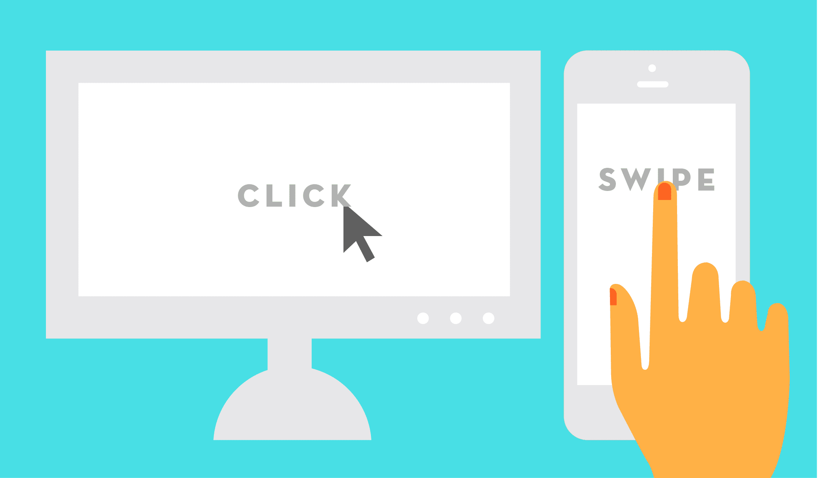
Figure 1: https://penningtoncreative.com/mobile-vs-desktop/
One of the challenges of creating responsive designs is preserving the intuitiveness of the original designs across different screen sizes. Consider how mobile and desktop navigation systems operate in different ways especially dropdown menus. Most desktop user interfaces will make use of an “on hover” drop down menu system, meaning that when the user hovers their cursor over a drop-down menu it will open. However, users on mobile devices with touch screens cannot “hover” their cursor, they must “tap”
the screen. One solution is to simply make the menu open whenever its clicked or tapped. However, in most cases the drop-down menu title is also a link so when the user clicks or taps the menu to try and open it, they are taken to a different page.
This is why Bootstrap – an extremely popular HTML, CSS and JavaScript framework do not recommend “on hover” drop down menus and deliberately do not natively support it [5]. For those who choose to use “on hover” menus a separate navigation menu for mobile can be deployed. An example of this can be found on a site the author has personally worked on available at: https://www.hengoedcare.co.uk/ The disadvantage of this is that the developer must maintain two sets of navigation menus. This is just one of many complications which come with responsive web development.

User Experience (UX) and Accessibility
User experience refers to how the user interface is designed to provide users with what they need, value and to define the abilities and limitations of the UI [6]. There are 7 fundamentals for UX design which are represented through Peter Morville’s “UX honeycomb” [7]
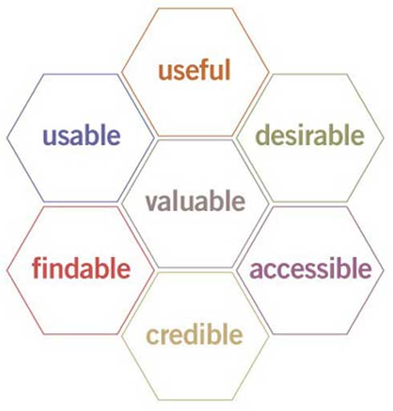
Figure 2: http://semanticstudios.com/user_experience_design/

Accessibility
Web Accessibility refers to how websites can be ‘designed’ and ‘developed’ so that people with disabilities can interact and use them properly [8]. Designing accessibility friendly websites refers to creating a page design that is easily readable and browsable. This means using large clear fonts and clear contrasting colours. Developing accessibility friendly websites involves making pages accessible to screen readers, via “alt text” (descriptive text which is not visible in the UI but is read by screen readers). Fortunately, a page with good accessibility will also be well optimised for SEO [9] (search engine optimisation – refers to how google decides where pages are ranked in search results).

Case Study – Terra Improving User Engagement using Dark Mode [10]
The following is based around an article examining how Terra [11] (A blockchain protocol and payment platform) reduced bounce rate on their website by 60% by implementing a “dark mode or night mode” across their website. Bounce rate refers to the percentage of visitors which leave a webpage without interacting with it [12].

The article is authored by two very experienced developers: Demian Renzulli – a developer at Google, and André Bandarra – Developer Relations Engineer for Chrome and the Web at Google. The conclusion of the article states that by providing the users with a choice between dark mode and traditional light mode options boosted engagement metrics: a 60% reduction in bounce rate and 170% increase in pages visited per session. They also conclude that this boost of engagement came from the users who have their devices in dark mode by default. This may be because they expect sites they visit to adapt to their device settings.
Dark mode is not a new idea by any means. However, it has been slow when it comes to big name websites implementing it. For example, YouTube first introduced their dark mode back in May of 2017 [13], Facebook added its dark mode as recently as October 2020 [13].
The results from this case study show that web design is constantly evolving, and that new and unique browsing experiences are viable and that they can have powerful influence on how users engage with a site or if they’ll even consider using the site.

Aims & Objectives

Project Goal
The main overarching aim of this project is to improve and progress web-based experiences (web-based experiences refer to how the user navigates and interacts with a website). These “experiences” are mostly curated through front-end / UX design.

Research – Two weeks
To achieve this goal, the project will start with research on the literature surrounding the subject and existing websites to find out if there are common technologies, methodologies or practices which are used across the industry. This research should also include any specific cases where design changes have had big results such as the case study previously discussed in this document.

Exploratory Development – Three weeks
The project will then go into its initial development phase where the author will design and develop different components relating to web-based experiences such as navigation, media interaction, page layouts etc. Which can then be tested by external subjects to figure out what people like and dislike. The results from this will be used to decide how to recreate existing web applications in the project’s main development phase.

Design & Development – Two months
The project’s main development phase will include selecting and redesigning 1-3 arbitrary web applications, considering the previous research / testing when doing so. These designs could be created using tools such as “figma”, “Adobe XD” or other page designers. After completing the designs, the next step is creating them using HTML, CSS, and JavaScript (potentially React).

Feedback & Analysis – Two weeks
The projects final phase is again testing the new designs against the old. This could be achieved by conducting a controlled test where subjects are given tasks on each version of the site and the results are measured. The subjects could also be given feedback sheets / questionnaires where they can express their opinions. The author could then analyse this data using suitable data analysis and if applicable statistical analysis techniques.

Alternative Plan
Depending on time constraints the author may have to integrate phase 2 (Exploratory Development) into the main development phase and conduct all user testing at the end of the project. This could potentially produce weaker designs however the author is aware of some existing web development techniques, technologies, and standards from working in industry alongside professional web developers.

Project Design
The project evolves around creating new user interfaces for two – three existing web applications. one of these being Wikipedia’s main page, as it contains lots of interesting data which is currently displayed in bullet point lists. Making it a good starting point to experiment with different ways of displaying information on a web page.
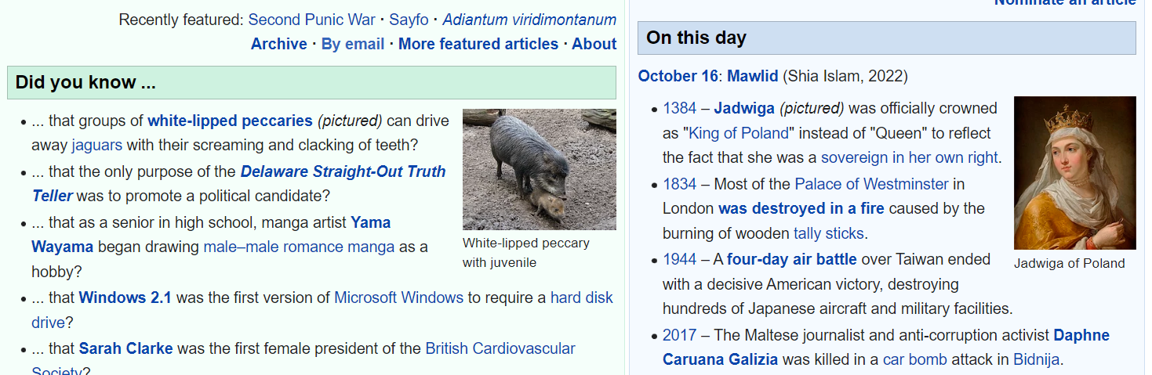
Figure 3 - Screenshot of Wikipedia's main page

Data Collection
Once this initial page has been re-designed and developed the author could have people use and compare the old design to the new. This exploratory research would generate qualitative data, meaning the research generates opinion-based feedback. however, the author could also conduct tests to find out which interface is more efficient, even though a more ‘efficient’ interface doesn’t necessarily provide a better user experience [14]. This data could then be used to figure out what works and what doesn’t when it comes to redesigning the next web application. This whole process can then be repeated for each redesign, with aiming for improved results for each design.

Risks
- Copyright infringement – Permission from the owners of the existing web applications may be requested depending on the fair use rules for their site.
- Lack of time – Implement the alternative plan previously discussed or even scale back the project to recreating two web applications.
- Loss of data – The entire project will be backed up on OneDrive and various physical storage mediums. The design files will be stored online via Figma’s site. The development files will be stored, and version controlled via Github.

Resources and Planning
This section covers the resources required for the design, development, and review stages of the project. It also includes the planning layout which documents each phase and its estimate required time to complete. Due to the nature of this project, it goes without saying that the author will make use of a computer running Windows.

Research - Resources
- Semantic Scholar - AI-powered research tool for scientific literature.
- UWTSD – Library & Learning Resources.
- Online Articles, Journals and example websites.

Design - Resources
The main interface design tool which the author may use is called ‘Figma’ – a web application for interface design [15]. Figma is essentially an online version of Adobe XD. The advantage of it being that design files can be accessed and edited from anywhere on any device. This application is popular within the industry and the author has had personal experience with it in industry. The author may also make use of other design tools such as Photoshop.

Development - Resources
- Visual Studio Code – a code editor which is popular among web developers due to its open-source nature and access to thousands of extensions [16].
- Various web browsers for testing the web page – Chrome, Firefox, Edge etc.
- Various programming languages – HTML, JavaScript and CSS.
- Various frameworks for these programming languages – Bootstrap [5] and jQuery [17].

Feedback – Resources
- Google forms – for creating questionnaires and gathering feedback data [18].
- Microsoft Excel – For performing statistical analysis if applicable [19].
- axe DevTools – Chrome extension for testing sites for accessibility [20].

Planning
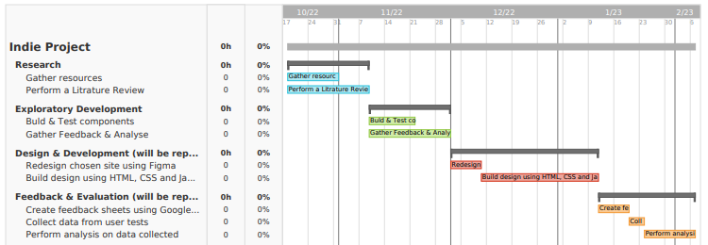

Conclusion
In conclusion the author has identified that new user experiences within web applications can provide very positive results. To test different experiences the author will start researching, designing, and developing re-designs for existing web applications such as Wikipedia’s website. These redesigns will then be tested by an audience who will provide feedback which should bring about a conclusion to which design techniques work and which do not.

Bibliography

[1] | G. Briones-Villafuerte, “User Interfaces Promoting Appropriate HCI:,” Iberian Journal of Information Systems and Technologies, 2021.
[2] | A. Dix, Interviewee, What is Human-Computer Interaction (HCI)?. [Interview]. 2020.
[3] | M. Ellis, “Web design, web development, UI and UX: What’s the difference and which do you need?,” 99Designs, 01 01 2018. [Online]. Available: https://99designs.co.uk/blog/web-digital/web-design-development-ui-ux-difference/#:~:text=User%20Interface%20(UI)%20%E2%80%94%20A,using%20the%20site%20or%20app.. [Accessed 14 10 2022].
[4] | J.-P. Voutilainen, . J. Salonen and . T. Mikkonen, “On the Design of a Responsive User Interface for a Multi-device Web Service,” IEEE, 2015.
[5] | Bootstrap, “Designing dropdowns in Bootstrap,” 27 02 2012. [Online]. Available: https://markdotto.com/2012/02/27/bootstrap-explained-dropdowns/. [Accessed 14 10 2022].
[6] | usability.gov, “User Experience Basics,” [Online]. Available: https://www.usability.gov/what-and-why/user-experience.html. [Accessed 10 14 2022].
[7] | “User Experience Design,” Sematilc Studios, 21 06 2004. [Online]. Available: http://semanticstudios.com/user_experience_design/. [Accessed 14 10 2022].
[8] | Web Accessibility Initive - WAI, “Introduction to Web Accessibility,” [Online]. Available: https://www.w3.org/WAI/fundamentals/accessibility-intro/#what. [Accessed 14 10 2022].
[9] | R. Everett, “How & Why Accessibility Matters for SEO,” SEJ, 3 09 2020. [Online]. Available: https://www.searchenginejournal.com/seo-accessibility/379582/. [Accessed 14 10 2022].
[10] | D. Renzulli, A. C. Bandarra and G. M. de Souza, “How Terra improved user engagement thanks to Dark Mode,” web.dev, 18 Dec 2021. [Online]. Available: https://web.dev/terra-dark-mode/. [Accessed 29 09 2022].
[11] | Terra, “About us,” [Online]. Available: https://www.terra.money/about-terra. [Accessed 09 10 2022].
[12] | “Bounce rate,” google, [Online]. Available: https://support.google.com/analytics/answer/1009409?hl=en. [Accessed 29 09 2022].
[13] | S. Perez, “YouTube’s dark theme has started gradually rolling out to Android,” techcrunch, 30 July , 2018. [Online]. Available: https://techcrunch.com/2018/07/30/youtubes-dark-theme-has-started-gradually-rolling-out-to-android/?guccounter=1&guce_referrer=aHR0cHM6Ly93d3cuZ29vZ2xlLmNvbS8&guce_referrer_sig=AQAAAFxlruit-m8lxgsHUFHXFXy8eG-Twpr55Exq3pLcndE1R6MhSQaAofPI2SxnC-mw3vs-jctreH. [Accessed 29 09 2022].
[14] | N. Rivers, “Efficiency vs Effectiveness,” boot camp design, 02 02 2022. [Online]. Available: https://bootcamp.uxdesign.cc/efficiency-vs-effectiveness-b3fd9cbd01b2. [Accessed 16 10 2022].
[15] | Adobe, “Figma,” [Online]. Available: https://www.figma.com/.
[16] | Microsoft, “visual studio,” Microsoft, [Online]. Available: https://code.visualstudio.com/.
[17] | J. Resig, “https://jquery.com/,” [Online]. Available: https://jquery.com/.
[18] | Google, “googleforms about,” Google, [Online]. Available: https://www.google.co.uk/forms/about/.
[19] | Microsoft, “Excel,” Microsoft, [Online]. Available: https://www.microsoft.com/en-us/microsoft-365/excel.
[20] | deque, “axe® - The Standard in Accessibility Testing,” deque, [Online]. Available: https://www.deque.com/axe/.

