Shericka Nelson
Certificate of Higher Education in Skills for the Workplace
Student ID: 1818265
Problem Solving and Decision Making BMSW4004
22/04/2020

Introduction
My name is Shericka, today in my report I am going to be talking about my experience in a workplace. I will be evaluating the problems and the decisions, that I had to make when I was in the workplace. I will also be including how I was able to manage an implement change in the workplace. As many might know that every workplace environment is very different compared to each other. Every workplace has its positive side and negative side, this is because some places have a friendly environment while others might have a hostile environment. In a workplace environment there are many kinds of different people with different personalities that you can come across.
Communication is one of the most popular issues that majority of workplaces face. In 1995 let’s make things better. This was a new global communication strategy that was introduced by Philip 1995¹. This strategy worked by not communicating differently but, thinking and acting differently as a company and as an individual. Philips 1995² was all about to strengthen a brand in the eyes of tomorrow consumers. Poor communication in a workplace can be for many reasons but can also leads to many disasters in a workplace.
In a workplace without communication, nothing can be accomplished for the business. Instructions would not be given; equipment’s and supplies would not be able to be ordered. Progress of the business would not be measured, and products and services could not be delivered to customers successfully. Drucker (1954)³ introduced five functions of management these are: planning, organizing, staffing, leading and controlling. These five-function management are all dependent on communication.
To be a successful manager, you need to have the ability to communicate effectively. This is one of the most important skills a manager needs for success. However, studies show that many employees believe their leaders are very bad at communicating, and so does some leaders feel the same way about their employees. Why would anything so fundamental, so crucial and so learnable be something people struggle with so much? Furthermore, about communication in the workplace will be explained in this assignment.

Workplace and leaders
I used to workplace in a local electrical a shop when I was still at school. There was a complex problem that took place in this workplace that was not unnoticeable. Working at this electrical shop was not a good experience, because the manager lacked a lot of the responsibility in leadership roles. That then lead to retention issues in the environment and low costumer satisfaction levels. The type of leader that the manager was in this particular workplace was a democratic leader. This is a type of leader that, often asks for input and considers feedback from their team.
Sometimes the employee’s opinions did play a part of the decision making. But one of the issues is that majority of the time employees’ input, was often never taking into consideration. The leader was also an incompetent and democratic leader. This means that the leader lacks some skills and as well as some of the employees. The effect an incompetent leader can also have to the business is loss of reputation and additional loss for cost. Down below is a list of the different types of leaders and its examples.
- Democratic Leadership – This type of leader makes decisions based on the input from each team member. Although he or she makes always makes the final decision, but each employee has an equal say on the project's direction.
- Transformational Leadership - Transformational leadership is all about transforming and improving the company's conventions. Employees usually have a basic set of tasks and goals that they must complete every week or month. The leader is constantly pushing employees outside of their comfort zone.
- Autocratic Leadership – This type of leadership is the inverse of democratic leadership. In this leadership style, the leader often makes decisions without consulting any employees who reports to them. Employees are not considered and consulted prior to a direction, they are expected to adhere to the leaders’ decision at the time and pace stipulated by the leader.
- Laissez-Faire Leadership – laissez-faire leadership is the least intrusive type of leadership. The French term for laissez faire translates to "let them do." leaders who have this trait has nearly all authority to their employees.
- Strategic Leadership – A Strategic leader is always joining between a company's main operations and the company’s growth opportunities. The leader accepts the burden of executive interest, while safeguarding that the current working conditions remain stable for other employees.
- Transactional leadership - Transactional leaders are fairly common. These leaders reward their employees very precisely in the work they do. The marketing team that promotes the business and receives a scheduled bonus, for helping generate a certain number of leads by the end of the quarter. This is commonly known as an example of transactional leadership.
- Coach-Style Leadership – This leader is similar to a sports team's coach. This leaders focus is all about identifying and nurturing every individual strength on their team. They also focus on strategies, that will enable their team to work more better together. This style offers a strong similarity to strategic and democratic leadership styles. But this leader puts more emphasis on the growth and success of their individual employees.
- Bureaucratic Leadership - Bureaucratic leaders work by the book. This type of leader majority of the time listens and consider the input of their employees. Unlike autocratic leader tends to reject an employee's input. only if it conflicts with the company’s policy or past practices.

Experience in my workplace/scope and impact
My experience in the workplace, was that there was also a lot of technical issues that the business was facing. Technology is a big part for a successful business, it has a very important effects on a business operation. No matter the size of the enterprise, technology has both visible and invisible benefits that can help make money faster and more sufficient, while producing the best results your customers’ demands. Technological infrastructure can affect the efficiency, culture and relationships of a business. Furthermore, it also affects the security of confidential information and trade advantages.
The workplace I used to work in was an electoral shop name harrow electricals. The aim and purpose of this business was, to provide and sell costumers goods of all electrical products for installation, design and maintenances. The company also did a scheme were clients was able to borrow items, if they did not have enough money to afford highly professional equipment’s. The scheme worked by, if a product cost £100 they can borrow the item for up 15 days for half the price of the originally cost of the item. Costumers were supposed to feel satisfied with the products they buy, and able to make any purchase on highly recommended professional equipment’s that they need.
This also meant that stock should never run low, and that there was always availability for items customers wanted or needed. There were only 2 stores in two different locations of the harrows’ electrical shop. The company plan was to have a long-term milestone for the business. The plan was to keep track of the business progress every year. This included sales, advertising, responsibilities, website development and system upgrade.
The manager did not seem to care about the business. The technology system that was used in the workplace was not upgraded from many years ago. When working on the tills the system used to completely shut down, this caused a lot of issues for business as well as for the costumers. Costumers used to walk out the shop because of the inconvenience that it caused them. Generally, customers used to complain about time it took to fix the problem. Often the feedback from costumers was that it was time consuming and the queues was long.
The effect also was that it caused, a lot of arguments in the shops between staffs and angry costumers. This was by customers shouting at staffs and asking to speak to the manger. When this type of situation occurred, our manager used to out and try to calm the situation down. Because, there was a shift in the dynamic atmosphere the manager used to get frustrated and infuriated with costumers. Because, of this the manger used to shout at staffs to hurry and fix the problem, because people were waiting. He also at the same time, used to kick out costumers out of the shop because the queues were to long and people became violent.
The business loss a lot of money, because of this people decided not to go in the shop. On many occasions we have tried to speak to our manager about the problem, but he was very reluctant to listen. This is where it became not only a technical issue, but a communication problem in the workplace. Whenever we brought any issues to the manager’s attention, he would become angry and insensitive and cuts the conversation. We frequently had to work under a lot pressure this led to loads of staff leaving.
Many staff left due to the managers attitude and behaviour. There was a consistency of different new staffs being employed due to the loss of staffs. Another problem was that most of the new staffs was not qualified for the job. They had no experience in working in fast business environment and some never worked before. There was also a language barrier with some of the new staffs, were English was not their first language. The managers response was that he does not have time or the patience to train new staffs.
The loss of a lot of money in the business, had the impact of the business having to permanently close. This is because the business was not making money from the scheme, and they became very low in stock. Also losing costumers was a loss in profits for the business to be substantial. Before the business permanently closed, they went into debt which cost the business a lot of money they owed back to the bank.
Root caused analysis/solution
If the manager did not lack certain skills as a leader the business could of probably be open today. One of the qualities the leader lacked was good communication skills. if he was able to convey mission to others while proposing a clear way of thinking, that could have orientated everybody’s work. Having a vision is one thing but being able to convey it is another.
The manager was able to tackle decisions on his own, but most importantly he was not capable of bearing the responsibility of the choices he made. It is crucial that the manager prioritize and develop their employees’ autonomy and empowering them all the while when they work hard and go beyond, they role for the business. The manager in command, should always keep an eye on the business goals, tackle obstacles head-on, manage their emotions professionally, give directives, be a role model for others and win the trust of others.
Nothing is more harmful to a team than a manager without directions. Who is unable to settle disputes and conflicts and refuses to see reality as it is? The manager was not good with criticism, and he did not answer for his own actions that was putting the business in jeopardy. It is the perfect recipe for disaster! Delegation is importance since, it allows the manager to rely on their real added values. In order to be able to delegate in the most optimal way, it is best necessary to trust employees and as well as the leader. And share the responsibilities as team as well as the credit.

Conclusion
Leadership is the ability to influence and guide a group of people towards a common goal. This is while having a relationship of mutual trust as I have previously mentioned before. Also, while a manager should be in charge by taking commands, encouraging employees and having vision. He should always be obtaining, the collaboration of a group with the main objective in mind. The type of manager at Harrows Electrical shop is not a good a leader as to why the business is now closed. I now have a lot of experience working with this type of manager style.
A great manager always wants to evolve, learn and better their self him. The more intellectual resources they have, the better and faster the learning occurs. A manager should have a logical style of thinking; and the ability to use an ordered and rigorous chain or reasoning or a systematic and deductive way of thoughts. They should be able to create and formulate hypotheses and have a 6th sense and be able to call upon their intuitions. In a storm of ambiguity and intuition which is a very essential tool.
A manager should have a global strategic vision with addition to a more operational way of viewing things. The manager should also be able to manipulate abstract concepts, that do not directly translate into direct applications, like an idea and conceptual notions.

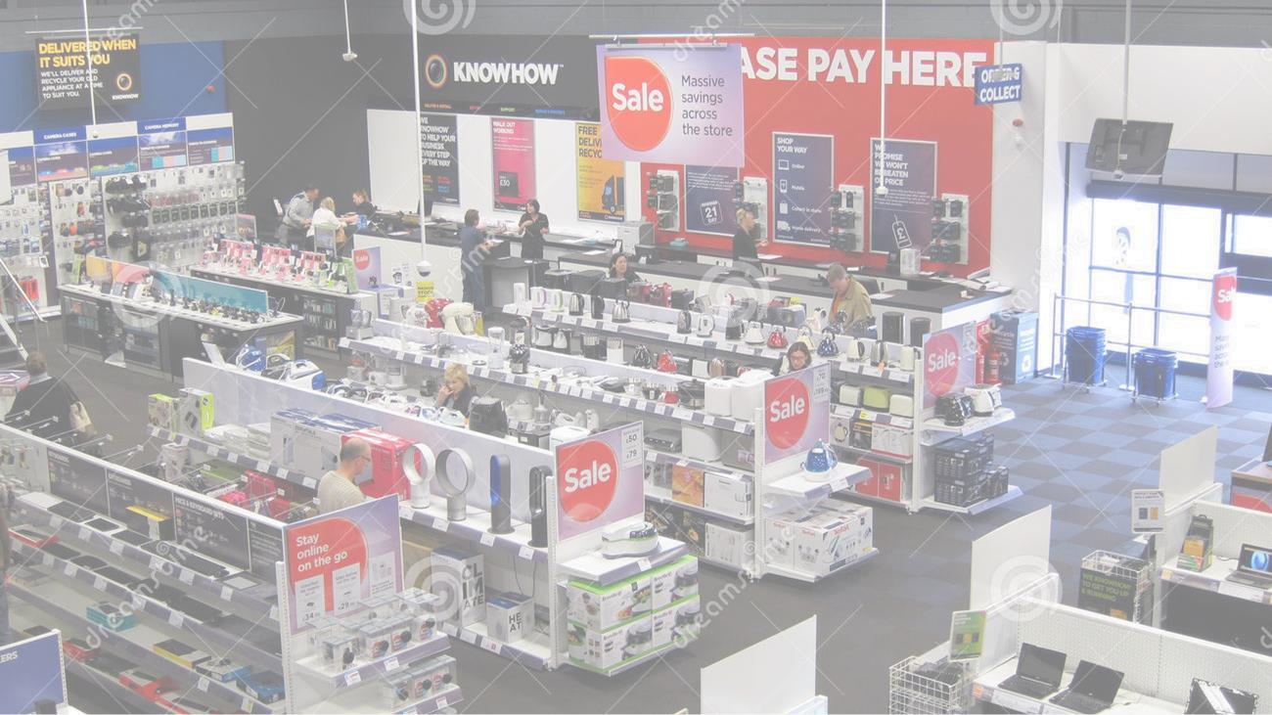
Problems
in workplace
Harrows’ Electrical shop

Introduction:
Workplace and leaders
There are many different types of
leaders in workplaces.
•Democratic Leadership
•Transformational Leadership
•Autocratic Leadership
•Laissez
-
Faire Leadership
•Strategic Leadership
•Transactional leadership
•Coach
-
Style Leadership
•Bureaucratic Leadership
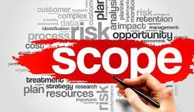
- My experience in Harrows electrical shop was very undistinguishing. The manager was a incompetent and a democratic leader.
- The scope of the business was very poor
due to the type of style the ma

Scope/purpose of Harrows Electrical shop

Scope and purpose
◆
There
was also a lot of technical
issues that the business was facing.
Technology is a big part for a
successful business, it has a very
important effects on a business
operation
.
◆
No matter the size of the
enterprise, technology has both
visible and invisible benefits that
can help make money faster and
more sufficient, while producing the
best results your customers’
demands.
◆
Technological
infrastructure can
affect the efficiency, culture and
relationships of a business.
Furthermore, it also affects the
security of confidential information
and trade advantages.

Scope and purpose Harrow’s Electricals
- Stock should never run low, and that there was always availability for items customers wanted or needed.
- There were only 2 stores in two different locations of the harrows’ electrical shop.
- The company plan was to have a long-term milestone for the business. The plan was to keep track of the business progress every year. This included sales, advertising, responsibilities, website development and system upgrade.

Analysis of Harrows’ Electrical shop
- The manager did not seem to care about the business. The technology system that was used in the workplace was not upgraded from many years ago. When working on the tills the system used to completely shut down, this caused a lot of issues for business as well as for the costumers.
- Costumers used to walk out the shop because of the inconvenience that it caused them. Generally, customers used to complain about time it took to fix the problem. Often the feedback from costumers was that it was time consuming and the queues was long.

Analysis of Harrows’ Electrical shop
- a lot of arguments in the shops between staffs and angry costumers. This was by customers shouting at staffs and asking to speak to the manger. When this type of situation occurred, our manager used to out and try to calm the situation down. Because, there was a shift in the dynamic atmosphere the manager used to get frustrated and infuriated with costumers.
- Because, of this the manger used to shout at staffs to hurry and fix the problem, because people were waiting. He also at the same time, used to kick out costumers out of the shop because the queues were to long and people became violent.

Solution of analysis
◆ If the manager did not lack certain skills as a leader the business could of probably be open today. One of the qualities the leader lacked was good communication skills. if he was able to convey mission to others while proposing a clear way of thinking, that could have orientated everybody’s work. Having a vision is one thing but being able to convey it is another.

Solution of analysis
- Nothing is more harmful to a team than a manager without directions. Who is unable to settle disputes and conflicts and refuses to see reality as it is?
- The manager was not good with criticism, and he did not answer for his own actions that was putting the business in jeopardy. It is the perfect recipe for disaster!
- Delegation is importance since, it allows the manager to rely on their real added values. In order to be able to delegate in the most optimal way, it is best necessary to trust employees and as well as the leader. And share the responsibilities as team as well as the credit.

What a successful business needs
A great manager always wants to evolve, learn and better him self. The more intellectual resources they have, the better faster and learning occurs. A managers should have a logical style of thinking; and the ability to use an ordered and rigorous chain of reasoning or a systematic and deductive way of thought.
They should be able to create and formulate hypotheses, and have a 6th sense and call upon their intuitions. In a storm of ambiguity, and intuition which is a very essential tool.
A manager should have a global strategic vision in addition to a more operational way of viewing things. The manager should be able to manipulate abstract concepts that do not directly translate into direct application, like a ideas and conceptual notions?

Images of successful businesses

1
2
3
4

- 1 formal dressing
- 2 progress
- 3 meetings
- 4 teamwork

Conclusion
◆ Leadership is the ability to influence and guide a group of people towards a common goal. This is while having a relationship of mutual trust as I have previously mentioned before. Also, while a manager should be in charge by taking commands, encouraging employees and having vision. He should always be obtaining, the collaboration of a group with the main objective in mind. The type of manager at Harrows Electrical shop is not a good a leader as to why the business is now closed. I now have a lot of experience working with this type of manager style.

Reference
Bernick, P 1995, The Democratization of communication, AMAZON, United Kingdom.
Peter, D 1954, The Practice of Management, AMAZON, United Kingdom.

