DS 1 Template

My Screenshots/Photos
- Please add 4–6 screenshots or photos of your digital life.
- You can use your phone or laptop.
- For each screenshot, write one or two sentences explaining what it shows.

Screenshot/Photo 1
[Insert Photo/Screenshot below]

The Ferrari is a world-famous sports car known for its exceptional speed, stunning design, and high performance. It offers an unforgettable driving experience and represents luxury and innovation.

Screenshot/Photo 2
[Insert Photo/Screenshot below]

This powerful black horse is a symbol of strength and grace. Its striking appearance and confident posture make it both beautiful and impressive

Screenshot/Photo 3
[Insert Photo/Screenshot below]
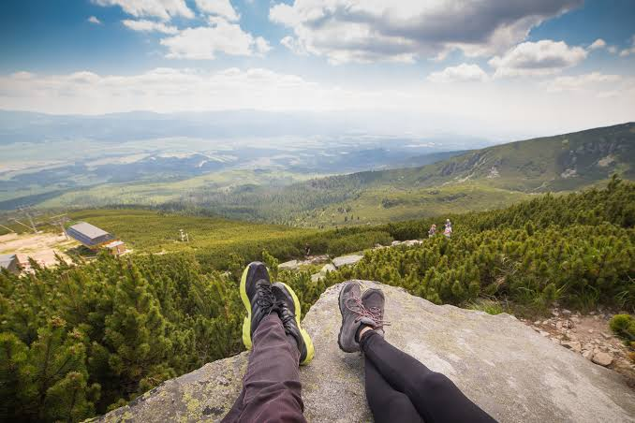
This relaxing landscape offers a sense of peace and serenity. Its a natural beauty creates the perfect environment to unwind and enjoy a moment of calm

Screenshot/Photo 4
[Insert Photo/Screenshot below]
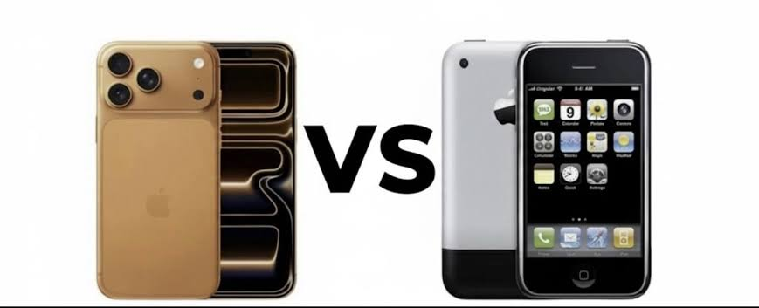
From Iphone 1 to Iphone 17, Apple has continuously transformed smartphone technology with innovative features and sleek designs, Each generation represents a step forward in performance, functionality, and user experience.

Screenshot/Photo 5
[Insert Photo/Screenshot below]

This happy family represents love, togetherness, and happiness. Their strong connection and joyful moments create beautiful memories that last a lifetime.

Screenshot/Photo 6
[Insert Photo/Screenshot below]
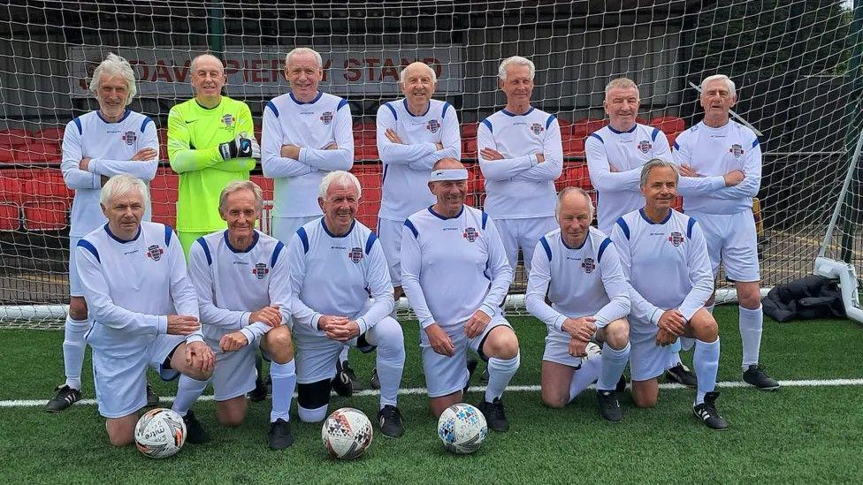
This veteran football team symbolizes teamwork, experience, and determination. Their journey and contributions to the sport have earned them respect and admiration from football fans.

My Short Reflection
- Write 5–8 simple sentences about your digital life.
- You can use the sentence starters below if helpful.
Digital skills are important for me because technology helps me communicate with friends and family, learn new things and access information quickly. It makes many tasks easier and saves time. At the same time, I believe it is important to use digital devices responsibly and maintain a balance between online and real-life activities. Overall, digital life offers many opportunities and has a positive impact on the way we live, work, and connect with others.

Sentence starters
- I use digital tools to …
- I feel confident when I …
- I want to improve …
- I often use these tools: …
- I sometimes feel nervous about …
- I hope this module will help me …
- Digital skills are important for me because …
You can write more if you want.

Submission Checklist
Before you submit, please check:
​​​ ☐ I added 4–6 screenshots
☐ I wrote short sentences for each screenshot
☐ I wrote my short reflection
☐ My work is my own
☐ My file opens correctly
​​☐ My file opens correctly

