Student name: Camilla Cutts, student number: 2130965
Module BMPF7008 Workbased learning project
Contents:
Project Proposal Form
Project Report:
Introduction
Literature Review
Methodology
Findings
Conclusion

References
Appendix 1: Project participant letter
Appendix 2: Participant consent form
Appendix 3: Transcription of interviews
Appendix 4: Focus Group Question Sheet
Appendix 5: Transcription of interviews
Appendix 6: Transcription of focus group discussion
Appendix 7: Ethics form
Appendix 8: Results from Yarbrough, Orman and Neill (2007) study

.

Project Proposal Form
Project Title:
The impact of sight singing on vocal resonance and technique.

- The context
The research project will take place at Da Capo Music Foundation where I teach singing to adult singers. The music school’s fundamental ethos is that music should be for everyone with Kodaly music teaching at the heart of the school. Using solfa as a method of teaching in lessons and in group settings, be it in choirs, orchestras or smaller instrumental and vocal groups. I have been teaching at this school for over 20 years having studied Kodaly under David Vinden at Trinity College of Music.
- The justification
There seems to be no formal guidance in safe and good vocal technique in the art of sight-singing, let alone becoming successful at the skill (Pollock, M.L., 2017). In my experience as a singer my vocal technique was compromised when sight-singing and I developed bad technical habits as well as a loss of confidence in my voice. As a result, I am interested in developing helpful approaches to improve vocal technique and artistry whilst sight-singing. Having the confidence to use one’s voice with a good vocal technique would enhance the sight-singing experience and satisfaction. This is a personal undertaking.
- The intended impact
Through this project I would like to develop practical singing methods to promote healthy and good vocal production whilst sight singing, providing a model from which to work. To improve and develop my knowledge of sight-singing from a vocal pedagogic position. The findings from this research project would be shared within the wider vocal pedagogic and singing community, to enhance and inform better sight-singing experiences.
- The outlined intention
I will conduct a literature review on singers’ experiences in sight-singing and sight-singing in the pedagogic arena to establish where my research fits in with current bodies of work pertaining to my research project (Bell, J, and Waters, S., 2018). The research project will be conducted at Da Capo Music foundation in my class room using 3 of my students from Da Capo Music Foundation. I will use mixed methods as my research methodology, using spectrographic software (Voce Vista) as an observation tool as my quantitative data collection and using interviews and a focus group as my qualitative data collection. The epistemological and ontological philosophy of the pragmatic paradigm suits this research project, allowing me to have a more flexible approach. Allowing me to have continuous reflective approach, which will be beneficial to this project (Morgan, D.L., 2014).
(Early April 2023) My participants will sign a consent form and will receive information detailing the research process. (Mid April 2023) My first and second observation using spectrograph analysis, Voce Vista, in the lesson happening on the same day and in the same half hour lesson. The first sight-singing observation followed by 6 attempts at the melody using the movable-do sol-fa system, focussing on strategies for healthier singing. Final observation to be conducted after the 6 attempts and recorded. With 1-1 on-line interviews conducted the week after, capturing my participants thoughts and experiences on sight-singing. (Late April – mid May 2023) Four individual lessons focussing on vocal technique strategies for healthier sight-singing. (Late May 2023) Final observation using Spectrograph analysis and focus group to discuss shared experiences. (Late May) The focus group interview arranged to discuss shared experiences. (Mid July) Presentation and a written report by middle of July 2023, which will be made available to my participants.

- The ethics and insider research
As an insider researcher subjectivity is unavoidable given that the subject to be studied will be influenced by my perspectives, experience and depth of knowledge (Costley et al, 2010). Therefore, it is crucial for me to clarify my role as the researcher while using qualitative methodology to make my research credible (Unluer, S., 2012). Being clear and fair as to what the purpose of the research is will ensure that the trust I have built up over the time is sustained.
As the singing teacher of the participants that I am going to study I will need to consider my position as their teacher carefully, that my students may feel that they need to say what they think I want to hear, and the need to make clear what is expected in terms of the research and the project. I will use the information gathered from the 1-1 interviews to inform a semi structured focus group meeting. Making sure that all participants of the group are heard equally and the participants will be asked to respect the confidentiality of those in the group (Bell, J. and Waters, S., 2018, Lincoln, Y.S. and Guba, E.G., 1989).

- Personal Learning Outcomes
Using the information gathered to minimise the possible detrimental effect of sight-singing on peoples’ voices, and to share my knowledge with my students and fellow singers.
To use the experience of doing this research project to inform and enhance my expertise in my pedagogic practice.
References
Bell, J. and Waters, S., 2018. Ebook: doing your research project: a guide for first-time researchers. McGraw-hill education (UK).
Costley, C., Elliott, G. and Gibbs, P. (2010) Doing work based research : approaches to enquiry for insider-researchers. Los Angeles: SAGE
Morgan, D.L., 2014. Pragmatism as a paradigm for social research. Qualitative inquiry, 20(8), pp.1045-1053.
Pollock, M.L., 2017. Sight-singing pedagogy: a survey of high school choral directors.
Unluer, S., 2012. Being an insider researcher while conducting case study research. Qualitative Report, 17, p.58.

Project Report:

Introduction
I have been a singer and singing teacher for over 20 years. Whilst at music college I was part of the chamber choir which regularly sang music that we had to sight-sing. I never felt that I used my voice to its fullest potential whilst in that environment as I was striving for pitch and rhythm accuracy and leaving behind musicality, artistry and embodiment of the sound… I was more interested in note accuracy than in good vocal technique and only felt satisfaction that the notes were right and had a feeling of overall dissatisfaction from a vocal or performance point of view. I felt that there was an area that was lacking and I was left with a feeling of unfulfillment vocally and artistically speaking, (as though the voice was not being heard). When I began thinking about my research topic this idea came back to me in the shape of my adult students who are all in choirs and talking to them about their singing experiences in choirs reminded me of that time. I thought that this would be a good topic to do research on with my singers. I considered that there was a difference in vocal production when sight-singing compared to singing something that one has been learning for some-time, and that resonance was affected by sight-singing. Why is that so and is there a way to produce better phonation in sight-singing that aids resonance in the vocal tract allowing for embodiment, artistry of the sound production?

Literature Review
Through this literature review I will look at the skills required to be a sight-singer and how they are taught through education and what sol-fa brings to sight reading music. Moving through to looking at the resonance formed in the vocal tract and the necessary requirements of this for making a good, relaxed confident sound.
Sight-singing is the ability to interpret and read music notation at first sight and along with aural and performing skills, build a solid foundation for musical independence (Pollock M.L., 2017). Using this skill the singer or instrumentalist develops the ability to hear and see the music in one’s head and then sing it or play it back. The singer or instrumentalist who has become proficient in the ability to hear music (the “seeing ear”) or the ability to see music (the “hearing eye”), and sing or play the music back with the voice or instrument, is indispensable and creates the bedrock for the singer’s ability to sight read music confidently and accurately (Pollock M. L., 2017, Karpinski, G.S., 2000).
I have found very little research done on the performance aspect of sight-singing from the singer’s point of view, on satisfaction of using their instrument, with good and correct technique so as to maximise its fullest potential. As opposed to just making sure the notes sung are correct, I appreciate that there is a different type of satisfaction there, the feeling of elation at getting the notes right regardless of how they sound. Research regarding sight-singing methods abounds with individuals and groups using a number of different methods, sol-fa both the moveable do and fixed do, letter names, numbers and intervals. With the moveable do being the more widely used method (Killian, J.N. and Henry, M.L., 2005, Pollock M, L, 2017), as a means of more accurate pitching and improvement of inner hearing, along with the use of hand signs “(defined as any observable movement of hands indicating Curwen hand signs)” (Killian, J.N. and Henry, M.L., 2005 pg, 62) improve the level of overall success in sight-singing accuracy. Although there is no consensus of opinion as to which, movable do or fixed do or any of the other solmization systems is the most efficacious to sight-singing (Karpinski, G.S., 2000).
Guido D’Arezzo (980-1050) a medieval monk and music theorist is recognised as being the developer of the music staff and also being credited as creating a written system of reading music at sight using syllables. His system was constructed on a hexachord using the syllables ut, re, me, fa, sol, la in which the initial syllables fall on the first line and different note of the hexachod, of his composition of the hymn Ut queant laxis (More, B.E., 1985 Pollock M.L., 2017, Encyclopedia Britannica, January 1, 2023). Ut was replaced by do later (Pollock M.L., 2017, Encyclopedia Britannica, January 1, 2023). A device known as solmization, was extremely practical and helpful for sight-singing and learning music. Solmization is a system of associating each note of a scale with a syllable name, this is especially useful in teaching singing and is an accessible method for teaching sight-singing (More, B.E., 1985). There are a number of different solmization systems out there:
- Moveable do uses the sol-fa symbols do, re, me, fa, so, la, ti, each syllable is assigned to its scale number, such as do will always be 1 or the tonic in the scale, the rest of the scale follows on with re = 2, me = 3, fa = 4, so = 5, la = 6, ti = 7 and then repeated. This allowed for sight-reading of music by enabling a better understanding of the relationship between any given musical interval. Such as, the interval me-fa will always be a semitone no matter how high or low the two pitches are sung. By changing key or tonality the singer will always know that me-fa are a semitone apart (Pollock M.L., 2017, More, B.E., 1985). However, with key changes the syllables must change to accommodate the new tonal centre. This works well in tonal music but falls down when the music becomes more atonal with key changes constantly moving and the result for the singer is much more challenging.(REF)
Develops the singer’s hearing skills as the symbols represented in the music are always the same and therefore may be beneficial to understanding relationships between intervals, developing the inner ear (Pollock M.L., 2017).
- Fixed do uses sol-fa symbol which is related to a specific note on the scale, do = C, re = D, me = E and so on. Unlike the movable do system, key changes and modulations do not affect the symbol and there is no shift of names to fit the new key as is the case with movable do. This constancy helps the singer’s or instrumentalist’s development of if not close to, absolute pitch placements.
- Numerical sight-singing, uses a system where numbers are designated degrees on a scale. Tonic of a major scale will always be 1, followed by 2, 3 and so on. If the note is raised a semi tone, for example 5 it will be now thought of as ‘sharp 5’.
- Pitch names or letter names. This system uses the letter names already in the musical stave, using the English letter names for the scale A B C D E F G. (Pollock M.L., 2017)
Previous experiences with music that is primarily tonal can influence our expectations of how the melody should sound, so that we follow our musical instincts as well as what we are seeing on the page and hearing in our heads (Brittain, L.M., 1998). To improve sight-singing skills and vocal confidence daily sight-singing exercises, rhythms, and having a consistent structure will improve sight-singing (Brittain, L.M., 1998). Those with previous experience in school choral situations seemed to have an advantage and played a significant factor in sight-reading performance success (Brittain 1998). In conjunction with that, singers who have learned an instrument as a child are placed in a much better position when it comes to sight-singing. The previous experience learning a musical instrument gives them the confidence to perform the sight singing task, when it comes to looking at the music and singing it at sight.
Music literacy is a tool which according to Edward Asmus noted in Kuehne (2010), (Sight-Singing: Ten Years of Published Research) is becoming less common in undergraduates arriving at tertiary education with students not having been given the opportunity to learn to read music as the educators focus more on the quality of the performance rather than the teaching of reading music. Having learned the necessary skills of music reading then the singer can focus on the ‘interpretative elements that make performances truly moving and unforgettable’ (Kuehne J, M,. 2010 pg 7). Establishing a foundation of skills needed for confident sight-singing is necessary for singers.
In a study researched by Yarbrough, Orman and Neill (2007) (Kuehne J,M,. 2010) looking at the time choral directors used during sight-singing adjudication in high schools and middle schools in a state in America. Each director had 6 minutes to direct their choir before the first reading and 2 minutes to instruct their choir before the second reading. A total of eight minutes of instructional time. A number of musical areas of interest were brought about by the analysis of the time taken in instruction by the choral directors. Presenting musical information, performance, motivational instruction (approval and disapproval), non-verbal responses (body language, facial expressions, motions). The study reported on the amount of instructional time the directors spent on each area. They found that the directors concentrated most on pitch, with the remainder of the elements such tempo, rhythm, phrasing, dynamics, tone quality, texture, form, harmony, key and time signatures addressed least. For a full list of the results (see appendix 8). The results revealed that the overriding attention was spent on pitch accuracy at the expense of the other elements.
“Striving for balanced resonance as the vocal tract is responsible for changes in resonance” (Dromey, C, 2010 pg 678)
concentrating on that aspect and not on the benefit of the whole of the instrument.
The feeling or sensation of resonance and ease of creating a sound is one way for a singer to track how they are performing a piece of music. The vocal tract is a resonator, a cavity of air, going from the vocal folds all the way up to and including the lips. In order for resonance to happen one needs (Bozeman, K.W., 2013, https://www.voicescienceworks.org/resonance accessed on 14/06/2023) :
- a power source and air pressure system (lungs, breathing mechanism, diaphragm and ribs),
- a vibratory system (vocal folds)
- a resonator (vocal tract)
Resonance requires an opening and an empty space in which to produce sound. The vocal tract is an adjustable resonator, in that it is able to change shape, density of the walls and the size of the opening making it a unique resonator. The singer may have the sensation of resonance in the vibrations of the chest bones and vibrations may be felt in the head but these in themselves don’t add to the overall quality of sound being produced (https://www.voicescienceworks.org/resonance accessed on 14/06/2023). This is where the singer needs to be alert, as such vibration may influence them and might be of psychological help, it terms enjoying the vibrations they are experiencing and connecting them to a preferred tone; which sounds good to them but not necessarily to the listener (Vennard, W., 1967).
The air coming from the lungs passes through the vocal folds creating a vibration or a sound wave, it is that sound wave exciting the air in the vocal tract, that vibrates at a certain pitch range which can strengthen or weaken the frequencies that are introduced in to it by the vocal folds (Bozeman, K.W., 2013). As stated above the vocal tract is able to alter the shape, density of the pharyngeal walls and the size of the opening and it is these changes and adjustments that determine the vibrating pitch of the air inside (https://www.voicescienceworks.org/resonance accessed on 14/06/2023). It is here where quality, timbre and power are sourced. (Vennard, W 1967, Bozeman, K.W., 2013)
2 sound waves are similar they boost each other one wave ‘re-sounds’ the other ‘re-son-ate’
It is the filter (vocal tract) that can let us see the upper harmonics, which are visualised in the spectrograph readings in a spectrograph, and without the resonator we wouldn’t be able to see the upper harmonics.
So when the air in the vocal tract vibrates at a similar pitch (formant) as the harmonic frequency from the vocal folds, that frequency will be increased or amplified and the sound will be louder. Formants form in the vocal tract and are the pitch of air inside the vocal tract, the first formant is formed behind the tongue in the pharynx and the second formant is formed in the oral cavity known as the ??? formants and 3,4&5 are known as the vowel formants. , although there are more….. more smaller ones???? We can say that another way, when the formant is close to the harmonic frequency, the harmonic is amplified (https://www.voicescienceworks.org/resonance accessed on 14/06/2023). The lowest harmonic, the fundamental, is the perceived pitch of the note. frequency from the vocal folds is the lowest harmonic and it is the perceived pitch of the note. When the fundamental frequency matches the frequencies in the vocal tract the singer feels an ease in the singing and the sound would feel strong as well as getting buzzing sensations as a result of the resonance in the vocal tract.

Formants and Resonance. In my readings I have been frustrated by terminology and the distinction regarding formants and resonances, especially with reference to the vocal tract resonance. According to classical definitions as mentioned by Ingo Titze in his article (Some Consensus has been reached on the Labelling of Harmonics, Formants, and Resonances, 2016)
“formants are peaks in the spectrum of the sound output from the mouth. They can be influenced by both the source (vocal folds) and the filter (vocal tract). To the contrary, resonances of the vocal tract should (in principle) not contain source characteristics. Keeping source and filter characteristics completely separate is difficult in practice, however, because there is interaction”.
There is some confusion as to how to clarify voice terminology and bring in consistency in symbolic representation and voice terminology (Titze I et all 2015). It is important to have clear definitions and symbols on where the boundaries of resonance are. Whether it is the supraglottal (gottis closed) vocal tract being described as the resonator, resonance in the glottis or resonance in the whole airway from lungs to the end of the vocal tract (lips) (Titze I et all 2015). As Titze I et all (2015) suggests in Toward a Consensus on Symbolic Notation of Harmonics, Resonances and Formants in Vocalization, “the letter ‘R’ should be used as a word abbreviation for resonance, but two subscripts should be assigned to specify the resonance properties.” Unfortunately, there is still not a common definition between a formant and a resonance ((Titze I et all 2015).
The Formant frequency definition, as it appears in ASA (Acoustical society of America, 2004), is that a formant is “a range of frequencies in which there is absolute or relative maximum in the sound spectrum. The frequency at the maximum is the formant frequency”. The formant involves the source (vocal folds) and the filter (vocal tract).

Methodology
For the purpose of this research, I have drawn on both qualitative and quantitative research methods. In order for me to ascertain how the resonances were affected in sight-singing, for the quantitative section of the research, I used an analytical spectrographic software called Voce Vista Pro, to take readings from my students whilst they were sight-singing a melody that I had composed, this was a completely new piece of music that none of them had seen. Using experiential data analysis in the form of 1-1 interviews with each of my participants and a focus group meeting with them all, to identify and gather further information as to how my student’s approach and feel about sight-singing, calling on inductive reasoning to evaluate the experience of sight-singing. Before the research began, I sent to each of my participants a letter detailing the research project along with a contract of the project for them to sign, which they returned to me, 2 via email and 1 in hard copy. I confirmed that any information provided for this study would be treated with confidentiality and the identity of the participants would remain anonymous. In order for them to feel at ease and reassured, I asked them to contact me individually if they had any concerns or worries before we started, so that I could iron out any issues. I asked my participants which medium they would like to do the interviews and the Focus Group interview and we all agreed that it would be done on Zoom as that was the most pragmatic, simple and efficient way of arranging for us to meet. I conducted the 1-1 interviews on Zoom with my participants a week after the spectrograph recordings were taken, so that they still had a memory of their sight-singing experience. This was an informal and semi-structured interview enabling my participants the freedom to discuss more broadly their thoughts on the sight-singing exercise and their feelings about the test and how they thought they had done. A Focus group meeting was arranged on Zoom a couple of weeks after this, with the aim to give greater depth to the information collected from the 1-1 interviews. A contract was sent out alongside a letter giving information about the purpose of the focus group meeting and a list of more broad questions in advance for the participants to read. I also requested that the participants didn’t discuss any aspect of their fellow participants views, opinions, experiences and attitudes outside of the meeting. As stated above, for both the 1-1 interviews and the Focus Group interviews I used Zoom and they were all recorded visually and aurally. Before the interviews started, I indicated to the participants that I was recording each of the sessions, and explained that this was necessary for my qualitative data gathering (Berg, B.L., 2001). I felt that the pragmatic paradigm was the best framework for me to use as I hope to create knowledge the shared experiences my participants have of sight-singing. Under this paradigm the focus is on the research question, “as a human experience” (Morgan, D.L., 2014) and as this is very much the singers experience when sight-singing, the framework of pragmatism is suitable. The freedom of this paradigm allows me to move between subjectivity and objectivity adjusting to the needs of the research (Winter, D., 2021). The qualitative method allows me to include participants’ individual beliefs as to the nature of their vocal experiences and differences in sight-singing. Their active involvement in the process of inquiry, brings them personally into the research and hopefully my participants will find the outcomes believable and useful in their singing lives (Mertens, D.M., 2019, Morgan, D.L., 2014). A Hermeneutic research approach is used to interpret the transcripts with a view to understanding what is ”our experience of life” (Gadamer, H.G., pg77), and to describe events from the point of view of my participants, a subjective experience at the centre of my research enquiry (Mertens, D.M., 2019). that there is no single interpretation of their experience but multiple interpretations guiding my research(Mertens, D.M., 2019).
The rigour of my research is dependent on the clarity of my claims and with sufficient data to support those claims.
I used 3 female participants aged 60 years or older, who are known to me as they are all my singing students. They all sing in choirs and 2 of the participants are experienced choral singers with an average of more than 15 years of sight-singing experience under their belt and have been studying sol-fa (movable do), hand signs and rhythmic syllables for a number of years. 1 participant has no past experience in sight-singing and has just joined a choir with no previous experience in movable do sol-fa, hand signs and rhythmic syllables as an adult. She has just begun lessons in movable do with the music foundation where I teach. Her past experiences sol-fa are with fixed do which she learned as a child in her local church choir, where they sang by rote and didn’t read any music. The sight-singing test consisted of a newly composed melody of 8 bars in length, with a simple rhythm, it was homophonic and set in common time. I wanted to use a completely unseen and unheard piece of music as a good baseline from which to do my study, so that all my participants were starting from the same point. For the purposes of this study no attempt was made to account for inaccuracy and intonation of the melody as I was only interested in their vocal resonance, expressiveness, performance, artistry.
Research methodology - Paradigm- pragmatic? Method – mixed method, quantative and qualitative, quant – spectrographic analysis, qual – 1-1 interview and focus group, self reflection. Inductive
Equipment and procedure
It was very important for me to create an environment that wasn’t too intimidating, as there were new and different devices present for the purpose of the research. I made sure that the classroom looked as normal as possible, the keyboard in the room remained in the usual position and I showed them the microphone and the laptop that the software was on. My absolute intention was to preserve the trust and faith that my students have in me as their teacher and create an atmosphere where they felt safe and that they could undertake this part of the research (Mertens, D.M., 2019). Recordings of the singers’ voices were made using spectrographic software (Voce Vista Pro) on my laptop using a stand-alone microphone positioned about 10 cm from the mouth. The sight singing test comprised of a newly composed melody, that was rhythmically simple, homophonic and set in common time of 8 bars in length. Each participant was given a 60 second preparation time to look over the melody before taking the first recording on the spectrograph. The melody was sight-sung without a tonal accompaniment, to a vowel and after discussing it with my students we agreed on the vowel ‘u’, as we have been using this vowel in our vocal warm up exercises and was familiar to them. Each singer was recorded separately in my class room at Da Capo Music foundation at Wren Academy, North London. My participants received a 10minute vocal warm up before commencing the first sight-singing recording. The first note of the melody was played before they sight-sang the melody for the first time. After singing the melody, my singers were then allowed the opportunity to rehearse and look at the piece using familiar sol-fa (moveable do) 2 singers have much more experience and 1 singer has no or very little experience with sol-fa.

Findings or Results
Spectrograph Analysis:
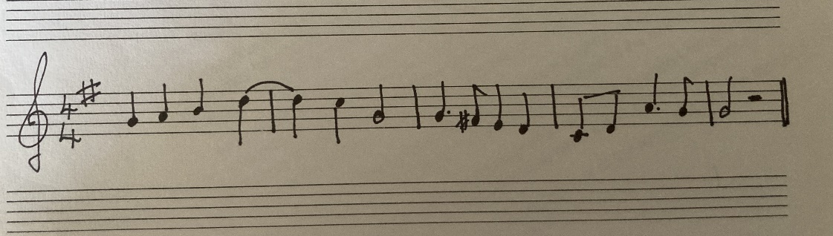
Melody
I took as my point of reference the section that was the highest point in the melody, as I thought that this would have the most energy output from the singers and would give me the best readings to analyse seeing the difference in their phonation from the first and second readings.
Participant A
Sight-singing Reading 1
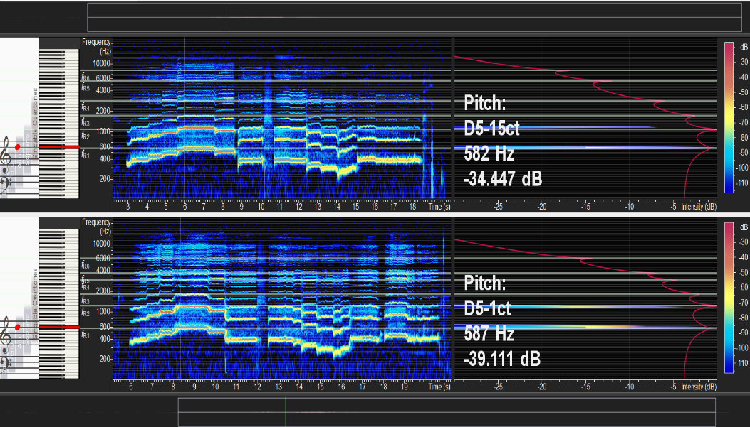
Sight-singing Reading 2

Participant B
Sight-singing Reading 1
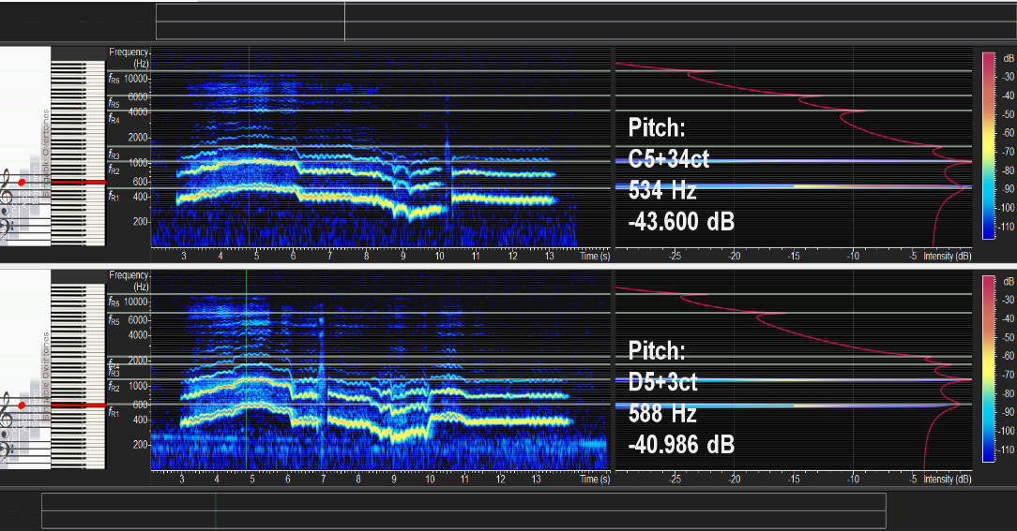
Sight-singing Reading 2
Participant C
Sight-singing Reading 1
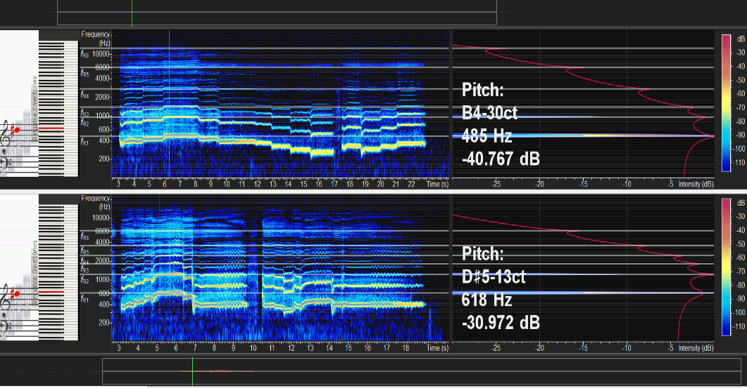
Sight-singing Reading 2

What I found and what the data says Before and after
Results:
Anaylsis of the data, the interpretation of the meaning of the data
  - Interviews and Focus Group: Qualitative
Findings and Results/analysis
Methods: interviews and focus group
Data collection stage of the research using 1-1 semi-structured to unstructured interviews, research comes somewhere along the line of the continuum – seeking information for a purpose to gather data related to the research question. A guided and focussed interview helpful to maintain focus. Certain questions asked but the participants have the freedom to talk about the topic and give their views (Bell, J. and Waters, S., 2018)
Transcripts for 1-1 interviews (see appendix 3)
Transcripts for Focus Group interview (see appendix 4)
Focus group data are group data reflecting collaborative notions shared in the group
Interviews data reflects views and opinions of the individual (Berg, B.L., 2001)
Analysis and findings can be presented by interweaving the results or prepared separately??? -
Pragmatism: I as the interviewer am not necessarily the expert in this field and consider myself a learner
Confirmation bias, being aware of the inclination to filter pre-existing beliefs as a way to interpret new information. As human beings it is normal to be looking to find confirmation of our beliefs, filtering out contradictory information. Be open to different opinions and beliefs, that I may disagree on (Mertens, D.M., 2019).
Observable behaviours my students exhibited, was of anxiety, fear of getting it wrong, just getting on and singing it, getting it over with as soon as possible. Even though I had reassured my participants many times that the test was about looking at resonance and artistry in their singing and not about their sight-singing accuracy. As there was not much previous experience in sight singing for one of my students I noticed an absence of worry about doing it. Seemed confident with what was being asked, not concerned with the accuracy of the notes. All were relieved when it was over!
There was no other harmonic help in the sight-singing exercise, with the singers singing acapella. The singers were played the first note of the melody on a keyboard before beginning to sing.
We then worked on the melody using solfa and relaxing their breathing, looking at the rhythm and pulse and noting the accidentals and understanding the key signature. This was done 6 times to give the singers a chance to use their knowledge of solfa or in 1 of the participants the chance to practice singing in sol-fa, to bring some musicality to the melody.
Table???

1.
2.
3.
4.
5.
6.
Then went back and sung it the 2nd time to ‘u’ vowel.

Vocal Technique should be of importance when sight-singing, but is often the thing that gets left out as we try to achieve our goal of pitch accuracy at the expense of our musicality and artistry. Not having the breath under control puts us at a disadvantage immediately and we are on the back foot from the start. This potentially adds to the stress and anxiety that sight-singing can bring to the singer (Melton, J. and Tom, K., 2003) Preparing the breath well and efficiently when we sing text is vitally important as it help us to navigate melodic passages and phrases of different lengths. Unlike the instrumentalist, where sight reading the notes only requires the use of the fingers to make the music, the singer has the added strain of having to put text to music as well as the communication of the meaning through the words, whilst accommodating pitch, volume and pulse for example (Melton, J. and Tom, K., 2003)
Confidence seems to be part of the main factor in sight-singing success, and those who take time to study and look at the piece and give themselves preparation time have a better chance of performing the music. Singing the piece out loud to give the singers the opportunity to hear the melody and to determine whether or not it has been sung correctly. Having an overall sense of the tonal framework of the piece will help the singer and confidence levels (Killian, J.N. and Henry, M.L., 2005).

Conclusion
The process of this research has been illuminating and I have learned so much about the process of sound and of making sound. Other musical factors that help with confidence in the performance keeping a steady beat, rhythmic awareness and stability, being unprepared for the upcoming melody. Additionally, I notice that having confidence in the sight-singing task makes a significant difference in the overall vocal security and resonance, which in turn allows the singer to relax and open up other aspects of the vocal process such as embodying the music more easily, allowing for vocal artistry, feeling physically free. As the singer is the instrument, any tension felt, specifically with sight-singing, will affect the singer’s vocal ability to produce a free and resonant sound. (REF)
My hope is that sight-singing can be transformed into an aesthetic experience through performance, free of stress.
Work based learning – this course – this research project - practice-based (PaR) research has a creative output with finding a program of using the voice safely whilst sight-singing would wish that my research will lead to practice-based
Although sight-singing is sometimes a requirement for singers, especially those in choirs and for auditions, it shouldn’t be forgotten that my participants are not studying singing for a career but as a hobby. They should be given the tools and strategies to continue their pursuit in becoming better musicians and singers as part of their lives (Kuehne, J.M., 2010).

References:
Henrich, N., Kiek, M., Smith, J. and Wolfe, J., 2007. Resonance strategies used in Bulgarian women's singing style: A pilot study. Logopedics Phoniatrics Vocology, 32(4), pp.171-177
https://www.voicescienceworks.org/resonance accessed on 14/06/2023
Bell, J. and Waters, S., 2018. Doing your research project: a guide for first-time researchers. McGraw-hill education (UK).
Berg, B.L., 2001. Qualitative research methods for the social sciences. Allyn & Bacon.
Bozeman, K.W., 2013. Practical vocal acoustics. Pedagogic Applications for Teachers and Singers (Hillsdale, NY: Pendragon Press, 2013).
Britannica, T. Editors of Encyclopaedia. "Guido d’Arezzo." Encyclopedia Britannica, January 1, 2023. https://www.britannica.com/biography/Guido-dArezzo-Italian-musician. accessed 14/06/2023
Brittain, L.M., 1998. Sight-singing pedagogy: Research applied to classroom methods. The Choral Journal, 39(1), pp.9-18.
Costley, C., Elliott, G. and Gibbs, P. (2010) Doing work based research : approaches to enquiry for insider-researchers. Los Angeles: SAGE
Dromey, C., Heaton, E. and Hopkin, J.A., 2011. The acoustic effects of vowel equalization training in singers. Journal of Voice, 25(6), pp.678-682.
Gadamer, H.G., 1985. The hermeneutics of suspicion. Phenomenology and the human sciences, pp.73-83.
Karpinski, G.S., 2000. Aural skills acquisition: The development of listening, reading, and performing skills in college-level musicians. Oxford University Press on Demand.
Killian, J.N. and Henry, M.L., 2005. A comparison of successful and unsuccessful strategies in individual sight-singing preparation and performance. Journal of Research in Music Education, 53(1), pp.51-65.
Kuehne, J.M., 2010. Sight-singing: Ten years of published research. Update: Applications of research in music education, 29(1), pp.7-14.
Lincoln, Y.S. and Guba, E.G., 1989. Ethics: The failure of positivist science. The Review of Higher Education, 12(3), pp.221-240.
Melton, J. and Tom, K., 2003. One voice: Integrating singing technique and theatre voice training. Heinemann Drama.
Mertens, D.M., 2019. Research and evaluation in education and psychology: Integrating diversity with quantitative, qualitative, and mixed methods. Sage publications.
More, B.E., 1985. Sight singing and ear training at the university level: A case for the use of Kodály's system of relative solmization. The Choral Journal, 25(7), pp.9-22
Morgan, D.L., 2014. Pragmatism as a paradigm for social research. Qualitative inquiry, 20(8), pp.1045-1053.
P Pollock, M.L., 2017. Sight-singing pedagogy: a survey of high school choral directors.
Smith, B and Sataloff, R. T, 2012. Choral Pedagogy and the Older Singer. Plural Publishing, 2012.
Titze, I.R., 2016. Some consensus has been reached on the labeling of harmonics, formants, and resonances. Journal of Voice, 30(2), p.129.
Titze, I.R., Baken, R.J., Bozeman, K.W., Granqvist, S., Henrich, N., Herbst, C.T., Howard, D.M., Hunter, E.J., Kaelin, D., Kent, R.D. and Kreiman, J., 2015. Toward a consensus on symbolic notation of harmonics, resonances, and formants in vocalization. The Journal of the Acoustical Society of America, 137(5), pp.3005-3007.
Unluer, S., 2012. Being an insider researcher while conducting case study research. Qualitative Report, 17, p.58.
Winter, D., 2021. Voicing a Practitioner Research Methodology: Further Framing the Conversation. Voice and Speech Review, 15(1), pp.76-88.
Wolfe, J., Garnier, M. and Smith, J., 2010. Voice Acoustics: an introduction. UNSW: Music Acoustics.

Appendix 1: Project Participant letter
Dear
Firstly, I would like to say thank you for agreeing to participate in my research project.
This letter is to give you some information about what to expect during the research process, the rationale behind my research project and hopefully what I hope to gain at the end of it.
There will be 3 methods of research data collection and be conducted at DaCapo Music Foundation.
Use of Spectrographic analysis, using Voce Vista which I will be bringing in to the lesson. It’s a computer programme which will record your resonance on different notes, sung to a single vowel. The resonance collection will be easier done like that rather than me using a snippet of a piece of music. I will probably ask you to sing an arpeggio, or one note on a particular vowel or using solfa. I’ll use the exact same extract for the first session and last session. There will be no intervention from me, with regards to technique on either of the sessions, so that I can get (hopefully) a contrasting picture of resonance. This isn’t a test and I don’t want you to feel under any pressure to make a difference. The experiment will be what it is and show what ever it will show. Maybe nothing maybe something.
I will ask for us to have one or two 1-1 interviews during the course of the project, these can be done at your convenience, either in the lesson, over phone call or on zoom. The interviews will be semi structured with me starting off with some questions but it would be great to have the interview go with the flow, so to speak. These will be about your experiences in sight singing.
There will be hopefully a final focus group meeting with all of the participants discussing the experiences during the project and what they feel the out come has been. This could be done via zoom or in person at a time convenient to everyone.
I would like to give 4 individual lessons between the spectrograph analysis sessions, focussing on vocal technique strategies for healthier sight-singing and encouraging more artistry in your sight-singing.
Through this project I would like to develop practical singing methods to promote healthy and good vocal production whilst sight singing, providing a model from which to work. The findings of this project could be shared within the wider vocal pedagogic and singing community, to enhance and inform better sight-singing experiences.
Throughout the sessions all data collected will be confidential and I would ask during the focus group that this is especially respected from all participants.
This is an exciting project and hopefully the end result will be something useful for us fellow singers and teachers.

Thank you again for your help in bringing this about.
See you on Saturday.

Camilla

Appendix 2: Participant consent form

Appendix 3: Focus Group Contract



Focus Group Consent Form

Research project title: The impact of Sight-singing on vocal resonance and technique.
Research investigator: Camilla Cutts

- I agree to participate in the Focus Group carried out by Camilla Cutts of the Voice Study Centre and University of Wales Trinity Saint David, to aid with the research of Impact Sight-singing has on vocal resonance and technique.
- I have read the information sheet related to the Impact Sight-singing has on vocal resonance and technique and understand the aims of the project.
- I am aware of the topics to be discussed in the focus group.
- I am fully aware that I will remain anonymous throughout data reported and that I have the right to leave the focus group at any point.
- I am fully aware that data collected will be stored securely, safely and in accordance with Data Collection Act (1998).
- I am fully aware that I am not obliged to answer any question, but that I do so at my own free will.
- I agree to have the focus group recorded by Zoom, so it can be transcribed after the focus group is held. I am aware that I have the right to edit the transcript of the Focus Group once it has been completed.
- I am aware that I can make any reasonable changes to this consent form.

Printed Name

Participants Signature Date

Researchers Signature Date

Contact Information

This research has been reviewed and approved by the Voice Study Centre and the University of Wales Trinity Saint David Research Ethics Board.
If you have any further questions or concerns about this study, please contact:
Camilla Cutts
Full address:
32 Manor Park Road
East Finchley
N2 0SJ
Tel: 07900988149
E-mail: camilla6@btopenworld.com

You can also contact Camilla Cutts’s supervisor:
Pippa Anderson
Tel: 01206 298172
E-mail: pippa@voicestudycentre.com

What if I have concerns about this research?
If you are worried about this research, or if you are concerned about how it is being conducted, you can contact the Director of Studies at:
Voice Study Centre
The Old Stables
Hadleigh Road
East Bergholt
Suffolk
CO7 6QT
(or email at info@voicestudycentre.com).

Appendix 4: Focus Group Question Sheet
Appendix 5: Transcription of interviews
Appendix 6: Transcription of focus group discussion
Appendix 7: Ethics form

Appendix 8: Results from Yarbrough, Orman and Neill (2007) study
Results showed high school directors spent significantly more time (21%) than middle school directors (17%) presenting musical information and most used the moveable do method; eight high school directors used fixed do. Middle school directors spent significantly more time on social tasks (1%) than high school directors (0.66%), and middle school students spent significantly more time (53%) in performance than high school students (40%). However, high school students spent significantly more time (15.48%) in nonverbal responses than middle school students (5%). All but 10 directors used reinforcement (approval and disapproval). The average amount of time spent by all directors reinforcing was 3.82%. Middle school directors used more time giving specific disapproval reinforcement (2%) than high school directors (0.82%). High school directors gave more approval reinforcement than disapproval (59% of their reinforcements were approval vs. 41% disapproval) than middle school directors (49% approvals vs. 51% disapprovals).

Contract between researcher and participant.
Participants to read and sign – obtain informed consent
Confidentiality – where the participant is not presented in the research where they can be identified
Anonymity - no one will see the completed interview transcripts except me (the researcher) and all records will be shredded or deleted once the research is completed

