

MODULE NAME: DIGITAL SKILLS FOR PERSONAL DEVELOPMENT AND BUSINESS GROWTH

MODULE CODE: BMSW4008_SWAN

STUDENT NAME: DRE STEELE

STUDENT NUMBER: 2332005

LECTURER: PHILIPPA FITZGERALD

DATE: 28/03/2025

TABLE OF CONTENTS

TASK 1 QUESTIONNAIRE ANALYSIS 2
THE FOUR CHOSEN QUESTIONS 4
QUESTIONNAIRE DATA ANALYSIS 5
TASK 2 WEBSITE AND MARKETING MATERIALS 7
LINK TO ACCESS WEBSITE DESIGN AND MARKETING MATERIALS 7
WEBSITE SCREEN SHOTS 7
WEBSITE DESIGN 9
TASK 3 MICROSOFT EXCEL 11
TASK 4 STORYTELLING 13
REFERENCES 14
LINK TO YOUTUBE VIDEO 17

TASK 1 QUESTIONNAIRE ANALYSIS
SCAN THE QR CODE TO ACCESS THE SURVEY


THE FOUR CHOSEN QUESTIONS
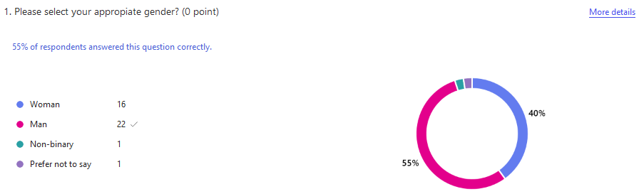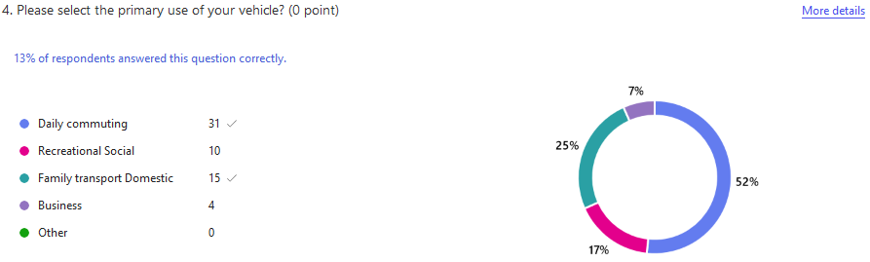
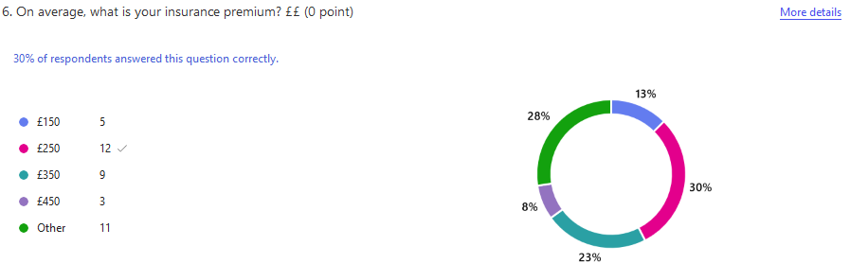
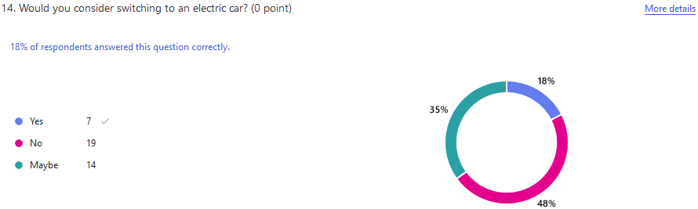

QUESTIONNAIRE DATA ANALYSIS

According to Nordhoff et al. (2022), the modified car scene, demographically, predominantly attracts males aged 18-44, although female participation has increased significantly in recent years. This is reflected in the survey data, which received 40 responses; 16 of those were from females. While historically associated with working class youth, the modern modifying community spans various backgrounds, from apprentice mechanics to corporate professionals, united by their passion for vehicle customisation.
Kong, C., Lei, J. and Zhou, X. (2024) agree that car modifiers typically display strong traits of independence and curiosity. They often seek to express their personality through their vehicles while belonging to a like-minded community. These enthusiasts commonly value mechanical knowledge, aesthetic creativity, and the respect of their peers within the scene. Many display a competitive spirit, whether through formal events or informal meets.
According to research conducted by Kong et al. (2023), most enthusiasts primarily use their vehicles for daily commuting, as reflected in the data, with 52% using their cars for this purpose, while only 17% use them for recreational purposes. Track days are very popular events among enthusiasts. One of the most common types of car modification involves changing the vehicle's appearance. This can include fitting new wheels, lowering the suspension, adding body kits, or applying custom paint jobs. Many people begin with these cosmetic changes because they are relatively straightforward and can significantly alter a car's appearance. Window tinting is another popular modification, although strict laws regulate the darkness of these tints.
Most young adults start at level one often starting with their first car and overtime progress to intermediate or advanced professionals they continue to be drawn to car modification, Vehicle modification gained notoriety in the 2000s due to pop culture phenomena like Pimp My Ride and the Fast & Furious franchise, they remain at the forefront of people’s minds. This was emphasised in the survey; nearly 80% of our respondents chose the beginners level they associated with car modification (Charriot, K.C. 2024).
Hatamleh et al. (2023) state that the car modification community is diverse and supportive. Local car clubs offer a platform for enthusiasts to share advice, organise meets, and assist one another with projects. Social media has made it easier for people to connect and share their builds, with platforms like Instagram and Facebook hosting large communities. Some enthusiasts spend thousands of pounds on high-end parts and professional installation, while others opt for a more budget-friendly approach, using second-hand parts and doing the installation themselves.
Benedek, and Nagy, (2023)suggest that the rising cost of car insurance for modified vehicles is a significant consideration for many people; the survey shows 28% pay a higher premium, as insurers often charge higher premiums for modified cars. Insurance considerations play a crucial role in the car modification scene. Modified vehicle owners must carefully document all alterations and seek appropriate coverage, as standard policies often prove insufficient. This has led to the emergence of specialist insurers who cater specifically to the modified car market, understanding the unique requirements and values of modified vehicles. Legal compliance remains a paramount concern for enthusiasts.
Udoh, Lu, and Xu (2024) said the MOT (Ministry of Transport) test requirements and road safety regulations significantly influence the types of modifications that can be implemented. Successful modifications must strike a delicate balance between personal expression and regulatory compliance, requiring considerable knowledge and expertise. The environmental impact of car modification has become an increasingly important consideration in recent years. Many enthusiasts now strive to strike a balance between performance improvements and environmental responsibility, resulting in a growing interest in hybrid and electric vehicle modifications. Nearly 35% of the survey respondents indicated that they would consider switching to an electric vehicle. This trend reflects broader societal concerns about environmental sustainability and may indicate the future direction of the modification culture.
The future of car modification appears ready for significant change. The increasing number of electric vehicles presents new challenges and opportunities for enthusiasts. Traditional performance modifications may become less relevant as electric powertrains become more common, potentially shifting focus toward software modifications and aesthetic customisation (Sebiraj, Advaith, and Priyadharshini, 2024).
Despite changes in the automotive industry, car modification remains a popular trend. It continues to adapt to new technologies while keeping its focus on creativity and community spirit. The survey data showed people's opinions surrounding car modification from cost implication and being environmentally conscious. Car modification continues to attract new enthusiasts while maintaining its core values of craftsmanship and attention to detail (Pidmurniak et al. 2020).

TASK 2 WEBSITE AND MARKETING MATERIALS

LINK TO ACCESS WEBSITE DESIGN AND MARKETING MATERIALS
https://square.online/app/website/users/152540914/sites/781443165513811289/dashboard/editor#/page/397f8480-045f-11f0-8344-51b00578e98a/pages

WEBSITE SCREEN SHOTS
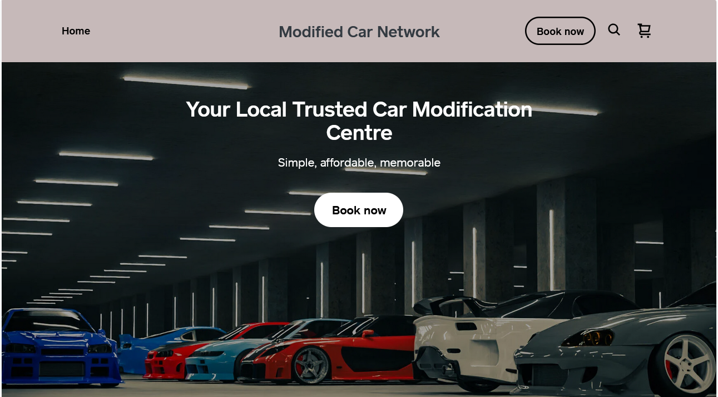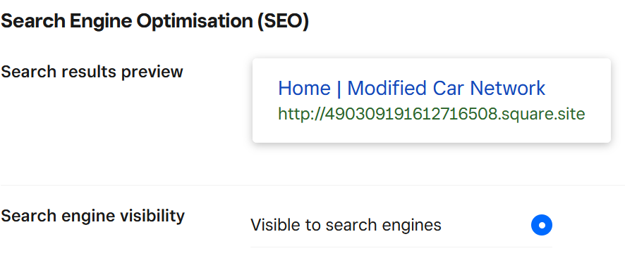

MARKETING MATERIALS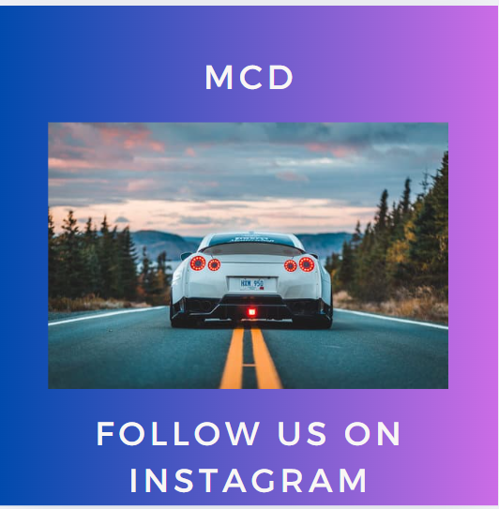
https://www.canva.com/design/DAGi7uTqYCg/AhVshKRVptHfpG7aAmyylQ/view?utm_content=DAGi7uTqYCg&utm_campaign=designshare&utm_medium=link2&utm_source=uniquelinks&utlId=h6493ec8e3e

WEBSITE DESIGN

Butkovskaya, G.V. and Ivliev, A.A (2021) states that creating a successful website for modified cars requires a carefully considered approach that combines captivating design elements with strategic marketing. The main objective is to create a platform that caters to automotive enthusiasts while maintaining a professional and trustworthy presence.
The homepage immediately captures the visitor's attention by featuring visually striking, high-quality photographs that showcase modified vehicles paired with a bold yet subtly automotive colour design choice, which creates the immersive atmosphere of the site. It utilises bold metallic greys, racing blue, and carbon-fibre blacks, all complemented by clean off-white space to ensure readability. Moore, C.J. (2022)
Ensuring a streamlined navigation system is vital for fostering a positive user experience. A well-designed, intuitive menu directs visitors seamlessly to essential sections, including vibrant product galleries, detailed mod guides, a bustling parts marketplace, engaging forums, and comprehensive event calendars. Incorporating a sophisticated mega-menu could serve as an excellent solution to maintain organisation and clarity, preventing users from feeling overwhelmed while they explore the site (Prananda Putra and Teduh Dirgahayu 2024).
Schell (2020) notes that due to the widespread use of mobile devices, responsive design is essential. The website must function flawlessly across all devices, as many enthusiasts often search for parts or share content while at car meets or in their garages. Emphasising fast load times and touch-friendly navigation will significantly enhance the mobile experience.
Caperon, Ahern, and Saville (2023) emphasise the importance of community engagement and highlight the effectiveness of integrating social media content as a powerful tool for achieving this goal. A live feed of posts from Instagram or YouTube can keep the site dynamic and connected to the larger modified car community. Features such as "Build of the Month" submissions can further encourage user-generated content and deepen community involvement.
Williams (2022) demonstrates that consistent branding across all marketing channels is crucial for creating a cohesive and recognisable identity. Whether it's for social media platforms, promotional events, eye-catching banners, or branded merchandise like T-shirts and tote bags, every piece of material should seamlessly reflect the website's design language, including its colour palette, typography, and overall aesthetic.

Email marketing campaigns can significantly increase user engagement when they are tailored to the unique interests and preferences of the audience. By segmenting the mailing list and customising content, businesses can combine informative articles, community updates, event announcements, and exclusive deals into visually appealing newsletters that resonate with subscribers. This approach not only increases open and click-through rates but also fosters a sense of connection and loyalty among the audience, ensuring that each communication feels personal and relevant (Sanders et al., 2021).
Key et al. (2019) demonstrate that content marketing should prioritise creating valuable resources for enthusiasts, including detailed guides, tutorials, reviews, and features on craftmanship and builds. Content should be optimised for search engines but written in an engaging style. Digital advertising efforts should target platforms like Facebook, Instagram, and YouTube, with high-quality visuals and community-focused messaging to attract the right audience.
Palamarchuk and Korkach (2023) demonstrate that the marketplace warrants particular attention and that product listings should include detailed specifications, compatibility information, high-resolution images, and user reviews. Streamlining the checkout process with easy payment options and transparent shipping details will enhance user satisfaction. To strengthen the sense of community, elements such as reputation systems, badges, and exclusive content for active members can be incorporated. A companion mobile app could enhance the experience, enabling users to document and share their modification journeys easily.
Maintaining the website's reliability hinges on the importance of regular maintenance. By actively utilising customer feedback, we can gain insights into user behavior and identify popular content, which can guide periodic updates to the website's design. Another critical aspect to consider is the implementation of robust online security measures for marketplace transactions and the protection of user data. This includes obtaining SSL certification and ensuring secure payment processing, both of which are essential to instilling trust among users (Stolley, 2017).
By creating a platform that seamlessly blends aesthetic appeal with practical functionality while fostering a welcoming community atmosphere, the modified car network website can position itself as an invaluable hub for automotive enthusiasts. Regular updates, coupled with ongoing community engagement, will be vital in ensuring the website's sustained success and relevance in an ever-evolving digital landscape (Shekhar and Valeri, 2024).

TASK 3 MICROSOFT EXCEL
MICROSOFT EXCEL SPREADSHEET

Alkhatib, S., Kecskés, P. and Keller, V. (2023) acknowledge that Microsoft Excel has emerged as a powerful force in today's digital world, offering practical solutions for businesses and professionals alike. By understanding and learning Excel's capabilities, companies can significantly improve their operational efficiency and decision-making processes. And La Cava et al. (2025) agree that to maximise Excel's potential, users can start with basic functions and gradually advance to more sophisticated features. The software's design enables beginners to create simple spreadsheets while allowing experienced users to develop complex data models.
For about twenty years, universities have taught Microsoft Excel because businesses wanted employees who knew how to use it. Things began to shift in mid-2020 when Google Sheets gained popularity, but Microsoft Excel remains the most widely used spreadsheet program. Companies consistently ask for Excel skills and value Excel certifications when hiring. While Google Sheets is becoming increasingly common, it hasn't yet replaced Excel as the primary spreadsheet tool in business and universities (Coombes, 2025).
Sbampato, Arruda, and Silva (2025) agree that one key advantage of Excel is its practical application across different business functions. Businesses can track performance metrics, finance and monitor inventory levels. By mastering Excel's features, Users can process and create more valuable insights for the future. While spreadsheet technology is changing, Excel remains the industry standard. Universities can best help their students by continuing to focus on Excel while also showing them other options. This equips students with the skills they need to secure employment and enables them to adapt to changing technology. So Callari and Puppione (2025) think that Excel offer excellent opportunities for better communication. By learning to create effective charts and graphs, professionals can present data in a way that helps stakeholders quickly understand complex information.
Mondati, A.D., et al. (2025) stated that the software's features provide a foundation for effective teamwork. Through shared workbooks and cloud integration, teams can collaborate effectively, regardless of their physical location. This capability supports modern work environments and helps organisations maintain productivity. However, for career development, mastering Excel can offer significant returns. Excel users often find themselves better positioned for advancement opportunities, as the software's analytical capabilities are highly valued across industries. Regular practice and continuous learning can help build this valuable skill set. Additionally, Campbell, Smallwood, and Stewart (2020) show that Excel continues to evolve with new functions and features. By staying current with these developments, Users can ensure they're making the most of the software's potential.
In conclusion, Excel serves as an important tool for user and business success in the digital era. By learning and implementing Excel's capabilities, individuals and organisations can maintain a competitive edge in today's data business environment.

TASK 4 STORYTELLING

There are essentially three types of storytelling techniques that were covered in class those we create, fiction, and events that happened to us and anecdotes. And the third case study. All can be great for use in compelling storytelling. Whether they're telling a made-up story or sharing an actual account, they possess that unique quality that makes everyone want to listen.
Creating stories is a unique talent. Using these storytelling methods, begin with an idea and then build everything around it. On the other hand, sharing stories about real-life experiences and anecdotes is different but equally enjoyable. Setting the scene is essential in all types of stories. You want your audience to feel as if they are right there with you.
Dialogue in your stories matters greatly. In fictional stories, conversations should flow naturally. Real-life anecdotes, including actual quotes, can be entertaining. Case studies serve as valuable narratives that explore real-life situations or scenarios. They are often used in business and academic settings to illustrate specific concepts or points effectively. By providing concrete examples, case studies demonstrate how various ideas can be successfully applied in real-world contexts, thereby increasing understanding and encouraging practical application.

REFERENCES

Alkhatib, S., Kecskés, P., & Keller, V. (2023). "Green Marketing in the Digital Age: A Systematic Literature Review," Sustainability, vol. 15, no. 16, p. 12369. Available at: https://doi.org/10.3390/su151612369.
Benedek, B. and Nagy, B.Z. (2023) ‘Traditional versus AI-Based Fraud Detection: Cost Efficiency in the Field of Automobile Insurance’, Financial and economic review, 22(2), pp. 77–98. Available at: https://doi.org/10.33893/FER.22.2.77.
Butkovskaya, G.V., & Ivliev, A.A. (2021). Marketing Technologies for the Development of Digital Products in the Automotive Industry. E-Management (Moscow, Russia), 4(1), pp. 74–84. Available at: https://doi.org/10.26425/2658-3445-2021-4-1-74-84.
Callari, T.C., & Puppione, L. (2025). Can generative artificial intelligence productivity tools support workplace learning? A qualitative study on employee perceptions in a multinational corporation. The Journal of Workplace Learning, 37(3), pp. 266–283. Available at: https://doi.org/10.1108/JWL-11-2024-0258.
Campbell, C. D., Smallwood, Z. M., & Stewart, M. I. (2020). "A Self-Directed Workshop for Developing Advanced Data Processing and Analysis Skills in Chemistry Using Microsoft Excel." Journal of Chemical Education, 97(9), 2635–2642. Available at: https://doi.org/10.1021/acs.jchemed.0c00732.
Caperon, L., Ahern, S., & Saville, F. (2023). ‘Voice, choice and power: Using co-production to develop a community engagement strategy for an ethnically diverse community’, Gateways (Sydney, N.S.W.), 16(1), pp. 1–20. Available at: https://doi.org/10.5130/ijcre.v16i1.8085.
Charriot, K.C. (2024) Case Study & Business Plan for Charriot Motors. ProQuest Dissertations & Theses.
Coombes, L. (2025). Microsoft Excel Review: What’s New in Excel 2024? Macworld (Online). San Francisco: Foundry.
Hatamleh, I.H.M. Safori, A.O.; Habes, M.; Tahat, O.; Ahmad, A.K.; Abdallah, Rania A-Q; Aissani, R. (2023) ‘Trust in Social Media: Enhancing Social Relationships’, Social Sciences (Basel), 12(7), pp. 416. Available at: https://doi.org/10.3390/socsci12070416.
Key, K.D. Holden, D., Lewis, E. Yvonne, Cunningham, R., Zimmerman, Marc A., Johnson-Lawrence, Vicki, & Selig, Suzanne. (2019) ‘The Continuum of Community Engagement in Research: A Roadmap for Understanding and Assessing Progress’, Progress in Community Health Partnerships, 13(4), pp. 427–434. Available at: https://doi.org/10.1353/cpr.2019.0064.
Kong, C. Lei, J., Chao, J., Zhou, Xiong Hui (2023). Research on the Automatic Analysis and Layout System for the Stamping Process of Automotive Panels and Its Key Technologies. International Journal of Advanced Manufacturing Technology, 129(9–10), pp. 4101–4120. Available at: https://doi.org/10.1007/s00170-023-12540-5.
Kong, C., Lei, J., and Zhou, X. (2024). Research on the intelligent design system for automotive panel dies, driven by geometry and knowledge. International Journal of Advanced Manufacturing Technology, 133(1–2), 765–790. Available at: https://doi.org/10.1007/s00170-024-13728-z.
La Cava, L., et al. (2025). "Heuristic-Informed Mixture of Experts for Link Prediction in Multilayer Networks." Available at: https://doi.org/10.48550/arxiv.2501.17557.
Mondati, A.D., Reeve, S.A., Vladescu, J.C., DeBar, R.M., & Thomas, R.R. (2025). ‘Remote Teaching of AB Graphs in Microsoft Excel’. Behavior Analysis in Practice, 18(1), 96–108. Available at: https://doi.org/10.1007/s40617-024-00943-z.
Moore, C.J. (2022) ‘Buying platform transforms acquisitions; It’s a transparent, easy, cheaper way to build inventory, group says’, Automotive News, 97(7069), pp. 21-.
Nordhoff, S., Louw, T,Madigan, R Lee, Yee M Innamaa, S ; Lehtonen, E Malin, F Bjorvatn, A ,Beuster, A Happee, R Kessel, T Merat, Natasha (2022). "Profiling the Enthusiastic, Neutral, and Sceptical Users of Conditionally Automated Cars in 17 Countries: A Questionnaire Study." Journal of Advanced Transportation, 2022, pp. 1–22. Available at: https://doi.org/10.1155/2022/8053228.
Palamarchuk, O., & Korkach, I. (2023). ‘Trends in the development of digital marketing in modern business conditions’. Ekonomìčnij vìsnik unìversitetu, (57), pp. 63–68. Available at: https://doi.org/10.31470/2306-546X-2023-57-63-68.
Pidmurniak, O., et al. (2020). Innovative Approaches to Assessing Organizational Changes in Automotive Industry Enterprises: The EU Experience for Ukraine. Acta Logistica, 7(4), pp. 291–299. Available at: https://doi.org/10.22306/al.v7i4.196.
Prananda Putra and Teduh Dirgahayu (2024) ‘EVALUASI DAN REKOMENDASI PENINGKATAN PADA WEBSITE DINAS PERPUSTAKAAN DAN KEARSIPAN SLEMAN’, Edusaintek, 11(4). Available at: https://doi.org/10.47668/edusaintek.v11i4.1337.
Sanders, T., Vetta, L., Ackermann, N., Bauer, Kyla L., Bowen, Deborah J., & Goodman, M. S. (2021). "Strategies of community engagement in research: definitions and classifications." Translational Behavioral Medicine, 11(2), 441–451. Available at: https://doi.org/10.1093/tbm/ibaa042.
Sbampato, K., Arruda, H. and Silva, É.R. (2025) ‘ChatGPT, Python, and Microsoft Excel’, Journal of the Medical Library Association, 113(1), pp. 110–112. Available at: https://doi.org/10.5195/jmla.2025.2065.
Schell, R. (2020) Exploring the Digital Transformation in the Automotive Industry to Design an Improved Mobility Service Ecosystem for Mercedes-Benz. ProQuest Dissertations & Theses.
Sebiraj, N., Advaith, K. and Priyadharshini, P.S. (2024) ‘Enhancing User Experience and Design Exploration using Augmented Reality (AR) and Virtual Reality (VR)’, in 2024 5th International Conference on Smart Electronics and Communication (ICOSEC). IEEE, pp. 1620–1625. Available at: https://doi.org/10.1109/ICOSEC61587.2024.10722546.
Shekhar, M., & Valeri, M. (2024). Knowledge Clusters and the Impact of Digital Transformation on the Tourism and Hospitality Marketing Mix. International Journal of Tourism Policy, 14(2), 173–187. Available at: https://doi.org/10.1504/IJTP.2024.137157.
Stolley, K. (2017) How to Design and Write Web Pages Today. Second edition. New York: Greenwood.
Udoh, J., Lu, J., and Xu, Q. (2024). "Application of Machine Learning to Predict CO2 Emissions in Light-Duty Vehicles." Sensors (Basel, Switzerland), 24(24), pp. 8219. Available at: https://doi.org/10.3390/s24248219.
Williams, T. (2022). Introduction to website development technologies. Birmingham, England: PACKT Publishing.

LINK TO YOUTUBE VIDEO
https://youtube.com/shorts/783h7dQaVaY?si=-NUN8xBCgHXDmTdJ

