LCBB6002 International Financial Management

Assessment 1: Written Report

Beatrice Maria Takacs

Student Number: 1920012

Lecturer:Dr. Rexon Nting
Table of Contents
1.0 Introduction 3
2.0 Importance of International Financial Management to Multinational Corporations (MNCs) 3
3.0 Challenges Experienced by MNCs in Different International Financial Markets 4
4.0 Dividend Distribution Policy of HSBC Holdings 5
5.0 Efficient Market Hypothesis Theory of HSBC Holdings 6
6.0 Methods of Appraising Projects of HSBC Holdings 7
7.0 Conclusion 8
Reference List 9

1.0 Introduction
International Financial Management (IFM) can be treated as an important tool for finding the exchange rates, comparing the rates of inflation, extracting information about investing in international debt securities along with ascertaining the economic status of other countries for judging the international markets. The major objective regarding international financial management involves the maximisation of shareholder wealth. It can require developing sound financing and investment decisions, which can result in making an addition of value to the organisation respectively. The principal aim of the present study is to reflect on the potential aspects based on international financial management evolved within HSBC Holdings in an appropriate manner.

2.0 Importance of International Financial Management to Multinational Corporations (MNCs)
The major importance of IFM to the MNCs can be evaluated in the following:
- IFM plays an important role in the inter-economy exchange and international trade of products and services in an effective manner (Madura, 2020).
- Exchange rates can be demonstrated as an important element within the IFM as it helps to assess the relative value of currencies. IFM assists to measure the concerned rates in an appropriate way.
- Several economic factors can be helpful to make international investment decisions for MNCs. Economic factors regarding economies can be helpful to assess the safety of the money invested by investors with foreign debt securities respectively (Jawaad et al., 2019).
- Effective utilisation of "International Financial Reporting Standards (IFRS)" can be treated as an essential factor for numerous stages related to IFM. Financial statements can be developed by the respective countries, which have adopted identical IFRS respectively. It can be helpful for numerous countries to follow identical reporting systems over a specific period (Shapiro and Hanouna, 2019).
- IFRS can be treated as an effective part of international finance that can also be helpful to save money through abiding by the rules regarding reporting on an individual accounting standard.
- IFM plays a vital role to assess the basics regarding all international entities along with keeping the essential balance intact among them across the market.

3.0 Challenges Experienced by MNCs in Different International Financial Markets
The critical challenges that can be experienced by MNCs in various International Financial Markets can be demonstrated in the following:
Challenges | Effects
Currency Exchange and Inflation Rate Issues | - An international business can be engaged in receiving payments from various nations.  - The value of a pound in the native country cannot be always equivalent to the identical amount in other currencies (Cooke et al., 2019).  - As a result, it can be treated as one of the critical problems regarding international business as the value of the currency fluctuates in a consistent way for the identical number of products and services.
Supply Chain Risks | - Regulating the supply chain which encompasses the national borders primarily lies among the critical problems related to international business.  - The particulars of related logistics, offshore shipping, imports, and exports have been steered by international laws as well as other international legislations (Jaiswal et al., 2022).  - Managing the supply chains can lead to a critical threat to international business.
Talent Acquisition and Onboarding | - Retaining and hiring talented employees can be treated as an important aspect of international expansion (Paul and Mas, 2020).  - Motivated and talented staff with the required base of knowledge and industry experience regarding the specific region can be demonstrated as assets to multinational corporations such as HSBC Holdings.  - Lack of experience among the business employees that can be engaged in acting as an anchor for respective locations can impose critical challenges for the concerned MNCs in terms of international expansion.
Table 1: Obstacles faced by MNCs in various IFM
(Source: Created by the Author)

4.0 Dividend Distribution Policy of HSBC Holdings
A dividend refers to the payment that can be made by the organisation to its shareholders in terms of the distribution of its profit over a specific period. The profits that have been generated by the organisation can either be retained within the business organisation and can be utilised for diversification, expansion or acquisition (Chan et al., 2021). It can also be distributed to the key shareholders of the business organisation in an appropriate manner.
- HSBC Holdings is highly engaged in setting up to enhance the payments of dividends sharply in the year 2022. It can be demonstrated as an effective attempt for placating investors calling for its breakup. However, the pay-outs can be unlikely to reach the pre-pandemic levels in an effective way.
- It has been forecasted by the concerned entity for making a payment of a dividend per share of 31 cents in the year 2022, which is 24% higher as compared to the year 2021. The concerned figure is still 40% lower in comparison with 51 cents for each share paid in the year 2019 (HSBC, 2023).
- It has also been targeted by HSBC Holdings to make an improved pay-out ratio regarding 50% of its reported earnings for each year for the years 2023 and 2024. The concerned MNC is also engaged in targeting a return on tangible equity, which can be treated as a measure of the profitability of around 12% from the year 2023 onward (Froese et al., 2020).
Finance stocks cannot always be engaged in making a payment of dividends. However, HSBC Holdings significantly indulged in making the payment for its dividend in terms of the reward to its key shareholders across the respective market.

5.0 Efficient Market Hypothesis Theory of HSBC Holdings
The Efficient Market Hypothesis (EMH) can also be known as an "Efficient Market Theory." It can be contemplated as a hypothesis, which states that share prices primarily reflect all the necessary information and the consistent generation of Alpha is impossible (Le et al., 2019). As per the aspects of EMH, stocks can always be engaged in trading at their fair value on exchanges, which makes it difficult for investors to sell stocks or purchase undervalued stocks for inflated prices. As a result, it can be impossible to outperform the overall market with the help of market timing or expert stock selection.
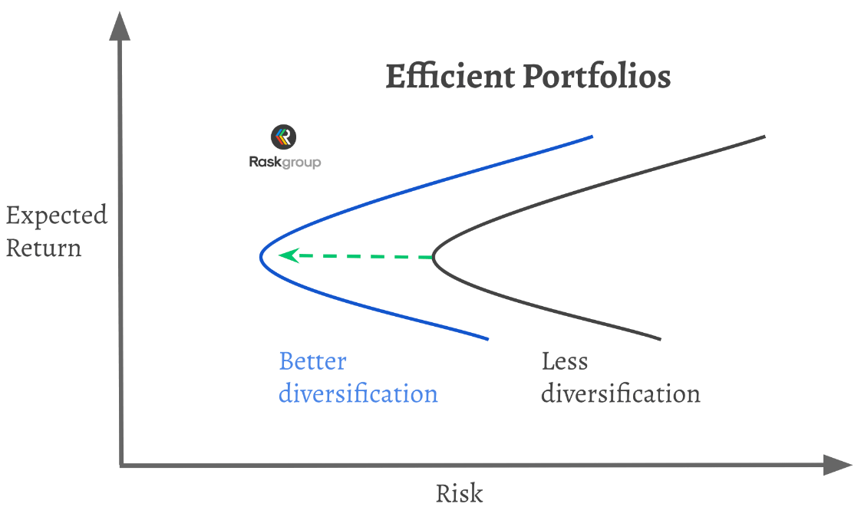
Figure: Efficient Market Hypothesis
(Source: Mees-Buss et al., 2019)
It can also be demonstrated as an effective way for obtaining higher returns by investors through purchasing riskier investments across the definite market. The relevant proponents of EMH can posit that the investors can gain a necessary benefit from investing in a passive and low-cost portfolio. Monopolistic competition can be evolved across the banking market of Europe. It can be treated as a major cause for making an advancement in the loan and deposit market hypothesis in Europe, which is perfectly competitive (Shahwan and Almubaydeen, 2020). It cannot be rejected irrespective of whether the power of the test in terms of an alternative or not equilibrium is not very high. Barriers can also be developed across the banking market in case of a substantial switching cost, which is included in shifting from one bank to another across the respective market for HSBC Holdings.

6.0 Methods of Appraising Projects of HSBC Holdings
HSBC Holdings can be highly engaged in conducting stress tests in a regular way for assessing the resilience regarding its capital adequacy and balance sheet (Mees-Buss et al., 2019). It also plays an important role to offer actionable insights into determining the essential elements regarding its portfolio along with its behaviour during the financial crisis respectively.
- The concerned outcomes can effectively be utilised within the present MNC for calibrating its risk appetite along with reviewing the robustness related to its financial and strategic plans.
- It can be considered a vital factor for making an improvement in the quality of the decision-making within the management extensively (Aguilera et al., 2019).
- Analysis based on stress testing can be contemplated as a vital factor for the management in order to understand the extent and nature of the vulnerability, to which the Group has been exposed.
- The relevant outcomes from the stress test can also be engaged in driving resolution and recovery planning to assist the financial stability of the Group under several macroeconomic scenarios.
- Effective selection regarding the stress scenarios can be based upon the assessment and identification of its emerging and top risk identified along with its risk appetite over a definite period.
Internal stress tests can also be conducted within the present business entity that has explored the relevant effects of the key vulnerabilities in order to assess its exposition involving the COVID-19 pandemic and geopolitical issues respectively (Cooper and Nguyen, 2020). The consideration of the internal stress test imposed the impacts of several scenarios across all the types of risk on the capital resources extensively.

7.0 Conclusion
The above study reflects on the potential aspects based on international financial management that can be evolved by the financial manager of HSBC Holdings in an accurate way. The relevant significance of executing IFM within business organisations helps to achieve the organisational objectives over a definite period. The critical challenges can also be faced by the financial managers in terms of implementing IFM in the respective market which is important to overcome through developing relevant strategies extensively. Dividend distribution policy, efficient market hypothesis theory and relevant methods of appraising projects utilised within HSBC Holdings have also been reflected in the present study in a detailed way.

Reference List
Aguilera, R.V., Marano, V. and Haxhi, I., (2019). International corporate governance: A review and opportunities for future research. Journal of International Business Studies, 50, pp.457-498.
Chan, T.H., Boo, H.L. and Ali, R., (2021). Dividend Payout Policy and Global Financial Crisis: A Study on Malaysian Non-Financial Listed Companies. Asian Journal of Business and Accounting, 14(1), pp.145-170.
Cooke, F.L., Liu, M., Liu, L.A. and Chen, C.C., (2019). Human resource management and industrial relations in multinational corporations in and from China: Challenges and new insights. Human Resource Management, 58(5), pp.455-471.
Cooper, M. and Nguyen, Q.T., (2020). Multinational enterprises and corporate tax planning: A review of literature and suggestions for a future research agenda. International Business Review, 29(3), p.101692.
Froese, F.J., Shen, J., Sekiguchi, T. and Davies, S., (2020). Liability of Asianness? Global talent management challenges of Chinese, Japanese, and Korean multinationals. Human Resource Management Review, 30(4), p.100776.
HSBC (2023). Who We Are. Available at https://www.hsbc.com/ [Accessed on 26 March 2023]
Jaiswal, A., Arun, C.J. and Varma, A., (2022). Rebooting employees: Upskilling for artificial intelligence in multinational corporations. The International Journal of Human Resource Management, 33(6), pp.1179-1208.
Jawaad, M., Amir, A., Bashir, A. and Hasan, T., (2019). Human resource practices and organizational commitment: The mediating role of job satisfaction in emerging economy. Cogent Business & Management, 6(1), p.1608668.
Le, T.T.H., Nguyen, X.H. and Tran, M.D., (2019). Determinants of dividend payout policy in emerging markets: Evidence from the ASEAN region. Asian Economic and Financial Review, 9(4), pp.531-546.
Madura, J., (2020). International financial management. Cengage Learning.
Mees-Buss, J., Welch, C. and Westney, D.E., (2019). What happened to the transnational? The emergence of the neo-global corporation. Journal of International Business Studies, 50, pp.1513-1543.
Paul, J. and Mas, E., (2020). Toward a 7-P framework for international marketing. Journal of Strategic Marketing, 28(8), pp.681-701.
Shahwan, Y. and Almubaydeen, T.H., (2020). Effects of board size, board composition and dividend policy on real earnings management in the Jordanian listed industrial firms. International Journal of Financial Research, 11(4), pp.195-202.
Shapiro, A.C. and Hanouna, P., (2019). Multinational financial management. John Wiley & Sons.

