
Community Engagement
Community Engagement Assignment 2 – Reflective Report
Student ID

Table of Contents
Introduction 3
Theoretical model of reflection and the nature and purpose of reflective practice in the context of community engagement 4
Reflection of personal experience/ various skills and competences 5
The relationship between academic theories and experiences in creatively solving problems 6
Conclusion 7
References 8

Introduction
"Learning through and through experience in the direction of acquiring additional insight into self and practice" is the definition of reflective practice. The practice of reflection is fundamental to the educational process. Its mission is to "challenge assumptions of daily practice and critically evaluate practitioners' own reactions to practice circumstances," with the end goal of enhancing one's awareness of their own expert knowledge and activity in the workplace (Waterton, 2015). The reflective approach encourages individuals to collaborate with other people so they may share what they have found to be the most effective practices and rely on the support of others. In the end, reflection requires that students learn more successfully since learning may be individualized for each student. Or, to put it another way, reflexivity is the capacity to ponder on one's activities in order to assume a critical posture or attitude regarding one's own practice as well as that of one's peers, so participating in a process of constant adaptation and learning. Reflection is a vital component of social studies courses and activities (Wallerstein et al, 2015). Reflection facilitates meaning-making, and frequent reflection exercises help students relate their community involvement experience to classroom or program learning goals. Studies suggest that reflection may increase analytical reasoning and enhance the development of young people on measurements of civic ideals and personal growth. Reflection may occur in various ways, but it’s most useful when it’s continual. Continuous, linked, difficult, and context-dependent reflection helps students manage the phases of community participation and enables them to prepare for and understand their experiences.

Theoretical model of reflection and the nature and purpose of reflective practice in the context of community engagement
Kolb’s model
David Kolb created a four-stage reflective model. Kolb's Process of Learning (1984) emphasizes reflective practice to derive insights from an event (O’Mara-Eves et al, 2015). Applying what was learnt to new circumstances continues the cycle. It has four stages. Practitioners gain experience. First-time classroom experimentation is required. Interactivity is needed to test novel ideas and instructional practices.
Then comes observation of the actual experience, which is followed by reflection on the experience. Here, practitioners should think about the advantages of the lesson and their own opportunities for improvement. Practitioners need to have a knowledge of what promotes and inhibits student development (Ojha et al, 2016).
The development of abstract conceptions should result from this. The practitioner must interpret what has occurred. Making connections between what they may have experienced, what they really know, and everything they need to learn should help them do this. To aid in the growth and comprehension of the patient, the practitioner should include concepts from textbooks and research. Additionally, they could rely on the assistance of their fellow workers and their prior experience. Based on whatever they have discovered through their observations and more extensive studies, practitioners should adapt their theories or come up with new strategies.
The practitioner thinks about how they will put what they may have learned into practice at the cycle's final stage (Moser and Pike, 2015). The practitioner's abstract thoughts become tangible when they are used to test theories in hypothetical scenarios, leading to fresh experiences. As they are incorporated into future instruction, the concepts from observation and conceptualization are turned into active experimentation. In this new approach, the loop is then repeated. Kolb's goal with his approach is to show how important it is to use both our own real-world experiences and academic research to learn more.
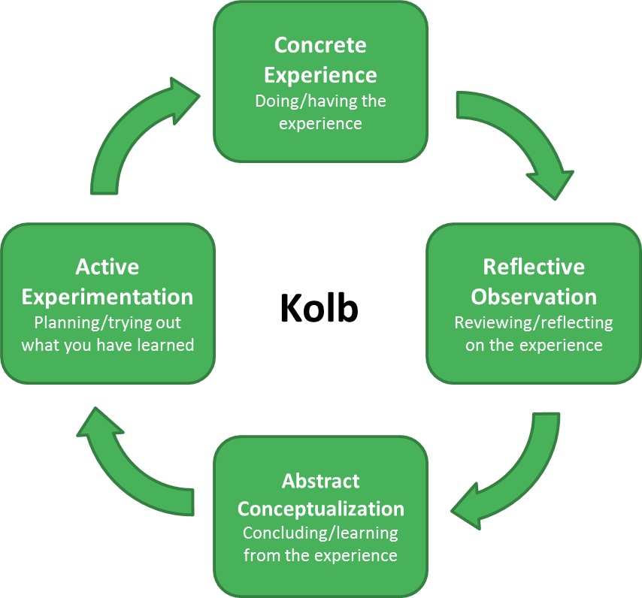
Figure 1: Kolb’s model (Nicole brown, 2022).
Gibbs’ reflective cycle
In 1998, Gibbs devised the cycle reflection concept. This paradigm uses a six-stage method, from experience description through conclusions and future concerns. Gibbs' model is an excellent tool for reflecting on experiences (Mtawa et al, 2016).
Description
This section should detail the practitioner's experience. This must be a true classroom report. Not analytical yet.
Feelings
This portion invites the practitioner to examine ideas and emotions from the incident. The practitioner should describe sentiments and present teaching-related examples. Even if they feel negatively, the practitioner must be honest about how they feel. After identifying sentiments, the practitioner may use techniques to overcome hurdles.
Evaluation
The assessment portion lets the practitioner discuss and analyze practice. Consider development regions and things that didn't go as anticipated. This assessment should evaluate practitioner and student learning. They evaluate what benefited or impeded learning. The practitioner turns to appropriate literature or information to make sense of the event.
Conclusion
At this point, the practitioner combines concepts. They should know what to improve and have recommendations based on their investigation.
Preparedness
In this step, the practitioner summarizes the cycle. They plan the new experiential learning step-by-step. Practitioners decide what to maintain, grow, and change.
Bloom’s taxonomy learning
Each level relies on the level below it in Bloom's taxonomy, a structure for studying, teaching, and educational attainment. It is often shown as a pyramid, much like Maslow's hierarchy of requirements. Comprehension, application, analysis, synthesis, and assessment are five skills and abilities that must be developed in order to successfully complete the educational process. Basic knowledge is the initial step of learning (Moore et al, 2016). Each stage is on a continuum, despite the fact that each has subcategories within it. The idea is that students use each level of the Bloom's taxonomy pyramid, beginning with extremely fundamental information, to gain a greater understanding of a topic, with each level being essential to the growth of the next. Bloom's taxonomy may be used by teachers to help students understand the goals of each step of the process by having them ask questions and complete projects that directly relate to those goals. Multiple-choice questions, for example, can be used to see how well a student understands and remembers a topic, while asking a student to make a comparison or an analogy marks the beginning of the application or analysis stage.
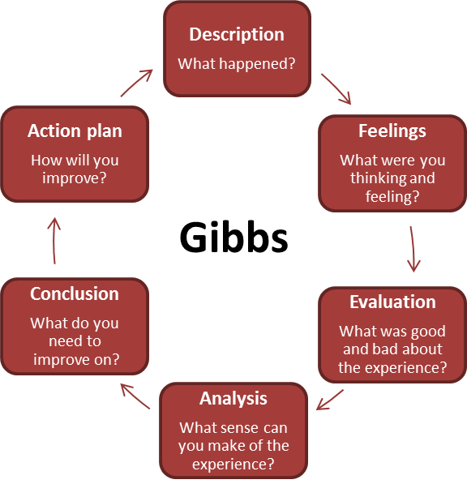
Figure 2: Gibbs model (simplypsychology, 2022).
Reflection of personal experience/ various skills and competences
Students have more opportunities to immediately apply what they learn in class to real-world scenarios when they participate in community service, which results in a more profound level of comprehension. Increase the number of students enrolled in your classes by luring those who are highly motivated and engaged. It also provides possibilities for networking with active professors from other institutions. These are the things that I picked up from my training in community involvement. This improves the possibility that a project or solution will be approved by a large number of people. Citizens who take part in these procedures demonstrate a tremendous commitment to assisting with the implementation of the initiatives (MacQueen et al, 2015). It facilitates the development of more efficient solutions. Solutions that are both practical and successful may be developed by drawing on the local expertise of a varied set of people. It increases people's general knowledge as well as their ability to solve problems. Participants get an in-depth education on the topics at hand. They are able to perceive the issue from many perspectives as a result of their increased knowledge. Citizens have the opportunity to hone their communication and deliberation abilities. It facilitates the empowerment and integration of individuals from a variety of backgrounds. Groups who believe they are being neglected might have a stronger sense of control over their lives and the society in which they reside. People from diverse parts of the community frequently discover that they have a lot in common with one another when they work together on a project (Kumar and Kumar, 2020). Develop local networks consisting of individuals from the community. The greater the number of individuals in a community who are aware of what is taking place and who are prepared to work toward achieving a common objective, the greater the likelihood that the community will be successful in accomplishing those objectives. Make sure there are several chances to talk about your worries. People are more likely to say what's on their minds during ongoing conversations that happen regularly, before problems get out of hand.
Build people's faith in the community's organizations and leadership. Cooperation leads to improvements in both communication and comprehension. If you know what the government, community members and leaders, and groups can and can't do, you might be able to avoid future conflicts.
The three broad goals are outlined in the Community Engagement Triangle, which are as follows:
The process of decision-making gives communities the opportunity to participate in the process of making better decisions. Relationship building, also known as community engagement, is the process of establishing new connections with members of a community or strengthening those already in place (Kimmel et al, 2019). Capacity building is a type of community development that involves building on what the community already has. This gives people and groups more chances to change the physical, social, environmental, economic, and cultural settings where they live.
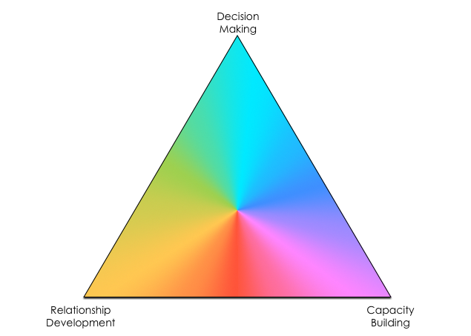
Figure 3: Three goals of community engagement (bioestate, 2022).
The relationship between academic theories and experiences in creatively solving problems
Maslow's hierarchy of requirements places fundamental demands at the bottom and intangible needs at the top (Joosten et al, 2015). When a person's basic needs are addressed, they may meet higher-level needs.
Physiological needs are Maslow's lowest, id-driven wants. Food, water, sleep, clothing, shelter, health, and reproduction are human necessities. Maslow argues that humans must fulfill their fundamental physiological requirements before moving on.
2. Safety Needs Next, safety needs Safety comprises physical protection, emotional stability, financial stability, and health security.
Social needs, or the third stage of Maslow's hierarchy, include connecting with others. Friends and family, biological and adoptive, are essential. Physical and social intimacy —from sexual engagements to intimate emotional ties —is vital for kinship. Social groups help satisfy this need. Unions, clubs, and interest groups are social groupings.
Higher demands are ego-driven, beginning with esteem wants. Self-respect and self-esteem make up self-esteem. Maslow distinguishes between self-esteem based on others' acceptance and self-esteem based on your own appraisal. This self-esteem leads to confidence and independence.
Self-actualization needs: Self-actualization means maximizing your potential. Maslow's theory places self-actualization needs at the top. Self-actualization requires education, skill development, and more general aspirations like acquiring new talents, traveling, and gaining praise (Hollebeek et al, 2017).
Theory of change
A theory explains how we think change will occur and, therefore, how we intend to devote our money and effort to bringing about that change.
The groundwork for grant-making strategy is laid by it.
An ambiguity in the theoretical framework at the outset leaves many investors and non-profits with little proof of the beneficial effects of effective initiatives (Cyril et al, 2015). If an organization doesn't link program results to its theory of change, it can't say that it has much of an impact, which could hurt its credibility with funders, trustees, and other important people.
It verifies presumptions. It requires critical thought on the issue description, the intended actions, and the desired results if the change management is apparent from the beginning. This introspection could lead to hard conversations and wake-up calls among (or within) the different people who have a stake in the organization (Bandy, 2016).
It facilitates team member dialogue. A conceptual framework that can be better owned by the whole team may be developed by requiring communication among the organizational stakeholders. This can lead to clearer processing, the chance for more participatory cooperation, and better results. As a result, your whole business will have a common understanding of how the firm thinks change will occur, which can then be communicated in a thorough but concise way.
It acts as a benchmark for success. The theoretical framework may be seen as a compass for assessing effectiveness and interpreting progress, success, or failure. This could then help come up with success metrics, critical success factors, and strategic choices for implementation.
It offers a foundation for making decisions. The idea may aid in advancing decision-making on time and resource expenditures at all levels of program management, from broad to tactical choices (Barnes and Schmitz, 2016).

Conclusion
The goal of community engagement is to include members of the community in the pursuit of sustainable results, equitable choice processes, and the strengthening of relationships and trust between government organizations and the communities they serve. Community involvement, which is enabled via feedback, makes it possible for police and government decision-making bodies to listen, which, in turn, allows them to show the effect of community input. Therefore, community involvement results in partnerships between public institutions and communities that are richer, more robust, and marked by an increased level of trust. This report's discussion on the significance of community management, together with the theory of change, Kolb's model, and Maslow's model, has been brought to a close.

References
Bandy, J., 2016. What is service learning or community engagement. Center for Teaching, Vanderbilt University. https://cft. vanderbilt. edu/guides-subpages/teaching-through-community-engagement.
Barnes, M. and Schmitz, P., 2016. Community engagement matters (now more than ever). Stanford Social Innovation Review, 14(2), pp.32-39.
Cyril, S., Smith, B.J., Possamai-Inesedy, A. and Renzaho, A.M., 2015. Exploring the role of community engagement in improving the health of disadvantaged populations: a systematic review. Global health action, 8(1), p.29842.
Hollebeek, L.D., Juric, B. and Tang, W., 2017. Virtual brand community engagement practices: a refined typology and model. Journal of Services Marketing.
Joosten, Y.A., Israel, T.L., Williams, N.A., Boone, L.R., Schlundt, D.G., Mouton, C.P., Dittus, R.S., Bernard, G.R. and Wilkins, C.H., 2015. Community engagement studios: a structured approach to obtaining meaningful input from stakeholders to inform research. Academic Medicine, 90(12), p.1646.
Kimmel, P.L., Jefferson, N., Norton, J.M. and Star, R.A., 2019. How community engagement is enhancing NIDDK research. Clinical Journal of the American Society of Nephrology, 14(5), pp.768-770.
Kumar, J. and Kumar, V., 2020. Drivers of brand community engagement. Journal of Retailing and Consumer Services, 54, p.101949.
MacQueen, K.M., Bhan, A., Frohlich, J., Holzer, J. and Sugarman, J., 2015. Evaluating community engagement in global health research: the need for metrics. BMC Medical Ethics, 16(1), pp.1-9.
Moore, T., McDonald, M., McHugh-Dillon, H. and West, S., 2016. Community engagement: A key strategy for improving outcomes for Australian families.
Mtawa, N.N., Fongwa, S.N. and Wangenge-Ouma, G., 2016. The scholarship of university-community engagement: Interrogating Boyer's model. International Journal of Educational Development, 49, pp.126-133.
Moser, S.C. and Pike, C., 2015. Community engagement on adaptation: Meeting a growing capacity need. Urban Climate, 14, pp.111-115.
Ojha, H.R., Ford, R., Keenan, R.J., Race, D., Vega, D.C., Baral, H. and Sapkota, P., 2016. Delocalizing communities: Changing forms of community engagement in natural resources governance. World Development, 87, pp.274-290.
O’Mara-Eves, A., Brunton, G., Oliver, S., Kavanagh, J., Jamal, F. and Thomas, J., 2015. The effectiveness of community engagement in public health interventions for disadvantaged groups: a meta-analysis. BMC public health, 15(1), pp.1-23.
Wallerstein, N., Minkler, M., Carter-Edwards, L., Avila, M. and Sanchez, V., 2015. Improving health through community engagement, community organization, and community building. Health behavior: theory, research and practice, 5.
Waterton, E., 2015. Heritage and community engagement. The ethics of cultural heritage, pp.53-67.

