Discuss the nature and direction of creative writing and the relationship within the wider range of humanities.

Exploring the humanities module HPHP4018

What is meant by the nature of creative writing? – Well foremost, to be accessible to the person who will read, watch, hear, or feel it. The target audience needs to know what the author is talking to them about, its no good explaining the process of how to land an aeroplane if your audience is a group from the gardening club.
In this essay the writer explores the nature of storytelling by famous conservationists to influence and change human behaviour. The common thread is that saving the earth and its wildlife is integral to saving Humanity.
“Tell me the facts and I’ll learn. Tell me the truth and I’ll believe. But tell me a story and it will live in my heart forever”
Native American Proverb. (Johnson, 2016)
The concept of Creative writing according to Google contains the six characteristics, Craft, imagination, artistic expression, beyond the ordinary, diversity of form, and purposeful authorship. The author does not intend to provide a technical instruction guide or a factual testimony.
Creative writing as an expression of the Conservation author’s storytelling is what the writer will explore, how it becomes a recognisable construct that influences humans, and how Authors are using storytelling to attempt to change behaviours of people with regards to saving the planet, from destruction by humans themselves.
In the writers first work (News Summary – “Jane Goodall dies age 91 October 2 2025”) an introduction was explored as to the power of storytelling to change how scientists viewed chimpanzees in the 1960s and the development of conservationism.

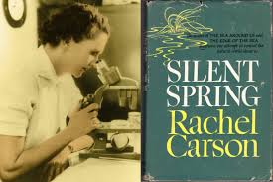
At the same time and on the other side of the world from Goodall, Rachel Carson had published “Silent Spring” in 1962. Carson also received, as had Goodall, ridicule from the scientific community. “Even a former US secretary of agriculture was known to wonder in public 'why a spinster with no children was so interested in genetics'. Her unpardonable offence was that she had overstepped her place as a woman." (Mckie, 2012) Despite the ridicule “Silent Spring” became a revolutionary text in conservationism igniting a new environmental debate on the harmful use of pesticide. This book is commonly viewed as the turning point in conservation and brought about the banning of the pesticide Dichlorodiphenyltrichloroethane (DDT) in the UK in 1984.
As a scientist Carson had told the story of thinning eggshells in wild birds wiping out millions, whose food were poisoned insects. The effect on the food chain and potential effects on humans was fundamental to political pressure brought about by conservationists and although the evidence is absolute in 1962, it still took over 20 years to action a ban. Sadly it is still used in developing countries to this day.
The combination of science, storytelling, and public pressure appears to have had success, albeit a slow directional change, but change never the less. So clearly humanities (what it is to be human) in all its epistemologies have a part to play in the art of a story. Creative writing can bring about change but needs to co-exist with evidence from science and other genres, shown so clearly in Carson’s Silent Spring.
Creative writing, the art of storytelling, is the glue that binds the evidence of the planet in trouble together, be it climate change, loss of habitat, or chemical annihilation of species. It can proffer a solution through teaching, engaging, and encouraging action for a better world, and that of hope.
Loss of hope is a top indicator of suicide, a point when a person feels there are no choices left but death, a profound metaphor on the responsibility of storytellers to offer hope whilst being conscious of the seriousness of the precipice humanity faces and the leverage required to force governments to act. It would be disastrous if all the literature we could access was only negative, people would most likely disengage from the argument and await their fate. The question being, how to manage and engender hope, that Earth can be saved from apocalypse and is this a realistic expectation?
Certainly Professor Dave Goulson believes there is hope. A UK world renowned entomologist, specialising in bumble bees, in his book Silent Earth - Averting the Insect Apocalypse, Goulson attempts to address the issue of hope and states,

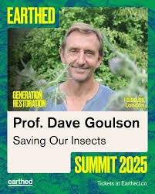
“the main investors in farming research and development are the big pesticide companies and other agro-industries…..we should reinstate government funded experimental farms, doing research into how to optimise truly sustainable agriculture”

Goulson goes on to provide a roadmap for Government, farmers and everyone, in what we can do in big or little ways to save the Earth. An offer of hope!
Silent Earth is a mixed book of hard hitting well-resourced scientific evidence with some storytelling, however it most likely appeals to the already converted which Goulson does acknowledge. Its failings appear to be its appeal to the masses that are looking for stories.
An examination of the Conservation movement itself that used storytelling as a successful driver for protecting the natural world can offer some explanations.
This power of writing to create environmental conservation and action is epitomised in the work of John Muir over 100 years before Jane Goodall landed in Gombe (now Gombe National park in Tanzania). Muir’s work inspired and captivated millions and indeed “The treasures of the Yosemite” and “Features of the proposed Yosemite National Park” were instrumental in the creation of Yosemite National Park. The American political system (The Senate) voted unanimously for this in 1890.(infor, 2025)
As regards to the Native American’s whose lives depended on these treasured landscapes, they continued to be victimised, abused and re located, the treaties, battles and skirmishes continued, finally ending with Battle of Bear valley in 1924, by which time Native American’s were living in reservations, their old way of life with the natural world, decimated.
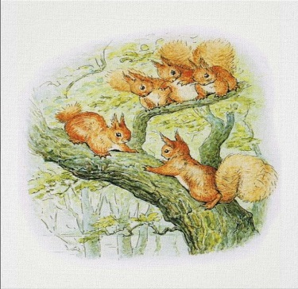
The National Trust in the British Isles by comparison was founded privately in 1895 and was established as a statuary corporation to provide a public service by an act of parliament in 1907. It has remained to this day a private charity.
Although Beatrix Potter is remembered for her philanthropic gifting of land to the Lake district and its subsequent National Park status it was her children’s stories she is greatly remembered for, who has not seen Peter Rabbit, Jemima puddle duck and of course Squirrel Nutkin, the red squirrel now an endangered species clinging on for survival following man’s introduction of the grey squirrel. Potter is much lesser known for her scientific papers on fauna and flora, and botany study. In contrast to the Native Americans the generational farmers remained on their land still farming their old ways until the industrialisation of food production of the 1930’s onwards.
If we look at the emergence of National parks in the UK, in contrary to preserving nature it is mob trespass in the 1930’s that forces parliament to eventually act in 1948 and this was solely for the benefit people to access and appreciate the beauty and take recreational exercise (Legislation.gov.uk, 1949) there is no reference to preserving wildlife the natural world or sustainability within the bill.
History tells us through its storytelling, archaeology, and science that humanity has been subject to change through evolution, just as Charles Darwin described in 1859 as “natural selection” in “On The Origin of the Species”. (Darwin, 2011) Our mistake may be to think we have reached the pinnacle of evolution when actually we may have reached a tipping point. Any civilisation is vulnerable to collapse, it would be arrogant to think otherwise, for example who would have thought the Romans, Mesopotamians, Incas, all living highly organised successful intelligent Communities would be lost for centauries only to be re discovered by archaeology in the last 100 years or so.
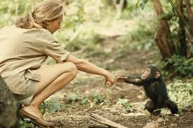
Dr Jane Goodall, the celebrated Conservationist, scientist, behaviour list, ecologist, was a cover girl for National Geographic– she used this as an advantage at the time, to raise awareness and funds for preserving the African Chimpanzees. Her characteristics as a person were the reasons that Leakey chose her for the study in the first place. A woman (perceived as patient, gentle, compliant, and led by her emotion. Of course we all question these so called womanly qualities today and the overt sexism of the time would be illegal today.
Her creative writing used popular fiction of Edgar Rice Burroughs (1875-1950) and imaginatively recreated herself as Tarzans Jane living in the jungle besides the apes. Instead of fighting the rhetoric Goodall embraced and worked it to her own advantage and goal. Her goal was to protect the chimps!
Goodall understood the power of storytelling. Her ability to show and tell gave her the evidence to prove that animals are sentient beings. The law now recognising animals as having rights which is a fundamental legacy that Goodall was responsible for.

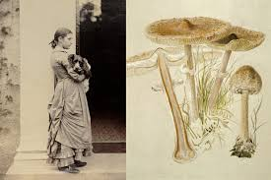
Beatrix Potter (1866-1943) needed no persuasion that animals were sentient beings, she embraced anthropomorphosis. Her animal characters of children’s books brought her the financial independence she needed.
A prolific studier of Fungi her botanical studies do remain, as well as many of her scientific papers. As a woman in Victorian England she was not allowed to present her own paper on the theory of fungi spore germination to the prestigious Linnean Society of London. (Watling, 2016) Instead a male mycologist presented this for her in 1897, one can only imagine her frustration that women were not permitted to attend or become members at the time. Interestingly the paper was lost, we can only speculate as to why!
Potter was not able to use her sex as a door opening tool as Goodall did, either for her science or her literature and initially battled to have her children’s stories published. As with Goodall however, using creative storytelling does sell and the money made by these women they put back into their cause to use in other ways.
This is a clear demonstration of cultural dogma preventing or accelerating human behaviour change according to the perceptions of the time. However, one constant that is apparent for either sex is that of creating wealth to aid research, protect lands and cultures. Money talks and storytellers can make money.
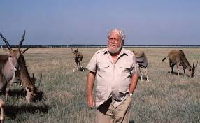
Gerald Durrell (1925-1995) another prolific Conservationist storyteller of the 1960/70’s. He was aware like Potter that storytelling not only made him financially mobile to develop his conservation. But he was adept at engaging his readers, harnessing emotion, imagery and empathy. He wrote over 40 books.

His legacy of captive breeding for conservation led the world of Zoos away from collections for the sake of collections to a forward thinking environmental sustainability philosophy.
It is questionable that Durrell faced the same sexist blocks or rhetoric that Goodall, Carson or Potter faced. However, it could be argued that he used his role wisely for the outcome he needed i.e. selling books to fund his work. Durrell created autobiographical popular fiction, he fitted into an accepted archetypal white male adventurer, expeditions collecting dangerous animals, educated, gifted handsome that was popular with his readers. Unlike Potter he had little problem getting published. Unlike Goodall he had little problem with his lack of formal education, to be taken seriously within the scientific world of conservation breeding. He had none. Unlike Carson he was a humanitarian not a scientist and did not try to prove any science, his interest was captive breeding programmes of endangered animals. However he did eventually befriend the scientific community in his own right.
It would be remiss not to include Sir David Attenborough, another great Conservationist storyteller. In the 1980’s Attenborough was showing us Lions eating baby zebras on the African savannah and this was “Life on Earth”(1979-1997), (Life on Earth: ANatural History by David Attenborough, 1979-2022) the audience cared, but had to accept it! Attenborough’s documentaries often left the audience informed but without prescribed action to make things better. Caring is a human emotion that evokes a will to do something – we want to help – Goodall was able to instruct us what to do with that emotion. Goodall told us that if we didn’t stop using cosmetics and hairspray this “life on earth” would disappear.
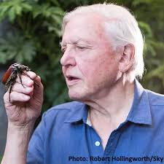
Attenborough’s journey from documenting the beauty of the natural world gradually changes; he begins to publicly speak out for the need to action. Attenborough is an observational storyteller and as such his action is to bear witness, as at COP 26 he says,

“In my lifetime I have witnessed a terrible decline, In yours you could and should witness a wonderful recovery”

These are examples of storytelling to support and activate messages to save the Earth and indeed the human race. Individually storytellers have succeeded in persuading people, politicians and whole governments as well as societies to make changes. Humanitarians are collaborating with scientists. Women are informing men. One person is inspiring millions. Individually they have a powerful voice. Collectively they are a power for hope.
In conclusion - on her death Jane Goodall turns to the camera in her final interview and says,
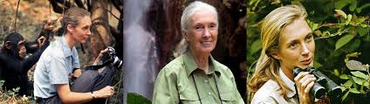
“Each and every one of you has a role to play and every single day you live, you make a difference in the world. And you get to choose the difference you make.”

References
(Johnson, 2016)
(Darwin, 2011)
(Dillon, 2021)
(Legislation.gov.uk, 1949)
(Life on Earth: A Natural History by David Attenborough, 1979-2022)
(Mckie, 2012)
(NPS infor, 2025)
(Sprackland, 2016)
(Watling, 2016)

