Nazreen Akhtar - 2128933
BMHP5004_BIRM Colin Barr
CHILDREN, YOUNG PEOPLE AND FAMILIES
Assessment 2 - Essay

Contents
Introduction 3
Safeguard Children Policy 4
Children Acts 1989 & 2004 4
Policies & Rights of European Children 5
Parenting & Adoption Polices 6
Child care Policies 6
Child Care Agency 7
Legislation 7
Mandatory procedure 8
The Care Act 2014 9
Conclusion 11
References 12

Introduction
In this assignment, I will be discussing the importance and significance of safeguarding policies and procedures in the UK whilst making reference to the 2 high profile safeguarding cases which are the Victoria Climbie and Daneil Pelka. Protecting means making sure that everyone, especially children, can live a life free from harm, abuse, and abandonment. This is a crucial industry since it ensures the health as well as security of the populace, especially children. All members of society, whether young or old, have a responsibility to protect children. The purpose of this article is to describe the process for focusing on protect Children; the foundation for the Evaluation of Children in Need and their Families (2000), and relevant recommendations on establishing provisions that safeguard and advance the welfare of children under section 11 of the Children Law 2004 (2007).


Safeguard Children Policy
The concept of child protection is explained in Safeguarding children entails working collaboratively to avoid harm to children, keep them healthy and developing normally, and raise them in an environment where they may get the best possible care. A child's inherent kindness The UN Convention on the Rights of the Child (1989) defines a child as any human being below the age of 18 (Hughes, 2019). The legal system is employed to legitimize a society and its laws and rules have far-reaching or absolute effects on even the youngest children. The phrase "keep free of jeopardy fight off or guarantee their safety" is crucial to the success of any effort to protect or improve the lives of children. There were a lot of adults in positions of power and businesses who supported children's rights so that they might get what they were due.
Awareness: To protect minors from sexual exploitation and abuse, we will raise awareness about this problem among the general public, our business partners, and other authorities. Both children and their careers will learn what kind of conduct they should anticipate from the people we elect and what steps to take if they have a problem.
Prevention: To help individuals and organisations reduce potential dangers to children, we are spreading education and best practices (Peckover, 2017). Create a safe workplace free of misconduct, discrimination, and assault, with a particular focus on protecting children's rights.
Reporting: How can we ensure that those who deal with children respond appropriately when they have worries about possible abuse of children or exploitation?
Responding: Wherever there is reason to suspect children may be subjected to mistreatment or exploitation, we shall see to it that suitable measures are implemented on their behalf.

Children Acts 1989 & 2004
Both the Child Protection Act of 1989 and the children Act of 2004 were crucial in guaranteeing that governments in England adopted the necessary measures to establish services and structures to all children in need under their jurisdiction. The message about protecting newborns spreads. The introduction of The Children Law in 1989 has resulted in the existence of two major Laws. Another Law came up with Law (1989) for protecting children (Holland, 2018). The Child Law of 2004 is the applicable legal document in this situation. The legal basis for doing so may be found in Chapter 10 of the Children's Act (1989) in the United Kingdom. All children deserve to be cared for, while there should be expectations for children's obligations and obligations. The Child Act of 2004 is very laudable since it ensures that families and children get the individualized attention to which they are entitled. The Children's Act of 1989 established the importance of the children's responsibilities to their parents above their rights.
In the UK, there are far too many instances when parents receive inquiries regarding their role as primary careers for their children (Easton, 2022). The goal is to decrease instances of child abuse. If which is the case, the leadership of the United Kingdom has to dispatch social service providers to keep an eye out for any child abuse or neglect. If there's any indication that a child is in danger or that things are tense at home, the counselor must act immediately to ensure the child's safety and happiness.

Policies & Rights of European Children
The premise here is the idea that protecting children is a top priority for signatories to the European Convention on the Rights of Children. A number of the difficulties that have come to light in recent abuse of children instances. But such groups continue to be at work in crisis situations with regards to their children learning and fatherly guidance. Children need to be shielded from harm inside this complex system, though children have no idea who is going to be in charge (Collicott, 2019). In the 1990s, organisations such make sure that Start and UK Childhood Fund developed new strategies to protect at-risk youngsters, and they have been doing so ever since.

Parenting & Adoption Polices
However, most parenting programmes focus on the poorest parents despite the fact that all children benefit from successful parenting. Adoption rules are an additional term that comes up in conversations about safety.
Those regulations or guidelines are widely accepted throughout Europe as a means of keeping children safe. All of these steps are taken to guarantee that your child will be cared for in a secure environment. Recent studies show that the number of abandoned children in the UK is high. Those children either were without parents anymore or had parents who weren't prepared to or interested in caring for them. Adoption procedures must be followed in such instances. There is always a need for caring adults in all communities with a sizable child population. This is why the government approved another Act, known as the Adoption Law for Children (Children Law, 2002). The programme targets any group that does not promote domestic abuse, which puts children at risk. Every negative event that can be traced back to familial violence is going to happen while domestic violence is prevalent. Foster policy was also a major emphasis of the Act. If a child doesn't have parents or relatives, social services will try to find a good fit for him or her (Peckover, 2017). The immediate family was persuaded to bring in the adoptive child as well. If which is the case, it might contribute to a decrease in family violence. And it's helpful in identifying which parents a child really needs.

Child care Policies
They received 10,199 new individuals for application, a decrease of approximately 10.8 percent from the previous fiscal year in response to the soaring popularity of minor assistance. This demonstrates the effectiveness of the framework where the Minors' Law is imposed on the nation, compelling businesses to act swiftly and effectively in order to protect the freedoms of children. Starting next April on, all parents of children as young as two will have possession of 15 hours each week, provided they work no less than seventeen hours per week. Beginning in the ninth month of 2024, it will begin to be made available to the identical qualifying parents who are employed of children ages from nine weeks to three years old (Easton, 2022). Therefore, they are shielded from the offensive material. All youngsters without families or with significant issues are given extra attention under this programme.

Child Care Agency
Every Child Matters (ECM) & Common Assessment Framework (CAF): The Safeguarding Children's Agenda was put into motion thanks to a court ruling that established a baseline of protections for all youngsters and laid the groundwork for their full participation in society. This choice was made together with all of Laming's other acts. This set the stage for everyone to work towards protecting the interests of children and meeting their needs. All of the staff members are working tirelessly on this project to help the children (Hughes, 2019). And others are encouraged to step up, make choices, establish objectives, and collaborate as a result of these activities.
North Yorkshire Safeguarding Children: The duties of the board include evaluating existing child care programmes, developing new ones, and making sure that all disadvantaged children benefit from them, particularly those with health problems. Each child must be assigned a caretaker who is responsible for coordinating and overseeing all of the children's services. A group of people should keep tabs on all targets and do their best to make sure all goals and strategies are carried out as intended.

Legislation
Several acts required further research on law, which boosted the discovery of children's passions and needs. All of this forethought and action resulted in a coherent standard by which to judge the performance of every employee in this Bureau. The personnel, who are professional who have been hired, are primarily accountable, as they work tirelessly around the clock to better the lives of all children who are in poverty (Holland, 2018). In addition, a team dedicated to protecting the freedoms of children has to be assembled, and a professional strategy needs to be developed. To protect the children and the frail adolescents, these experts need to remain honest and dignified. Clients seldom, if ever, seek or expect complete collaboration from and management of all social services staff members.
Legislation Situation Example
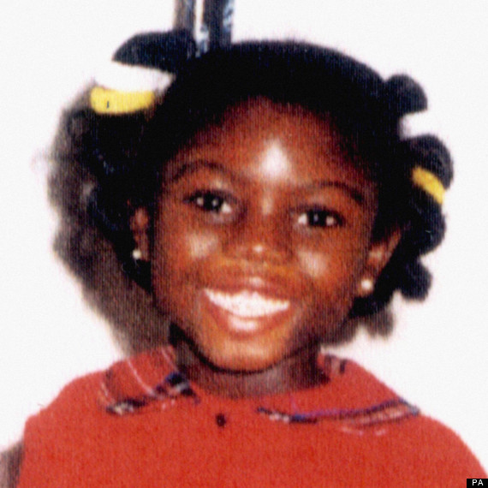
After seven years and a month and a half, in January of 1999, the infamous Victoria Climbie catastrophe happened. Almost a year passed while Victoria Climbie was unwell. She uses a wide range of medications besides health care. Due to a lack of competent parents, the child was neglected after she became unwell. Numerous monetary considerations have compromised Victoria's security. In terms of child protection, this youngster was in an unsafe environment. She received the incorrect treatment throughout her illness, and she nearly perished as a result. The second part of this case begins afterwards the event. The social child professional was summoned in an emergency, however none of the organisations responded well. Because of it, she failed to provide the child what she deserved (Collicott, 2019). The UK authorities were startled by these events and became aware of the child's widespread maltreatment. Both the Child Law (1989) and the legislation (2004) are in support of the administration's position. According to Article 10, the authorities must intervene if a group fails to protect the liberties of a child.
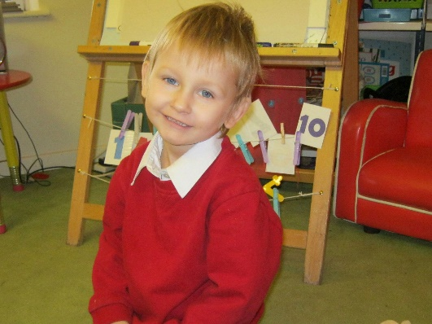
Furthermore, the second high profile case was the Daniel Palka case which was 13 years after the first case. Daniele Pelka was a young boy who was failed by the child protection system. Daniel's life was marred by unimaginable abuse and neglect. His parents, Magdalena Luczak and Mariusz Krezolek, subjected him to relentless physical and emotional torment. He was found dead on March 3rd, 2012, at 4 years old. Both children were suffered by physical abuse and neglect from their caregivers which therefore resulted in death. These cases highlight the importance of effective communication, thorough investigations, and timely interventions to safeguard vulnerable children. Additionally sharing information between social workers police officers and medical professionals in both cases were nonexistent.

Mandatory procedure
Incident Reporting: In the case when a child reports being exploited, agency staff and spokespeople ought to adhere to the flowchart of actions outlining children's protections and their required training. They have 24 hours to bring up any instances of apparent misbehavior to the Director of Child Safeguarding. In this method, children will be safe (Peckover, 2017). That agency's rate of child abuse will go down, for instance, and so will the rate of misbehavior at home where the child doesn't have to deal with it.
Staff training: In the United Kingdom, workers must do refresher classes on a yearly basis, and if their position changes due to an alteration in an act, they must complete learning specific for the new duty prior to implementing the updated law. Those responsible for taking precautions need to have enough training in this area. Since we have assured which the child will receive the necessary care and protection in whatever event.
Applicable Act: When possible, protect the young. The UK's Disability Assistance for Children Act 2016 requires that all workers and advocates disclose any disabilities that would prevent them from interacting with adolescents. Partnering with families is a crucial element of child protection, and the only way to ensure the greatest and most beneficial outcome possible. Parents were expected to help their children perfect their act for the performance (1989) (Holland, 2018). It's a must-read for any parent that shirks parental responsibilities. The legislation aids, aids a great deal required Children's for raising a child calmly. The Act (1989) always affects children's protection when tense circumstances arise.
Partnership Agreements: It takes a lot of money or energy to raise a child. This was too much for some parents to take. In such a circumstance, other organisations will pitch in to help shoulder the load. They all decided to pitch in to make sure the children were taken care of. A few households refuse to accept the assistance or services offered by these groups, which has a profoundly detrimental effect on the safety of the children in their care (Hughes, 2019). The fact that a few parents are eager to assist such groups by partnering together in order to educate their children securely has received a lot of attention.

Adoption procedure: Adopting places a premium on parental authority. Understanding what the whole adoption process works is crucial for any social worker who is hoping to comply with the parenting Law (2002). The Act of (1989) concerning the father's actions is related to the Participation in Other Elements Law (2002). Adoption is no exception to the rule because the biological father makes all major decisions for his child. My dad has taken care of everything necessary to keep the baby safe. The parent is responsible for and obligated to provide for his child (Collicott, 2019). The term "parental obligation" will be used to describe any governmental or professional obligation involving a baby. The responsibility of raising a child is not just the responsibility of the state; rather, each child is the responsibility of his or her parents.

The Care Act 2014
Care and support cooperation between the health sector and municipal governments is mandated by law according to the Care Act of 20141. Local and regional social care organisations are collaborating with NHS England and the Clinical Commissioning Groups in an attempt to improve health outcomes for patients. Safeguarding is the duty of the local government. They're charged with a shared responsibility with wellness to advance community health. Everyone working in the healthcare industry has a duty to ensure the health and safety of both patients and staff members. A life untainted by physical and emotional abuse is a need for human flourishing and a basic human right. Protecting adults means making sure everybody's patients are secure and cared for, with extra precautions taken for those who are most vulnerable. When it comes to security for patients, patient health, and the desired results from the NHS, safeguarding people is essential. Protecting seniors is crucial to meeting regulatory requirements and keeping healthcare costs down. Use these playing cards in conjunction with your organization's safeguarding procedures and guidelines if you are experiencing a concern about someone's safety.
The goals of protecting adults are:
- Individuals with special requirements for care and assistance must be protected from injury and from the possibility of neglect or assault.
- "Making Safeguarding Personal" is protecting people in a manner that allows them to make decisions and exercise agency over their own lives.
- To advocate for a safeguarding strategy based on results that really improve lives of individuals.
- Raise public consciousness about the issue of neglect of children in order to get more people involved in spotting and stopping it.

Conclusion
The summary to establish the crucial function of safeguarding children in the United Kingdom. So many distinct modifications in Law and some analysts argue that the necessary alterations are not needed, characterize the case of Victoria Climbed, whose emphasis is on the gap of flawless authorized or professional usage. But if better child protection is to be achieved, then action must be taken now. The major audience it would have an impact on is those working for governments or non-profits. Parent-organization partnerships flourish as a result of this nurturing environment. The protection of children has always been a priority in the law (1989 and 2004) (Easton, 2022). The safety of children has consistently been the focus in these landmark statutes. "Every Child Matters" ought to be their primary slogan. Non-profit organizations in the United Kingdom are making significant strides in ending child abuse. Overall, the similarities between Victoria Clumbia and Daniel Pelka's cases underscore systemic failures within child protection systems. The lack of communication between agencies and inadequate investigations contributed significantly to their tragic outcomes.

References
Alexander, G. and Sinnett, W., 2020. Business performance management. 4th ed. [Florham Park, N.J.]: Financial Executives Research Foundation.
B, G. and J, J., 2018. Safeguarding children in the UK: a longitudinal study of services to children suffering or likely to suffer significant harm. Child & Family Social Work, 13(4), pp.365-377.
Baggio, R. and Valeri, M., 2020. Network science and sustainable performance of family businesses in tourism. Journal of Family Business Management.
Bokhari, F., 2016. Falling Through the Gaps: Safeguarding Children Trafficked into the UK. Children & Society, 22(3), pp.201-211.
Brandon, M. and Thoburn, J., 2018. Safeguarding children in the UK: a longitudinal study of services to children suffering or likely to suffer significant harm. Child & Family Social Work, 13(4), pp.365-377.
Cleaver, H., 2015. Safeguarding children. Chichester, UK: Wiley-Blackwell.
Collicott, H., 2019. Everybody's Business? A Research Analysis of the Informal Safeguarding of Other People's Children in the UK. Children & Society, 25(5), pp.209- 210.
Cox, P., 2019. Safeguarding Children from Abroad: Refugee, Asylum-Seeking and Trafficked Children in the UK. British Journal of Social Work, 42(4), pp.796-797.
Easton and Gee, 2022. Safeguarding Children — Pediatric Research on Medical Countermeasures. LondonJournal of Medicine, 368(13), pp.1171-1173.
Green, P., 2019. New child safeguarding arrangements for England. BMJ, p.l5813.
Hek, R., Hughes, N. and Ozman, R., 2019. Safeguarding the seeking of Children and Young People Seeking Asylum in the UK: Addressing Past Failings and Meeting Future Challenges. Child Abuse Review, 21(5), pp.335-348.
Holland, S., 2018. Everybody's Business? A Research Analysis of the Informal Safeguarding of Other People's Children in the UK. Children & Society, 25(5), pp.406- 416.
Jenox, 2015. Children & Society, Falling Through the Gaps: Safeguarding Children Trafficked into the UK. 22(3), pp.201-211.
Nadrew, 2019. CQC: Safeguarding children. Vital, 8(1), pp.41-41.
Peckover, 2018. Improving Standards of healthy for Alternative Child and Youth Care: Systems, Policies, and Practices. Institutionalized Children Explorations and Beyond, 3(2), pp.264-265.
Peckover, S., 2017. From 'public health' to 'safeguarding children: British health visiting in policy, practice, and research. Children & Society, 27(2), pp.116-126.
Taylor, J. and Themessl-Huber, M., 2019. Safeguarding children in primary health care. London, UK: Jessica Kingsley Publishers.

