

Module: Leading and Implementing Change (LIC)
Module code: LCLM6003

Student Name: Surma Bibi
Student ID: 2308945
Lecturer: DR Sujeewa Herath

Table of Contents
1. Introduction to the Organisation 3
2. Environmental and Organisational Analysis 4
2.1 External Environment Analysis (PESTLE) 4
2.2 Internal Environment Analysis (SWOT and RBV) 7
2.3 Triggers for Change 8
3. Review and Evaluation of Change Management Models 8
3.1 Lewin’s Three-Step Model 9
3.2 Kotter’s Eight-Step Model 10
3.3 ADKAR Model 10
3.4 McKinsey 7S Framework 11
3.5 Justification of Selected Hybrid Model 11
4. Leadership and Organisational Culture in Change 12
4.1 Transformational Leadership 12
4.2 Transactional Leadership 13
4.3 Situational Leadership 13
4.4 Organisational Culture and Change 14
4.5 Overall Impact on Change 14
5. Proposed Strategic Change Management Plan 15
5.1 Change Vision and Objectives 15
5.2 Stakeholder Analysis 15
5.3 Implementation Framework 16
5.4 Communication Plan 17
5.5 Financial and Resource Plan 17
5.6 Risk Assessment and Mitigation 18
5.7 Evaluation and KPIs 19
6. Discussion and Critical Reflection 19
7. Conclusion 20
References 22

1. Introduction to the Organisation
Hilton Hotels and Resorts is a hospitality organisation that is known globally, and it is under Hilton Worldwide Holdings Inc., which is one of the largest hotel chains in the world. The company was founded in the year 1919 by Conrad Hilton and has since expanded to have over 7000 properties in its operation in over 120 nations and territories. Hilton operates a diversified set of luxury hotel brands (Waldorf Astoria, Conrad), mid-scale and focused service (Hilton Garden Inn, Hampton by Hilton), enabling it to serve a variety of customer segments.
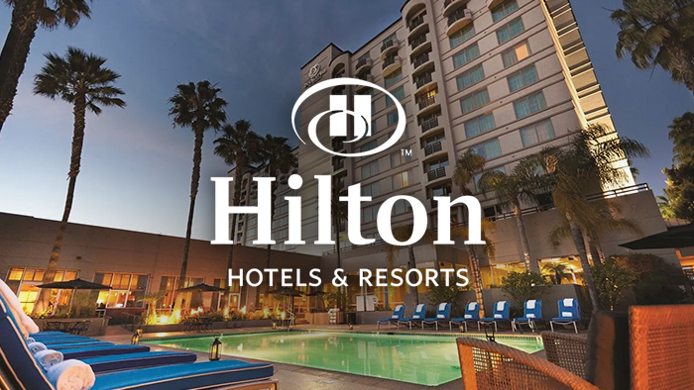
Figure 1: Hilton Hotels and Resorts
Source: (Derowitsch et al., 2025)
The world hospitality sector is very competitive and dynamic, as well as sensitive to changes in the outside environment. The cycles of the economy, tourism flows around the world, digital disruption, geopolitical turbulence, and epidemics of diseases affect it. The pandemic negatively impacted the industry, leading to severe occupancy rates, revenue per available room (RevPAR) and demand for international travel. This has necessitated fast strategic reactions such as agility, quicker digitalisation and operational resilience by hotel organisations.
According to the corporate mission of Hilton, the company aims to be the most hospitable company in the world; it tries to provide guests with heartfelt experiences, meaningful opportunities for its staff members, as well as high value to its owners and other stakeholders. Its vision focuses on setting new standards in customer service by means of innovation, operational excellence and a good brand name. Hilton emphasises sustainability, digital innovation, customer loyalty (Hilton Honours programme), and data-driven decision making as one of its long-term strategies.
Nevertheless, Hilton has a lot of pressure on the environment. The development of online travel agencies (OTAs) like Booking.com and Expedia has also changed the channel of distribution and decreased the marginal direct booking. The guest expectations have been transformed by digital technologies, artificial intelligence (AI), automation, and mobile-first customer behaviour. Further, the rivalry in the market has escalated due to the presence of substitute accommodation sites like Airbnb. The post-pandemic environment also contributes to the strategic complexity with labour shortages and the increase in the cost of operations.
A few change initiatives already adopted by Hilton comprise the use of digital keys, AI customer analytics, and improved mobile check-in systems and commitments toward sustainability that are both ESG-compliant. However, the organisation should keep on adapting to technological disruption, changing consumer behaviour and competition to keep its leadership in the market.
Hilton has been chosen as the strategic change report because it is a worldwide company, it is vulnerable to environmental turbulence, and it is evident that it needs to undergo strategic change constantly in line with digitalisation and industry volatility. The organisation gives a good reason in the analysis of the change management model, leadership style and organisational culture in the complex international business world.

2. Environmental and Organisational Analysis

2.1 External Environment Analysis (PESTLE)
Hilton is a company in the hospitality sector that is volatile across the world, influenced by macro-environmental forces that directly affect the performance of strategic activities.
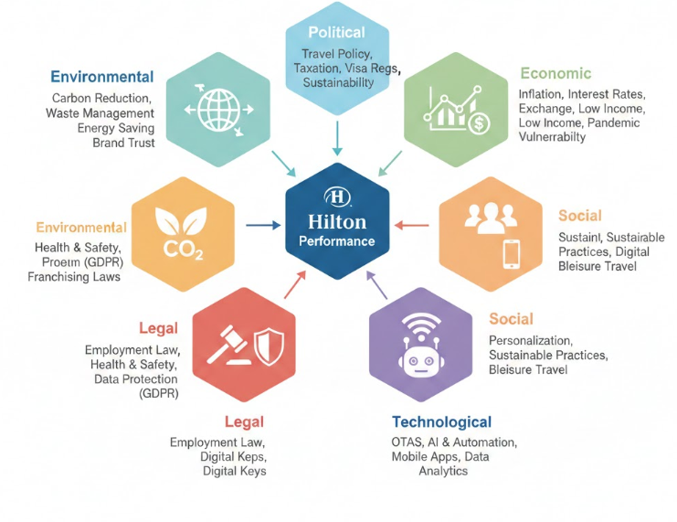
Figure 2: PESTLE
Source: (Derowitsch et al., 2025)
Political: Government policies that affect Hilton include international travel, taxation, labour laws, and visa regulations. Cultural and political uncertainties and shifting immigration policies may limit international tourism (Derowitsch et al., 2025). More attention to the sustainability and carbon reduction policies at the government level gives regulatory pressure to the big hotel chains in proving themselves responsible to the environment.
Economic: The sensitivity of the hospitality industry to the economic cycles is high. Direct effects on travel demand are through inflation and interest rates, exchange rate volatility and low consumer disposable income. The COVID-19 pandemic has shown the industry's vulnerability, where occupancy and revenue per available room (RevPAR) have gone down drastically across the globe (Singh and Corsun, 2023). The recovery after the pandemic is skewed, and the increase in labour and energy prices continues to pressure profitability.
Social: The expectation of consumers is changing at a very fast pace. The needs of the guests are getting more personal, with a focus on sustainable practices, digital comfort, and booking policy flexibility. Mobile check-in, contactless, and loyalty-based engagement is starting to gain more and more popularity (Daimah and Anwar, 2025). Service expectations are also transformed because of the shift in travel behaviour, such as the increase in business-to-leisure travel (bleisure).
Technological: The most disruptive force is technology. Online travel agencies (OTAs) like Booking.com and Expedia changed the channels of distribution and amplified the level of price transparency. Customers are now interacting with artificial intelligence (AI), automation, mobile applications, digital keys and data analytics, which have changed the level of interaction and operational efficiency (Anozie et al., 2024). The inability to digitalise will be a source of competition.
Legal: The obligation to act according to employment law, health and safety laws, data protection legislation (such as GDPR), and international franchising laws makes the operations more complex (Abd Aziz et al., 2025). Failure to comply could hurt brand reputation and profitability.
Environmental: The pressure of sustainability is growing as the stakeholders require reduced emissions and proper disposal of waste materials, high efficiency in energy consumption, and effective environmental accountability.

2.2 Internal Environment Analysis (SWOT and RBV)
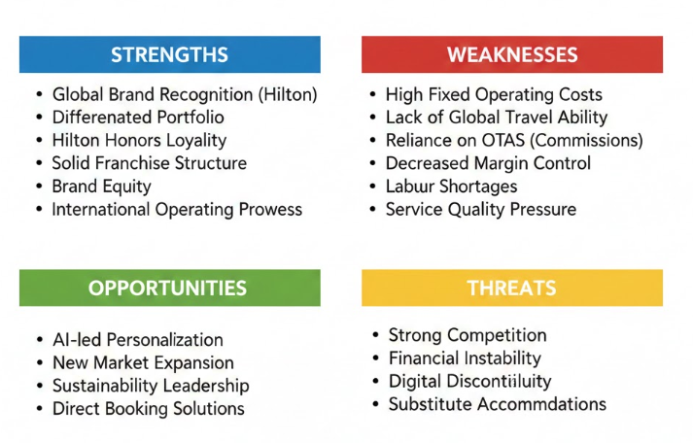
Figure 3: SWOT and RBV
Source: (Gabelaia and Gabelaia, 2025)
Strengths: Global brand equity, worldwide portfolio, and the Hilton Honours are inimitable RBV strengths exploited by Hilton Worldwide Holdings Inc.
Weaknesses: The high fixed operating costs, lack of ability to travel worldwide, and reliance on OTAs on commissions decrease margin control (Gabelaia and Gabelaia, 2025). Shortages of labour also put pressure on the quality of service.
Opportunities: The growth opportunities are presented by customer personalisation led by AI, entering new markets, sustainability leadership, and targeting capacity through direct booking digital solutions.
Threats: There is strong competition, financial instability, digital discontinuity, and substitute accommodation modes that endanger long-term market share.

2.3 Triggers for Change
Hilton Worldwide Holdings Inc. has various strategic pressures that demand constant organisational reconfiguration. Digital disruption, more specifically the fast proliferation of online travel agencies (OTAs) and mobile booking apps, is one of the greatest motivators as it has disrupted traditional channels and channels of distribution, and heightened price transparency. Online comparison among customers has made brand differentiation and direct booking strategy more significant (Yadav, 2025). Meanwhile, the development of artificial intelligence (AI) and data analytics is transforming the personalisation of the guest experience by hospitality firms, the management of revenues, and operational efficiency.
The global hospitality industry has turned out to be a case of quite stiff competition. It puts an additional burden on the pricing, innovation, and customer acquisition by the big hotel chains such as Marriott International and online booking platforms such as Airbnb (Garcia et al., 2022). Their service models (digital-first) are raising the levels of the industry and transforming the expectations of the customers. In order to remain competitive, Hilton Worldwide Holdings Inc. has to continue enhancing its value proposition and establishing a strong loyalty ecosystem.
In the meantime, post-pandemic consumer requirements and pressure require a greater organisational response. The guests would desire convenient online experiences, conspicuous sustainability policies and service responsiveness. The deficiencies of labour and increased costs of running the business have made Hilton reconsider the workforce policies and improve agility (Kontis and Skoultsos, 2022). As an informal set of pressures, they lead to strategic redraw, digital enablement, and a more responsive organisational form to maintain long-term competitive advantage.

3. Review and Evaluation of Change Management Models
Managing complexity, opposition, and aligning organisational capability with environmental pressures is only possible through effective strategic change at Hilton, with structured frameworks to address any form of change. There are a number of habeas models that offer a theoretical basis in managing change, namely The Three-Step Model by Lewin, The Eight-Step Model by Kotter, the ADKAR and the McKinsey 7S Framework. They both have their advantages and weaknesses in the context of their implementation in a global hospitality organisation.
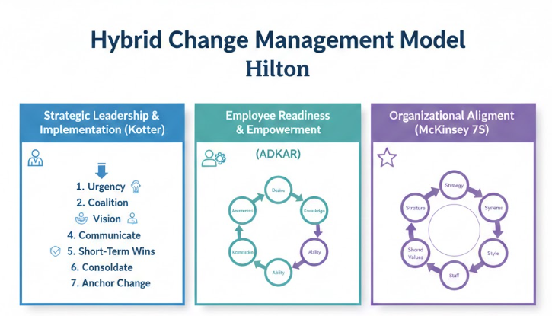
Figure 4: Change Management Models
Source: (Adelman-Mullally et al., 2023)

3.1 Lewin’s Three-Step Model
The model by Lewin perceives change as a three-step process: Unfreeze, Change, and Refreeze. The unfreeze stage entails breaking the status quo and getting the organisation into a psychological readiness for transformation (Adelman-Mullally et al., 2023). Change stage brings about new behaviours, systems or processes. Lastly, there is the process of refreezing that helps to entrench the change into organisational culture.
The model by Lewin has the strength of being simple and behaviour-oriented. In the case of Hilton, the unfreezing might be associated with the message about the urgency that online travel agencies (OTAs), Airbnb competitors and AI-induced demands have developed. The model assumes that change is episodic and ultimately organisations will stabilise in a new state. Permanent refreezing might not be realistic in the hospitality industry, where technological development and consumer behaviour are changing with time (Carnall, 2014). Although Lewin offers an efficient conceptual basis, it can simplify the dynamism of the ZIP of the environment in which Hilton operates.

3.2 Kotter’s Eight-Step Model
Kotter built on Lewin by giving him a framework that is more leader-oriented. The eight steps involve: generating urgency, creating a guiding coalition, vision, communicating the vision, creating short-term wins, consolidating gains, and anchoring change in organisational culture (Bencivenga).
The model suggested by Kotter applies specifically to the giant Hilton strategic projects, i.e., the digital transformation or the sustainability integration. Its focus on alignment and communication in leadership is helpful in the structured implementation of the geographically dispersed properties (Somera and Petrova, 2024). Organisational commitment can also be enhanced by generating short-term wins, e.g. by successful pilot digital projects.
Though the Kotter model has been criticised as being linear and prescriptive. Organisations in fast-changing industries may have to change dynamically and not in a stage-by-stage development (Equenot, 2024). The model places a lot of emphasis on top management leadership that might not appreciate the role of distributed and collaborative leadership in service organisations such as Hilton.

3.3 ADKAR Model
The ADKAR model changes the emphasis to organisational processes and moves it to personal change readiness. It is comprised of five elements, which are Awareness, Desire, Knowledge, Ability and Reinforcement. This model acknowledges the fact that the only way sustainable change can come is when the employees embrace and believe in change.
In the case of Hilton, the ability of the staff and their involvement are crucial to the successful implementation of AI technologies, the introduction of digital check-in, and sustainability (Sivadasan, 2025). The ADKAR model has been the most effective in resistance management and employee development (which is vital in the labour-intensive hospitality settings).
ADKAR does not focus on overall strategic change, but rather on micro-level behavioural change, and can be strategic at the organisational level (Lup et al., 2025). Although it works well in implementation, it does not address completely such aspects as competitive positioning and the complexity of the environment.

3.4 McKinsey 7S Framework
The McKinsey 7S model analyses the whole idea of organisational alignment in seven interrelated areas, namely Strategy, Structure, Systems, Shared Values, Skills, Staff and Style. It is internalised and systemic within, which is unlike stage-based models.
Such a framework becomes extremely applicable to Hilton since the digital transformation is not evident solely in technology but also in the organisational structure and culture, the leadership approach, the competencies of the labour force, and the process of work (Ivaldi et al., 2022). The application of AI-based customer analytics needs to be supported by the structures, highly qualified personnel, and consistent with the shared values like customer excellence.
The 7S model lacks the barriers to change implementation that are directed step by step. It works as a diagnostic tool and not as an implementation roadmap.

3.5 Justification of Selected Hybrid Model
Hilton has a complicated international business, and it cannot be reduced to one model. The most suitable approach is the combination of a structured implementation process suggested by Kotter and the people-oriented approach of ADKAR, as well as the alignment model proposed by McKinsey 7S (Prentice et al., 2025).
Kotter gives tactical advice and leadership. ADKAR secures employee participation and the development of their abilities. The 7S model guarantees alignment in the organisation. The principles of unfreezing and reinforcing behaviour, as described by Lewin, form the basis of the entire logic of transformation.
This combined methodology is an indication of current scholarly debates where change in complex organisations must take multi-level concepts, which consider both the structural and behavioural aspects (Lee and Legendre, 2023). In the case of Hilton, strategic leadership, employee preparedness and organisational alignment are more sustainable in terms of competitive advantage in a hospitality industry that is digitally disrupted.

4. Leadership and Organisational Culture in Change
A successful strategic change in Hilton must be built not only on the structured models but also on proper leadership and the organisational culture. The style of leadership affects the motivation of employees, their resistance rate, and the ability of the change process to be sustained, whereas the organisational culture defines the way change is understood and internalised.
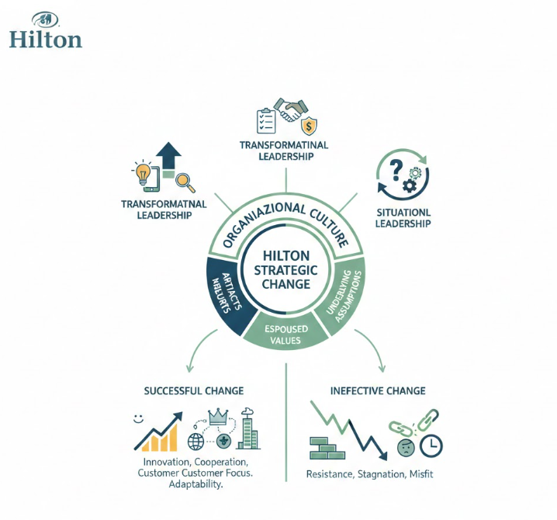
Figure 5: Leadership and Organisational Culture in Change
Source: Self Made

4.1 Transformational Leadership
Transformational leadership is about inspiring the employees in the form of the vision, motivation, intellectual stimulation, and consideration. Transformational leadership is specifically applicable in the context of Hilton to spearhead digital transformation and sustainability efforts (Yas et al., 2022). When leaders introduce a powerful message of innovation and customer excellence, they can promote the adoption of AI technologies, mobile solutions, and new models of service by employees.
Transformational leaders encourage staff empowerment and innovativeness, which is important in the hotel industry since the quality of the service rendered largely relies on the commitment of the employees. Critics claim that within transformational leadership, there is a possibility of neglecting operational control unless this is balanced with things like structured management (Zen et al., 2023). Inspirational leadership should have systems and accountability systems to support inspirational leadership within an international organisation, such as Hilton, to create uniformity between properties.

4.2 Transactional Leadership
Transactional leadership focuses on and provides structure, performance goals, and monitoring and reward motivation. The style is widespread in operational facilities, including hotels, where the service quality, work efficiency, and customer satisfaction ratings have to be kept at a high level.
Transactional leadership at Hilton is used to facilitate day-to-day management services, brand standards, and cost management in the recovery after the pandemic (Akter et al., 2023). Rewards and clear performance expectations can be used to reinforce behaviour change, especially when the management is introducing new technologies or operations.
But the issue is that transactional leadership on its own could be restrictive to innovation. Excessive control and monitoring have the potential to diminish employee creativity and flexibility, which is necessary in accelerating response to digital disruption and changing customer demands (Garengo and Betto, 2024).

4.3 Situational Leadership
Situational leadership argues that a leader should be flexible to suit the level of employee preparedness and the difficulty of tasks. This flexibility is very suitable in the global situation of Hilton (Nguyen et al., 2023). An example is that senior managers of a property that is already present might need a delegating style, and new employees who adopt AI systems might need a more directive style of guidance.
Situational leadership increases flexibility, especially in a complicated transition process. However, its efficacy is affected by how leaders can clearly measure the level of competence and commitment of the employees, and this could be different in different regions and cultures.

4.4 Organisational Culture and Change
The role of the organisational culture in terms of the success of change programmes is significant. According to the model of Schein, the three levels are: artefacts (observable behaviour and processes), espoused values (proclaimed strategies and goals) and underlying assumptions (profound beliefs) (Musaigwa, 2023). The culture of Hilton is based on hospitality, excellence of services and teamwork. To be successful, digital transformation should be in line with these core values and not be contrary to them.
According to the typology of Hilton proposed by Handy, this company is representative of both role and task culture (organised processes and brand heritage; the service delivery based on teams) (Xenikou and Furnham, 2022). Although role culture contributes to the consistency, too much bureaucracy can hinder innovation.
The cultural dimensions developed by Hofstede are especially applicable to the multinational activities of Hilton. Power distance, individualism, and uncertainty avoidance disparities between different countries can also affect how employees react to change.

4.5 Overall Impact on Change
Transformational leadership and situational adaptability are the most effective ways to induce strategic change, and operational stability is achieved with the help of transactional mechanisms, which is applicable, in the case of Hilton (Yas et al., 2022). Innovation, cooperation, and a customer orientation culture boost the execution of change. Such a noncongruity between the organisational culture and the leadership style may result in resistance, and deter resistance to long-term change; on the other hand, they can be ineffective.

5. Proposed Strategic Change Management Plan
Hilton requires a digital transformation programme that is a strategic programme and might be implemented with a focus on the incorporation of AI, optimisation in direct bookings and in the personalisation of customers (IMC and IFORATMC, 1990). This change is aimed at developing the competitive advantage, reducing the dependence on online travel agencies (OTAs), and making the company more efficient.

5.1 Change Vision and Objectives
Vision:
To turn Hilton into a fully digital-savvy hospitality disruptor that introduces personalised and data-fuelled guest experience, and maximise operational efficiency and sustainability.
Strategic Objectives:
- Grow direct bookings by 20% within three years by improving the digital platform and engagement loyalty.
- Install customer analytics (AI) in every property to enhance the personalisation of the services (Bencivenga).
- Minimise OTA commission expenses by increasing the Hilton Honours membership.
- Enhance efficiency in operations by automating selected administrative operations.
- Intensify sustainability performance by the use of digital energy management systems.
These goals are in line with the mission of Hilton to provide superior guest experiences and structural financial strength and competitiveness.

5.2 Stakeholder Analysis
Successful implementation requires identification and management of key stakeholders.
Internal Stakeholders:
- Executive leadership (strategic direction and resource approval)
- Hotel managers (local implementation)
- Employees (system adoption and service delivery)
- IT teams (technical integration)
External Stakeholders:
- Guests (primary beneficiaries of enhanced digital services)
- Franchise owners and investors (financial performance focus)
- Technology partners (AI and system providers)
- Regulatory bodies (data protection compliance)
Immediately, a stakeholder mapping approach classifies stakeholders according to power and interest. Board members, large investors, and other stakeholders who have high power and interest should be closely handled (Nguyen et al., 2023). Resistance needs to be minimised by having full engagement of employees so as to develop capability. Improved online services should be communicated to the guests to help them embrace the services.

5.3 Implementation Framework
An integrated change model incorporating Kotter's phases and the ADKAR concepts will be used to guide the implementation.
Phase 1 - Create Urgency and Awareness:
Current performance indicators of OTA dependence, competitive forces, and digital divide. Assess the dangers of the lack of action.
Phase 2 - Build a Guiding Coalition:
Establish a cross-walled digital transformation team that will include the highest-ranking executives, IT professionals and property managers.
Phase 3 - Formulate and Share Vision:
Demonstrate the value of AI and online platforms in ensuring a better experience of the hotel visit and more efficient running of the work of the employee.
Phase 4 - Capability Development:
Create official capacity-building training workshops for staff to acquire digital knowledge and skills. Test pilot programs in certain premises.
Phase 5 - Create Short-Term Wins:
Document a reality shift in the level of customer satisfaction and direct bookings during pilots.
Phase 6 - Embed and Reinforce:
Add performance measures on the internet and reward innovation.
This gradual strategy makes sure that it will have strategic alignment and adoption at the employee level.

5.4 Communication Plan
Effective communication is critical to reducing resistance and building commitment.
Communication Objectives:
- Explain the rationale for change.
- Clarify benefits for employees and guests.
- Provide transparent timelines and expectations.
Channels:
- Executive town hall meetings
- Internal newsletters and digital dashboards
- Manager-led team briefings
- E-learning modules
- Feedback surveys
Communication needs to be ongoing, and not a one-off process. A transformational style of communication should be adopted, whereby leaders focus on vision and opportunity, as opposed to threat.

5.5 Financial and Resource Plan
Digital transformation requires strategic investment but offers long-term cost savings.
Investment Areas:
- AI software and analytics platforms
- IT infrastructure upgrades
- Staff training programmes
- Cybersecurity systems
The investment can be rolled out over three years to lessen the strain on the budget in a given year. Despite the large start-up expense, the anticipated advantages will be a decrease in OTA commission charges, an increase in their occupancy rates, more loyalty retention, and a decrease in operational costs due to automation.
The cost-benefit analysis is to be used in ensuring that the projected return on investment (ROI) is in line with strategic targets.

5.6 Risk Assessment and Mitigation
Several risks may undermine implementation:
Resistance to Change:
- Employees may fear job displacement due to automation.
- Mitigation: Transparent communication, training, and reassurance that AI supports rather than replaces service roles.
Technology Failure or Cybersecurity Breaches:
- Digital systems increase exposure to data security risks.
- Mitigation: Robust cybersecurity measures and compliance with data protection regulations.
Financial Risk:
- High upfront investment may strain budgets.
- Mitigation: Phased rollout and pilot testing before full-scale deployment.
Operational Disruption:
- System integration may temporarily affect service quality.
- Mitigation: Gradual implementation and contingency planning.
- A structured risk register should be maintained and reviewed quarterly.

5.7 Evaluation and KPIs
Monitoring performance ensures accountability and continuous improvement.
Key Performance Indicators (KPIs):
- Direct booking percentage increase
- Reduction in OTA commission costs
- Customer satisfaction and Net Promoter Score (NPS)
- Employee digital competency assessment results
- Operational cost reduction percentage
- Sustainability performance metrics (energy consumption reduction)
The executive leadership team should carry out quarterly performance reviews. Real-time monitoring can be offered by data-driven dashboards.
The constant state of feedback will enable the change in strategy, keeping it in line with the situation in the market and the abilities of the organisation.

6. Discussion and Critical Reflection
The Hilton digital transformation plan proposed shows a number of strategic strengths. To begin with, it is pretty well aligned with external environmental forces, especially with the digital disruption, the development of AI, and the growing threat of online platforms. The plan strengthens the competitive positioning and decreases the store dependency on online travel agencies by directly booking optimised and personalised with the help of AI (Oladele, 2025). Secondly, the hybrid change management model incorporates leadership, employee activation, and structural congruence, which makes the implementation more sustainable. Accountability and strategic clarity are further enhanced by the fact that measurable KPIs and gradual financial planning are included.
There are drawbacks to the plan. Digital transformation on a scale involves a huge amount of capital expenditure and can create financial pressure in the near term (Han, 2024). Also, the implementation of the phenomenon in Global Hilton administrative properties might be inconsistent because of the differences in the cultures and technological preparedness rates. Employment resistance because of fears of automation and the loss of jobs will hinder uptake. Effective leadership and communication are therefore very crucial in the plan.
Ethically, the growing rate of the use of AI and customer data analytics leads to concerns about data privacy and cybersecurity. Hilton will have to guarantee that it adheres to the global data protection laws and remains open in its data usage to remain credible to the stakeholders (Daimah and Anwar, 2025). Moreover, automation requires that ethical workforce management be implemented to avoid perceived job loss.
Regarding sustainability, environmental responsibility and efficiency of operations in the long run are facilitated by the integration of digital management systems of energy (Anozie et al., 2024). But it has its environmental costs associated with having technological infrastructure, and sustainable procurement practices should also be taken into account.
The proposed change plan is balanced, though strategically justified; the success of the change plan will be achieved with the help of balanced leadership, ethical governance and constant review to enable long-term organisational resilience.

7. Conclusion
This report has been critical of the strategic stance of Hilton in a very competitive and digitally disrupted hospitality industry. The external environment analysis revealed that the company faces severe external pressures such as digital transformation, AI implementation, increased competition with online travel agencies and Airbnb, changing consumer expectations, and sustainability. Hilton, internally, has a good brand equity, experience in operating globally and a loyalty programme, whereby, nevertheless, its operational costs are high, and reliance on intermediary booking systems makes it vulnerable strategically.
Working with change management models allowed us to conclude that there is no single model that can help to manage the complicated transformation requirements of Hilton. The hybrid model that is a fusion of Kotter's levels of structured leadership process, ADKAR principles of employee-centred approach, and McKinsey 7S alignment model, can be used as an extensive basis of sustainable change. As the most important success factors, leadership style and organisational culture were singled out, and the transformational and situational leadership styles were found to provide the best balance between inspiration and the ability to control operations.
The strategy change proposal to be carried out at Hilton Worldwide Holdings Inc. will focus on the staged digital transformation based on AI-assisted personalisation, better optimisation of direct booking, and operational efficiency. The process of implementation must be organised in terms of specific goals, clear accountability, stakeholder involvement, financial planning, risk reduction, and KPI measurements to assess the progress of the process and the possibility of creating value sustainably.
Investment in digital possibilities, enhancing internal communication and establishing a culture of innovation based on ethical governance and sustainability promise should be among the priorities of the Board. This strategy will result in increased competitiveness in the long run, better customer satisfaction, and organisational resilience.

References
Abd Aziz, N. A., Sabaran, N. N. H., Ramdan, M. R., and Aziz, K. A. (2025). Exploring regulatory challenges in franchising governance for international business expansion. Journal of Governance and Integrity, 8(2), 1051-1058.
Adelman-Mullally, T., Nielsen, S., and Chung, S. Y. (2023). Planned change in modern hierarchical organizations: A three-step model. Journal of Professional Nursing, 46, 1-6.
Akter, R., Rathnayaka, S., and Ahmadi, Z. (2023). The effect of leadership and organisational culture on organisational innovation. International Journal of Services Technology and Management, 28(5-6), 360-388.
Anozie, U. C., Onyenahazi, O. B., Ekeocha, P. C., Adekola, A. D., Ukadike, C. A., and Oloko, O. A. (2024). Advancements in artificial intelligence for omnichannel marketing and customer service: Enhancing predictive analytics, automation, and operational efficiency. International Journal of Science and Research Archive, 12(2), 1621-1629.
Bencivenga, J. (2002) John Kotter on leadership, management and change. American Association of School Administrators.
Carnall, C.A. (2014) Managing change in organizations . Sixth edition. Harlow, England :, Pearson.
Daimah, D., and Anwar, S. (2025). The effect of customer experience on guest satisfaction and loyalty: A study on digital service-based hotels. Hospitality Management and Operations Journal, 2(1), 19-28.
Derowitsch, J., Ngo, T., Katt, T., Henning, M., and Soukup, L. (2025). Strategic Audit: Hilton Worldwide Holdings, Inc.
Equenot, T. (2024). Change management dynamics applied to the fast-evolving luxury hotel industry (Master's thesis, T. Equenot).
Gabelaia, I., and Gabelaia, S. (2025). Assessing the Impact of Online Travel Agencies on Hotel Operations and Financial Outcomes: A Mix Methodology. Journal of Marketing Research and Case Studies, 790809.
Garcia, G., Dos Anjos, S., and Doğan, S. (2022). Online travel agencies and their role in the tourism industry. Advances in Hospitality and Tourism Research (AHTR), 10(3), 361-386.
Garengo, P., and Betto, F. (2024). The role of organisational culture and leadership style in performance measurement and management: a longitudinal case study. Production planning and control, 35(2), 151-169.
Han, J. (2024). The impact of digital transformation on the dynamic adjustment of corporate capital structure. Transactions on Economics, Business and Management Research, 7, 25-30.
Institute of Management Sciences. and Institute for Operations Research and the Management Sciences. (eds.) (1990) Organization science : a journal of the Institute of Management Sciences. Providence, R.I. :, Institute of Management Sciences.
Ivaldi, S., Scaratti, G., and Fregnan, E. (2022). Dwelling within the fourth industrial revolution: organizational learning for new competences, processes and work cultures. Journal of Workplace Learning, 34(1), 1-26.
Kontis, A. P., and Skoultsos, S. (2022). Digital evolution in tourism marketing channels: Greek tourism industry and Online Travel Agencies. European Journal of Tourism Research, 30, 3004-3004.
Lee, R. H., and Legendre, T. S. (2023). Learning from Hilton Worldwide–Successful Corporate Social Responsibility Strategies. In Teaching Cases in Tourism, Hospitality and Events (pp. 191-200). GB: CABI.
Lup, F. G., Bacter, R. V., Gherdan, A. E. M., Dodu, M. A., Lazar, A., Chereji, A., and Ungureanu, A. (2025). Implementing the Adkar Change Management Model to Enhance Sustainability Transitions in Romanian Swine Farms. Agriculture, 15(24), 2588.
Musaigwa, M. (2023). The role of leadership in managing change. International review of management and marketing, 13(6), 1.
Nguyen, N. P., Hang, N. T. T., Hiep, N., and Flynn, O. (2023). Does transformational leadership influence organisational culture and organisational performance: Empirical evidence from an emerging country. IIMB Management Review, 35(4), 382-392.
Oladele, O. K. (2025). The role of strategic planning in managing technological disruptions in business.
Prentice, C., Tracogna, A., and Akbar, Y. H. (2025). The Paths to an Enhanced Ecosystem for International Hotel Chains. Journal of the Knowledge Economy, 16(5), 16033-16057.
Singh, A., and Corsun, D. L. (2023). Cross-Sectional Differences in Hotel Revenue Performance During the Covid-19 Pandemic. Cornell Hospitality Quarterly, 19389655231184475.
Sivadasan, J. (2025). The effects of Change Management Approaches on Employment Productivity (Doctoral dissertation, Dublin, National College of Ireland).
Somera, F. A. R., and Petrova, K. (2024). A change management view on technology adoption in hotel organizations: A review and a conceptual framework. Businesses, 4(4), 791-811.
Xenikou, A., and Furnham, A. (2022). Leadership and organizational culture. Handbook of research methods for organisational culture, 23-38.
Yadav, S. J. (2025). Digital Platforms and Open Innovation: How Online Travel Agencies Shape the Future of Hospitality. In Open Innovation and Technology in Tourism and Hospitality (pp. 75-92). IGI Global Scientific Publishing.
Yas, H., Othman, B., Mohammad, A. J., and Agala, S. R. (2022). Investigating the role of leadership and organisational culture in fostering innovation. International journal of health sciences, 6(S5), 2316-2334.
Zen, A., Yanti, S., Hutomo, M. R., Kraugusteeliana, K., and Arisutama, H. Y. (2023). The role of leadership in managing organisational culture change in the context of information technology implementation. Jurnal Minfo Polgan, 12(1), 1247-1255.

