Managing People & Change
Managing People & Change report
M6X01102

Student: David Price
Student number: P131188
Lecturer: James Williams
Table of Contents
List of Tables and Figures 3
Introduction 4
Change management 4
Change drivers 4
Solarcentury case study internal driver 5
Solarcentury case study external driver 5
Lewin’s Force-field Analysis 5
Solarcentury force-field analysis applied 5
Change management theories and strategies 7
Lewin Freeze phase model 7
Kubler-Ross model 7
Mindfulness & change management 8
Transtheoretical model 9
Emotional intelligence 10
Prosci ADKAR model 10
Kotter’s 8 stage process 11
Contemporary Leadership and Management styles 12
Conclusion and Recommendations 13
References 14
Bibliography 16
Appendix 17

List of Tables and Figures
Figure 1 - Force-Field analysis 6
Figure 2 - Lewin freeze model [10] 7
Figure 3 - Kubler-Ross model [14] 8
Figure 4 - Transtheoretical model of change[17] 9
Figure 5 - ADKAR model[20] 11
Figure 6 - Kotter’s 8 stage process [22] 12
Figure 7 - Leadership and management differences [24]. 12
Figure 8 – Solarcentury SLEPT Analysis 17

Introduction
Businesses need to overcome and adapt to maintain their stature amongst others within the ever-changing society. Change isn’t always welcomed if anything it is resisted. It can often be viewed as a threat or a surety to employees and other entities related to the business, change is vital to businesses to stay afloat and relevant in society. Their goal is to be successful but as external and internal factors occur, this demands change. If a business fails to keep up with change, it will not flourish and survive, a business should constantly be looking to improve and lead the change to prosper and not fall behind the curve. Change can be uncomfortable at first, the inevitable of not knowing what may happen or could happen scares individuals who are involved involuntarily with the change. This can be alleviated with the help of Change Management.
Change management is an overview of the processes involved when organizational change is happening, it provides support for the employees and organization when going through the change. It provides and guides the organization through a smooth transition into the new change concept established by the business. Even though change is unique, and the entities involved are unique, there are methods to manage the change that covers each aspect during the transition of change. It provides a guided approach of how to adapt to change and the factors of individuals and the organization itself may go through and shows how to cope when going through the stages of transition. There are models that allow the transition to proceed smoothly and efficiently, these models provided a structured guideline of change.
This paper will look at Solarcentury, the UK’s largest solar company. They provided vast amounts of solar panels for commercial, utility and residential use, they are partnered with some of the biggest companies in the UK and around the globe.

Change management
Change management is the process of continually renewing the organization's direction, structure, and capabilities to serve the ever-changing needs of the marketplace, customers and employees.[1] As Solarcentury is leading the way within Britain when it comes to solar energy, they must lead the way when it comes to adapting and preparing for driving factors that may steer them off course that could harm the business financially and their reputation. The organization has changed drastically since its creation in 1998, not only are green renewable energy sources relied upon now more than ever before, the vast improvement in technology has helped this become at the forefront of many avenues of discussion whether it be politically or being greener as a society. “An effective and efficient innovation and change management involves support, by getting the people on the side of the change.”[2].
Continuous improvement is necessary for business, it is an “array of powerful techniques that has produced substantial improvements in numerous companies and organizations.”[3]. Continuous improvement is the process of continually improving an aspect of a business, being ahead of the curve. By continually improving it leaves a business less vulnerable to unknown internal and external changing drivers, being more fortified to certain circumstances that cannot be maintained or managed initially.

Change drivers
Change within the business is necessary, for change to take place certain events must take place, these are dictated by change drivers which are broken up into two subcategories of internal and external drivers. These drivers are catalysed “by a number of forces that trigger first awareness and then action.”[4]. To identify these changing drivers there is a need for a SLEPT analysis, which looks at the following drivers:
- Social
- Legal
- Economic
- Political
- Technological
The analysis provides an “assessment of the external environment in which a company operates or intends to operate, it thus provides a satellite view”[5]. Applying this framework to Solarcentury will show evidence of the following drivers in more detail, referring to (see figure 8) the SLEPT analysis gives an overview of what specific drivers may be apparent by categorising them via the SLEPT framework.

Solarcentury case study internal driver
The departure of high-level employees within the business can impact the overall morale and work ethic of some departments, even though the change of managerial positions happens frequently, the risk of change of person can dictate the foreseeable future if that person who gets hired into that new position is not up to the task[6].

Solarcentury case study external driver
As Solarcentury is a global business and recently started to expand into Central Europe and Latin America, these projects are vast and can take an impact not internally but externally as well. With the deal of Latin America and Europe, they have had to halt operations slightly within the UK to adjust and manage the workload to other countries in different continents. This has had an impact on their revenue within the UK, but the trade-off is their revenue from abroad has doubled[7].

Lewin’s Force-field Analysis
Lewin’s force-field analysis provides an overview of the possible change a business might propose and split the factors into two types of forces, driving forces and restraining forces. The force-field analysis will give evidence that “any situation or performance can be viewed as a state of temporary equilibrium. This equilibrium is caused by two sets of opposing forces”[8].
The analysis is used to:
- Identify important members/stakeholders within a change
- Acquire allies and identify opponents of the change
- Find how to influence opposing groups that change is for the better good.

Solarcentury force-field analysis applied
Step 1 – Solarcentury are developing their new model of an in-home battery
Step 2 – Driving forces for the change
- Internal:
  - They haven’t released a new in-home battery for x years
  - To become ahead of the curve and be market leading
  - Increase overall reputation
  - Increase market presence
  - Increase revenue
- External
  - Competitors regionally and globally (Canadian Solar Inc, Lightsource)
  - Stakeholder impatience
  - Show off new innovative technology to competitors in the market
Step 3 – Restraining forces for the change
- Internal
  - Unknown market trajectory
  - New technology
    - New components
    - New production methods
  - Potentially bad PR for the product
    - Possible bugs
- External
  - Government legislation towards greener renewable energy sources
  - Political opinions on the energy sources
Step 4 – Assign scores
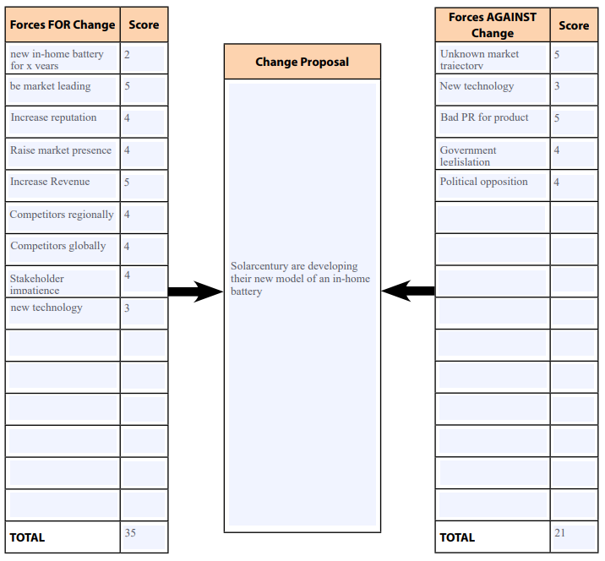Figure 1 - Force-Field analysis
The analysis completed above shows that the forces for change outweigh the forces against, using this analytical method give the company a good indication whether the proposed change is for the good or whether it wouldn’t be practical or healthy for change in the current climate.

Change management theories and strategies
Change management theories are being used to manage the process of the change, transitioning a business from their current state to a future state in which is more suitable and desirable for them. Theories can be used to motivate and empower the teams, individuals to get on board with the change, the proposed theories look at the emotional states of the individuals and the practicality of the change, whether it can be managed more efficiently by empowering the individuals and to make the transition more smoothly.

Lewin Freeze phase model
This model looks at the proposed stages for change, a straightforward approach to achieve change efficiently. Kurt Lewin was a social scientist he looks at behaviour as “a dynamic balance of forces working in opposing directions. Driving forces facilitate change because they push employees in the desired direction.”[9].
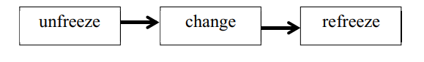 Figure 2 - Lewin freeze model [10]
This model is broken up into 3 steps (see figure 2, [10]), each of these stages plays a vital role in the change management process.
- Unfreeze is preparing the business for the change
  - Schein broadens Lewin’s idea about unfreezing by mentioning “to see that human change, whether at the individual or group level, was a profound psychological dynamic process”[11]
- Change is the transition into the new change environment
  - Schein documents that “unfreezing creates motivation to learn, but does not necessarily control or predict the direction of learning.”[11].
- Refreeze is solidifying the new environment
This model would be consistent with what Solarcentury are trying to achieve in this case study, especially convenient as the company decides to expand and grow globally e.g. opening potentially new offices.

Kubler-Ross model
Kubler-Ross model was devised throughout a period looking at emotions that terminally ill people would experience, this model has been applied to business change and the model gives a good framework of what emotions are experienced when dealing with change. This model provides a progression of these emotions at each stage of the change, “those who can accept organizational death are more likely to learn from it and have the opportunity to grow.”[12].
There are usually 5 stages of emotional response in this model:
- Denial
  - This emotion is based on the refusal of the change, it is a temporary defence of the individual[13].
- Anger
  - This emotion triggers the individual to feel uncomfortable and likely to project their feelings verbally to change.
- Bargaining
  - Negotiating/postpone the inevitable, this stage might help individuals to cope with change.
- Depression
  - Individuals may start distancing themselves or pushing others away, possible low morale due to the change
- Acceptance
  - Starting to accept the change
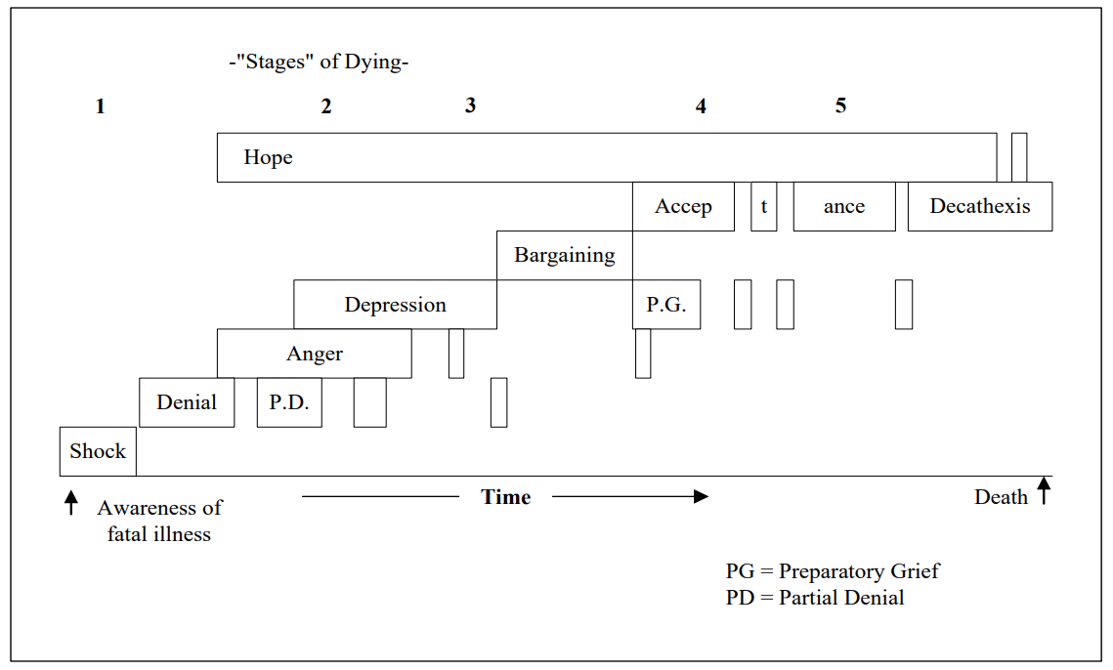 Figure 3 - Kubler-Ross model [14]

Mindfulness & change management
Mindfulness, when applied to change management is a good indicator to show how the individuals react when in the moment of change. To provide evidence that the individual is aware and not overwhelmed with everything going on around them, this can be identified by reflective practices, by doing this allows a deeper understanding of ones’ mindset when going through the change process and helps them embrace criticism by acknowledging it.
Mindfulness has been recognised “as potentially effective antidotes against common forms of psychological distress – rumination, anxiety, worry, fear, anger.”[15]. It is now considered a must-have for managerial positions to make effect decision-making and to protect us from unwanted stress, this reflects and becomes contagious to other individuals in the workplace which is a positive impact on the overall business and allows more rational decisions to be made.

Transtheoretical model
This model looks at what the individual goes through when experiencing change, the model is based on “critical assumptions about the nature of behavior change and interventions that can best facilitate such change.”[16]. The model interprets change in six stages, each of these stages provides an insight into the individual thought process through the change over a period.
- Precontemplation
  - Individuals underestimate the benefits of change, only focus on the negatives of the potential change.
- Contemplation
  - Starting to consider the benefits of the change, will develop change with behaviour.
- Preparation
  - Individuals begin to plan for the immediate future.
- Action
  - Replace many of their problematic tendencies with a more healthy approach to change.
- Maintenance
  - Become more confident with themselves during the change process, less likely to relapse.
- Termination
  - Prior problematic behaviours are no longer prevalent.
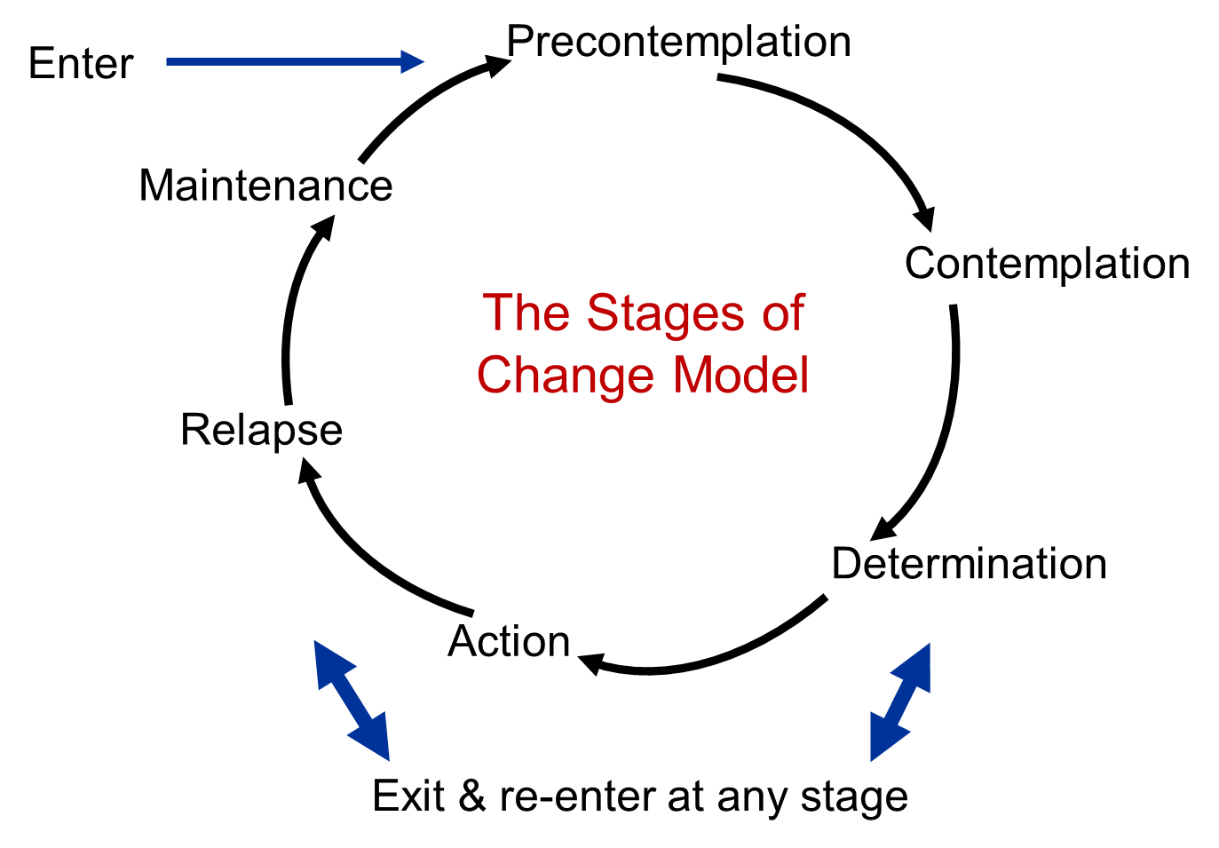 Figure 4 - Transtheoretical model of change[17]

Emotional intelligence
This model compliments emotional intelligence which looks at how the individual copes and processes emotions of themselves and others in a group. Daniel Goleman who is a renowned psychologist and science journalist have listed that emotional intelligence can be narrowed down to 5 components.
- Self-awareness
  - Self-confidence, be aware of your own emotional well-being. Daniel Goleman notes, “the importance of recognizing one’s own feelings and how they affect one’s performance”[18].
- Self-regulation
  - Expressing your emotions appropriately.
- Motivation
  - Being motivated beyond materialistic things, improve and fulfil ones’ goal.
- Empathy
  - Daniel Goleman notes, “gives people an astute awareness of others’ emotions, concerns, and needs.”[18].
- Social skills
  - “Developing Others involves sensing people’s developmental needs and bolstering their abilities”[18].
Emotional intelligence is important in change management as it allows to manage emotions during a change, knowing what to say or do in certain scenarios is key to how others react to change.

Prosci ADKAR model
This model is primarily goal-orientated which acts as a guideline for organizations to follow, how to implement the ideal conditions to adapt to new scenarios and behaviours. ADKAR model notes that “organizations don’t change, people within organizations change.”[19]. ADKAR is an acronym based on 5 elements:
- Awareness
  - Be aware of the need for change.
  - Why is it happening?
- Desire
  - Desire to participate and support the change.
- Knowledge
  - Provide knowledge to individuals so they can change for the better (e.g. provide training).
- Ability
  - Acquire the skills to implement the change.
- Reinforcement
  - Create a relaxed environment to maintain the change.
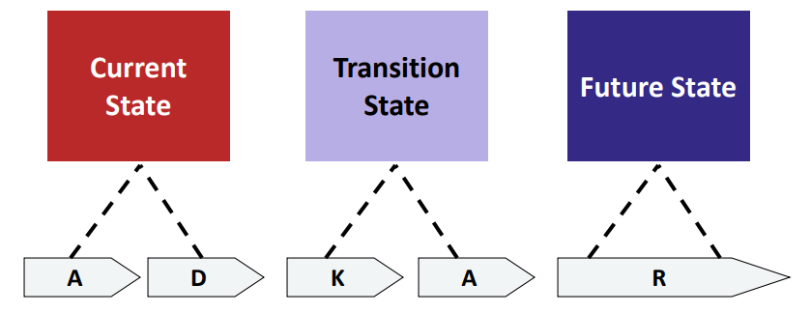 Figure 5 - ADKAR model[20]

Kotter’s 8 stage process
This strategy was implemented by John Kotter, to increase the chance of success and the ability to do so, he notes that “change process goes through a series of phases that, in total, usually require a considerable length of time.”[21], he has come up with 8 stages of change which is a guideline provided to support and increase the likelihood of a successful change.
- Create urgency for change
  - Developing urgency can motivate change.
  - Research and examine market competitors.
- Form a coalition
  - Convince teams and individuals that change is necessary, back it up with research from step 1.
  - Build a team whilst checking for weak areas within teams and individuals.
- The vision for a change
  - Give outlines and plans for how the future will look after the change.
- Communicate the vision
  - Persuade individuals that change is for the best interest and get them supporting the change initiative.
  - Address any concerns about the change, be clear and concise.
- Remove any obstacles
  - Reward achievements.
  - Planning for visible performance improvements[21].
- Create short-term goals
  - Short-term goals and win can be achieved easily which will motivate individuals which allow the change to stay on track.
- Build on the change
  - Don’t stop the motion of the change, become more relentless until the completion of change.
- Steer change to appease the corporate culture
  - Replace old habits with new behaviours and culture
  - Change cannot stop until the new culture has been fully implemented to stop any stagnation.
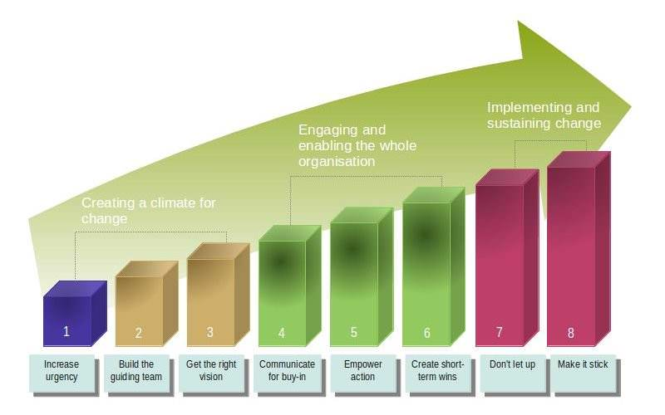 Figure 6 - Kotter’s 8 stage process [22]

Contemporary Leadership and Management styles
Leadership and management styles play a vital role within a business, how these relate to change is important as each style can determine how successful and smoothly a transition can be if implemented correctly. The words ‘leaders and managers’ dominate the workplace and are usually coupled together but they do completely different tasks. As Forbes states “Leaders create a vision, managers create goals.”[23].
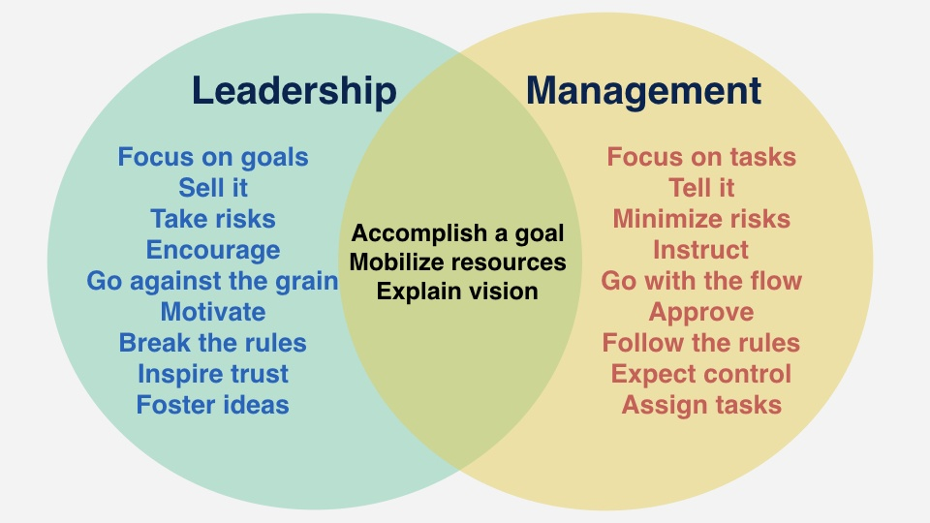 Figure 7 - Leadership and management differences [24].
Some leadership and management styles are:
- Democratic management
  - This style looks at including the employees, but the leader has the final decision, useful to take insight from other sources within a workplace to make more rational decisions.
- Participative leadership
  - Includes contribution from employees on all company decisions, the staff is kept up to date on change with input allowed from them regarding it.
These leadership and management styles complement one another, they both allow participation from employees. Emotional intelligence links well with both these styles as both these styles allow contribution from individuals and being able to respond correctly to contribution plays a major role in getting everyone on your side with regards to change.

Conclusion and Recommendations
This report has looked at various styles of how to manage change, and how to manage individuals within that change. After providing evidence concerning each of the proposed styles, models and strategies to manage change, the recommended styles for Solarcentury and their change imitative would be Kotter’s 8 stage model alongside Kubler-Ross model with a democratic leadership, each of these styles and strategies would allow a smooth transition. These recommendations would also help with the case studies provided throughout this report with a new managerial position taken and the expansion into Central Europe and Latin America. As emotional intelligence plays a major part in the change in today’s climate having a model, strategy and leadership style to represent a change would be important during the change process.

References
[1] J. W. Moran and B. K. Brightman, “Leading organizational change,” MCB UP Ltd, vol. 12, no. 2, pp. 66–74, 2001.
[2] L. Bucciarelli, “A Review of Innovation and Change Management: Stage Model and Power Influences,” Univers. J. Manag., vol. 3, no. 1, pp. 36–42, 2015.
[3] W. I. Zangwill and P. B. Kantor, “Toward a Theory of Continuous Improvement and the Learning Curve,” Manage. Sci., vol. 44, no. 7, pp. 910–920, 1998.
[4] J. B. Arbaugh, Beyond Change Management: Advanced Strategies for Today’s Transformational Leaders (Book)., vol. 1, no. 2. 2002.
[5] D. Ward and E. Rivani, “An Overview of Strategy Development Models and the Ward-Rivani Model,” Econ. Work. Pap., 2005.
[6] Solarcentury, “Solarcentury appoints Debbie Hayes as HR Director,” October 23, 2018. [Online]. Available: https://www.solarcentury.com/solarcentury-appoints-debbie-hayes-hr-director/.
[7] L. Stoker, “Solarcentury buoyed by international growth as UK revenues tumble,” 26 February, 2018. [Online]. Available: https://www.solarpowerportal.co.uk/news/solarcentury_buoyed_by_international_growth_as_uk_revenues_tumble.
[8] S. Kumar, “Force field analysis : applications in PRA,” IIED London, no. 36, pp. 17–23, 1999.
[9] A. Kritsonis, “Comparison of Change Theories,” vol. 8, no. 1, pp. 1–7, 2005.
[10] S. Cummings, T. Bridgman, and K. G. Brown, “Unfreezing change as three steps: Rethinking Kurt Lewin’s legacy for change management,” Hum. relations, vol. 69, no. 1, pp. 33–60, 2016.
[11] S. H. Edgar, “Kurt Lewin’s Change Theory in the Field and in the Classroom: Notes Toward a Model of Managed Learning,” no. July, p. 259, 1995.
[12] E. Bell and S. Taylor, “Beyond letting go and moving on: New perspectives on organizational death, loss and grief,” Scand. J. Manag., vol. 27, no. 1, pp. 1–10, 2011.
[13] Elisabeth Kubler-Ross, On Death and Dying. The Macmillan Company, 1969.
[14] J. R. Sánchez, “REVISITING ELISABETH KUBLER-ROSS: PASTORAL AND CLINICAL IMPLICATIONS OF THE DEATH AND DYING STAGE MODEL IN THE CARING PROCESS Genesis of Kübler-Ross Stage Model Theory,” Am. J. Psychiatry, vol. 101, no. 1, pp. 5–10, 2007.
[15] S. L. Keng, M. J. Smoski, and C. J. Robins, “Effects of mindfulness on psychological health: A review of empirical studies,” Clin. Psychol. Rev., vol. 31, no. 6, pp. 1041–1056, 2011.
[16] J. O. Prochaska and W. F. Velicer, “The transtheoretical model of health behavior change,” Am. J. Heal. Promot., vol. 12, no. 1, pp. 38–48, 1997.
[17] W. W. LaMorte, “The Transtheoretical Model (Stages of Change),” Boston University School of Public Health, 2018. [Online]. Available: http://sphweb.bumc.bu.edu/otlt/MPH-Modules/SB/BehavioralChangeTheories/BehavioralChangeTheories6.html.
[18] Cary Cherniss & Daniel Goleman, “An EI-Based Theory of Performance,” Emot. Intell. Work., pp. 27–44, 2001.
[19] B. J. M. Hiatt, “The Essence of ADKAR : a model for individual change management,” p. 2006, 2006.
[20] C. Baywork and C. M. Practitioner, “The Prosci ADKAR Model.”
[21] J. P. Kotter, “Leading Change Why Transformation Efforts Fail Leaders who successfully transform businesses do eight things right (and they do them in the right order),” Hbr, 2007.
[22] V. Webster and M. Webster, “Successful Change Management — Kotter’s 8-Step Change Model,” Leadership Thoughts, 2018. [Online]. Available: https://www.leadershipthoughts.com/kotters-8-step-change-model/#kotters8stepchangemodelforleadingchange.
[23] W. Arruda, “9 Differences Between Being A Leader And A Manager,” Forbes, 2016. [Online]. Available: https://www.forbes.com/sites/williamarruda/2016/11/15/9-differences-between-being-a-leader-and-a-manager/#925199646096.
[24] L. Ho, “Leadership vs Management: Is One Better Than the Other?,” Lifehack, 2018. [Online]. Available: https://www.lifehack.org/674254/leadership-vs-management-is-one-better-than-the-other.

Bibliography
https://www.solarcentury.com/
https://www.businessballs.com/change-management/kotters-change-model/
https://www.solarcentury.com/homes-uk/wp-content/uploads/2018/01/20180104-Solarcentury-Products-Sunstation-UK-datasheet-J26-295_300Wp-17870-01-2-1.pdf
https://www.apm.org.uk/body-of-knowledge/delivery/scope-management/change-management/
https://www.england.nhs.uk/improvement-hub/wp-content/uploads/sites/44/2017/11/Overview-Change-management.pdf
https://www.tutor2u.net/business/reference/models-of-change-management-lewins-force-field-model
https://files.eric.ed.gov/fulltext/ED011996.pdf
https://www.change-management-coach.com/kubler-ross.html
https://www.exeter.ac.uk/media/universityofexeter/humanresources/documents/learningdevelopment/the_change_curve.pdf
https://www.atl.org.uk/Images/Emotional%20intelligence.pdf
http://ei.yale.edu/wp-content/uploads/2013/09/pub184_Brackett_Rivers_Salovey_2011_Compass-1.pdf
https://smallbusiness.chron.com/advantages-participative-leadership-17629.html

Appendix
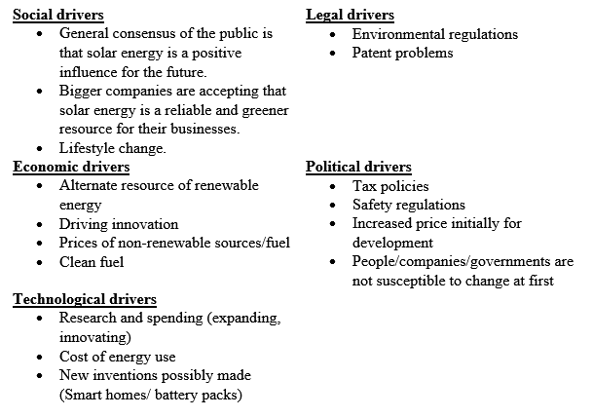Figure 8 – Solarcentury SLEPT Analysis

