Community Engagement
(LCBB4002)

University name
University of Wales Trinity Saint David

Lecturer's name
Dr Molly Jack

Student name
Stanislav Momchev Danailov
Student ID
2112418

Table of Contents
Introduction 1
London Borough of Bexley 2
Case study I 5
Case Study II 5
Case Study III 5
Key Holders and their contribution 6
The Social Media Presence of Bexley 9
Events that bring communities together 9
Core community issues in Bexley 10
Conclusion 11
Recommendations 11
References 12

Introduction

According to Graham (2006) the notion ‘Community’ illustrates togetherness that is distinguished from the forms of isolation and individualism. The author underlines the arguments of Durkheim, who makes linkages between the evolvement of human solidarity and morality, that are estimated by patterns of inhabitants, migrants, and geographical mobility (Graham,2006). Therefore, community has an alternating nature and is influenced by great number of tangible and formal factors.
Nonetheless, community is often identified as one whole machine that is assembled by groups of people that are widely differing from skills to abilities, interests, and status. London Councils (2008) describes the term community as one that is consists of other smaller communities which are divided by ethnicity, gender, age, disability, place of residence, beliefs, culture, hence each community has diverse wants and needs that ought to be balanced and maintained.
Moreover, where social connections are poor there will probably be high levels of ignorance, lack of awareness and togetherness, inappropriate behaviours, gang cultures, tension, conflicts, and violence, along with vandalism and poor educational status (London Borough of Bexley, 2019). Communities with good social links tend to be happier, healthier, and are becoming even economically consistent.
Community engagement itself does not have precise description or concept, therefore it might be understood in several ways. For instance, London Councils (2008) utilised one definition that employs Wilcox’s model (1994) known as ‘ladder of participation’. (Fig.1)

London Borough of Bexley

The chosen local Authority is London Borough of Bexley in which the participant has been living since 2020. If fact, Borough of Bexley is known as safe and appealing borough with a family friendly, suburban character, that plays an important role in London’s economy and has six geographic regions (London Borough of Bexley, 2012) (Map.1).
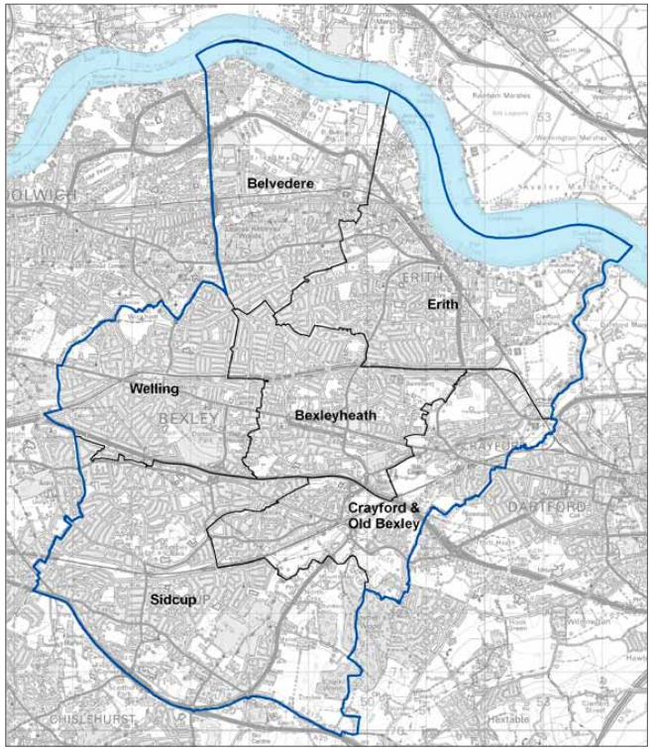
Map.1 The six regions – Borough of Bexley

Source: London Borough of Bexley, 2012
Bexleyheath is the strategic centre and provides a key contribution to the borough’s employment and services because it has that ‘village’ feeling with some modernised leisure places and shops.
Bexley thoroughly publishes statements regarding Community Involvement that ‘have the potential to have a positive impact on all protected characteristic groups’(Borough of Bexley, 2019). Moreover, the borough ought to arrange how the Council will protect local communities, businesses, and stakeholders, and ensures that each one of the parties can have higher involvement when planning and live in maintained houses and streets(Fig.2).

Figure.2 Bexley: part, present and future

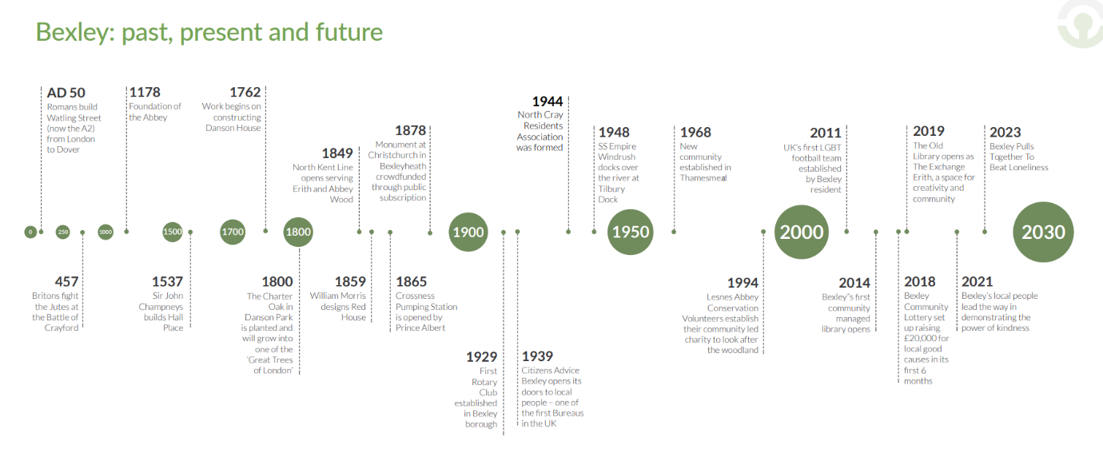Source: London, Borough of Bexley, 2019-2023

As mentioned already, Borough of Bexley is obliged to publish information, planning, strategies, and programmes with the aim to maintain and provide best practises for its local communities. Therefore, some of the statements and programs are included below for further clarification.

Case study I

Bexley Council has introduced its core strategy that lays out one strong and vast programme that has to be achieved until 2026, ensuring that fundings and development decisions are interconnected and appropriate. Indeed, the Council aims to achieve ‘strong, sustainable and cohesive community’ with four top priorities such as building stronger communities, development and promotion of environment and the economy and services for all age groups.

Case Study II

Connected Communities is a ‘Growth program’ that sets out strategy which involves plans for investments, supporting and developing the local communities (London Borough of Bexley, 2019). As the population in Bexley constantly changes, its Council is determined to know local communities and therefore proactive approach is utilised through forum that can find answers on many social and economic questions and issues (Borough of Bexley, 2019). The forum itself intends to obtain volunteers that will represent Black, Asian, Minority Ethic Bexley communities, along with African Caribbean Association. All these associations can exchange practices and expand in relationships for robust sector and achieved long-term goals.

Case Study III

Borough of Bexley has also published an Adult Statement which underlines the social care and well-being principles (Bexley,2021a). Furthermore, this statement provides information how the Council will work along with the service members, their caregivers, partners, providers and lastly – the vast social community care that helps the whole population to stay ‘healthy and independent’ (Bexley, 2021a). As discussed above, Bexley Council utilised the Wilcon’s model of participation, whereby the first step is information, second one – consultation, then acting together and lastly supporting individuals.

Therefore, it is not surprising that the Statement is consist of information about the adult social care, tips on how to live healthy, or raise a safeguarding concern. The Borough assures that information will be accurate and free of charge, including advice, care, and support. Moreover, it is discussed how ‘together’ everything can be done to prevent issues from happening, attempt to stop things from deteriorating.
Nonetheless, Council also may consider supporting an individual financially who needs personal carer but cannot pay for it. The documentation also covers the independence and well-being of the community as well as safety and dignity, which highly advises to respect everyone’s privacy, support the ‘right to live free from abuse or neglect’. As a matter of fact, Bexley offers help to those who feel abused or neglected and will work closely with their users to prevent it from occurring again(Bexley, 2021a).

Key Holders and their contribution

Certainly, there are many parties involved in the development of Bexley Council due to its broad strategies, diverse communities, transportation, and utilities. Hence, Bexley Council ought to outline an Infrastructure Delivery plan that explains all current goods, services, accommodations, buildings, transport links, along with future programs, and key holders who contributed towards the development of Bexley Council.
The transportation infrastructure involves rail network, bus and local public transport, roads, streets and liveable neighbourhoods, river crossings, walking and cycling routes, electric vehicle charging (Bexley, 2021b). Some of the major stakeholders are TfL, Southeastern, Royal Borough of Greenwich, Peabody, Greater London Authority, Highways England, Living Streets, Metropolitan Police Authority, and Transport Focus Group, Campaign to Protect Rural England (Bexley, 2021b). Moreover, the developing partnership between Bexley council and Transport for London is notable. From one side the Council started a program that improves the roads in and out of Erith, from other side TfL launched a scheme program known as ‘Lively Neighbourhood’ that aims to reduce bus delays, improve physical links for walking and cycling, and partnering together, they were able to obtain £11,000 by bidding (Fig.3)(Bexley, 2021b).

Figure. 3 Part of the transportation infrastructure project
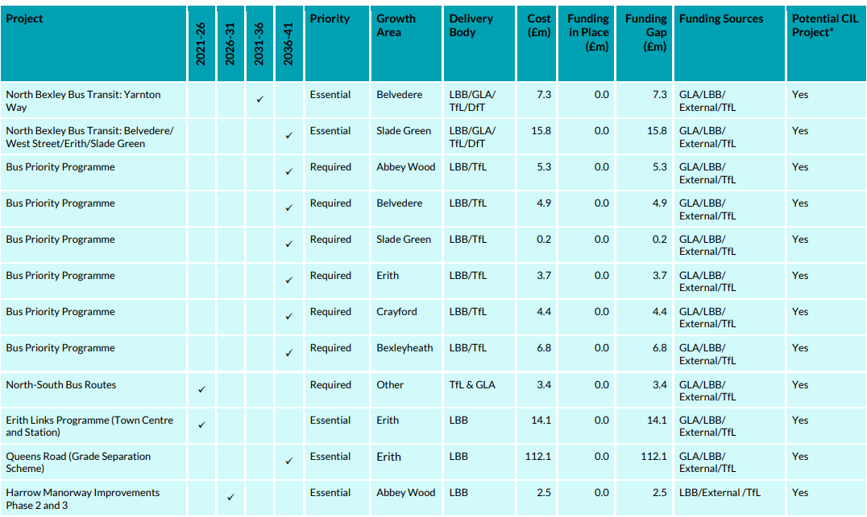
Source: Bexley, 2021b

Diverse communities require stable health centres, education for children and adults, emergency services (ambulance, fire stations, police), open spaces, libraries, play areas, leisure, cemeteries which are all include in the Infrastructure Delivery plan for 2020 as Social and Community Infrastructure (Bexley, 2021b). Some of the stakeholders are NHS England, Bexley Public Health, Metropolitan Police Service, London Ambulance Service, London Fire and Rescue Service, Bexley Natural Environment Forum, The Department for Digital, Culture, Media, and Sport. Moreover, Bexley suggestion to open a new SEN Free School was approved by the Secretary of State for Education in March 2019 and will provide pupils of secondary age their special educational needs (Fig.4)(Bexley, 2021b).

Figure4. Forecast of secondary schools needed by 2028.
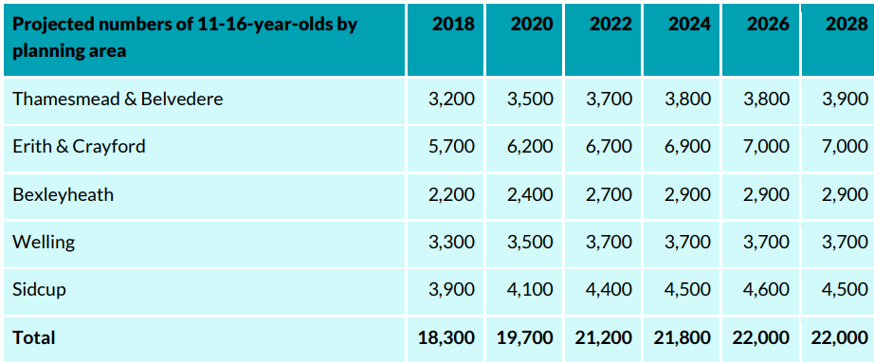
Source: Bexley, 2021b

Furthermore, Utilities also play significant role in the stakeholder relationships with the borough, such as water supply and sewerage, flood risk, waste and recycling, electricity, gas, district heat networks, digital infrastructure (Bexley, 2021b). The key parties here are Thames Water, Environment Agency, London Wildlife Trust, Southern Regional Flood and Coastal Committee, Southeast London Joint Waste Planning Group, UK Power Networks, National Grid Gas, Cory Riverside Energy, Central Government, Internet Service Providers (Bexley,2021b) In fact, Cory Riverside Energy has applied for building a waste energy recovery centre which will produce electricity to serve a district heat network locally (Bexley,2021b).

The Social Media Presence of Bexley

London Borough of Bexley has an online presence, and it can be found on the government’s official website. Furthermore, it provides information regarding the services for residents, along with section ‘Discover Bexley’ and further details about the Council (London Borough of Bexley, 2022). Bexley has also created a social media profile in many online platforms, such as Facebook, Twitter, YouTube, and Instagram. In all of them, the Council shares posts and keep its followers updated for all events, social workshops, and meetings. According to Bexley, (2021c) social media is a vital tool in engaging with local communities, and stakeholders, that share content and interact with others.
Hence, the social media platforms help with reaching more people and meeting them. Some may want to become volunteers, others can decide to donate fundings to their local charities, and thirds may simply request a park for their own event, guided and implemented with the help of the Council.

Events that bring communities together

In accordance with Gilchrist (2009) who stated that arts activities often support people from different backgrounds to relate to each other and share their stories.
Nonetheless, some of the events are set to celebrate important figure in United Kingdom, such as the Queens’s Platinum Jubilee at Lesnes Abbey that invite whole families to have picnic together. The event will offer street food and will manifest the culture and diversity of the Kingdom. There also will be some locally produced items, singers, circus performers and magicians that will contribute towards local businesses (London Borough of Bexley, 2022).
Further interesting eco community event is called Bexley Eco Festival for 2022 that is also family-friendly and is suitable for all age groups. This event promotes clubs, organisations, and individuals, and bring awareness around education and teaching. Moreover, encourages the wellbeing of the local community, environment and the efforts that are made to sustain all that (London Borough of Bexley,2022).
One unforgettable parade took place in 2018 through the centre of Bexleyheath. The parade included all local community groups who lived within the borough, dressed in traditional clothes and uniforms. Moreover, the event had been filled with music and singing throughout the day to celebrate the unity and diversity of the community of Bexley (BAME ANGLICAN,2018).

Core community issues in Bexley

Bexley Council (2022) announced that violence against the person has increased with 31 cases per month between 2016 and 2018 (Map.2). Other concern within the Borough is domestic abuse with an increase of 6.1% for the same period. The average number of sexual offences for one year have increased with 11%. Surprisingly, the hate crime incidents, drug offences and anti-social behaviour have notably fallen. However, residential burglaries have risen with the significant 70.7% .
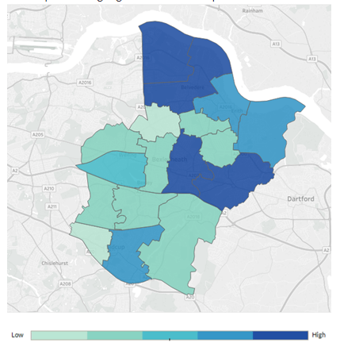
Map.2 Violence against the person in Bexley

Source: Bexley Council, 2022

Conclusion

As an end it ought to be mentioned that Community Engagement creates networks that coordinates various points of views and interests into one project for better future of the borough. At times it might be challenging, especially in areas of population contrast, whereby strong community development must be adopted. Nevertheless, to achieve that, it is suggested to organise more informal gatherings between communities to enhance people talking directly, which in turn helps with paradoxes, issues, and community resistance. Undoubtedly, as adopted by Gilchrist (2009) there are key elements of community engagement such as networks, interactions and entertainment, common purpose, community identity and organisational infrastructure that only bring an equal partnership.

Recommendations

Program that is supporting local communities who suffered from burglary will be launched as an event. The aim of the event is to raise awareness regarding the issue and will provide useful information on how to handle such an incident, as well as how to protect and insure belongings of the homeowners. Informal meetings and discussions with local authorities, advice and tips from insurance companies are also planned. The main idea of the event is to raise funding and help those in need. Local producers and food makers can participate in the event with symbolic financial involvement earned through the event, as well as signers and dancers who will contribute towards Bexley’s economy.

References

Aylett, A. (2010). Participatory Planning, Justice, and Climate Change in Durban, South Africa. Environment and Planning A. 42. 99-115. 10.1068/a4274.
BAME ANGLICAN,2018, Windrush festival in Bexley, Available at: https://bameanglican.wordpress.com/2018/06/23/windrush-festival-in-bexley/
Bexley, 2021a, Adult Social Care Vision Statement, Available at: https://www.bexley.gov.uk/sites/default/files/2021-10/Adult-Social-Care-Vision-Statement-Guiding-Principles.pdf
Bexley, 2012, Bexley Core Strategy, Available at: https://www.bexley.gov.uk/sites/default/files/2020-05/Bexley-Core-Strategy.pdf
Bexley, 2019 – 2023, Connected Communities, Available at: https://www.bexley.gov.uk/sites/default/files/2021-10/connected-communities-strategy-2019-to-2023.pdf
Bexley Council, 2022, Key Issues and priorities for Bexley, Available at: https://bexleyjsna.co.uk/wider-determinants/crime-bexley-key-issues/
Bexley, 2021b, Infrastructure Delivery Plan 2020, Available at: https://www.bexley.gov.uk/sites/default/files/2021-05/Infrastructure-delivery-plan-january-2021.pdf
Bexley, 2021c, Members’ Code of Conduct, Available at: https://www.bexley.gov.uk/sites/default/files/2021-04/Members-code-of-conduct.pdf
Day, G 2006, Community and Everyday Life, Taylor & Francis Group, London. Available from: ProQuest Ebook Central. [2 May 2022].
Gilchrist, A., (2009), The well-connected community [electronic resource] : a networking approach to community development, 2nd ed., Bristol University Press, Policy Press, Available at: https://doi.org/10.2307/j.ctt9qgrjc
London Borough of Bexley, 2022, What's on in and around Bexley, Available at: https://www.bexley.gov.uk/events/bexley-eco-festival-2022
London Councils, (2008)’ Community Engagement - What is it and why is it important? ‘ Available at: https://www.londoncouncils.gov.uk/node/5871

