Name of trainee: XXXXXX |  |  | Session Ref:
Personal target(s) in relation to QTS:

Year Group: | Number of learners: |  | ALN: | Additional adults:
Learning objective(s): |  |  | Success criteria:
Links to Previous Learning:

Curriculum coverage (range, skills)

Literacy: |  |  | Numeracy:
ICT: | Thinking: |  | ESDGC:  . | YCC:
Time | Session activities, organisation and management |  |  | Key questions & assessment for learning opportunities:
 | Introduction:
 | Main activities:
 | Plenary:
Key Vocab |  | Resources


Appendix 1

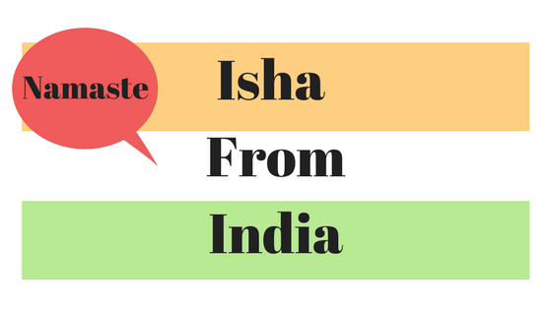

Example of cards each child will be given for the task 1 (Include a themed name, name and flag of the country and how to say hello in their native language).
Appendix 2
Using PowerPoint, this will be where the children will get all the information for their graphs.
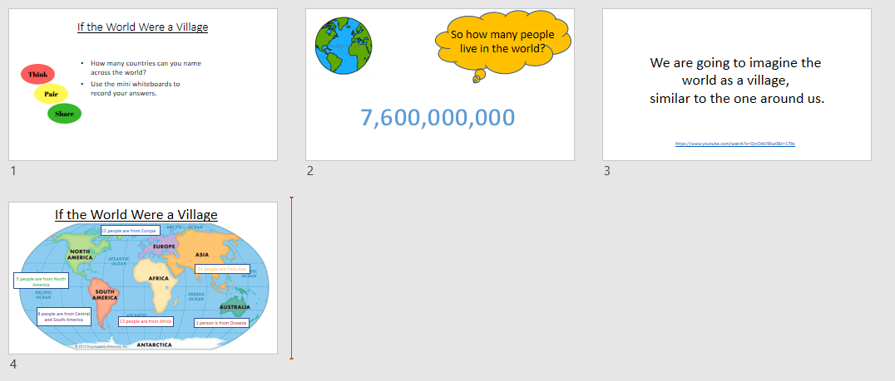
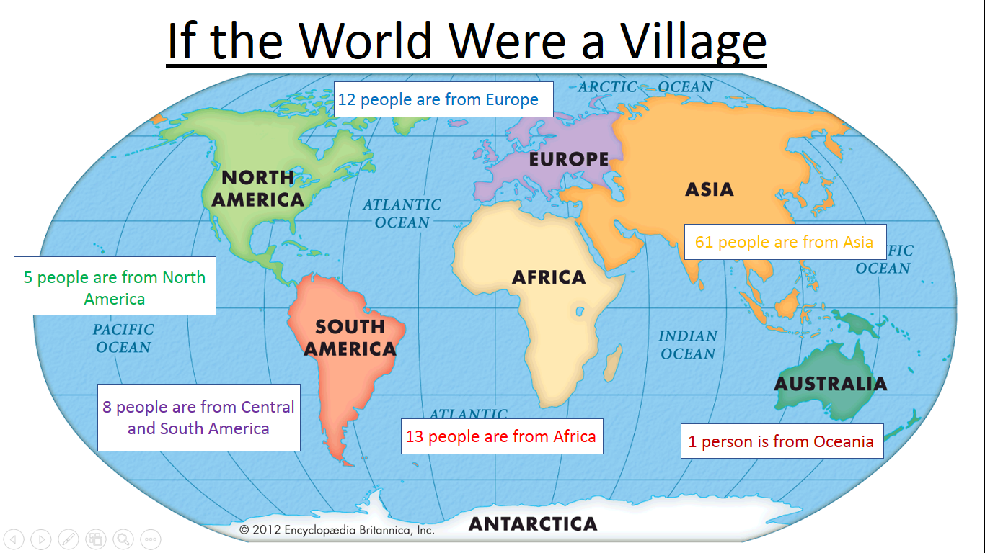
Using this slide to help complete their worksheets.

Appendix 3
For higher ability they would have to label the axis themselves, they would then complete the extension task.
Middle ability would complete the worksheet, before moving on to the extension task.
Lower ability would not have questions Q6, Q7 and Q10, they would also be placed on a table of a similar ability with a teaching assistant for extra guidance.

