STUDENT NAME : SAMUEL YOUSEF SALI
STUDENT ID : 1710464
MODULE ID : BMSW 5004
ASSESSMENT : MANAGING PROJECTS IN THE ORGANISATION
LECTURER : DR. GULNER ALI

EXECUTIVE SUMMARY
Travelling is becoming more popular today. With every coming year, people are becoming more aware of the beautiful and amazing sceneries and sites through social media thus increasing the demand for traveling around the world. In this report the company in frame of reference is Verdant Leisure and the discussion done is critical analysis of a prospective project of the company, “Dream Destinations”. All the important and impacting factors have been discussed in extensive detail. The core concept of the project is to provide tailored tours to potential customers. Due to increasing demand for tours, the Verdant Leisure has decided to launch this Dream Destinations project to ease the process of going on a tour for its customers. Various options and choices have been defined such as the budget-friendly option and the luxurious option. The goal is to provide the best service possible to the consumer of the service.

Table of Content:

Introduction………………………………………………………………………………..……1
Project Management Approaches………………………………………………………………3

Project Management Tools and Techniques…………..………………………………………4
Organizational Structure………………………………………………………………………10
SWOT Analysis………………………………………..……………………………………….11
Project Character………………………………………………………………………………12
Reflection……………………………………………………..…….……………………...……15
Personal Development Planning……………………………………….………………………16
Conclusion 17
References……………..……………………………...…………………………………………18

Introduction
Project management provides a complete and comprehensive scheme that observes the organization’s objectives. It also figures and changes the organization's and client’s aims and purposes. Various tools and techniques are used to assure concrete establishing and administration and their allied distinct errands. I have selected to manage a self-designed vacation trip for customers where they plan their own trips and their own locations, their own lodges and everything they want for their perfect vacation and l called it Dream Destination under the organization called Verdant Leisure. It seemed easy to deliver what people desire but it requires a lot of effort, management skills, effective team, and time management. Starting from offering a self-designed trip to its final execution, there is a lot to take care of and this project delivers the management efforts and skills required to make such trips happen for the customers.
Before starting any project, there is a typical structure that we follow to ensure the proper accomplishment of the project. First we plan how the project is going to initiate and we forecast the outcomes of our decisions. Second, we design the structure of or project and how we are going to construct then we monitor our activities and regulate them and finally the completion and finishing of our project. For the desired results and conclusion several decisions, tools, techniques, and approaches are taken into account. By travelling, you can experience things that you could never practice at home. You could see attractive places and sceneries that do not exist where you are living. You might meet people that will alter your life, and you’re intellectual. You may try activities that you have never tried before. Many travelling companies are operating in the UK but many few are in this business for a long time. This 45 years old male traveler Graham Hodgson,
1
who has himself travelled to more 38 countries all by himself and is now offering help and guidance to others to help explore them the opportunities and adventures they might couldn’t practice with their own experiences. But with his help and assistance and the amazing deals he offers, people are travelling around the world more efficiently and more economically. He owns his own travel company and tracks three parks in Scotland and Riverside Leisure Park in Wooler and now is planning to offer her customers’ new and exciting self- designed trips with the best possible services.
Verdant Leisure was established in September 2010 and in February 2018 has announced the attainment of its eighth leisure park. This is Verdant Leisure’s fourth purchase in the last 18 months (Verdant leisure, 2019). Verdant is a family holiday park in Scotland and Northern England. They offer self-catering lodge, caravan and holiday home. Families are given time to relax and let the daily stresses life fall away. Families are give space to try out new activities and spend quality time together in Verdant Leisure with great entertainments, food and drinks. Verdant Leisure with such achievement comes great responsibility for maintaining their reputation in the market to the providence of best-rated services to the customers. To start with this project, the “Dream Destinations”, the first thing is to market the idea to the right platforms from where they could get the appropriate public eye and after that develop a website from where all the further operations will be carried out and customers can design their own trips, enter their dream location, days of trip, their affordability and every little detail about what they want for the trip and after that the team will draft a customized trip for them revealing every little feature to the managing team and the team will consult with the suppliers. Within 15 working days a personalized trip will be ready for the customers and an email will be sent to the customer
2
bringing up all the trip details, available dates, available restaurants, and available lodges and with everything. With the suitable efforts and steps the Verdant Leisure will deliver in which they are specialists. For these steps to be carried out smoothly and perfectly, four different teams are required: Marketing team, Web development, and web maintaining team, Management team, risk management team and a project manager.

Project Management Approaches
Many management approaches were observed depending upon the availability of the data.
  - PRINCE2 is a procedure-based approach that helps in controlling the project from start to finish. It helps in the thorough planning of the plan before the outset and structures each stage of the scheme tying up every loose end once the project settles leaving a learning experience for other projects (Khoja at al., 2010). It helps the organization to understand the problems, results, prospects much better making it appropriate to use in our project.
  - Agile is one of the more identifiable project management methodologies. Extracted from the morals and ethics of Agile Manifesto, it is best for iterative and phased projects and projects that comprise of teams in need of a flexible approach is conversant terrain to “agile” approaches to schemes (Fernandez, 2008).Our project consists of different teams managing different areas of the project therefore the Scrum approach is suitable for the project.
  - Scrum comprises of pledge, daring, focus, honesty, and respect. Scrum develops, carries and sustains compound products through teamwork, responsibility, and iterative growth. Distribution of responsibility and its operation differs Scrum
3
from Agile project management (Azanha Et al., 2017)
- The waterfall is one of the most traditional projects management approach. It is linear chronological method devising in the industrial and production industries emphasizing the importance of documentation in an organization thus making it
untimely to use in our project.

Project Management Body of Knowledge (PMBoK) Initiated by Project management Institute (PMI), it is an approach that certifies a controlled appliance of providing a project destined with time, latitude, budget and quality (Khoja at al., 2010). Its application with time management and quality assurance makes it perfect for our project.

Critical Path Method (CPM) It categorizes all the events required to complete the project inside a work cessation arrangement and then it maps the work duration to each action (Carruthers, 1966).This approach helps in the projects whose activities are interdepended thus making it seamless to use in our project. Since all the tasks and activities in this project have to be done simultaneously therefore this methodology is fitting for this project.
- Lean project management it encourages the maximization of the customer value while minimizing the waste in production, lessens surplus work and better manages employees (Pinch, 2005). It is not fitting for our project since there is no production or waste involved.

Project Management Tools and Techniques
While mapping the outline for this project, it is important to evaluate the risks and other related factors that can have an effect on the project. In order to ensure that everything is
4
accomplished as per the requirement and within the time constraint that has been allotted to specific deliverables, a detailed analysis is the core requirement. Almost all the planning activities have great dependency upon deliverables, in order for the plan to run efficiently and without any flaws and delays, everything that pertains to the deliverables needs to be catered
such as defining the right timestamps for ordering and collection, developing the right and mutual chancel of communication with the sponsors and other important stakeholders (Roberts, 2011).The tools and techniques that have been chosen for this project and the relevant reasons why have they been selected are given below:
A Gantt chart is a horizontal bar chart that was made as a tool for production control in 1917 by Henry L. Gantt, a social scientist, and an American Engineer. Widely employed in project management, a Gantt gives a graphical illustration of a schedule that aids in planning, scheduling, coordination, and tracking of various tasks in a project. This will help in calculations for the Estimated Time Required Time for completion and also the Actual Time that will be consumed in the completion of the Project.
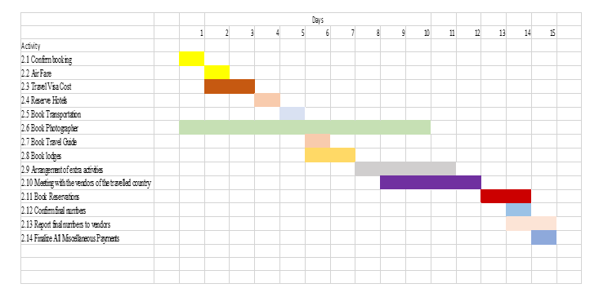
Figure 1: Gantt Chart
Source: Author (2019)
5
A Risk Map is a map that represents the risks in biases of impact and likelihood. In a Risk Map, to classify the probability of risk as low, medium and high is a key requirement, with
alike classification if the risk is materialized (PMI, 2019).An important risk is classified under the classification of high probability and high impact. In other to undertake the very low and very high, the classifications can be extended.
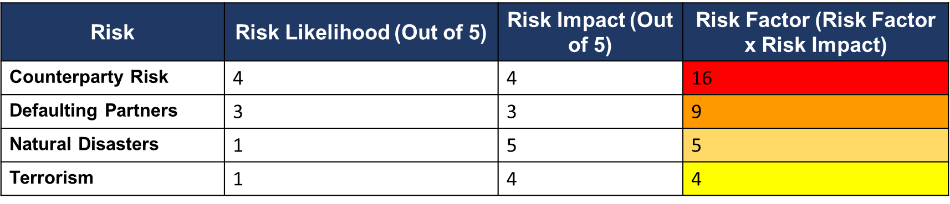
In order to plot a risk Map, it is important that all the risk factors are identified; the risk factors that can have a potential impact on the project are as follows:
- Counterparty Risk; possibility that the customers who book a program, in the end, cancel it, in order to counter such risk, a small premium would be taken in from the customers as caution money, which would be a part of the overall expenses that they would pay for the trip. If they cancel the trip at a point where it could impact the organization, in such case the money would not get refunded.
- Risk of defaulting partners; in this type of risk, the partners where booking have been done, such as hotel partners, transport partners in specific locations may go against the agreements, it would raise a concern for the organization, as arranging such a partner in a short time would be expensive and difficult.
- Risk of Disasters and Terrorism; Some destinations might have the risk of natural disasters, such as Japan, where the probability of floods in certain cities might be
6
higher and also some countries would have a higher risk of terrorist activities, such as if a client was to opt for destinations such as Afghanistan, the risk of experiencing terrorist activities would increase.

Stakeholder Map is important to understand who your stakeholders are. The stakeholder Map serves the basic function of identifying all the stakeholders that can have a direct or an indirect impact upon your project. It differentiates between the internal and external stakeholders involved in the project (Allen and Kilvington, 2009)

Stakeholder Map
External Stakeholders
Internal Stakeholders
The Stakeholder Map has defined the internal and external influencers of the project, in this case, following are the stakeholders of the project. The sponsors of the project will be the tour participants; because all the financing would be done by those who want the custom tour to be designed for them. The other major stakeholder which have been classified as internal
7
Stakeholders are the Tour Guide and Tour Operator, this is the organization that has been taken who would be performing the tasks of arranging all the required bookings and other stuff related to the tour. The third factor which is the tour guide. It is an important factor since he would be the on-field representative for the company and would ensure that everything is executed as per the requirements which would be set at the time of the contract and also that nothing gets delayed and the set schedule is followed and the contingency plan in case something unexpected was to happen. The external shareholders are all those who can in some way affect the project, most of the stakeholders being those who would impact when the tour is in action and also those who are tourism location-based factors have also been included in the above stakeholder map.

Stakeholder Power Interest Matrix
According to Allen et al. (2009) the Stakeholder Power Interest Matrix, also referred to as the Power/Interest Matrix is a tool that tells you the power and interest of the stakeholders in
regard to their interest in the project. It helps in keeping the focus on the crucial stakeholders who can make or break the project. In lieu of that, one can prioritize the stakeholders in line with the project

Stakeholder Power Interest Matrix
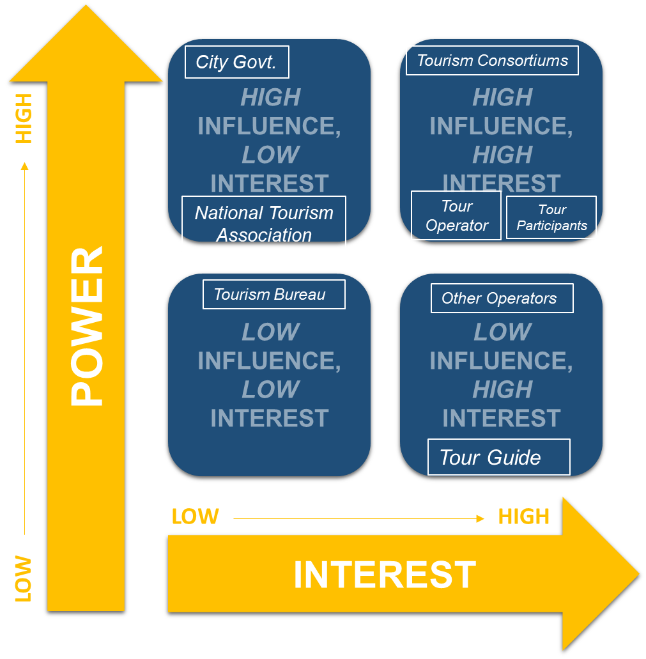
8
In the case of this matrix, there are four major sectors, the classifications for the important stakeholders have been shown in the above figure. It is important to keep the Tour Participants happy and also to make sure they are managed since they are the main source of funding for the tour and the custom tours that they would be availing would be more expensive than the normal group tours that are offered by the company. The second major stakeholder is the tour guide, basically he would also be acting as the supervisor of the tour and would be accompanying the tour participants, would be assisting them throughout the tour. Since the company would be paying him a huge chunk of money, it is crucial that he is monitored properly and is informed likely as well.
A decision tree is a powerful tool that analyses different decisions available. In a decision tree, an extremely efficient structure is setup which incorporates the different possible outcomes which are analyzed critically. Another function of the Decision tree is it helps in the identification of Risks and Rewards associated with each and every possibility. A decision tree is most helpful when one has limited resources and many options are available. It helps in making the best decision possible (Rokach and Maimon, 2005). Decision Tree:
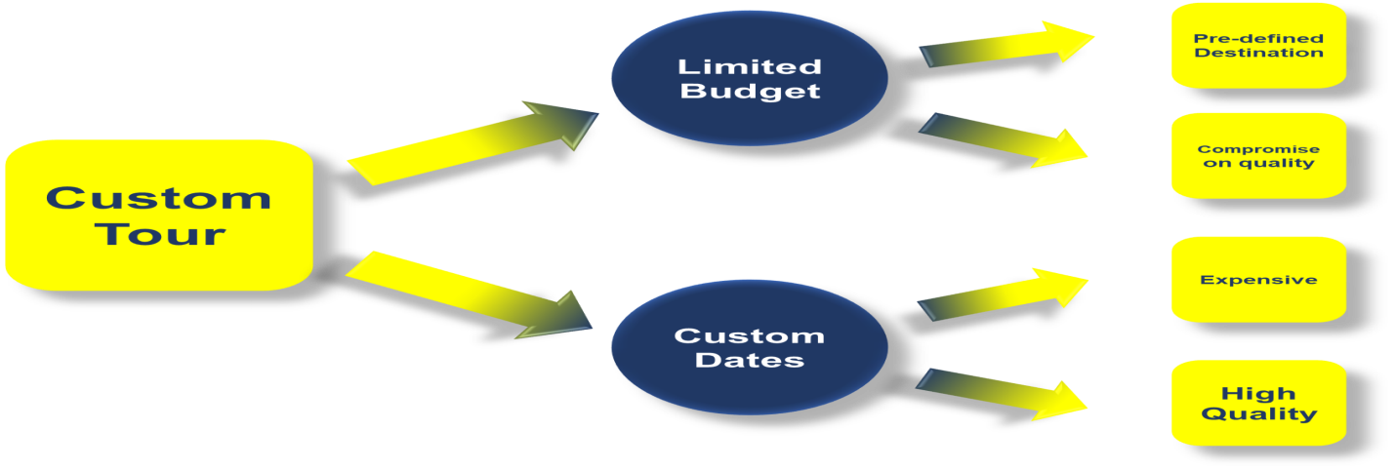
9
The above decision tree for the project can be dissected into two possibilities;
First is when the customer has a limited budget, while the second possibility is when the customer requires the tour to be held at his custom dates.
In the first case, the customer would be required to put a little compromise on quality, such as using three stars or lower hotels for accommodation, using public transport for travelling to cut costs instead of personalized transport, etc whereas if the customer opts for the executive or the custom dates option, he would have the get executive class service, everything would go up a notch and the net service would be better than the economical option, because here the budget won’t be a constraint.

Organizational Structure
Dream destinations will appoint and adopt a functional organizational approach where every individual will perform their chief task in the area of their proficiency. An open transmission among all employees must be ensured at all levels in order to capture organizational structure. With a supportive and communicative team, we believe that it will be easy to make dream destinations a success. More utilization will be structured as the company and project grow, with new staff being dispersed an administrator or subsidiary. When the corporation will be at its full workforce latent, it will function as any diligently held exploiting, but sustain the personal concern in each employee's private and domestic prosperity and their assistance to the corporate. We recognize the datum that effective enlisting, incentive, and restraint procedures are bases to the development of the exploitation. Therefore we expect to endorse and preserve good effort relations, stout optimism and high worth work per worker.

10

SWOT Analysis
SWOT translates to Strengths, Weakness and Opportunities and Threats. A SWOT analysis identifies these factors and gives an in-depth analysis from the perspective of the project. The implementation of SWOT Analysis is uncomplicated and clear and is easily understood by those going through it. The internal analysis of the business and the external factors of the environment contribute to the build-up of SWOT Analysis. The most widely used and feasible application of SWOT is gaining insight into other competitors present in the industry and also the current market position (Sammut‐Bonnici and Galea, 2015).
Strengths: The potential strengths for the company can be as follows, Niche destination knowledge, excellent relationship with a supplier, strong consortia membership, strong reputation in the market, well regarded in community civic organizations, contacts with the press are good, well off financially, Location of business is good, and Customers are excellent, Designations that are destination specialized.
Weakness: The weakness the project could have are. Limited number of agents available for outsourcing, not through understanding of social media, Limited budget for marketing for the program, whether or not customers would get attracted by this project, possibility of failure if the feedback is negative, Competitors might copy the idea and bring a more cost-efficient alternative thus it would end the monopoly of the project.
Opportunities: The possible opportunities that could arise are as follows: High demand for travel since the economy is booming and more people are willing to spend money on tours, other competitors in the industry are yet to launch such a project, would create employment opportunities for more people, would add to the economy of the destination where the tour would
11
happen, people would have a choice to go on a custom tour since before most of the people who do so do on their own and no professional travel organization does it for them, most of the tours being offered by other organizations are of pre-defined dates and usually take place in groups.

Threats: The project could have the following threats: The political factors could serve as a potential threat as if the tour is meant to happen in a country where there is political instability, another threat could be the serving agent that is present at the destination of the tour might double-cross in a sense that at the eleventh hour, he might not be willing to be the tour guide, to ensure that the tour goes smoothly is of vital importance as it anything was to go wrong it would highly damage the reputation of the organization putting the project in jeopardy.

Project Character

Title
“ Dream Destinations” is the title of the project. It is a customized design trip for individuals and for families to design their dream trips best fitted to their affordability. To offer them time to relax and space to try out new activities and spend quality time together. Trips can last up to 2 days to whatever the customer’s desire, offering around the world. This trip offers a number of extra activities from sky diving to deep-sea diving, amazing breathtaking sceneries and sites. Whether you are a family looking for the perfect vile for a fun-filled pause, daily stresses free time or a pair seeking a romantic vacation haven, one of our wonderful trips, elected for their peaceful positions, will offer the best solution. What’s more, with the blend of bizarre on-site facilities, exceptional customer service, nice food and variety of drinks from all over the world and fabulous convoy , cottage accommodation and caravans that bids exceptional worth for

12

money, you have the liberty and suppleness to make your own perfect break that you will recollect for years to come.

Objective
The objective of this project is to deliver the best trips and romantic sceneries to your best affordability on just a click.

Project Scope
Initial Session, Air Fare, Travel Visa Cost, Reserve Hotels, Book Transportation, Book Photographer, Book Travel Guide, confirm final numbers, Report final numbers to vendors, Finalize All Miscellaneous Payments.

The Project deliverables
Shown in the Gantt chart below in Figure 1:
2.1 Confirm booking
2.2 Air Fare
2.3 Travel Visa Cost
2.4 Reserve Hotels
2.5 Book Transportation
2.6 Book Photographer
2.7 Book Travel Guide
2.8 Book lodges
2.9 Arrangement of extra activities
13
2.10 Meeting with the vendors of the travelled country
2.11 Book Reservations
2.12 Confirm final numbers
2.13 Report final numbers to vendors
2.14 Finalize All Miscellaneous Payments
Project Constraints
Budget Limit, Absence of objects, Unavailability of hotels in case of the holiday season, Inaccessibility of air tickets, Unavailability of lodges.

Project Assumptions
All the customers will show up, No lateral in the departure, all parties will perform their jobs, Hotels will be reserved, Transportation will be available, and everything will be done in the pre-decided budget

Risk Management Process
With every project, there is some risk associated with it. Many tools and techniques are used to project such risks. Once the risks are identified, there must be placed some precautions to reduce the chances of them to happen. Following are some identified risks associated with the project:

Hotel Accommodation
In the vacation seasons, hotels are pre-reserved and search of hotels become difficult thus, in the holiday seasons reservations must be done ahead of time to avoid any risks

Contract with Dealers
All dealings must be done on time and with the relevant people .Specific payments must
14
be done on time to book the buses and transport on time. An extra photographer must be pre-booked in case the actual photographer does not show up. Enough rooms and lodgings must be taken into account to entertain last time bookings and entrants
Reflection
Having prior experience in project management and been a member of the tourism industry for over a decade, I have handled many projects and by my experience, executing the correct practices it is potential to certify that a project will be concluded on time and within the financial plan. Being a tourist guide I have helped many to create their lifetime memories and to
create a strong bond with our clients. Good communication, good knowledge of funding, political support and strong and creative leadership are the assets that I have possessed as a project manager. Lack of marketing expertise and computer aids has been my flaw.Slow implementation of trips and tours has been a burden since the arrangement of such expeditions requires time and scheduling is time-consuming. With the emerging urge for tourism and travelling, new opportunities have arisen for the company. With an increase in the number of clients, it has created more opportunities for the tourism industry and more and more individuals are willing to travel the world thus increasing the opportunities for tourism and hence for a project manager. With an upsurge in tourism, new entrants are arriving the tourism market thus increasing the competition and maintenance of brand name and arrangement of safe trips and tours are becoming difficult. This new arrival has caused instability in the national market and taxes on tourism have made it more difficult to plan and arrange affordable trips for the clients.

15
Personal Development Planning
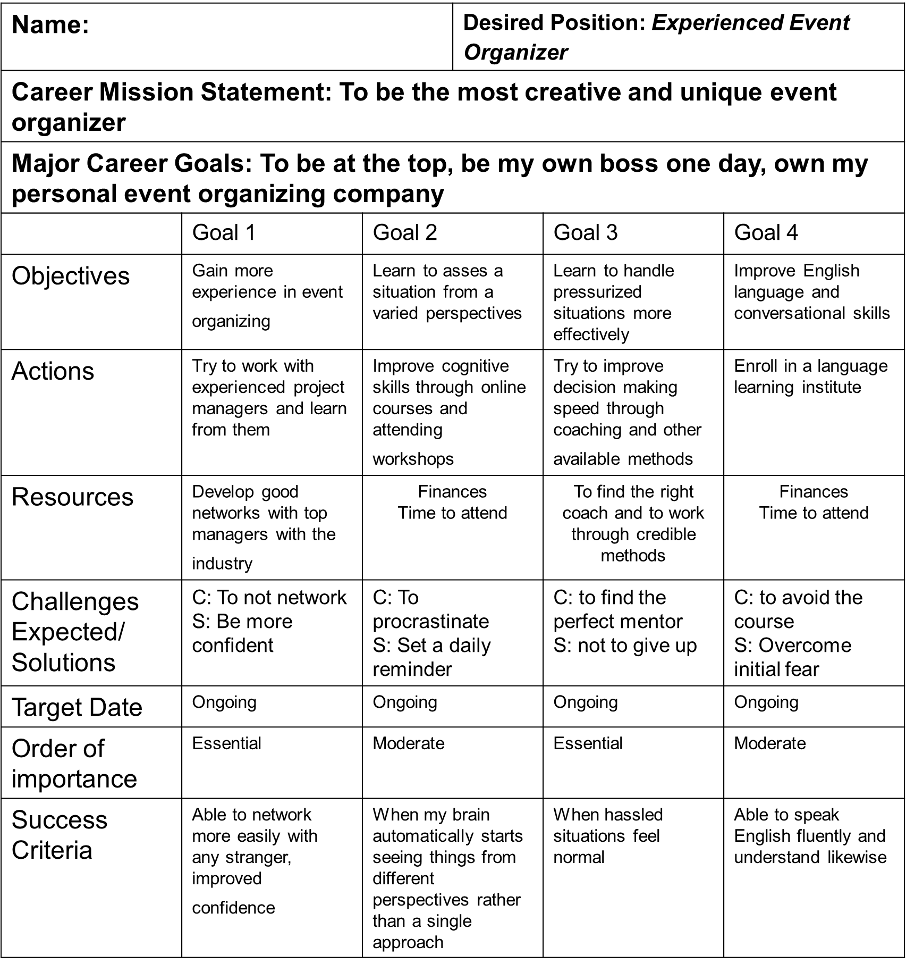
16

Conclusion
The project that has been chosen is “Dream Destinations” custom tours service, it is something which not being provided by other competitors in the industry. A detailed analysis has been done in the report, also the relevant project management tools have been discussed and followed by their effect on the project. All other relevant elements such as the management tools, management approaches, characters, risk, structure and deliverables have been defined in the report.
According to the analysis, the project has both its pros and cons but the unique part of this project “Dream Destinations” is that no any other competitor in the market has come up with such an idea, to offer customers a holiday with much freedom of choice, therefore the rate of success is higher since more people are willing to spend on tours and a high number of them want personalized tours rather than going as a part of a group.

17
References
Azanha, A., Argoud, A., Camargo Junior, J. and Antoniolli, P. (2017), "Agile project management with Scrum", International Journal of Managing Projects in Business, Vol. 10 No. 1, pp. 121-142. https://doi.org/10.1108/IJMPB-06-2016-0054
Badi, S. and Pryke, S. (2016), "Assessing the impact of risk allocation on sustainable energy innovation (SEI)", International Journal of Managing Projects in Business, Vol. 9 No. 2, pp. 259-281. https://doi.org/10.1108/IJMPB-10-2015-0103
Carruthers, J.A. and Battersby, A., 1966. Advances in critical path methods. Journal of the Operational Research Society, 17(4), pp.359-380.
Fernandez, D.J. and Fernandez, J.D., 2008. Agile project management—agilism versus traditional approaches. Journal of Computer Information Systems, 49(2), pp.10-17.
Joslin, R. and Müller, R. (2016), "The impact of project methodologies on project success in different project environments", International Journal of Managing Projects in Business, Vol. 9 No. 2, pp. 364-388. https://doi.org/10.1108/IJMPB-03-2015-0025
Kanakaris, N., Karacapilidis, N. and Lazanas, A., 2019. On the Advancement of Project Management through a Flexible Integration of Machine Learning and Operations Research Tools.
Kerzner, H., 2019. Using the project management maturity model: strategic planning for project management. Wiley.
Khoja, S.A., Dhirani, L.L., Chowdhary, B.S. and Kalhoro, Q., 2010, November. Quality control and risk mitigation: A comparison of project management methodologies in practice. In 2010 International Conference on Education and Management Technology (pp. 19-23). IEEE.
18
Patil, A.V., 2019. Comparative Analysis between Sequential and Iterative Project Management Approaches. interfaces, 6(07).
Pinch, L., 2005. Lean construction. Construction Executive, 15(11), pp.8-11.
Pollack, J. and Algeo, C. (2016), "Project managers’ and change managers’ contribution to success", International Journal of Managing Projects in Business, Vol. 9 No. 2, pp. 451-465. https://doi.org/10.1108/IJMPB-09-2015-0085
Pyzdek, T., 2003. The six sigma. Estados Unidos: Mcgraw-hill
Tomanek, M. and Juricek, J., 2015. Project risk management model based on PRINCE2 and SCRUM frameworks. arXiv preprint arXiv:1502.03595.
Verdant Leisure, 2019 [online] Available at: https://www.verdantleisure.co.uk/about/news/amazon-growing-business-awards/ [Accessed 25/11/2019]
Roberts, P., 2011. Effective project management: Identify and manage risks plan and budget keep projects under control. Kogan Page Publishers.

18
Allen, W. and Kilvington, M. (2009). Stakeholder analysis. [online] Available at: https://learningforsustainability.net/pubs/Allen2009-Stakeholder_analysis.pdf [Accessed 27 Nov. 2019].
Sammut‐Bonnici, T. and Galea, D., 2015. SWOT analysis. Wiley Encyclopedia of Management, pp.1-8.
PMI (2019). Risk analysis and management. [online] Pmi.org. Available at: https://www.pmi.org/learning/library/risk-analysis-project-management-7070 [Accessed 27 Nov. 2019].
Rokach, L. and Maimon, O., 2005. Decision trees. In Data mining and knowledge discovery handbook (pp. 165-192). Springer, Boston, MA.

19

