An Investigation into the Portrayal of Women as Submissive Within Advertising, Critically Evaluating the Male Gaze.

Bliss Horstead P145946
Submitted in partial fulfilment of the requirements for the degree
BA (Hons) Fine Art at University of Wales Trinity St Davids
December 2017
Tutor: Ryan Moule
Word Count: 5105
Contents

List of Illustrations
Summary
Introduction

Chapter 1 The Role of the Male Gaze
1.1 The History of the Male Gaze
1.2 The Mirror Effect
1.3 John Berger on Contemporary Advertising

Chapter 2 Gender Roles within Advertising
2.1 History of Gender Roles since the 50’s
2.2 Analysing 1950’s Advertising – Woman’s Own Magazine
2.3 Cindy Sherman
2.4 Contemporary Advertising

Chapter 3 Cultural Factors Influencing Advertising
3.1 Targeted Advertising
3.2 Subliminal Advertising -Semiotic Coding and Signifiers
3.3 Psychological Influence of the Mirror Effect

Chapter 4 Subverting the Male Gaze
4.1 Artists attempts to subvert the Male Gaze
4.2 My Personal Art Practice

Conclusion

Reference List

Bibliography
List of Illustrations
Figure 1 Movie still from ‘Transformers’ (2007) Megan Fox on Screen. [Online] Available at: https://malegazefinal.wordpress.com/2016/05/03/an-example-analysis-transformers/ (Accessed: 16 October 2017)

Figure 2 Reni, G. (1620-5) Susannah and the Elders. [Oil on Canvas] The National Gallery, London.
https://www.nationalgallery.org.uk/paintings/guido-reni-susannah-and-the-elders

Figure 3 Tintoretto, J. (1557) Susannah and the Elders. [Oil on Canvas] Kunsthistorisches Museum, Vienna.
http://mini-site.louvre.fr/venise/en/exhibition/reflections_and_radiance.html#page1_pictureInfo2

Figure 4 Advertisement from ‘Woman’s Own’ Magazine (1955) Dolcis Shoe Advert. [Photograph].

Figure 5 Advertisement from ‘Woman’s Own’ Magazine (1955) Quaker Oats Porridge Advert. [Photograph].

Figure 6 Sherman, C. (1978) Untitled #10. [Photograph] Museum of Modern Art: New York.

Figure 7 Sherman, S. (1979) Untitled #52. [Photograph] Museum of Modern Art: New York.

Figure 8 (2007) Dolce and Gabbana Advert. [Online] Available at: https://www.independent.ie/style/fashion/fashion-news/seven-of-the-most-controversial-fashion-ads-ever-30349497.html (Accessed 12 November 2017)

Figure 9 Kruger, B. (1982) Untitled (We have Received Orders not to Move). [Photograph] Mary Boone Gallery, New York. https://www.nga.gov/press/exh/4708/images.html (Accessed: 20 November 2017)

Figure 10 Kruger, B. (1981) Untitled (Your Gaze Hits the side of my Face). [Photograph and Type on Paperboard] Glenstone Museum: Maryland. https://www.nga.gov/press/exh/4708/images.html (Accessed: 20 November 2017)
Figure 11 Horstead, B. (2016) What are you really Selling? [Mixed Media] Artists own Collection

Summary
This paper will be examining the presentation of women as submissive in advertising, how the male gaze transpired, and how this psychological way of thinking, that is so ingrained in contemporary media has caused women to subconsciously think differently about how they choose to portray themselves. I will be analysing the work of Laura Mulvey, John Berger, examining gender roles within past and contemporary advertising, including the works of Cindy Sherman’s’ artistic representations of women.

Introduction
This dissertation will be an evaluation of the effect that the male gaze has in advertising and media and the psychological sense of ownership men place over women because of this; thus creating women to have a ‘mirror effect’ towards the way they look at themselves.
Laura Mulvey invented the term the ‘Male Gaze’ discussing how in film, the narrative conventionally portrays women as passive in comparison to the male leading role, this reflects a patriarchal order that is shown in media. Mulley’s theory regarding the patriarchal centralization and sense of importance surrounding the male character came about in 1975, however they are still reflecting the normal power play within characters in media in contemporary society. As Mulvey states in Visual and Other Pleasures, ‘Unchallenged, mainstream film coded the erotic into the language of the dominant patriarchal order.’ (1989:16)
As Stefania Sorrentino (2014) suggests in Subverting the Male Gaze, the patriarchal society in which we live in greatly influences the narrative film’s structure. The main argument is that Hollywood narrative films represent female characters in a way that provides the male audience with a pleasurable on screen experience. As a result, the woman is always the object of the gaze, and the roles are rarely reversed.
In the majority of films, the woman is displayed for the pleasure of the male protagonist, and also the male audience. As the films plot goes on, she becomes the reward for the male character. Transformers is a typical example of the male gaze, using seductive camera shots to put emphasis on the attractiveness of the female role. The female character is often portrayed as secondary.
Females comprised 12% of protagonists featured in the top 100 grossing films of 2014. This represents a decline of 3 percentage points from 2013 and a decline of 4 percentage points from 2002. Lauzen (2014: 01)


Figure 1 Mikaela Banes in Transformers (2007)

I shall be exploring the history of the male gaze and the power dynamic in which historical paintings were created, and discussing the ‘mirror effect’ regarding how women look at themselves and subliminally present themselves in a way that is appealing to a man, discussing John Bergers views on the way women portray themselves in relation to men.
I will be examining the history of gender roles since the 1950s and analysing the advertising from that era, in comparison to contemporary advertising; looking into how the psychology has changed to a more hypersexualised nature, but still with the same suggestion of men being the dominant and women being the submissive. Exploring the correlation between the chauvinism in contemporary advertising versus that of the fifties. I will also be examining Cindy Sherman’s take on the representation of women from the 50s and how she projected ideological identities from fake movie stills, using self-portraiture as a way of placing herself in domestic housewife roles, to suggest where a woman’s place in society is implied to be.
I shall also be looking into cultural factors which influence advertising, such as targeted and subliminal advertising and the psychological impact that the mirror effect has created culturally. I am also going to examine how feminist artists create work to challenge these notions, and will be briefly discussing my own art practice.

Chapter 1 The Role of the Male Gaze
1.1 The History of the Male Gaze
Laura Mulvey created the phrase Male Gaze in 1975, it is a concept depicting the way in which women are perceived through a masculine point of view.
Conventional films will almost always assume that the audience is male, and the male leading role in the narrative will assert some kind of power or sexual engagement upon the female role. The blog Finally Feminism 101 states that the male character is the active possessor, this is derived due to factors like the assumption that heterosexual men in western culture are the default target audience in most aspects of media and film genres. (Tekanji 2007)
This stereotype presents men as controlling and presents the women as passive objects of desire which implies that they are the reward for the male character. This encourages the audience to objectify the woman, and view the narrative through a male perspective of sexual desire. Mulvey (1989) calls this Fetishistic Scopophilia. Discussing how cinema encourages scopophillic tendencies:
In a world ordered by sexual imbalance, pleasure in looking has been split between active/male and passive/female. The determining male gaze projects its fantasy onto the female figure, which is styled accordingly. In their traditional exhibitionist role women are simultaneously looked at and displayed, with their appearance coded for strong visual and erotic impact so that they can be said to connote to-be-looked-at-ness. (Mulvey 1989: 19)

The male gaze has been around for centuries, as men have always been the majority of the people in power, even looking back at old renaissance paintings, you are looking back through the eyes of an upper middle class male. Jones (2011). The male gaze has existed within representation for a long time. Those in positions of power get to decide how history and culture is written. Much like modern day, within advertising and media.
Fig. 2 and 3 are paintings depicting the story of Susannah and the Elders from biblical times, which was popular to paint in Europe in the Renaissance period. This story directly relates to the male gaze. This Biblical story, in which a young woman is spied on by old men, was painted by many Renaissance and Baroque artists because it was an opportunity to depict naked flesh. Jones (2011) The painting by Tintoretto depicts Susannah looking at herself in a mirror, the mirrors role in this painting is to symbolise her vanity towards herself.
The mirror was often used as a symbol of the vanity of woman. The moralizing, however, was mostly hypocritical. You painted a naked woman because you enjoyed looking at her, you put a mirror in her hand and you called the painting vanity, thus morally condemning the woman whose nakedness you had depicted for your own pleasure. Berger (2003: 38)

I feel that these show examples of how a male perspective has skewed convicted notions of a woman’s body image, objectifying the female form into a sight, using the mirror effect to glorify the perversions of the male spectator, condemning the subject to vanity when the painter had a choice of what he painted.


Figure 3 Tintoretto, J. Susannah and the Elders. (1557)
Figure 2 Reni, G. Susannah and the Elders. (1620-5)

1.2 The Mirror Effect
The mirror effect is a by-product of the male gaze, it encourages women to present themselves in a way that would be appealing to a man. A woman will display herself without realising that she is presenting herself in the way a man would idealistically like to view her. This way of female thinking has been rooted into our psychology and thoughts about gender stereotyping, insinuating that men are watchers, and women are being watched.
Advertising aimed at women is not exempt: it engages in the mirror effect described above, wherein women are encouraged to view themselves as the photographer views the model, therefore buying the product in order to become more like the model advertising it. Wykes and Gunter (2005:41)

This way of thinking can have harmful ramifications towards the development of women’s brains as they get older. As a result of constantly viewing their appearance from a harsh perspective in their own minds, attempting to hold their appearance to a cultural standard is a difficult task, thus failing to meet that standard can have very negative effects, resulting in body shame and a host of mental health problems.
Objectification theory posits that women’s gender role socialization and sexual objectification experiences promote self-objectification and body surveillance. Self-objectification and body surveillance, in turn, promote body shame and anxiety and reduce or interfere with flow and awareness of internal bodily states. This chain of relations ultimately contributes to women’s risk for depression, sexual dysfunction, and eating disorders. Fredrickson & Roberts cited in Moradi and Huang (2008: 347)

1.3 John Berger on Contemporary Advertising
Throughout history in social culture, women have always been perceived as subservient to men, and the presence of a man in society differs to that of women. In contemporary and past society, the overall presence of a man denotes power and authority. Women in contrast within contemporary society are still living in a patriarchal system, there is an element of control that pervades our everyday life through advertising and media. Emma Allwood discusses in Why we still need John Berger’s Ways of Seeing how women will consequently always critique their appearance for the benefit of societal acceptance due to this. (2017)
In 2017 Gunaratnam discusses how in Berger’s most celebrated book titled, Ways of Seeing, gives evidence that we require a narrative and a visual language to make sense of an image. Advertising and media exploits this, using women to provide a gratifying visual stimulation for men, this is because we are living in a patriarchal society which influences the narrative and structure of films. In fact it is ingrained into all forms of everyday media, depicting the woman as typically being the object of the gaze.
One might simplify this by saying: men act and women appear. Men look at women. Women watch themselves being looked at. This determines not only most relations between men and women but also the relation of women to themselves. The surveyor of woman in herself is male: the surveyed female. Thus she turns herself into an object – and most particularly an object of vision: a sight. Berger (2003: 38)

Chapter 2 Gender Roles within Advertising
2.1 History of Gender Roles since the 50s
After World War Two had ended, advertising and media were actively aspiring to promote the Happy Housewife consumerist lifestyle. The representation of women in films at that time suggested that the integrity of the Happy Housewife was under threat post war from the reality of the time where femininity was being defined by cultural changes. Lloyd and Johnson (2003: 1)
After men came back from war, women were encouraged to give up their jobs to stay in and look after their husbands, this became the focus of advertising, especially in women’s magazines, which heavily focused on the importance of home and family values.
The concept of family involved both parents: men returning from the war to build a new peacetime life as well as the women who were returning to the home to take up their conventional role as wives and mothers. Recent feminist social critiques have shown the ways in which emerging sociology, psychological theories, social policy and women’s magazines tried to return women to contend roles in the family after their involvement in the war economy. Wandor (1987: 3)

2.2 Analysing 1950s Advertising – Woman’s Own Magazine
Pictured are advertisements from the 22nd edition of Woman’s Own magazine, which was printed in 1955. You will notice that both adverts are referencing an obvious desire for male approval. In Fig. 4 the text reads, ‘Ask any man what he thinks is the most flattering shoe a woman can wear – and the answer is “a simple court.” In Fig. 5 the man is expressing displeasure towards the woman that his porridge isn’t ready, suggesting a hierarchy within the domestic household. Both these advertisements are targeted at women, giving evidence that even ten years after the war, women were still being conditioned into a patriarchal subservience.
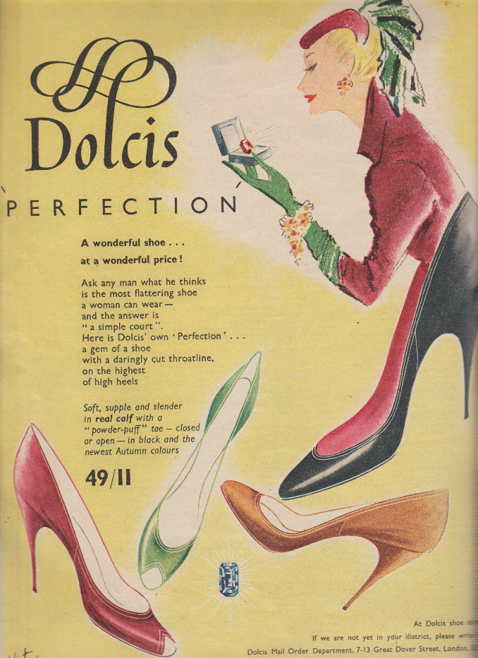
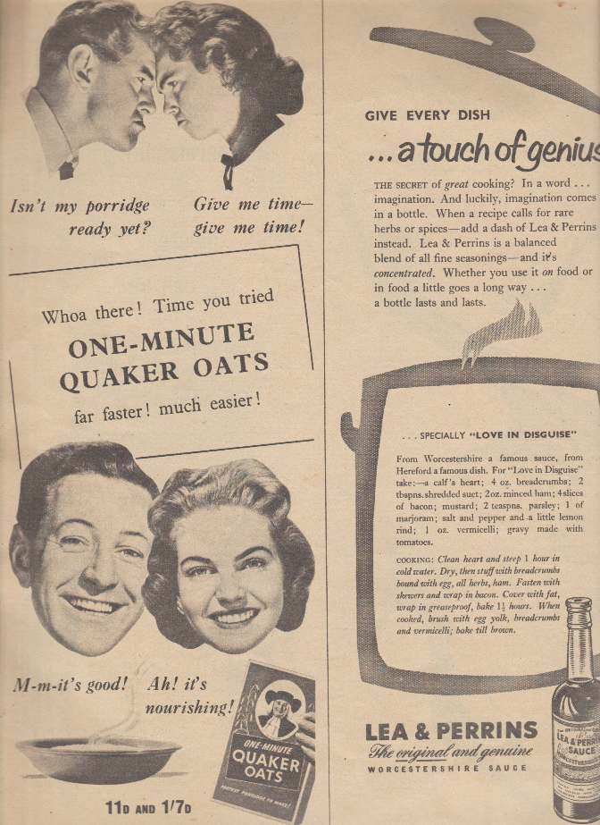

Figure 5 Quaker Oats Advertisement
Figure 4 Dolcis Shoe Advertisement

2.3 Cindy Sherman
Cindy Sherman’s most iconic works are a range of fake movie stills taken in the 80s, primarily inspired by the 50s Happy Housewife era. Sherman created a range of powerful self-portraits, where she projected constructed ideological identities illustrating a women’s place in society, mostly placing herself in traditional housewife roles within domestic settings. Sherman discusses how she was not aware of the Male Gaze while creating her images, however the way she shot the film stills, was with intention to evoke a self-conscious awareness of the female characters. Trying to depict a conflict between what we originally stereotype the characters to be, in contrast to the implied scene’s surroundings and facial expressions of the character. Showing a depth within each scene. Sherman (2003)
I wasn’t working with a raised “awareness,” but I definitely felt that the characters were questioning something-perhaps being forced into a certain role. At the same time, those roles are in a film: the women aren’t being lifelike, there acting. There are so many levels or artifice. I liked that whole level of ambiguity. Sherman (2003: 9)

Shermans photographs could be said to portray the Mirror Effect, where a woman holds herself in various positions and poses in a way that would be attractive or alluring to a man. MoMA.org discusses how Sherman’s work successfully examines the socio-political structure of traditional gender roles that are so ingrained into media and society, that they are viewed as stereotypical. (2017)
Fig. 6 is of a woman on the floor, putting away groceries. By the composition of the shot, and the facial expressions on the woman, you can tell that she is doing this work for someone, and not herself, wearing an oversized men’s jacket suggests that there is an ownership implied to this character. These is also an intentionally shown bruise on her outstretched arm, implying the character has been subjected to violence. Fig.7 is of a woman in bed, lying in a vulnerable position the camera shot implies that the spectator is male, due to this image being themed from the 50s-60s era as it’s in an intimate setting. Considering the cultural appropriateness of this image at that time implies that there is a male point of view behind the camera, however this differs from contemporary imagery as a shot like this taken in current day could be taken by any sex on the other end of the camera to be put on social media, it could even be a Selfie. It could be an advertisement.. Anyone could have taken it today but nevertheless it would still be seen as predominately for the male gaze.
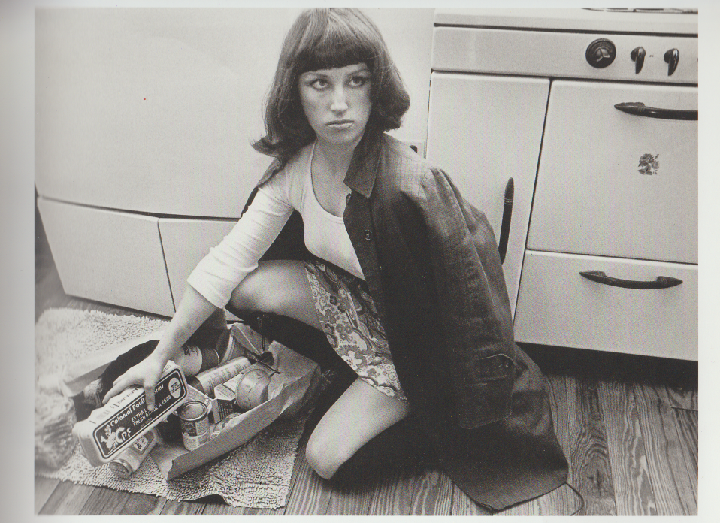

Figure 6 Cindy Sherman Untitled #10 1978


Figure 7 Cindy Sherman Untitled #52 1979

Nicholas Mirzoeff discusses in How to see the World the way in which the cinematic gaze always represents men as the bearer of the look, thus being the spectator. (2015) Also this encourages the Mirror Effect where the characters ‘see themselves seeing themselves’ in the sense that they act as if they are being admired by a third party and will act accordingly, this seems to be more apparent with female characters rather than male ones. Mirzoeff states the way in which the traditional male heroic role in film is often an active one, being the character that makes things happen, controlling the narrative and the power structure of the storyline which is projected onto the male and female spectator.
‘Men look at the action through the eyes of the male hero and women are obliged to do the same, a form of compulsory gender manipulation.’ Mirzoeff (2015: 53)

2.4 Contemporary Advertising
In contemporary advertising, the male gaze facilitates the notion of a woman as the selling point, especially in ‘High Fashion’ aftershave and perfume advertisements. The advertising typically suggests or portrays the woman as sexual and submissive, in a manner that shows the male role successful in seducing her with his masculinity. A view discussed by Marcel Danesi in Interpreting Advertisements; A Semiotic Guide, the over sexualisation of said products taps into a primordial consciousness, if you take into consideration that the function of the product being advertised is perfume, it taps into our primordial state as biological humans as a sense of smell is a biological sexual stimulant. (1995: 67) These type of adverts use semiotics of the male gaze via submissive women to entice the viewer into thinking of the product in a sexual and primordial way. It also engages women in the mirror effect, actively suggesting that femininity and passivity go together.
Fig. 8 is an ad by Dolce and Gabbana from 2007, this fashion company chose to have an advert with a woman in a swimsuit being restrained on the floor, surrounded by a group of half-dressed men. Freya Drohan discusses how this advert was under heavy criticism after it was thought to glorify ‘gang rape’. Although the designer Stafano Gabbana defended the image, saying its intention was to show an erotic dream or a sexual game. (2014) This is a clear example of using a woman as the selling point and a commodity, showing the woman as submissive and the man as powerful, marketing to men the idea that Dolce and Gabbana products will make you strong and powerful, at the same time subconsciously reinforcing the idea that the woman is there for the purpose of male pleasure. Marketing this to women implies that passivity and submissiveness are qualities to strive for in terms of femininity in contemporary fashion. Sigmund Freud discusses that masculinity has an active principle and femininity has a passive principle. Freud later goes on to discuss that all libido (sexual drive) is essentially active and therefore masculine. (2009: 47)



Figure 8 Dolce & Gabbana ad, 2007
If, in the 1950s, it was the home that was the ideal focus for women's labour and attention and from which their 'worth’ was judged, in the new millennium it is the body. A sleek, controlled figure is today essential for portraying success…… Today, the body is portrayed in advertising and many other parts of the media as the primary source of women's capital. (Bordo cited in Gill 2008: 13)

It is clear that contemporary advertising has remodelled the image of a woman to be far more hypersexualised, the marketing of women as a commodity began picking up during the 1950’s but it was apparent that this was due to the desire for women to become domesticated and more feminine after the war. However in recent years the modern woman remains feminine, but has a much higher focus on the body and sex appeal to the target audience. The aim for the male audience is to attract and objectify the woman so they will buy a product, or to engage the female viewer in the Mirror Effect creating a lifestyle image that is unattainable unless the woman buys the product which the model is endorsing.
One of the most significant shifts in advertising in the last decade or more has been the construction of a new figure: a young, attractive, heterosexual woman who knowingly and deliberately plays with her sexual power and is always 'up for it' (that is, sex). This figure has become known in some advertising circles as 'the midriff’, named after the fashion for exposing this part of the body (Gill 2008:12)

Chapter 3 Cultural Factors Influencing Advertising
3.1 Targeted Advertising
Advertising will always present deliberate signs to target a specific audience, just as films code the patriarchal fantasies of the dominant gender into mainstream film. Mulvey (1989:16). This determines how men view women and women view themselves, as it has been thoroughly imbedded into our consumerist contemporary culture.
Thorough the photographic image, femininity is constructed as a locus of male desire and pleasure, embedded in the photographed and commodified female body via a system of Fetishistic visual codes. The photographed female body operates as an object of exchange. Jones (2003: 315)

Advertising targeted at men generally involve an element of control and masculinity, when a woman is used in the advertising, she is fetishized to be the object of sexual gratification, even when there are no apparent sexual connotations related to the object being sold, the woman is present and being viewed as a commodity for the male viewer. When advertising is targeted at women there is often a subconscious suggestion that the product is needed to become more like the model in the advert, engaging the female viewer in the mirror effect.
In advertisements with women in, the woman isn’t only being objectified, she becomes the selling point, the ideology of what the woman symbolises is an example of the male gaze. In this context, the woman becomes a commodity to sell a product. Wykes and Gunter (2005:41)

3.2 Subliminal Advertising - Semiotic Coding and Signifiers
All kinds of sexual references are woven into advertisements to create subtle sexual overtones to usually sexless products, take for example the herbal essences advert, a woman is washing her hair exclaiming “Yes! Yes! Yes!” with pleasure at the shampoo, imitating an orgasm and also making reference to a line in a film from popular culture. Women in adverts often use objects and phrases not directly related to sex, but seen in the relation to themselves as an object, insinuates sexual thoughts to the viewer. ‘The Herbal Essences advertisement ends with the strap-line ‘A totally organic experience’, thereby underlining the sexual narrative at its core and its ‘naturalness’’ Maclaran and Stevens (2007: 172)
Danesi discusses how the semiotic analysis of an ad or commercial constitutes an act of decoding, i.e. of unravelling the code that may lie below the surface text. (1995) Semiotics is the study of when we culturally give meaning to things through communications in society via signs and signals. In the Herbal Essences advert, the semiotic signifier is the woman’s voice, this takes on a symbolic reference and is interpreted as sexual.
Content interpreted as sexual at the subconscious level. Includes words like sex, nonsexual perceptible objects that can connote sexual body parts and sexual actions. Bohbot (2003)

Michele Bohbot discusses in Sex in Advertising, Perspectives on the Erotic Appeal how advertising appropriates the power of fetishism to be able to sell goods, services, and ideas to the default audience, and how advertising encourages a fetish like relationship with things in general, and can psychologically influence people to create new associations into cultural items. (2003: 83)
Using subliminal imagery and actions in advertising can play on the viewers’ subconscious mind and cause them to make associations with objects to feelings, for example in the Herbal Essences advertisement the woman is using a hygiene product, however is expressing a lot of pleasure from the use of this, there is a comedy aspect to this which suggests that the shampoo is making her partner feel inadequate, exclaiming that it ‘satisfies her in a way never thought possible.’ This advert is a clear example of the subliminal sexualisation of nonsexual product while also fetishizing the shampoo to a certain extent. ‘Fetishism….contributes to a larger project of linking products with psychological fulfilment, emotional satisfaction, and sexual gratification.’ Bohbot (2003: 83)

3.3 Psychological Influence of the Mirror Effect
The way women are culturally presented via advertising and media clearly has a psychological influence on the way women view themselves from an early age, defining their relation to the world around them and how they act around opposing genders. As Allwood discusses in Why we still need John Berger’s Ways of Seeing (2017) living in a western patriarchal society means women engage in the constant consumerist lifestyle of attempting to change their bodies through buying products that are targeted at them, showing a means to pleasing men and competing with other women for that male attention. Struggling with the reality of body image.

Chapter 4 Subverting the Male Gaze
4.1 Artists attempts to subvert the Male Gaze
Many artists attempt to subvert the male gaze through their unique practice. Barbara Kruger uses graphic design to collage imagery together in an advertising format, using an iconic red font. Kruger’s work directly addresses the subjects of feminism, politics, consumerism and the economy, the way in which she works encourages the viewer to look at the socio-political factors in relation to problems in contemporary society and to reconsider the viewers’ personal values.
Fig. 9 is a piece that is making a comment on the way in which women are often the subject of masculine control, Kruger uses collaged imagery of a woman pinned into a submissive position. Making a comment on the patriarchal society that we live in, the format of the words give suggestion that the phrase is coming from a woman’s perspective, the format of the image looks like it is a poster or an advert, relating to the masculine control and male gaze in contemporary consumerism.
On a literal level Untitled (We Have Received Orders Not to Move) momentarily immobilizes the viewer who takes the time to read its simple declarative statement. Its arresting impact intensifies as it becomes clear that the collective 'we,' defined by a woman's voice, encompasses the pinned model, the artist, and the female spectators subject to masculine control. Brawer, C. and Rosen, R. (1989: 196)

The image is kept simple, allowing the viewer to focus on the outline of the woman which brings attention to the restraints around her silhouette.


Figure 9 Barbara Kruger Untitled (We have Received Orders not to Move) (1982)

Fig. 10 is my favourite piece by Kruger. The representation of the female as a statue makes a direct comment on the implication that women are objectified through the Male Gaze. The statement is simple and is directed towards the male viewer, this highlights how language is seen as manipulative and powerful when curated in a certain context, as so little visual information is needed to create a strong impact on the viewer.


Figure 10 Barbara Kruger Untitled (Your Gaze Hits the side of my Face) (1981)

4.2 My Personal Art Practice
Personally I create feminist artwork facilitating ideas surrounding the role that the Male Gaze plays in contemporary advertising and consumerism. Interest was initially raised in this subject after coming across imagery of my grandmother posing in an advertisement next to a wash boiler aged nineteen, taken in the 1950’s. Using Photoshop and collaging, I merged imagery of myself with the images of my grandmother Fig. 11, inspired by the socio-political aspect to this and by using pictures of family it also had a deeply personal element. From this I explored the notions of change in values regarding gender stereotyping from the 1950s to current day within advertising. Since then I have had an interest in feminist conceptual art, using my body as a reference point and a tool to converse with the viewer on a personal level. Aiming to evoke deep thought within the viewer and encourage them to question their own perceptions on how women are portrayed as a commodity, and how women are treated in everyday life situations.
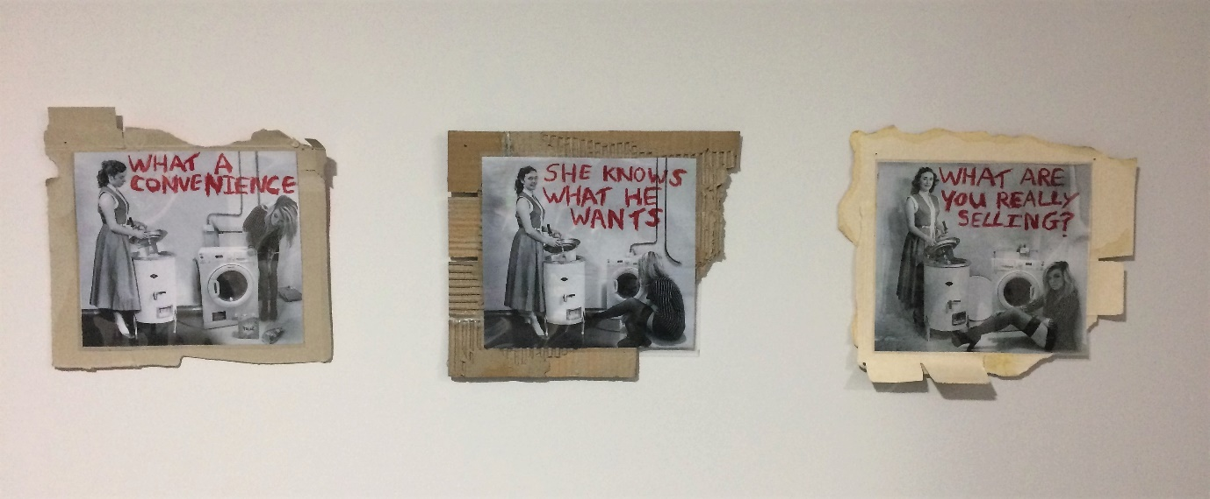
Figure 11 Bliss Horstead. What are you Really Selling? (2016)

This year I have recently been making site specific art, using my body as the site to explore the notions of the grey area surrounding consent and the impact male privilege and entitlement has on women in society, working with mixed media I am incorporating traditional feminine objects such as lipstick and flowers to subvert traditional meanings and connotations surrounding the stereotype that women are perceived as feminine and weak.

Conclusion
Our culture seems to be abundant with advertising and media that suggests a strong gender stereotyping; in our contemporary culture, it has changed from a conventional stereotyping of pleasing men and being traditional in values, to a far more hypersexual stereotype of women, but through the investigation into themes from this dissertation I can conclude that the basis of the content has stayed the same implying that women are submissive and therefore in a sense, portrayed as below men in media and advertising. I feel that this is an important issue and although time has passed, the urgency of bringing these issues back to the foreground seem incredibly important. Especially if you think about the way in which the subject of gender pay gaps has still not been resolved and presidencies that propagate sexist and misogynistic views are in positions of power. These are just some concerns that reinforce ideas of male dominance in all areas of our lives. I do believe that there are more subcultures actively working on deconstructing these values, and people are not as strongly influenced by advertising and a patriarchal way of thinking to the same extent in contemporary society.
Contemporary women may be unfazed by the sexual objectification found in today's advertising. They may choose to exercise their "girl power" and make their decisions independently of how women in advertisements may be portrayed. Dahlberg and Zimmerman (2008: 73)

This may be due to factors such as a heavier exposure to art and a more relaxed way of thinking than people had in the 1950’s. Many postmodern artists actively work to deconstruct these views and ideals, regarding the default hierarchy shown within media, challenging the viewer to reconsider their morals, such as Cindy Sherman and Barbara Kruger achieve within their work.
Dahlberg and Zimmerman also discuss how women in contemporary society are less offended by the portrayal of woman as sex objects, as they understand that it does not reflect reality and are representative of the new and more rational sophisticated consumers that understand the use of gender stereotyping is to make a sale and how it’s not a depiction of real life. (2008: 77)
These sexualised adverts still exist in the sense that the woman is subservient to the man, generally because that has been the stereotypical ‘norm’ for so long. However contemporary society is changing and people are choosing to be non-binary, oscillating between both feminine and masculine traits, rather than stick to a set one that is in relation to their cis gender. It has increasingly become more socially acceptable for women to have their own voice and to live independent lives. So this gender representation of what is ‘normal’ may not be the case for much longer.
With any form of representing, it’s important to question who and for what purposes. Each representation is a distortion, and the fundamental question should always be, why and for what? I feel that because men have historically been the dominant gender, misogynistic advertising deliberately puts focus on the portrayal of woman as submissive. This propagates the current patriarchal power dynamic.

Reference List
Books
Bohbot, M. (Ed) Reichert, T. and Lambaise, J. (2003) Sex in Advertising, Perspectives on the Erotic Appeal. London: Lawrence Erlbaum Associates
Brawer, C. and Rosen, R. (1989) Making Their Mark: Women Artists Move into the Mainstream. New York: Abbeville Press.
Danesi, R. (1995) Interpreting Advertisments A Semiotic Guide. Canada: Legas
Freud, S. (1997) Sexuality and the Psychology of Love. New York: Simon and Schuster Inc
Jones, A. (Ed) (2003) The Feminism and Visual Culture Reader. Oxon: Routledge
Mulvey, L. (1989) Visual and Other Pleasures. Hampshire: Palgrave
Mirzoeff, N. (2015) How to see the World. London: Pelican
Sherman, C. (2003) The Complete Untitled Film Stills Cindy Sherman. London: Thames and Hudson Ltd.
Thurschwell, P. (Ed) (2009) Sigmund Freud. Second edition. London: Routelige
Wandor, M. (1987) Look Back in Gender. New York: Routledge
Wykes, M. Gunter,B. (2005) The media and body image : if looks could kill. London: Sage

Websites
Drohan, F. (2014) Seven of the most controversial fashion ads... ever. Available at: https://www.independent.ie/style/fashion/fashion-news/seven-of-the-most-controversial-fashion-ads-ever-30349497.html (Accessed 12 November 2017)
Hope Allwood, A. (2017) Why we still need John Berger’s Ways of Seeing. Available at: http://www.dazeddigital.com/artsandculture/article/34166/1/why-we-still-need-ways-of-seeing-john-berger (Accessed: 19 October 2017)
Jones, J. (2011) Men, women and the art of exclusion. Available at: https://www.theguardian.com/artanddesign/jonathanjonesblog/2011/may/27/women-artists-exclusion (Accessed 8 November 2017)
MoMA. (2017) Cindy Sherman. Available at: https://www.moma.org/interactives/exhibitions/2012/cindysherman/gallery/2/mobile.php (Accessed: 20 October 2017)
Sorrentino, S. (2014) Subverting the Male Gaze. Available at: https://curatingthecontemporary.org/2014/11/07/subverting-the-male-gaze-femininity-as-masquerade-in-untitled-film-stills-1977-1980-by-cindy-sherman/ (Accessed 31 October 2017)
Tekanji (2007) FAQ: What is the “male gaze?” Available at: https://finallyfeminism101.wordpress.com/2007/08/26/faq-what-is-the-%E2%80%9Cmale-gaze%E2%80%9D/ (Accessed 7 November 2017)
University of Louisville. (2017) Untitled (We Have Received Orders Not to Move). Available at: http://digital.library.louisville.edu/cdm/ref/collection/vrc/id/332 (Accessed:20 November 2017)

Journals and Articles
Dahlbeg, J. and Zimmerman, A. (2008) ‘The Sexual Objectification of Women in Advertising: A Contemporary Cultural Perspective.’ Journal of Advertising Research. Pg 71-78. [Online] Available at: http://pure.au.dk/portal/files/10594/8_-_sexual_objectification_of_women.pdf (Accessed 3 December 2017)
Gill, R. (2008) ‘Empowerment/Sexism: Figuring female Sexual Agency in Contemporary Advertising.’ Feminism and Psychology. Vol 18. (1) pg 5-60. [Online] Available at: http://openaccess.city.ac.uk/4112/1/Empowerment,%20Sexism.pdf (Accessed: 22 November 2017)
Gunaratnam, Y. Bell, V. (2017) How John Berger changed our ways of seeing art: He taught us that photographs always need language, and require a narrative, to make sense. Independent. Culture and Arts. 10 January 2017. JOURNAL/NEWSPAPER ARTICLES Available at: http://www.independent.co.uk/arts-entertainment/art/features/john-berger-ways-of-seeing-a7518001.html (Accessed 16 October 2017)
Lauzen, M. (2015) ‘It’s a Man’s (Celluloid) World: On-Screen Representations of Female Characters in the Top 100 Films of 2014’ The Centre for the Study of Women in Television and Film; Research. [Online] Available at: http://womenintvfilm.sdsu.edu/files/2014_Its_a_Mans_World_Report.pdf (Accessed: 31 October 2017)
Lloyd, J. Johnson, L. (2003) The Three Faces of Eve: The Post-War Housewife, Melodrama, and Home 1. Feminist Media Studies. Vol 3. (1) pg 1. Available at: https://research-repository.griffith.edu.au/bitstream/handle/10072/21145/52907_1.pdf?sequence=1 (Accessed: 31 October 2017)
Maclaran, P. and Stevens, L. (2007) ‘The Carnal Feminine: Womanhood, Advertising and Consumption.’ Association for Consumer Research. Vol 8. pg 169-174. [Online] Available at: http://www.acrwebsite.org/volumes/eacr/vol8/eacr_vol8_170.pdf (Accessed: 22 November 2017)
Moradi, B. and Huang, Y. (2008) ‘Objectification Theory and Psychology of Women: A Decade of advances and Future Directions’. Psychology of Women Quarterly. Vol 32. Issue 4. Pg 347-497. [Online] Available at: http://onlinelibrary.wiley.com/doi/10.1111/j.1471-6402.2008.00452.x/abstract (Accessed 22 November 2017)

Bibliography
Books
Barthes, R. (ed.) Carter, M. Stafford, A. (2006) The Language of Fashion. United Kingdom: Biddles
Bohbot, M. (Ed) Reichert, T. and Lambaise, J. (2003) Sex in Advertising, Perspectives on the Erotic Appeal. London: Lawrence Erlbaum Associates
Brawer, C. and Rosen, R. (1989) Making Their Mark: Women Artists Move into the Mainstream. New York: Abbeville Press.
Chapman, R. and Rutherford, J. (Ed) (1988) Male Order Unwrapping masculinity. London: Lawrence & Wishart Limited
Danesi, R. (1995) Interpreting Advertisments A Semiotic Guide. Canada: Legas
Freud, S. (1997) Sexuality and the Psychology of Love. New York: Simon and Schuster Inc
Gauntlett, D. (2002) Media, Gender and Identity an Introduction. (Second Edition) Oxon: Routledge
Hall, S. (2012) This Means this this Means that. Second Edition. London: Laurence King Publishing Ltd
Hall, S. (ed) (2013) Representation. Second edition. London: Sage Publications.
Irigaray, L. (1985) This Sex Which is Not One. New York: Cornell University Press
Jones, A. (Ed) (2003) The Feminism and Visual Culture Reader. Oxon: Routledge
Marsen, S. (2006) Communication Studies. New York: Palgrave Macmillan
Mulvey, L. (1989) Visual and Other Pleasures. Hampshire: Palgrave
Mirzoeff, N. (2015) How to see the World. London: Pelican
Sherman, C. (2003) The Complete Untitled Film Stills Cindy Sherman. London: Thames and Hudson Ltd.
Thurschwell, P. (Ed) (2009) Sigmund Freud. Second edition. London: Routelige
Wandor, M. (1987) Look Back in Gender. New York: Routledge
Wykes, M. Gunter,B. (2005) The media and body image : if looks could kill. London: Sage

Websites
Demelio. (2012) A Quick Analysis of John Bergers Ways of Seeing. Available at: https://demeliou.wordpress.com/2012/11/25/a-quick-analysis-of-john-bergers-ways-of-seeing/ (Accessed 31 October 2017)
Drohan, F. (2014) Seven of the most controversial fashion ads... ever. Available at: https://www.independent.ie/style/fashion/fashion-news/seven-of-the-most-controversial-fashion-ads-ever-30349497.html (Accessed 12 November 2017)
Freeman, A. (2016) Your ultimate guide to Cindy Sherman. Available at: http://www.dazeddigital.com/photography/article/32147/1/your-ultimate-guide-to-cindy-sherman (Accessed: 8 November 2017)
Hope Allwood, A. (2017) Why we still need John Berger’s Ways of Seeing. Available at: http://www.dazeddigital.com/artsandculture/article/34166/1/why-we-still-need-ways-of-seeing-john-berger (Accessed: 19 October 2017)
Jones, J. (2011) Men, women and the art of exclusion. Available at: https://www.theguardian.com/artanddesign/jonathanjonesblog/2011/may/27/women-artists-exclusion (Accessed 8 November 2017)
MoMA. (2017) Cindy Sherman. Available at: https://www.moma.org/interactives/exhibitions/2012/cindysherman/gallery/2/mobile.php (Accessed: 20 October 2017)
Sorrentino, S. (2014) Subverting the Male Gaze. Available at: https://curatingthecontemporary.org/2014/11/07/subverting-the-male-gaze-femininity-as-masquerade-in-untitled-film-stills-1977-1980-by-cindy-sherman/ (Accessed 31 October 2017)
Tate. (2017) Barbara Kruger. Available at: http://www.tate.org.uk/art/artists/barbara-kruger-1443 (Accessed 19 November 2017)
Tekanji (2007) FAQ: What is the “male gaze?” Available at: https://finallyfeminism101.wordpress.com/2007/08/26/faq-what-is-the-%E2%80%9Cmale-gaze%E2%80%9D/ (Accessed 7 November 2017)
University of Louisville. (2017) Untitled (We Have Received Orders Not to Move). Available at: http://digital.library.louisville.edu/cdm/ref/collection/vrc/id/332 (Accessed:20 November 2017)

Journals and Articles
Dahlbeg, J. and Zimmerman, A. (2008) ‘The Sexual Objectification of Women in Advertising: A Contemporary Cultural Perspective.’ Journal of Advertising Research. Pg 71-78. [Online] Available at: http://pure.au.dk/portal/files/10594/8_-_sexual_objectification_of_women.pdf (Accessed 3 December 2017)
Gill, R. (2008) ‘Empowerment/Sexism: Figuring female Sexual Agency in Contemporary Advertising.’ Feminism and Psychology. Vol 18. (1) pg 5-60. [Online] Available at: http://openaccess.city.ac.uk/4112/1/Empowerment,%20Sexism.pdf (Accessed: 22 November 2017)
Gunaratnam, Y. Bell, V. (2017) How John Berger changed our ways of seeing art: He taught us that photographs always need language, and require a narrative, to make sense. Independent. Culture and Arts. 10 January 2017. JOURNAL/NEWSPAPER ARTICLES Available at: http://www.independent.co.uk/arts-entertainment/art/features/john-berger-ways-of-seeing-a7518001.html (Accessed 16 October 2017)
Lauzen, M. (2015) ‘It’s a Man’s (Celluloid) World: On-Screen Representations of Female Characters in the Top 100 Films of 2014’ The Centre for the Study of Women in Television and Film; Research. [Online] Available at: http://womenintvfilm.sdsu.edu/files/2014_Its_a_Mans_World_Report.pdf (Accessed: 31 October 2017)
Lloyd, J. Johnson, L. (2003) ‘The Three Faces of Eve: The Post-War Housewife, Melodrama, and Home 1.’ Feminist Media Studies. Vol 3. (1) pg 1. [Online] Available at: https://research-repository.griffith.edu.au/bitstream/handle/10072/21145/52907_1.pdf?sequence=1 (Accessed: 31 October 2017)
Maclaran, P. and Stevens, L. (2007) ‘The Carnal Feminine: Womanhood, Advertising and Consumption.’ Association for Consumer Research. Vol 8. pg 169-174. [Online] Available at: http://www.acrwebsite.org/volumes/eacr/vol8/eacr_vol8_170.pdf (Accessed: 22 November 2017)
Moradi, B. and Huang, Y. (2008) ‘Objectification Theory and Psychology of Women: A Decade of advances and Future Directions’. Psychology of Women Quarterly. Vol 32. Issue 4. Pg 347-497. [Online] Available at: http://onlinelibrary.wiley.com/doi/10.1111/j.1471-6402.2008.00452.x/abstract (Accessed 22 November 2017)

